Extended Data

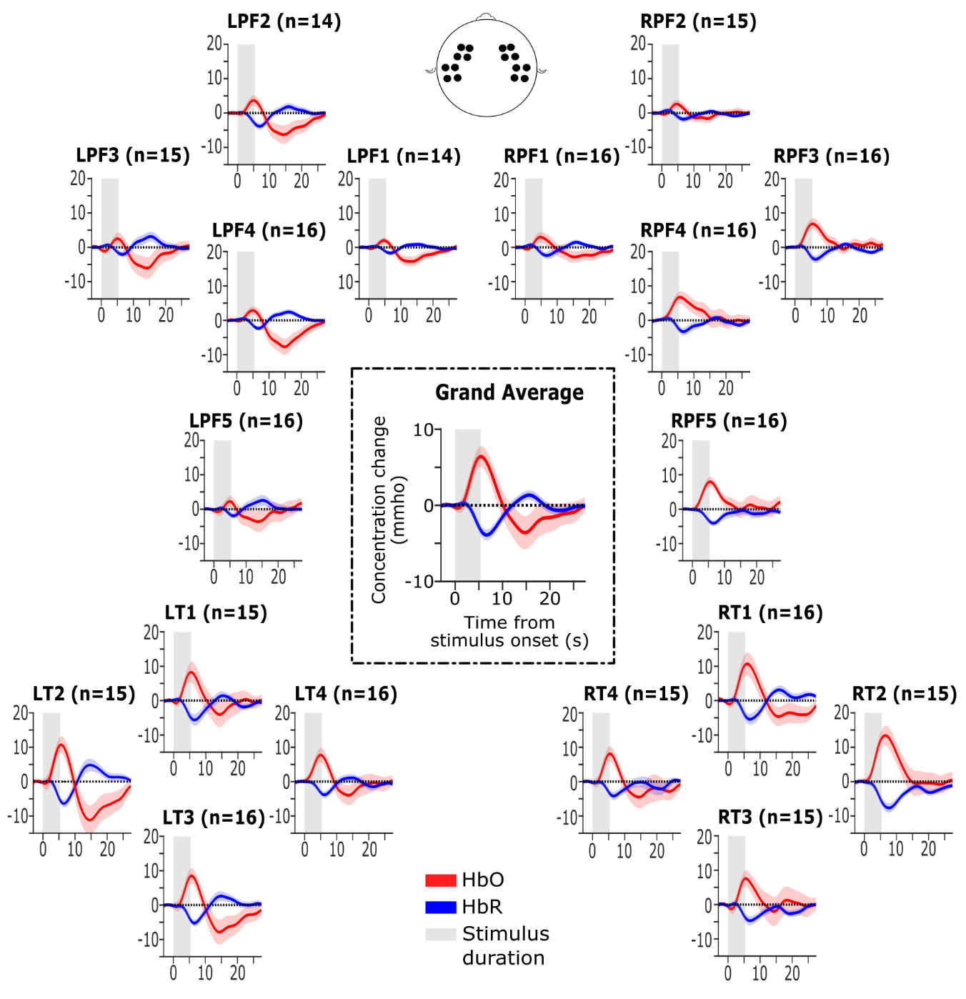
Extended Data Fig. 1. The group average fNIRS responses per channel. Epochs were averaged across trials and subjects for each channel. Each subplot title depicts the hemisphere, the regions of interest and the number of subjects included in the analysis (n). L = left, R = right, PF = pre-frontal, T= temporal. The number of subjects across channels was unequal because some subjects had one or more channels discarded due to a low SCI threshold. The subplot in the centre is the grand average fNIRS response across all trials, channels and participants. Shaded regions represent one standard error of mean (SEM).
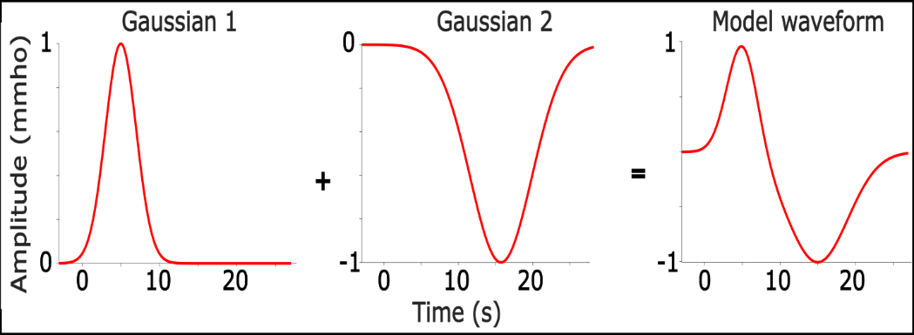
Extended Data Fig. 2 The model waveform as a summation of two Gaussian functions.

Extended Data Table 1. Initial values and bounds of the parameters used as inputs to the optimisation.
Parameters | Initial values |  | Bounds
Parameters | Gaussian $f_{1}$ | Gaussian $f_{2}$ | Bounds
Peak latency, $μ$ | 5 s | 10 s | [1, 20] s
Peak width, $σ$ | 2 | 2 | [1, 10]
Maximum possible amplitude, $A$ | 20 mmho | 20 mmho | [-100, 100] mmho
Decay, $τ$ | -0.2 | -0.2 | [-20, 20]
Contant, $C$ | 0 | 0 | [-100 100]

