SUPPLEMENTARY MATERIAL

Figure S1 – V4 16 S rRNA gene primer fusion sequences

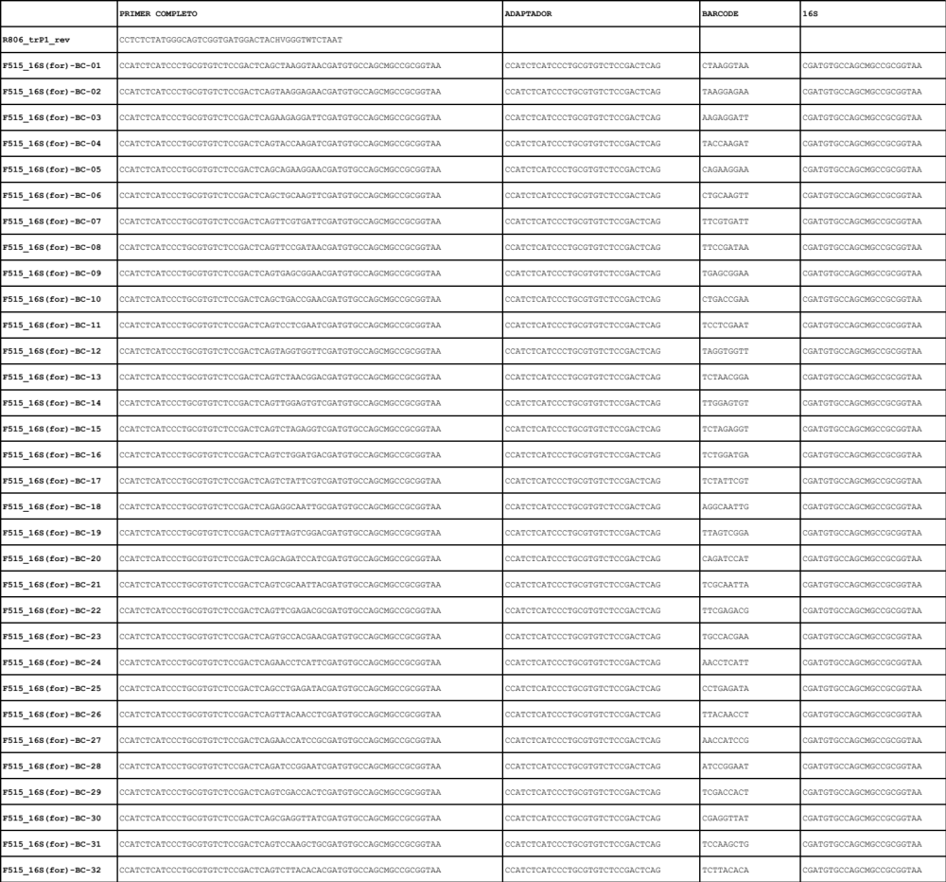

Figure S2 – Sample classification in CSTs

