Supplementary Material:
Fire-Smart Territories: a proof of concept based on Mosaico approach

Fernando Pulido, Javier Corbacho, Manuel Bertomeu, Álvaro Gómez, Nuno Guiomar, Enrique Juárez, Beatriz Lucas, Gerardo Moreno, Javier Navalpotro & Gonzalo Palomo

Table S1. Fuel models used in this study (from Rothermel 1972).
Group | Model | Description
Grass | 1 | Dried, short grass with complete ground cover. Scattered woody plants may be found on 1/3 of the area or less.  Fuel load (dry matter): 1–2 t/ha
Grass | 2 | Dried, short grass with complete ground cover.  Scattered woody plants covering from 1/3 to 2/3 of the area. Fire spread is still governed by herbaceous fuels.  Fuel load (dry matter): 5–10 t/ha.
Grass | 3 | Thick, dense, dried and tall grass (>1 m).  Scattered woody plants may be present.  Fuel load (dry matter): 4–6 t/ha.
Shrubs | 4 | Mature shrubs or dense plantations of young trees, with a height greater than 2 m.  Fire spread through the canopy layer.  Fuel load (dry matter): 25–35 t/ha.
Shrubs | 5 | Dense, live, short shrubs (<1 m).  Fire spread through leaf litter and grass layer.  Fuel load (dry matter): 5–8 t/ha.
Shrubs | 6 | Similar to model 5, but with more flammable species, or logging slash and taller plants.  Fire spread in conditions of moderate to strong wind.  Fuel load (dry matter): 10–15 t/ha.
Shrubs | 7 | Highly flammable shrubs, 0.5 to 2 m high, as an understory layer in conifer forest.  Fuel load (dry matter): 10–15 t/ha.
Timber litter | 8 | Dense forest, without shrub understory.  Fire spread through thick leaf litter.  Fuel load (dry matter): 10–12 t/ha
Timber litter | 9 | Similar to model 8, with less thick leaf litter of long needles or large leaves of broadleaves.  Fuel load (dry matter): 7–9 t/ha.
Timber litter | 10 | Forests with large quantities of dead biomass and fallen, dead trees due to perturbations (windstorm, pests, etc.).  Fuel load (dry matter): 30–35 t/ha.
Logging slash | 11 | Open forest intensively thinned. Pruning and thinning debris. Scattered debris from pruning and thinning, with resprouting herbaceous plants.  Fuel load (dry matter): 25–30 t/ha.
Logging slash | 12 | Biomass debris more abundant than trees.  Ground completely covered by pruning and thinning debris.  Fuel load (dry matter): 50–80 t/ha.
Logging slash | 13 | Ground completely covered by large amounts of heavy and thick biomass debris.  Fuel load (dry matter): 100–150 t/ha.
Table S2. Absolute frequency of transitions among fuel models in the three types of interventions (note that in some interventions the fuel model remains the same).

Agricultural interventions
Final model
Initial  model | 0 | 1 | 2 | 3 | 4 | 5 | 6 | 7 | 8 | 9
1 |  | 1
2 | 4 | 1 | 11
3
4 | 4 |  | 4
5 | 3
6
7 | 3 |  | 3
8
9
10
11
12 |  |  | 1
Forestry interventions
Final model
Initial model | 0 | 1 | 2 | 3 | 4 | 5 | 6 | 7 | 8 | 9
1
2
3
4 | 1
5 |  |  | 1
6
7 |  |  | 2 |  |  |  |  |  |  | 34
Livestock interventions
Final model
Initial model | 0 | 1 | 2 | 3 | 4 | 5 | 6 | 7 | 8 | 9
1 |  | 1
2 |  |  |  |  | 4
3
4 |  |  | 1 |  | 4 | 2
5 |  | 1 |  |  |  | 1
6 |  |  |  |  |  |  | 1
7 |  |  |  |  |  |  |  | 1 |  | 2
8
9 |  |  |  |  |  |  |  |  |  | 1

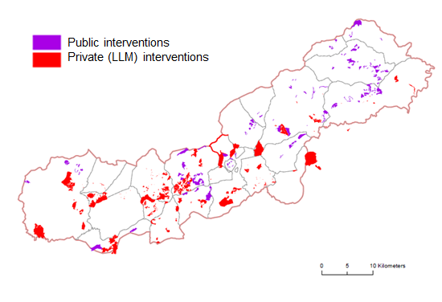

Figure S1. Comparative map of LLM (red) and public (purple) interventions (Scenario S2).
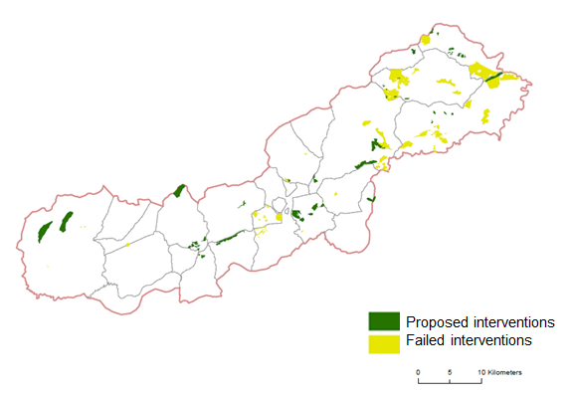

Figure S2. Map of interventions proposed by UEX (dark green) and failed interventions (pale green).

