Appendix A - Standard Feedback Cues

Goal: To transition the runner from a rearfoot strike pattern to a forefoot strike pattern and to increase their step rate 5-10% from baseline.
Foot Strike Pattern
Verbal Cues | Visual Cues | Visual Example
“Run on your toes (or “the balls”) of your feet” (Roper et al., 2016)  “Only put weight on the ball of your feet when you land” (Chow, Woo, & Koh, 2014)  “land softly,”  “Run quietly” (Helmhout et al., 2015; Moore et al., 2019)  “Run with a flat foot” (Moore, et al., 2019)  If necessary, subjects give detailed verbal instructions on how to accurately perform forefoot strike running, ie “change from heel strike to fore-foot strike” or “we are aiming to change foot strike, so run quietly” (Roper, et al., 2016) | Circle – point out foot-strike position  N/A  Degree – foot strike compared to the ground  Share video of runner with non-rearfoot strike pattern | 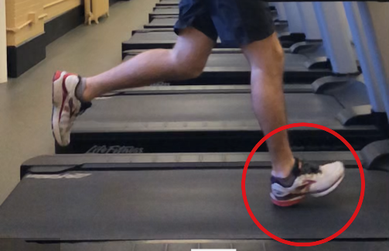  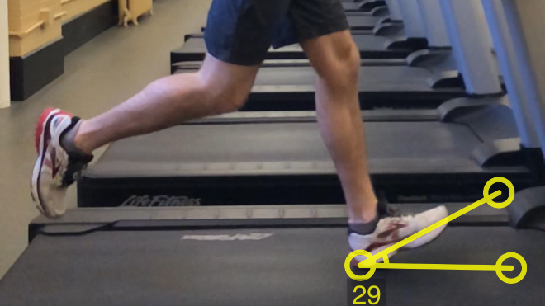
Step Rate
Verbal Cues | Visual Cues | Visual Example
“take shorter steps” (Helmhout, et al., 2015)  “take quicker steps” (Helmhout, et al., 2015) | Line(s) – center of mass to heel-strike  N/A | 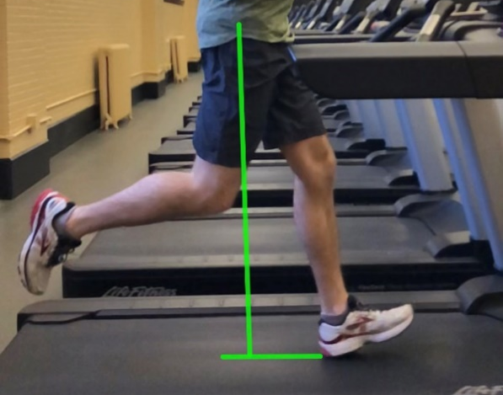

References

Chow, J. Y., Woo, M. T., & Koh, M. (2014). Effects of external and internal attention focus training on foot-strike patterns in running. International Journal of Sports Science & Coaching, 9(2), pp. 307-320.
Helmhout, P. H., Diebal, A. R., van der Kaaden, L., Harts, C. C., Beutler, A., & Zimmermann, W. O. (2015). The Effectiveness of a 6-Week Intervention Program Aimed at Modifying Running Style in Patients With Chronic Exertional Compartment Syndrome: Results From a Series of Case Studies. Orthopaedic Journal of Sports Medicine, 3(3), p 2325967115575691. doi:10.1177/2325967115575691 Retrieved from https://www.ncbi.nlm.nih.gov/pubmed/26665032
Moore, I. S., Phillips, D. J., Ashford, K. J., Mullen, R., Goom, T., & Gittoes, M. R. J. (2019). An interdisciplinary examination of attentional focus strategies used during running gait retraining. Scandinavian Journal of Medicine & Science in Sports, 29(10), pp. 1572-1582. doi:10.1111/sms.13490 Retrieved from https://www.ncbi.nlm.nih.gov/pubmed/31149751
Roper, J. L., Harding, E. M., Doerfler, D., Dexter, J. G., Kravitz, L., Dufek, J. S., & Mermier, C. M. (2016). The effects of gait retraining in runners with patellofemoral pain: A randomized trial. Clin Biomech (Bristol, Avon), 35, pp. 14-22. doi:10.1016/j.clinbiomech.2016.03.010 Retrieved from https://www.ncbi.nlm.nih.gov/pubmed/27111879

