Supplementary Data

 | Parameters | N total | Mean | SD | Median | Range
 |  |  |  |  |  | Minimum | Maximum
Characteristics of participants | Age (years) | 120 | 49.60 | 17.58 | 50.08 | 20.09 | 84.73
Characteristics of participants | Height (cm) | 120 | 170.70 | 8.91 | 169.55 | 149.00 | 191.80
Characteristics of participants | Weight (kg) | 120 | 78.13 | 13.62 | 77.80 | 54.10 | 114.10
Characteristics of participants | BMI (kg/m²) | 120 | 26.83 | 4.48 | 25.55 | 19.70 | 45.10
Characteristics of participants | Appendicular lean mass per height (ALM/height, kg/m) | 117 | 7.84 | 1.39 | 7.98 | 4.64 | 12.14
Characteristics of participants | Whole body BMD (g/cm²) | 116 | 1.11 | 0.15 | 1.11 | 0.77 | 1.43
Characteristics of participants | Spine BMD (g/cm²) | 117 | 1.09 | 0.17 | 1.09 | 0.68 | 1.45
Characteristics of participants | Femoral Neck BMD (g/cm²) | 117 | 0.89 | 0.17 | 0.85 | 0.55 | 1.35
Physical performance scales | Total SPPB score | 120 | 11.65 | 0.88 | 12.00 | 7.00 | 12.00
Physical performance scales | SPPB gait speed score | 120 | 3.99 | 0.09 | 4.00 | 3.00 | 4.00
Physical performance scales | Usual gait speed (m/s) | 120 | 1.40 | 0.18 | 1.40 | 0.74 | 2.00
Physical performance scales | Fast gait speed (m/s) | 120 | 2.05 | 0.34 | 2.05 | 1.01 | 3.28
Physical performance scales | Best Grip Strength (kg) | 120 | 34.53 | 12.80 | 34.85 | 6.60 | 63.00
Physical performance scales | Time for 5 chair stands (s) | 120 | 8.87 | 2.96 | 8.08 | 2.13 | 19.77
Physical performance scales | 6-min walk test (m) | 117 | 569.62 | 109.81 | 580.00 | 160.00 | 969.00
Physical performance scales | PROMIS score | 120 | 56.42 | 7.27 | 54.70 | 40.40 | 73.30
Physical performance scales | SF-36 PFS raw score | 120 | 92.96 | 12.79 | 100.00 | 20.00 | 100.00

Supplementary Table 1. Demographics and Characteristics of 120 white non-Hispanic individuals (aged 20–85 years) recruited from the ICMH-Clinical Research Center FitCore Program.

 | Variables | Physical performance levels | Pearson Correlations |  |  |  |  |  |  |  |  |  |  |  |  |  | Spearman Rank Correlations
 | Variables | Physical performance levels | Female |  |  |  |  |  | Male |  |  |  |  |  |  |  | Female |  |  |  |  |  |  |  | Male
 | Variables | Physical performance levels | N | Age |  | BMI |  |  | N | Age |  | BMI |  |  |  |  | N | Age |  | BMI |  |  |  |  |  |  | N |  | Age |  |  | BMI
 |  |  |  | r | p-value | r | p-value |  |  | r | p-value | r | p-value |  |  |  |  | ρ | p-value | ρ | p-value |  |  |  |  |  |  | ρ |  | p-value | ρ |  | p-value
Physical performance scales | Total SPPB score | Overall | 60 |  |  |  |  |  | 60 | -0.3410 | 0.0077 |  |  |  |  | 60 |  |  |  |  |  |  |  |  |  | 60 |  | -0.3449 |  | 0.0070
Physical performance scales | Total SPPB score | HP | 20 |  |  |  |  |  | 20 |  |  |  |  |  |  | 20 |  |  |  |  |  |  |  |  |  | 20
Physical performance scales | Total SPPB score | AP | 20 | -0.3969 | 0.0831 |  |  |  | 20 |  |  |  |  |  |  | 20 |  |  |  |  |  |  |  |  |  | 20
Physical performance scales | Total SPPB score | LP | 20 |  |  |  |  |  | 20 | -0.5467 | 0.0126 |  |  |  |  | 20 |  |  |  |  |  |  |  |  |  | 20 |  | -0.6754 |  | 0.0011
Physical performance scales | Usual gait speed | Overall | 60 | -0.2486 | 0.0554 | -0.2457 | 0.0585 |  | 60 | -0.2316 | 0.0749 | -0.2624 | 0.0428 |  |  | 60 |  | -0.2345 | 0.0713 | -0.2780 | 0.0315 |  |  |  |  | 60
Physical performance scales | Usual gait speed | HP | 20 | -0.3944 | 0.0853 |  |  |  | 20 |  |  | -0.5913 | 0.0060 |  |  | 20 |  | -0.4018 | 0.0791 |  |  |  |  |  |  | 20 |  |  |  |  | -0.5158 |  | 0.0199
Physical performance scales | Usual gait speed | AP | 20 |  |  |  |  |  | 20 |  |  |  |  |  |  | 20 |  |  |  |  |  |  |  |  |  | 20
Physical performance scales | Usual gait speed | LP | 20 |  |  |  |  |  | 20 | -0.3899 | 0.0892 |  |  |  |  | 20 |  |  |  |  |  |  |  |  |  | 20 |  | -0.4039 |  | 0.0774
Physical performance scales | SPPB gait speed score | Overall | 60 | . | . | . | . |  | 60 |  |  |  |  |  |  | 60 |  | . | . | . | . |  |  |  |  | 60
Physical performance scales | SPPB gait speed score | HP | 20 | . | . | . | . |  | 20 |  |  |  |  |  |  | 20 |  | . | . | . | . |  |  |  |  | 20
Physical performance scales | SPPB gait speed score | AP | 20 | . | . | . | . |  | 20 |  |  |  |  |  |  | 20 |  | . | . | . | . |  |  |  |  | 20
Physical performance scales | SPPB gait speed score | LP | 20 | . | . | . | . |  | 20 |  |  |  |  |  |  | 20 |  | . | . | . | . |  |  |  |  | 20
Physical performance scales | Fast gait speed | Overall | 60 | -0.3779 | 0.0029 | -0.2709 | 0.0363 |  | 60 | -0.3426 | 0.0074 |  |  |  |  | 60 |  | -0.3848 | 0.0024 | -0.3414 | 0.0076 |  |  |  |  | 60 |  | -0.2998 |  | 0.0199
Physical performance scales | Fast gait speed | HP | 20 | -0.3973 | 0.0828 |  |  |  | 20 |  |  |  |  |  |  | 20 |  |  |  |  |  |  |  |  |  | 20
Physical performance scales | Fast gait speed | AP | 20 | -0.5843 | 0.0068 |  |  |  | 20 |  |  |  |  |  |  | 20 |  | -0.6138 | 0.0040 | -0.5121 | 0.0210 |  |  |  |  | 20
Physical performance scales | Fast gait speed | LP | 20 |  |  |  |  |  | 20 | -0.4027 | 0.0784 |  |  |  |  | 20 |  |  |  |  |  |  |  |  |  | 20 |  | -0.4808 |  | 0.0319
Physical performance scales | Best Grip Strength | Overall | 60 | -0.2290 | 0.0784 | -0.2712 | 0.0361 |  | 60 | -0.4865 | <.0001 |  |  |  |  | 60 |  | -0.2420 | 0.0625 | -0.2865 | 0.0265 |  |  |  |  | 60 |  | -0.4736 |  | 0.0001
Physical performance scales | Best Grip Strength | HP | 20 | -0.6538 | 0.0018 |  |  |  | 20 | -0.8234 | <.0001 |  |  |  |  | 20 |  | -0.5950 | 0.0057 |  |  |  |  |  |  | 20 |  | -0.8071 |  | <.0001
Physical performance scales | Best Grip Strength | AP | 20 | -0.9287 | <.0001 |  |  |  | 20 | -0.7926 | <.0001 |  |  |  |  | 20 |  | -0.9214 | <.0001 |  |  |  |  |  |  | 20 |  | -0.7695 |  | <.0001
Physical performance scales | Best Grip Strength | LP | 20 |  |  |  |  |  | 20 | -0.5214 | 0.0184 | -0.4339 | 0.0559 |  |  | 20 |  |  |  | -0.3857 | 0.0931 |  |  |  |  | 20 |  | -0.4842 |  | 0.0305
Physical performance scales | Time for 5 chair stands | Overall | 60 | 0.2167 | 0.0964 |  |  |  | 60 | 0.2890 | 0.0251 |  |  |  |  | 60 |  | 0.2321 | 0.0744 | 0.2372 | 0.0680 |  |  |  |  | 60 |  | 0.2226 |  | 0.0874
Physical performance scales | Time for 5 chair stands | HP | 20 |  |  |  |  |  | 20 | 0.4782 | 0.0329 |  |  |  |  | 20 |  | 0.4105 | 0.0722 |  |  |  |  |  |  | 20 |  | 0.4355 |  | 0.0549
Physical performance scales | Time for 5 chair stands | AP | 20 | 0.6797 | 0.0010 |  |  |  | 20 |  |  |  |  |  |  | 20 |  | 0.6662 | 0.0013 |  |  |  |  |  |  | 20
Physical performance scales | Time for 5 chair stands | LP | 20 |  |  |  |  |  | 20 | 0.4004 | 0.0802 |  |  |  |  | 20 |  |  |  |  |  |  |  |  |  | 20 |  | 0.4301 |  | 0.0584
Physical performance scales | RCS 30s | Overall | 60 | -0.2931 | 0.0230 | -0.2165 | 0.0966 |  | 60 | -0.3028 | 0.0187 |  |  |  |  | 60 |  | -0.2878 | 0.0258 | -0.2433 | 0.0610 |  |  |  |  | 60 |  | -0.2910 |  | 0.0241
Physical performance scales | RCS 30s | HP | 20 | -0.5277 | 0.0168 |  |  |  | 20 | -0.5376 | 0.0145 |  |  |  |  | 20 |  | -0.6012 | 0.0050 |  |  |  |  |  |  | 20 |  | -0.5884 |  | 0.0064
Physical performance scales | RCS 30s | AP | 20 | -0.8209 | <.0001 |  |  |  | 20 | -0.5602 | 0.0102 |  |  |  |  | 20 |  | -0.8326 | <.0001 |  |  |  |  |  |  | 20 |  | -0.6623 |  | 0.0015
Physical performance scales | RCS 30s | LP | 20 |  |  |  |  |  | 20 |  |  |  |  |  |  | 20 |  |  |  |  |  |  |  |  |  | 20 |  | -0.3800 |  | 0.0984
Physical performance scales | 6 min walk test | Overall | 59 | -0.3053 | 0.0187 | -0.3288 | 0.0110 |  | 58 | -0.4509 | 0.0004 | -0.3290 | 0.0117 |  |  | 59 |  | -0.3011 | 0.0205 | -0.3433 | 0.0078 |  |  |  |  | 58 |  | -0.4570 |  | 0.0003 | -0.3035 |  | 0.0205
Physical performance scales | 6 min walk test | HP | 20 | -0.5211 | 0.0185 | -0.4498 | 0.0466 |  | 19 | -0.4631 | 0.0459 |  |  |  |  | 20 |  | -0.4331 | 0.0565 |  |  |  |  |  |  | 19 |  | -0.5088 |  | 0.0261
Physical performance scales | 6 min walk test | AP | 20 |  |  |  |  |  | 19 | -0.5639 | 0.0119 | -0.6478 | 0.0027 |  |  | 20 |  |  |  |  |  |  |  |  |  | 19 |  | -0.4860 |  | 0.0349 | -0.5645 |  | 0.0118
Physical performance scales | 6 min walk test | LP | 19 |  |  |  |  |  | 20 | -0.4062 | 0.0755 |  |  |  |  | 19 |  |  |  |  |  |  |  |  |  | 20 |  | -0.4541 |  | 0.0443
Physical performance scales | PROMIS score | Overall | 60 | -0.3830 | 0.0025 |  |  |  | 60 | -0.4693 | 0.0002 | -0.2829 | 0.0285 |  |  | 60 |  | -0.3877 | 0.0022 |  |  |  |  |  |  | 60 |  | -0.4240 |  | 0.0007 | -0.2383 |  | 0.0667
Physical performance scales | PROMIS score | HP | 20 | -0.3814 | 0.0971 |  |  |  | 20 | -0.6848 | 0.0009 |  |  |  |  | 20 |  |  |  |  |  |  |  |  |  | 20 |  | -0.6898 |  | 0.0008
Physical performance scales | PROMIS score | AP | 20 | -0.4326 | 0.0568 |  |  |  | 20 | -0.4271 | 0.0603 |  |  |  |  | 20 |  | -0.4005 | 0.0802 |  |  |  |  |  |  | 20
Physical performance scales | PROMIS score | LP | 20 | -0.4087 | 0.0736 |  |  |  | 20 | -0.4422 | 0.0509 | -0.4645 | 0.0391 |  |  | 20 |  | -0.4144 | 0.0692 |  |  |  |  |  |  | 20 |  | -0.4155 |  | 0.0685 | -0.4164 |  | 0.0678
Physical performance scales | SF36 PFS raw score | Overall | 60 | -0.5103 | <.0001 | -0.2172 | 0.0955 |  | 60 | -0.5011 | <.0001 | -0.3132 | 0.0148 |  |  | 60 |  | -0.4905 | <.0001 | -0.2212 | 0.0894 |  |  |  |  | 60 |  | -0.5087 |  | <.0001 | -0.2604 |  | 0.0445
Physical performance scales | SF36 PFS raw score | HP | 20 |  |  | -0.5478 | 0.0124 |  | 20 | -0.5636 | 0.0097 |  |  |  |  | 20 |  | -0.3812 | 0.0973 |  |  |  |  |  |  | 20 |  | -0.5669 |  | 0.0091 | -0.4378 |  | 0.0535
Physical performance scales | SF36 PFS raw score | AP | 20 | -0.6831 | 0.0009 |  |  |  | 20 | -0.4827 | 0.0311 |  |  |  |  | 20 |  | -0.7353 | 0.0002 |  |  |  |  |  |  | 20 |  | -0.3840 |  | 0.0946
Physical performance scales | SF36 PFS raw score | LP | 20 | -0.4552 | 0.0437 |  |  |  | 20 | -0.6112 | 0.0042 | -0.4448 | 0.0494 |  |  | 20 |  |  |  |  |  |  |  |  |  | 20 |  | -0.7080 |  | 0.0005 | -0.5080 |  | 0.0222
BMD values | Total BMD | Overall | 56 | -0.2961 | 0.0267 | 0.3071 | 0.0213 |  | 60 | -0.3989 | 0.0016 |  |  |  |  | 56 |  | -0.2545 | 0.0583 | 0.3413 | 0.0101 |  |  |  |  | 60 |  | -0.4132 |  | 0.0010
BMD values | Total BMD | HP | 18 | -0.6507 | 0.0035 |  |  |  | 20 | -0.4174 | 0.0671 |  |  |  |  | 18 |  | -0.4781 | 0.0448 |  |  |  |  |  |  | 20 |  | -0.3949 |  | 0.0849
BMD values | Total BMD | AP | 20 |  |  |  |  |  | 20 |  |  |  |  |  |  | 20 |  |  |  |  |  |  |  |  |  | 20
BMD values | Total BMD | LP | 18 |  |  | 0.4620 | 0.0536 |  | 20 | -0.4238 | 0.0626 |  |  |  |  | 18 |  |  |  | 0.5196 | 0.0271 |  |  |  |  | 20 |  | -0.5243 |  | 0.0176
BMD values | Spine BMD | Overall | 57 | -0.2357 | 0.0775 |  |  |  | 60 |  |  | 0.2168 | 0.0961 |  |  | 57 |  | -0.2554 | 0.0552 |  |  |  |  |  |  | 60
BMD values | Spine BMD | HP | 19 | -0.5703 | 0.0108 |  |  |  | 20 |  |  |  |  |  |  | 19 |  | -0.5450 | 0.0158 |  |  |  |  |  |  | 20
BMD values | Spine BMD | AP | 20 |  |  |  |  |  | 20 |  |  |  |  |  |  | 20 |  |  |  |  |  |  |  |  |  | 20
BMD values | Spine BMD | LP | 18 |  |  |  |  |  | 20 |  |  | 0.3996 | 0.0809 |  |  | 18 |  |  |  |  |  |  |  |  |  | 20
BMD values | Femoral Neck BMD | Overall | 57 | -0.6350 | <.0001 |  |  |  | 60 | -0.5738 | <.0001 |  |  |  |  | 57 |  | -0.6843 | <.0001 |  |  |  |  |  |  | 60 |  | -0.5113 |  | <.0001
BMD values | Femoral Neck BMD | HP | 19 | -0.6550 | 0.0023 |  |  |  | 20 | -0.5835 | 0.0069 | -0.3794 | 0.0990 |  |  | 19 |  | -0.7000 | 0.0008 |  |  |  |  |  |  | 20 |  | -0.4453 |  | 0.0491 | -0.4304 |  | 0.0582
BMD values | Femoral Neck BMD | AP | 20 | -0.6890 | 0.0008 |  |  |  | 20 | -0.7356 | 0.0002 |  |  |  |  | 20 |  | -0.7368 | 0.0002 |  |  |  |  |  |  | 20 |  | -0.6807 |  | 0.0010
BMD values | Femoral Neck BMD | LP | 18 | -0.5720 | 0.0131 |  |  |  | 20 | -0.4354 | 0.0550 |  |  |  |  | 18 |  | -0.6409 | 0.0042 |  |  |  |  |  |  | 20 |  | -0.4105 |  | 0.0722
Lean/fat mass | Total Lean Mass | Overall | 57 | -0.3639 | 0.0054 | 0.3643 | 0.0053 |  | 60 |  |  | 0.3563 | 0.0052 |  |  | 57 |  | -0.3830 | 0.0033 | 0.3360 | 0.0106 |  |  |  |  | 60 |  | -0.2604 |  | 0.0445 | 0.3342 |  | 0.0091
Lean/fat mass | Total Lean Mass | HP | 19 |  |  | 0.6121 | 0.0053 |  | 20 |  |  |  |  |  |  | 19 |  |  |  | 0.6655 | 0.0019 |  |  |  |  | 20
Lean/fat mass | Total Lean Mass | AP | 20 | -0.5918 | 0.0060 |  |  |  | 20 |  |  | 0.7306 | 0.0003 |  |  | 20 |  | -0.5383 | 0.0143 |  |  |  |  |  |  | 20 |  |  |  |  | 0.6629 |  | 0.0014
Lean/fat mass | Total Lean Mass | LP | 18 |  |  | 0.4585 | 0.0556 |  | 20 |  |  |  |  |  |  | 18 |  |  |  | 0.4407 | 0.0672 |  |  |  |  | 20
Lean/fat mass | Total Fat Mass | Overall | 57 | 0.2381 | 0.0745 | 0.8731 | <.0001 |  | 60 | 0.3956 | 0.0018 | 0.8537 | <.0001 |  |  | 57 |  | 0.2482 | 0.0627 | 0.8316 | <.0001 |  |  |  |  | 60 |  | 0.3938 |  | 0.0019 | 0.8370 |  | <.0001
Lean/fat mass | Total Fat Mass | HP | 19 |  |  | 0.8485 | <.0001 |  | 20 | 0.4741 | 0.0347 | 0.8191 | <.0001 |  |  | 19 |  |  |  | 0.7234 | 0.0005 |  |  |  |  | 20 |  | 0.4331 |  | 0.0565 | 0.7845 |  | <.0001
Lean/fat mass | Total Fat Mass | AP | 20 | 0.5002 | 0.0247 | 0.8394 | <.0001 |  | 20 |  |  | 0.8090 | <.0001 |  |  | 20 |  | 0.4090 | 0.0733 | 0.8402 | <.0001 |  |  |  |  | 20 |  |  |  |  | 0.9082 |  | <.0001
Lean/fat mass | Total Fat Mass | LP | 18 |  |  | 0.9553 | <.0001 |  | 20 | 0.6268 | 0.0031 | 0.9304 | <.0001 |  |  | 18 |  |  |  | 0.9298 | <.0001 |  |  |  |  | 20 |  | 0.6632 |  | 0.0014 | 0.8528 |  | <.0001
Lean/fat mass | Total Fat Percent | Overall | 57 | 0.3822 | 0.0033 | 0.6147 | <.0001 |  | 60 | 0.4764 | 0.0001 | 0.5639 | <.0001 |  |  | 57 |  | 0.3534 | 0.0070 | 0.6596 | <.0001 |  |  |  |  | 60 |  | 0.5062 |  | <.0001 | 0.6682 |  | <.0001
Lean/fat mass | Total Fat Percent | HP | 19 |  |  | 0.7337 | 0.0004 |  | 20 | 0.5095 | 0.0218 | 0.6979 | 0.0006 |  |  | 19 |  |  |  | 0.6037 | 0.0062 |  |  |  |  | 20 |  | 0.5122 |  | 0.0209 | 0.7359 |  | 0.0002
Lean/fat mass | Total Fat Percent | AP | 20 | 0.6743 | 0.0011 |  |  |  | 20 |  |  |  |  |  |  | 20 |  | 0.5744 | 0.0081 | 0.5175 | 0.0194 |  |  |  |  | 20 |  |  |  |  | 0.4650 |  | 0.0388
Lean/fat mass | Total Fat Percent | LP | 18 |  |  | 0.8787 | <.0001 |  | 20 | 0.7046 | 0.0005 | 0.8374 | <.0001 |  |  | 18 |  |  |  | 0.9195 | <.0001 |  |  |  |  | 20 |  | 0.6702 |  | 0.0012 | 0.8614 |  | <.0001

Pearson correlations (r) and Spearman Rank correlations (ρ) with p-value < 0.1 are shown in the Table.

Supplementary Table 2. Pearson and Spearman correlations for age/BMI with different physical performance scales, BMD values, and lean/fat mass in humans.

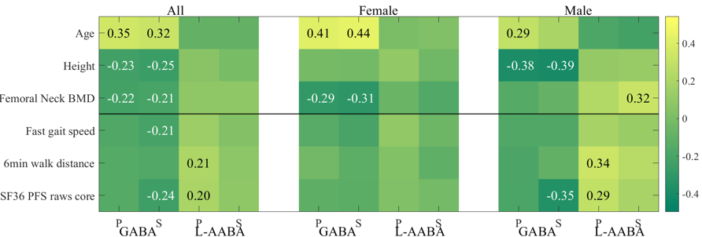

Supplementary Figure 1. Heatmaps of correlations of the GABA and L-AABA in 120 white non-Hispanic individuals (aged 20–85 years) with different gender.

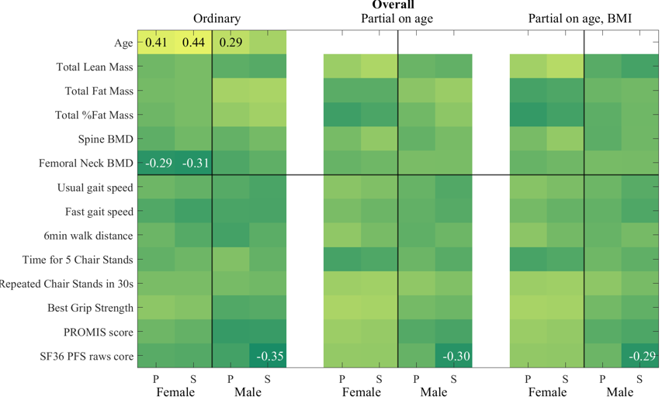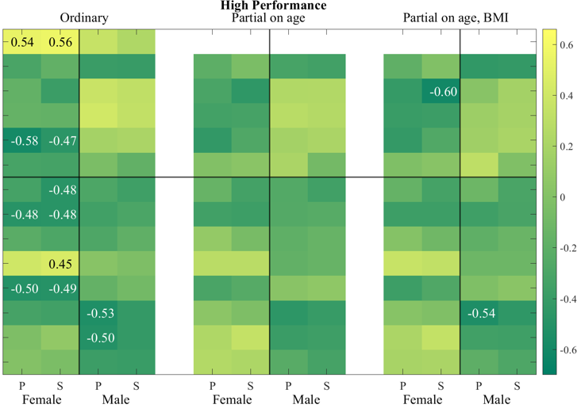
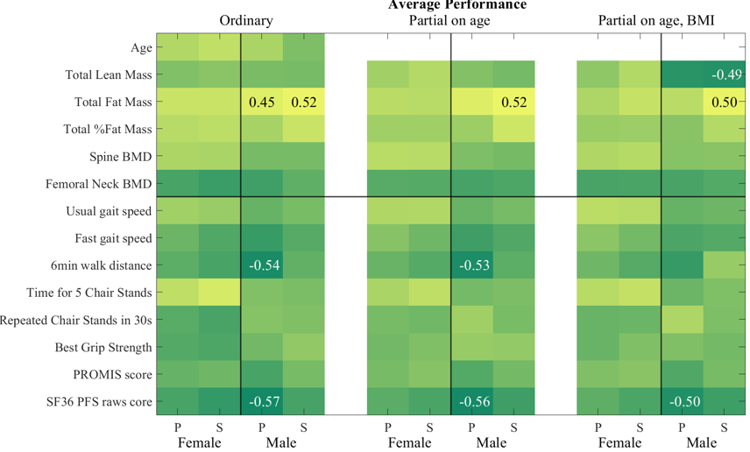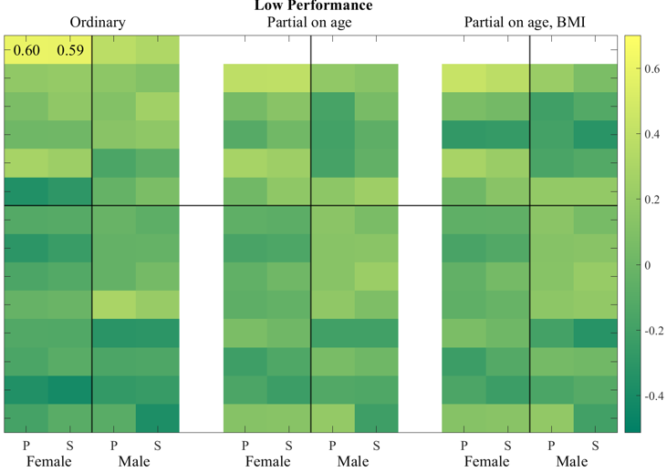
GABA
Supplementary Figure 2. Heatmaps of GABA associations with age and after controlling the effects of age and BMI, in overall (120 samples), HP, AP and LP groups.

