Supporting Information

Sensing of Disinfection Byproducts; An Iodo-Functionalized Metal–Organic Framework as a Platform

Vahid Amani,*ª Fataneh Norouzi^{b}
ªDepartment of Chemistry, Farhangian University, Tehran, Iran
E-mail: v_amani2002@yahoo.com, v.amani@cfu.ac.ir
^{b}Department of Inorganic Chemistry and Catalysis, Shahid Beheshti University, General Campus, Evin, Tehran 1983963113, Iran

Title | page
PL spectra of (a) UiO-67 and (b) UiO-67(I)2 upon excitation of 320 nm. | 2
PL spectra of UiO-67 upon addition of 10⁻⁴ solution of pyridine in DMF. | 2
PL spectra of UiO-67(I)₂ upon addition of 10⁻⁴ solution of pyridine in DMF. | 3
PL spectra of UiO-67 upon addition of 10⁻⁴ solution of aniline in DMF. | 3
PL spectra of UiO-67(I)₂ upon addition of 10⁻⁴ solution of aniline in DMF. | 4

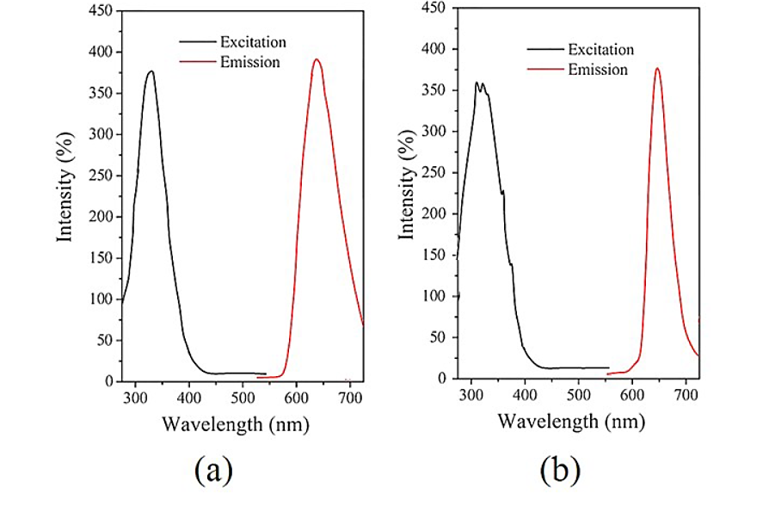
Figure S1. PL spectra of (a) UiO-67 and (b) UiO-67(I)2 upon excitation of 320 nm.

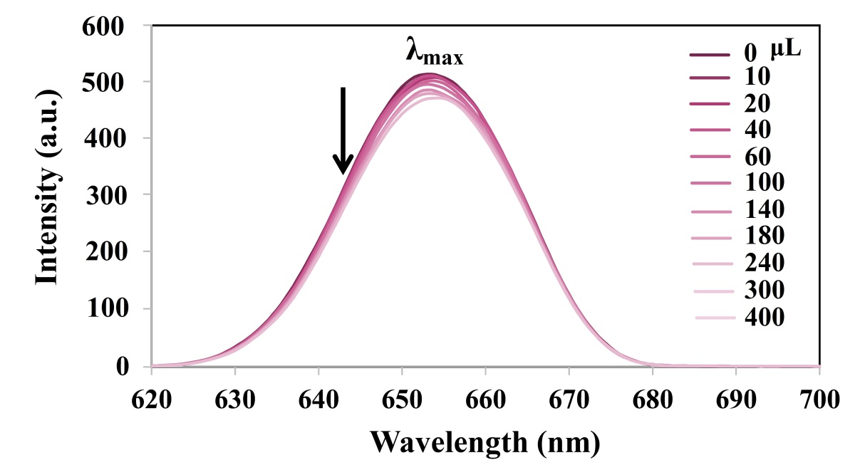
Figure S2. PL spectra of UiO-67 upon addition of 10⁻⁴ solution of pyridine in
DMF.

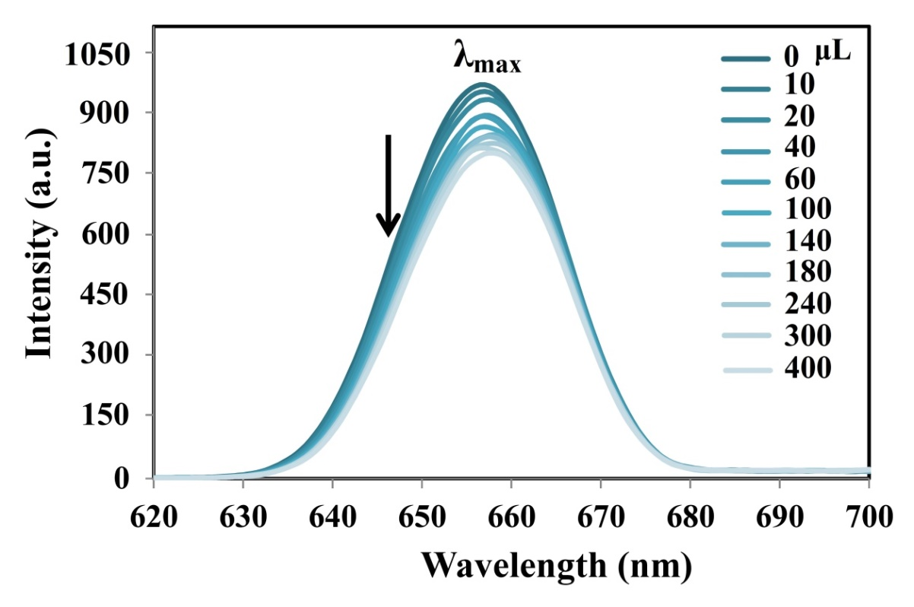
Figure S3. PL spectra of UiO-67(I)₂ upon addition of 10⁻⁴ solution of pyridine in
DMF.
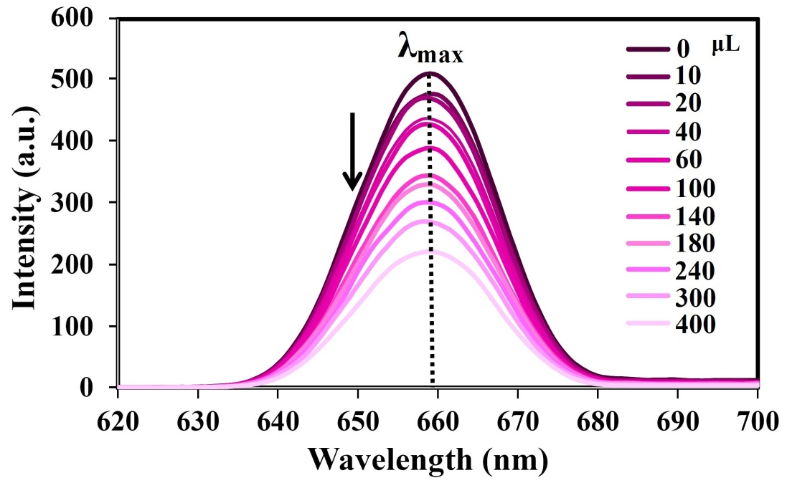
Figure S4. PL spectra of UiO-67 upon addition of 10⁻⁴ solution of aniline in
DMF.

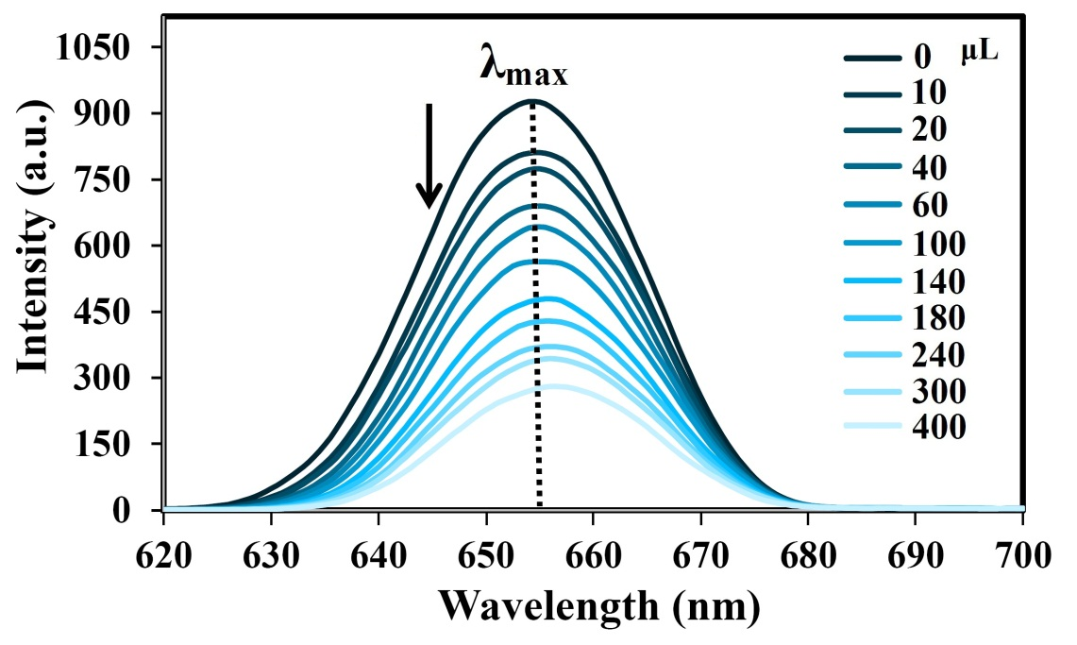
Figure S5. PL spectra of UiO-67(I)₂ upon addition of 10⁻⁴ solution of aniline in
DMF.

