Supplement – Tables
Supplement Table S1: Model for predictors of mortality using logistic regression model based on a-priori variables
Covariate | Coefficient  (Confidence Interval) | P.Value
(Intercept) | -2.1 (-11.41 - 7.21) | 0.700
Age | 0.06 (0.03 - 0.1) | <0.001*
Female | -1 (-2 - -0.2) | 0.015*
Nonwhite | 0.04 (-0.8 - 0.9) | 0.919
Body mass index | -0.03 (-0.09 - 0.03) | 0.341
Initial oxygen saturation | -0.02 (-0.11 - 0.07) | 0.638
Smoking | 0.02 (-0.74 - 0.8) | 1.000
Hypertension | 0.3 (-0.6 - 1.13) | 0.522
Chronic obstructive pulmonary disease | 0.4 (-0.43 - 1.16) | 0.400
Myocardial infarction | 0.02 (-1.1 - 1.14) | 1.000
Immunocompromised | 0.92 (-0.03 - 2) | 0.060
Mean creatinine | 0.1 (-0.07 - 0.3) | 0.228
Mean Renalase | -1e-04 (-2e-04 - -3e-05) | 0.004*
Mean IL-6 | -1e-04 (-3e-04 - 1e-04) | 0.400
Time of sample | -9e-04 (-0.05 - 0.05) | 1.000
- Statistically significant with P value <0.05

Supplement Table S2: Model for predictors of mortality using backward step logistic regression model
Covariate | Coefficient  (Confidence Interval) | P.Value
Minimum oxygen saturation | 0.2 (0.05 - 0.3) | 0.003*
Standard deviation of oxygen saturation | 4 (2 - 6) | <0.001*
Initial sodium | -0.4 (-0.8 - 0.04) | 0.074
Initial chloride | 0.41 (0.02 - 0.8) | 0.040*
Initial estimated glomerular filtration rate | 0.2 (0.04 - 0.33) | 0.014*
Initial fibrinogen | -0.005 (-0.01 - 0.003) | 0.243
Median BNP | -6e-04 (-0.001 - -2e-04) | 0.006*
Mean hemoglobin | 2.21 (0.8 - 4) | 0.003*
Mean platelet count | -0.02 (-0.03 - -0.003) | 0.013*
Mean Blood urea nitrogen | 0.2 (0.05 - 0.31) | 0.007*
Mean procalcitonin | 0.7 (-0.07 - 1.37) | 0.074
Mean troponin t | 34.03 (8.11 - 60) | 0.010*
Mean Renalase | -3e-04 (-5e-04 - -7e-05) | 0.009*
Mean High-Sensitivity Troponin | -0.03 (-0.06 - -0.01) | 0.013*
Mean Interleukin-6 | -4e-04 (-0.001 - 8e-04) | 0.515
Mean diastolic blood pressure | -0.09 (-0.2 - 0.01) | 0.080
Gastrointestinal symptoms at presentation | -2.05 (-4.41 - 0.32) | 0.090
- P value <0.05

Supplement Table S3: Profile of patients hospitalized with COVID-19 with 3 or more samples

Factor | Total (n=437) | Patients with 2 or fewer samples (n=309) | Patients with 3 or more samples  (n=128)
Demographics
Age; mean (SD) | 63.8 (17.0) | 64.1 (16.8) | 63.3 (17.6)
Male; n (%) | 233 (53.3%) | 157 (50.8%) | 76 (59.4%)
BMI; mean (SD) | 30.1 (7.6) | 30.0 (7.4) | 30.2 (8.1)
Race; n (%)  White  Black  Other | 228 (52.2%)  132 (30.2%)  77 (17.6%) | 161 (52.1%)  95 (30.7%)  53 (17.2%) | 67 (52.3%)  37 (28.9%)  24 (18.8%)
Clinical Course
Hospital length of stay; mean (SD) | 16.2 (13.7) | 14.3 (12.5) | 21.0 (15.2)
ICU Admission; n (%) | 167 (38.2%) | 97 (31.4%) | 70 (54.7%)
Follow-up in days; mean (SD) | 72.0 (61.0) | 71.5 (61.6) | 73.2 (59.8)

Supplemental Figure S1A: Comparison of BNP and Renalase Quartiles
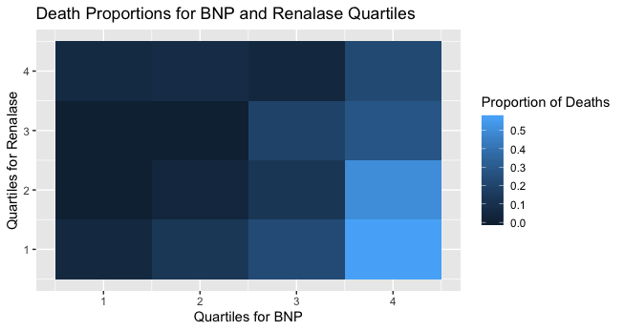
Supplemental Figure 1B: Comparison of High Sensitivity Troponin and Renalase Quartiles
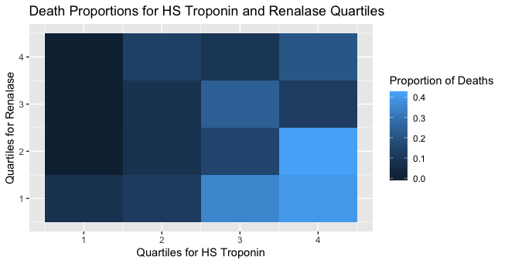
Supplemental Figure S1C: Comparison of Interleukin-6 and Renalase Quartiles
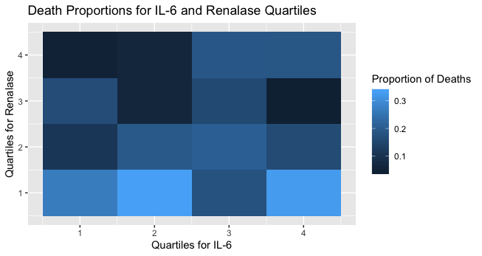
Supplemental Figure S1D: Comparison of Interleukin-1 and Renalase Quartiles
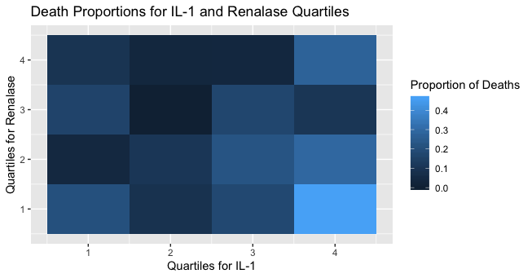

Supplemental Figure S1E: Comparison of Interferon and Renalase Quartiles
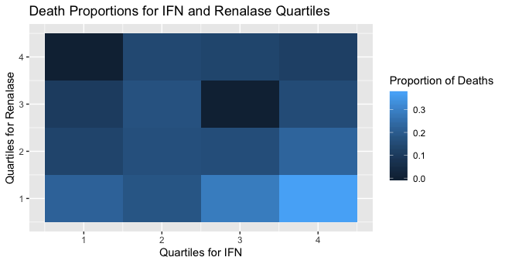
Supplemental Figure S1F: Comparison of Platelet Counts and Renalase Quartiles
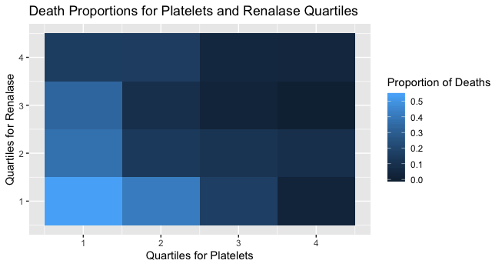

Supplement Figure S2: Calibration Plot for the Models
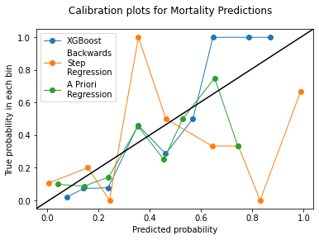

Supplement Table S4 – New Metrics
Method | Train PR-AUC | Validation PR-AUC | Test PR-AUC
A Priori Logistic Regression | 0.56 | 0.21 | 0.37
Backwards Step Logistic Regression | 0.94 | 0.55 | 0.56
XGBoost | 0.98 | 0.97 | 0.74

Supplement Table S5 – List of Variables Removed
- The following is a list of variables where 35% or more values were missing.
- C-reactive protein first value
- C-reactive protein value closest to the sample
- Troponin I first value
- Troponin I value closest to the sample
- Troponin I minimum value
- Troponin I maximum value
- Troponin I median value
- AC Ratio Urine maximum value
- AC Ratio Urine median value
- AC Ratio Urine mean value
- AC Ratio Urine minimum value
- Standard deviation of AC Ratio Urine values
- AC Ratio Urine first value
- Standard deviation of BNP values
- BNPPOC first value
- BNPPOC last value
- 25th Percentile of cortisol levels
- 75th Percentile of cortisol levels
- Cortisol first value
- Cortisol last value
- Cortisol maximum value
- Cortisol mean value
- Cortisol median value
- Cortisol minimum value
- Standard deviation of cortisol values
- 25th Percentile of ejection fraction values
- 75th Percentile of ejection fraction values
- Ejection fraction first value
- Ejection fraction last value
- Ejection fraction maximum value
- Ejection fraction mean value
- Ejection fraction median value
- Ejection fraction minimum value
- Standard deviation of ejection fraction values
- Length of stay in the ICU
- Time in the hospital

