The L-enantiomer of β- aminobutyric acid (L-BAIBA) as a potential marker of bone mineral density, body mass index, while D-BAIBA of physical performance and age.
Authors:
Charalampos Lyssikatos. MD^{1,┼}, Zhiying Wang PhD^{2,┼}, Ziyue Liu PhD, BMED^{1,3}, Stuart J. Warden PT, PhD, FACSM, FASBMR^{1,4}, Marco Brotto, BSN, MPharm, PhD², Lynda Bonewald PhD^{1*}
¹Indiana Center for Musculoskeletal Health, Indiana University School of Medicine, Indianapolis, IN, USA
²Bone-Muscle Research Center, College of Nursing and Health Innovation, University of Texas-Arlington, Arlington, TX, USA
³Department of Biostatistics and Health Data Science, Indiana University School of Medicine,
Indianapolis, IN, USA
⁴Department of Physical Therapy, School of Health and Human Sciences, Indiana University, Indianapolis, IN, USA

Supplemental figure 1. Heatmap of D- and L- BAIBA after the age and BMI effect was removed in A all 120 samples, 60 females and 60 males, age 20- 85. and Β in the subgroups (LP, AP, HP)

A.
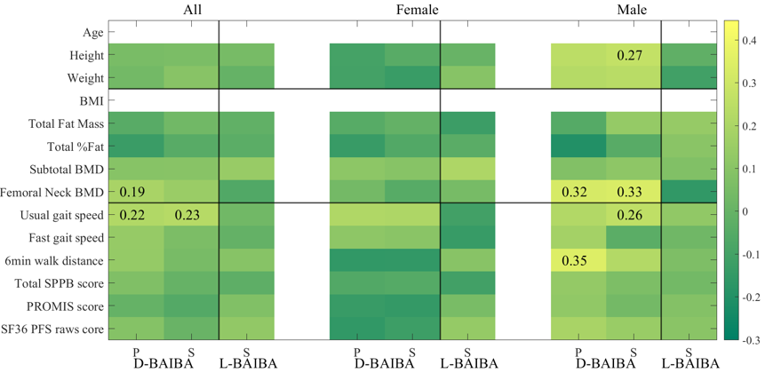
B.
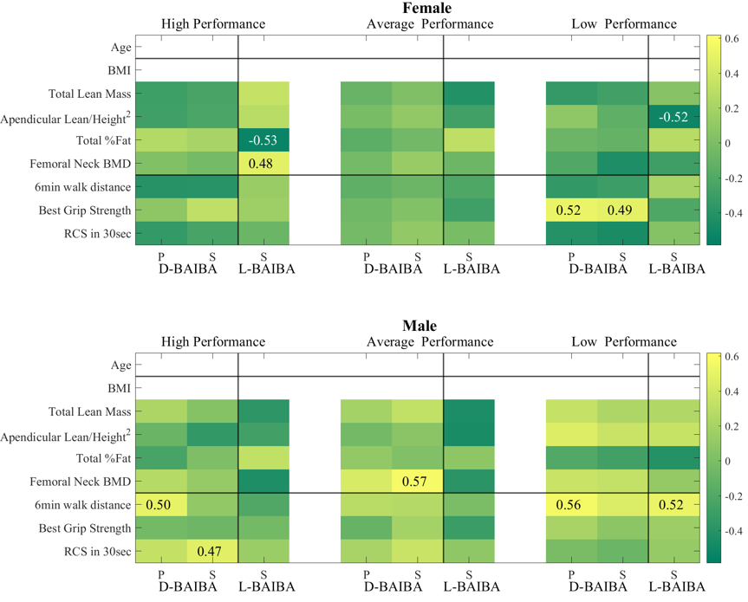
Supplementary tables:
Table S1. Characteristics on separate groups by performance (low, average, high).
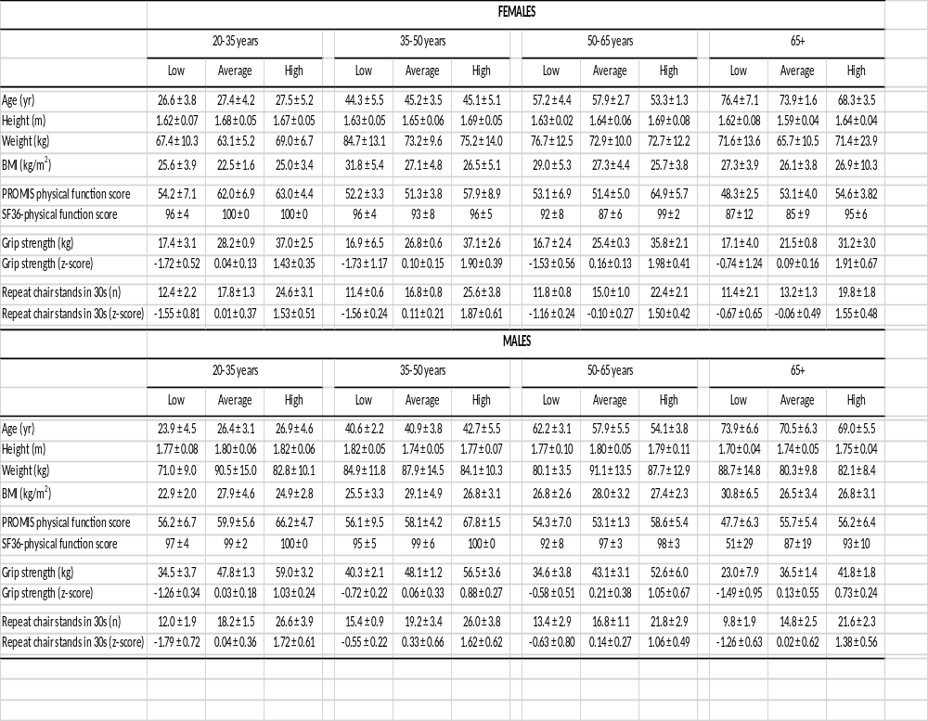

Table S2. Characteristics on performance (high, average, low) groups, gender (female, male) and by age with gender group.
  - High performance group
Label | N | Mean | SD | Median | Min | Max
Age (years) | 40 | 48.13 | 15.88 | 50.08 | 20.25 | 78.07
Height (cm) | 40 | 172.59 | 8.68 | 170.70 | 158.60 | 191.80
Weight (kg) | 40 | 78.14 | 13.65 | 75.90 | 54.10 | 113.50
BMI (kg/m²) | 40 | 26.25 | 4.52 | 25.20 | 19.70 | 45.10
Appendicular lean/height² (kg/m²) | 39 | 8.20 | 1.33 | 8.25 | 5.10 | 10.94
Total BMD (g/cm²) | 38 | 1.15 | 0.15 | 1.16 | 0.77 | 1.43
Spine BMD (g/cm²) | 39 | 1.09 | 0.17 | 1.12 | 0.68 | 1.40
Femoral Neck BMD (g/cm²) | 39 | 0.91 | 0.16 | 0.90 | 0.61 | 1.30
Total SPPB score | 40 | 12.00 | 0.00 | 12.00 | 12.00 | 12.00
SPPB gait speed score | 40 | 4.00 | 0.00 | 4.00 | 4.00 | 4.00
Usual gait speed (m/s) | 40 | 1.45 | 0.18 | 1.46 | 1.08 | 2.00
Fast gait speed (m/s) | 40 | 2.26 | 0.30 | 2.26 | 1.72 | 3.28
Best Grip Strength (kg) | 40 | 43.86 | 10.49 | 39.80 | 28.30 | 63.00
Time for 5 chair stands (s) | 40 | 6.21 | 1.12 | 6.27 | 2.13 | 7.84
6-min walk distance (m) | 39 | 627.49 | 92.98 | 632.00 | 427.00 | 969.00
PROMIS score | 40 | 61.14 | 6.83 | 60.90 | 48.50 | 73.30
SF-36 PFS raw score | 40 | 97.63 | 5.06 | 100.00 | 75.00 | 100.00

  - Average
 | N | Mean | SD | Median | Min | Max
Age (years) | 40 | 50.03 | 17.53 | 49.59 | 22.84 | 81.14
Height (cm) | 40 | 170.37 | 8.91 | 169.80 | 153.80 | 189.20
Weight (kg) | 40 | 78.09 | 14.71 | 77.85 | 57.50 | 114.10
BMI (kg/m²) | 40 | 26.81 | 4.05 | 25.90 | 21.00 | 35.50
Appendicular lean/height² (kg/m²) | 40 | 7.81 | 1.54 | 7.80 | 5.12 | 12.14
Total BMD (g/cm²) | 40 | 1.10 | 0.14 | 1.11 | 0.84 | 1.38
Spine BMD (g/cm²) | 40 | 1.12 | 0.17 | 1.13 | 0.79 | 1.41
Femoral Neck BMD (g/cm²) | 40 | 0.90 | 0.18 | 0.86 | 0.60 | 1.35
Total SPPB score | 40 | 11.85 | 0.58 | 12.00 | 9.00 | 12.00
SPPB gait speed score | 40 | 4.00 | 0.00 | 4.00 | 4.00 | 4.00
Usual gait speed (m/s) | 40 | 1.41 | 0.17 | 1.44 | 1.10 | 1.66
Fast gait speed (m/s) | 40 | 2.05 | 0.27 | 2.06 | 1.52 | 2.74
Best Grip Strength (kg) | 40 | 34.69 | 10.21 | 32.20 | 20.90 | 51.50
Time for 5 chair stands (s) | 40 | 8.55 | 1.54 | 8.25 | 5.28 | 12.38
6-min walk distance (m) | 39 | 561.82 | 80.40 | 566.00 | 367.00 | 700.00
PROMIS score | 40 | 55.36 | 5.72 | 54.70 | 47.70 | 73.30
SF-36 PFS raw score | 40 | 93.00 | 9.66 | 95.00 | 55.00 | 100.00

  - Low
 | N | Mean | SD | Median | Min | Max
Age (years) | 40 | 50.64 | 19.49 | 49.96 | 20.09 | 84.73
Height (cm) | 40 | 169.13 | 9.03 | 167.25 | 149.00 | 187.10
Weight (kg) | 40 | 78.16 | 12.77 | 79.40 | 58.10 | 113.70
BMI (kg/m²) | 40 | 27.44 | 4.86 | 26.30 | 20.50 | 41.50
Appendicular lean/height² (kg/m²) | 38 | 7.52 | 1.24 | 7.60 | 4.64 | 10.05
Total BMD (g/cm²) | 38 | 1.07 | 0.14 | 1.08 | 0.83 | 1.43
Spine BMD (g/cm²) | 38 | 1.06 | 0.17 | 1.04 | 0.74 | 1.45
Femoral Neck BMD (g/cm²) | 38 | 0.84 | 0.15 | 0.83 | 0.55 | 1.19
Total SPPB score | 40 | 10.83 | 2.15 | 12.00 | 0.00 | 12.00
SPPB gait speed score | 40 | 3.98 | 0.16 | 4.00 | 3.00 | 4.00
Usual gait speed (m/s) | 40 | 1.32 | 0.18 | 1.33 | 0.74 | 1.89
Fast gait speed (m/s) | 40 | 1.83 | 0.31 | 1.86 | 1.01 | 2.45
Best Grip Strength (kg) | 40 | 25.05 | 10.19 | 21.80 | 6.60 | 43.00
Time for 5 chair stands (s) | 40 | 11.86 | 2.56 | 11.23 | 7.39 | 19.77
6-min walk distance (m) | 39 | 519.54 | 125.01 | 540.00 | 160.00 | 872.00
PROMIS score | 40 | 52.75 | 6.65 | 51.60 | 40.40 | 68.80
SF-36 PFS raw score | 40 | 88.25 | 18.31 | 95.00 | 20.00 | 100.00

  - Female
 | N | Mean | SD | Median | Min | Max
Age (years) | 60 | 50.25 | 17.34 | 50.10 | 20.25 | 84.30
Height (cm) | 60 | 164.38 | 5.75 | 164.70 | 149.00 | 178.50
Weight (kg) | 60 | 71.98 | 12.59 | 67.05 | 54.10 | 113.50
BMI (kg/m²) | 60 | 26.73 | 5.05 | 25.15 | 19.70 | 45.10
Appendicular lean/height² (kg/m²) | 57 | 6.97 | 1.06 | 6.95 | 4.64 | 9.03
Total BMD (g/cm²) | 56 | 1.05 | 0.14 | 1.05 | 0.77 | 1.35
Spine BMD (g/cm²) | 57 | 1.09 | 0.17 | 1.09 | 0.68 | 1.43
Femoral Neck BMD (g/cm²) | 57 | 0.87 | 0.16 | 0.84 | 0.60 | 1.26
Total SPPB score | 60 | 11.67 | 0.68 | 12.00 | 9.00 | 12.00
SPPB gait speed score | 60 | 4.00 | 0.00 | 4.00 | 4.00 | 4.00
Usual gait speed (m/s) | 60 | 1.38 | 0.16 | 1.38 | 1.10 | 1.78
Fast gait speed (m/s) | 60 | 1.97 | 0.28 | 1.90 | 1.41 | 2.55
Best Grip Strength (kg) | 60 | 25.91 | 8.22 | 25.95 | 6.60 | 39.90
Time for 5 chair stands (s) | 60 | 9.08 | 2.89 | 8.79 | 2.13 | 16.01
6-min walk distance (m) | 59 | 543.22 | 80.51 | 555.00 | 348.00 | 713.00
PROMIS score | 60 | 55.50 | 7.11 | 54.70 | 44.50 | 73.30
SF-36 PFS raw score | 60 | 93.83 | 7.67 | 95.00 | 70.00 | 100.00

  - Male
 | N | Mean | SD | Median | Min | Max
Age (years) | 60 | 48.95 | 17.94 | 49.65 | 20.09 | 84.73
Height (cm) | 60 | 177.01 | 6.79 | 177.00 | 165.10 | 191.80
Weight (kg) | 60 | 84.28 | 11.77 | 83.70 | 61.60 | 114.10
BMI (kg/m²) | 60 | 26.94 | 3.87 | 26.05 | 20.50 | 41.50
Appendicular lean/height² (kg/m²) | 60 | 8.67 | 1.15 | 8.67 | 6.45 | 12.14
Total BMD (g/cm²) | 60 | 1.16 | 0.14 | 1.15 | 0.89 | 1.43
Spine BMD (g/cm²) | 60 | 1.10 | 0.16 | 1.09 | 0.74 | 1.45
Femoral Neck BMD (g/cm²) | 60 | 0.90 | 0.17 | 0.87 | 0.55 | 1.35
Total SPPB score | 60 | 11.45 | 1.83 | 12.00 | 0.00 | 12.00
SPPB gait speed score | 60 | 3.98 | 0.13 | 4.00 | 3.00 | 4.00
Usual gait speed (m/s) | 60 | 1.41 | 0.20 | 1.43 | 0.74 | 2.00
Fast gait speed (m/s) | 60 | 2.13 | 0.38 | 2.14 | 1.01 | 3.28
Best Grip Strength (kg) | 60 | 43.15 | 10.57 | 43.20 | 10.80 | 63.00
Time for 5 chair stands (s) | 60 | 8.66 | 3.03 | 7.82 | 4.42 | 19.77
6-min walk distance (m) | 58 | 596.47 | 128.41 | 613.00 | 160.00 | 969.00
PROMIS score | 60 | 57.33 | 7.38 | 56.20 | 40.40 | 70.30
SF-36 PFS raw score | 60 | 92.08 | 16.42 | 100.00 | 20.00 | 100.00
  - By gender and age group
Gender | Age | Measurement | N | Mean | SD | Median | Min | Max
Female | 20-34 | Age (years) | 15 | 27.18 | 4.11 | 26.78 | 20.25 | 34.68
Female | 20-34 | Height (cm) | 15 | 165.48 | 5.74 | 165.80 | 156.00 | 173.50
Female | 20-34 | Weight (kg) | 15 | 66.53 | 7.60 | 64.10 | 58.50 | 79.50
Female | 20-34 | BMI (kg/m²) | 15 | 24.37 | 3.20 | 23.20 | 21.00 | 32.00
Female | 20-34 | Appendicular lean/height² (kg/m²) | 15 | 7.12 | 1.07 | 7.06 | 5.10 | 8.83
Female | 20-34 | Total BMD (g/cm²) | 15 | 1.07 | 0.15 | 1.04 | 0.86 | 1.35
Female | 20-34 | Spine BMD (g/cm²) | 15 | 1.10 | 0.14 | 1.09 | 0.84 | 1.34
Female | 20-34 | Femoral Neck BMD (g/cm²) | 15 | 0.99 | 0.16 | 0.99 | 0.78 | 1.26
Female | 20-34 | Total SPPB score | 15 | 11.73 | 0.59 | 12.00 | 10.00 | 12.00
Female | 20-34 | SPPB gait speed score | 15 | 4.00 | 0.00 | 4.00 | 4.00 | 4.00
Female | 20-34 | Usual gait speed (m/s) | 15 | 1.47 | 0.13 | 1.47 | 1.28 | 1.75
Female | 20-34 | Fast gait speed (m/s) | 15 | 2.09 | 0.26 | 2.09 | 1.52 | 2.52
Female | 20-34 | Best Grip Strength (kg) | 15 | 27.52 | 8.56 | 28.20 | 13.40 | 39.70
Female | 20-34 | Time for 5 chair stands (s) | 15 | 8.70 | 3.20 | 7.57 | 4.95 | 16.01
Female | 20-34 | 6-min walk distance (m) | 15 | 568.00 | 87.06 | 566.00 | 348.00 | 700.00
Female | 20-34 | PROMIS score | 15 | 59.75 | 7.09 | 60.40 | 44.50 | 73.30
Female | 20-34 | SF-36 PFS raw score | 15 | 98.67 | 2.97 | 100.00 | 90.00 | 100.00
Female | 35-49 | Age (years) | 15 | 44.84 | 4.45 | 46.81 | 35.04 | 49.05
Female | 35-49 | Height (cm) | 15 | 165.66 | 5.47 | 166.60 | 155.80 | 175.50
Female | 35-49 | Weight (kg) | 15 | 77.72 | 12.58 | 81.00 | 58.20 | 97.00
Female | 35-49 | BMI (kg/m²) | 15 | 28.48 | 5.35 | 29.50 | 20.40 | 37.20
Female | 35-49 | Appendicular lean/height² (kg/m²) | 13 | 7.36 | 0.92 | 7.52 | 5.66 | 9.03
Female | 35-49 | Total BMD (g/cm²) | 13 | 1.11 | 0.12 | 1.16 | 0.91 | 1.26
Female | 35-49 | Spine BMD (g/cm²) | 13 | 1.23 | 0.12 | 1.21 | 0.96 | 1.43
Female | 35-49 | Femoral Neck BMD (g/cm²) | 13 | 0.94 | 0.14 | 0.92 | 0.75 | 1.19
Female | 35-49 | Total SPPB score | 15 | 11.67 | 0.62 | 12.00 | 10.00 | 12.00
Female | 35-49 | SPPB gait speed score | 15 | 4.00 | 0.00 | 4.00 | 4.00 | 4.00
Female | 35-49 | Usual gait speed (m/s) | 15 | 1.34 | 0.22 | 1.28 | 1.10 | 1.78
Female | 35-49 | Fast gait speed (m/s) | 15 | 1.97 | 0.28 | 1.93 | 1.52 | 2.52
Female | 35-49 | Best Grip Strength (kg) | 15 | 26.91 | 9.35 | 26.60 | 6.60 | 39.90
Female | 35-49 | Time for 5 chair stands (s) | 15 | 8.55 | 3.24 | 7.95 | 2.13 | 13.79
Female | 35-49 | 6-min walk distance (m) | 15 | 546.80 | 96.45 | 510.00 | 394.00 | 713.00
Female | 35-49 | PROMIS score | 15 | 53.79 | 6.25 | 52.10 | 48.20 | 73.30
Female | 35-49 | SF-36 PFS raw score | 15 | 95.00 | 5.98 | 95.00 | 80.00 | 100.00
Female | 50-64 | Age (years) | 15 | 56.13 | 3.53 | 55.95 | 51.16 | 62.61
Female | 50-64 | Height (cm) | 15 | 164.92 | 5.77 | 163.30 | 155.50 | 178.50
Female | 50-64 | Weight (kg) | 15 | 74.09 | 10.93 | 69.70 | 59.90 | 90.90
Female | 50-64 | BMI (kg/m²) | 15 | 27.33 | 4.42 | 26.70 | 20.90 | 35.50
Female | 50-64 | Appendicular lean/height² (kg/m²) | 15 | 6.93 | 1.26 | 6.77 | 4.64 | 8.98
Female | 50-64 | Total BMD (g/cm²) | 15 | 1.07 | 0.11 | 1.10 | 0.86 | 1.22
Female | 50-64 | Spine BMD (g/cm²) | 15 | 1.01 | 0.16 | 0.99 | 0.79 | 1.38
Female | 50-64 | Femoral Neck BMD (g/cm²) | 15 | 0.83 | 0.14 | 0.80 | 0.63 | 1.19
Female | 50-64 | Total SPPB score | 15 | 11.87 | 0.35 | 12.00 | 11.00 | 12.00
Female | 50-64 | SPPB gait speed score | 15 | 4.00 | 0.00 | 4.00 | 4.00 | 4.00
Female | 50-64 | Usual gait speed (m/s) | 15 | 1.34 | 0.15 | 1.33 | 1.15 | 1.64
Female | 50-64 | Fast gait speed (m/s) | 15 | 1.99 | 0.32 | 1.90 | 1.41 | 2.55
Female | 50-64 | Best Grip Strength (kg) | 15 | 25.95 | 8.23 | 25.30 | 14.10 | 38.20
Female | 50-64 | Time for 5 chair stands (s) | 15 | 9.17 | 2.30 | 9.44 | 5.02 | 12.06
Female | 50-64 | 6-min walk distance (m) | 14 | 549.71 | 69.86 | 561.50 | 412.00 | 658.00
Female | 50-64 | PROMIS score | 15 | 56.47 | 8.29 | 54.70 | 47.70 | 73.30
Female | 50-64 | SF-36 PFS raw score | 15 | 92.67 | 7.29 | 95.00 | 80.00 | 100.00
Female | 65+ | Age (years) | 15 | 72.86 | 5.54 | 73.43 | 65.04 | 84.30
Female | 65+ | Height (cm) | 15 | 161.46 | 5.54 | 162.70 | 149.00 | 167.50
Female | 65+ | Weight (kg) | 15 | 69.58 | 15.96 | 63.80 | 54.10 | 113.50
Female | 65+ | BMI (kg/m²) | 15 | 26.75 | 6.26 | 24.90 | 19.70 | 45.10
Female | 65+ | Appendicular lean/height² (kg/m²) | 14 | 6.50 | 0.82 | 6.43 | 5.17 | 8.25
Female | 65+ | Total BMD (g/cm²) | 13 | 0.96 | 0.13 | 0.93 | 0.77 | 1.24
Female | 65+ | Spine BMD (g/cm²) | 14 | 1.03 | 0.18 | 1.02 | 0.68 | 1.33
Female | 65+ | Femoral Neck BMD (g/cm²) | 14 | 0.73 | 0.08 | 0.74 | 0.60 | 0.87
Female | 65+ | Total SPPB score | 15 | 11.40 | 0.99 | 12.00 | 9.00 | 12.00
Female | 65+ | SPPB gait speed score | 15 | 4.00 | 0.00 | 4.00 | 4.00 | 4.00
Female | 65+ | Usual gait speed (m/s) | 15 | 1.37 | 0.13 | 1.36 | 1.11 | 1.58
Female | 65+ | Fast gait speed (m/s) | 15 | 1.82 | 0.19 | 1.78 | 1.54 | 2.27
Female | 65+ | Best Grip Strength (kg) | 15 | 23.27 | 6.69 | 21.20 | 10.70 | 35.70
Female | 65+ | Time for 5 chair stands (s) | 15 | 9.90 | 2.84 | 9.87 | 5.82 | 15.72
Female | 65+ | 6-min walk distance (m) | 15 | 508.80 | 58.78 | 496.00 | 408.00 | 612.00
Female | 65+ | PROMIS score | 15 | 51.99 | 4.26 | 51.60 | 45.00 | 60.90
Female | 65+ | SF-36 PFS raw score | 15 | 89.00 | 9.86 | 90.00 | 70.00 | 100.00
Male | 20-34 | Age (years) | 15 | 25.77 | 4.07 | 24.26 | 20.09 | 31.70
Male | 20-34 | Height (cm) | 15 | 179.73 | 6.67 | 178.70 | 165.10 | 191.80
Male | 20-34 | Weight (kg) | 15 | 81.45 | 13.61 | 77.40 | 61.60 | 111.10
Male | 20-34 | BMI (kg/m²) | 15 | 25.16 | 3.78 | 24.40 | 20.50 | 35.50
Male | 20-34 | Appendicular lean/height² (kg/m²) | 15 | 8.78 | 1.23 | 9.15 | 6.45 | 10.35
Male | 20-34 | Total BMD (g/cm²) | 15 | 1.20 | 0.09 | 1.18 | 1.08 | 1.43
Male | 20-34 | Spine BMD (g/cm²) | 15 | 1.12 | 0.15 | 1.15 | 0.83 | 1.34
Male | 20-34 | Femoral Neck BMD (g/cm²) | 15 | 1.06 | 0.21 | 1.07 | 0.63 | 1.35
Male | 20-34 | Total SPPB score | 15 | 11.87 | 0.52 | 12.00 | 10.00 | 12.00
Male | 20-34 | SPPB gait speed score | 15 | 4.00 | 0.00 | 4.00 | 4.00 | 4.00
Male | 20-34 | Usual gait speed (m/s) | 15 | 1.41 | 0.18 | 1.42 | 1.10 | 1.68
Male | 20-34 | Fast gait speed (m/s) | 15 | 2.22 | 0.43 | 2.17 | 1.42 | 3.28
Male | 20-34 | Best Grip Strength (kg) | 15 | 47.09 | 10.73 | 46.70 | 30.30 | 63.00
Male | 20-34 | Time for 5 chair stands (s) | 15 | 8.45 | 2.83 | 8.15 | 4.42 | 15.72
Male | 20-34 | 6-min walk distance (m) | 15 | 659.60 | 138.25 | 665.00 | 296.00 | 969.00
Male | 20-34 | PROMIS score | 15 | 60.74 | 6.82 | 59.70 | 50.00 | 70.30
Male | 20-34 | SF-36 PFS raw score | 15 | 98.67 | 2.97 | 100.00 | 90.00 | 100.00
Male | 35-49 | Age (years) | 15 | 40.86 | 3.62 | 39.17 | 35.59 | 48.18
Male | 35-49 | Height (cm) | 15 | 177.76 | 6.52 | 178.80 | 166.50 | 187.50
Male | 35-49 | Weight (kg) | 15 | 85.64 | 11.53 | 85.30 | 66.80 | 105.70
Male | 35-49 | BMI (kg/m²) | 15 | 27.15 | 3.88 | 26.10 | 20.90 | 35.20
Male | 35-49 | Appendicular lean/height² (kg/m²) | 15 | 8.72 | 1.44 | 8.64 | 6.55 | 12.14
Male | 35-49 | Total BMD (g/cm²) | 15 | 1.22 | 0.15 | 1.28 | 0.95 | 1.40
Male | 35-49 | Spine BMD (g/cm²) | 15 | 1.04 | 0.15 | 1.08 | 0.74 | 1.41
Male | 35-49 | Femoral Neck BMD (g/cm²) | 15 | 0.87 | 0.10 | 0.89 | 0.70 | 1.05
Male | 35-49 | Total SPPB score | 15 | 12.00 | 0.00 | 12.00 | 12.00 | 12.00
Male | 35-49 | SPPB gait speed score | 15 | 4.00 | 0.00 | 4.00 | 4.00 | 4.00
Male | 35-49 | Usual gait speed (m/s) | 15 | 1.51 | 0.24 | 1.49 | 1.08 | 2.00
Male | 35-49 | Fast gait speed (m/s) | 15 | 2.23 | 0.27 | 2.27 | 1.67 | 2.67
Male | 35-49 | Best Grip Strength (kg) | 15 | 48.33 | 7.37 | 48.50 | 37.20 | 61.40
Male | 35-49 | Time for 5 chair stands (s) | 15 | 7.25 | 1.61 | 7.74 | 4.51 | 9.35
Male | 35-49 | 6-min walk distance (m) | 15 | 615.67 | 95.42 | 616.00 | 427.00 | 872.00
Male | 35-49 | PROMIS score | 15 | 60.09 | 7.95 | 60.70 | 44.90 | 70.30
Male | 35-49 | SF-36 PFS raw score | 15 | 97.00 | 4.93 | 100.00 | 85.00 | 100.00
Male | 50-64 | Age (years) | 15 | 58.03 | 5.23 | 59.40 | 51.12 | 64.96
Male | 50-64 | Height (cm) | 15 | 177.39 | 7.87 | 178.00 | 165.40 | 188.10
Male | 50-64 | Weight (kg) | 15 | 86.31 | 11.21 | 84.20 | 69.40 | 114.10
Male | 50-64 | BMI (kg/m²) | 15 | 27.39 | 2.56 | 26.50 | 24.30 | 33.20
Male | 50-64 | Appendicular lean/height² (kg/m²) | 15 | 8.75 | 1.04 | 8.56 | 6.77 | 10.94
Male | 50-64 | Total BMD (g/cm²) | 15 | 1.13 | 0.15 | 1.13 | 0.89 | 1.43
Male | 50-64 | Spine BMD (g/cm²) | 15 | 1.13 | 0.14 | 1.10 | 0.94 | 1.40
Male | 50-64 | Femoral Neck BMD (g/cm²) | 15 | 0.86 | 0.09 | 0.85 | 0.70 | 1.01
Male | 50-64 | Total SPPB score | 15 | 11.67 | 0.90 | 12.00 | 9.00 | 12.00
Male | 50-64 | SPPB gait speed score | 15 | 4.00 | 0.00 | 4.00 | 4.00 | 4.00
Male | 50-64 | Usual gait speed (m/s) | 15 | 1.40 | 0.13 | 1.40 | 1.24 | 1.60
Male | 50-64 | Fast gait speed (m/s) | 15 | 2.15 | 0.30 | 2.06 | 1.77 | 2.74
Male | 50-64 | Best Grip Strength (kg) | 15 | 43.42 | 8.66 | 43.90 | 28.80 | 62.00
Male | 50-64 | Time for 5 chair stands (s) | 15 | 8.83 | 2.47 | 7.96 | 5.37 | 15.73
Male | 50-64 | 6-min walk distance (m) | 14 | 597.00 | 62.60 | 598.00 | 447.00 | 700.00
Male | 50-64 | PROMIS score | 15 | 55.31 | 5.36 | 54.00 | 47.00 | 64.30
Male | 50-64 | SF-36 PFS raw score | 15 | 95.67 | 5.63 | 95.00 | 80.00 | 100.00
Male | 65+ | Age (years) | 15 | 71.14 | 6.09 | 70.10 | 65.19 | 84.73
Male | 65+ | Height (cm) | 15 | 173.17 | 4.54 | 173.70 | 165.60 | 180.80
Male | 65+ | Weight (kg) | 15 | 83.71 | 11.16 | 82.60 | 67.30 | 113.70
Male | 65+ | BMI (kg/m²) | 15 | 28.04 | 4.72 | 27.60 | 21.80 | 41.50
Male | 65+ | Appendicular lean/height² (kg/m²) | 15 | 8.44 | 0.90 | 8.16 | 7.16 | 10.05
Male | 65+ | Total BMD (g/cm²) | 15 | 1.08 | 0.12 | 1.05 | 0.91 | 1.35
Male | 65+ | Spine BMD (g/cm²) | 15 | 1.09 | 0.21 | 1.07 | 0.77 | 1.45
Male | 65+ | Femoral Neck BMD (g/cm²) | 15 | 0.79 | 0.11 | 0.79 | 0.55 | 0.98
Male | 65+ | Total SPPB score | 15 | 10.27 | 3.31 | 12.00 | 0.00 | 12.00
Male | 65+ | SPPB gait speed score | 15 | 3.93 | 0.26 | 4.00 | 3.00 | 4.00
Male | 65+ | Usual gait speed (m/s) | 15 | 1.33 | 0.23 | 1.36 | 0.74 | 1.63
Male | 65+ | Fast gait speed (m/s) | 15 | 1.90 | 0.42 | 2.06 | 1.01 | 2.35
Male | 65+ | Best Grip Strength (kg) | 15 | 33.75 | 9.29 | 36.60 | 10.80 | 43.80
Male | 65+ | Time for 5 chair stands (s) | 15 | 10.12 | 4.19 | 7.80 | 6.13 | 19.77
Male | 65+ | 6-min walk distance (m) | 14 | 507.71 | 156.49 | 545.50 | 160.00 | 703.00
Male | 65+ | PROMIS score | 15 | 53.19 | 6.89 | 54.00 | 40.40 | 66.10
Male | 65+ | SF-36 PFS raw score | 15 | 77.00 | 27.24 | 85.00 | 20.00 | 100.00

Table S3a. Correlations of D-BAIBA with age and characteristics of physical performance in 120 individuals (aged= 20–85 years).
Gender | Parameters | N |  | D-BAIBA
Gender | Parameters | N |  | Pearson |  |  | Spearman
Gender | Parameters | N |  | P | p-value |  | S | p-value
Both | Age | 120 |  | 0.1961 | 0.0319
Both | Height | 120
Both | Usual gait speed | 120 |  |  |  |  | 0.1983 | 0.0299
Both | Fast gait speed | 120
Both | Six Min Distance | 117
Both | Total SPPB score | 120
Both | PROMIS score | 120
Both | SF36 PFS raw score | 120
Both | Subtotal BMD | 117
Both | Femoral neck BMD | 117
Female | Age | 60
Female | SF36 PFS raw score | 60
Female | Femoral neck BMD | 57
Male | Age | 60
Male | BMI | 60
Male | Height | 60
Male | Usual gait speed | 60
Male | Six Min Distance | 58 |  | 0.2734 | 0.0379
Male | PROMIS score | 60
Male | SF36 PFS raw score | 60
Male | Subtotal BMD | 60
Male | Femoral neck BMD | 60
Pearson correlations (r) and Spearman Rank correlations (ρ) with p-value < 0.05 are shown in the Table.

Table S3b. Correlations of L-BAIBA with age and characteristics of physical performance in 120 individuals (aged 20–85 years).
Gender | Variables |  |  | 120 participants
Gender | Variables |  | N |  |  |  |  |  | Spearman
Gender | Variables |  |  |  |  |  |  |  | S |  |  | p-value
Both | Age
Both | Weight |  |  | 120
Both | BMI |  |  | 120 |  |  |  |  |  |  | 0.22851 |  | 0.01206
Both | Total fat mass |  |  | 117 |  |  |  |  |  |  | 0.18651 |  | 0.04407
Both | Subtotal BMD |  |  | 117
Female | Age
Female | Weight |  |  | 60 |  |  |  |  |  |  | 0.27028 |  | 0.03674
Female | BMI |  |  | 60 |  |  |  |  |  |  | 0.26381 |  | 0.04168
Female | Total SPPB score |  |  | 60
Female | SF36 PFS raw  score
Female | Subtotal BMD |  |  | 57 |  |  |  |  |  |  | 0.27988 |  | 0.03498
Male | Usual gait speed
Male | Total fat mass |  |  | 60 |  |  |  |  |  |  | 0.25811 |  | 0.04646
Male | Total % fat mass |  |  | 60

Spearman Rank correlations (ρ) with p-value < 0.05 are shown in the Table.

Table S4a. L-BAIBA in ♀ using Spearman correlation (p <0.05)
 | group | N | LBAIBA
 | group | N | Ordinary |  | Partial on age |  | Partial on age, BMI
 | group | N | correlation | p value | correlation | p value | correlation | p value
BMI | Overall | 60 | 0.26 | 0.0417
 | Average | 20 | 0.49 | 0.0274
Total BMD | Overall | 56 | 0.28 | 0.0358 | 0.29 | 0.0287
Subtotal BMD | Overall | 57 | 0.28 | 0.0350 | 0.32 | 0.0164
Femoral Neck BMD | High | 19 | 0.50 | 0.0285 |  |  | 0.48 | 0.0498
Total Lean Mass | High | 19 | 0.47 | 0.0407
Total Fat Percent | High | 19 |  |  |  |  | -0.53 | 0.0275
 | Average | 20 | 0.50 | 0.0243
Appendicular lean/height^2(kg/m^2) | Low | 18 | -0.51 | 0.0291 |  |  | -0.52 | 0.0404

Table S4b. L-BAIBA in ♂ using Spearman correlation (p <0.05)
Variable | group | N | LBAIBA
Variable | group | N | Ordinary |  | Partial on age |  | Partial on age, BMI
Variable | group | N | correlation | p value | correlation | p value | correlation | p value
SixMinDistance | Low | 20 |  |  | 0.53 | 0.0199 | 0.53 | 0.0279
Femoral Neck BMD | High | 20 | -0.46 | 0.0430 | -0.48 | 0.0372
 | Average | 20 | -0.47 | 0.0387
Total Fat Mass | Overall | 60 | 0.26 | 0.0465
Table S5. D-BAIBA in overall, LP and HP ♂ using Pearson and Spearman correlation
Variable | group | N | DBAIBA (Pearson) |  |  |  |  |  | DBAIBA (Spearman)
Variable | group | N | Ordinary |  | Partial on age |  | Partial on age, BMI |  | Ordinary |  | Partial on age |  | Partial on age, BMI
Variable | group | N | correlation | p value | correlation | p value | correlation | p value | correlation | p value | correlation | p value | correlation | p value
Usual gait speed | Overall | 60 |  |  |  |  |  |  |  |  | 0.27 | 0.04 | 0.26 | 0.049
Six Min Distance | Overall | 58 | 0.27 | 0.04 | 0.37 | 0.00 | 0.34 | 0.0090
Femoral Neck BMD | Overall | 60 |  |  | 0.30 | 0.02 | 0.32 | 0.0130 |  |  | 0.32 | 0.01 | 0.33 | 0.01
Six Min  Distance | LP | 20 | 0.54 | 0.01 | 0.56 | 0.01 | 0.56 | 0.01 | 0.47 | 0.04 | 0.46 | 0.05
Appendicular  lean/height^2  (kg/m^2) | HP | 20 |  |  |  |  |  |  | -0.52 | 0.02 | -0.49 | 0.03
Table S6. D-BAIBA in the LP ♀ using Pearson and Spearman correlation
Variable | group | N | DBAIBA (Pearson) |  |  |  |  |  | DBAIBA (Spearman)
Variable | group | N | Ordinary |  | Partial on age |  | Partial on age, BMI |  | Ordinary |  | Partial on age |  | Partial on age, BMI
Variable | group | N | correlation | p value | correlation | p value | correlation | p value | correlation | p value | correlation | p value | correlation | p value
Age | LP | 20 | 0.49 | 0.03
Best Grip Strength | LP | 20 |  |  |  |  | 0.52 | 0.03 | 0.45 | 0.04 | 0.48 | 0.04 | 0.49 | 0.04
Time for 5 chair stands | LP | 20 |  |  |  |  |  |  | 0.49 | 0.03 | 0.52 | 0.02 | 0.52 | 0.03
RCS30s | LP | 20 | -0.47 | 0.04 |  |  |  |  | -0.51 | 0.02 | -0.47 | 0.04
Femoral  NeckBMD | LP | 18 | -0.52 | 0.03 |  |  |  |  | -0.63 | 0.01

Table S7. D-BAIBA in ♂ using Pearson correlation
Variable | group | N | DBAIBA (Pearson correlation)
Variable | group | N | Ordinary |  | Partial on age |  | Partial on age, BMI
Variable | group | N | correlation | p value | correlation | p value | correlation | p value
Six Min Distance | Overall | 58 | 0.27338 | 0.0379 | 0.37319 | 0.0042 | 0.34598 | 0.0090
 | High | 19 |  |  |  |  | 0.50339 | 0.0394
 | ²Low | 20 | 0.53931 | 0.0141 | 0.56149 | 0.0124 | 0.56395 | 0.0148
Femoral Neck BMD | Overall | 60 |  |  | 0.29682 | 0.0224 | 0.32446 | 0.0130
Total Lean Mass | Overall | 60 |  |  |  |  | 0.28114 | 0.0325
Total Fat Mass | High | 20 |  |  | -0.52328 | 0.0215
Total Fat Percent | Overall | 60 |  |  | -0.26788 | 0.0402
 | High | 20 |  |  | -0.51767 | 0.0232

Table S8. D-BAIBA in ♂ using Spearman correlation
Variable | group | N | DBAIBA (Spearman correlation)
Variable | group | N | Ordinary |  | Partial on age |  | Partial on age, BMI
Variable | group | N | correlation | p value | correlation | p value | correlation | p value
Usual gait speed | Overall | 60 |  |  | 0.27203 | 0.0371 | 0.25891 |  | 0.0497
RCS_30s | High | 20 |  |  |  |  | 0.47116 |  | 0.0484
Six Min Distance | Low | 20 | 0.46917 | 0.0369 | 0.45984 | 0.0476
Femoral Neck BMD | Overall | 60 |  |  | 0.32240 | 0.0128 | 0.33456 |  | 0.0103
 | Average | 20 |  |  | 0.53998 | 0.0170 | 0.56890 |  | 0.0137
Appendicular lean/height^2(kg/m^2) | High | 20 | -0.51729 | 0.0195 | -0.48907 | 0.0336

Table S9. D-BAIBA in LP ♀ using Pearson correlation with age; and age & BMI effect removed
Variable | group | N | DBAIBA (Pearson correlation)
Variable | group | N | Ordinary |  | Partial on age |  | Partial on age, BMI
Variable | group | N | correlation | p value | correlation | p value | correlation | p value
Age | Low | 20 | 0.49099 | 0.0279
Best Grip Strength | Low | 20 |  |  |  |  | 0.51806 | 0.0276
Time for 5 chair stands | Low | 20
RCS_30s | Low | 20 | -0.47192 | 0.0357
Femoral Neck BMD | Low | 18 | -0.51533 | 0.0286

Table S10. D-BAIBA in LP ♀ using Spearman correlation with age; and age & BMI effect removed
Variable | group | N | DBAIBA (Spearman correlation)
Variable | group | N | Ordinary |  | Partial on age |  | Partial on age, BMI
Variable | group | N | correlation | p value | correlation | p value | correlation | p value
Best Grip Strength | Low | 20 | 0.45424 | 0.0442 | 0.48078 | 0.0372 | 0.49167 | 0.0382
Time for 5 chair stands | Low | 20 | 0.49323 | 0.0271 | 0.51900 | 0.0228 | 0.51811 | 0.0276
RCS_30s | Low | 20 | -0.51398 | 0.0204 | -0.46774 | 0.0434
Femoral Neck BMD | Low | 18 | -0.63055 | 0.0050

