Appendix A – Knowledge Pre and Post-Test Assessment
Name:__________________________________________________________________ PGY:______________
Please circle the correct answer choice.
Question 1: Nerves blocked with a fascia iliaca block include the
- Sciatic nerve
- Femoral nerve
- Lateral Femoral Cutaneous Nerve
- A and B
- A, B, C
- B and C
- All of the above
Question 2: In the diagram below, regional anesthesia of the area depicted by #1 can be accomplished with a block of the:
- Radial nerve
- Musculocutaneous nerve
- Ulnar nerve
- Median nerve
- Coracobrachialis nerve
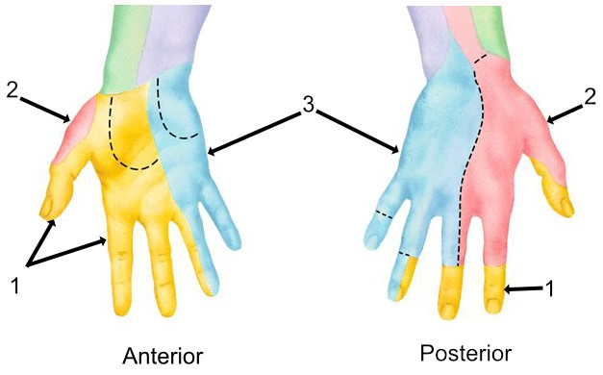
Question 3: Which structure accompanies the ulnar nerve in the distal forearm?
- Radial artery
- Ulnar artery
- Medial branch of the median nerve
- Adductor pollicis muscle
- Palmaris longus tendon
Question 4: Which movements belong to the ive basic ultrasound probe maneuvers?

- Gliding
- Tilting
- Skating
- Probing
- All of the above

Question 5: Branches of the femoral nerve anesthetized during an ankle block include:

- Super icial peroneal nerve
- Deep peroneal nerve
- Tibial nerve
- Saphenous nerve
- Sural nerve

Question 6: Which are the branches coming off the posterior cord of the brachial plexus?

- Axillary and long thoracic nerves
- Median and musculocutaneous nerves
- Ulnar and medial antebrachial nerves
- Axillary and radial nerves
- Median and radial nerves

Question 7: Which muscle usually needs to be penetrated in order to perform an adductor canal block?

- Adductor longus muscle
- Adductor brevis muscle
- Adductor magnus muscle
- Sartorius muscle
- Vastus medialis muscle

Question 8: What does the term “Anisotropy” refer to?

- Change of visibility of a nerve depending on the patient’s Body Mass Index
- Change of visibility of a nerve depending on the tilt of the ultrasound probe
- Change of visibility of a nerve depending on the depth of the target
- Difference appearance of muscles depending on the number of muscle ibers
- Worsening of the visibility of nerves with the use of certain anesthesia gases

Question 9: What is the most commonly used approach for ultrasound guided peripheral nerve blocks?

- “No plane, no gain”
- “Long axis, out of plane”
- “Long axis, in plane”
- “Short axis, out of plane”
- “Short axis, in plane”

Question 10: Using the igure below, a block of the sural nerve would produce anesthesia of (select the appropriate letter of the igure):
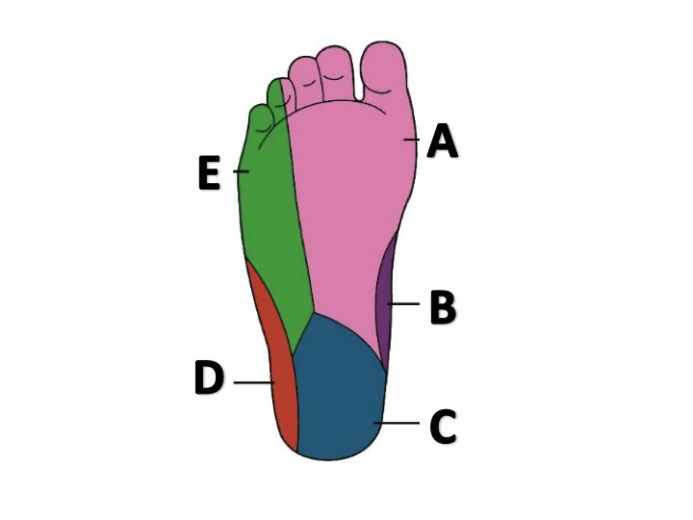

Question 11: Between which muscles does the brachial plexus travel in the interscalene approach?

- Anterior scalene and sternocleidomastoid muscles
- Anterior and middle scalene muscles
- Middle and posterior scalene muscles
- Anterior and posterior scalene muscles
- Pectoralis major and minor muscles

Question 12: In the parasagittal view of the fascia iliaca block, the arrows here indicate muscle bellies of the:
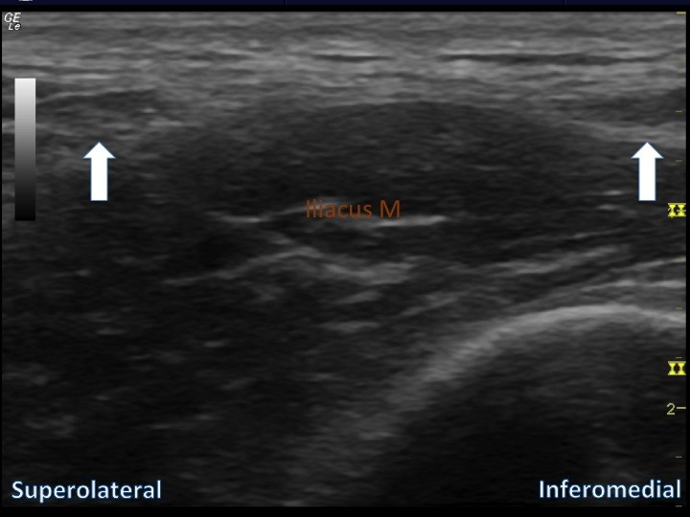
- Transverse abdominis and internal oblique
- Internal oblique and rectus femoris
- Internal oblique and sartorius
- Sartorius and pectineus
- Sartorius and adductor brevis

Question 13: The white arrow here in the supraclavicular view indicates:
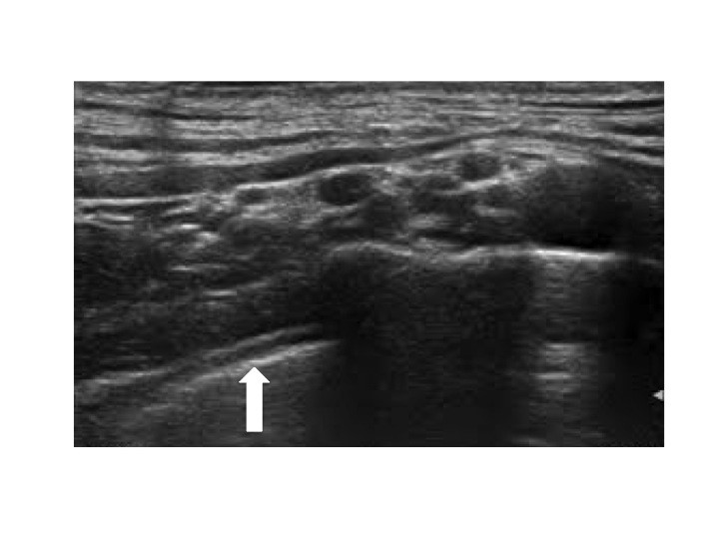
- Coracoid process
- First rib
- Clavicle
- Pleura
- Conjoint tendon

Question 14: The phrenic nerve arises from the

- Nucleus ambiguous
- Sympathetic side chain
- C1‐C2 nerve roots
- C3‐C5 nerve roots
- C6‐T1 nerve roots

Question 15: Between which muscles is the musculocutaneous nerve usually sandwiched in the axillary brachial plexus block?

- Biceps and triceps muscles
- Coracobrachialis and triceps muscles
- Coracobrachialis and biceps muscle
- Biceps and deltoid muscle
- Latissimus dorsi and triceps muscle

Question 16: What does the hyperechoic structure behind the femoral artery represent?

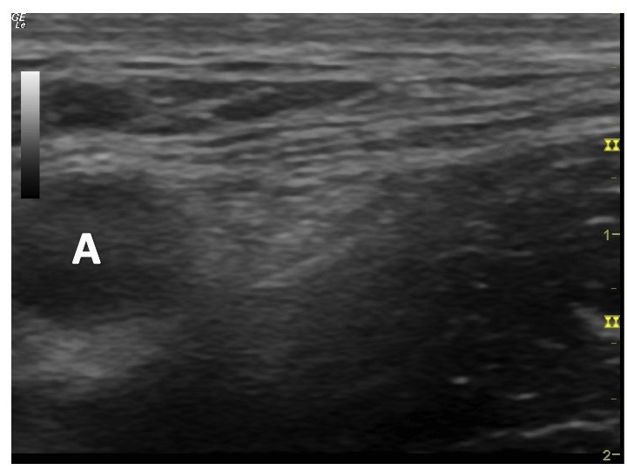

- Deep femoral nerve branch
- Saphenous nerve
- Posterior branch of the obturator nerve
- Lateral femoral cutaneous nerve
- Acoustic enhancement artifact

Question 17: For a super icial cervical plexus block, the needle enters

- Slightly below the mastoid process
- Along the upper border of the clavicle
- At the posterior border of the sternocleidomastoid muscle
- Medial from the coracoid process
- Below the cricoid cartilage

Question 18: Which muscles does the needle pass for an infraclavicular nerve block?

- Deltoid and pectoralis major
- Sternocleidomastoid and anterior scalene
- Latissimus dorsi and serratus anterior
- Teres major and teres minor
- Pectoralis major and minor

Question 19: Which structure passes anterior to the anterior scalene muscle?

- Subclavian vein
- Subclavian artery
- Roots of the brachial plexus
- Sympathetic trunk
- Stellate ganglion

Question 20: The recurrent laryngeal nerve:

- lies anterior to the anterior scalene muscle
- lies in the interscalene triangle
- ascends posterior to the thyroid gland
- emerges from behind the sternocleidomastoid muscle
- is a branch of the cervical plexus of nerves

Question 21: Potential complications from the interscalene nerve block include:

- Mydriasis
- Miosis
- Hoarseness
- Inability to close their eyelid
- A and C
- B and C
- C and D
- All of the above

Question 22: The cords of the brachial plexus (medial, lateral, posterior) are named for their relationship to the:

- Subclavian artery
- Subclavian vein
- Axillary artery
- Axillary vein
- Clavicle

Question 23: The skin on the lateral part of the forearm is innervated by the:

- Musculocutaneous nerve
- Median nerve
- Ulnar nerve
- Axillary nerve
- Radial nerve

Question 24: The lumbar plexus is made up of nerves from:

- L1 – L4
- L2 – L4
- L4 – S3
- L1 – S4
- S2 – S4

Question 25: The femoral nerve innervates the:

- Hamstring muscles
- Adductor muscles of the thigh
- Quadriceps muscles
- Medial malleolus
- A and B
- A, B, C only
- C and D
- All of the above

Question 26: Into which two branches does the sciatic nerve split?

- Deep and super icial peroneal nerves
- Saphenous and sural nerves
- Tibial and common peroneal nerves
- Femoral and obturator nerves
- Posterior and anterior tibial nerves

Question 27: What is an appropriate motor response to nerve stimulation for a lumbar plexus block?

- Isolated adductor twitch
- Isolated hamstring twitch
- Isolated quadriceps twitch
- Dorso lection of the foot
- Plantar lexion of the foot

Question 28: Which nerve is not a sensory nerve?

- Deep radial nerve
- Super icial radial nerve
- Saphenous nerve
- Lateral femoral cutaneous nerve
- Supraclavicular nerve

Question 29: Which of the following is not a contraindication for an interscalene brachial plexus block?

- Patient’s age > 85 years
- Infection at the puncture site
- Contralateral phrenic nerve palsy
- Severe COPD
- Patient refusal to have a block

Question 30: Which nerve will most frequently be missed by any brachial plexus block?

- Ulnar nerve
- Musculocutaneous nerve
- Axillary nerve
- Lateral antebrachial cutaneous nerve
- Intercostobrachial nerve

