Supplementary Information (Fig S1):

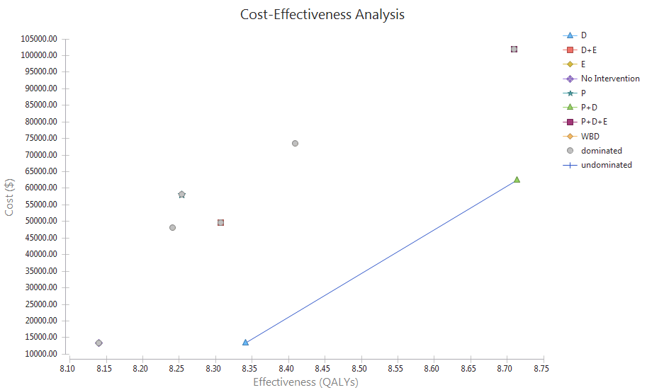
- P: Protein; D: Vitamin D₃; E: Exercise; WBV: Whole body vibration
Fig S1: Base case cost-effectiveness Analysis of Sarcopenia Management Strategies in Iran

