Supplementary Information (Fig S2):

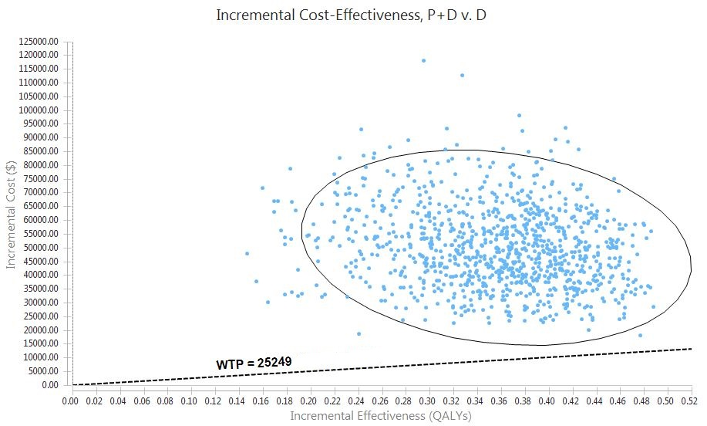
- P: Protein; D: Vitamin D₃
Fig S2: Monte-carlo Simulation (Incremental Cost Effectiveness scatter plot) of Cost-Utility Analysis of Sarcopenia Management Strategies

