Supplemental Figures and Tables
Figure.S1 Effects of buffers and temperatures on the infective of spiked phages (A) and phage genome (B). The percentages of phage activity (y-axis) or phage genomic recovery (y-axis, log10 scale) were determined by plaque assay at each different time point (x-axis) or qPCR. The error bars indicate the standard deviation with 3 replicates.
Figure.S2 The effects of temperatures (A) and time (B) on the viral overall-alpha diversity with the measurement of Observed and Shannon index. NS indicates not significant, and two asterisks indicate a highly significant difference (p < 0.01, t.test).
Figure.S3 Representative of “sneaker contigs”. (A) The abundances of representative contigs annotated at different taxonomy levels, the chosen contigs are based on these contigs had high abundance compared to that of in SM buffer (the abundance is 0 or near to 0). (B) Genomic maps of the open reading frames (ORFs) which are predicted by prodigal and then annotated by blasts from the NCBI protein database, the best hits were used to visualize the functional regions of these contigs. Different colors indicate different annotated proteins, directional boxes indicate ORFs in the respective orientation. NA: not assigned, HTP: hypothetical protein.
Figure.S4 Universal nuclease activity tests in the selected storage buffers (RNAlater, CANVAX and SM buffer). The selected buffers were spiked with exogenous DNA and then the activity of universal nuclease was tested. (A) The residues of exogenous DNA after 10 and 30 min treatment with universal nuclease in the selected buffers. (B) The residues of exogenous DNA in the selected buffers by different times of washing with SM buffer. The error bars indicate the standard deviation with 3 replicates.
Fig. S1
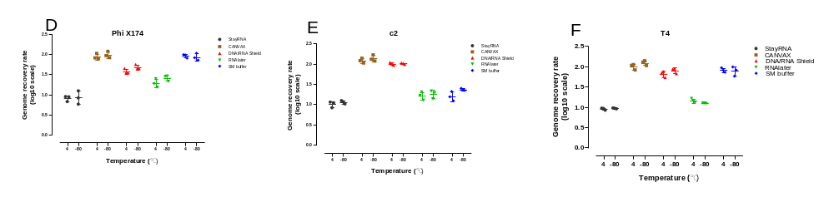
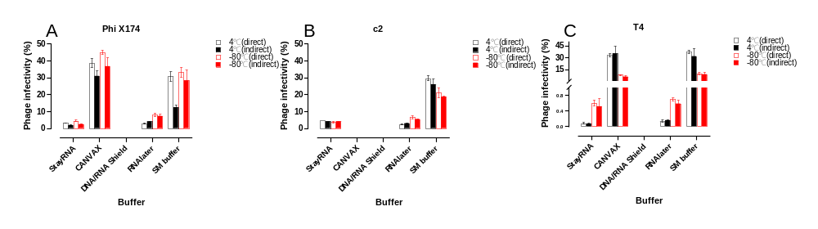

Fig. S2
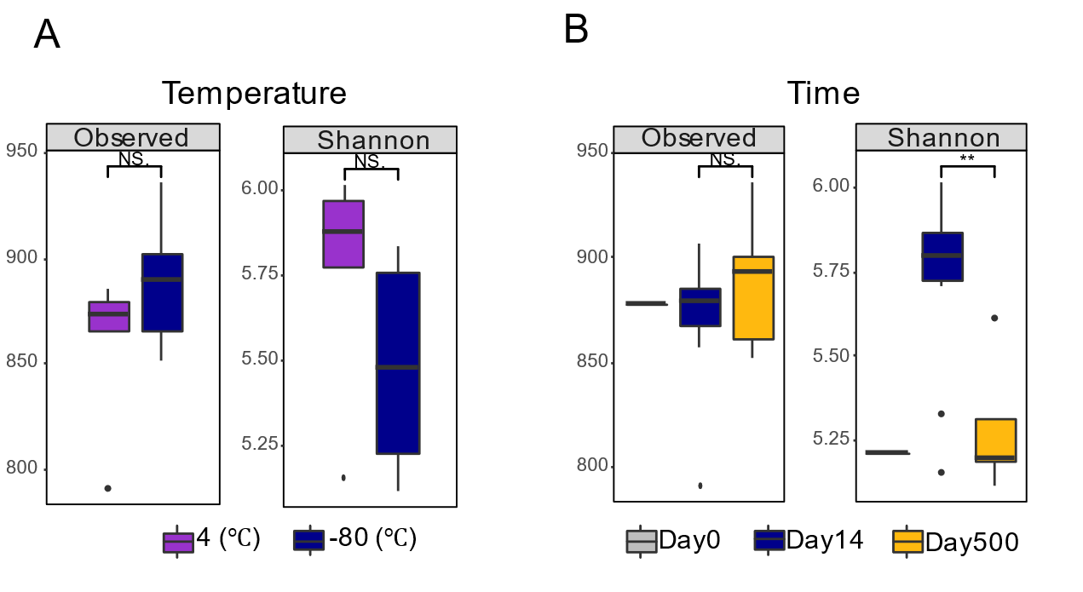

Fig. S3
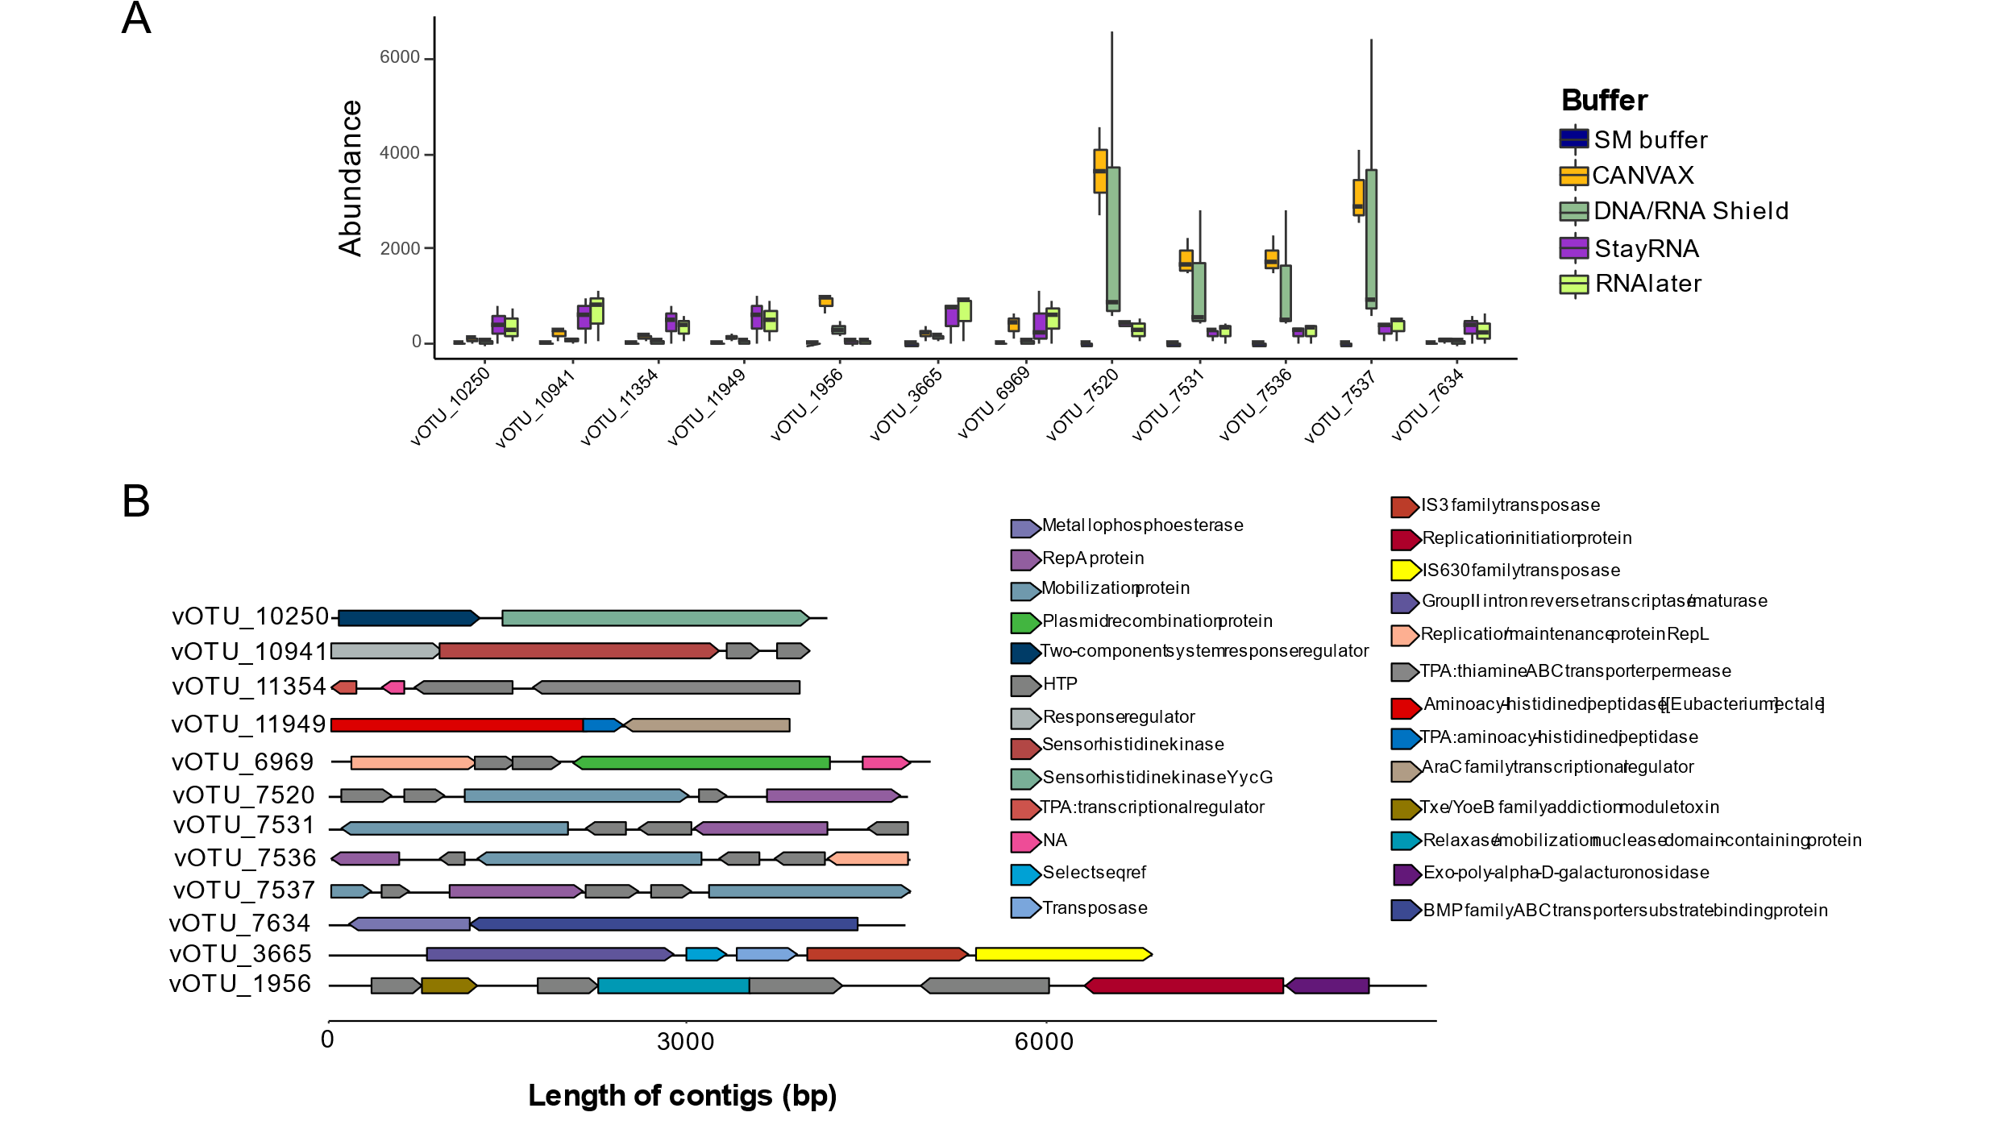

Fig. S4
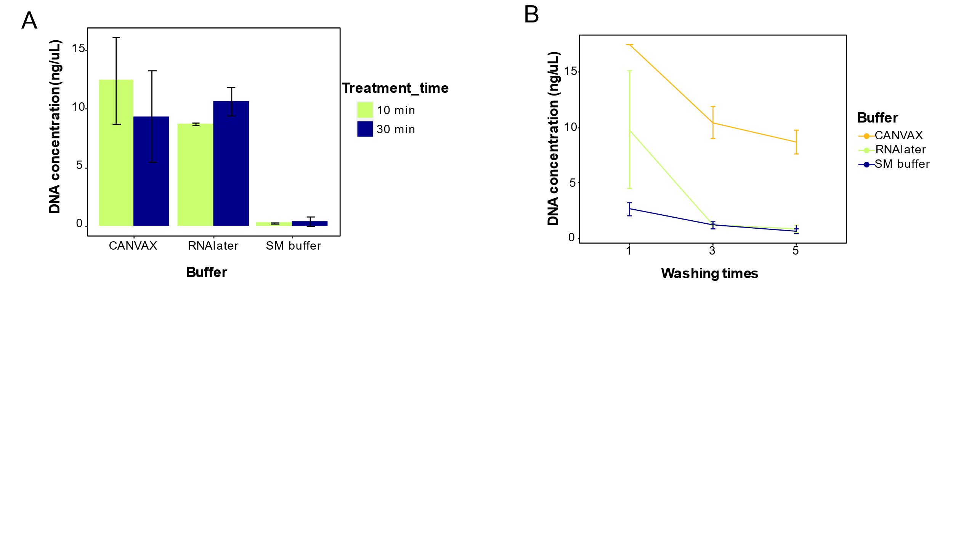

Table S1 Phages and their respective host bacteria in the present study.
Phage (Family) | Shape | Nucleic acid | Host bacteria
Phi X174 (Microviridae) | Non-envoloped, isometric, cubic, icosahedral | Circular ssDNA | Escherichia Coli ATTC 13706
c2 (Siphoviridae) | Non-enveloped, prolate-headed, long and non-contractile tail | Linear dsDNA | Lactococcus lactis MG 1363
T4 (Myoviridae) | Non-enveloped, long and contractile tail, consisting of a sheath and a central tube | Linear dsDNA | Escherichia Coli DSM 613

Table S2 Primers and targeted position for T4, c2 and Phi X174 genomes.
Phage | Primers | Targeted position (bp)
T4 | Forward: 5’-CACAGAGGAACGGTCTTGTAAA-3’ | 53,921 to 54,070
T4 | Reverse: 5’-GAGAAGCCCTCCAGAATCATAAA-3’ | 53,921 to 54,070
c2 | Forward: 5’-CGGATAGAACCACCAACAAGAG-3’ | 2,190 to 2,209
c2 | Reverse: 5’-CTGGATGCCTAAAGACGAATGAG-3’ | 2,190 to 2,209
Phi X174 | Forward: 5’-GAGAAGACGGTTACGCAGTT-3’ | 853 to 872
Phi X174 | Reverse: 5’-GCCTCTACGCGATTTCATAGT-3’ | 853 to 872

Table S3 Plaque assay and qPCR-based phage recovery rate (%) after spiking phages (T4, c2 and Phi X174) in fresh fecal with different buffers (day0).
 |  | StayRNA | CANVAX | DNA/RNA Shield | RNAlater | SM buffer
Plaque  assay | T4 | 0.07 ± 0.008 | 26.0 ± 3.22 | ND | 0.35 ± 0 | 37.4 ± 3.51
Plaque  assay | c2 | 17.0 ± 3.42 | ND | ND | 10.1 ± 1.42 | 39.7 ± 2.38
Plaque  assay | Phi X174 | 3.36 ± 0.43 | 36.6 ± 1.34 | ND | 8.22 ± 2.13 | 34.6 ± 4.09
qPCR | T4 | 7.98 ± 1.82 | 126.9 ± 27.6 | 78.6 ± 29.6 | 14.6 ± 3.72 | 74.7 ± 11.9
qPCR | c2 | 9.23 ± 2.92 | 170.2 ± 35.5 | 114.5 ± 10.9 | 19.9 ± 3.41 | 20.4 ± 6.97
qPCR | Phi X174 | 15.7 ± 3.45 | 163.0± 34.5 | 40.9 ± 5.38 | 28.5 ± 8.30 | 91.2 ± 7.06
ND: not detected

Table S4 Up-concentration differences of fecal samples for virome isolation with CentriSart (100kDa).
Buffer | pH | Storage temperature (°C) | Storage time  (days) | Up-concentration temperature (°C) | Final volume (μL) | Up-concentration time (min) | DNA concentration (ng/μL) | Purity (260/280)
Baseline | 7.66 | - | 0 | 4 | 280 | 180 | 6.22 | 2.69
StayRNA | 4.84 | 4 | 14 | 4 | 140 | 120~180 | 6.00 | 2.56
StayRNA | 4.84 | -80 | 14 | 4 | 280 | 120~180 | 5.65 | 2.66
StayRNA | 4.84 | -80 | 500 | 4 | 140 | 120~180 | 4.64 | 2.51
CANVAX | 7.46 | 4 | 14 | 25 | 300 | >300 | 51.0 | 2.09
CANVAX | 7.46 | -80 | 14 | 25 | 420 | >300 | 42.0 | 2.09
CANVAX | 7.46 | -80 | 500 | 25 | 280 | >300 | 40.6 | 2.06
DNA/RNA Shield | 6.19 | 4 | 14 | 25 | 420 | 240~300 | 44.8 | 1.96
DNA/RNA Shield | 6.19 | -80 | 14 | 25 | 420 | 240~300 | 56.2 | 1.96
DNA/RNA Shield | 6.19 | -80 | 500 | 25 | 280 | 240~300 | 49.1 | 2.01
RNAlater | 4.88 | 4 | 14 | 4 | 140 | 90~120 | 6. 41 | 2.74
RNAlater | 4.88 | -80 | 14 | 4 | 140 | 90~120 | 5.86 | 2.78
RNAlater | 4.88 | -80 | 500 | 4 | 140 | 90~120 | 4.63 | 2.63
SM buffer | 7.66 | 4 | 14 | 4 | 280 | 180~210 | 7.3 | 2.71
SM buffer | 7.66 | -80 | 14 | 4 | 140 | 180~210 | 6.62 | 2.73
SM buffer | 7.66 | -80 | 500 | 4 | 280 | 180~210 | 6.32 | 2.62

Table S5 Relative abundance (%) of viral composition at order level.
Buffer | Storage temperature (°C) | Storage time (days) |  | Order_level (%)
Buffer | Storage temperature (°C) | Storage time (days) | Caudovirales |  | Herpesvirales | Petitvirales | Unclassified | Unknown
Baseline | - | 0 | 58.6 |  | 0.04 | 0.04 | 31.2 | 10.0
StayRNA | 4 | 14 | 33.3 |  | 0.10 | 0.04 | 42.6 | 23.9
StayRNA | -80 | 14 | 37.5 |  | 0.12 | 0.10 | 40.1 | 22.2
StayRNA | -80 | 500 | 56.8 |  | 0.10 | 3.49 | 28.7 | 10.9
CANVAX | 4 | 14 | 28.9 |  | 0.06 | 0.45 | 33.4 | 37.1
CANVAX | -80 | 14 | 29.7 |  | 0.08 | 0.19 | 28.5 | 41.5
CANVAX | -80 | 500 | 30.4 |  | 0.17 | 0.26 | 21.8 | 47.3
DNA/RNA Shield | 4 | 14 | 37.6 |  | 0.19 | 0.00 | 37.7 | 24.5
DNA/RNA Shield | -80 | 14 | 37.9 |  | 0.11 | 0.00 | 33.0 | 28.9
DNA/RNA Shield | -80 | 500 | 32.7 |  | 0.14 | 0.01 | 20.3 | 46.8
RNAlater | 4 | 14 | 31.7 |  | 0.06 | 0.03 | 43.0 | 25.2
RNAlater | -80 | 14 | 36.6 |  | 0.10 | 0.08 | 39.5 | 23.7
RNAlater | -80 | 500 | 56.2 |  | 0.08 | 2.49 | 29.2 | 12.0
SM buffer | 4 | 14 | 56.8 |  | 0.06 | 3.61 | 30.1 | 9.41
SM buffer | -80 | 14 | 57.0 |  | 0.06 | 1.03 | 31.1 | 10.8
SM buffer | -80 | 500 | 59.6 |  | 0.02 | 3.04 | 27.4 | 9.93
NA: not assigned

Table S6 The number of reads and coverage of spiked phages (T4, c2 and Phi X174) to their respective reference genomes. The coverage rate was calculated by Botwie2.
Buffer | Storage temperature (°C) | Storage time (days) | Total reads | Number of reads |  |  | Coverage |  |  | Mean depth
 |  |  |  | C2 | Phi X174 | T4 | c2 | Phi X174 | T4 | c2 | Phi X174 | T4
Baseline | - | 0 | 4191972 | 25154 | 511 | 18280 | 99.9 | 100 | 99.0 | 170 | 14.2 | 16.3
StayRNA | 4 | 14 | 3350280 | 2299 | 156 | 451 | 98.5 | 96.0 | 26.2 | 15.6 | 4.36 | 0.40
StayRNA | -80 | 14 | 4363504 | 7395 | 536 | 1935 | 99.9 | 99.5 | 63.4 | 50.0 | 14.9 | 1.71
StayRNA | -80 | 500 | 3943580 | 18749 | 45139 | 6129 | 99.3 | 100 | 89.9 | 127 | 1259 | 5.44
CANVAX | 4 | 14 | 3606452 | 320 | 424 | 209 | 72.0 | 98.9 | 14.5 | 2.20 | 11.9 | 0.19
CANVAX | -80 | 14 | 2747160 | 258 | 201 | 85 | 70.8 | 99.5 | 5.9 | 1.75 | 5.61 | 0.07
CANVAX | -80 | 500 | 2764752 | 440 | 578 | 161 | 85.0 | 100 | 10.8 | 2.99 | 16.1 | 0.14
DNA/RNA Shield | 4 | 14 | 3344852 | 2531 | 2 | 1580 | 99.1 | 4.51 | 60.3 | 17.2 | 0.06 | 1.41
DNA/RNA Shield | -80 | 14 | 2685972 | 2051 | 40 | 1492 | 98.2 | 55.6 | 58.5 | 13.9 | 1.11 | 2.33
DNA/RNA Shield | -80 | 500 | 3265632 | 4267 | 292 | 4127 | 99.9 | 99.5 | 84.1 | 28.9 | 8.13 | 3.67
RNAlater | 4 | 14 | 5394640 | 3249 | 273 | 1035 | 99.9 | 100 | 45.3 | 21.9 | 7.60 | 0.92
RNAlater | -80 | 14 | 4772444 | 11537 | 386 | 1472 | 99.9 | 99.4 | 57.8 | 78.2 | 10.8 | 1.31
RNAlater | -80 | 500 | 6529708 | 35451 | 75659 | 15333 | 98.9 | 100 | 98.5 | 240 | 2112 | 13.6
SM buffer | 4 | 14 | 661636 | 8426 | 2302 | 11852 | 99.7 | 100 | 99.0 | 57.3 | 64.4 | 10.6
SM buffer | -80 | 14 | 3086580 | 32379 | 22636 | 12277 | 99.8 | 100 | 97.2 | 219 | 632 | 10.9
SM buffer | -80 | 500 | 3638596 | 30979 | 38846 | 9749 | 99.8 | 100 | 96.9 | 209 | 1084 | 8.67

