Appendix A. Description of available data on drug, patient, provider and system level characteristics
 | Description | Measurement | Timing of Measurement | Functional Form
Opioid-related Characteristics
Opioid Dispensations
ATC code | Anatomical Therapeutic Chemical Classification System code used to identify opioids and other concurrent medications that the patient is taking  Opioids ATC Included: N02A, R05DA | RAMQ prescription claims. | In the community one year prior to admission | N/A
Dose | The daily amount of drug taken by patient was calculated based on information about the number of tablets prescribed, strength and number of days’ supply; daily dose was converted to milligram morphine equivalents to facilitate comparison across opioids | From RAMQ prescription claims | The initial post-discharge dispensation | Binary, time-fixed
Duration | The days’ supply on the drug claim as entered by the pharmacist | From RAMQ prescription claims | The initial post-discharge dispensation | Binary, time-fixed
Type of opioid | Type of opioid ingredient; e.g.: hydromorphone, oxycodone, morphine, fentanyl, etc. | From RAMQ prescription claims | The initial post-discharge dispensation | Categorical, time-fixed
Opioid formulation | E.g.: short-acting, long-acting | From RAMQ prescription claims | The initial post-discharge dispensation | Binary, time-fixed
Filled within 30 days‘ post-discharge | Patient filled their initial dispensation within 30 days following the index hospitalization | From RAMQ prescription claims | The initial post-discharge dispensation | Binary, time-fixed
Filled ≥1 type of opioid | Patient filled more than one type of opioid ingredient on the first dispensation following their index hospitalization | From RAMQ prescription claims | The initial post-discharge dispensation | Binary, time-fixed
Opioid Administration in Hospital
ATC code | Anatomical Therapeutic Chemical Classification System code used to identify administered opioids | Hospital pharmacy | In hospital | Categorical
Opioid Prescription at Hospital Discharge
Status of opioid medication | Continued or stopped from community, or newly prescribed at discharge | From patient chart | At hospital discharge | Categorical, time-fixed
Presence of a multi-modal pain management regimen | The opioid prescription at hospital discharge as part of multi-modal pain treatment regimen | From patient chart | At hospital discharge | Categorical,  time-fixed
Demographics
Age |  | From patient chart | Admission to hospital | Continuous, time-varying
Sex | Male, Female | From patient chart | Admission to hospital | Binary, time-fixed
Drug insurance status | E.g.: Full copay, partial copay, no copay; serves as proxy for socio-economic status | From RAMQ drug programs | Admission to hospital | Categorical, time-fixed
Co-Existing Illnesses
History of mental health conditions | E.g.: Anxiety, depression, psychiatric diagnosis, mood disorder, and post-traumatic stress disorder | ICD-9 from RAMQ medical services and ICD-10 codes from hospitalization data | In community one year prior to admission, in hospital, post-discharge | Binary per condition, time-varying
Pain syndromes | E.g.: Chronic back pain, back and neck pain, back disorder, arthritis, migraine, headache, fibromyalgia, fracture | ICD-9 from RAMQ medical services and ICD-10 codes from hospitalization data | In community one year prior to admission, in hospital, post-discharge | Binary per condition, time-varying
Health conditions associated with abuse | E.g.: Alcohol abuse, drug abuse | From patient chart. Also from RAMQ medical series and prescription claims | In community one year prior to admission, in hospital, post-discharge | Binary per condition, time-varying
Tobacco use | Patient-reported history of tobacco use | From hospital charts | At admission | Binary, time-fixed
Cancer diagnosis | E.g.: Metastatic, non-metastatic, lymphoma | ICD-9 from RAMQ medical services and ICD-10 codes from hospitalization data | In community one year prior to admission, in hospital, post-discharge | Binary per condition, time-varying
Other comorbidities | E.g.: Acute MI, cerebrovascular diseases, chronic kidney, COPD, diabetes, heart failure, hypertension, ischemic heart disease, liver, obesity | ICD-9 from RAMQ medical services and ICD-10 codes from hospitalization data | In community one year prior to admission, in hospital, post-discharge | Binary per condition, time-varying
Drug and Healthcare utilization
Use of potential interacting drugs increasing the risk of opioid misuse | E.g.: Selective serotonin reuptake inhibitors, other antidepressants, benzodiazepines, other antipsychotic drugs, central nervous system depressants, psychotropic medication | ATC codes, DIN, Generic Drug name used to extract information from RAMQ prescription claims, hospital data, patient chart. | In community one year prior to admission, in-hospital | Binary per drug, time-varying
Use of non-opioid pain medications | E.g.: NSAIDS, COX-2, Acetaminophen, gabapentin, anti-migraine medications, muscle-relaxants, other anti-inflammatories and anti-rheumatoid medications | ATC codes, DIN, Generic Drug name used to extract information from RAMQ prescription claims, hospital data, patient chart. | In community one year prior to admission, in-hospital | Binary per drug, time-varying
Receipt of radiotherapy | The patient received radiotherapy | Procedure codes | In community one year prior to admission | Binary, time-fixed
Receipt of chemotherapy | The patient received chemotherapy | Procedure codes | In community one year prior to admission | Binary, time-fixed
Number of emergency department (ED) visits and hospitalizations | Total number of ED visits and hospitalizations | From RAMQ prescription claims and hospital data | One year prior to hospital admission & one year post-discharge | Categorical, continuous, time-varying
Active prescriptions at admission | Total number of active dispensations (duration of the dispensation overlapped with the date of admission) at index hospitalization admission | From RAMQ prescription claims | One year prior to hospital admission | Continuous, categorical, time-fixed
Measures of Care Continuity
Number of physicians | Number of unique physicians that prescribed an opioid medication to a patient in the year post hospital admission | From RAMQ medical services | One year prior to hospital admission & one year post-discharge | Categorical, continuous, cumulative time-varying
Number of dispensing pharmacies | Number of unique pharmacies that a patient has opioid medications dispensed at in the one year post to hospital admission | From RAMQ medical services | One year prior to hospital admission & One year post-discharge | Categorical, continuous, cumulative time-varying
In-hospital Characteristics
Reason for index hospital admission | Reasons were classified as opioid-related if patient presented to the hospital for cancer-related reasons, respiratory, cardiovascular, etc. | From hospitalization data | During the hospital stay | Binary, time-fixed
Type of surgery | For surgical patients only, the type of surgery that the patient received during their index hospitalization | From hospitalization data | During the hospital stay | Categorical, time-fixed
Admission to the intensive care unit (ICU) | A record for patient being admitted to the ICU during their index hospitalization | From hospitalization data | From hospitalization data | Binary, time-fixed
Length of hospital stay | The duration of the index hospitalizations (days) | From hospitalization data | From hospitalization data | Binary, time-fixed
Discharge Destination | Home community, long term care | Patient chart | Upon discharge | Binary, time-fixed
RightRx patients | Patients, who were part of the initial randomized controlled trial and electronic medication reconciliation was used | Patient chart | Upon discharge | Binary, time-fixed
Attending Physician Characteristics
Years of practice | Number of years practiced since graduation from medical school | From hospital chart, Collège des Médecins du Quebec | Upon discharge | Categorical, time-fixed
Discharge prescription signed by | Attending physician vs resident | From hospital chart | Upon discharge | Binary, time-fixed

Appendix B. Codes Used for Drug Classification and Rationale for Opioid Dose Calculations

Supplement Method B.1. Inclusion criteria for opioid medications.
ATC codes used to identify opioids: N02A (opioids), R05DA (opium alkaloids and derivatives)

Exclusions: Not all drug forms were included in the analyses. Only patches and tablets of these medications were kept. Injectable, liquid and rectal forms were excluded. Methadone and buprenorphine/naloxone combinations were kept to define subclinical patient populations but were excluded from all dosing/duration calculations as these medications are used to treat addiction and we want to focus on the association of duration/dose of opioids used for pain relief.

Supplement Method B.2. Calculation of daily dose and overlapping prescriptions.
The daily dose of each opioid was calculated by first dividing the quantity of units dispensed by the prescription duration to determine the number of units per day, and then multiplying the number of units by the strength. To account for concurrent prescriptions, a subsequent dispensation was considered as an early refill if days of overlap were ≤30% of the previous dispensation duration. Otherwise, the opioids were considered to be taken simultaneously. Daily dose of each dispensation was converted to MME doses using the Center for Disease Control Opioid Morphine Equivalent Conversion Factor and the opioid doses determined to be concurrently dispensed were added together.

Appendix C. Opioid Morphine Equivalent Conversion Factor ¹
Drug Name Conversion Factor
Buprenorphine patch² | 12.6
Buprenorphine tab or film | 10
Butorphanol | 7
Codeine | 0.15
Dihydrocodeine | 0.25
Fentanyl buccal or SL tablets, or lozenge/troche³ | 0.13
Fentanyl film or oral spray⁴ | 0.18
Fentanyl nasal spray⁵ | 0.16
Fentanyl patch⁶ | 7.2
Hydrocodone | 1
Hydromorphone | 4
Levorphanol tartrate | 11
Meperidine hydrochloride | 0.1
Methadone | 3
Morphine | 1
Nalbuphine | 1
Opium | 1
Oxycodone | 1.5
Oxymorphone | 3
Pentazocine | 0.37
Tapentadol | 0.4
Tramadol | 0.1
¹ Centers for Disease Control and Prevention, Atlanta, GA, May 2014.
² The MME conversion factor for buprenorphine patches is based on the assumption that one milligram of parenteral buprenorphine is equivalent to 75 milligrams of oral morphine and that one patch delivers the dispensed micrograms per hour over a 24-hour day. Example: 5 ug/hr buprenorphine patch * 24 hrs = 120 ug/day buprenorphine = 0.12 mg/day buprenorphine = 9 mg/day oral morphine milligram equivalent. In other words, the conversion factor not accounting for days of use would be 9/5 or 1.8. However, since the buprenorphine patch remains in place for 7 days, we have multiplied the conversion factor by 7 (1.8 X 7 = 12.6). In this example, MME/day for four 5 μg/hr buprenorphine patches dispensed for use over 28 days would work out as follows: Example: 5 ug/hr buprenorphine patch * (4 patches/28 days) * 12.6 = 9 MME/day.
³ The MME conversion factor for fentanyl buccal tablets, sublingual tablets, and lozenges/troche is 0.13. This conversion factor should be multiplied by the number of micrograms in a given lozenge/troche.
⁴ The MME conversion factor for fentanyl film and oral spray is 0.18. This reflects a 40% greater bioavailability for films compared to lozenges/tablets and 38% greater bioavailability for oral sprays compared to lozenges/tablets.
⁵ The MME conversion factor for fentanyl nasal spray is 0.16, which reflects a 20% greater bioavailability for sprays compared to lozenges/tablets.
6 The MME conversion factor for fentanyl patches is based on the assumption that one milligram
of parenteral fentanyl is equivalent to 100 milligrams of oral morphine and that one patch delivers
the dispensed micrograms per hour over a 24 hour day. Example: 25 ug/hr fentanyl patch * 24 hrs=
600 ug/day fentanyl = 60 mg/day oral morphine milligram equivalent. In other words, the conversion
factor not accounting for days of use would be 60/25 or 2.4. However, sincethe fentanyl patch
remains in place for 3 days, we have multiplied the conversion factor by 3 (2.4 X 3 = 7.2).
In this example, MME/day for ten 25 μg/hr fentanyl patches dispensed for use over 30 days would work
out as follows: Example: 25 ug/hr fentanyl patch * (10 patches/30 days)* 7.2 = 60 MME/day.

Sources:
- Centers for Medicare & Medicaid Services. Opioid Oral Morphine Milligram Equivalent (MME) Conversion Factors. https:\\www.cms.govMedicarePrescription-Drug-CoveragePrescriptionDrugCovContraDownloadsOpioid-Morphine-EQConversion-Factors-vFeb-.pdf. Accessed: September 5, 2019
- Svendsen, K., Borchgrevink, P., Fredheim, O., Hamunen, K., Mellbye, A., & Dale, O. (2011). Choosing the unit of measurement counts: the use of oral morphine equivalents in studies of opioid consumption is a useful addition to defined daily doses. Palliative Medicine, 25(7), 725–732. http://doi.org/10.1177/0269216311398300

Appendix D. Results from assessing the proportional hazards (PH) assumption in the main Cox PH model (global p-value = 0.0021)

Covariate | P-value
Emergency department visits/hospitalizations, ≥1 | 0.040
Ambulatory visits, ≥15 | 0.89
Radiotherapy | 0.31
Chemotherapy | 0.43
Charlson Comorbidity Index, ≥3 | 0.16
History of renal disease | 0.86
History of diabetes | 0.20
History of heart disease | 0.021
History of lung cancer | 0.41
History of opioid use | 0.07
History of benzodiazepine use | 0.90
Cardiac surgery | 0.45
Gastrointestinal surgery | 0.69
Thoracic surgery | 0.93
Unrelated surgery | 0.57
Admission to the ICU | 0.40
Hospital LOS, ≥6 | 0.0091
Discharge prescription of a non-opioid analgesic | 0.67
ICU= Intensive care unit; LOS=Length of hospital stay
Statistically significant findings are bolded.

Appendix D.1. Smooth residual plot for the time-dependent effect of history of emergency department (ED) visit in the year proceeding the index hospitalization

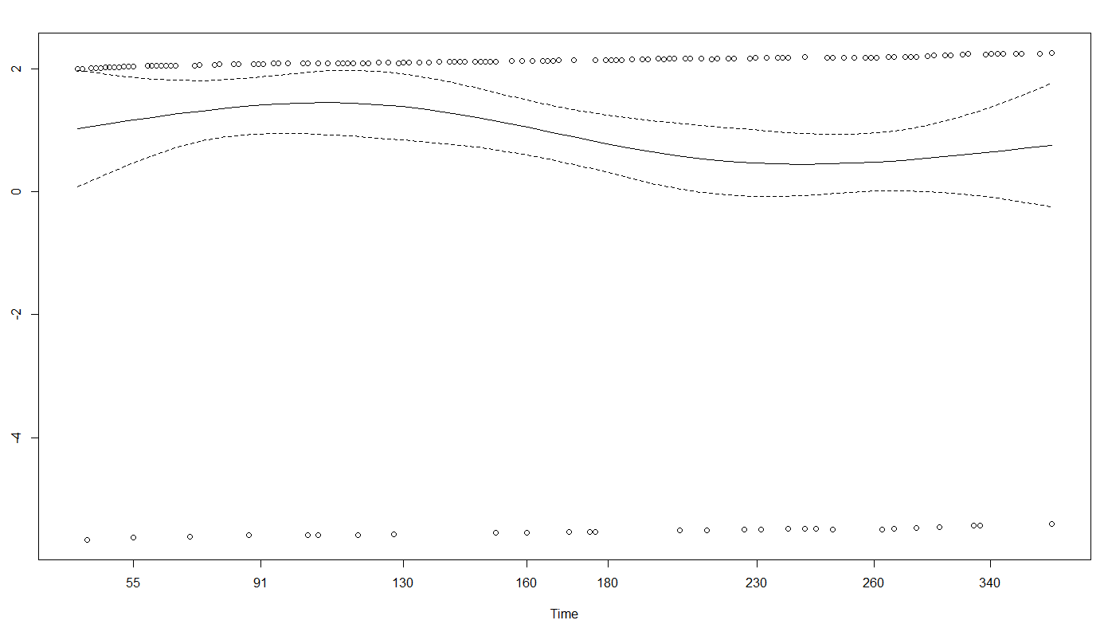

Supplement Method D.1. From the graph of the smooth residual plot, we see that history of ≥1 emergency department visits is associated with an increase in risk over the entire follow-up period. This consistent increase in risk is observed under constant proportional hazards effect with a p-value of 0.04 (Appendix D.1) and a HR >1 (HR=1.80). This increase in risk of the outcome associated with an having a history of ≥1 ED visits was even higher during the first three to four months of follow-up.

Appendix D.2. Smooth residual plot for the time-dependent effect of the history of heart disease

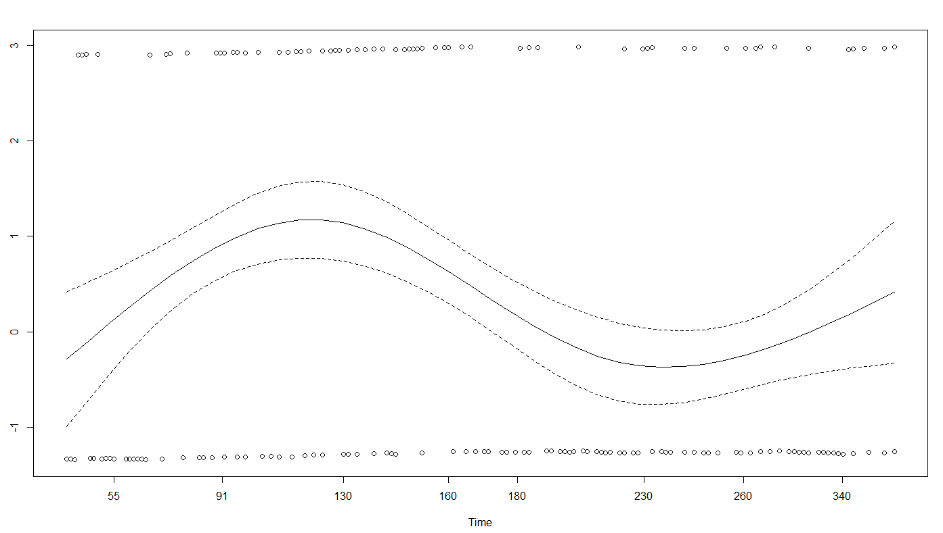

Supplement Method D.2. From the graph of the smooth residual plot, the impact of history of heart disease on the hazard increases with time, starting with gradual increases in risk three to four months following hospital discharge to decreasing risk after four months post-discharge. The risk increases again after six months of discharge up until the end of follow-up.

Appendix D.3. Smooth residual plot for the time-dependent effect of the length of hospital stay of the index hospitalization

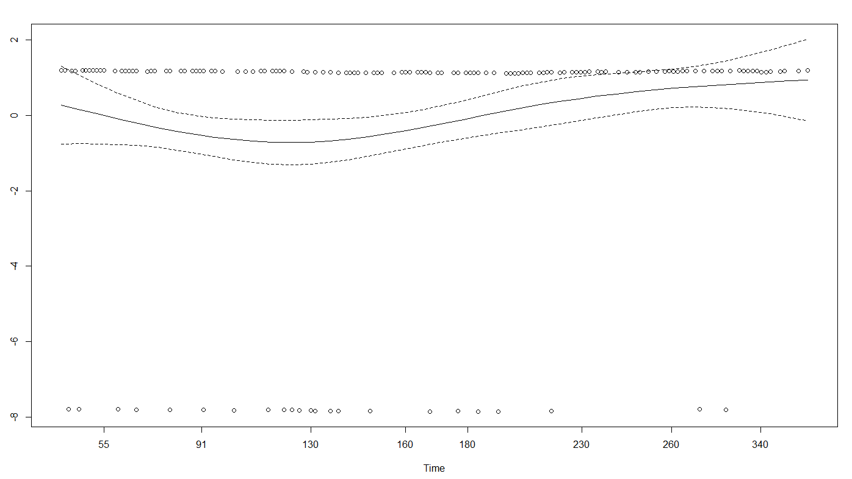

Supplement Method D.3. From the graph of the smooth residual plot, we see that having a length of hospital stay of ≥6 days is significant (p-value of 0.0091). The impact of having a length of hospital stay of ≥6 days on the hazard slowly and gradually decreases at first, up until four months of follow-up and then gradually increases with time until the end of follow-up. The crossing hazards could explain why the effect of having a length of hospital stay of ≥6 days on the risk of becoming a frequent ED user is non-significant (HR is close to 1, and the confidential intervals span the null).

