Table 4. Production of superoxide reactive oxygen species by leukocytes of individuals with CKD treated with HD and 12 weeks after conversion to HDF.

4.1. Production of  Superoxide (O₂^{●-}) | Percentage of cells that: | Control | HD | HDF | Test  p value
4.1. Production of  Superoxide (O₂^{●-}) | Percentage of cells that: | Median (mim to max) (%) |  |  | Test  p value
Basal production  (cells without yeasts) | produced O_{2●}⁻ | 37  (19 to 71) | 20*  (4 to 33) | 54  (10 to 73) | AN  p = 0.003
Stimulated production  (cells + yeasts) | ingested yeasts and produced O_{2●}⁻ | 73  (50 to 81) | 9*  (5 to 21) | 52*  (17 to 82) | AN  p < 0.0001
Stimulated production  (cells + yeasts) | did not ingested yeasts, but produced O_{2●}⁻ | 17  (7 to 46) | 5*  (0 to 10) | 14  (2 to 33) | KW  p = 0.007
Stimulated production  (cells + yeasts) | ingested yeasts and did not produce O_{2●}⁻ | 17  (7 to 46) | 5*  (0 to 10) | 14*  (2 to 33) | KW  p < 0.0001
Stimulated production  (cells + yeasts) | did not ingested yeasts and did not produce O_{2●}⁻ | 4  (1 to 7) | 23*  (7 to 52) | 5  (0 to 32) | KW  p < 0.0001
HD – Hemodialysis. HDF – Hemodiafiltratin. PMP – Pathogens molecular pattern. AN – ANOVA. KW – Kruskal-Wallis. (*) Values that differ from the control. Gray color indicate different pairs. Median (minimum to maximum) were used for non-parametric data.

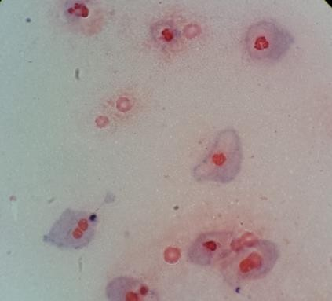
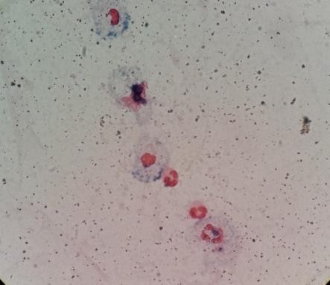
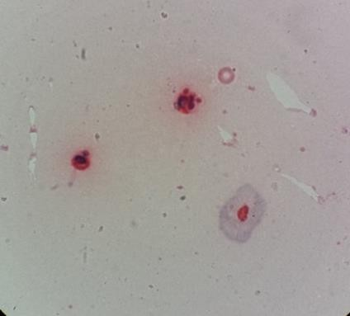
4.2. Circle indicate a phagocyte that ingested yeasts, but did not produce O_{2●}⁻. Arrows indicate phagocytes that not ingested yeasts, but produced O_{2●}⁻. Stain with Giemsa (10%). 1000 x of magnification.
HD
Control
HDF

