Supplementary material for “Rapid Indian ocean warming threatens Agricultural productivity in North America”

Young-Min Yang*^{1,2}
¹Key Laboratory of Meteorological Disaster, Ministry of Education (KLME)/Joint International Research Laboratory of Climate and Environment Change (ILCEC)/Collaborative Innovation Center on Forecast and Evaluation of Meteorological Disasters (CIC-FEMD), Nanjing University of Information Science and Technology, Nanjing, 210044, China. ²Department of Atmospheric Sciences and International Pacific Research Center, University of Hawaii, Honolulu HI 96822, USA. * indicates a corresponding author; e-mail: ymyang@hawaii.edu

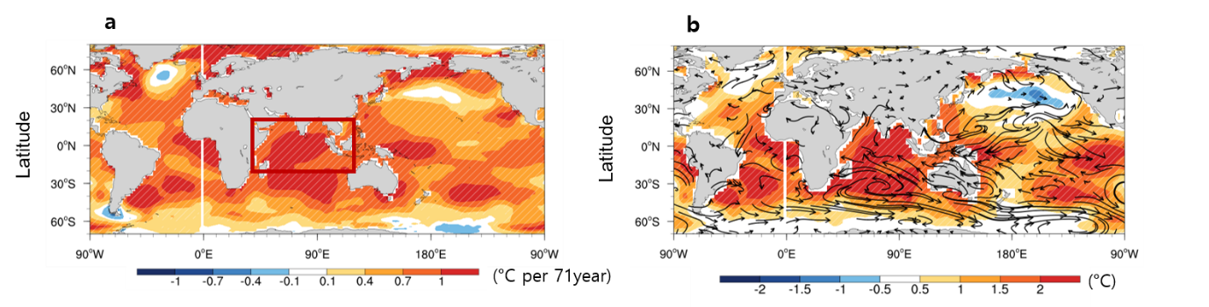

Supplementary Figure S1. Historical warming trends. a Observed trends (1950–2020) in annual-mean sea surface temperature (SST; units: °C 50 year−1 ). The red box represents the region where the Indian Ocean index was defined. Observed SST (K) and surface wind anomalies (arrow, m/s) regressed onto (b) Indian Ocean (IO) index (15°S–15°N, 60°–90°E). The hatched area represents the regressed SST and is significant at the 95% confidence level. For b, the 11-year running average data were used for 1950–2020 and long-term linear trends were removed.

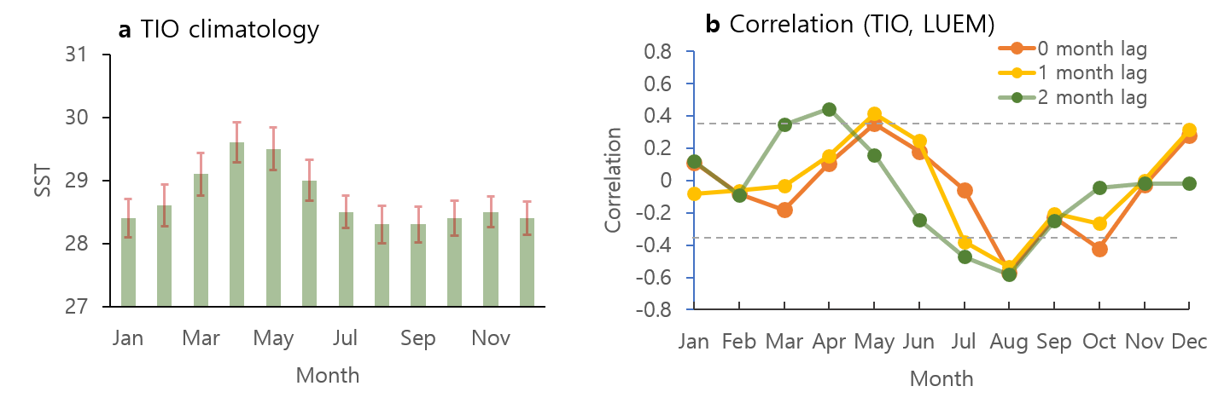

Supplementary Figure 2. (a) Monthly climatological observed SST over the tropical Indian Ocean (TIO) (60°–90°E, 15°S –15°N). (b) The monthly correlation coefficient between TIO and GPP from LUEM over eastern US GPP (100°–75°W, 30°–60°N). The dashed black line shows a 95% significant level.

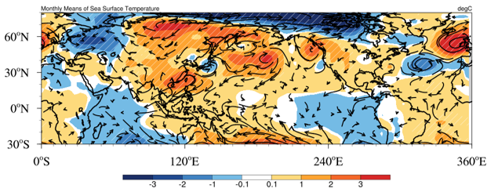

Supplementary Figure S3. IO warming impacts on climate Regression coefficients of August SLP (hPa) and surface wind (m s⁻¹) onto June TIO index from observation. The 1982–2016 data are used for analysis. Hatching and scale bars represent a range of 95% confidence level based on a Student’s t-test.

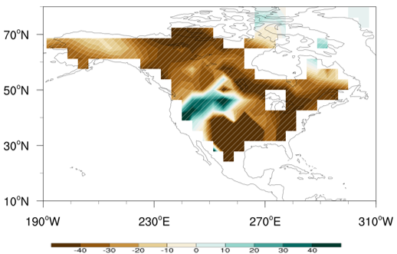

Supplementary Figure S4. IO warming impacts on August terrestrial productivity. Regression coefficients of August GPP historical simulation from NESM3.0 for the period (1982–2016) with respect to June TIO index. Hatching and scale bars represent a range of 95% confidence level on the basis of a Student’s t-test.

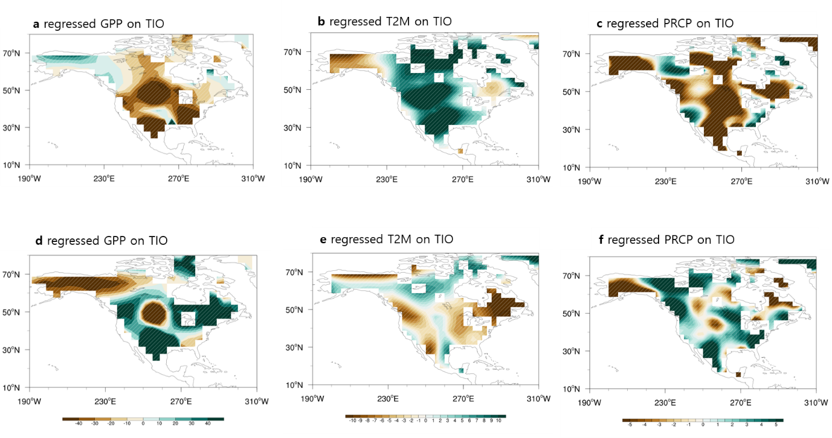

Supplementary Figure 5. IO warming impacts using Earth system model. a–c Regression coefficients of August (a) GPP, (b) T2m, and (c) PRCP onto TIO index from NESM with observed TIO SST. d-e Same as a-c but from NESM with climatological IO SST. The 1982–2016 data are used for analysis. Hatching and scale bars represent a range of 95% confidence level on the basis of a Student’s t-test.

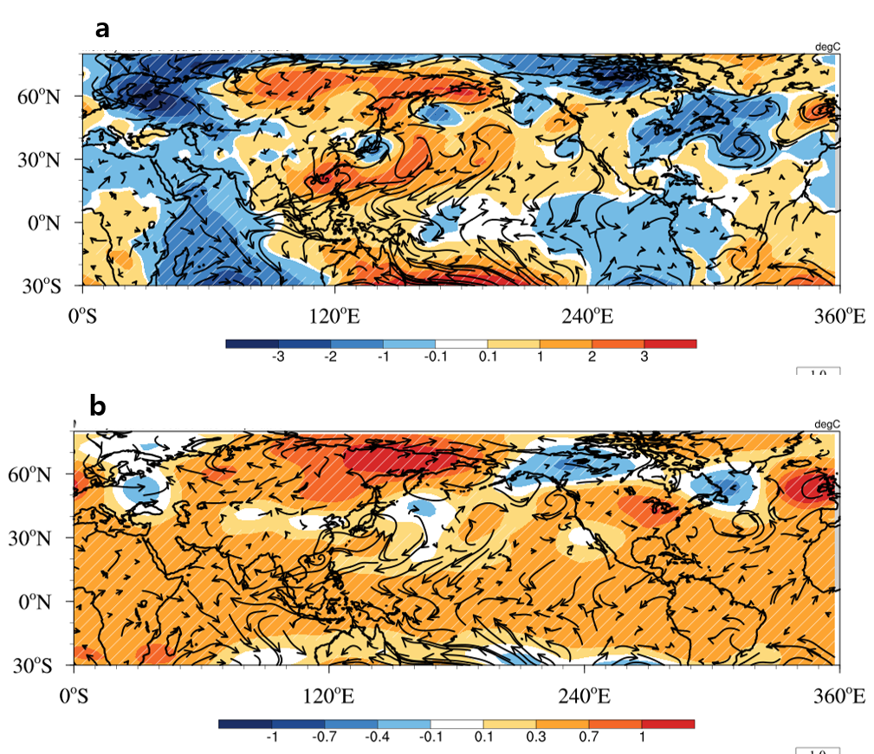

Supplementary Figure S6. IO warming impacts on climate a Regression coefficient of August SLP (hPa) and surface wind (m s⁻¹) onto June TIO index from NESM with observed SST over the tropical Indian ocean. b Same as a but for geopotential height and upper troposphere wind at 300 hPa (m s⁻¹). The 1982–2016 data are used for analysis. Hatching and scale bars represent a range of 95% confidence level on the basis of a Student’s t-test.

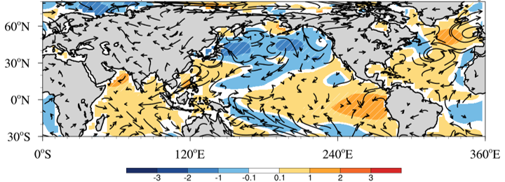

Supplementary Figure S7. IO warming impacts on climate a Regression coefficient of August SST (K) and surface wind (m s⁻¹) onto June TIO index from observation The 1982–2016 data are used for analysis. Hatching and scale bars represent a range of 95% confidence level on the basis of a Student’s t-test.

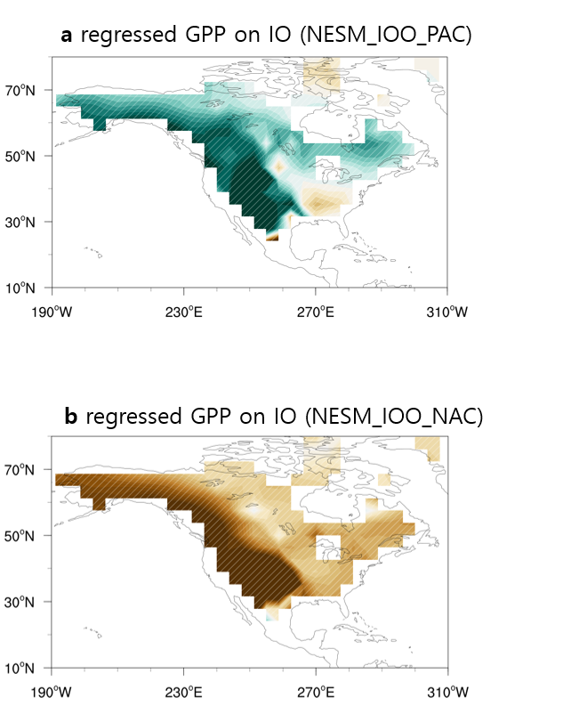

Supplementary Figure 8. Horizontal patterns of August gross Terrestrial primary productivity (GPP) anomalies depicted by GPP anomalies (K) onto June tropical Indian ocean (IO) index (-30◦–20◦N, 40◦–110◦E) with lag 0 years (1982–2016) from (a) NESM with observed IO SST and climatological Pacific SST and (b) with with observed IO SST and climatological North Atlantic SST. Long-term linear trends in the SST data were removed prior to regression analysis. The hatched line area represents a 95% significance level from observation and model simulations.

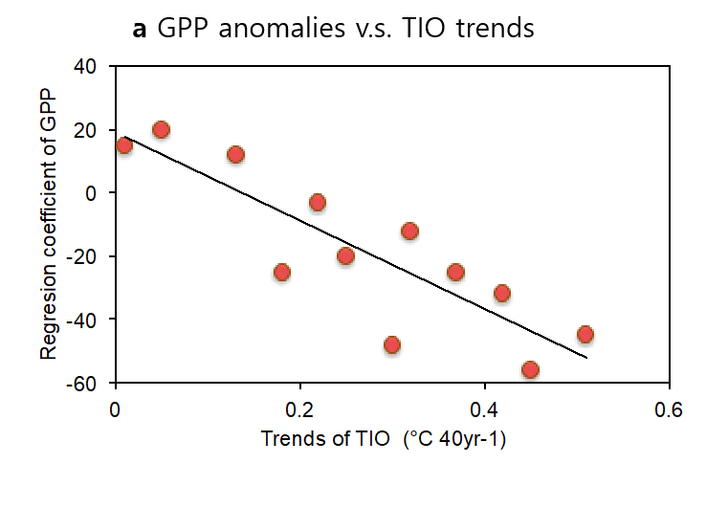

Supplementary Figure S9 Scatter plots between regression coefficient of August eastern US GPP (30◦–60◦N, 260◦–285◦E) from the historical simulation with observed TIO SST pattern and different trends for 1980‒2020. Observed TIO warming signals were engaged in the model by nudging the observed SST anomalies with various trends for the TIO region.

