Supplementary Information

eFigure 1: Illustration of analyses conducted for censored data

eFigure 2: Participant inclusion for the CI-DFU

eFigure 3: Participant inclusion for the CSM

eTable 1: Subject-knowledge driven variable selection and rationale

eTable 2: Table of exposures and outcomes for vaccine uptake primary outcome

eTable 3: Table of exposures and outcomes for SwissCovid app uninstalling primary outcome

eTable 4: Effect sizes of confounders and variables of interest in exploratory multivariable analyses for vaccine uptake outcome

eTable 5: Effect sizes of confounders and variables of interest in exploratory multivariable analyses for SwissCovid app uninstalling

eFigure 4: Cumulative hazard curves for the Inverse Probability of Censoring Weighting (IPWC) analysis for vaccine uptake outcome based on SwissCovid app use. Panel A curves are from the CI-DFU, while panel B curves are from the CSM.

eFigure 5: Cumulative hazard curves for the Inverse Probability of Censoring Weighting (IPWC) analysis for SwissCovid app uninstalling outcome based on vaccine uptake. Panel A curves are from the CI-DFU, while panel B curves are from the CSM.

eFigure 6: Point process Poisson regressions for vaccine uptake outcome based on SwissCovid app use. Panel A curves are from the CI-DFU, while panel B curves are from the CSM.

eFigure 7: Point process Poisson regressions for SwissCovid app uninstalling outcome based on vaccine uptake. Panel A curves are from the CI-DFU, while panel B curves are from the CSM.

This supplementary material has been provided by the authors to give readers additional information about their work.
eFigure 1: Illustration of analyses conducted for censored data

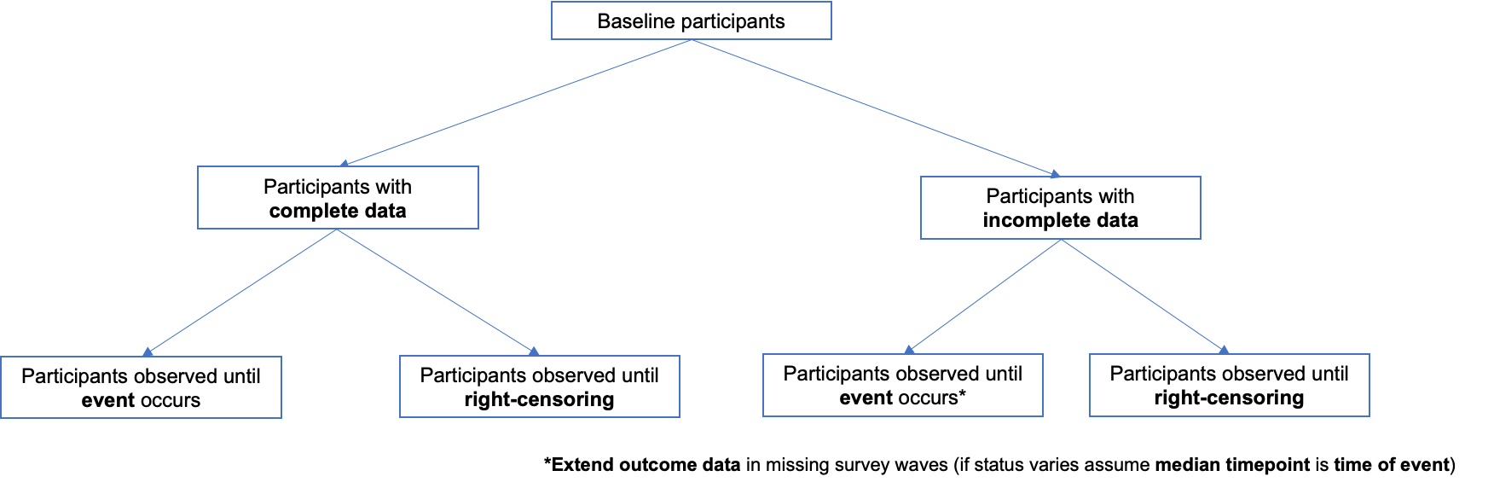
eFigure 2: Participant inclusion for the CI-DFU

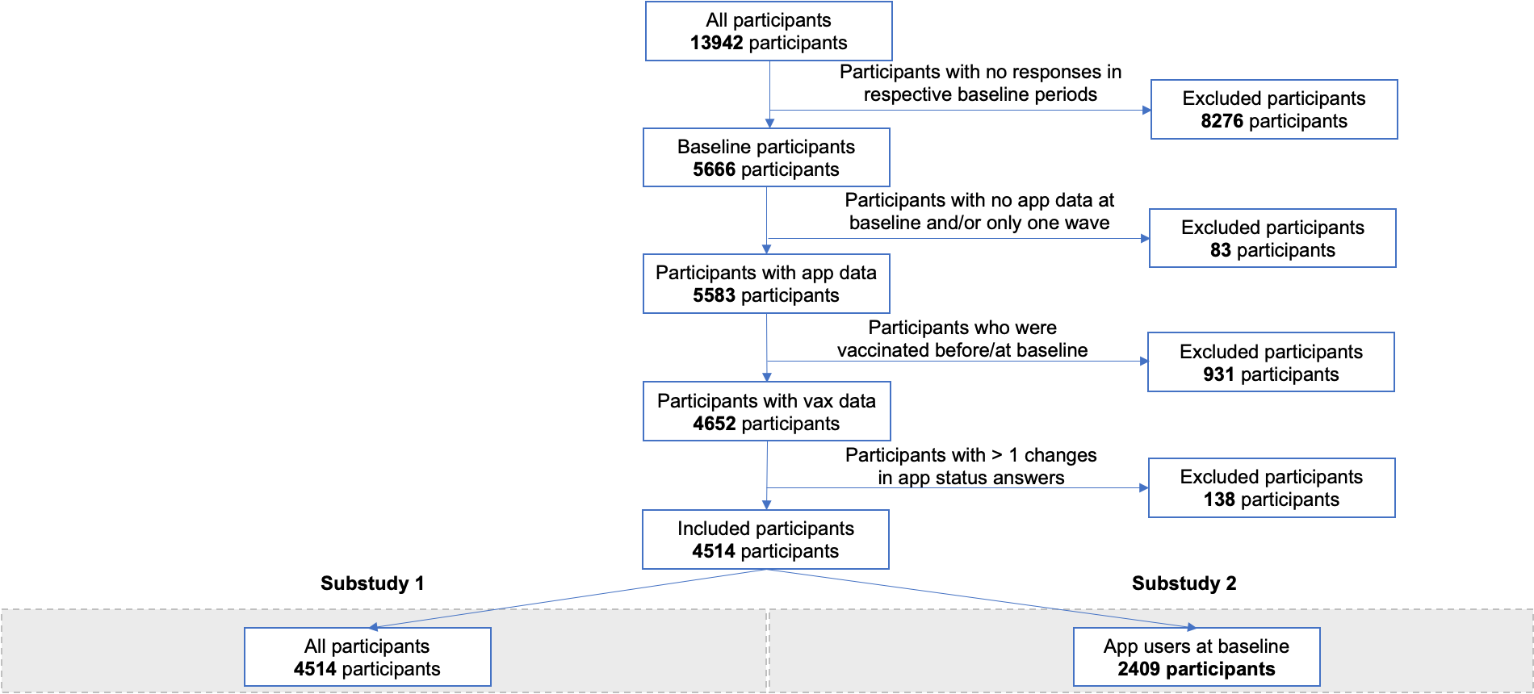

eFigure 3: Participant inclusion for the CSM

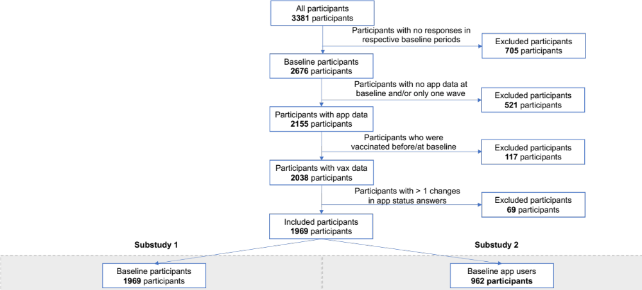
eTable 1: Subject-knowledge driven variable selection and rationale

Variables | Expected Correlation / Comments
Confounders fixed in model:
Age | The time-varying availability of vaccines based on age group can affect individuals’ choice to keep using digital proximity tracing apps as a preventive measure against SARS-CoV-2.
Chronic condition | Higher risk population groups may be more likely to adhere to preventive measures against SARS-CoV-2.
Gender | Vaccine hesitancy and uptake of additional preventive measures against SARS-CoV-2 spread has been shown to differ between genders.
Education | Individuals with higher levels of education tend to be more compliant with preventive measures against SARS-CoV-2.
Employment status | Individuals who work are expected to be healthier, which may have an impact on the extent to which they want to adhere to preventive measures against SARS-CoV-2.
Income level | Individuals with higher incomes may have easier means to comply to preventive measures against SARS-CoV-2.
Language region | Individuals from different language regions may show differences in acceptance and compliance to preventive measures against SARS-CoV-2.
Exposures / Outcomes of interest
Vaccine uptake | The use of digital proximity tracing application use may be perceived as a sensible preventive measure both in the absence of vaccine availability or following getting vaccinated against SARS-CoV-2.
SwissCovid app uninstalling | The use of a digital proximity tracing application may be perceived as a preventive measure against SARS-CoV-2.
Variables of interest (exploratory analyses):
Preventive measures | Individuals who adhere to other preventive measures against SARS-COV-2, such as social distancing, are more likely to complement such measures with getting vaccinated or using a digital proximity tracing app on a frequent or consistent basis.
Received app warning | Individuals who received a possible exposure to SARS-CoV-2 warning from a digital proximity tracing app may change their adherence to preventive measures, such as by uninstalling the app.
Positive test last month | Individuals who tested positive for SARS-CoV-2 may change their adherence to preventive measures.
Quarantine last month | Individuals who entered quarantine as a result of a possible exposure to SARS-CoV-2 may change their adherence to preventive measures.

eTable 2: Table of exposures and outcomes for vaccine uptake primary outcome

CI-DFU (n=4514)

 | SwissCovid app user | Not SwissCovid app user
Received first vaccine dose | 1734 (38%) | 1413 (31%)
Did not receive first vaccine dose | 607 (13%) | 760 (17%)

CSM (n=1969)

 | SwissCovid app user | Not SwissCovid app user
Received first vaccine dose | 878 (45%) | 763 (39%)
Did not receive first vaccine dose | 66 (3.3%) | 262 (13%)

eTable 3: Table of exposures and outcomes for SwissCovid app uninstalling primary outcome

CI-DFU (n=2409)

 | Received first vaccine dose | Did not receive first vaccine dose
Uninstalled SwissCovid | 150 (6.2%) | 59 (2.4%)
Kept using SwissCovid | 1662 (69%) | 538 (22%)

CSM (n=962)

 | Received first vaccine dose | Did not receive first vaccine dose
Uninstalled SwissCovid | 79 (8.2%) | 30 (3.1%)
Kept using SwissCovid | 797 (83%) | 56 (5.8%)

eTable 4: Effect sizes of confounders and variables of interest in exploratory multivariable analyses for vaccine uptake outcome

Variables | CI-DFU (n=4154) | CSM (n=1969)
 | Multivariable hazard ratio 95% CI | Multivariable hazard ratio 95% CI
Confounders fixed in model:
Gender:ª male | 1.04 (0.97 - 1.12) | 1.07 (0.97 - 1.18)
Gender: not reported | 1.08 (0.15 - 7.73) | n.a. (not available)
Education:^{b} mandatory schooling | 0.54 (0.13 - 2.21) | n.a.
Education: apprenticeship | 0.57 (0.14 - 2.28) | n.a.
Education: matura | 0.63 (0.15 - 2.53) | 1.19 (0.92 - 1.54)
Education: higher technical school / university of applied sciences | 0.59 (0.15 - 2.39) | n.a.
Education: university | 0.69 (0.17 - 2.76) | 1.46 (1.11 - 1.91)
Employment status^{c} | 0.88 (0.80 - 0.98) | 0.92 (0.80 - 1.05)
Income:^{d} CHF 3000 - 6000 (CI-DFU) | 1.12 (0.96 - 1.31) | n.a.
Income: CHF 6000 - 9000 (CI-DFU)  CHF 5000 - 9999 (CSM) | 1.26 (1.07 - 1.47) | 1.28 (1.12 - 1.46)
Income: CHF 9000 - 12000 (CI-DFU)  > 10000 CHF (CSM) | 1.28 (1.08 - 1.51) | 1.74 (1.49 - 2.05)
Income: CHF 12000 - 15000 (CI-DFU) | 1.47 (1.22 - 1.77) | n.a.
Income: CHF 15000 - 18000 (CI-DFU) | 1.45 (1.17 - 1.79) | n.a.
Income: CHF 18000 - 21000 (CI-DFU) | 1.63 (1.21 - 2.19) | n.a.
Income: >CHF 21000 (CI-DFU) | 1.65 (1.31 - 2.08) | n.a.
Income: not reported | n.a. | 1.17 (0.97 - 1.41)
Language region:^{e} German | 0.99 (0.87 - 1.11) | 0.96 (0.84 - 1.11)
Language region: French | n.a. | 1.03 (0.87 - 1.22)
Variables of interest (exploratory analyses):
Digital proximity tracing app use | 1.51 (1.40 - 1.62) | 1.79 (1.62 - 1.99)
Preventive measures^{f} | 1.44 (1.28 - 1.62) | 1.82 (1.52 - 2.18)
Received app warning | 1.12 (0.85 - 1.47) | 0.77 (0.34 - 1.73)
Positive test last month | 0.04 (0.01 - 0.31) | 0.18 (0.07 - 0.47)
Quarantine last month | 1.04 (0.84 - 1.28) | 1.25 (0.86 - 1.82)

ª Reference: Female gender
^{b} Reference: No school certificate (CI-DFU); Compulsory schooling (CSM)
^{c} Reference: Unemployed
^{d} Reference: < 3000 CHF (CI-DFU); < 5000 CHF (CSM)
^{e} Reference: French region (CI-DFU); Italian region (CSM)
^{f} Reference: Did not take at least one preventive measure

eTable 5: Effect sizes of confounders and variables of interest in exploratory multivariable analyses for SwissCovid app uninstalling

Variables | CI-DFU (n=2409) | CSM (n=962)
 | Multivariable hazard ratio 95% CI | Multivariable hazard ratio 95% CI
Confounders fixed in model:
Gender:ª male | 0.96 (0.71 - 1.30) | 1.13 (0.76 - 1.68)
Gender: not reported | n.a. (not available) | n.a.
Education:^{b} mandatory schooling | n.a. (HR < 0.01) | n.a.
Education: apprenticeship | n.a. (HR < 0.01) | n.a.
Education: matura | n.a. (HR < 0.01) | 1.29 (0.31 - 5.35)
Education: higher technical school / university of applied sciences | n.a. (HR < 0.01) | n.a.
Education: university | n.a. (HR < 0.01) | 1.16 (0.27 - 4.98)
Employment status^{c} | 0.91 (0.59 - 1.42) | 1.02 (0.58 - 1.79)
Income:^{d} CHF 3000 - 6000 (CI-DFU) | 1.11 (0.61 - 2.00) | n.a.
Income: CHF 6000 - 9000 (CI-DFU)  CHF 5000 - 9999 (CSM) | 0.67 (0.36 - 1.23) | 1.29 (0.72 - 2.31)
Income: CHF 9000 - 12000 (CI-DFU)  > 10000 CHF (CSM) | 0.65 (0.34 - 1.23) | 1.67 (0.87 - 3.19)
Income: CHF 12000 - 15000 (CI-DFU) | 0.89 (0.44 - 1.79) | n.a.
Income: CHF 15000 - 18000 (CI-DFU) | 0.70 (0.30 - 1.61) | n.a.
Income: CHF 18000 - 21000 (CI-DFU) | 0.14 (0.02 - 1.12) | n.a.
Income: >CHF 21000 (CI-DFU) | 0.66 (0.25 - 1.76) | n.a. d
Income: not reported | n.a. | 1.62 (0.78 - 3.34)
Language region:^{e} German | 0.98 (0.59 - 1.62) | 1.01 (0.56 - 1.80)
Language region: French | n.a. | 0.88 (0.42 - 1.83)
Variables of interest:
Vaccination status | 0.55 (0.38 - 0.81) | 0.45 (0.27 - 0.78)
Preventive measures^{f} | 0.81 (0.56 - 1.16) | 1.18 (0.72 - 1.95)
Received app warning | 1.13 (0.27 - 4.68) | 1.14 (0.14 - 9.23)
Positive test last month | 3.64 (0.74 - 17.89) | 0.60 (0.05 - 6.73)
Quarantine last month | 1.16 (0.43 - 3.12) | 2.38 (0.58 - 9.85)

ª Reference: Female gender
^{b} Reference: No school certificate (CI-DFU); Compulsory schooling (CSM)
^{c} Reference: Unemployed
^{d} Reference: < 3000 CHF (CI-DFU); < 5000 CHF (CSM)
^{e} Reference: French region (CI-DFU); Italian region (CSM)
^{f} Reference: Did not take at least one preventive measure

eFigure 4: Cumulative hazard curves for the Inverse Probability of Censoring Weighting (IPWC) analysis for vaccine uptake outcome based on SwissCovid app use. Panel A curves are from the CI-DFU, while panel B curves are from the CSM.
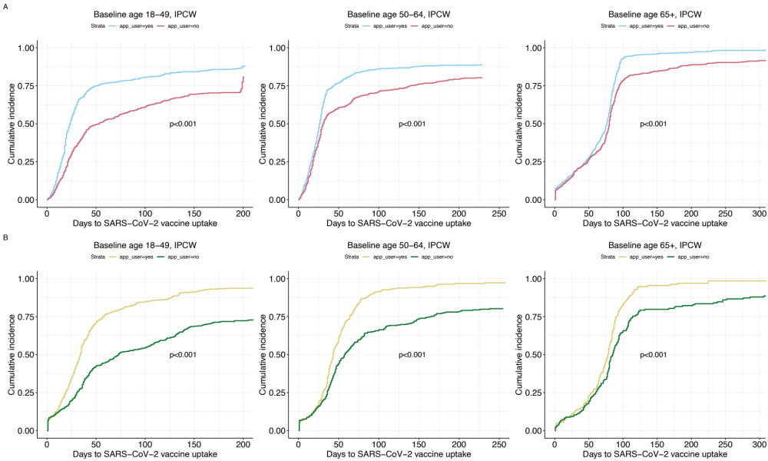

eFigure 5: Cumulative hazard curves for the Inverse Probability of Censoring Weighting (IPWC) analysis for SwissCovid app uninstalling outcome based on vaccine uptake. Panel A curves are from the CI-DFU, while panel B curves are from the CSM.

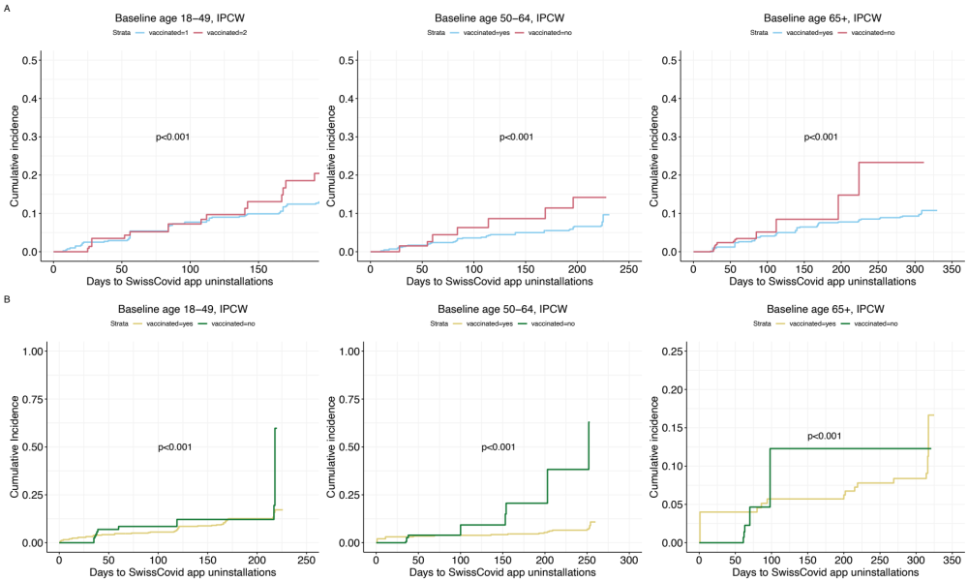

eFigure 6: Point process Poisson regressions for vaccine uptake outcome based on SwissCovid app use. Panel A curves are from the CI-DFU, while panel B curves are from the CSM.

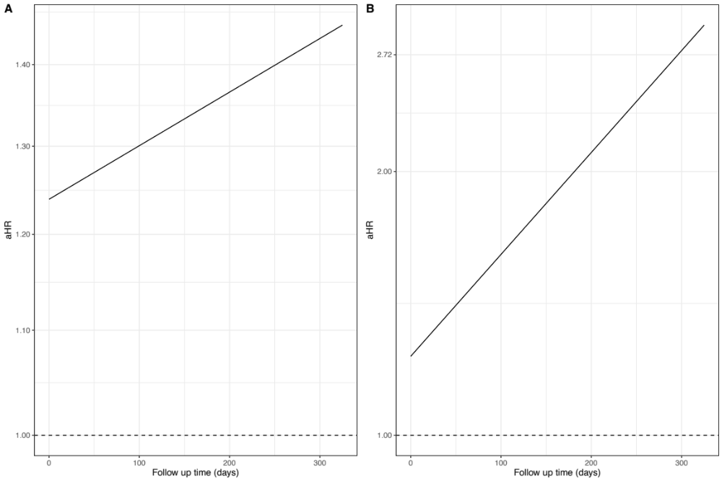
eFigure 7: Point process Poisson regressions for SwissCovid app uninstalling outcome based on vaccine uptake. Panel A curves are from the CI-DFU, while panel B curves are from the CSM.

