Plots for meta-analysis results on resistance rates of A. flavus to amphotericin B
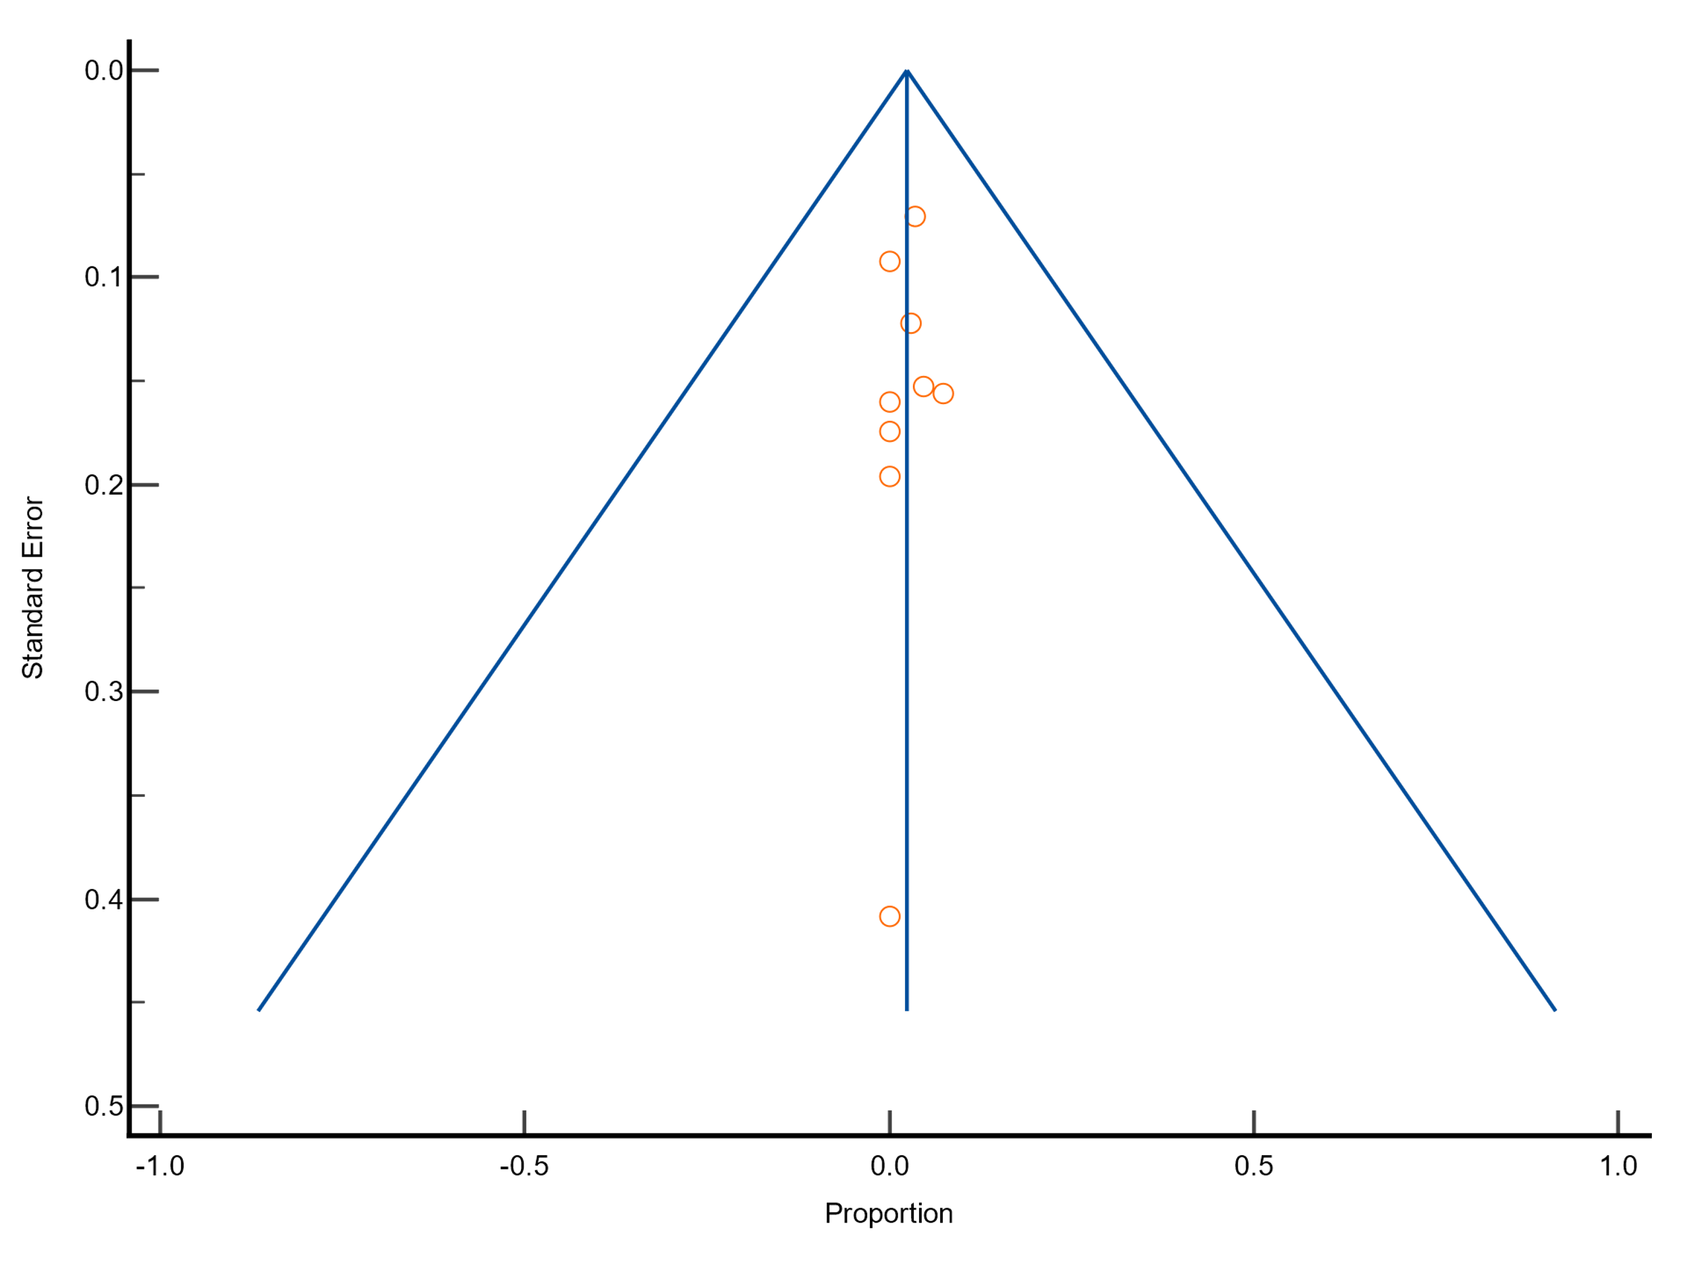
Funnel plot
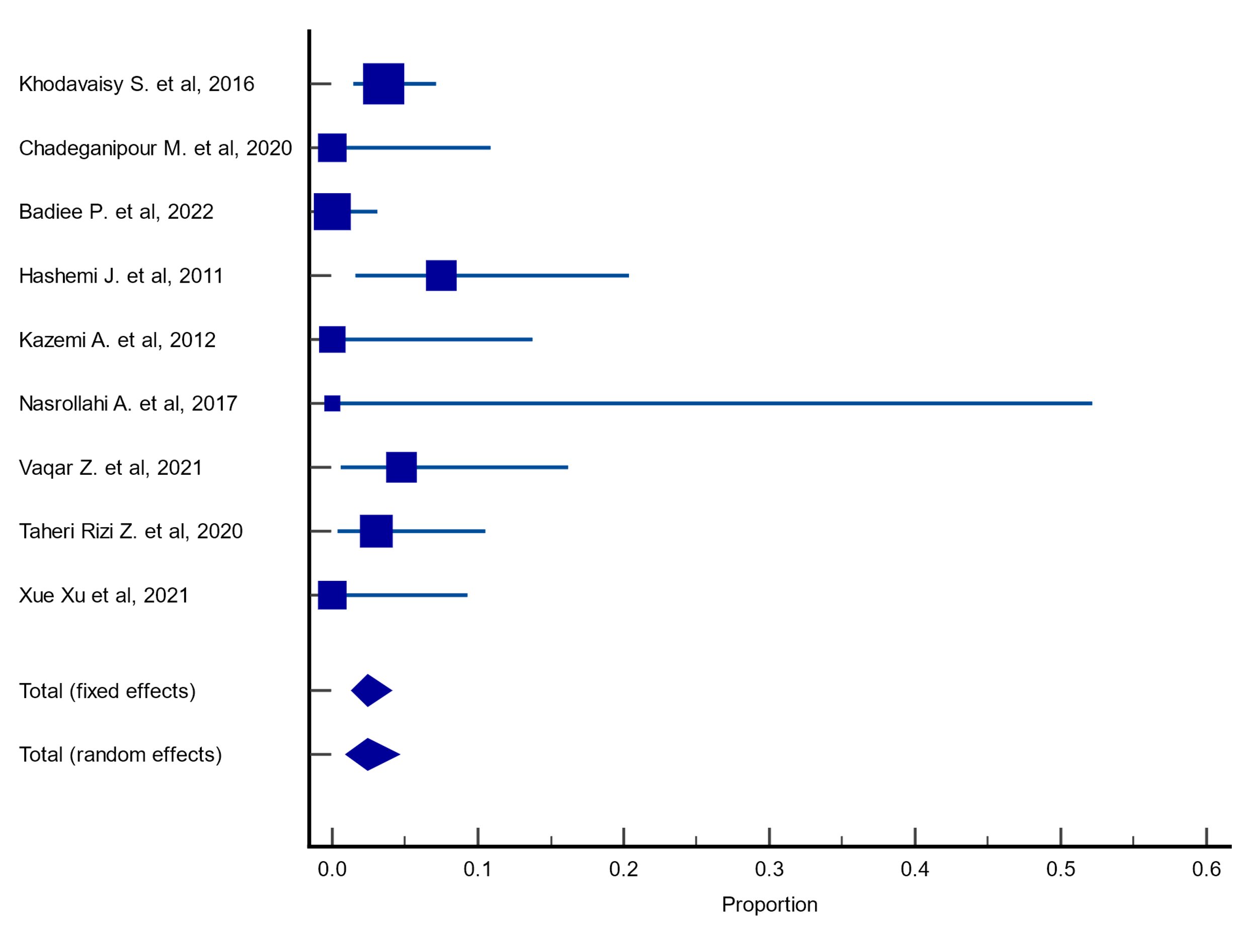
Forest plot

Plots for meta-analysis results on resistance rates of A. fumigatus to amphotericin B
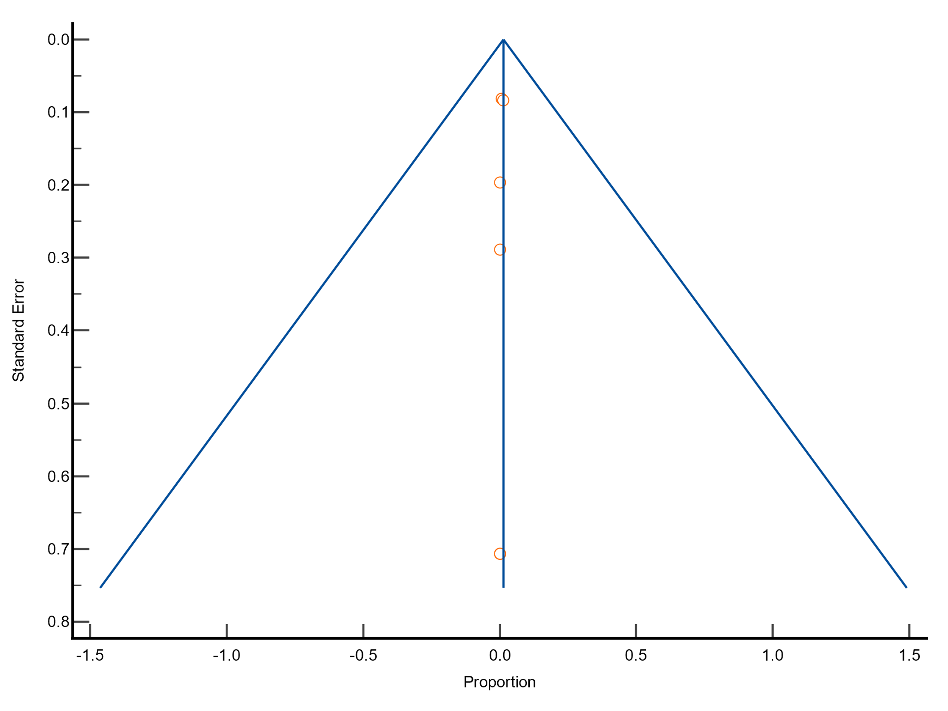
Funnel plot
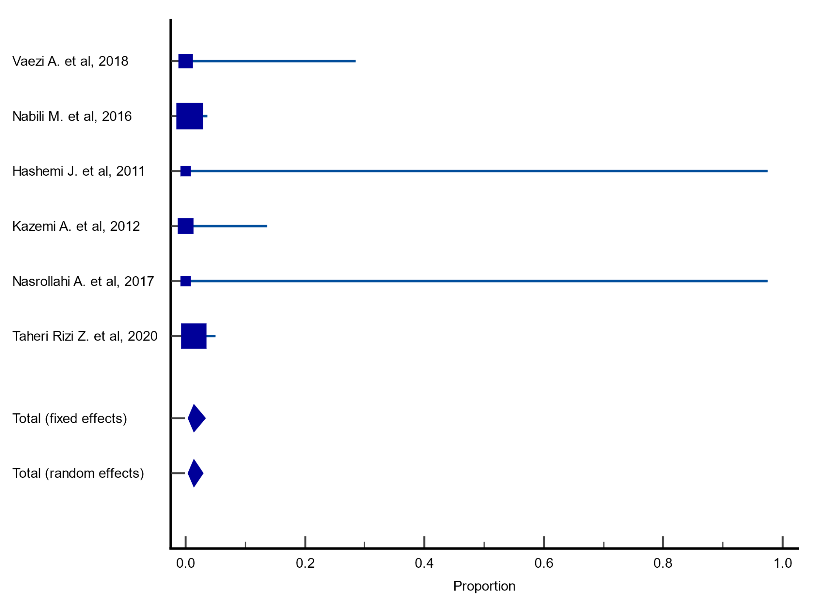
Forest plot

Plots for meta-analysis results on resistance rates of A. niger to amphotericin B
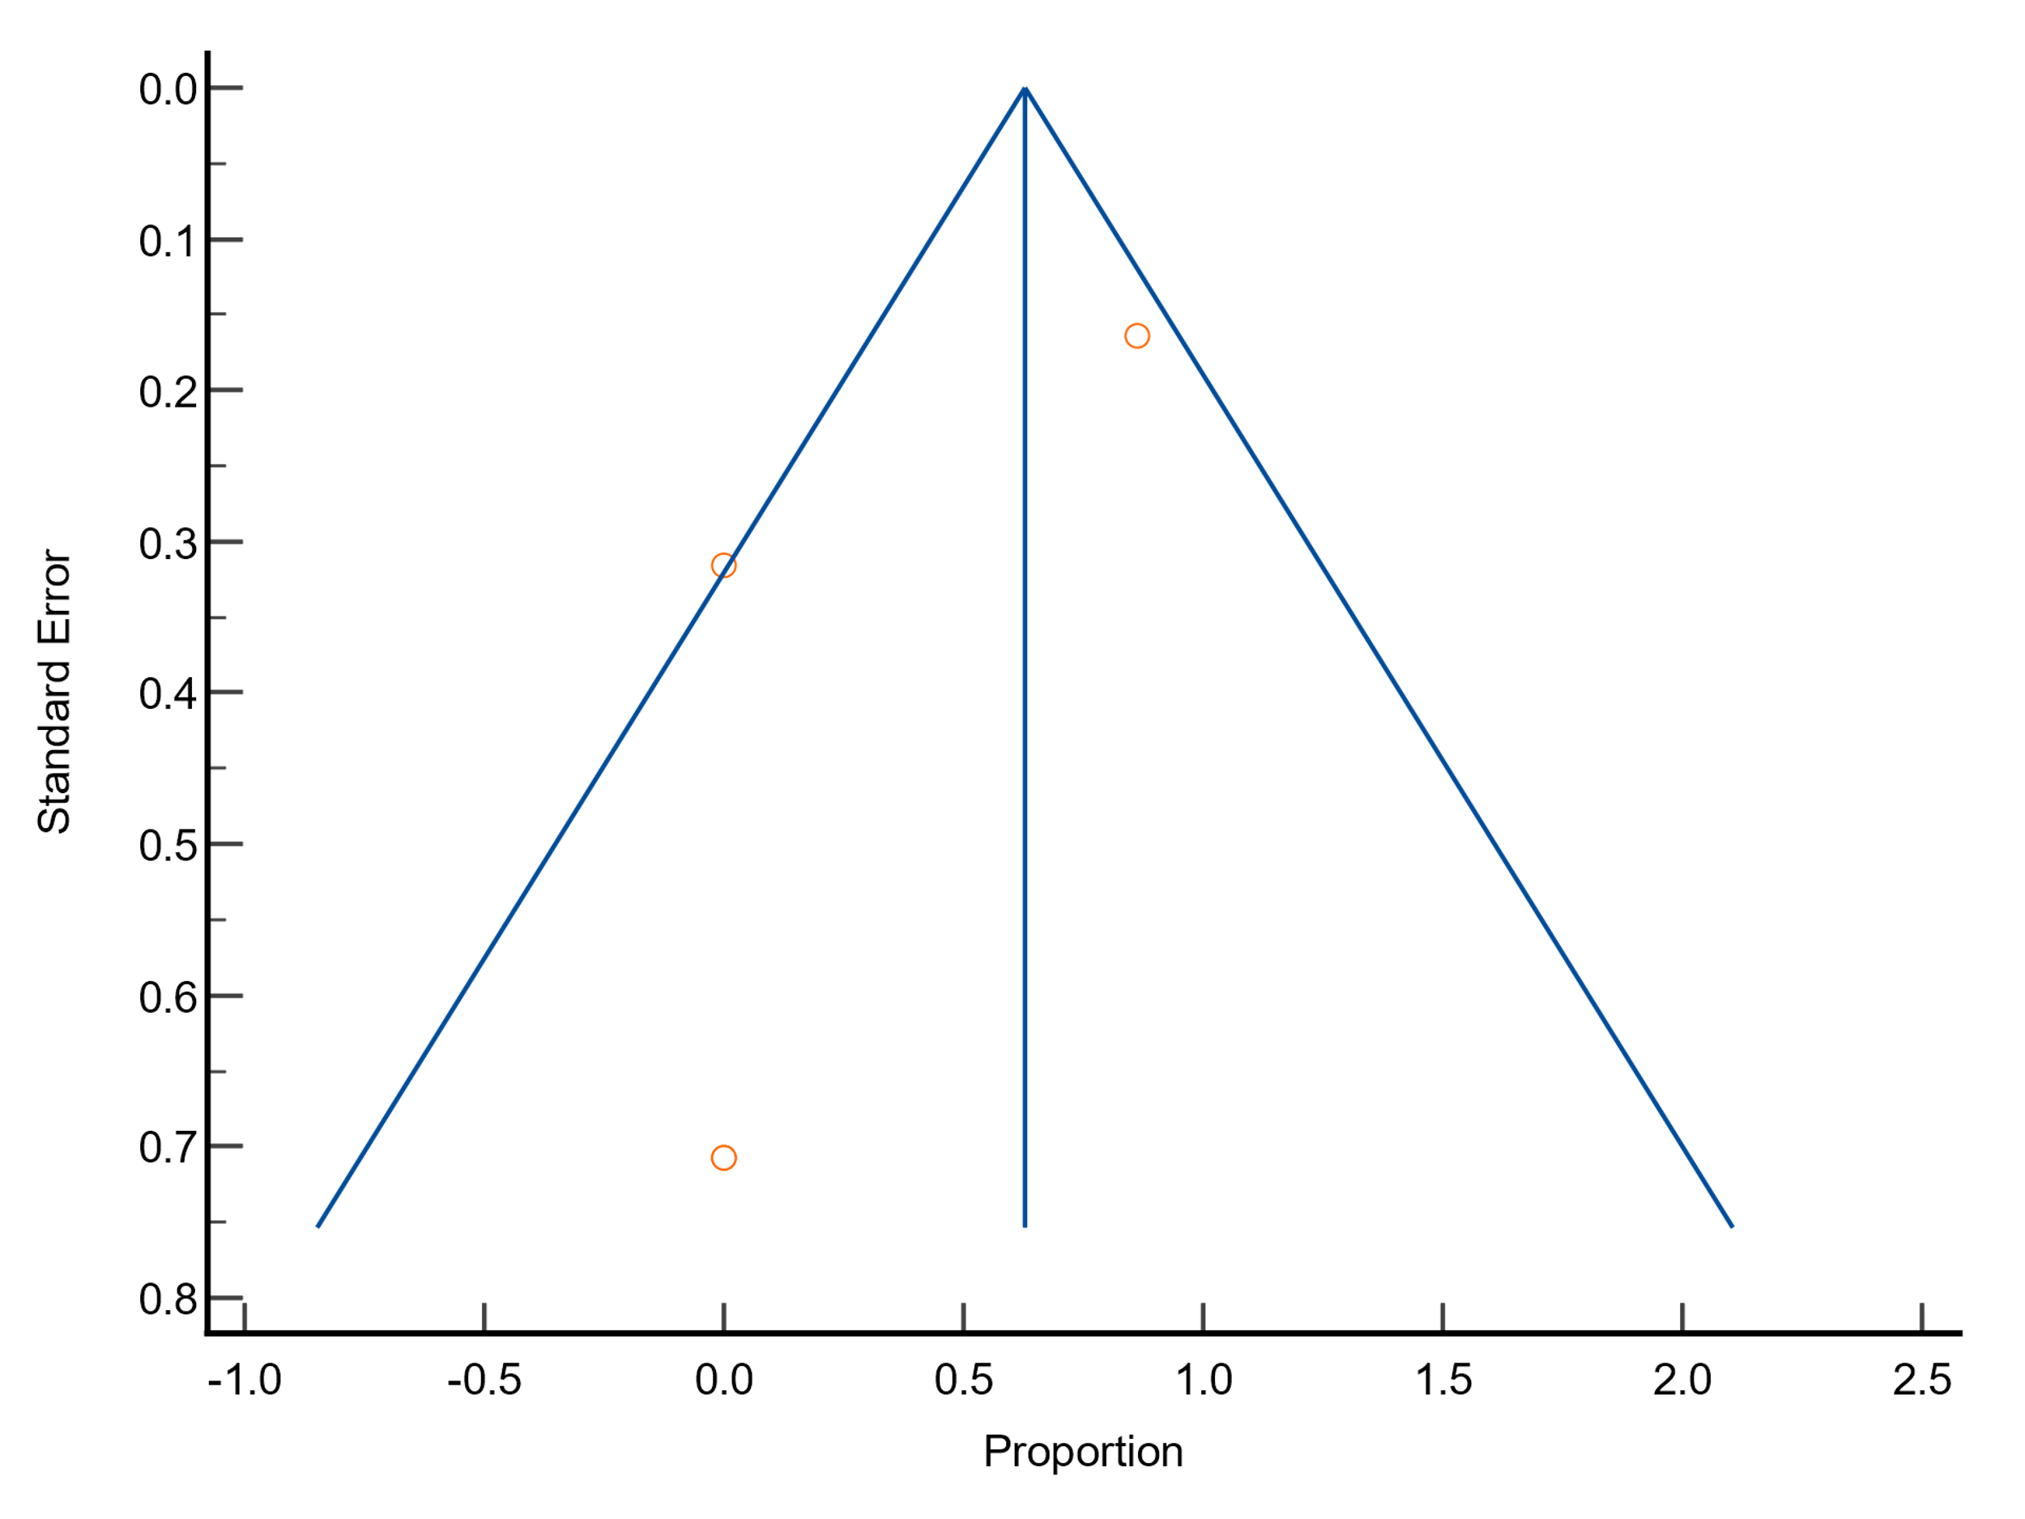
Funnel plot
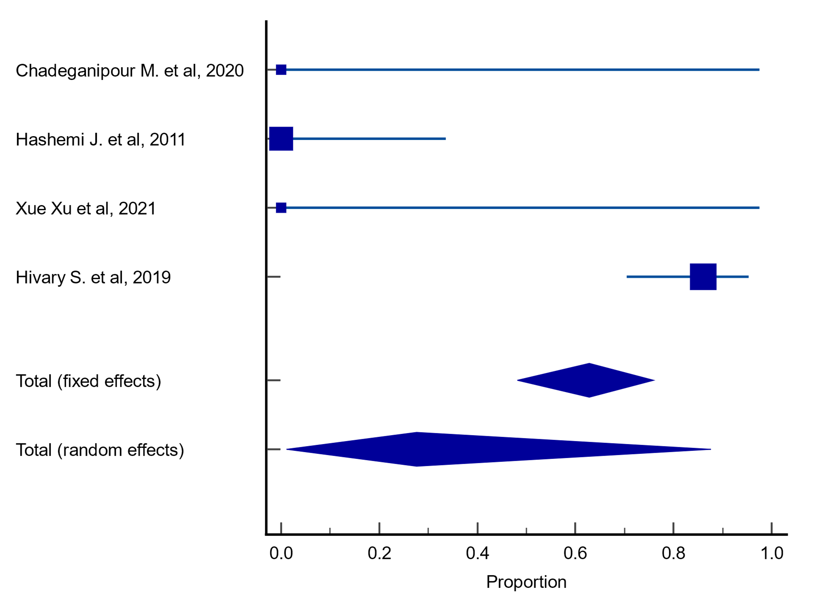
Forest plot

Plots for meta-analysis results on resistance rates of A. terreus to amphotericin B
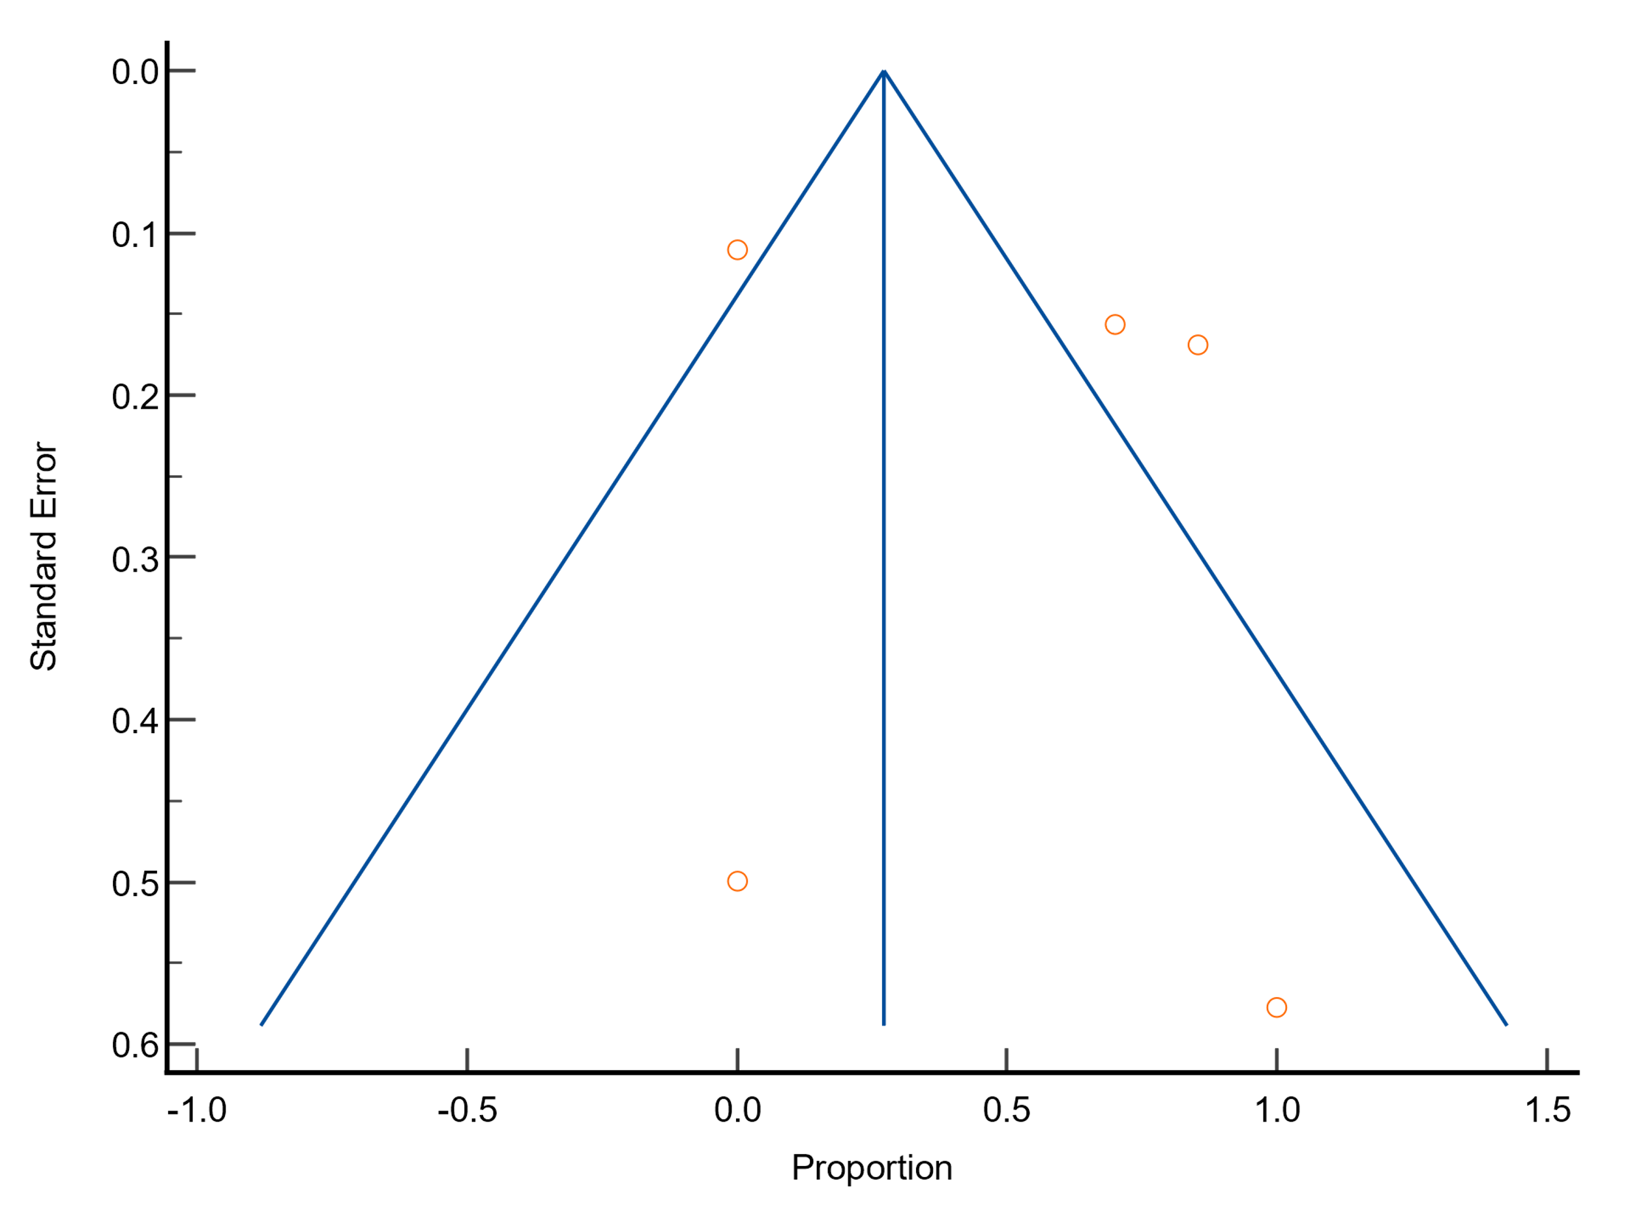
Funnel plot
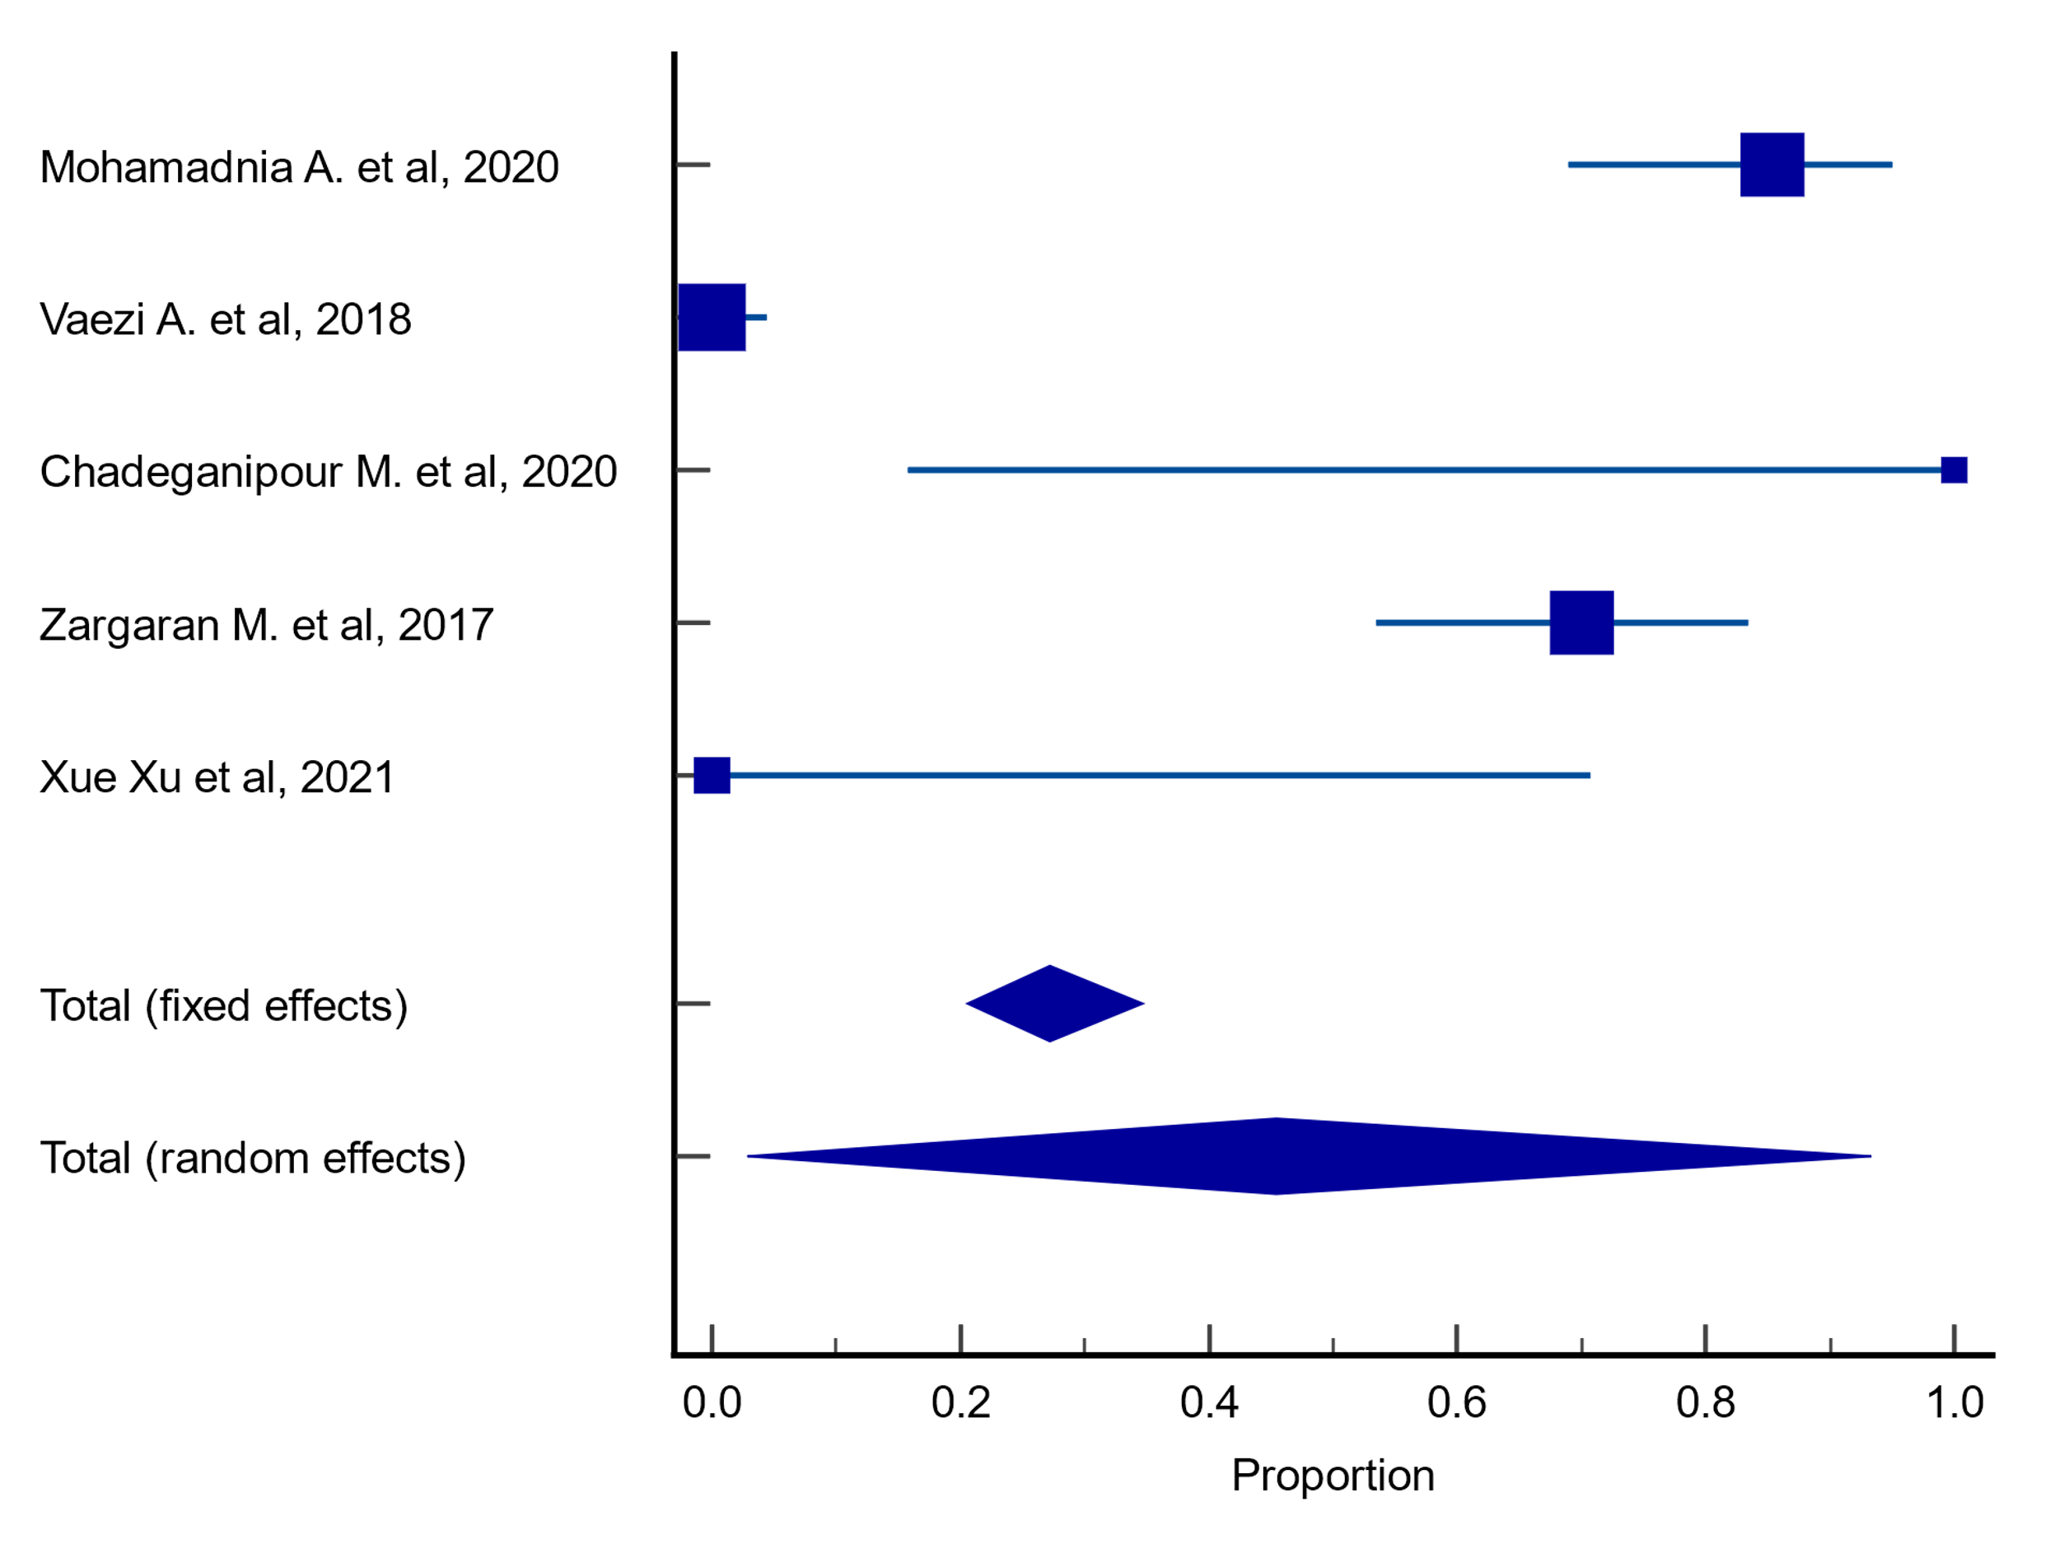
Forest plot

Plots for meta-analysis results on resistance rates of A. flavus to caspofungin
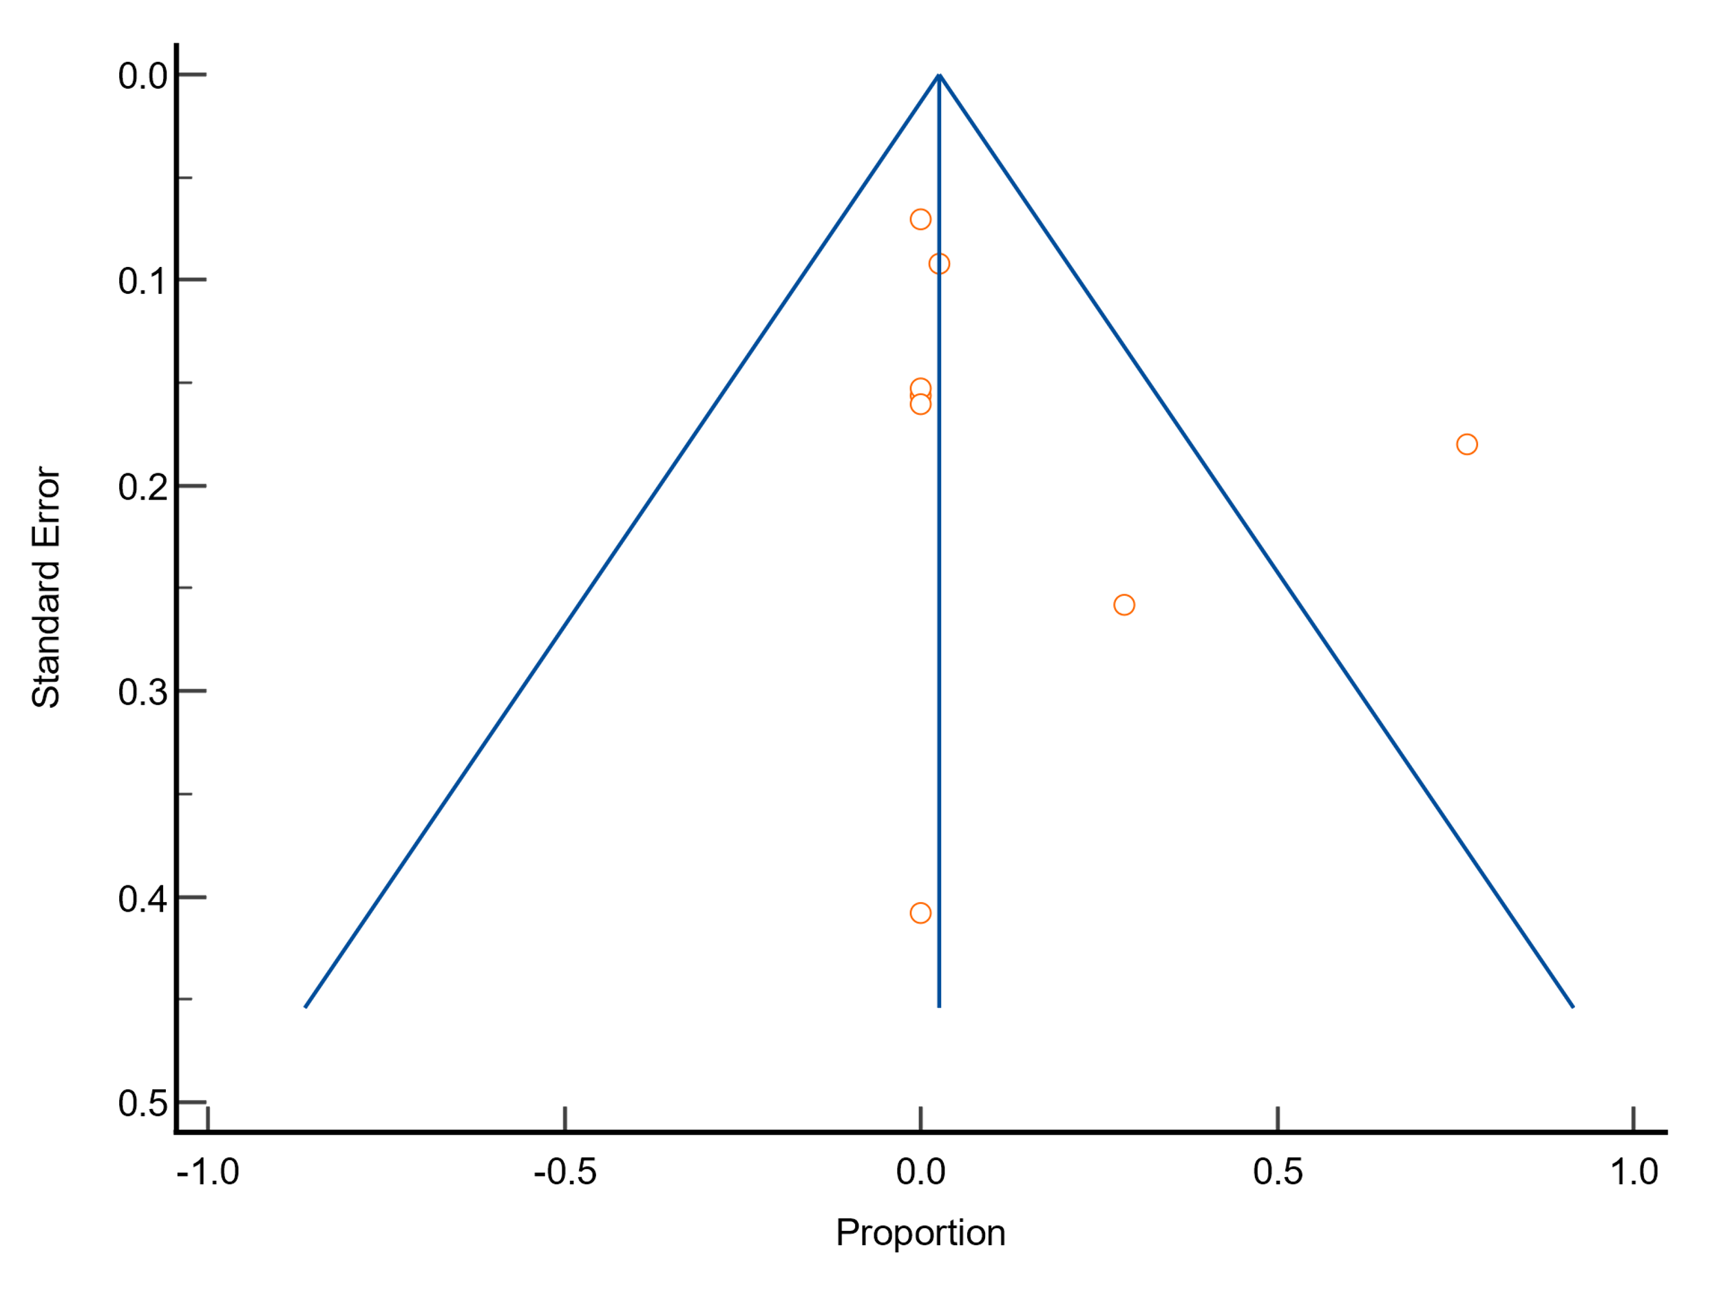
Funnel plot
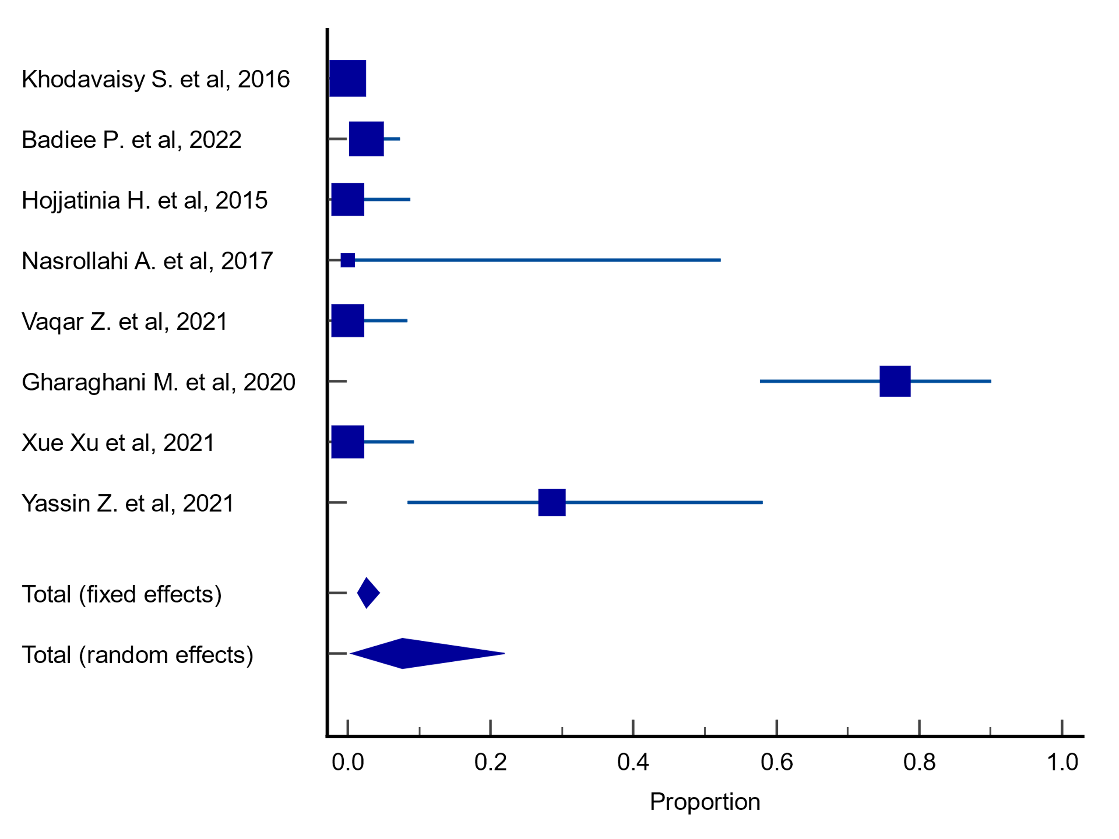
Forest plot

Plots for meta-analysis results on resistance rates of A. niger to caspofungin
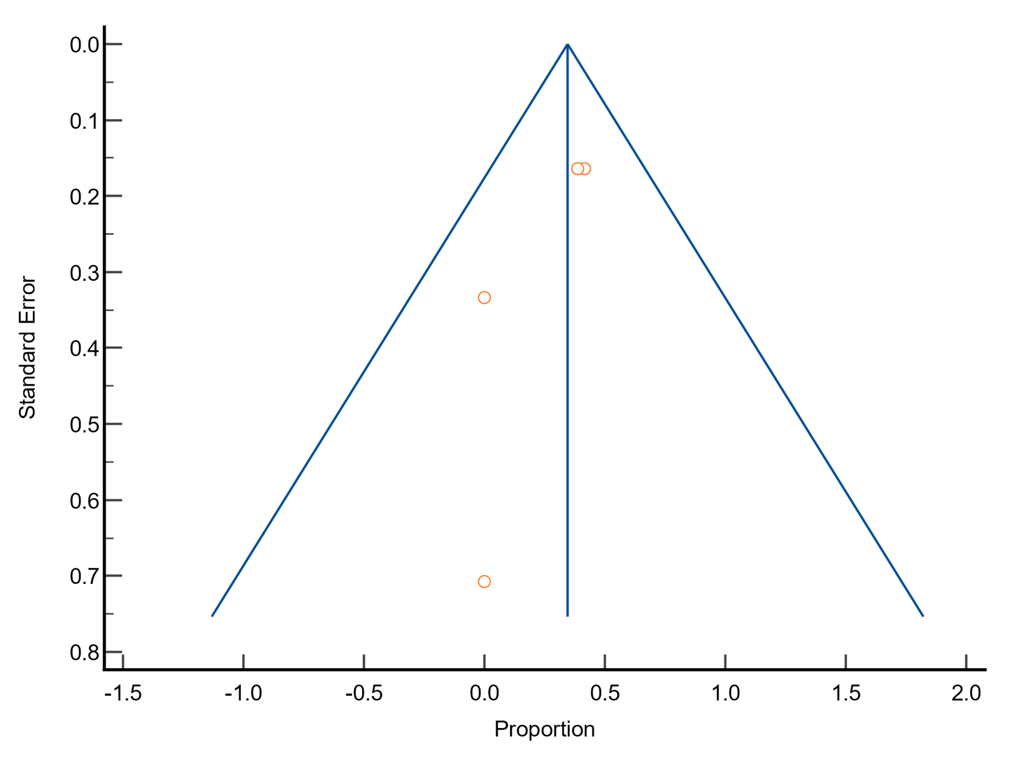
Funnel plot
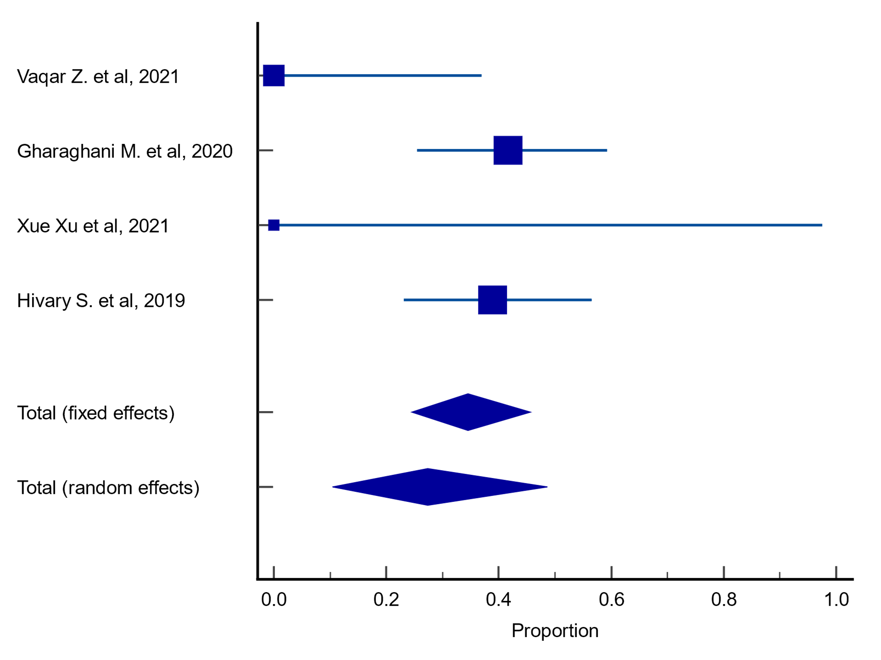
Forest plot

Plots for meta-analysis results on resistance rates of A. terreus to caspofungin
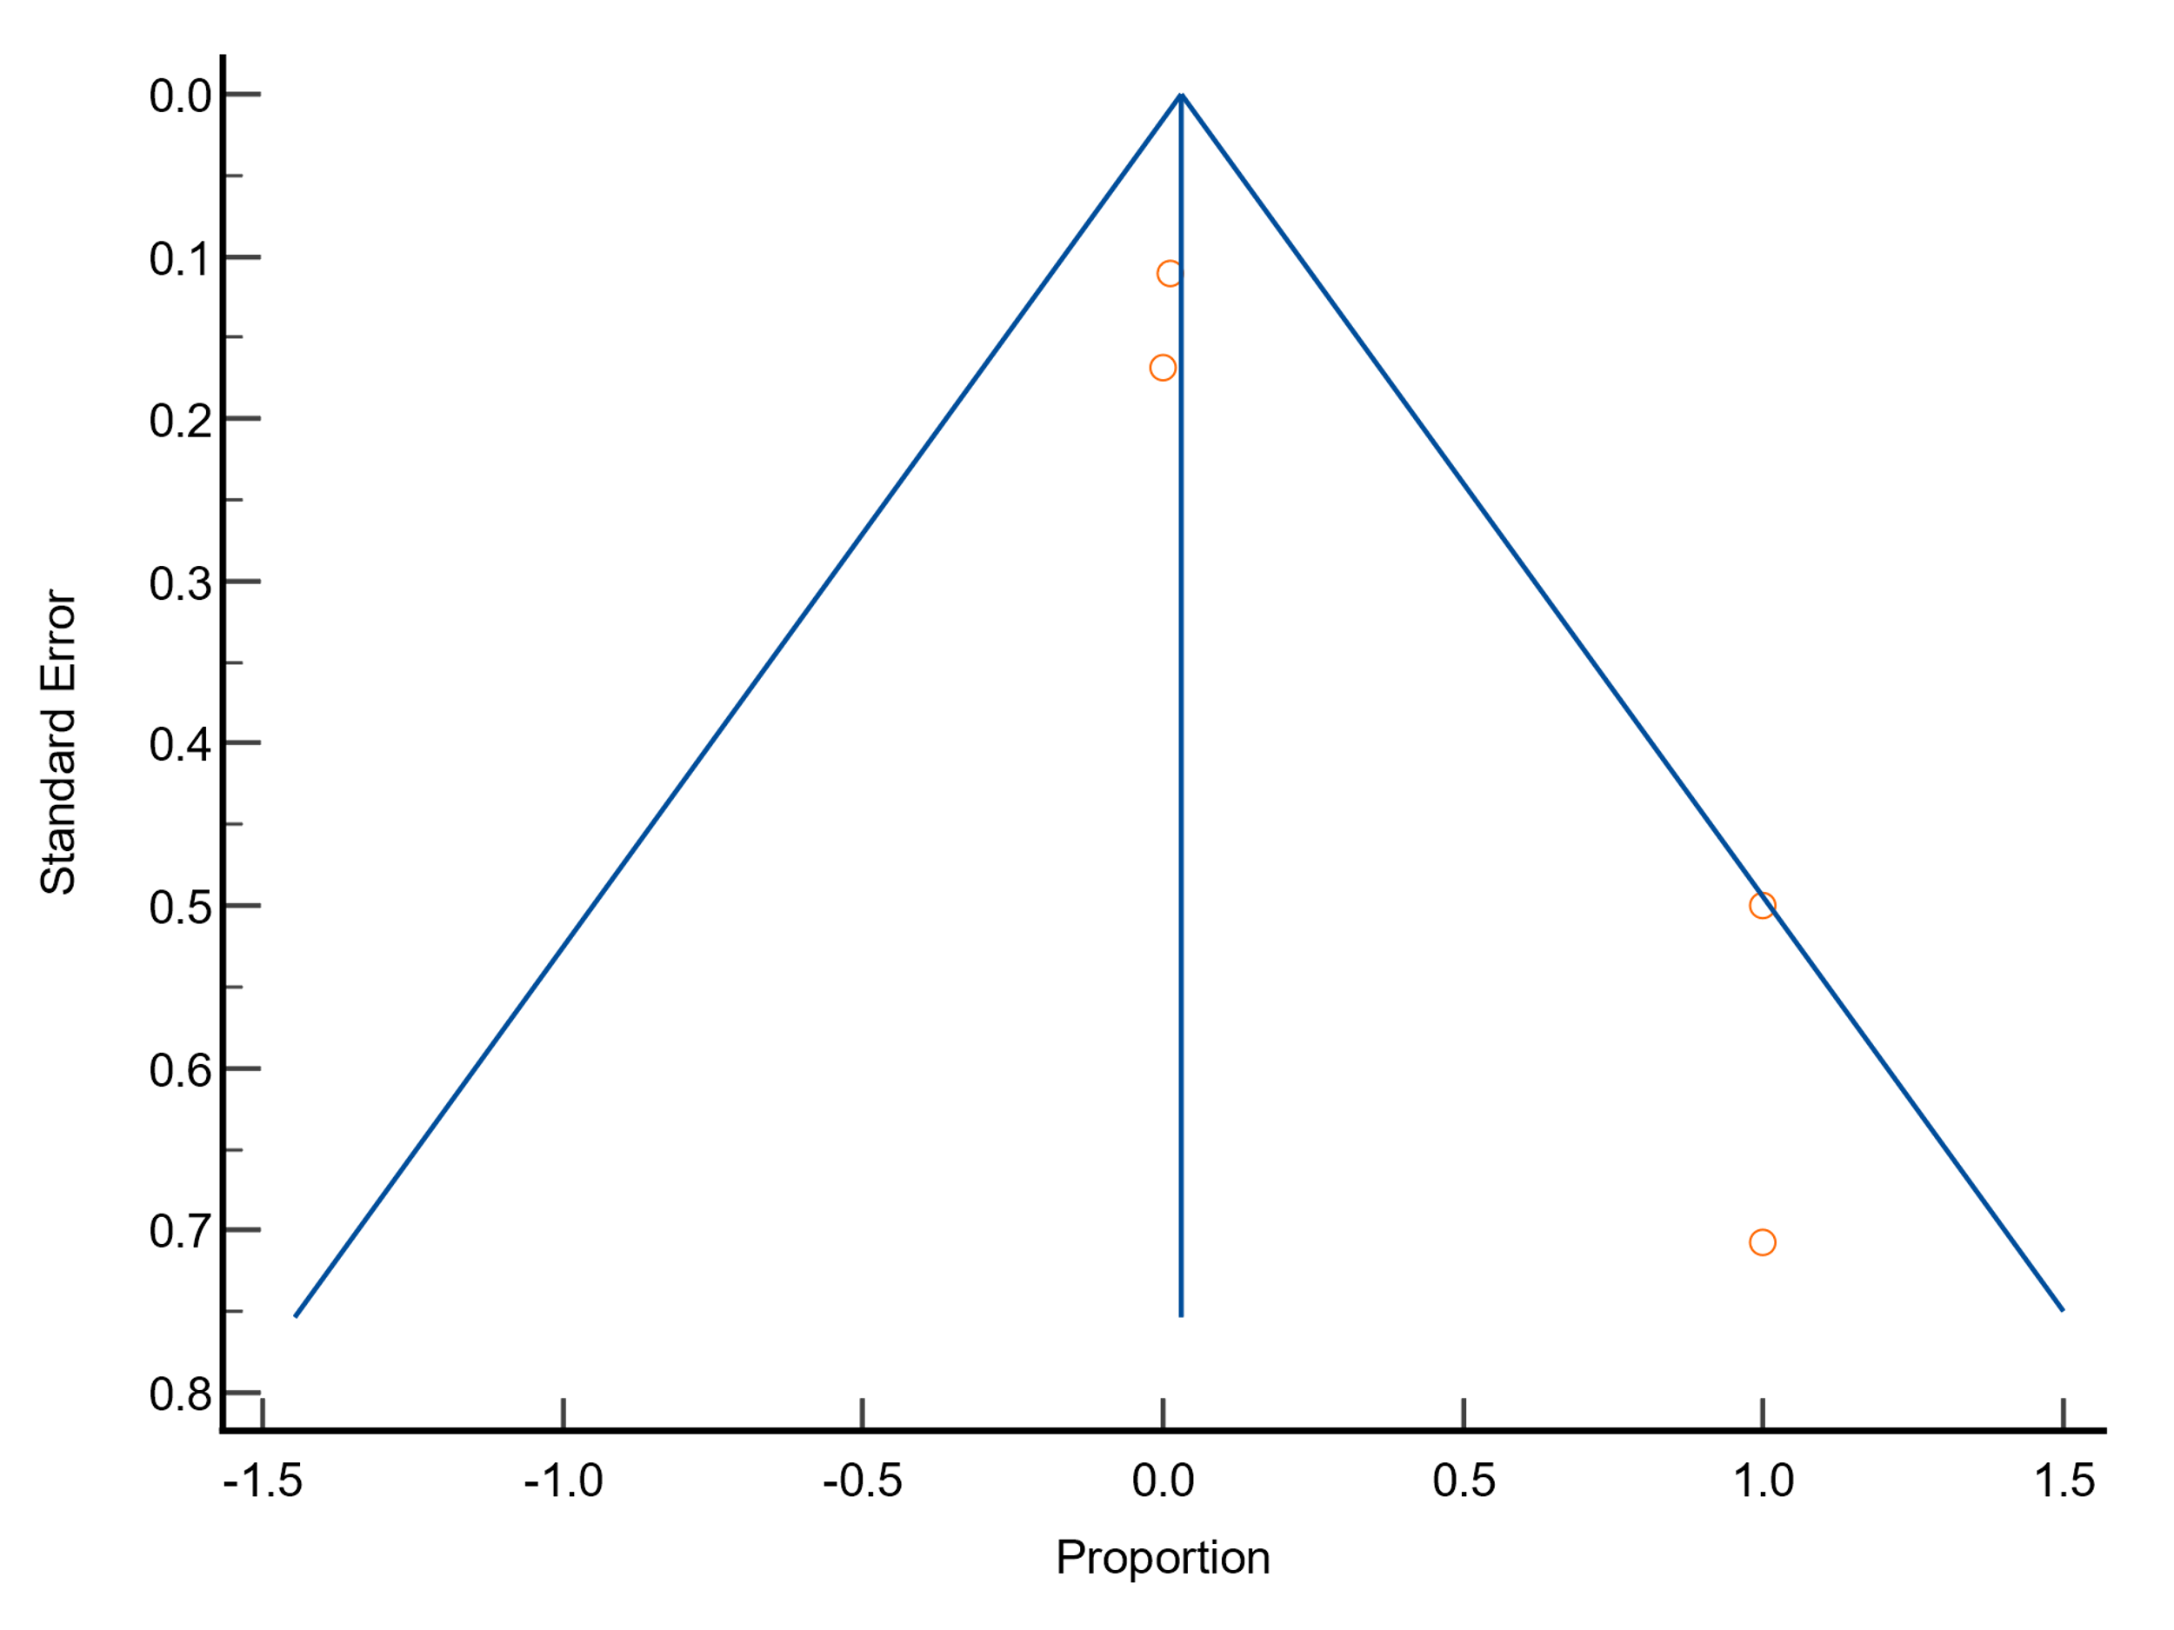
Funnel plot
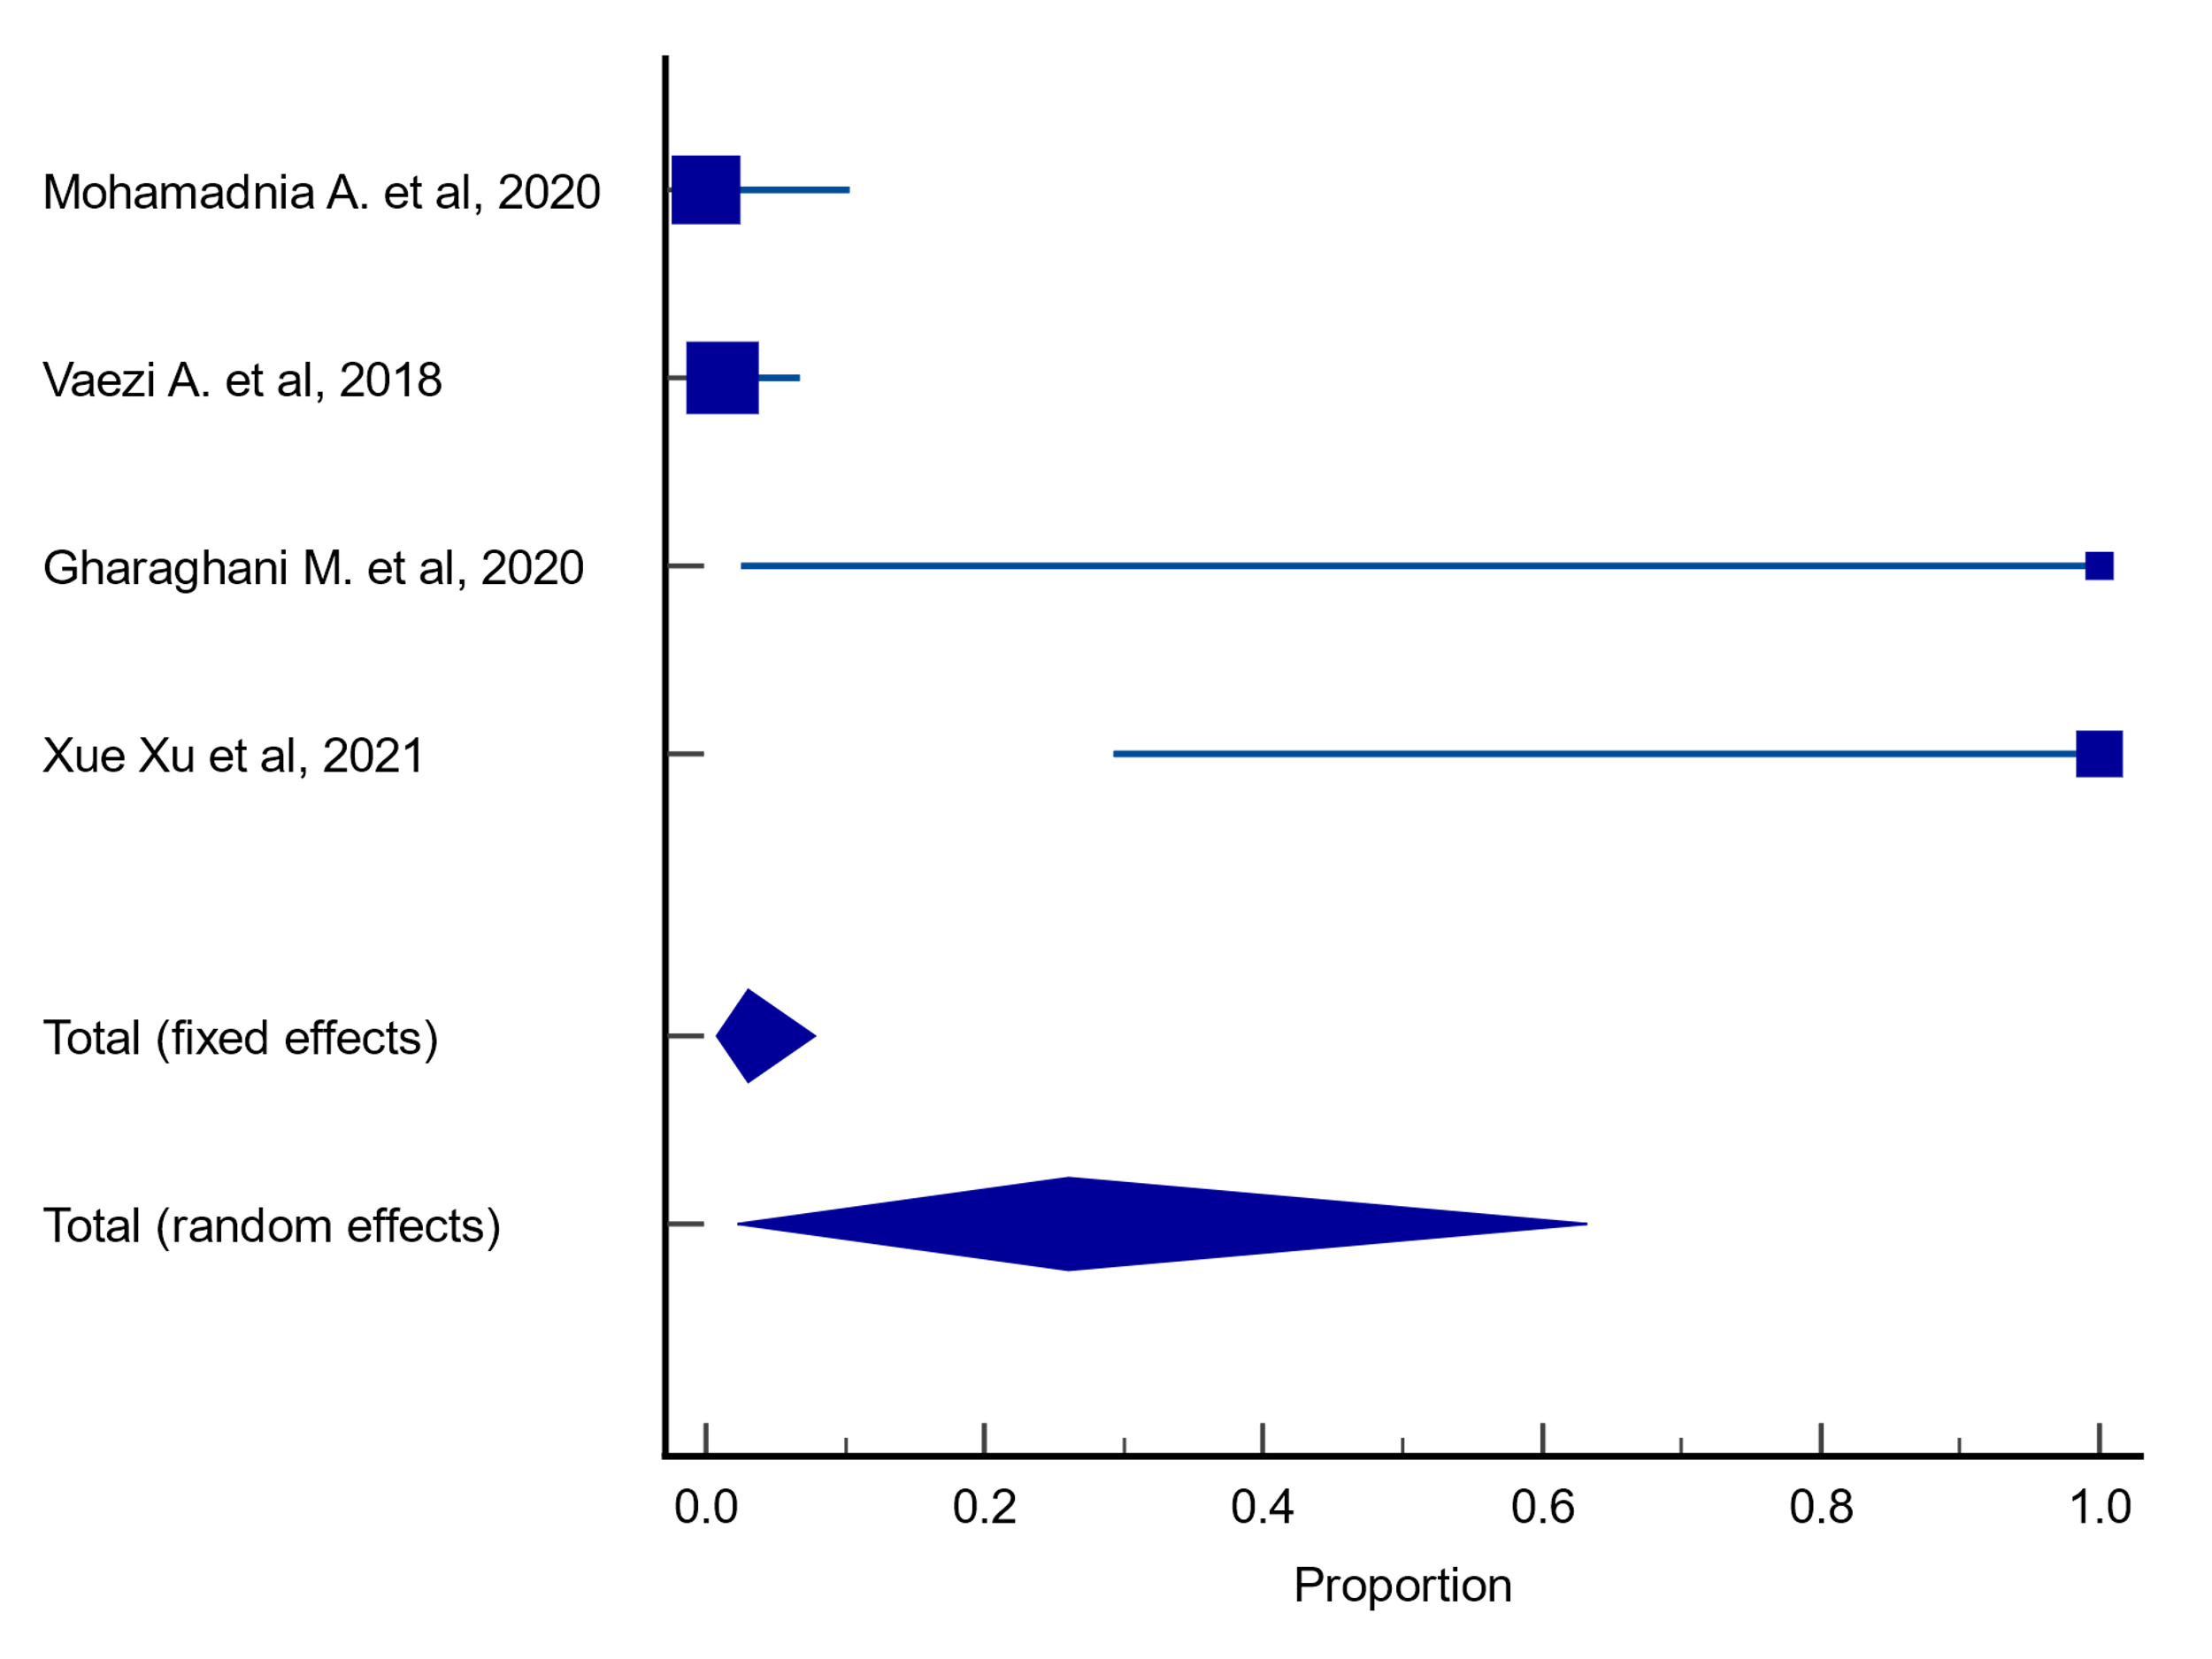
Forest plot

Plots for meta-analysis results on resistance rates of A. flavus to itraconazole
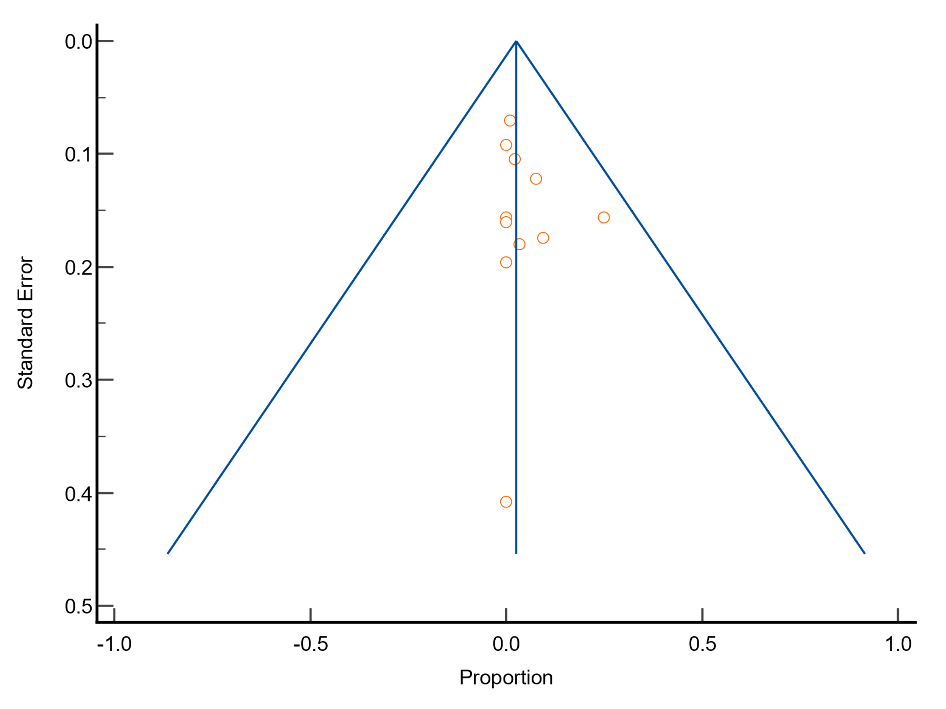
Funnel plot
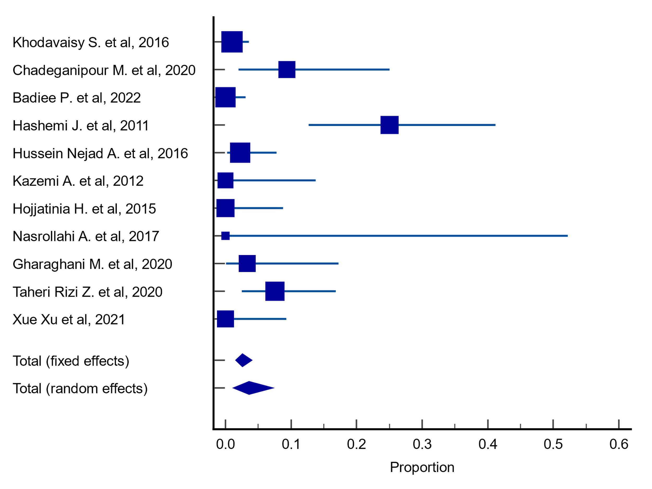
Forest plot

Plots for meta-analysis results on resistance rates of A. fumigatus to itraconazole
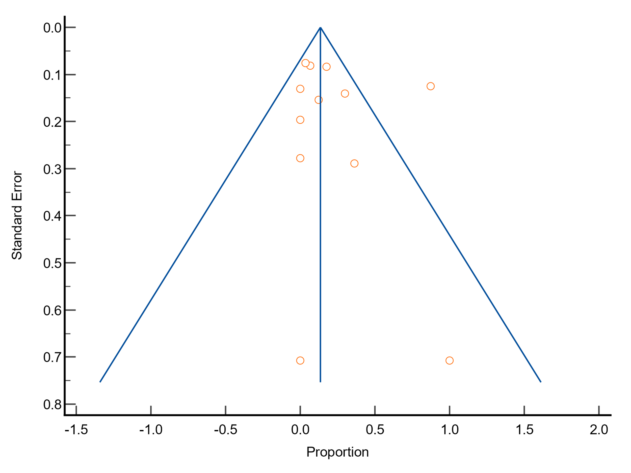
Funnel plot
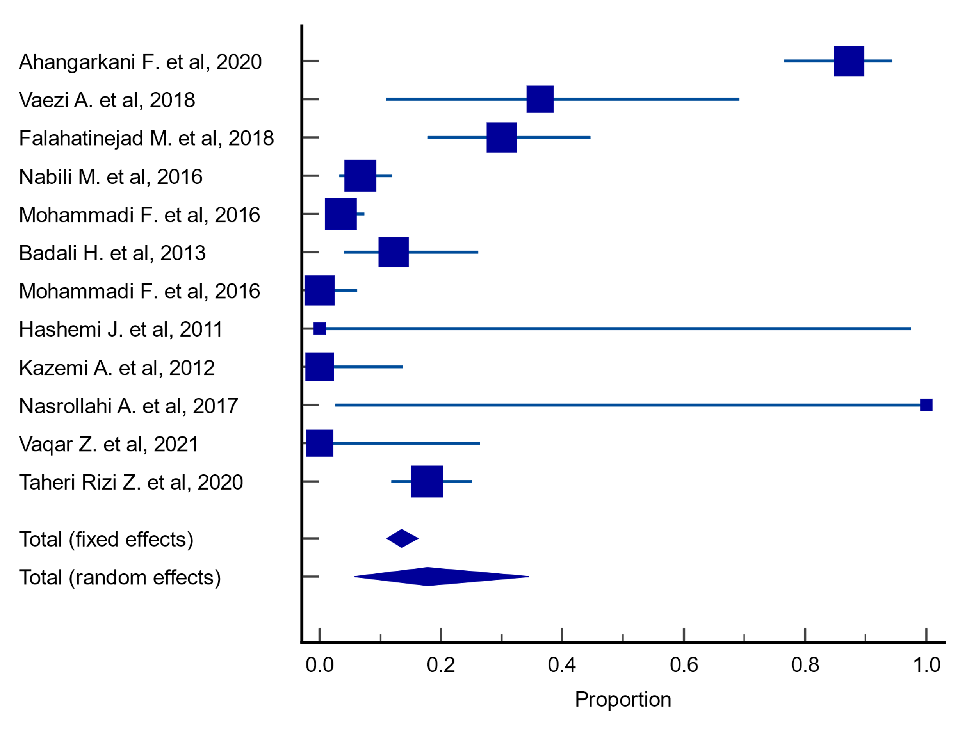
Forest plot

Plots for meta-analysis results on resistance rates of A. niger to itraconazole
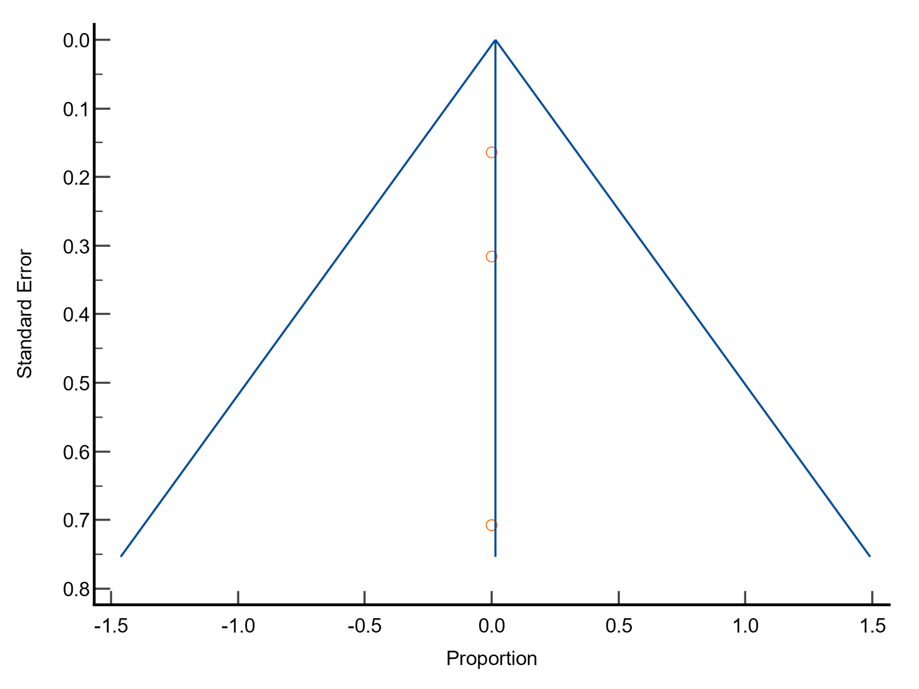
Funnel plot
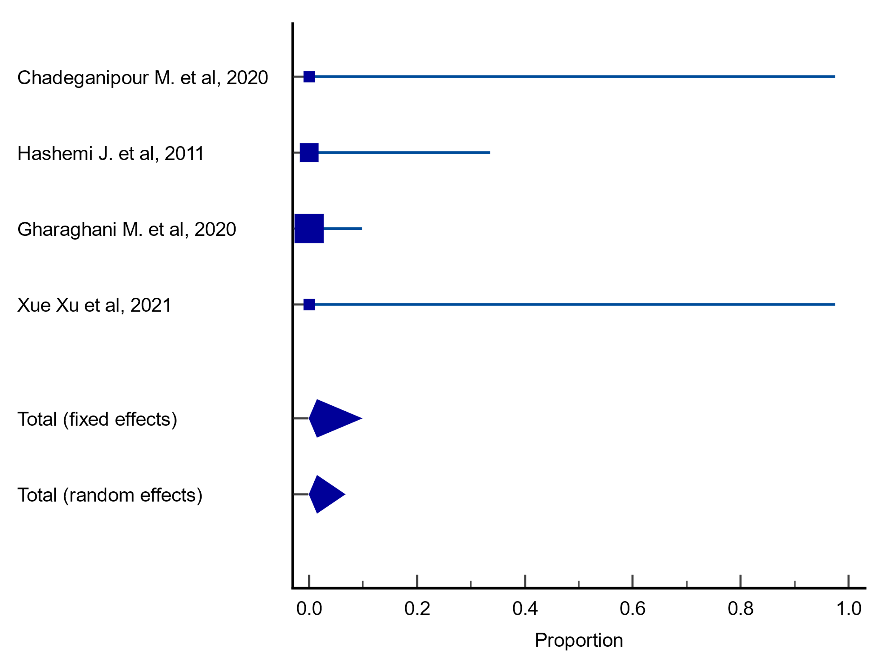
Forest plot

Plots for meta-analysis results on resistance rates of A. terreus to itraconazole
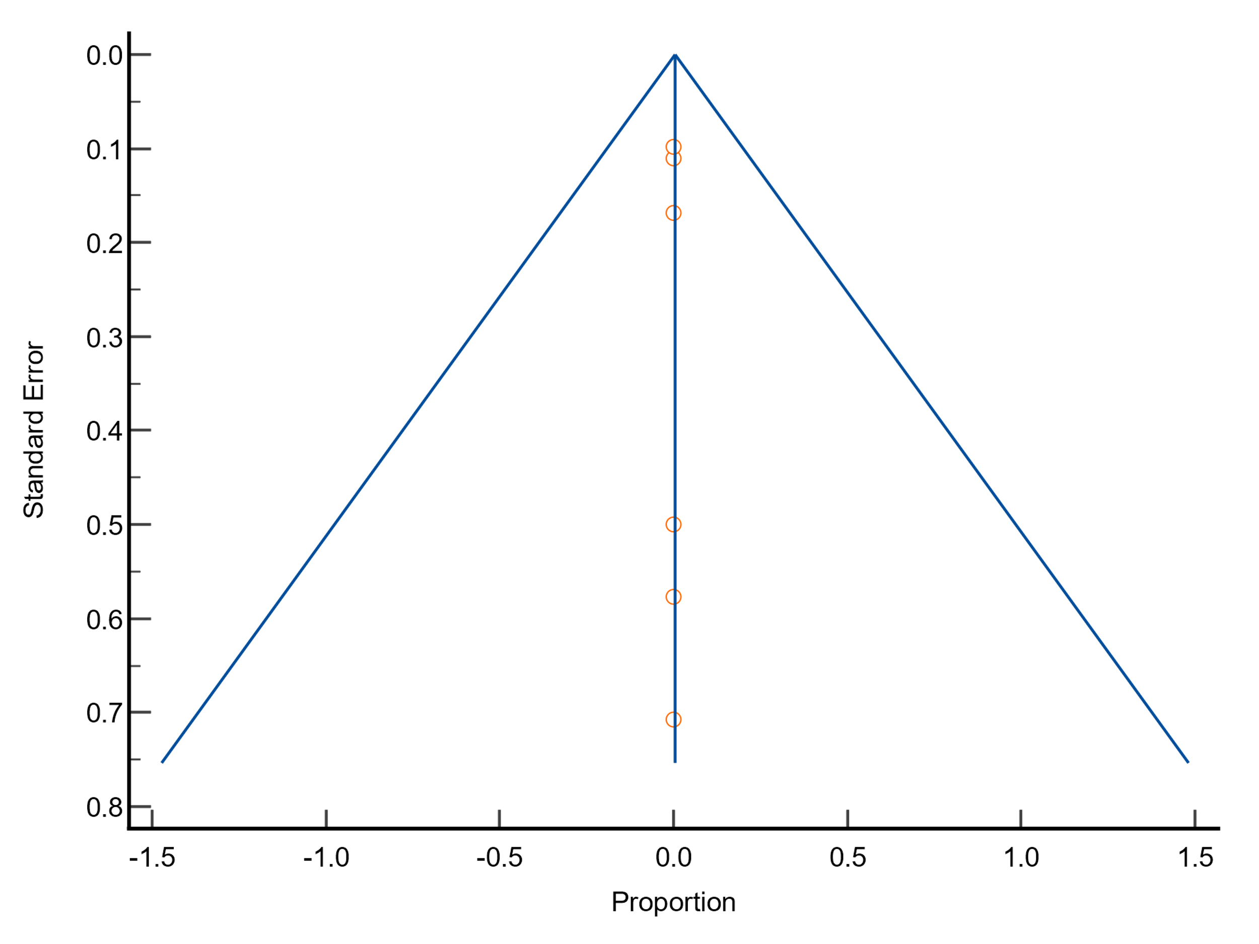
Funnel plot
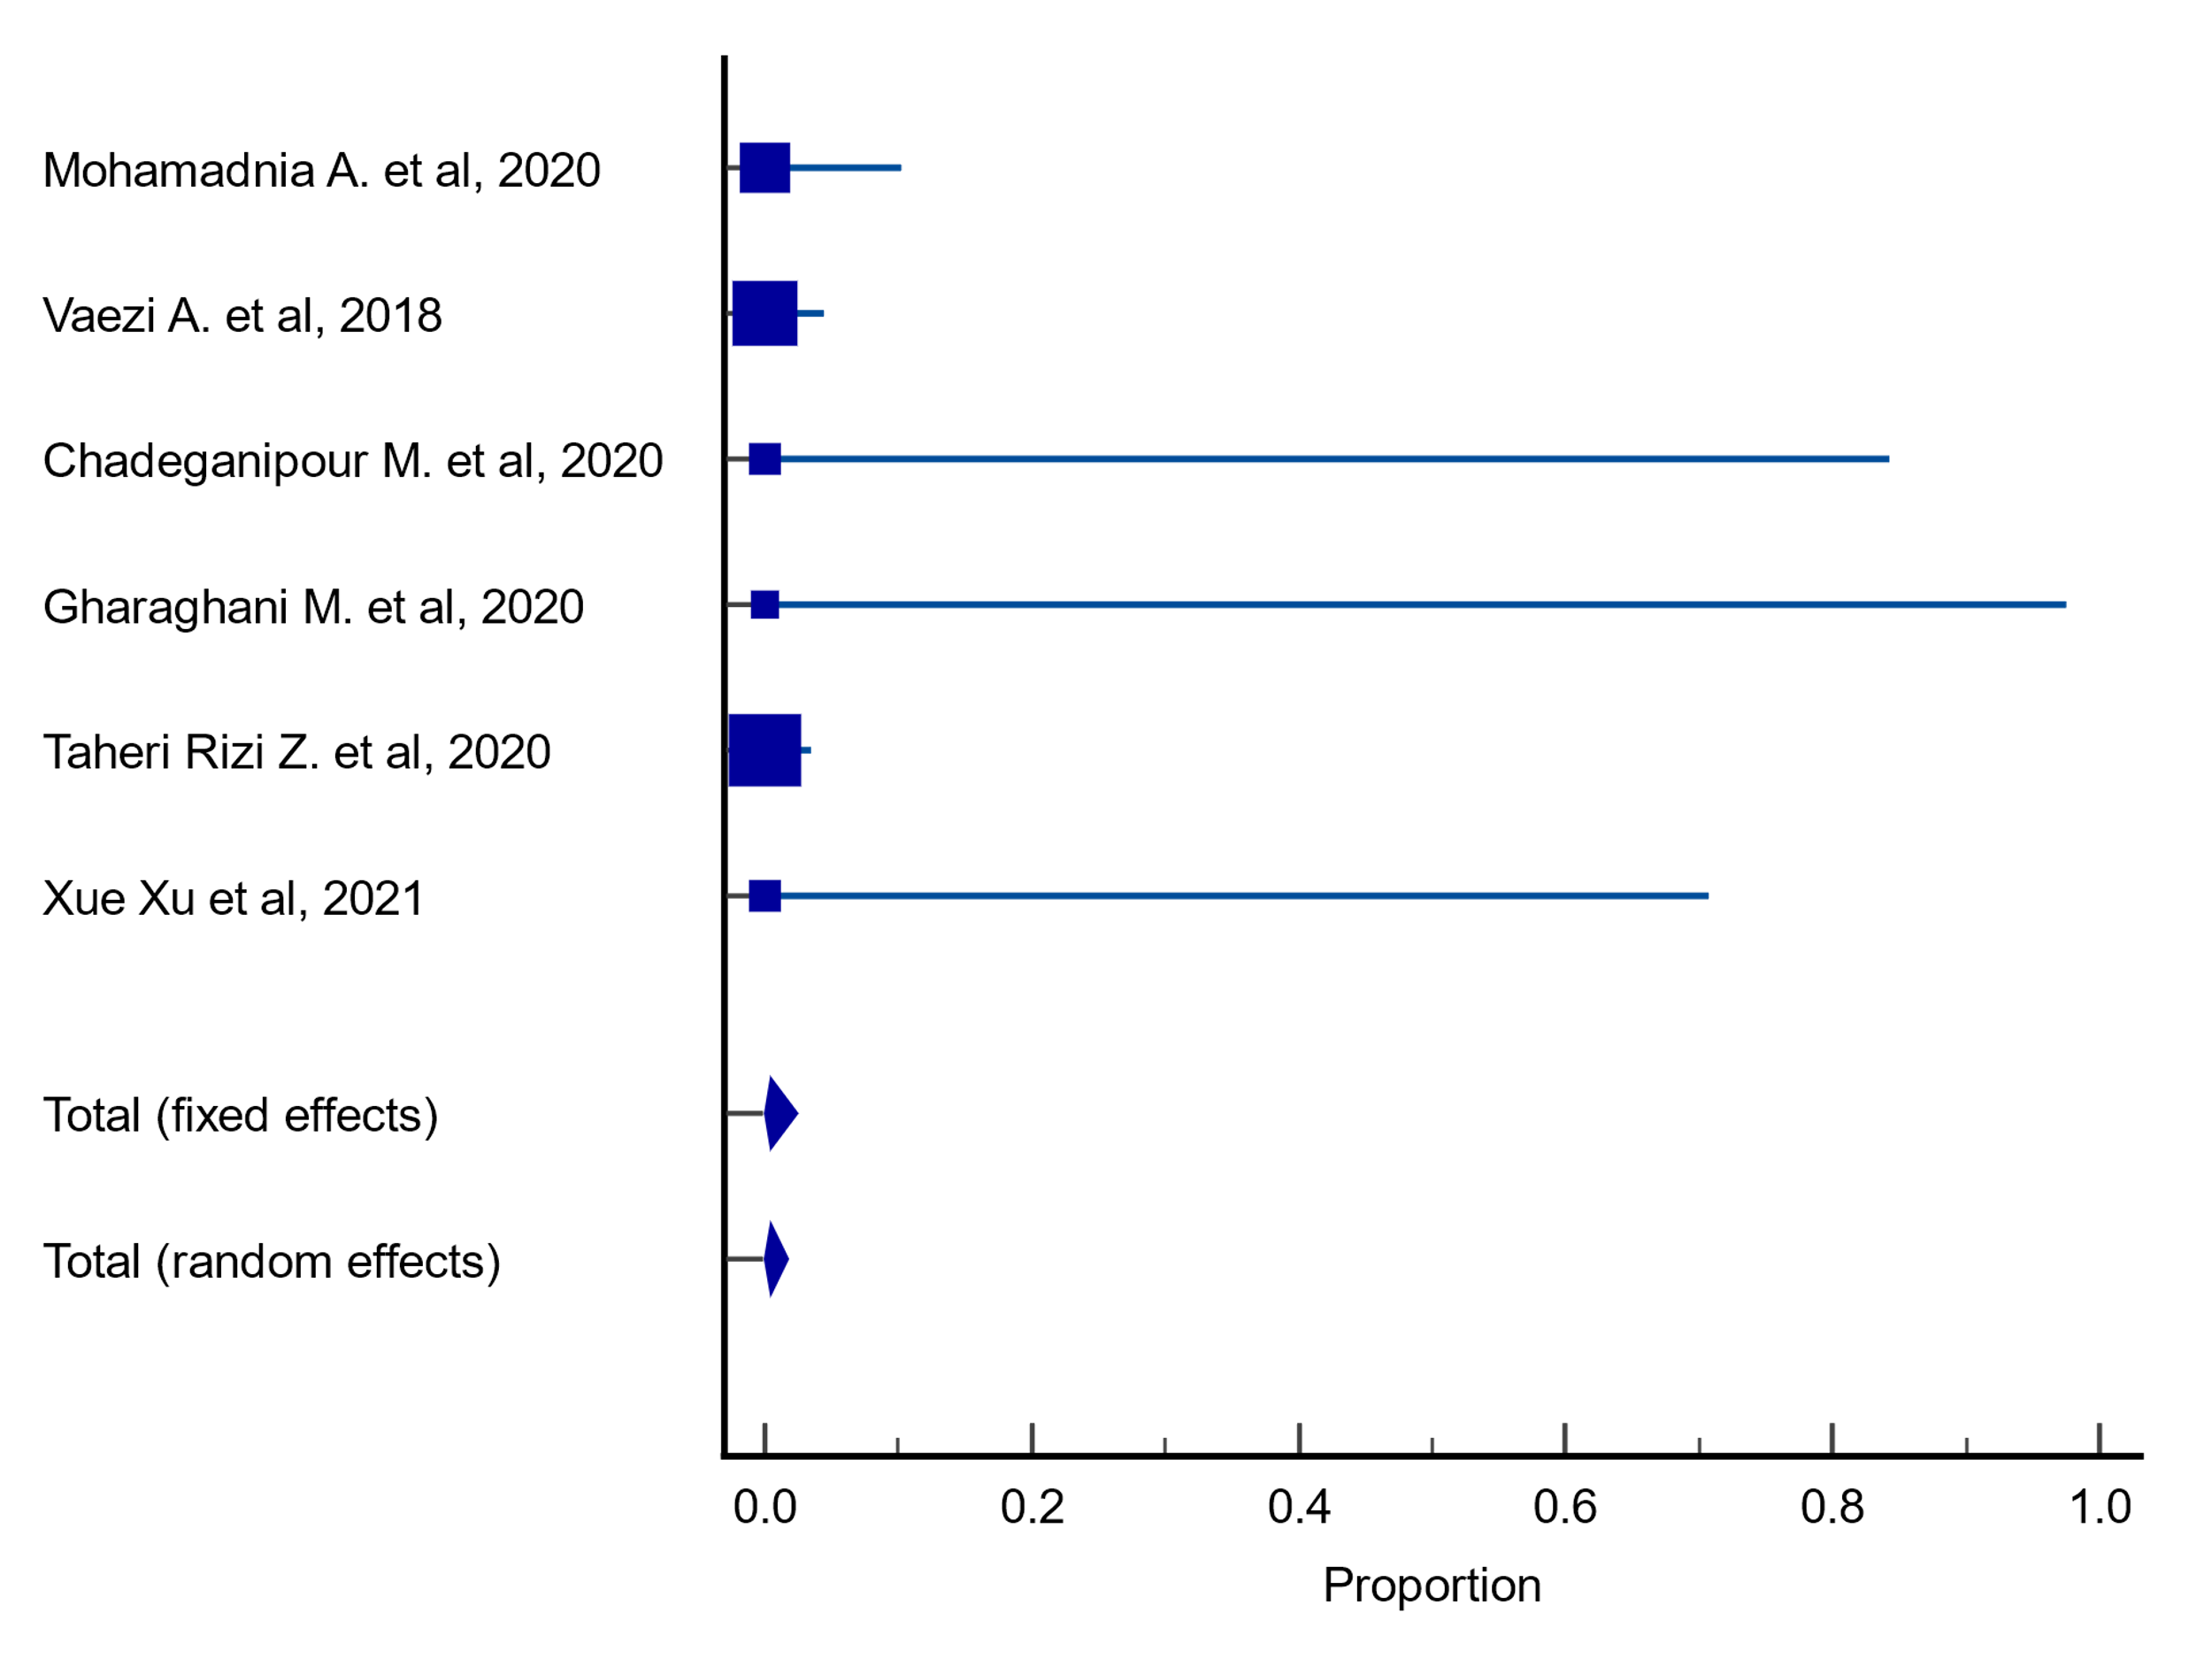
Forest plot

Plots for meta-analysis results on resistance rates of A. flavus to posaconazole
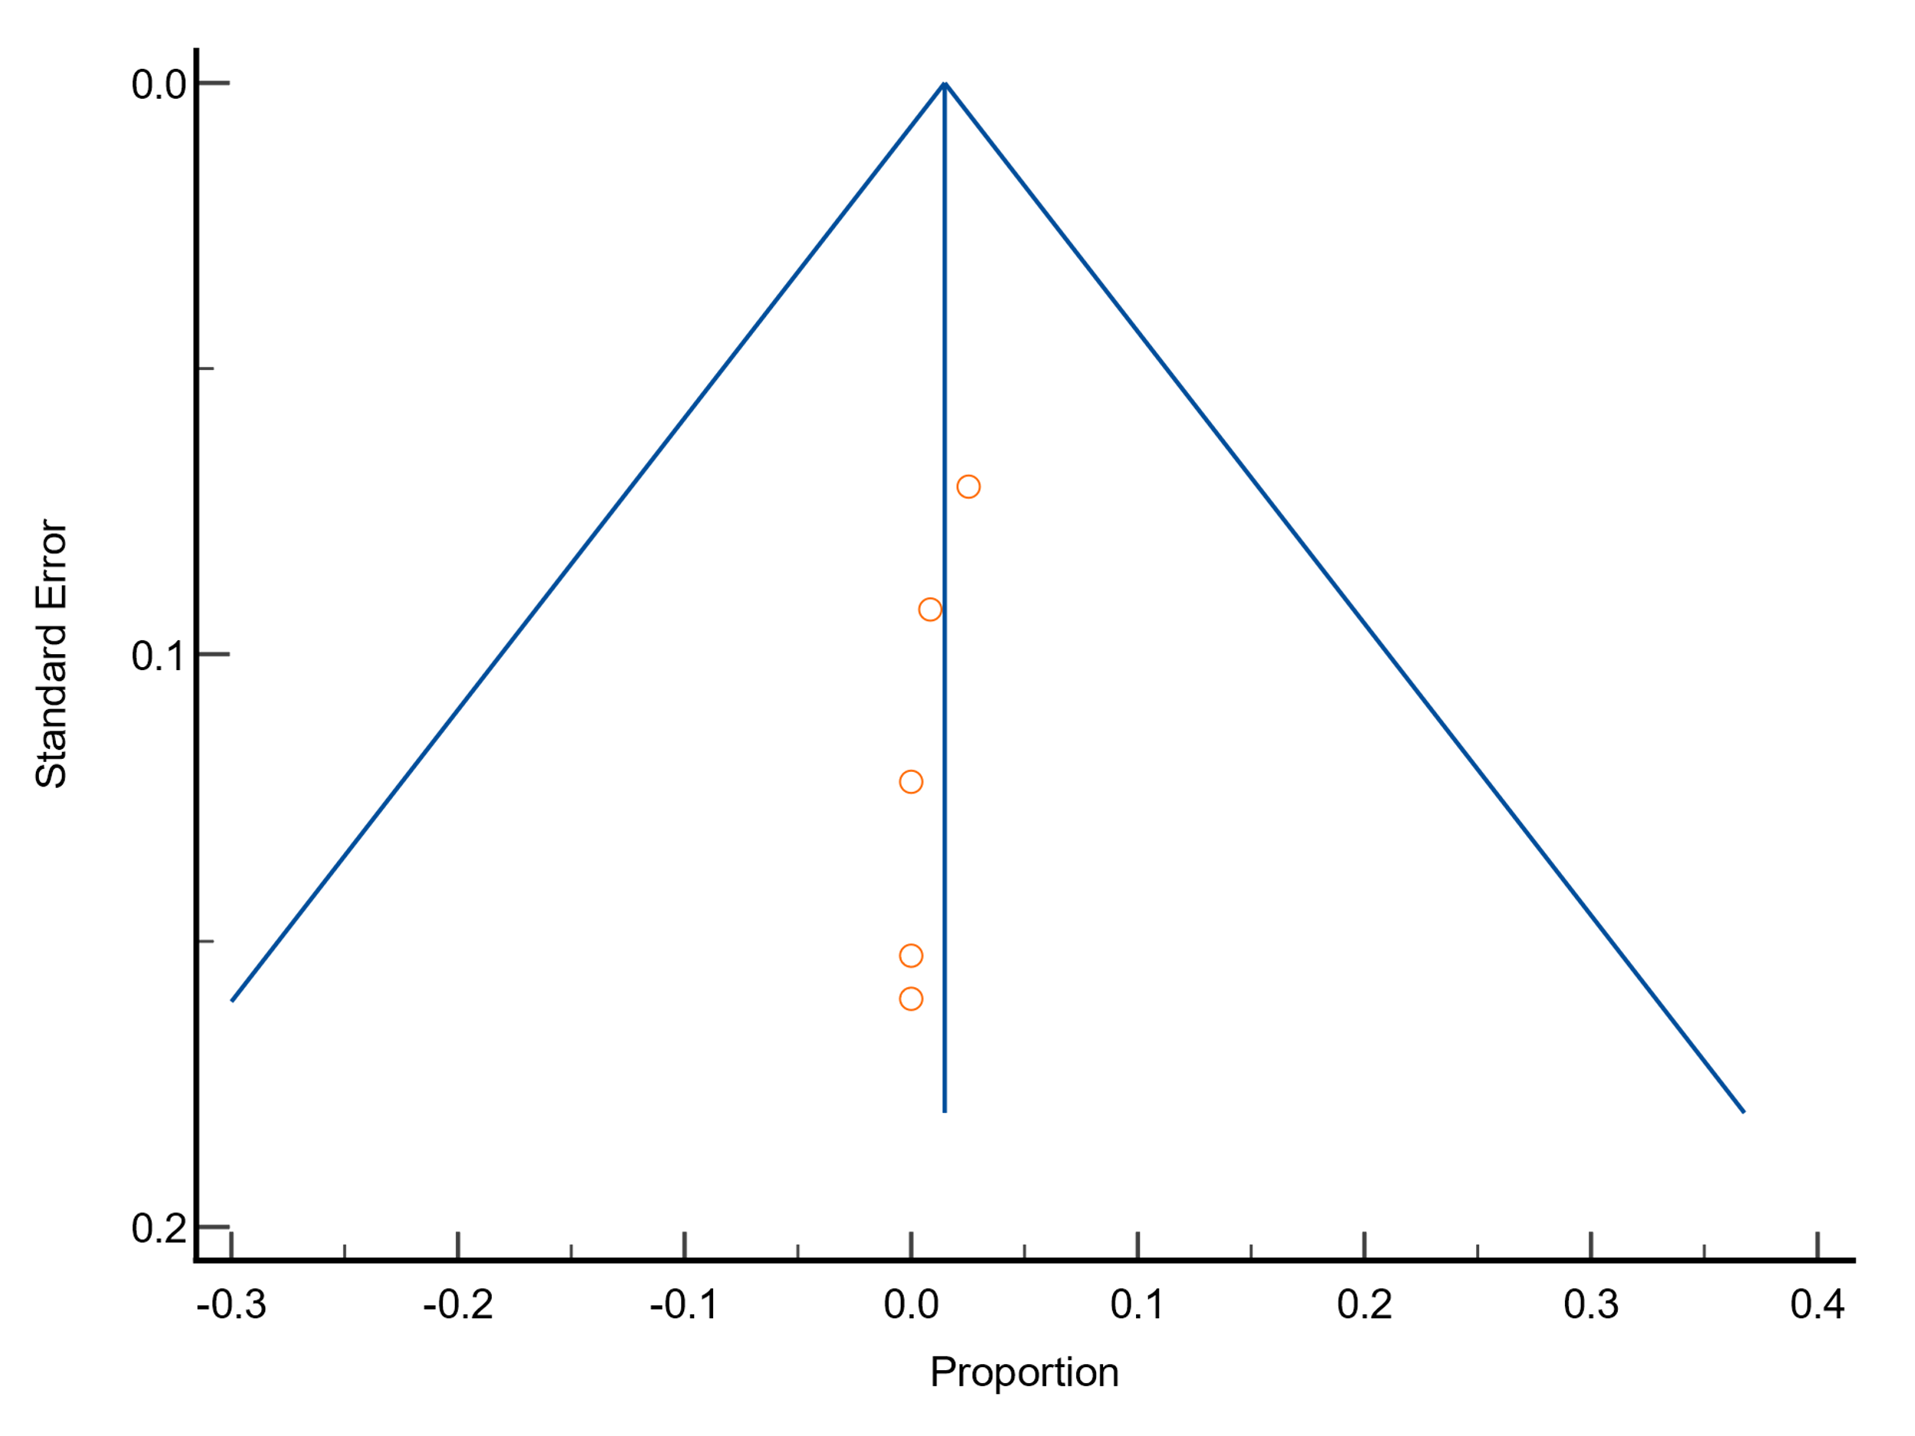
Funnel plot
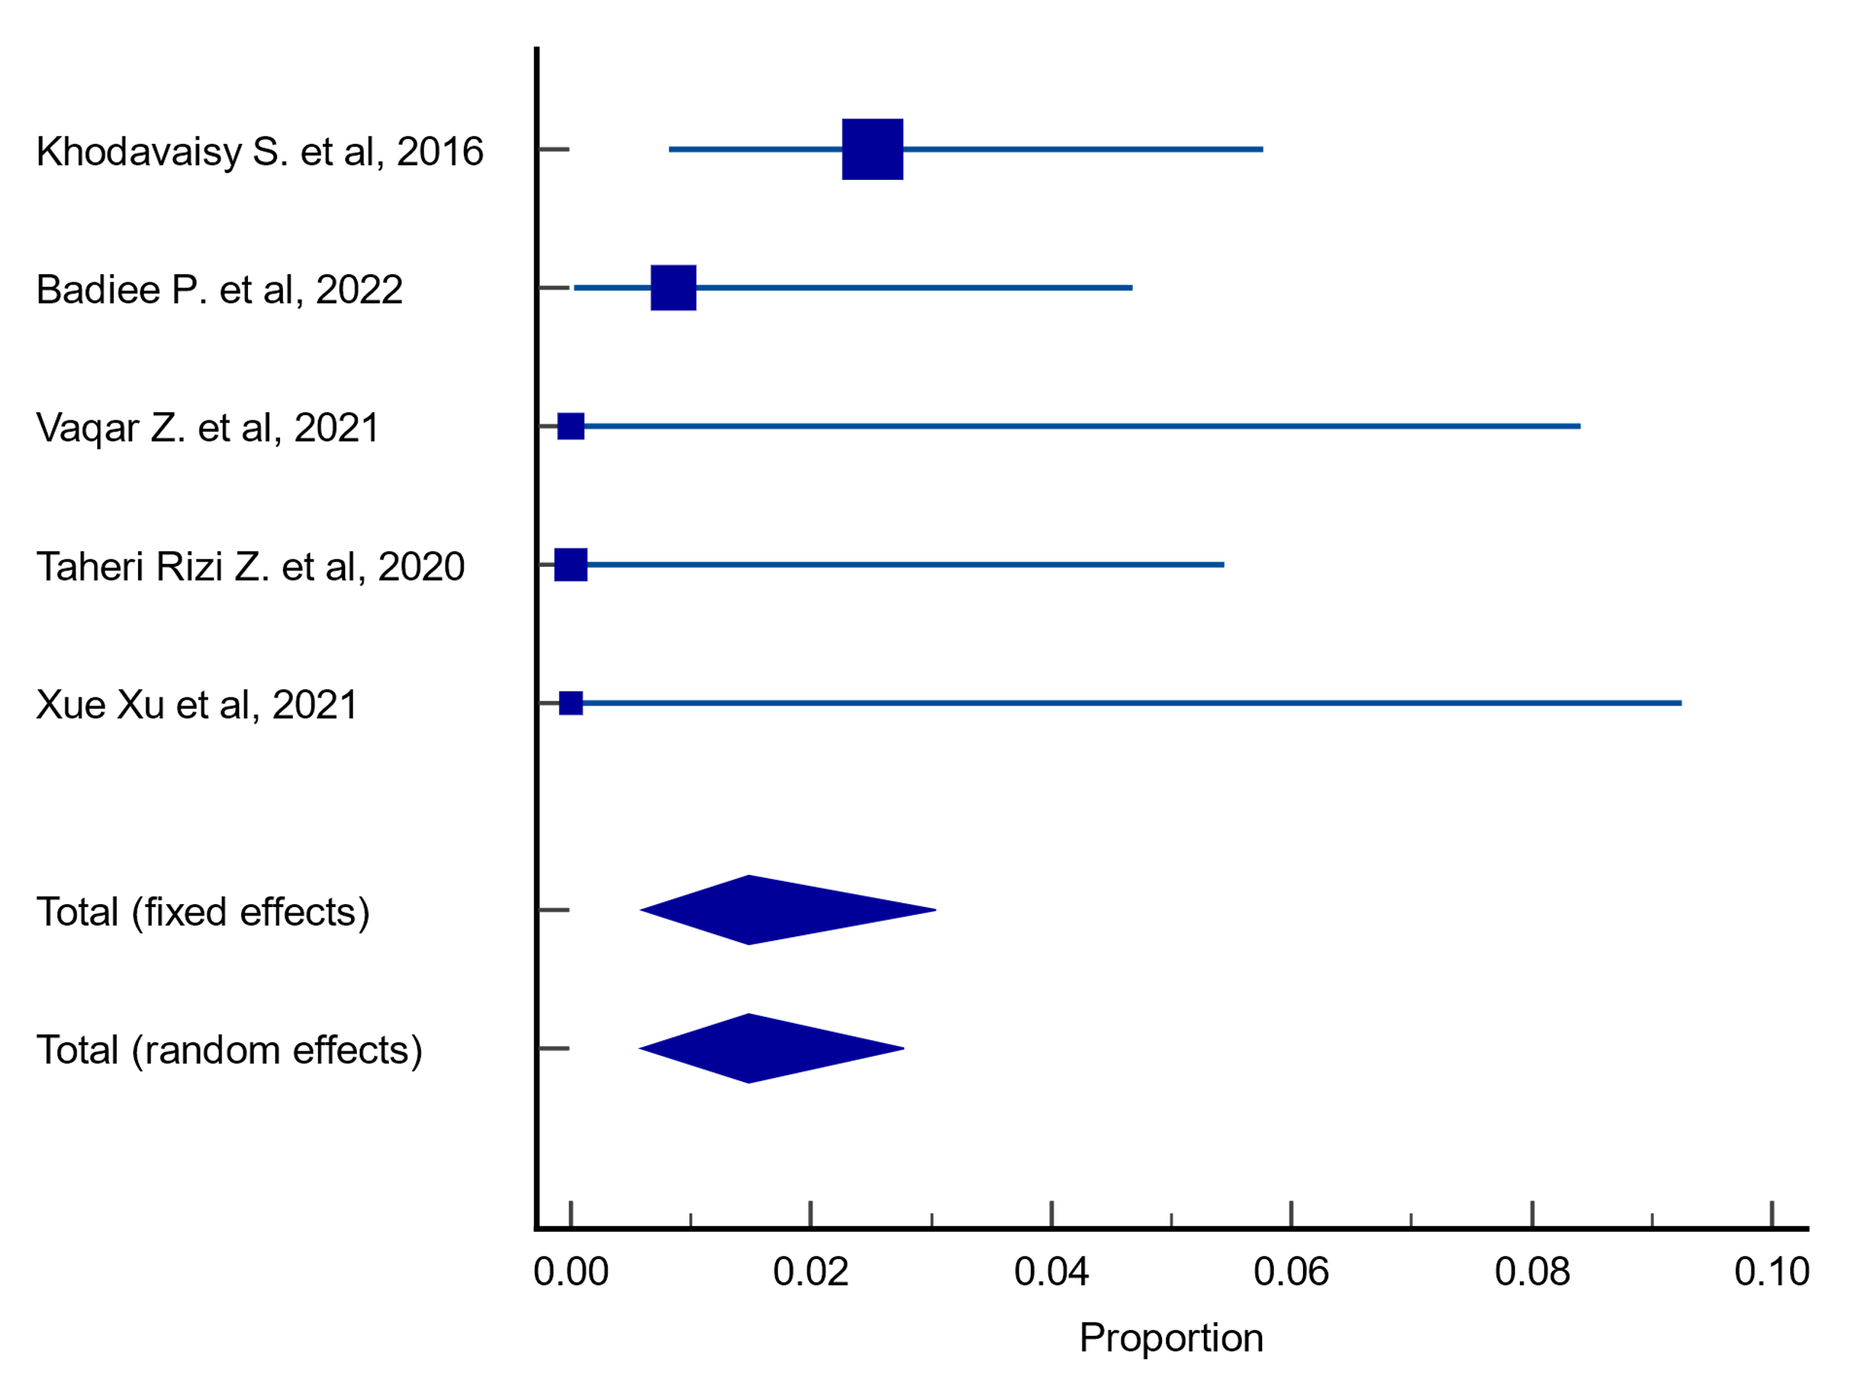
Forest plot

Plots for meta-analysis results on resistance rates of A. fumigatus to posaconazole
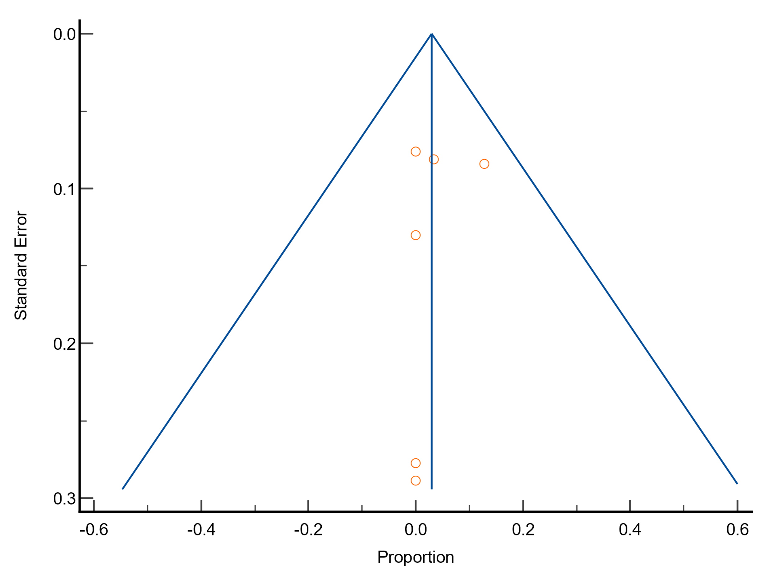
Funnel plot
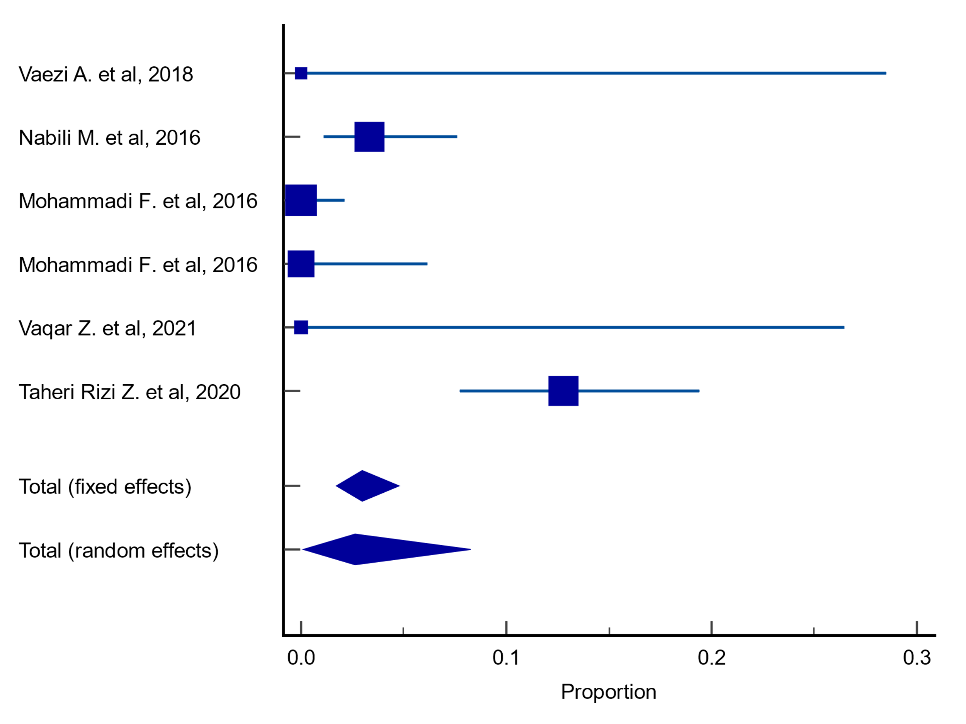
Forest plot

Plots for meta-analysis results on resistance rates of A. terreus to posaconazole
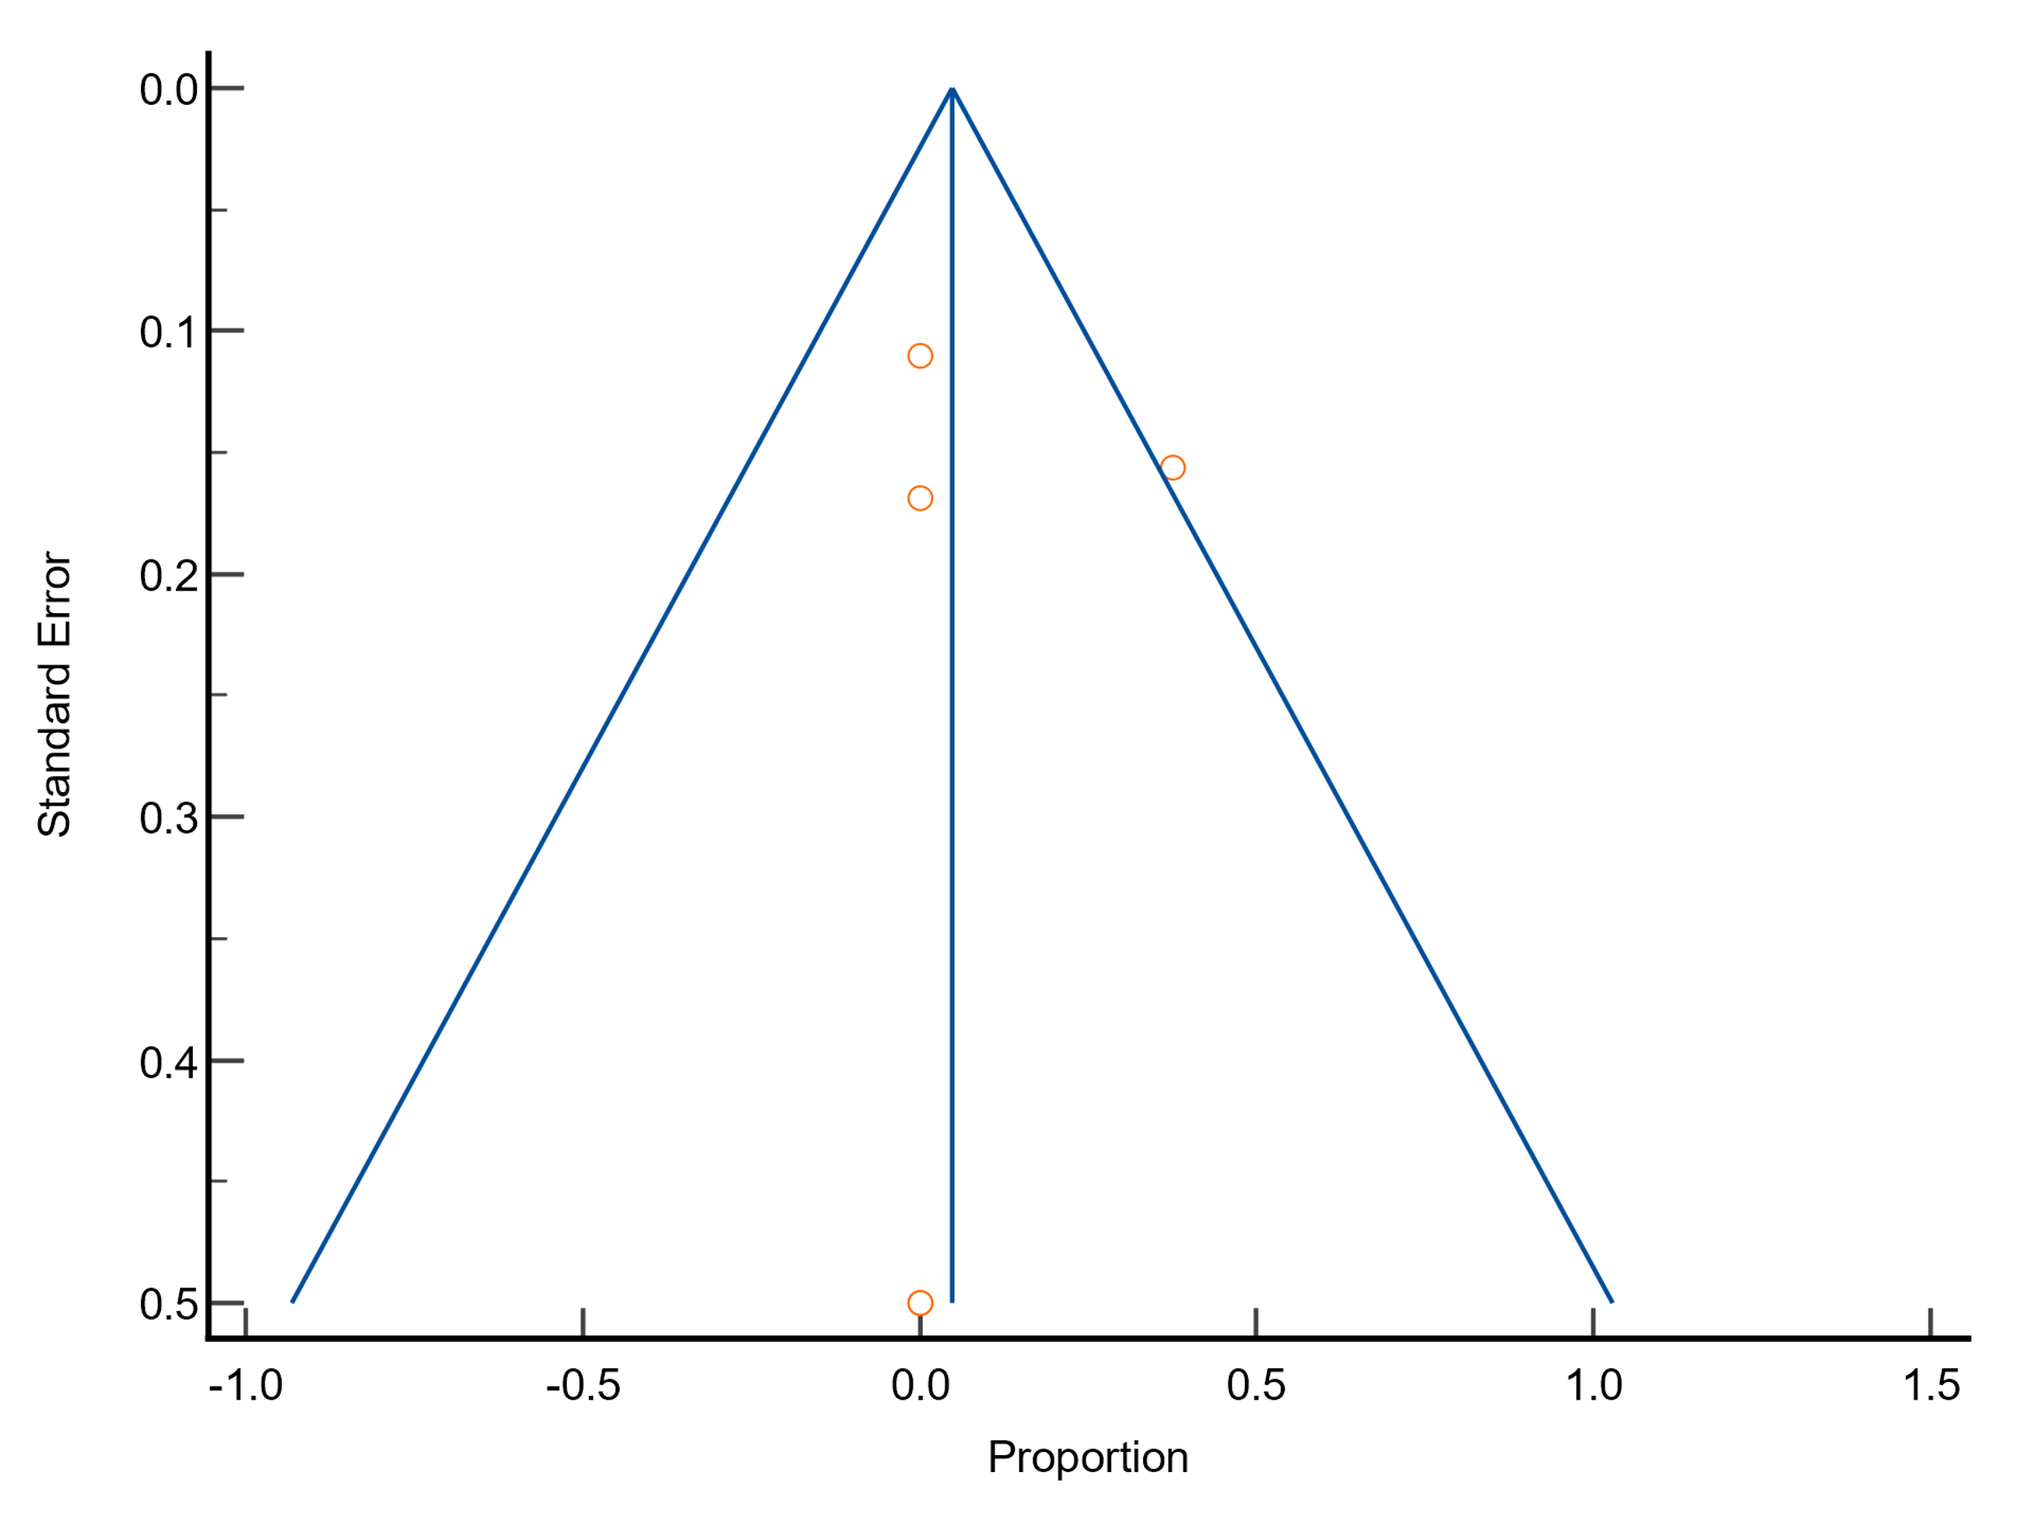
Funnel plot
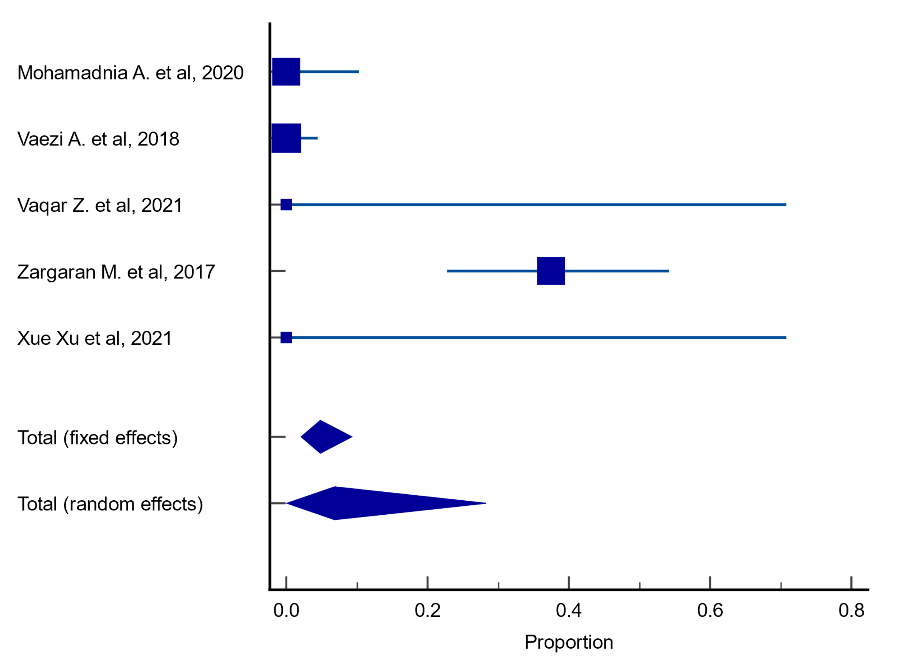
Forest plot

Plots for meta-analysis results on resistance rates of A. flavus to voriconazole
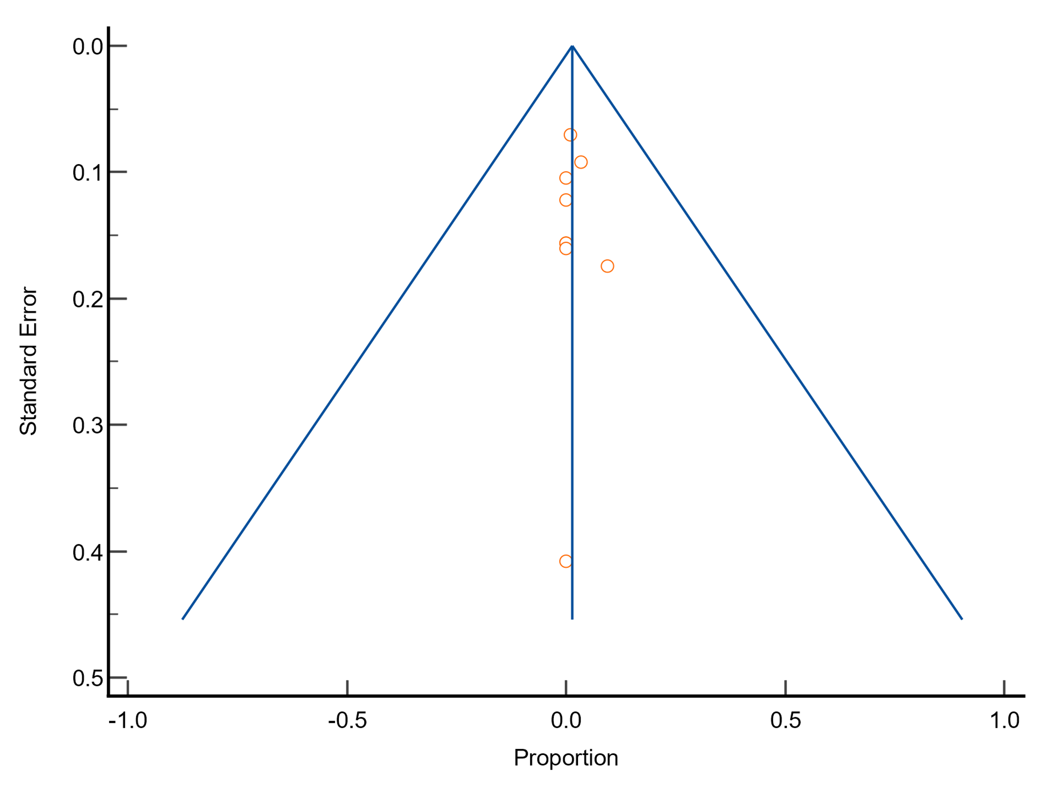
Funnel plot
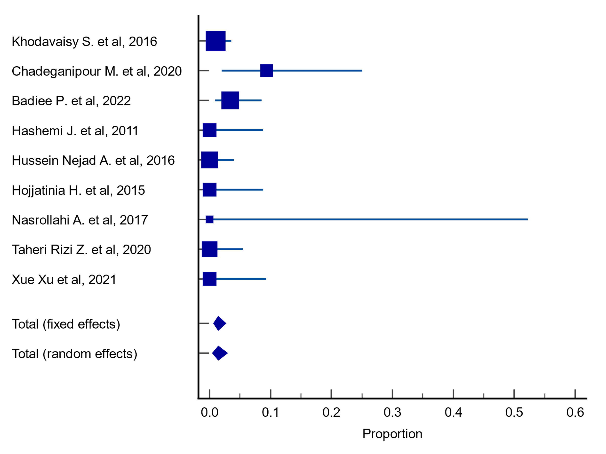
Forest plot

Plots for meta-analysis results on resistance rates of A. fumigatus to voriconazole
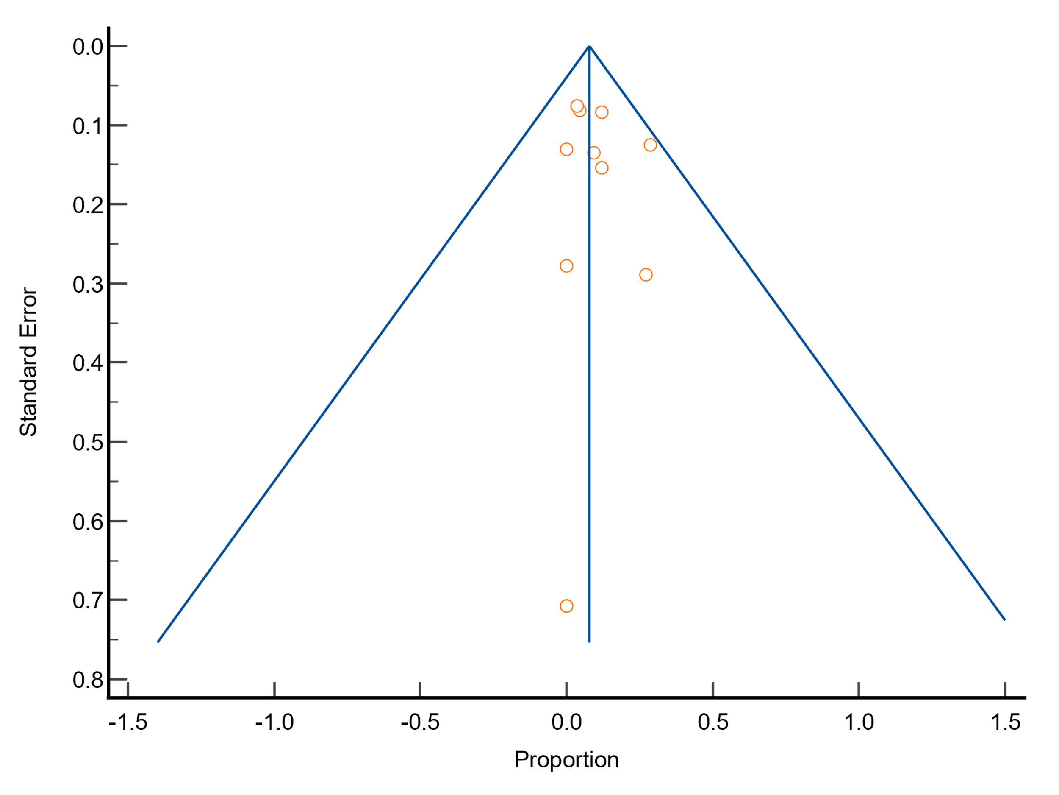
Funnel plot
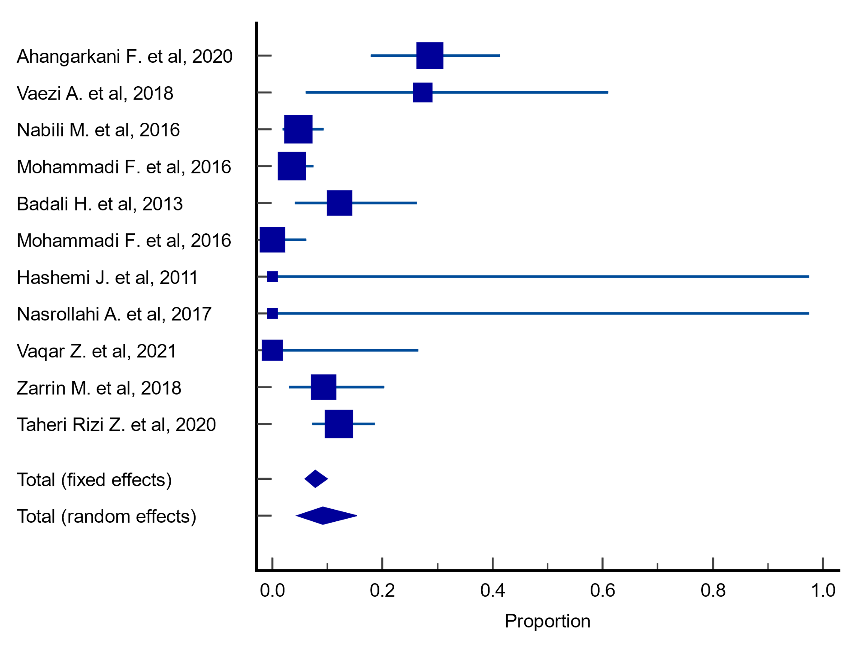
Forest plot

Plots for meta-analysis results on resistance rates of A. niger to voriconazole
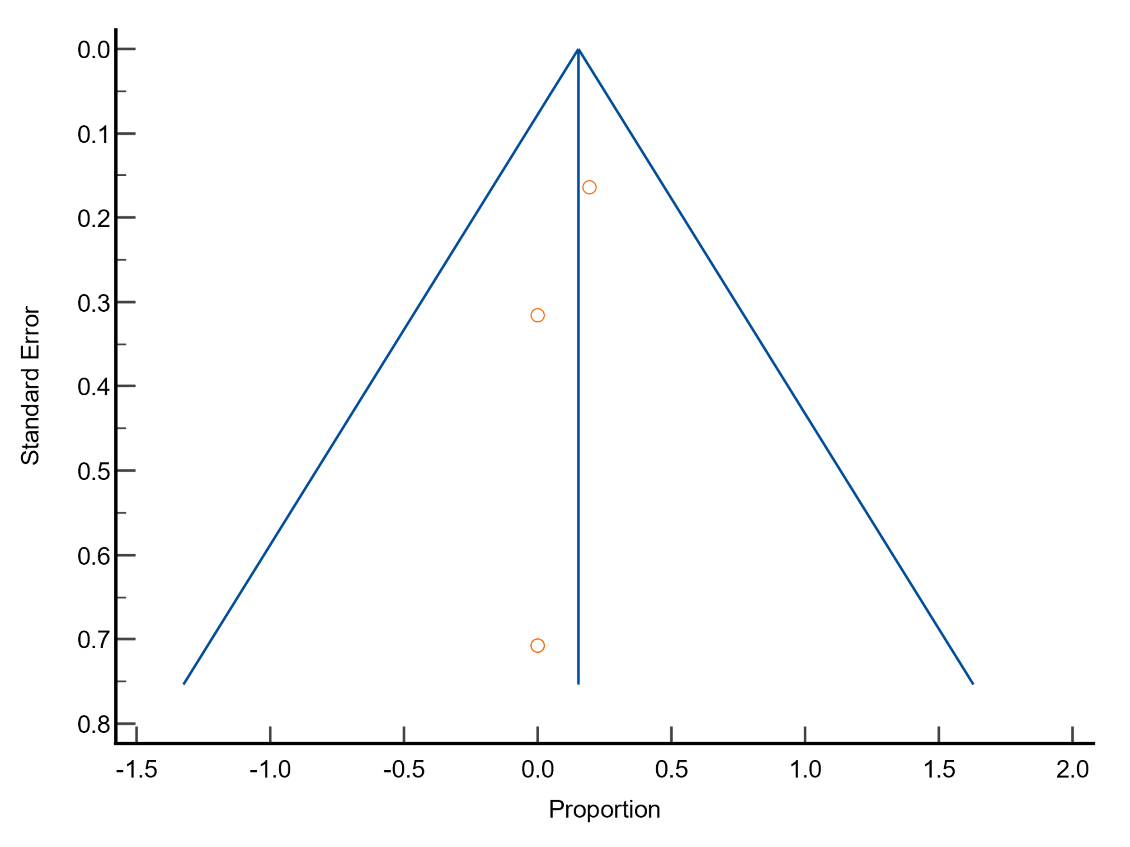
Funnel plot
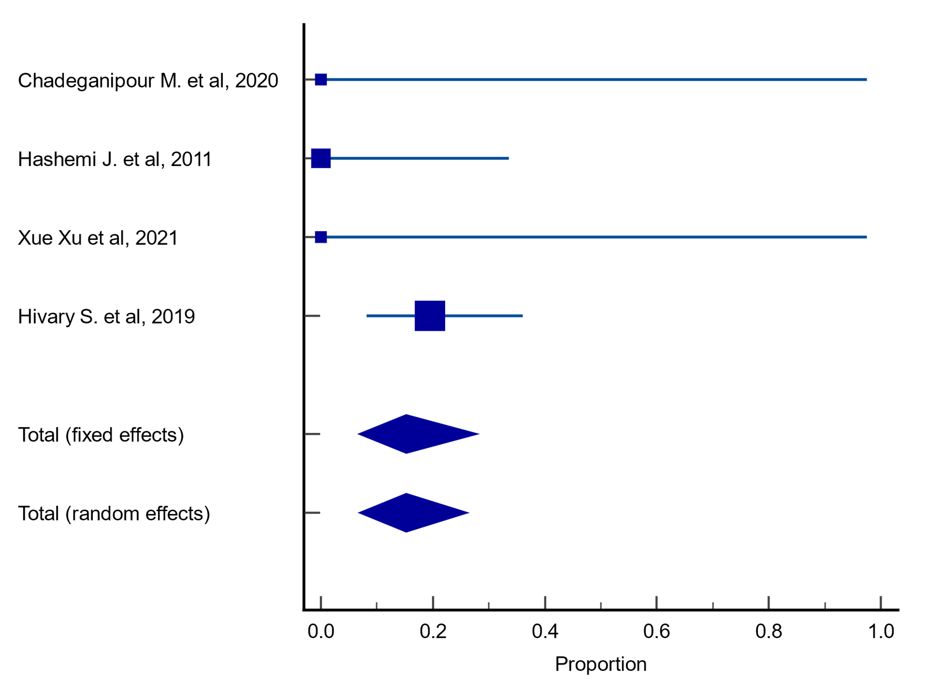
Forest plot

Plots for meta-analysis results on resistance rates of A. terreus to voriconazole
Funnel plot
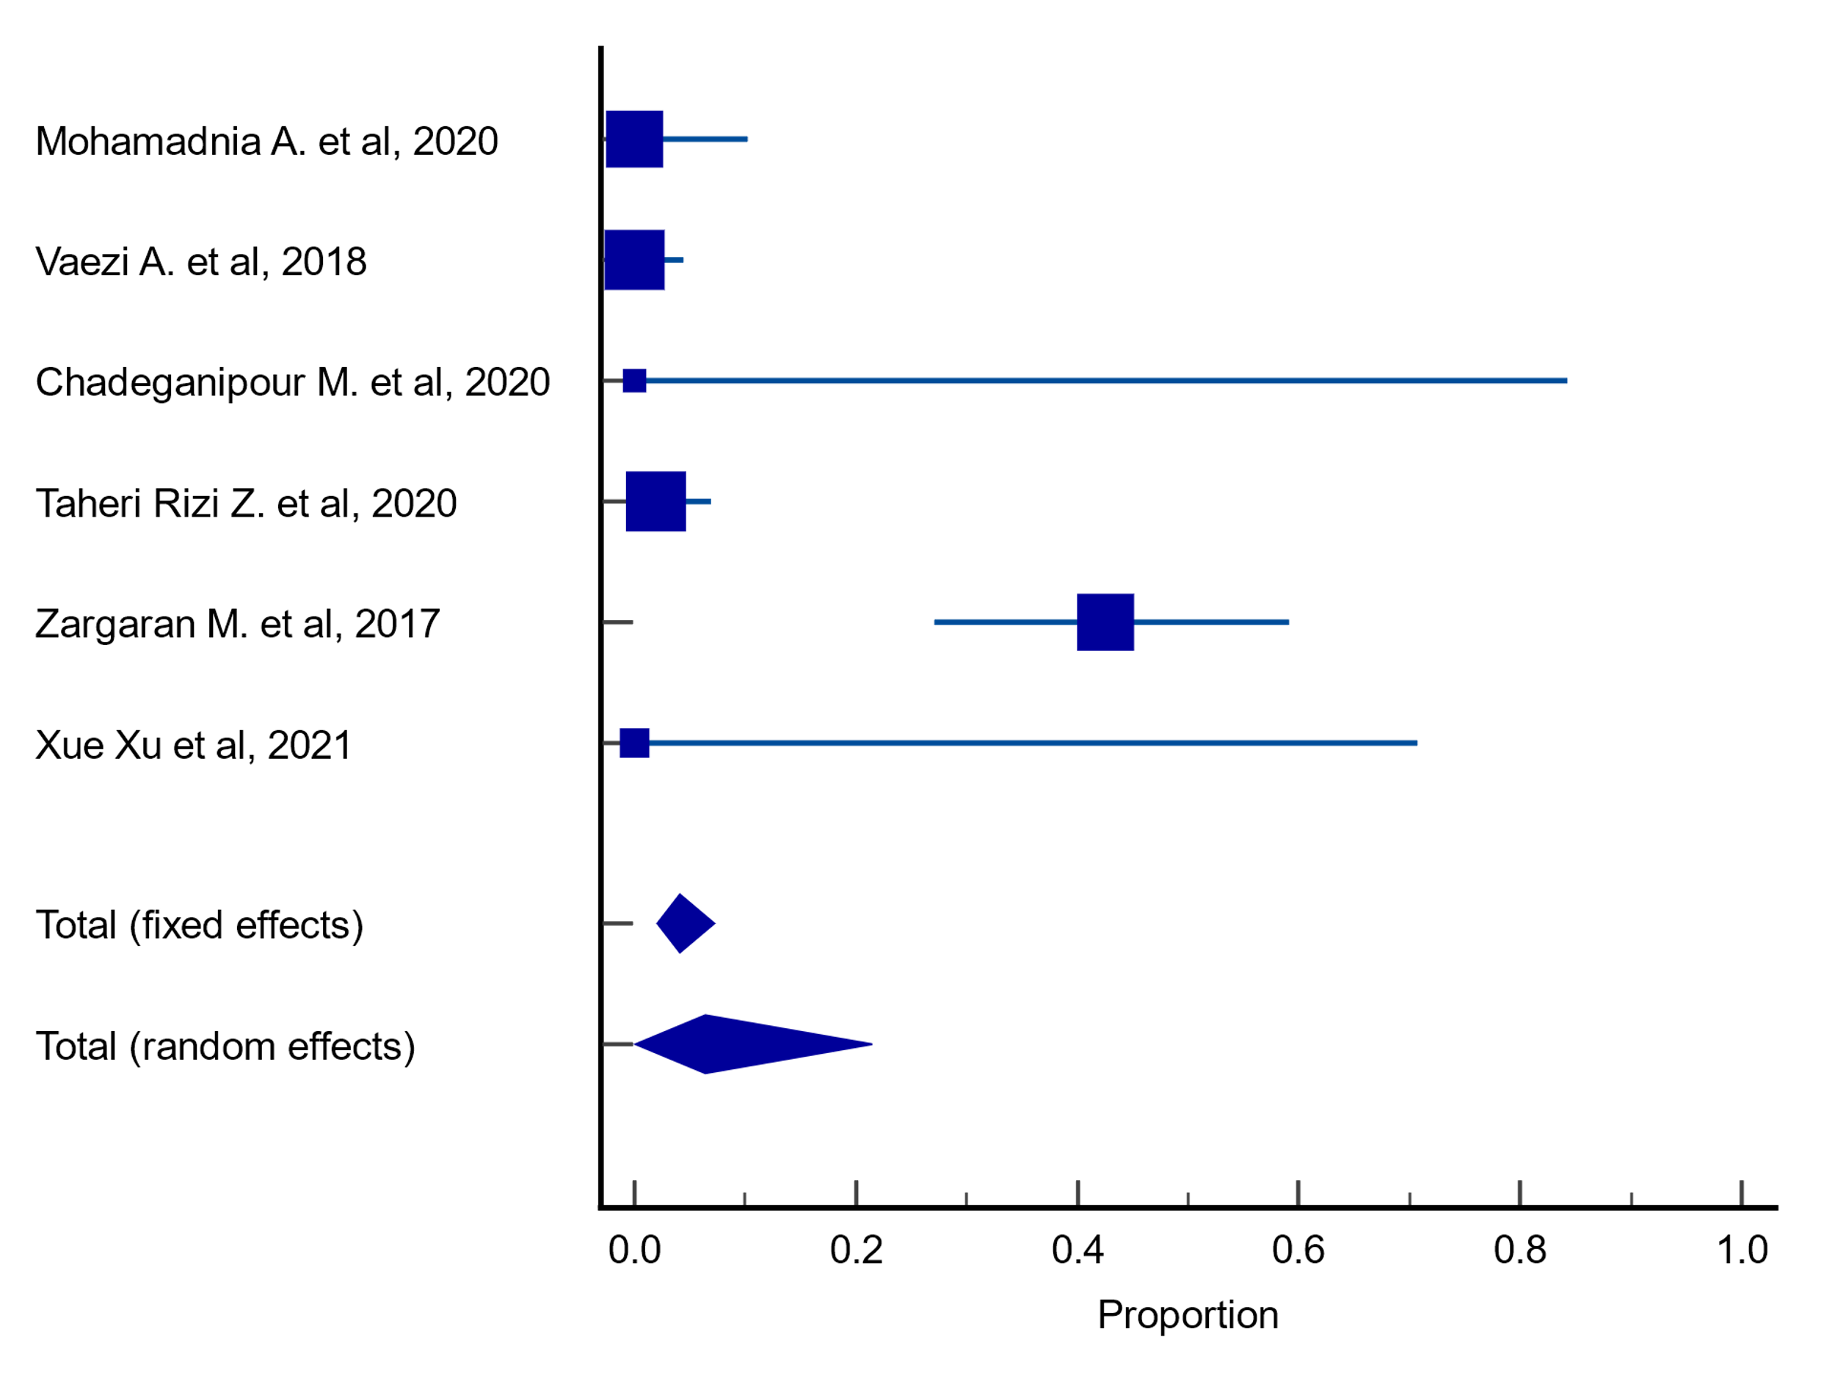
Forest plot

