Accurate quantitation of the phenyl group in methylphenyl silicone oils by GPC-UV
Huiru Li, Yuting Kang, Baoshan Zhang, JirongWu*, Xilin Hua, Kezhi Jiang*
Hangzhou Normal University, College of Material Chemistry and Chemical Engineering, Key Laboratory of Organosilicon Chemistry and Material Technology, Ministry of Education, Key Laboratory of Organosilicon Material Technology of Zhejiang Province, Hangzhou 311121, Zhejiang, People's Republic of China

Supplementary Data:

Fig. S1 UV spectrum of phenyl silicone oil
Fig. S2 Standard curve for the determination the phenyl content in phenyl silicone oil
Fig. S3 GPC-UV chromatogram of methylphenylcyclosiloxane
Fig. S4 GPC-UV chromatogram of (a) toluene, (b) phenyl silicone oil in tetrahydrofuran, and (c) phenyl silicone oil in toluene
Fig. S5 GPC-UV chromatogram of (a) xylene solution, (b) phenyl silicone oil in ietrahydrofuran and (c) phenyl silicone oil in xylene
Fig. S6 GPC-UV chromatogram of (a) methyl silicone oil (b) hydroxyl silicone oil(c) vinyl silicone oil
Fig. S7 GPC-UV chromatogram of (a) phenyl silicone oil, (b) mixture of phenyl silicone oil and hydroxy silicone oil (m:m =1:1), and (c) mixture of phenyl silicone oil and hydroxy silicone oil (m:m =1:10)
Fig. S8 GPC-UV chromatogram of (a) phenyl silicone oil, (b) mixture of phenyl silicone oil and vinyl silicone oil (m:m =1:1), and (c) mixture of vinyl silicone oil and hydroxy silicone oil (m:m =1:10)
Fig. S9 ¹HNMR spectra of phenyl silicone oil sample H1

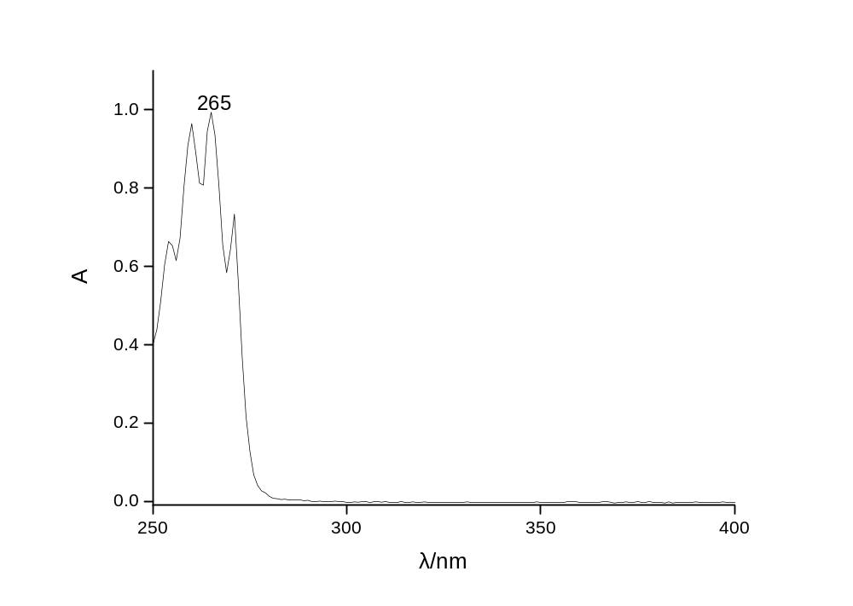
Fig. S1 UV spectrum of phenyl silicone oil

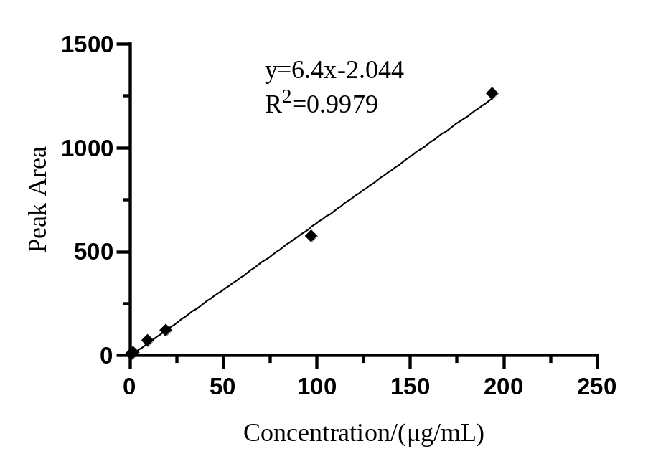
Fig. S2 Standard curve for the determination the phenyl content in phenyl silicone oil

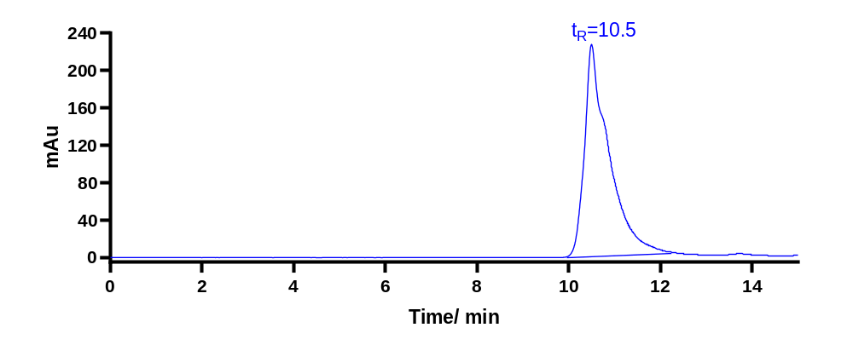
Fig. S3 GPC-UV chromatogram of methylphenylcyclosiloxane
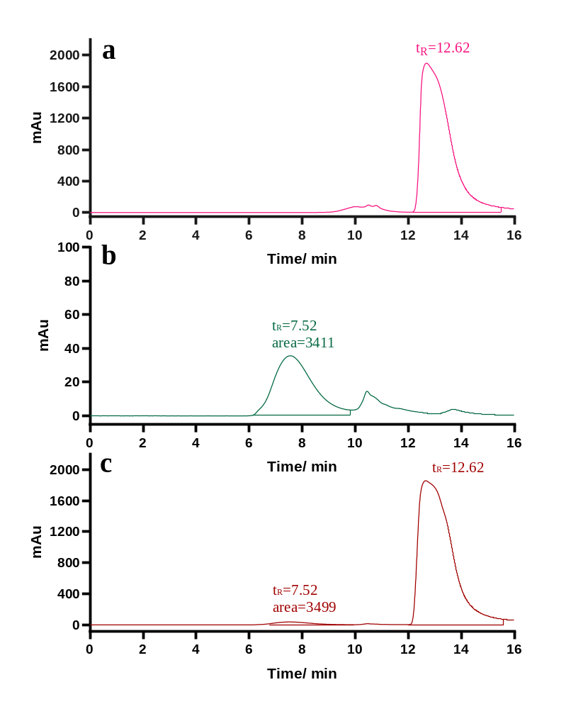

Fig. S4 GPC-UV chromatogram of (a) toluene, (b) phenyl silicone oil in tetrahydrofuran, (c) phenyl silicone oil in toluene

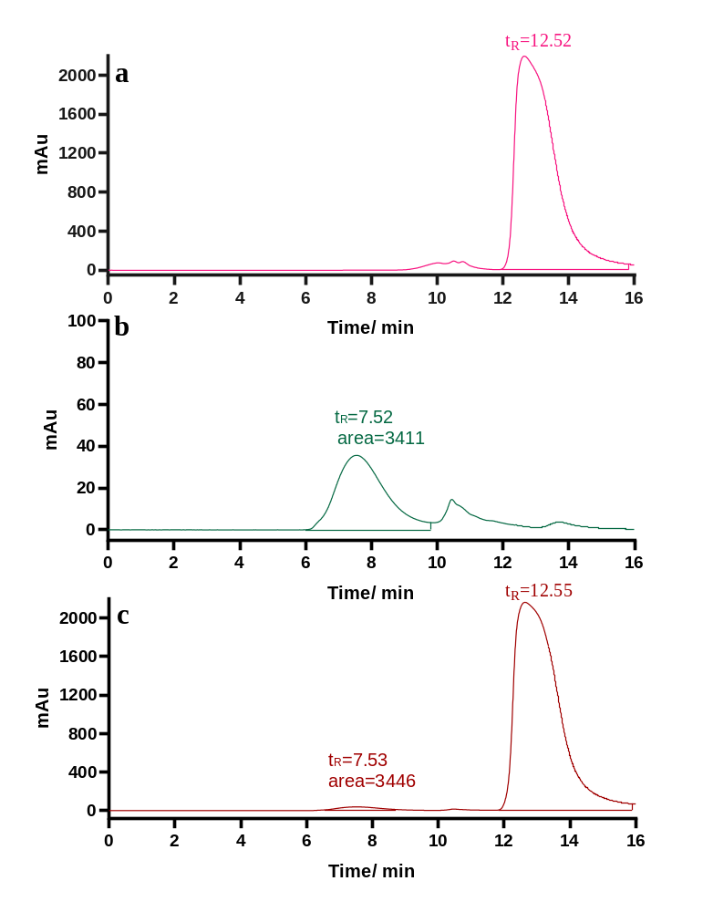
Fig. S5 GPC-UV chromatogram of (a) xylene solution, (b) phenyl silicone oil in ietrahydrofuran (c) phenyl silicone oil in xylene

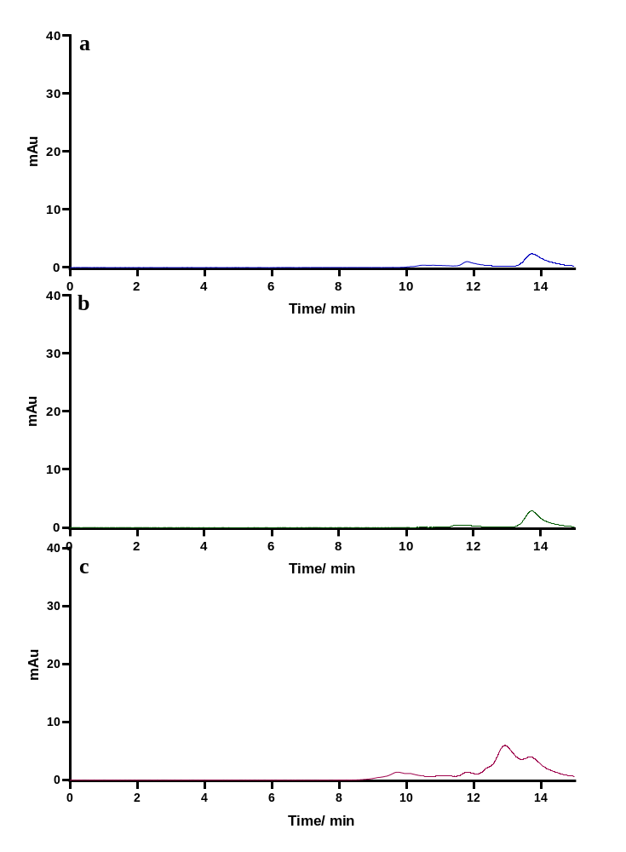
Fig. S6 .GPC-UV chromatogram of (a) methyl silicone oil (b) hydroxyl silicone oil(c) vinyl silicone oil

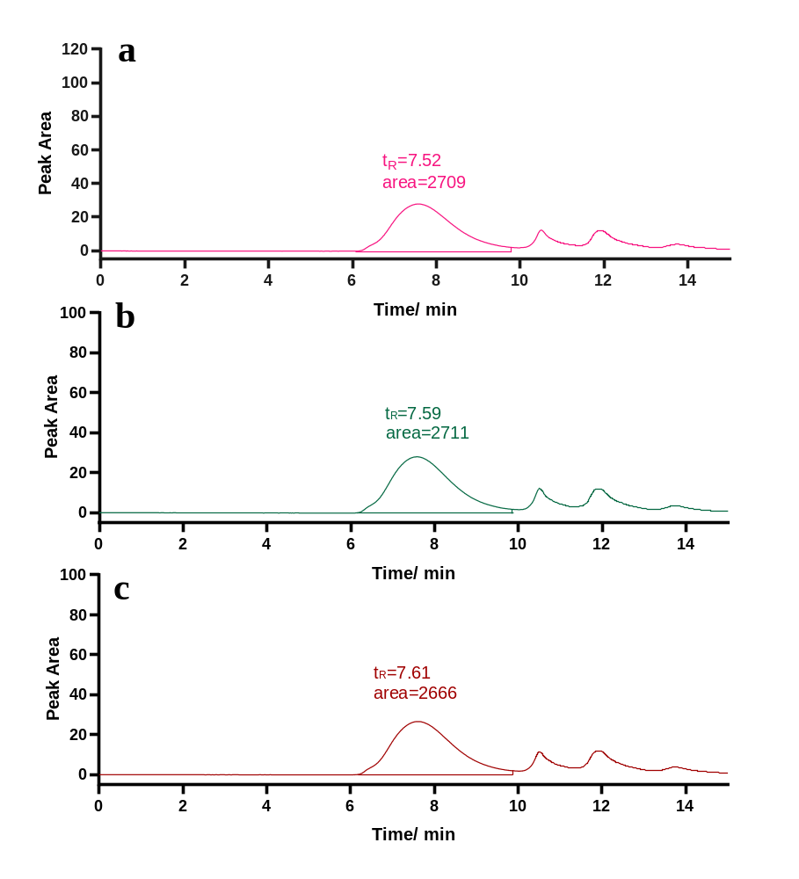
Fig.S7 GPC-UV chromatogram of (a) phenyl silicone oil, (b) mixture of phenyl silicone oil and hydroxy silicone oil (m:m =1:1), (c) mixture of phenyl silicone oil and hydroxy silicone oil (m:m =1:10)

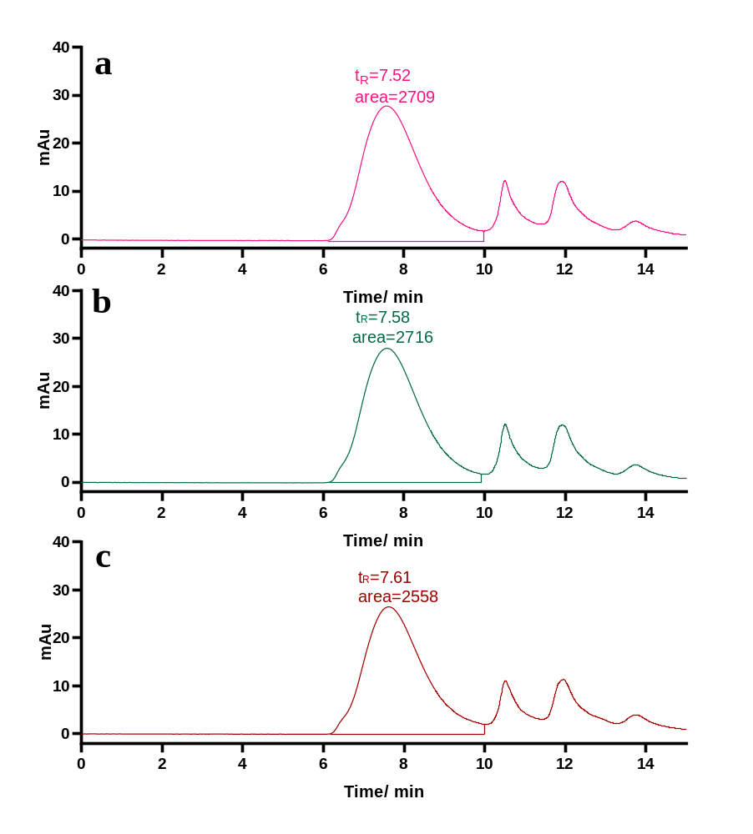
Fig.S8 GPC-UV chromatogram of (a) phenyl silicone oil, (b) mixture of phenyl silicone oil and vinyl silicone oil (m:m =1:1), (c) mixture of vinyl silicone oil and hydroxy silicone oil (m:m =1:10)

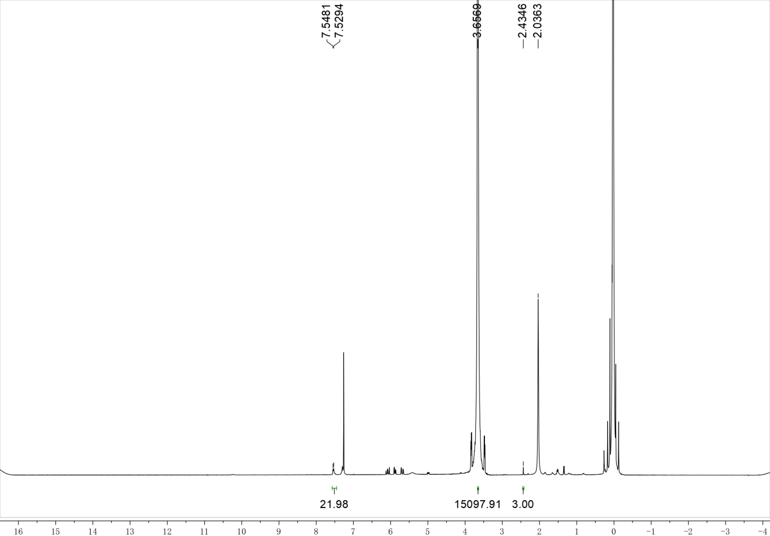

Figure. S9 ¹HNMR spectra of H1

