Table 3. Shows sample input and the segmented leaf of different segmentation techniques applied to the CCDDB and PDDB datasets.
Global threshold | Sample Leaf |  | Segmented leaf |  |  | Adaptive  mean | Sample Leaf |  |  | Segmented leaf
CCDDB | 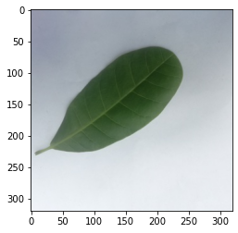 |  | 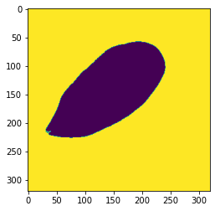 |  |  | CCDDB | 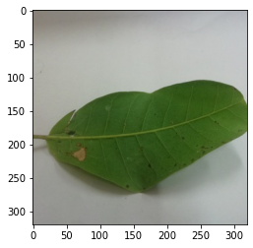 |  |  | 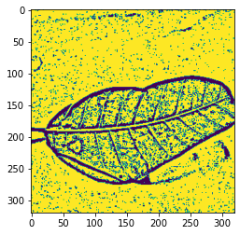
PDDB | 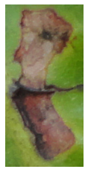 |  | 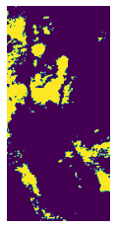 |  |  | PDDB | 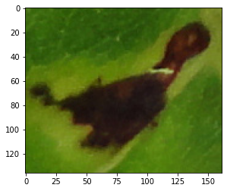 |  |  | 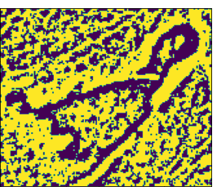
Adaptive Gaussian | Sample Leaf |  | Segmented Leaf |  | Otsu  Threshold |  | Sample Leaf |  | Segmented Leaf
CCDDB |  |  | 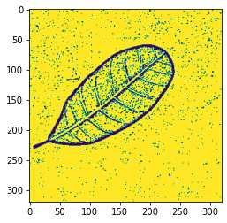 |  | CCDDB |  | 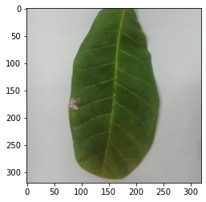 |  | 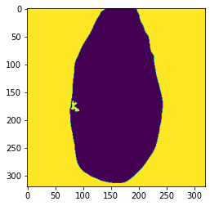
PDDB |  |  | 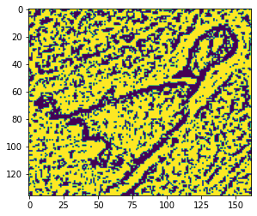 |  | PDDB |  | 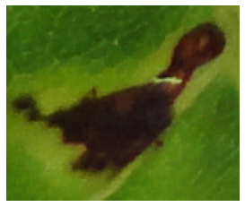 |  | 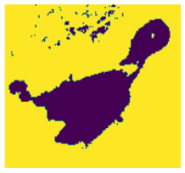
Canny Edge Detection | Sample Leaf |  | Segmented Leaf | Sobel Edge Detection |  |  | Sample Leaf | Segmented Leaf
CCDDB |  |  | 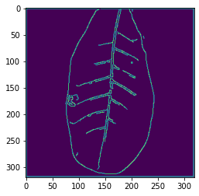 | PDDB |  |  | 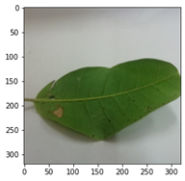 | 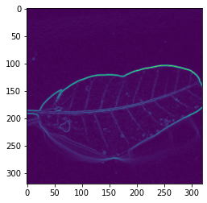
PDDB | 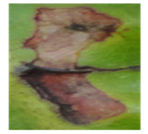 |  | 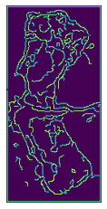 | CCDDB |  |  | 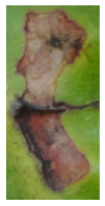 | 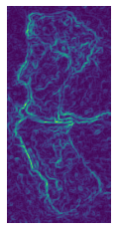
K-Means | Sample Leaf | Segmented Leaf
CCDDB | 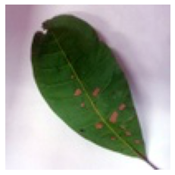 | 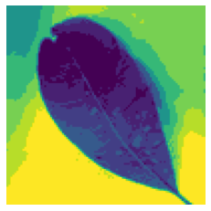
PDDB |  | 