Evaluation of optimal methods and ancestries for calculating polygenic risk scores in East Asian population

Dong Jun Kim¹, Joon Ho Kang¹, Ji-Woong Kim¹, Myeong Jae Cheon¹, Sun bin Kim¹, Young Kee Lee¹, Byung-Chul Lee^{1*}

¹Genoplan Korea, Seoul, Korea

*Corresponding author:
Byung-Chul Lee
Genoplan Korea, Seoul, Korea
E-mail: io@genoplan.com

Table S1. Information of GWAS summary statistics from UK Biobank and BioBank Japan.
 | UK Biobank | N cases | N controls | Bio Bank Japan | N cases | N controls
Asthma | GCST90013888 | 50,231ª | 351,616ª | JENGER ID: 30 | 8,216 | 201,592
Breast Cancer | GCST90041886 | 10,152 | 446,124 | JENGER ID: 102 | 5,552 | 89,731
CAD | GCST90013864 | 29,338^{b} | 322,724^{b} | JENGER ID: 103 | 29,319 | 183,134
Glaucoma | GCST90038648 | 5,126 | 479,472 | GCST90018632 | 8,448 | 168,903
Hyperthyroidism | GCST90038636 | 3,731 | 480,867 | GCST90018640 | 994 | 172,656
Hypothyroidism | GCST90038637 | 23,497 | 461,101 | GCST90018642 | 1,114 | 172,656
T2D | GCST90013892 | 19,373^{c} | 387,458^{c} | JENGER ID: 14 | 36,614 | 155,150
CAD coronary artery disease, T2D type 2 diabetes.
a. estimated number from 1:7 case-control ratio of 401,847.
b. estimated number from 1:11 case-control ratio of 352,063.
c. estimated number from 1:20 case-control ratio of 406,831.

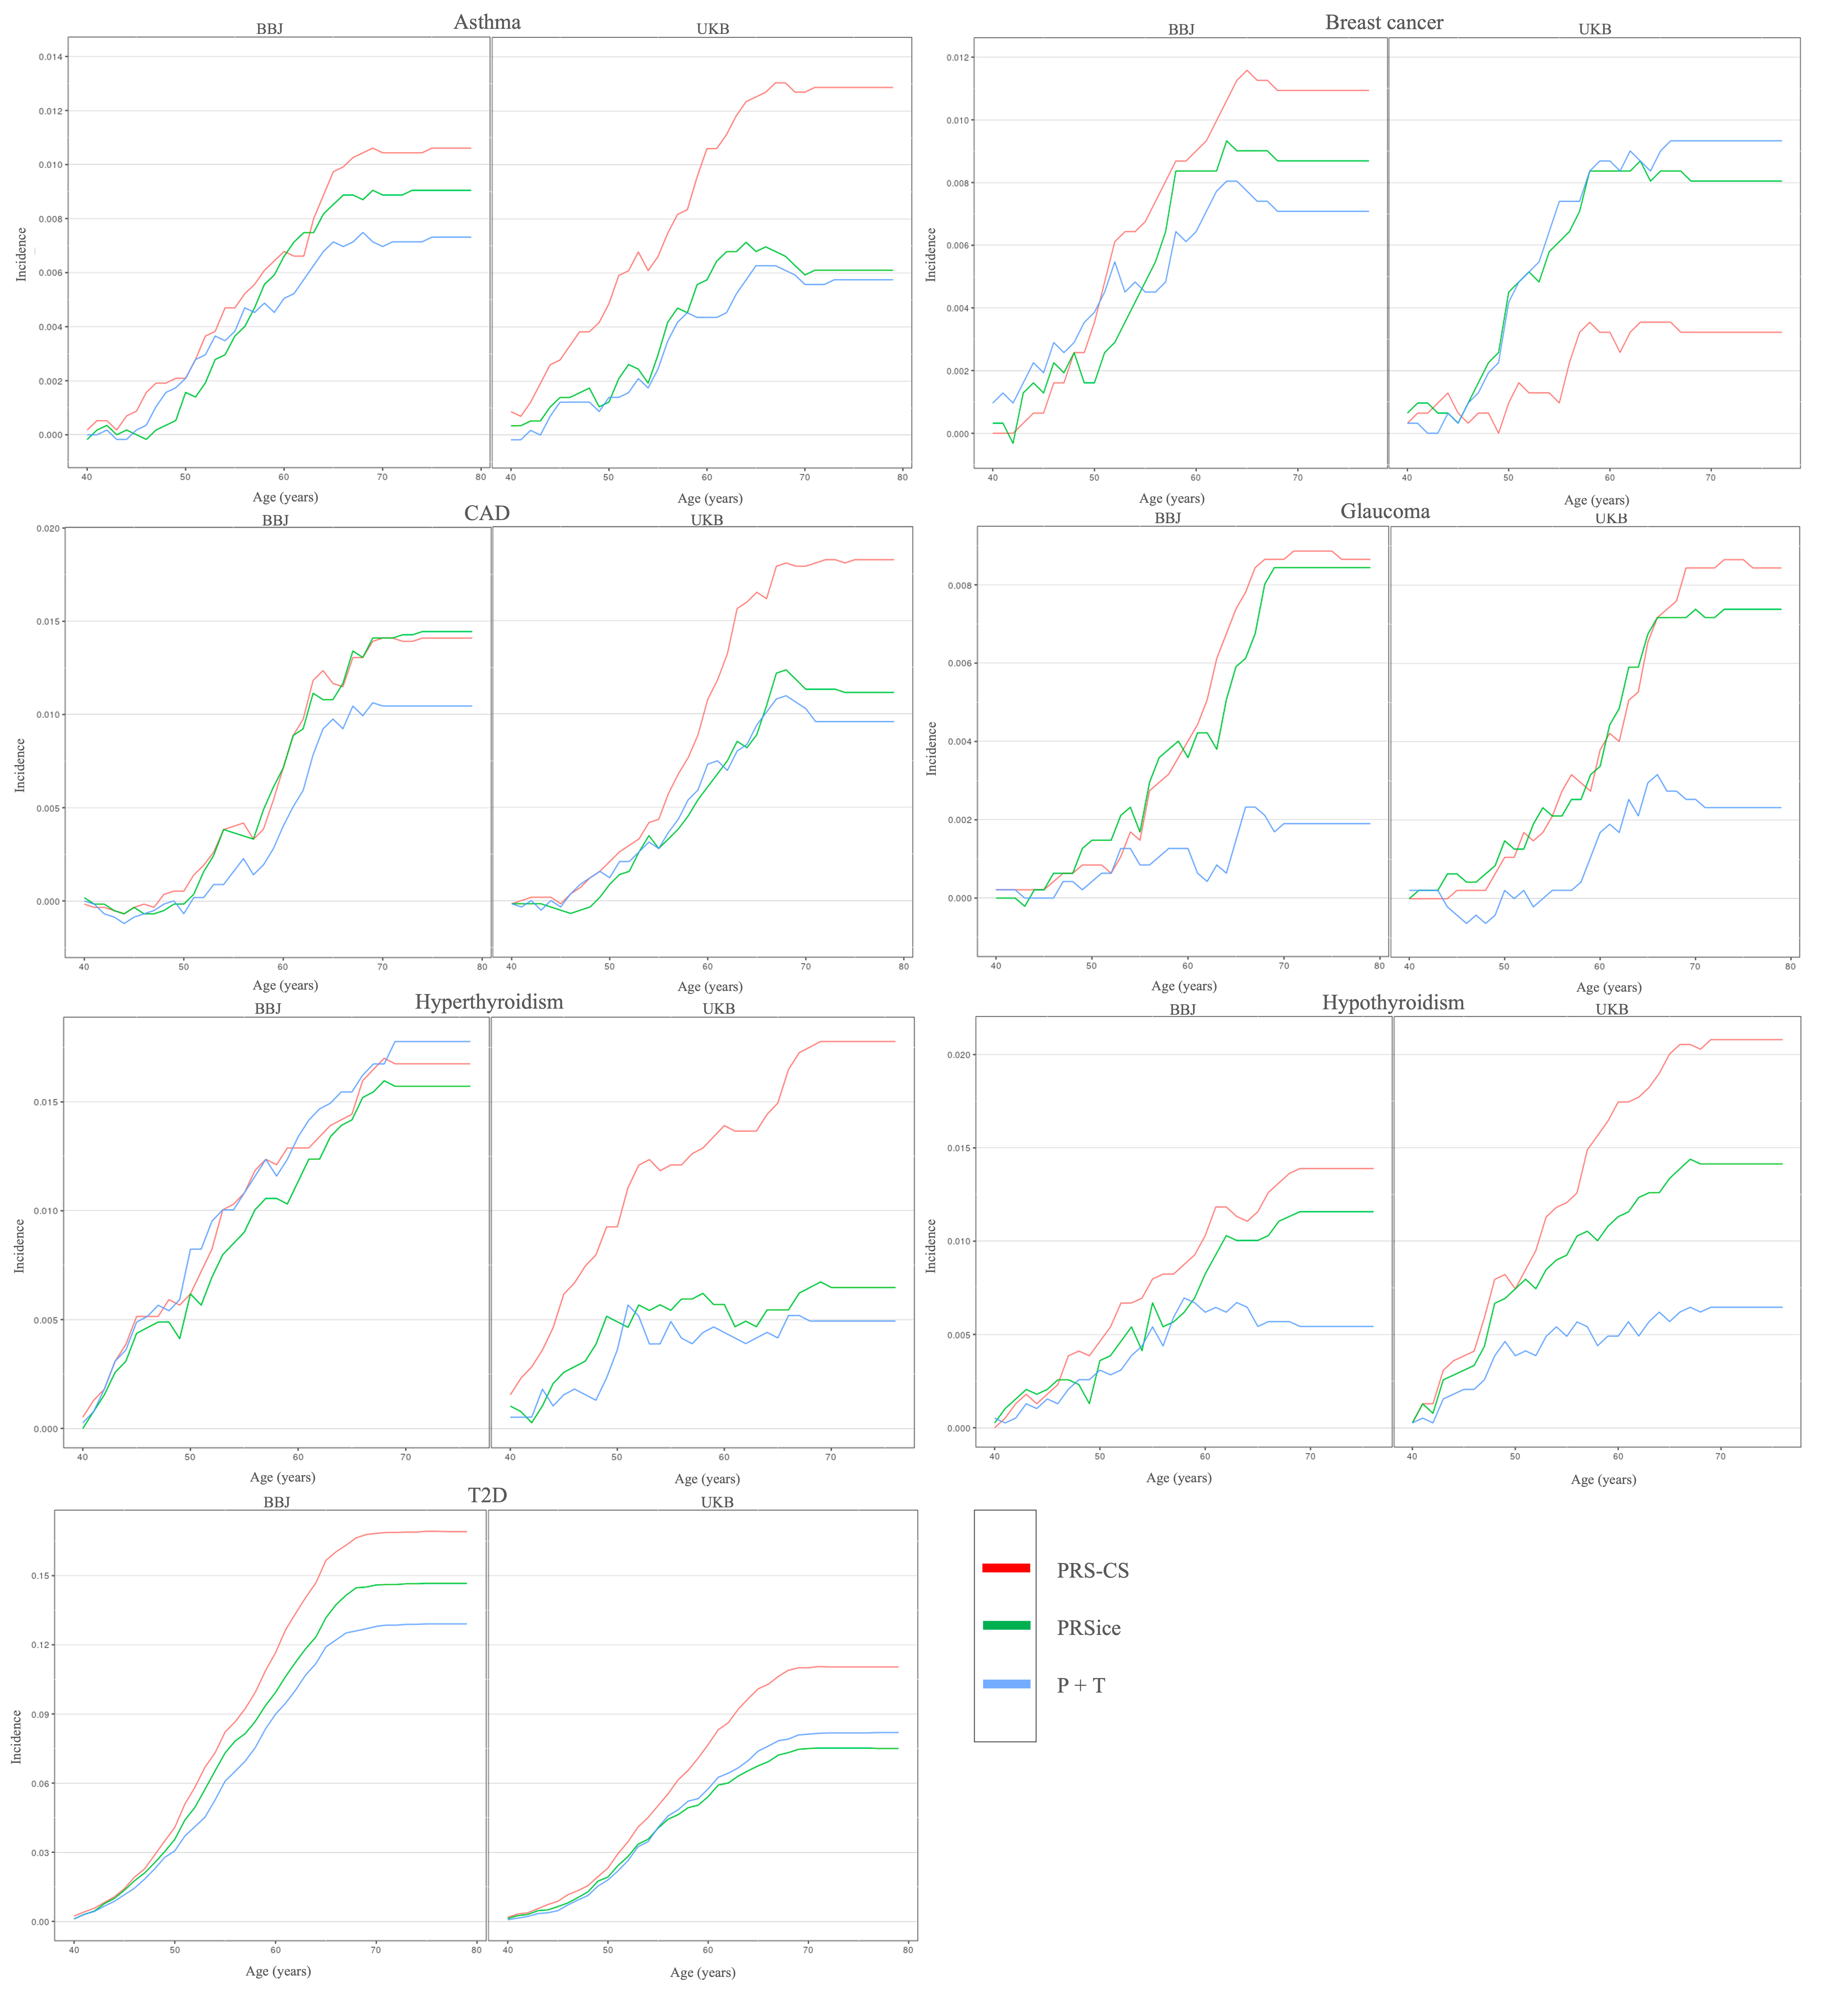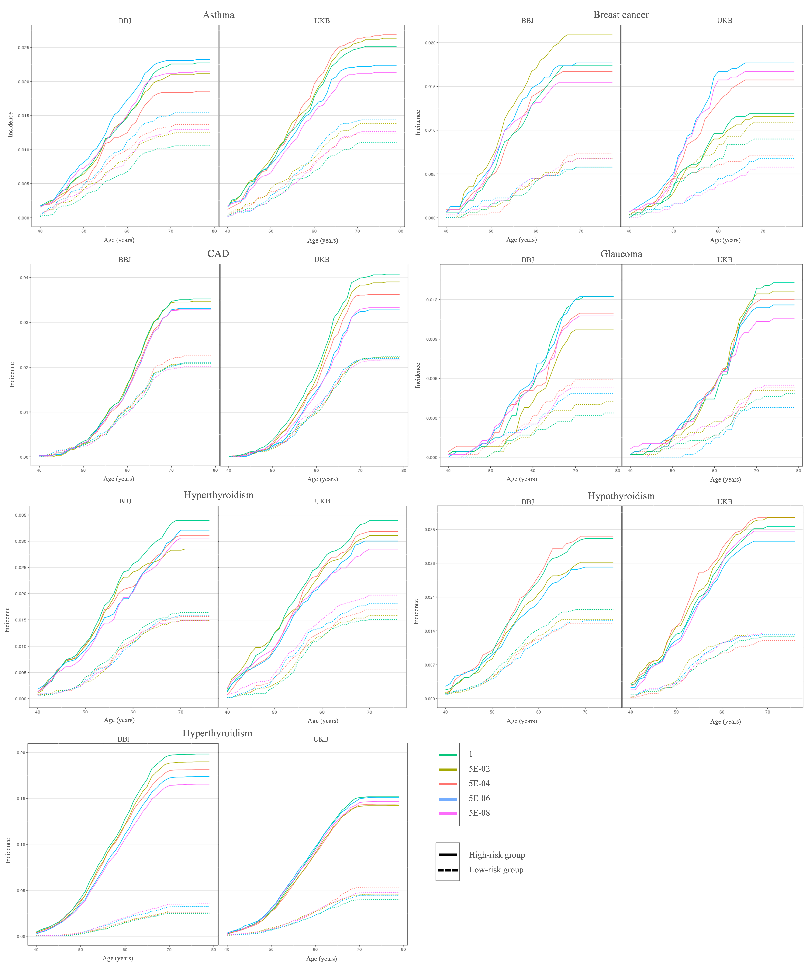
Figure S1. Difference of disease incidence for risk-group. Each plot shows the difference of disease incidence between highest 10% and lowest 10% of the PRS distribution, by given age. Colors of the line indicate the PRS-CS (red), PRSice (green), and P+T (blue) of the PRS methods.
CAD coronary artery disease, T2D type 2 diabetes.

Figure S2. Cumulative incidence plots presenting the predictive performance of PRS-CS applying P-value threshold. Each plot shows the cumulative incidence of disease till the given age. Colors of the line indicate the threshold of P-value, and the types of the line indicate the high-risk group (solid line) and low-risk group (dotted line) which are highest 10% and lowest 10% of the PRS distribution.
CAD coronary artery disease, T2D type 2 diabetes.

