Figure.S1
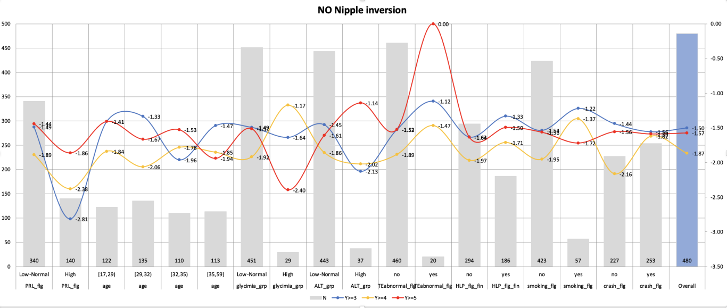
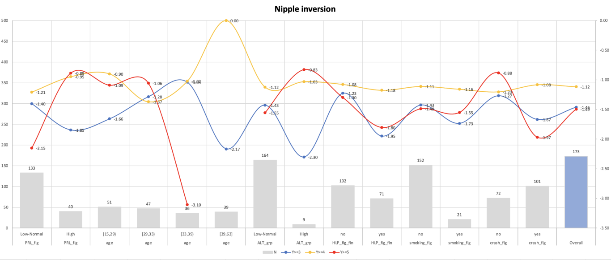

Table T1. VIF for patient with and without NI
 | NI
Test Multicollinearity
 | Term | VIF | VIF_CI_low | VIF_CI_high | SE_factor | Tolerance | Tolerance_CI_low | Tolerance_CI_high | Correlation
1 | PRL_flg | 13.43 | 10.34 | 17.55 | 3.66 | 0.07 | 0.06 | 0.10 | Low
2 | age | 1.21 | 1.09 | 1.54 | 1.10 | 0.82 | 0.65 | 0.92 | High
3 | ALT_grp | 1.16 | 1.05 | 1.50 | 1.08 | 0.86 | 0.67 | 0.95 | Low
4 | glycimia_grp | 1.98 | 1.65 | 2.49 | 1.41 | 0.50 | 0.40 | 0.61 | Low
5 | HLP_flg_fin | 1.11 | 1.02 | 1.51 | 1.05 | 0.90 | 0.66 | 0.98 | Low
6 | smoking_flg | 2.25 | 1.85 | 2.84 | 1.50 | 0.44 | 0.35 | 0.54 | Low
7 | crash_flg | 12.78 | 9.85 | 16.69 | 3.58 | 0.08 | 0.06 | 0.10 | High

 | Non NI
Test Multicollinearity
 | Term | VIF | VIF_CI_low | VIF_CI_high | SE_factor | Tolerance | Tolerance_CI_low | Tolerance_CI_high | Correlation
1 | PRL_flg | 24.79 | 20.92 | 29.40 | 4.98 | 0.04 | 0.03 | 0.05 | Low
2 | age | 1.06 | 1.01 | 1.30 | 1.03 | 0.94 | 0.77 | 0.99 | High
3 | glycimia_grp | 1.12 | 1.05 | 1.29 | 1.06 | 0.89 | 0.77 | 0.95 | Low
4 | ALT_grp | 1.05 | 1.01 | 1.33 | 1.03 | 0.95 | 0.75 | 0.99 | Low
5 | TEabnormal_flg | 1.49 | 1.34 | 1.69 | 1.22 | 0.67 | 0.59 | 0.75 | Low
6 | HLP_flg_fin | 1.08 | 1.02 | 1.28 | 1.04 | 0.92 | 0.78 | 0.98 | Low
7 | smoking_flg | 1.75 | 1.56 | 2.00 | 1.32 | 0.57 | 0.50 | 0.64 | Low
8 | crash_flg | 13.44 | 11.38 | 15.90 | 3.67 | 0.07 | 0.06 | 0.09 | High

Table T2
 |  | External force
 | level | no | yes | p
n |  | 302 | 372
age (mean (SD)) |  | 32.46 (7.07) | 32.45 (6.57) | 0.974
TEabnormal_flg (%) | no | 288 (95.4) | 355 (95.4) | 1
 | yes | 14 ( 4.6) | 17 ( 4.6)
HLP_flg_fin (%) | no | 189 (62.6) | 216 (58.1) | 0.266
 | yes | 113 (37.4) | 156 (41.9)
smoking_flg (%) | no | 269 (89.1) | 325 (87.4) | 0.574
 | yes | 33 (10.9) | 47 (12.6)
tumor_flg (%) | no | 299 (99.0) | 354 (95.2) | 0.008
 | yes | 3 ( 1.0) | 18 ( 4.8)
nipple_flg (%) | no | 229 (75.8) | 259 (69.6) | 0.088
 | yes | 73 (24.2) | 113 (30.4)
relapse_flg (%) | no | 292 (96.7) | 367 (98.7) | 0.145
 | yes | 10 ( 3.3) | 5 ( 1.3)
abortion_flg (%) | no | 300 (99.3) | 367 (98.7) | 0.627
 | yes | 2 ( 0.7) | 5 ( 1.3)
HMsupply_flg (%) | no | 299 (99.0) | 368 (98.9) | 1
 | yes | 3 ( 1.0) | 4 ( 1.1)
THabnormal_flg (%) | no | 294 (97.4) | 369 (99.2) | 0.116
 | yes | 8 ( 2.6) | 3 ( 0.8)
mental_flg (%) | no | 299 (99.0) | 369 (99.2) | 1
 | yes | 3 ( 1.0) | 3 ( 0.8)
PRL_flg (%) | Low-Normal | 220 (72.8) | 262 (70.4) | 0.545
 | High | 82 (27.2) | 110 (29.6)
glycimia_grp (%) | Low-Normal | 284 (94.0) | 354 (95.2) | 0.637
 | High | 18 ( 6.0) | 18 ( 4.8)
ALT_grp (%) | Low-Normal | 277 (91.7) | 350 (94.1) | 0.295
 | High | 25 ( 8.3) | 22 ( 5.9)

