Supplementary material

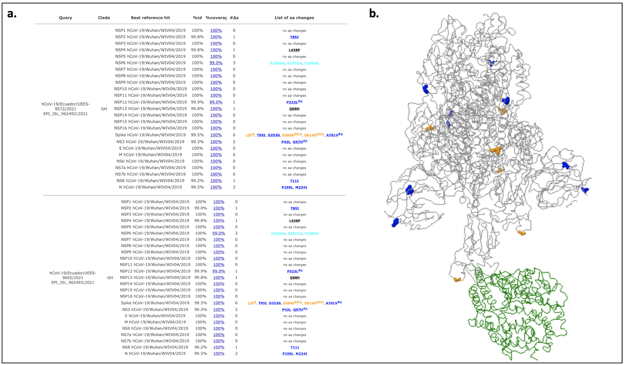
Figure S1. Mutation Analysis of SARS-CoV-2 genomes from B.1.526 lineage a) Summary of query report list of variations b) 3D structural visualization of the spike glycoprotein with aa changes identified in the query sequences shown as colored balls, ACE2 receptor colored in green ribbon

Table S1. SARS-CoV-2 genomes with Spike_E484K, Spike_D614G, NSP12_P323L, NS3_Q57H, L5F, T95I, D253G, A701V substitutions corresponding to B.1.526 lineage (16th February 2021).

