Appendix
A1. Exchange Term Causes Nonlinearity:
The nonlinear terms $\left(n_{pl}+1\right)$ is essential for the intensity dependence of the predicted values. A linear model suggests a constant response by evaluating the following linear equations,
$$\frac{dn_{pl}}{dt}=pI\left(t\right)-Γn_{pl}-T_{ph} n_{pl}+T_{pl}n_{ph}$$ | (S1)

$$\frac{dn_{ph}}{dt}=(1-p)I\left(t\right)-En_{ph}+T_{ph}n_{pl}-T_{pl}n_{ph}$$ | (S2)
and the results have no laser intensity dependence. By increasing the intensity $I_{0}$ by a factor $α$, and defining $n_{pl}$=${αn}_{pl}^{'}$ and $n_{ph} =αn_{ph}^{'}$, the equations are now in the form of:
$$α\frac{dn_{pl}^{'}}{dt}=αpI\left(t\right)-αΓn_{pl}-αT_{ph} n_{pl}+αT_{pl}n_{ph}$$ | (S3)

$$α\frac{dn_{ph}^{'}}{dt}=(1-p)αI\left(t\right)-αEn_{ph}+{αT}_{ph}n_{pl}-αT_{pl}n_{ph}$$ | (S4)
And $α$ could be canceled from the equation, the resulting transmissivity is again:
$$Transmission=\frac{E\int{n_{ph}\left(t\right)dt}}{\int{αI\left(t\right)dt}}=\frac{E\int{n_{ph}^{'}\left(t\right)dt}}{\int{I\left(t\right)dt}}$$ | (S5)
which cancels out to give the same result, and thus the linear model does not have intensity dependence.

A2. Rescaling the Numerical Parameters for Better Convergence
Such extreme values are hard to solve using the previous iteration rules as the dimension of parameters span over thirty orders of magnitude, which leads to possible precision loss and convergence problems. To reduce the computational difficulty, the equations are rewritten by introducing a new variable $δ=T_{pl}-T_{ph}$, two scaling factors and their corresponding reduced photon/plasmon number $n_{pl}^{'}=\frac{n_{pl}}{s_{pl}}$ and $n_{ph}^{'} =\frac{n_{ph}}{s_{ph}}$.

The equations are now in the form of:
$$n_{pl}^{'}\left(t+1\right)=n_{pl}^{'}\left(t\right)+Δt(\frac{pI\left(t\right)}{s_{pl}}-Γn_{pl}^{'}\left(t\right)+T_{ph}(n_{ph}^{'}\left(t\right)\frac{s_{ph}}{s_{pl}}-n_{pl}^{'}(t))+δn_{pl}^{'}(t)n_{ph}^{'}(t)s_{ph}+δn_{ph}^{'}(t))$$ | (S6)

$$n_{ph}^{'}(t+1)=n_{ph}^{'}\left(t\right)+Δt(\frac{\left(1-p\right)I\left(t\right)}{s_{ph}}-En_{ph}^{'}\left(t\right)-(T_{ph}(n_{ph}^{'}\left(t\right)\frac{s_{pl}}{s_{ph}}-n_{pl}^{'}(t))+δn_{pl}^{'}n_{ph}^{'}(t)s_{pl}+δn_{ph}(t)))$$ | (S7)

By adjusting the scaling factors $s_{pl}$ and $s_{ph}$, the numerical solution could be obtained.

A3. Solutions at Steady States
Consider an equilibrium state where the input, the plasmon number and the photon number are constant, the differential equations become:
$$pI-Γn_{pl}+T_{ph}\left(n_{ph}-n_{pl}\right)+δn_{pl}n_{ph}+δn_{ph}=0$$ | (S8)
$$\left(1-p\right)I-En_{ph}-T_{ph}\left(n_{ph}-n_{pl}\right)-δn_{pl}n_{ph}-δn_{ph}=0$$ | (S9)
And the steady state plasmon and photon numbers could be solved:
$$n_{pl}=-\frac{1}{2δΓ}(A_{1}+\sqrt{A_{1}^{2}+A_{3}})$$ | (S10)
$$n_{ph}=\frac{1}{2δE}(A_{2}+\sqrt{A_{1}^{2}+A_{2}})$$ | (S11)
Where $A_{1}=δΓ+EΓ-δI+{ET}_{ph}+ΓT_{ph}$, $A_{2}=δΓ+EΓ+δI+{ET}_{ph}+ΓT_{ph}$, $A_{3}=4δΓ\left(δI+EIp+{IT}_{ph}\right).$By using the fitted values and $I=max⁡(I\left(t\right))$ from equation 6, the equilibrium values are calculated to be $n_{pl}\sim 2.3×{10}^{14}$ and $n_{ph}\sim {10}^{18}$ respectively. The plasmon numbers are close to that in Figure 8, but the photon numbers are much higher, since the maximum intensity was used as a constant input.

A4. The Plasmon Interaction Model at Lower Intensities
Different sources of the damping factor were considered, the first was thermal electrons. ^{[A1]}
$Γ_{e-e}=\frac{π^{3}}{12hE_{f}}[{\left(k_{B}T\right)}^{2}+{\left(\frac{hω}{2π}\right)}^{2}]$ | (S8)
The electron temperature of gold was calculated using the electron contribution of specific heat of gold ^{[A2]},
$$C_{v}=γ_{Au}T$$ | (S9)
Where $γ_{Au}=0.729mJ mol^{-1}K^{-2}$. By integrating from a room temperature of 300 K to current electron temperature $T_{e}$, the energy $E_{e}$ needed is calculated to be
$$E_{e}=\frac{γ_{Au}}{2}(T_{e}^{2}-{300K}^{2})$$ | (S10)

And final electron temperature is

$$T_{e}=\sqrt{\frac{2E_{e}}{γ_{Au}}+{300K}^{2}}$$ | (S11)

Where E_{e} is the energy from thermalized electrons, which is calculated by integrating the total amount of energy dissipated through the Γ damping process $\int_{0}^{t}{Γ\left(t\right)n_{ph}(t)dt}$.

The interaction between a 20 nm gold film and a laser pulse based on Rotenberg et al.^{[A3]} was simulated. The electron temperature rose to 2500 K, the damping factor $Γ$ rose from ~0.18 to 0.185, and the transmission decreases from 4.41% to 4.36% at a pulse energy of 20 nJ, similar to an expected 4.32% as derived from their results. Since the changes are small, the simulation is relatively sensitive to the area of irradiation and thickness, which determines the volume in which the energy is absorbed and the peak electron temperature.
In the simulation, the electron temperature was capped at 40,000K, which is the fermi temperature of gold. This upper limit wouldn’t impact nanojoule laser pulses, as the final electron temperature is around 7,000K.
This electron temperature term could be explained as the source of the saturated damping term from our previous research on gold nanorods^{[A4]}, and the saturation might be a result of the limited electron temperature.
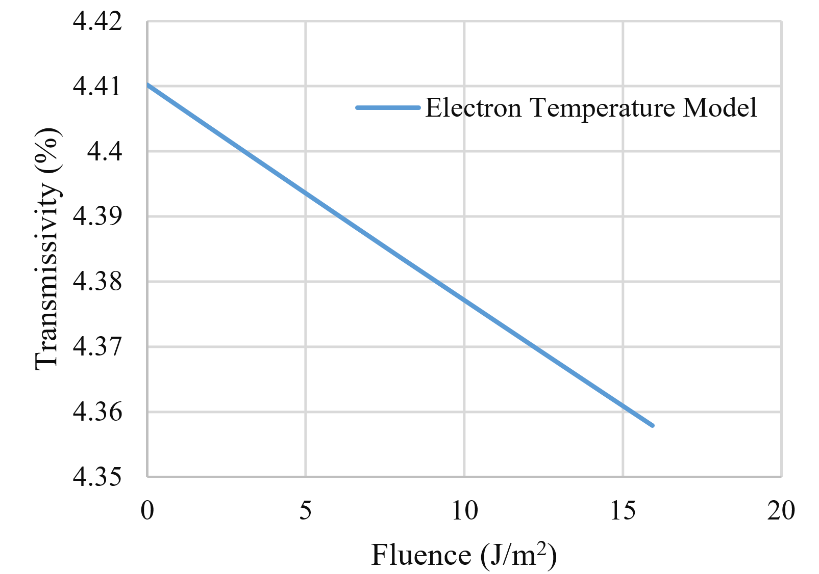
Figure A1 Simulated transmissivity with a temperature damping term at lower energies. As the total photons increase, the electron temperature rises and increases the damping factor, which leads to increased absorption.

The nonlinear indices were reported to have a pulse duration dependence, that the nonlinear index $β$ is roughly proportional to the pulse duration^{[A3,A5]}. This linear dependence suggests that the nonlinear effect depends on fluence instead of intensity for picosecond lasers, as max intensity is inversely proportional to pulse duration.
Such pulse duration dependence was tested with this model. Simulation shows that the transmissivity is roughly consistent with the given intensity, and a pulse duration ranging from 100 to 1000 fs.
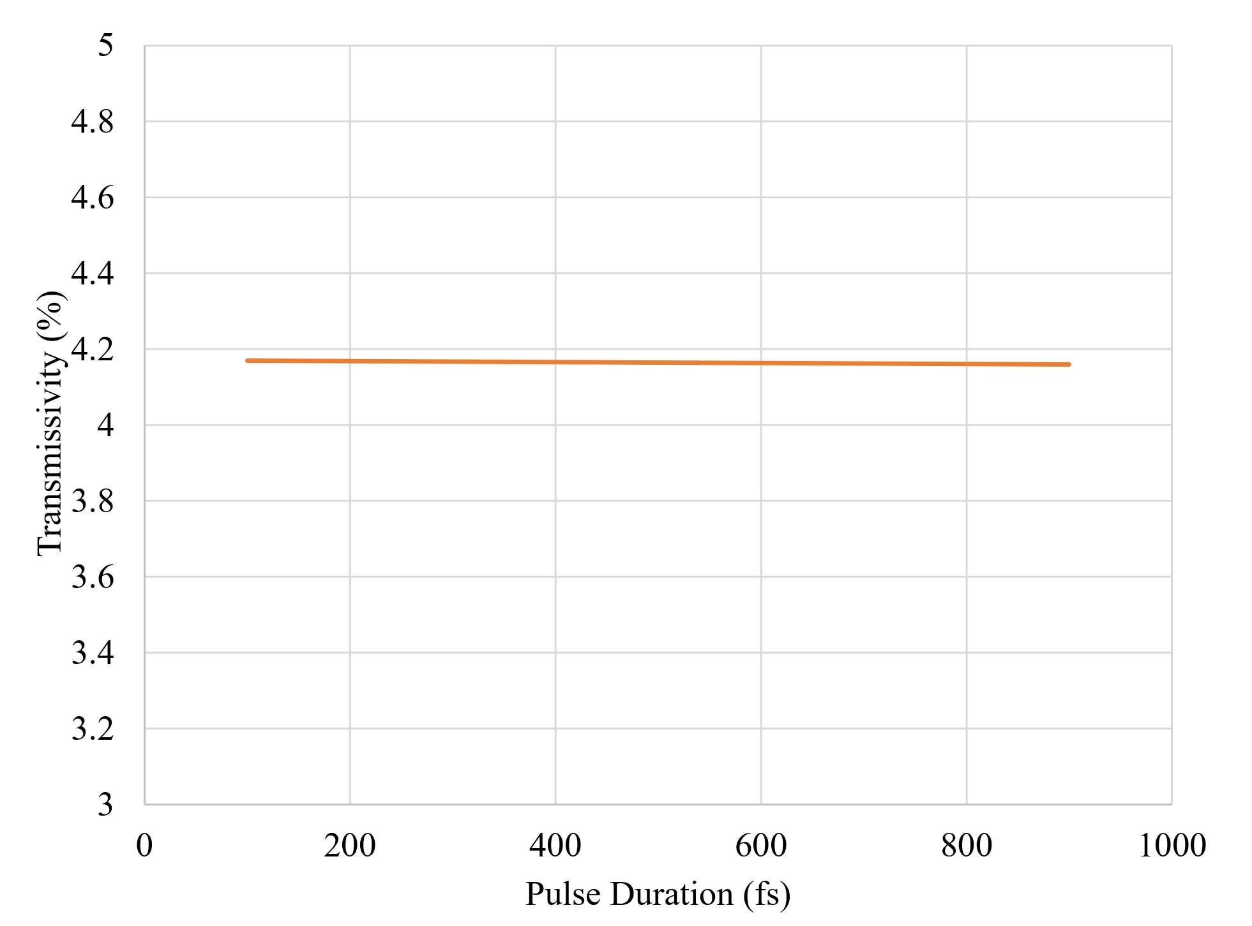
Figure A2 Transmissivity vs. pulse duration for nano-joule laser pulses
For the electron temperature model, the electron temperature rose drastically and the damping factor quickly outvalued its original weak limit.

References
A1. Alabastri A, Tuccio S, Giugni A, Toma A, Liberale C, Das G, Angelis FD, Fabrizio ED, Zaccaria RP: Molding of Plasmonic Resonances in Metallic Nanostructures: Dependence of the Non-Linear Electric Permittivity on System Size and Temperature. Materials 2013, 6(11):4879-4910.
A2. Kittel C, McEuen P, McEuen P: Introduction to solid state physics, vol. 8: Wiley New York; 1996.
A3. Rotenberg N, Bristow A, Pfeiffer M, Betz M, Van Driel H: Nonlinear absorption in Au films: Role of thermal effects. Physical Review B 2007, 75(15):155426.
A4. Wang Z: Spectral Hole Burning Experiments of Gold Nanostructures at Strong Laser Excitation. University of Massachusetts Lowell; 2020.
A5. Boyd RW, Shi Z, De Leon I: The third-order nonlinear optical susceptibility of gold. Optics Communications 2014, 326:74-79.

