Supplemental Information

Table of Contents
Supplemental Information 1
1. Electricity-Based Hydrogen Production Mathematical Approach 5
2. Fossil-Based Hydrogen Production Mathematical Approach 9
3. Electricity-Based Hydrogen Production Configuration and Data Table 10
4. Fossil-Based Hydrogen Production Configuration and Data Tables 11
5. Electricity-Based Hydrogen Production Parameter Sensitivity Analysis 13
6. Fossil-Based Hydrogen Production Parameter Sensitivity Analysis 14
7. Next-Decade LCOH Input Parameter Sample Distributions for Error Bar Analysis 15
8. Next Decade Technology Hydrogen Production Pathway Emissions and LCOH Figures 16
9. Next Decade Technology, Electricity-Based Hydrogen Production Pathway Operations Figures 18
10. Current and Mid-Century LCOH Figures 26
11. Inflation Reduction Act Raw Data Tables 27
References 30

Tables and Figures
Table S.1: Electricity-based hydrogen production model input parameters for current, next decade, and mid-century timeframes. * Next decade values are used to generate model results shown in main text. 10
Table S.2: Fossil-based hydrogen production model input parameters. (1) Refers to an SMR with process CO₂ capture. (2) Refers to an SMR with process and flue gas CO₂ capture. (3) Refers to an ATR with process CO₂ capture 11
Table S.3: Fossil-based hydrogen production model input parameters that change for current, next decade, and mid-century timeframes 12
Table S.4: Baseline next decade, electricity-based LCOH values in $/kg H₂. PV+S refers to solar PV and energy storage systems available. PV+S+G refers to solar PV, energy storage, and grid connection available. PV+G refers to solar PV and a grid connection available without energy storage. 12
Table S.5: LCOH sensitivities explored for next decade electricity-based hydrogen production. Grid electricity related parameter changes are only explored in the pathway with a grid connection. 12
Table S.6: Hourly reliable (with solar PV, a grid connection, and energy storage) LCOH sensitivity analysis with next decade technology 13
Table S.7: Baseline next decade, fossil-based LCOH values in $/kg H₂. (1) Refers to SMR with process CO₂ capture. (2) Refers to SMR with process and flue gas CO₂ capture. (3) Refers to ATR with process CO₂ capture. Baseline LCOH values assume GWP20 and 1.5% natural gas leakage. 13
Table S.8: LCOH sensitivities explored for next decade fossil-based hydrogen production 13
Table S.9: Hourly reliable (ATR with process CO₂ capture) LCOH sensitivity analysis with next decade technology 14
Table S.10: Summary data table containing sample distributions for each input parameter. These distributions are used to generate error bars on next-decade LCOH figures through Monte Carlo simulation. 14
Figure S.1: Next decade life cycle emissions of solar PV based hydrogen production under various levels of reliability. * Indicated an hourly-reliable production pathway that has a grid connection for added reliability 16
Figure S.2: Next decade life-cycle emissions of various fossil-based hydrogen production pathways 16
Figure S.3: Levelized cost of hourly-reliable net-zero hydrogen produced from fossil-based pathways. Pathways include SMR, SMR-CCS with process CO₂ capture (1), SMR-CCS with process and flue gas CO₂ capture (2), and ATR-CCS with process CO₂ capture (3) 17
Figure S.4: Next decade fractional electricity usage versus curtailment for various levels of hydrogen production reliability pathways 17
Figure S.5: Next decade fractional electricity usage versus curtailment for hourly production reliability pathways 18
Figure S.6: Next decade fractional hydrogen delivery for various levels of hydrogen production reliability pathways 18
Figure S.7: Next decade fractional hydrogen delivery for hourly production reliability pathways 19
Figure S.8: Daily fractional electricity usage versus curtailment for yearly reliable solar PV hydrogen production pathway 19
Figure S.9: Daily fractional electricity usage versus curtailment for hourly reliable solar PV and storage hydrogen production pathway 20
Figure S.10: Daily fractional electricity usage versus curtailment for hourly reliable solar PV, storage, and grid connected hydrogen production pathway 20
Figure S.11: Daily fractional hydrogen delivery for hourly reliable solar PV and storage hydrogen production pathway 21
Figure S.12: Daily fractional hydrogen delivery for hourly reliable solar PV, storage, and grid connected hydrogen production pathway 21
Figure S.13: Hourly electricity usage versus curtailment for yearly reliable solar PV hydrogen production pathway for a week in the month of May 22
Figure S.14: Hourly electricity usage versus curtailment for hourly reliable solar PV and storage hydrogen production pathway for a week in the month of May 22
Figure S.15: Hourly electricity usage versus curtailment for hourly reliable solar PV, storage, and grid connected hydrogen production pathway for a week in the month of May 23
Figure S.16: Hourly hydrogen delivery for yearly reliable solar PV hydrogen production for a week in the month of May 23
Figure S.17: Hourly hydrogen delivery for hourly reliable solar PV and storage hydrogen production pathway for a week in the month of May 24
Figure S.18: Hourly hydrogen delivery for hourly reliable solar PV, storage, and grid connected hydrogen production pathway for a week in the month of May 24
Figure S.19: Hourly hydrogen storage for hourly reliable solar PV and storage hydrogen production pathway for a week in the month of May 25
Figure S.20: Hourly hydrogen storage for hourly reliable solar PV, storage, and grid connected hydrogen production pathway for a week in the month of May 25
Figure S.21: Hourly reliable, net-zero hydrogen production cost comparison between electricity-based and fossil-based production pathways assuming current technologies and Sacramento, California facility location 26
Figure S.22: Hourly reliable, net-zero hydrogen production cost comparison between electricity-based and fossil-based production pathways assuming mid-century technology projections and Sacramento, California facility location 26
Table S.11: (a) Total life-cycle emissions for each hydrogen production pathway considered, under various emission scenarios and considering next-decade technology (in kg CO₂e / kg H₂ produced). The corresponding 45V PTC achievable given life-cycle emissions is shown in parenthesis. (b) Total LCOH (in $/kg H₂ produced) for each hourly-reliable hydrogen production pathway considered, under various emission scenarios. The LCOH values that are highlighted red consider 45V and are valid for the first 10 years of project operation as defined in the IRA. LCOH values highlighted blue consider 45Q and are valid for the first 12 years of project operation. All other LCOH values are not highlighted because the production pathway does not qualify for 45V or 45Q. 27
Table S.12: (a) Total life-cycle emissions for each hydrogen production pathway considered, under various emission scenarios and considering current technology (in kg CO₂e / kg H₂ produced). The corresponding 45V PTC achievable given life-cycle emissions is shown in parenthesis. (b) Total LCOH (in $/kg H₂ produced) for each hourly-reliable hydrogen production pathway considered, under various emission scenarios. The LCOH values that are highlighted red consider 45V and are valid for the first 10 years of project operation as defined in the IRA. LCOH values highlighted blue consider 45Q and are valid for the first 12 years of project operation. All other LCOH values are not highlighted because the production pathway does not qualify for 45V or 45Q. 27

Electricity-Based Hydrogen Production Mathematical Approach
This section details the decision variables, constraints, and the objective function used for the electricity-based hydrogen production model.
Decision Variables:
S_{B} - Solar size (capacity of solar farm to build – kW)
E_{B} - Electrolyzer size (capacity of electrolyzer – kW)
T_{B} – Hydrogen storage tank size (kg)
B_{B} – Battery storage size (kWh)
L_{A} - Land required for PV facility (acres)
G_{B} – Grid connection size (kW)
E_{U} – Electricity used each hour of the year (kWh)
E_{N} – Electricity curtailed each hour of the year (kWh)
H_{UD} – Hydrogen used directly from electrolyzer each hour of the year (kg)
H_{S} – Hydrogen put into storage each hour of the year (kg)
H_{T} – Hydrogen taken and used from storage each hour of the year (kg)
H_{IS} – Hydrogen in storage each hour of the year (kg)
E_{S} – Electricity put into storage each hour of the year (kWh)
E_{T} – Electricity taken from storage each hour of the year (kWh)
E_{IS} – Electricity in storage each hour of the year (kWh)
E_{G} – Electricity taken from the grid each hour of the year (kWh)
C_{A} – Annual CO₂-equivalent emissions (kg)
W_{CA} – Annual water costs
R_{E} – Electrolyzer ramping (Change in kW between each hour of the year)
R_{B} – Battery storage ramping (Change in kWh stored between each hour of the year)
R_{T} – Hydrogen storage ramping (Change in kg stored between each hour of the year)
Constraints:
Electricity Balance:
$${∀i∈i=1…n: \left({CF}_{S}\right)}_{i}*\left(S_{B}\right) +{\left(E_{T}\right)}_{i}+{m*(E_{G})}_{i}= {(E_{U})}_{i} + {(E_{N})}_{i}$$
where:
- i = each hour of a year
- n = total number of hours in a year
- CF_{S} = solar PV capacity factor each hour of the year in Sacramento
- m = 0 or 1, depending on if a grid connection is considered

Electrolyzer Capacity Constraint:
$${∀i∈i=1…n: \left(E_{U}\right)}_{i}- {\left(H_{S}\right)}_{i}*\left(C_{E}\right) -{\left(E_{S}\right)}_{i}-{m*\left(E_{G}\right)}_{i}<=(E_{B})$$
where:
- C_{E} = energy requirement for hydrogen compression (kWh/kg H₂)

Electricity and Hydrogen Energy Balance:
$${∀i∈i=1…n: \left(E_{U}\right)}_{i}= {\left(H_{UD}\right)}_{i}*\left(E_{E}\right) +{\left(H_{S}\right)}_{i}*\left(\left(E_{E}\right)+ \left(C_{E}\right)\right)+{(E_{S})}_{i}$$
where:
- E_{E} = electricity input requirement for hydrogen production from electrolysis (kWh/kg H₂)

Hydrogen Delivery Reliability Constraints:
${∀ i∈i=1…n: \left(H_{UD}\right)}_{i}+{\left(H_{T}\right)}_{i}=(\frac{P_{E}}{n})$ with hourly hydrogen delivery constraint
${∀ a∈a=1…x: \left(H_{UD}\right)}_{a}+{\left(H_{T}\right)}_{a}=(\frac{P_{E}}{x})$ with daily hydrogen delivery constraint
${∀ b∈b=1…y: \left(H_{UD}\right)}_{b}+{\left(H_{T}\right)}_{b}=(\frac{P_{E}}{y})$ with monthly hydrogen delivery constraint
${∀ c∈c=1…z: \left(H_{UD}\right)}_{c}+{\left(H_{T}\right)}_{c}=(\frac{P_{E}}{z})$ with yearly hydrogen delivery constraint
with:
$${∀ a∈a=1…x: (H_{UD})}_{a} , {(H_{T})}_{a}=\sum_{i= \left(a-1\right)*\left(\frac{n}{x}\right)+1}^{a*(\frac{n}{x})}{{(H_{UD})}_{i} , {(H_{T})}_{i}}$$
$${∀ b∈b=1…y: (H_{UD})}_{b} , {(H_{T})}_{b}=\sum_{i= \left(b-1\right)*\left(\frac{n}{y}\right)+1}^{b*(\frac{n}{y})}{{(H_{UD})}_{i} , {(H_{T})}_{i}}$$
$${∀ c∈c=1…z: (H_{UD})}_{c} , {(H_{T})}_{c}=\sum_{i= \left(c-1\right)*\left(\frac{n}{z}\right)+1}^{c*(\frac{n}{z})}{{(H_{UD})}_{i} , {(H_{T})}_{i}}$$
where:
- i = each hour per year, n = total hours per year = 8760
- x = each day per year, a = total days per year = 365
- y = each month per year, b = total months per year = 12
- z = each year per year, c = total years per year = 1
- P_{E} = yearly hydrogen production rate for electricity-based production (kg H₂ per year)

Grid Connection Capacity Constraints:
$${∀i∈i=1…n: \left(E_{G}\right)}_{i}<= (G_{B})$$

$${∀i∈i=1…n: \left(E_{N}\right)}_{i}<= (G_{B})$$
Energy Storage Balance:
$${∀i∈i=1…n: \left(H_{IS}\right)}_{i+1}- {\left(H_{IS}\right)}_{i}= {η_{T}*\left(H_{S}\right)}_{i}- {\left(H_{T}\right)}_{i}$$

$${∀i∈i=1…n: \left(E_{IS}\right)}_{i+1}- {\left(E_{IS}\right)}_{i}= {η_{B}*\left(E_{S}\right)}_{i}- {\left(E_{T}\right)}_{i}$$

where:
- η_{B} = battery storage efficiency
- η_{T} = hydrogen tank storage efficiency

$${\left(H_{IS}\right)}_{1} = {\left(H_{IS}\right)}_{n}$$

$${\left(E_{IS}\right)}_{1} = {\left(E_{IS}\right)}_{n}$$
Energy Storage Capacity Constraints:

$${∀i∈i=1…n: \left(H_{IS}\right)}_{i} <=(T_{B})$$
$${∀i∈i=1…n: \left(H_{S}\right)}_{i} <=(T_{B})$$
$${∀i∈i=1…n: \left(H_{T}\right)}_{i} <=(T_{B})$$

$${∀i∈i=1…n: \left(E_{IS}\right)}_{i} <=(B_{B})$$
$${∀i∈i=1…n: \left(E_{S}\right)}_{i} <=(B_{B})$$
$${∀i∈i=1…n: \left(E_{T}\right)}_{i} <=(B_{B})$$
Land Area Constraint:

$$\left(L_{A}\right)= \left(\frac{S_{B}}{\begin{aligned}1000\frac{kW}{MW} \\ \end{aligned}} \right)*A_{S}$$
where:
- A_{S} = Land area required per MW of solar PV installed (acres/MW)
Annual Emission Constraint:
$$C_{A}={(C}_{S})*\sum_{i=1}^{n}{{({CF}_{S})}_{i}* {(S}_{B})+(m)*\sum_{i=1}^{n}{{(E_{G})}_{i}* {{(C}_{G})}_{i}}}$$
where:
- C_{S} = the carbon intensity of upstream solar PV production (kg CO₂e / kWh)
- C_{G} = the carbon intensity of the grid in Sacramento each hour of a year (kg CO₂e / kWh)
Annual Water Cost Constraint:
$$W_{CA}={(W}_{C})*(P)*{(W}_{U})$$
where:
- W_{C} = the cost of water ($ / kg H₂O)
- W_{U} = the usage rate of water (kg H₂O / kg H₂ produced)
Ramping Constraints:
$${∀i∈i=1…n-1: \left(R_{E}\right)}_{i}≥ {\left(E_{U}\right)}_{i}- {\left(E_{U}\right)}_{i+1}$$
$${∀i∈i=1…n-1: \left(R_{E}\right)}_{i}≥ {-(\left(E_{U}\right)}_{i}- {\left(E_{U}\right)}_{i+1})$$

$${∀i∈i=1…n-1: \left(R_{B}\right)}_{i}≥ {\left(E_{IS}\right)}_{i}- {\left(E_{IS}\right)}_{i+1}$$
$${∀i∈i=1…n-1: \left(R_{B}\right)}_{i}≥ {-(\left(E_{IS}\right)}_{i}- {\left(E_{IS}\right)}_{i+1})$$

$${∀i∈i=1…n-1: \left(R_{T}\right)}_{i}≥ {\left(H_{T}\right)}_{i}- {\left(H_{T}\right)}_{i+1}$$
$${∀i∈i=1…n-1: \left(R_{T}\right)}_{i}≥ {-(\left(H_{T}\right)}_{i}- {\left(H_{T}\right)}_{i+1})$$

Objective Function:
Minimize the levelized cost of hydrogen produced (LCOH= f(x)). LCOH is equivalent to the annualized hydrogen production cost divided by the annual hydrogen production rate:

$$min:f(x)=$$
$$\frac{\begin{aligned}[\left(CRF+S_{OM}\right)*S_{B}*S_{C}+\left(CRF+E_{OM}\right)*E_{B}*E_{C} \\ + \left(CRF+T_{OM}\right)*T_{B}*T_{C}+\left(CRF+B_{OM}\right)*B_{B}*B_{C} \\ +m*\sum_{i=1}^{n}{{{((E}_{G})}_{i}*(LM{P)}_{i}-} {{(E}_{N})}_{i}*\left(NSC{R)}_{i}\right)+W_{CA} \\ + m*(G_{B}*\left(D_{C}+I_{C}\right)*b+ F_{C} \\ + m*\left(CRF+G_{OM}\right)*G_{B}*G_{C}+\left(L_{A}*L_{C}\right)+{(C}_{A}*M_{C}) \\ +\sum_{i=1}^{n-1}{{{((R}_{E})}_{i}*({R)}_{C1}}{{+(R}_{T})}_{i}*\left({R)}_{C2}\right)+\sum_{i=1}^{n-2}{{{((R}_{B})}_{i}*({R)}_{C1})]}\end{aligned}}{P_{E}}$$
where:
- CRF = capital recovery factor (% CAPEX/yr)
- S_{OM} = solar PV operation and maintenance cost (% CAPEX/yr)
- S_{C} = solar PV capital cost ($/kW)
- E_{OM} = electrolyzer operation and maintenance cost (% CAPEX/yr)
- E_{C} = electrolyzer capital cost ($/kW)
- T_{OM} = hydrogen storage tank operation and maintenance cost (% CAPEX/yr)
- T_{C} = hydrogen storage tank capital cost ($/kg)
- B_{OM} = battery storage operation and maintenance cost (% CAPEX/yr)
- B_{C} = battery storage capital cost ($/kWh)
- LMP = locational marginal electricity pricing ($/kWh)
- NSCR = net surplus compensation rate ($/kWh)
- D_{C} = grid demand charges ($/max kW/month)
- I_{C} = grid infrastructure charge ($/kW/month)
- F_{C} = fixed grid infrastructure charge ($/month)
- G_{OM} = grid connection operation and maintenance cost (% CAPEX/yr)
- G_{C} = grid connection capital cost ($/kW)
- L_{C} = cost for land lease ($/acre/yr)
- M_{C} = cost for CO₂ mitigation ($/kg CO₂ mitigated)
- R_{C1} = small cost incurred due to electrical system ramping ($/change in kWh).
- R_{C2} = small cost incurred due to hydrogen system ramping ($/change in kg H₂)

and:
$$CRF=\frac{WACC}{1-{\left(1+WACC\right)}^{-t}}$$
where:
- WACC = weighted average cost of capital, also known as a discount rate (%)
- t = project life (years)

Fossil-Based Hydrogen Production Mathematical Approach
This section details the fossil-based hydrogen production computational model input variables and equations. The primary equation being the LCOH from fossil-derived hydrogen production.
$${LCOH}_{j}=$$
$$\frac{\left(CRF\right)*\left({{(C}_{R})}_{j}+{{(C}_{PC})}_{j}+{{(C}_{FC})}_{j}+{{(C}_{AS})}_{j}\right)+{\left(F_{OM}\right)}_{j}+{\left(V_{OM}\right)}_{j}}{F_{1}}$$
$$+ \left({NG}_{C}\right)*\left({HV}_{NG}\right)*{\left(I_{NG}\right)}_{j}+\left(E_{P, avg}\right)*{\left(I_{E}\right)}_{j}+\left(C_{CTS}\right)*{\left(O_{CC}\right)}_{j}+\left(M_{C}\right)*{(E_{F})}_{j}$$

and:
$${(E_{f})}_{j}={(E_{D})}_{j}+\left(C_{G,avg}\right)*{\left(I_{E}\right)}_{j}+\left({NG}_{L}\right)*{\left(I_{NG}\right)}_{j}*\left(GWP\right)+\left({NG}_{P}\right)*{\left(I_{NG}\right)}_{j}$$
where:
- j = the fossil-based production pathway we are exploring
- C_{R} = the capital cost of the reformer ($/kW H₂)
- C_{PC} = the capital cost of process CO₂ capture ($/kW H₂)
- C_{FC} = the capital cost of flue gas CO₂ capture ($/kW H₂)
- C_{AS} = the capital cost of an air separation unit ($/kW H₂)
- F_{OM} = the fixed operating cost of the facility ($/kW/yr H₂)
- V_{OM} = the variable operating cost of the facility ($/kW/yr H₂)
- F₁ = conversion factor from kW to kg H₂ per year (263 [kg/yr]/kW)
- NG_{C} = natural gas cost ($/MJ)
- HV_{NG} = the heating value of natural gas (52 MJ/kg)
- I_{NG} = natural gas input at the facility (kg CH₄/kg H₂)
- E_{P, avg} = the average electricity price in Sacramento considering locational marginal pricing and grid use charges ($/kWh)
- I_{E} = electricity input at the facility (kWh/kg H₂)
- C_{CTS} = the cost for CO₂ transport and storage ($/kg CO₂)
- O_{CC} = carbon captured at the facility (kg CO₂/kg H₂)
- M_{C} = the cost for carbon mitigation ($/kg CO₂)
- E_{F} = all facility related and upstream carbon emissions (kg CO₂/kg H₂)
- E_{D} = direct facility carbon emissions (kg CO₂/kg H₂)
- C_{G,avg} = the average carbon intensity of the grid in Sacramento (kg CO₂e/kWh)
- NG_{L} = the fraction of the natural gas input that leaks during natural gas production and processing (kg CH₄ leaked/kg CH₄ input)
- GWP = global warming potential of CH₄ relative to CO₂
- NG_{P} = carbon emission associated with natural gas production and processing (kg CO₂/kg CH₄)

Electricity-Based Hydrogen Production Configuration and Data Table
This section contains data tables of the primary inputs used to develop the electricity-based production model results. In addition to next-decade technology, Table S.1 also contains input data for current and mid-century technology assumptions.
Table S.1: Electricity-based hydrogen production model input parameters for current, next decade, and mid-century timeframes. * Next decade values are used to generate model results shown in main text.
Parameter | Current Value | Next Decade Value * | Mid-Century Value | Units | Source
Hydrogen Supply | 25 | 250 | 500 | metric ton/day | Assumed
Solar PV Capacity Factor (hourly) | 31 | 31 | 31 | % average | [1]
Electrolysis Efficiency | 60 | 65 | 70 | % | [2]
H₂ Storage Efficiency | 100 | 100 | 100 | % | Assumed
Battery Storage Efficiency | 80 | 85 | 90 | % | [2]
Hydrogen Energy Content | 33.3 | 33.3 | 33.3 | kWh/kg | N/A
Compression Energy Input | 1.2 | 1.2 | 1.1 | kWh/kg | [2]
Capital Cost of Electrolyzer | 1025 | 570 | 485 | $/kW (1 MW system) | [2], [3]
Capital Cost of Solar Farm | 900 | 500 | 400 | $/kW (100 MW system) | [2], [4]
Capital Cost Grid Connection | 340 | 180 | 45 | $/kW | [2]
Electrolyzer O&M | 7.5 | 7.5 | 7.5 | %/year CAPEX | [2]
Solar O&M | 1 | 1 | 1 | %/year CAPEX | [2]
Grid Connect O&M | 1 | 1 | 1 | %/year CAPEX | [2]
Capital Cost H₂ Storage | 830 | 500 | 200 | $/kg | [2]
Capital Cost Elect Storage | 350 | 250 | 100 | $/kWh | [2]
H₂ Storage O&M | 1 | 1 | 1 | %/year CAPEX | [2]
Electricity Storage O&M | 1 | 1 | 1 | %/year CAPEX | [2]
Project Life | 25 | 25 | 25 | years | [2]
WACC | 10 | 8 | 5 | % | [2]
Electrolyzer Cost Scaling Factor | 0.95 | 0.95 | 0.95 | N/A | Assumed
Solar PV Cost Scaling Factor | 0.9 | 0.9 | 0.9 | N/A | Assumed
Water Cost | 1 | 1 | 1 | $/ton | [2]
Water Usage | 15 | 15 | 15 | kg H₂O/kg H2 | [5]
Solar Land Cost | 750 | 750 | 750 | $/acre/year | [6]
Land for Solar Farm | 7.5 | 7.5 | 7.5 | acres/MW | [7]
Grid Compensation Rate | 0.04 | 0.01 | 0.00 | $/kWh average | [8]
Grid Electricity Cost (hourly) | 0.06 | 0.06 | 0.06 | $/kWh yearly average | [8]
Grid Emissions (hourly) | 0.24 | 0.12 | 0.048 | kg CO₂/kWh average | [9]
Grid Demand Charge | 1.61 | 1.61 | 1.61 | $/max kW/month | [10]
Site Infrastructure Charge | 4.27 | 4.27 | 4.27 | $/max kW/month | [10]
Fixed Grid Charge | 203.15 | 203.15 | 203.15 | $/month | [10]
Solar PV Lifecycle Emissions | 0.04 | 0.04 | 0.03 | kg CO₂/kWh | [11]
DAC Cost | 600 | 200 | 100 | $/metric ton CO₂ captured | [2]

Fossil-Based Hydrogen Production Configuration and Data Tables
This section contains data tables of the primary inputs used to develop the fossil-based production model results. In addition to next-decade technology, Table S.3 also contains input data that changes with current and mid-century technology assumptions.
Table S.2: Fossil-based hydrogen production model input parameters. (1) Refers to an SMR with process CO₂ capture. (2) Refers to an SMR with process and flue gas CO₂ capture. (3) Refers to an ATR with process CO₂ capture
Input Parameters | Production Method |  |  |  | Units | Source
Input Parameters | SMR | SMR-CCS (1) | SMR-CCS (2) | ATR-CCS (3) | Units | Source
Capacity Factor | 90% | 90% | 90% | 90% | N/A | [12]
CO₂ Capture Percent | 0% | 56% | 96% | 95% | % | [12]
Baseline H₂ Production Capacity | 483 | 483 | 483 | 660 | metric ton/day | [12]
Next Decade Production Capacity | 250 | 250 | 250 | 250 | metric ton/day | N/A
Plant Life | 30 | 30 | 30 | 30 | years | [13]
Electricity Use | 0.65 | 1.5 | 2.04 | 4 | kWh/kg H₂ capacity | [12]
Natural Gas Use | 3.53 | 3.58 | 3.75 | 3.52 | kg CH4/kg H₂ capacity | [12]
Water Consumption | 16 | 19 | 24 | 24 | kg H₂O/kg H₂ capacity | [12]
Reformer/Other Capital Cost | 549 | 576 | 809 | 604 | $/kW H₂ capacity | [12]
Air Separation Unit Capital Cost | 0 | 0 | 0 | 294 | $/kW H₂ capacity | [12]
Process Capture Capital Cost | 0 | 158 | 61 | 158 | $/kW H₂ capacity | [12]
Flue Gas Capture Capital Cost | 0 | 0 | 466 | 0 | $/kW H₂ capacity | [12]
Fixed O&M | 16 | 23 | 35 | 27 | $/kW per year H₂ capacity | [12]
Other Variable O&M | 10 | 14 | 23 | 17 | $/kW per year H₂ capacity | [12]
Natural Gas Cost | 10 | 10 | 10 | 10 | $/GJ CH₄ | [14]
Average Electricity Cost | 0.075 | 0.075 | 0.075 | 0.075 | $/kWh electricity | [2], [8], [10]
Natural Gas Energy Content | 52 | 52 | 52 | 52 | MJ/kg CH₄ | N/A
Discount Rate (WACC) | 5% | 5% | 5% | 5% | % | [12]
Cost Scaling Factor | 0.6 | 0.6 | 0.6 | 0.6 | N/A | [15]
Direct CO₂ Emissions | 9.3 | 4.1 | 0.4 | 0.5 | kg CO₂/kg H2 | [12]
CO₂ Captured | 0 | 5.2 | 10.1 | 8.6 | kg CO₂/kg H2 | [12]
Upstream Natural Gas Processing Carbon Intensity | 0.3 | 0.3 | 0.3 | 0.3 | kg CO₂/kg CH4 | [16]
Grid Carbon Intensity | 0.12 | 0.12 | 0.12 | 0.12 | kg CO₂/kWh electricity | [9]
CO₂ Transport and Storage Costs | 0 | 10 | 10 | 10 | $/metric ton CO₂ captured | [17]
CO₂ Mitigation Cost | 200 | 200 | 200 | 200 | $/metric ton CO₂ mitigated | [2]
Natural Gas GWP 100 | 30 | 30 | 30 | 30 | kg CO₂e/kg CH₄ | [18]
Natural Gas GWP 20 | 85 | 85 | 85 | 85 | kg CO₂e/kg CH₄ | [18], [19]

Table S.3: Fossil-based hydrogen production model input parameters that change for current, next decade, and mid-century timeframes
Parameter | Current Value | Next Decade Value | Mid-Century Value | Units | Source
Hydrogen Supply | 25 | 250 | 500 | metric ton/day | Assumed
Capital Cost Grid Connection | 340 | 180 | 45 | $/kW | [2]
Grid Emissions (hourly) | 0.24 | 0.12 | 0.048 | kg CO₂/kWh average | [9]
Natural Gas Processing Emissions | 0.5 | 0.3 | 0.1 | kg CO₂/kWh | [11]
DAC Cost | 600 | 200 | 100 | $/metric ton CO₂ captured | [2]

Electricity-Based Hydrogen Production Parameter Sensitivity Analysis
This section contains the raw data tables for the electricity-based hydrogen production model sensitivity analysis. Sensitivity results shown in these raw data tables are for the hourly-reliable PV + Storage + Grid hydrogen production scenario.
Table S.4: Baseline next decade, electricity-based LCOH values in $/kg H₂. PV+S refers to solar PV and energy storage systems available. PV+S+G refers to solar PV, energy storage, and grid connection available. PV+G refers to solar PV and a grid connection available without energy storage.
Yearly | Monthly | Daily | Hourly (PV+S) | Hourly (PV+S+G) | Hourly (PV+G)
$2.62 | $5.70 | $6.32 | $6.46 | $3.53 | $4.18

Table S.5: LCOH sensitivities explored for next decade electricity-based hydrogen production. Grid electricity related parameter changes are only explored in the pathway with a grid connection.
Parameter | Parameter Change: Lower LCOH | Parameter Change: Higher LCOH
Grid Connection Capital Cost | $45/kW | $340/kW
Battery Storage Capital Cost | $100/kWh | $350/kWh
Surplus Compensation Rate | $0.04/kWh | $0.00/kWh
H₂ Storage Capital Cost | $200/kg | $830/kg
Project Life | 30 years | 20 years
Average Annual Electricity Cost | $0.042/kWh ($0.037/kWh used) | $0.084/kWh ($0.072/kWh used)
Solar Life Cycle Emissions | 0.00 kg CO₂/kWh | 0.05 kg CO₂/kWh
Electrolyzer Efficiency | 70% | 60%
Discount Rate (WACC) | 5% | 10%
Average Annual Grid Carbon Intensity | 0.05 kg CO₂/kWh  (0.05 kg CO₂/kWh used) | 0.24 kg CO₂/kWh  (0.25 kg CO₂/kWh used)
Electrolyzer Capital Cost | $345/kW | $840/kW
Solar Capital Cost | $320/kW | $950/kW
CO₂ Mitigation Cost | $100/ton CO₂ | $600/ton CO₂

Table S.6: Hourly reliable (with solar PV, a grid connection, and energy storage) LCOH sensitivity analysis with next decade technology
Parameter | Lower LCOH | Higher LCOH
Grid Connection Capital Cost | $3.58 | $3.58
Battery Storage Capital Cost | $3.51 | $3.51
Surplus Compensation Rate | $3.38 | $3.48
H2 Storage Capital Cost | $3.47 | $3.57
Project Life | $3.46 | $3.75
Average Annual Electricity Cost | $3.38 | $3.81
Solar Life Cycle Emissions | $3.14 | $3.62
Electrolyzer Efficiency | $3.28 | $3.79
Discount Rate (WACC) | $3.34 | $3.85
Average Annual Grid Carbon Intensity | $3.27 | $3.85
Electrolyzer Capital Cost | $3.36 | $4.22
Solar Capital Cost | $3.35 | $4.44
CO₂ Mitigation Cost | $3.18 | $4.88

Fossil-Based Hydrogen Production Parameter Sensitivity Analysis
This section contains the raw data tables for the fossil-based hydrogen production model sensitivity analysis. Sensitivity results shown in these raw data tables are for the ATR-CSS hydrogen production scenario.
Table S.7: Baseline next decade, fossil-based LCOH values in $/kg H₂. (1) Refers to SMR with process CO₂ capture. (2) Refers to SMR with process and flue gas CO₂ capture. (3) Refers to ATR with process CO₂ capture. Baseline LCOH values assume GWP20 and 1.5% natural gas leakage.
SMR | SMR-CCS (1) | SMR-CCS (2) | ATR-CCS (3)
$5.06 | $4.30 | $4.08 | $3.99

Table S.8: LCOH sensitivities explored for next decade fossil-based hydrogen production
Parameter | Parameter Change: Lower LCOH | Parameter Change: Higher LCOH
CO₂ Transport and Storage Cost | $10/ton CO₂ | $20/ton CO₂
Economies of Scale Factor | 0.8 | 0.6
Plant Life | 40 years | 20 years
Average Grid Carbon Intensity | 0.05 kg CO2/kWh | 0.24 kg CO₂/kWh
Average Grid Electricity Cost | $0.045/kWh | $0.09/kWh
Natural Gas Processing Emissions | 0.1 kg CO₂/kg CH₄ | 0.5 kg CO₂/kg CH₄
Discount Rate (WACC) | 4% | 10%
GWP Timeframe | 100-year | 20-year
Facility Size | 500 ton/day | 25 ton/day
Natural Gas Price | $4.74/GJ ($5/MMBTU) | $11.37/GJ ($12/MMBTU)
Natural Gas Leakage Rate (GWP20) | 0% | 4%
CO₂ Mitigation Cost | $100/ton CO₂ | $600/ton CO₂

Table S.9: Hourly reliable (ATR with process CO₂ capture) LCOH sensitivity analysis with next decade technology
Parameter | Lower LCOH | Higher LCOH
CO₂ Transport and Storage Cost | $3.99 | $4.07
Economies of Scale Factor | $3.89 | $3.99
Plant Life | $3.95 | $4.08
Average Grid Carbon Intensity | $3.93 | $4.08
Average Grid Electricity Cost | $3.93 | $4.10
Natural Gas Processing Emissions | $3.85 | $4.13
Discount Rate (WACC) | $3.95 | $4.24
GWP Timeframe | $3.41 | $3.99
Facility Size | $3.86 | $4.80
Natural Gas Price | $3.12 | $4.34
Natural Gas Leakage Rate (GWP20) | $3.09 | $5.48
CO₂ Mitigation Cost | $3.34 | $6.60

Next-Decade LCOH Input Parameter Sample Distributions for Error Bar Analysis
The raw data table in this section contains details on the distributions chosen for each input parameter. Monte Carlo simulation is performed using the information in this raw data table to generate the errors bars in main text figures. For most input parameters, triangular distributions are chosen with lower and upper bounds of the distributions set as the current and mid-century technology options. Notably, we consider a trinomial distribution for the expected temporal LMP pricing over a year. We consider one solution where LMPs are constant each hour of the year, one case where the LMPs are the same as in 2020 (base case), and one case where LMPs are even higher at night and lower during the day than in 2020.

Table S.10: Summary data table containing sample distributions for each input parameter. These distributions are used to generate error bars on next-decade LCOH figures through Monte Carlo simulation.
Parameters |  | Distribution Type | Low Value | High Value | Base Value | Units
Electricity-Based H₂ | Electrolyzer Efficiency | Triangular | 60 | 70 | 65 | %
Electricity-Based H₂ | Electrolyzer Capital Cost | Triangular | 340 | 840 | 420 | $/kW
Electricity-Based H₂ | Solar Capital Cost | Triangular | 320 | 950 | 420 | $/kW
Electricity-Based H₂ | H₂ Storage Capital Cost | Triangular | 200 | 830 | 500 | $/kg
Electricity-Based H₂ | Battery Storage Capital Cost | Triangular | 100 | 350 | 250 | $/kWh
Electricity-Based H₂ | Solar Land Cost | Triangular | 500 | 1250 | 750 | $/acre/yr
Electricity-Based H₂ | Project Life | Triangular | 20 | 30 | 25 | yrs
Electricity-Based H₂ | WACC | Triangular | 5 | 10 | 8 | %
Electricity-Based H₂ | Solar Life Cycle Emissions | Triangular | 0 | 0.05 | 0.04 | kg CO₂/kWh
Electricity-Based H₂ | Surplus Compensation Rate | Uniform | 0 | 0.04 | N/A | $/kWh
Fossil-Based H₂ | Plant Life | Triangular | 20 | 40 | 30 | Years
Fossil-Based H₂ | WACC | Triangular | 4 | 10 | 5 | %
Fossil-Based H₂ | Economies of Scale Factor | Triangular | 0.6 | 0.8 | 0.6 | N/A
Fossil-Based H₂ | Natural Gas GWP | Binomial | 30 | 85 | N/A | kg CO₂e/kg CH₄
Fossil-Based H₂ | Natural Gas Leakage Rate | Uniform | 0 | 4 | N/A | %
Fossil-Based H₂ | Natural Gas Processing Emissions | Triangular | 0.1 | 0.5 | 0.3 | kg CO₂/kg CH₄
Fossil-Based H₂ | Natural Gas Price | Uniform | 5 | 12 | N/A | $/GJ
Fossil-Based H₂ | CO₂ Transport and Storage Cost | Triangular | 10 | 20 | 10 | $/metric ton CO₂
Electricity- and Fossil-Based H₂ | Average Annual Grid Electricity Cost | Triangular | 0.045 | 0.09 | 0.06 | $/kWh average
Electricity- and Fossil-Based H₂ | Temporal Grid Electricity Cost | Trinomial | Increased Variable LMPs | Constant  LMPs | Current  LMPs | $/kWh each hour
Electricity- and Fossil-Based H₂ | Grid Connection Capital Cost | Triangular | 45 | 340 | 180 | $/kW
Electricity- and Fossil-Based H₂ | Grid Site Charges | Triangular | 4.27 | 4.27 | 8.54 | $/max kW/month
Electricity- and Fossil-Based H₂ | Demand Charges | Triangular | 1.61 | 1.61 | 3.22 | $/max kW/month
Electricity- and Fossil-Based H₂ | Grid Carbon Intensity | Triangular | 0.05 | 0.24 | 0.12 | kg CO₂/kWh average
Electricity- and Fossil-Based H₂ | Carbon Mitigation Cost | Triangular | 100 | 600 | 200 | $/metric ton CO₂

Next Decade Technology Hydrogen Production Pathway Emissions and LCOH Figures
This section includes figures of the life-cycle emissions for each hydrogen production pathway explored in this study scenarios. It also includes a detailed cost breakdown figure of each hourly-reliable fossil-based production pathway explored since it was not included in the main text.
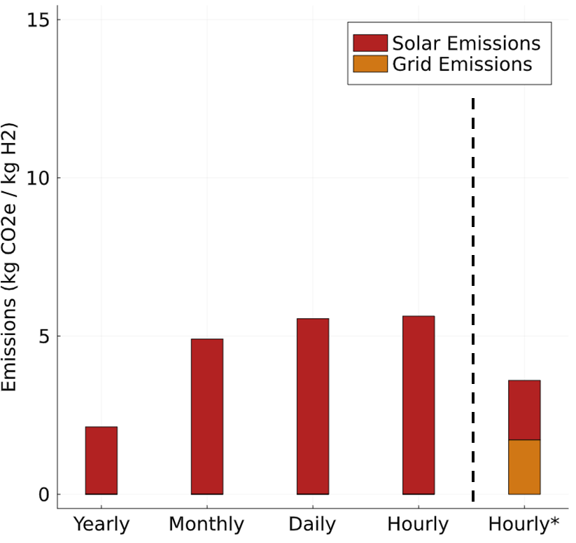
Figure S.1: Next decade life cycle emissions of solar PV based hydrogen production under various levels of reliability. * Indicated an hourly-reliable production pathway that has a grid connection for added reliability

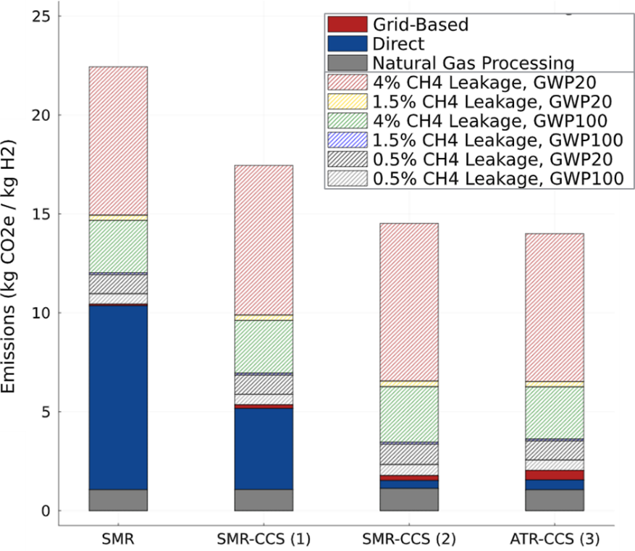
Figure S.2: Next decade life-cycle emissions of various fossil-based hydrogen production pathways
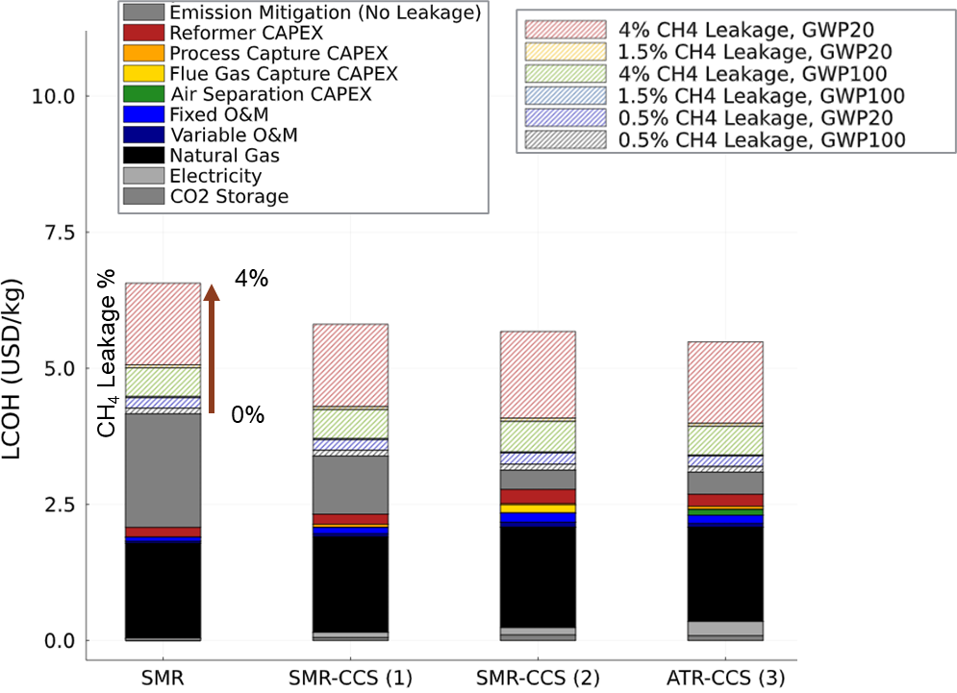
Figure S.3: Levelized cost of hourly-reliable net-zero hydrogen produced from fossil-based pathways. Pathways include SMR, SMR-CCS with process CO₂ capture (1), SMR-CCS with process and flue gas CO₂ capture (2), and ATR-CCS with process CO₂ capture (3)

Next Decade Technology, Electricity-Based Hydrogen Production Pathway Operations Figures
This section contains figures detailing electricity usage and curtailment for the electricity-based hydrogen production pathways. It also contains figures that show how hydrogen storage is utilized for each of these pathways.
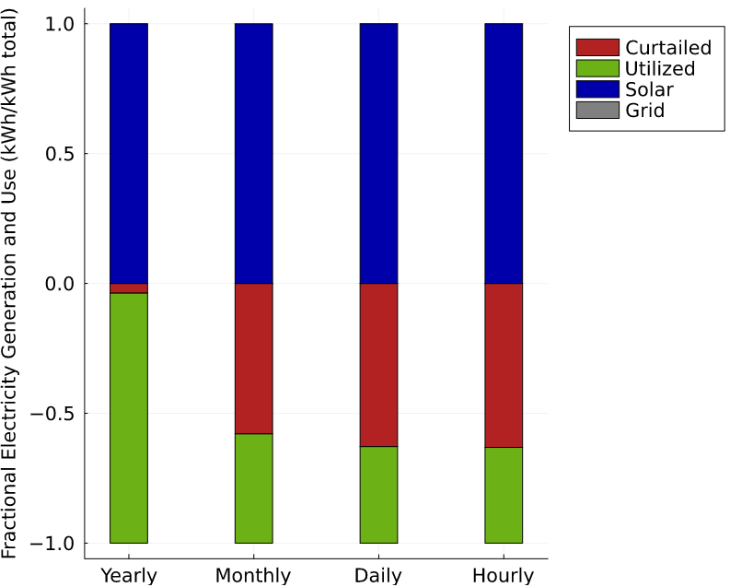
Figure S.4: Next decade fractional electricity usage versus curtailment for various levels of hydrogen production reliability pathways
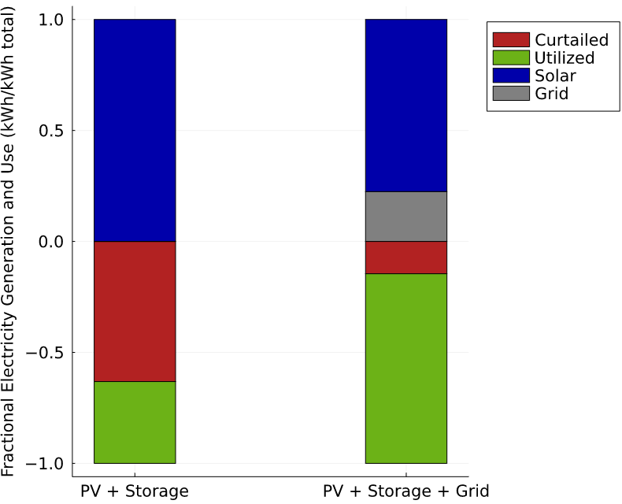
Figure S.5: Next decade fractional electricity usage versus curtailment for hourly production reliability pathways
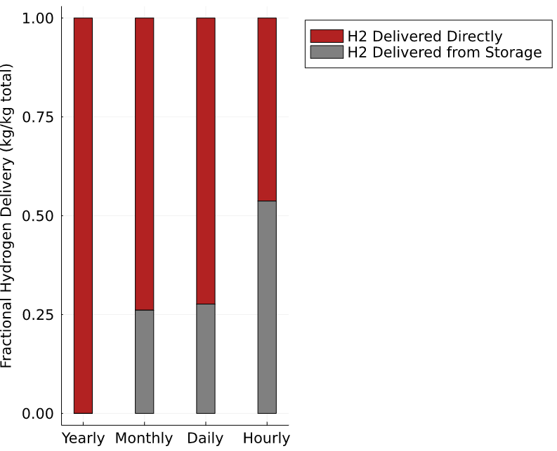
Figure S.6: Next decade fractional hydrogen delivery for various levels of hydrogen production reliability pathways
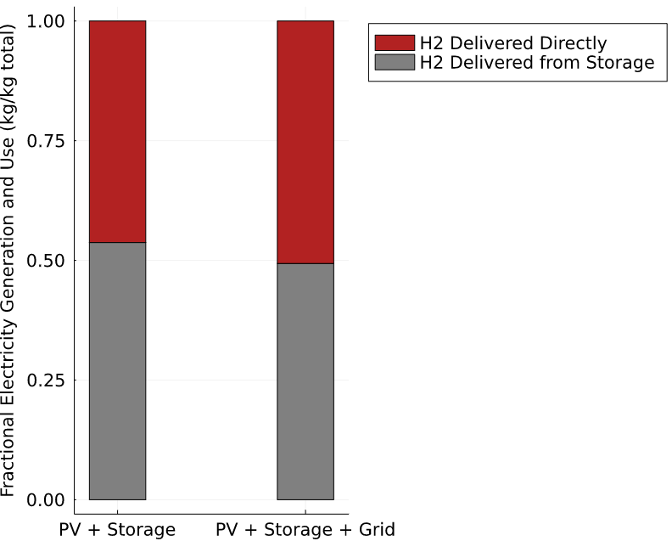
Figure S.7: Next decade fractional hydrogen delivery for hourly production reliability pathways

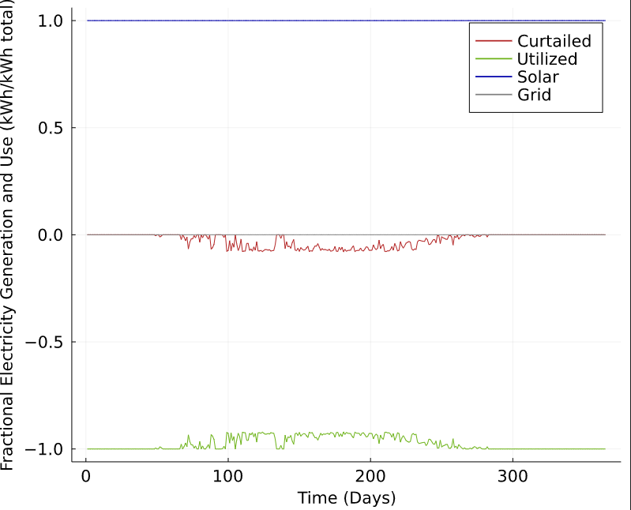
Figure S.8: Daily fractional electricity usage versus curtailment for yearly reliable solar PV hydrogen production pathway
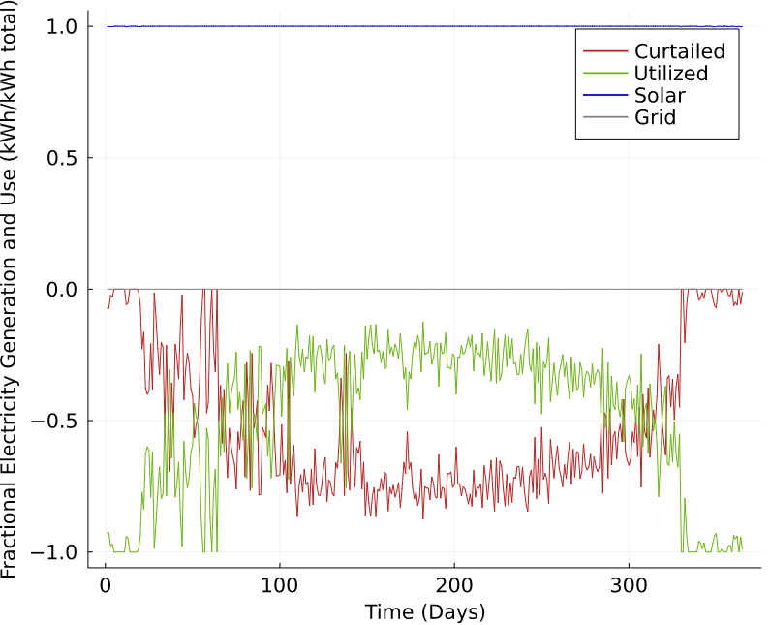
Figure S.9: Daily fractional electricity usage versus curtailment for hourly reliable solar PV and storage hydrogen production pathway
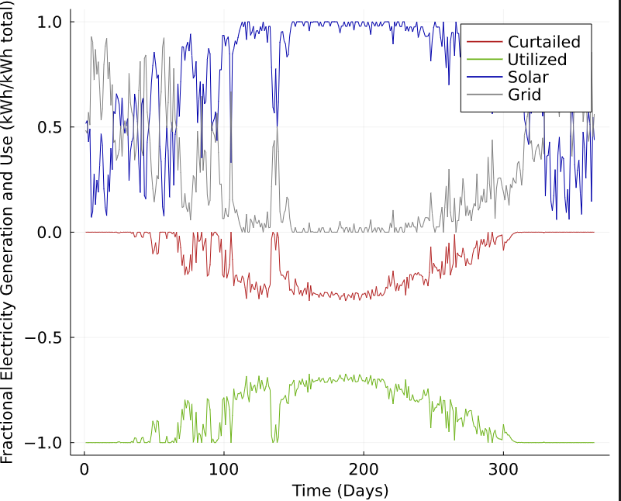
Figure S.10: Daily fractional electricity usage versus curtailment for hourly reliable solar PV, storage, and grid connected hydrogen production pathway

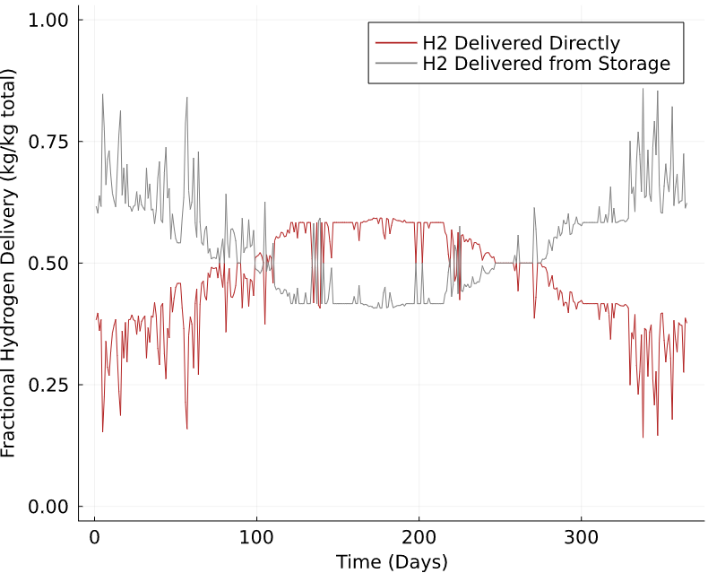
Figure S.11: Daily fractional hydrogen delivery for hourly reliable solar PV and storage hydrogen production pathway
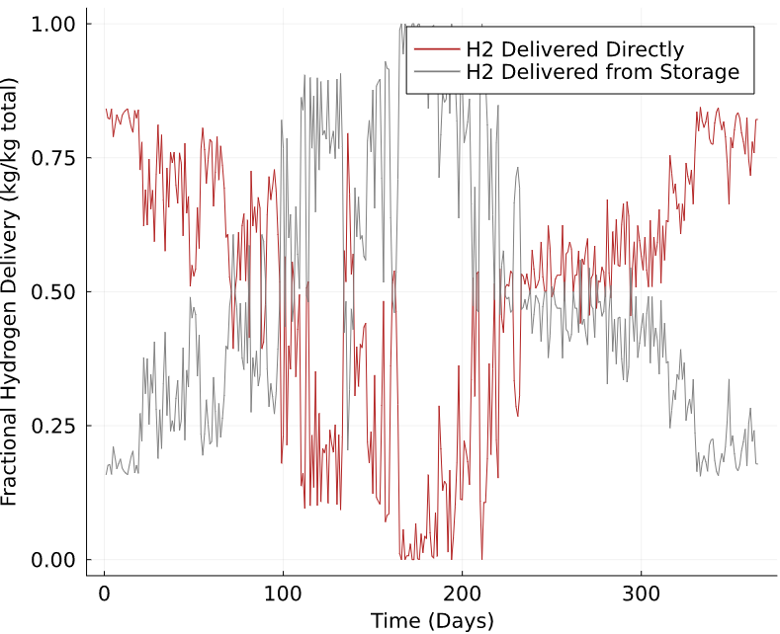
Figure S.12: Daily fractional hydrogen delivery for hourly reliable solar PV, storage, and grid connected hydrogen production pathway
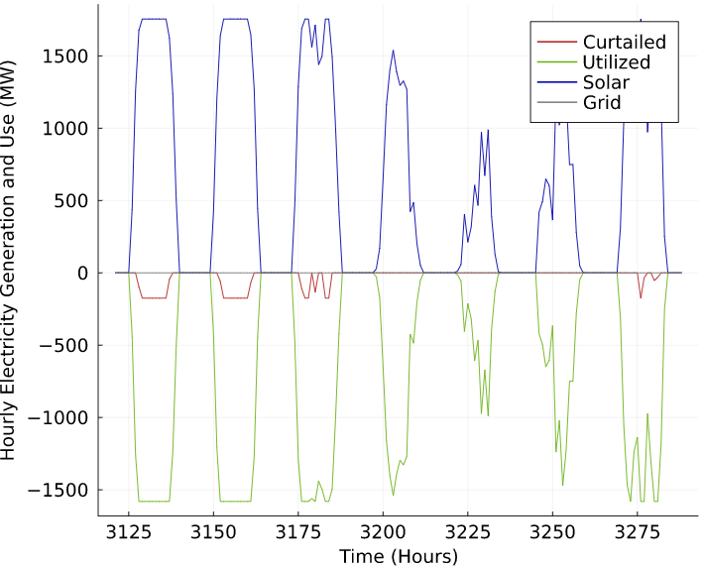
Figure S.13: Hourly electricity usage versus curtailment for yearly reliable solar PV hydrogen production pathway for a week in the month of May
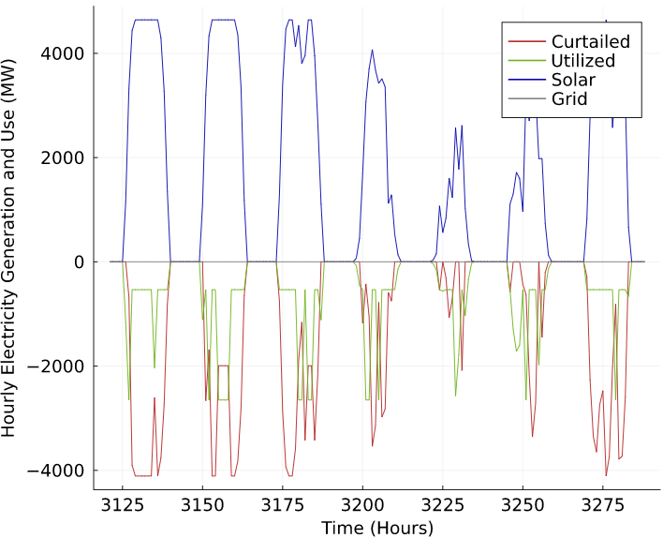
Figure S.14: Hourly electricity usage versus curtailment for hourly reliable solar PV and storage hydrogen production pathway for a week in the month of May

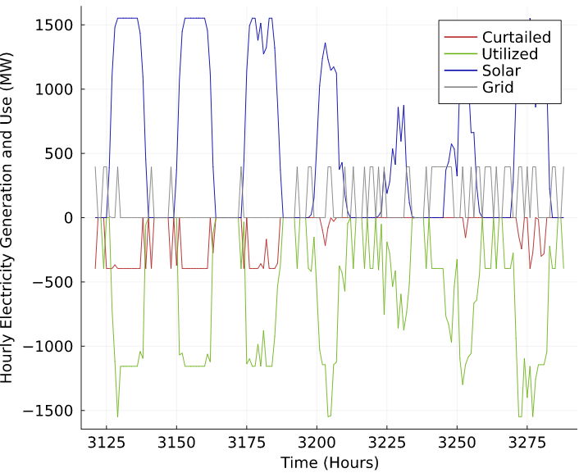
Figure S.15: Hourly electricity usage versus curtailment for hourly reliable solar PV, storage, and grid connected hydrogen production pathway for a week in the month of May

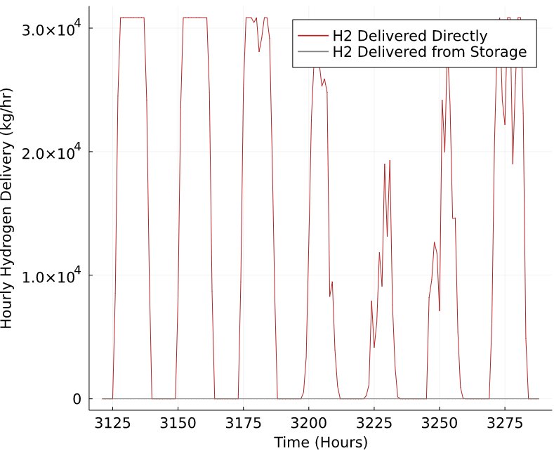
Figure S.16: Hourly hydrogen delivery for yearly reliable solar PV hydrogen production for a week in the month of May

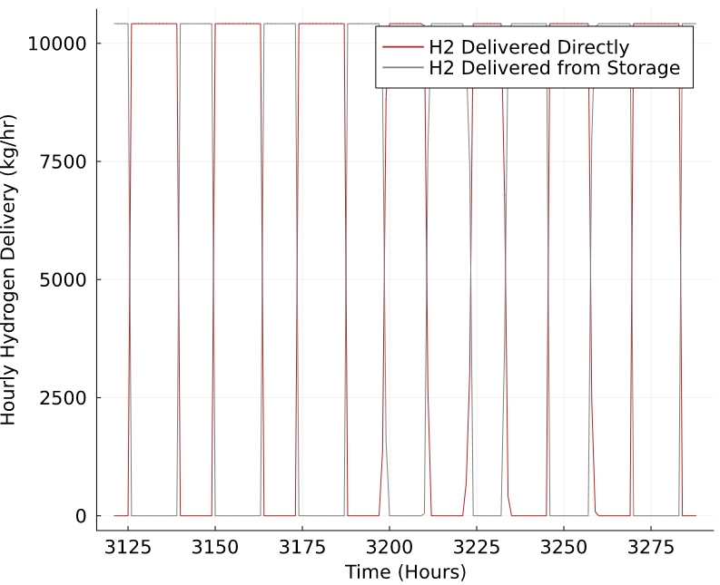
Figure S.17: Hourly hydrogen delivery for hourly reliable solar PV and storage hydrogen production pathway for a week in the month of May
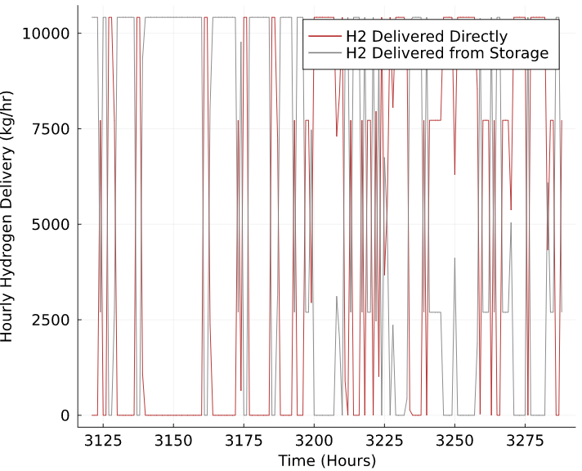
Figure S.18: Hourly hydrogen delivery for hourly reliable solar PV, storage, and grid connected hydrogen production pathway for a week in the month of May
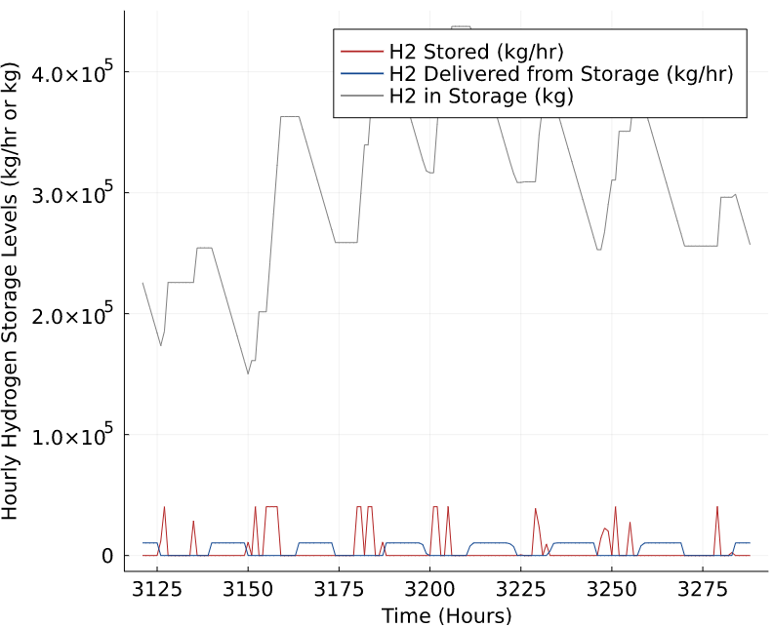
Figure S.19: Hourly hydrogen storage for hourly reliable solar PV and storage hydrogen production pathway for a week in the month of May
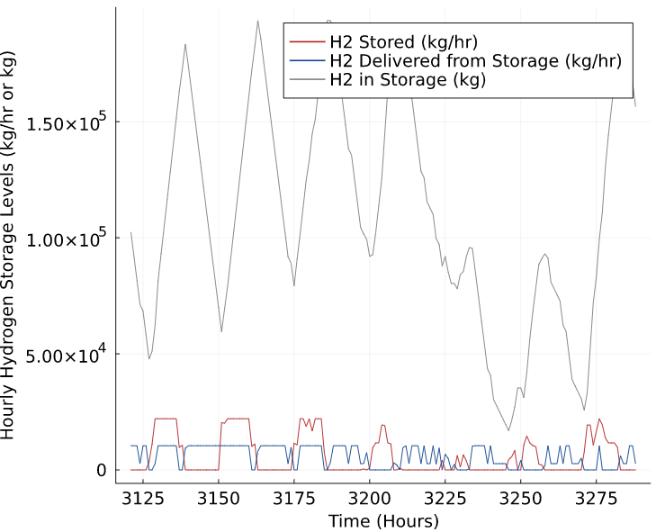
Figure S.20: Hourly hydrogen storage for hourly reliable solar PV, storage, and grid connected hydrogen production pathway for a week in the month of May

Current and Mid-Century LCOH Figures
This section contains summary figures for the LCOH using current and mid-century technology input assumptions instead of next decade technology assumptions. We find that all hourly-reliable, net-zero hydrogen production costs fall significantly by mid-century in comparison to current costs.
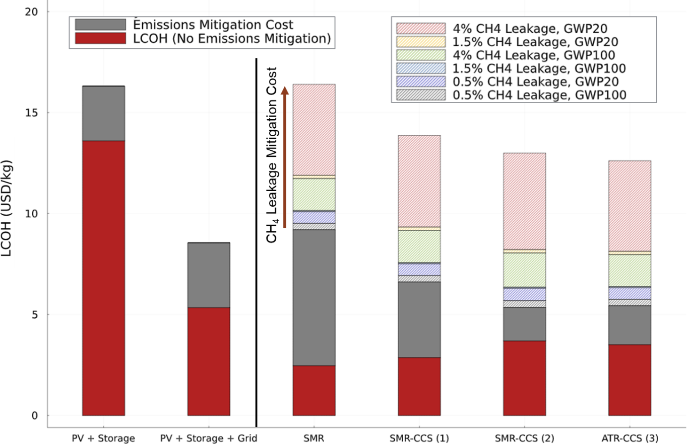
Figure S.21: Hourly reliable, net-zero hydrogen production cost comparison between electricity-based and fossil-based production pathways assuming current technologies and Sacramento, California facility location
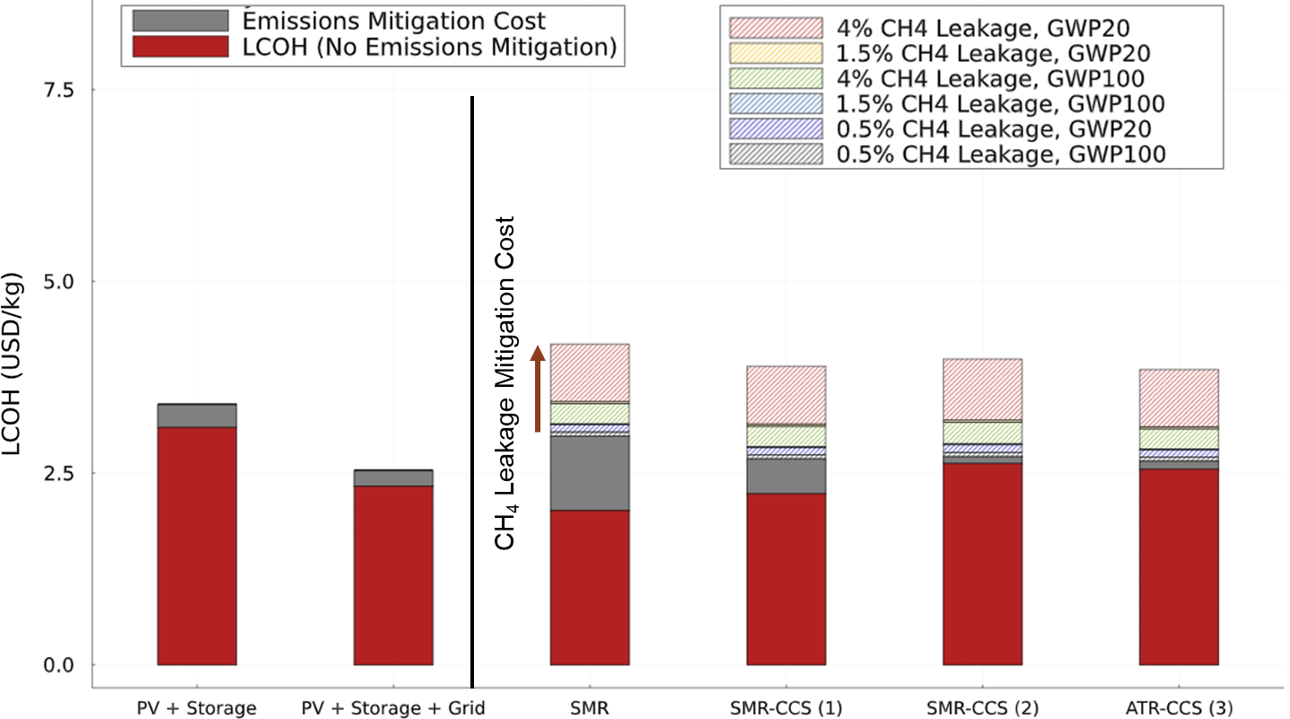
Figure S.22: Hourly reliable, net-zero hydrogen production cost comparison between electricity-based and fossil-based production pathways assuming mid-century technology projections and Sacramento, California facility location

Inflation Reduction Act Raw Data Tables
This section contains raw data results of the Inflation Reduction Act impact analysis discussed in the main text. The first table (Table S.11) in this section details total life-cycle emissions and LCOH (excluding net-zero emission constraint) of each hourly-reliable hydrogen production pathway explored under various emissions scenario and assuming next-decade technology. The second table (Table S.12) in this section is the same as Table S.11 but with a current technology assumption.

Table S.11: (a) Total life-cycle emissions for each hydrogen production pathway considered, under various emission scenarios and considering next-decade technology (in kg CO₂e / kg H₂ produced). The corresponding 45V PTC achievable given life-cycle emissions is shown in parenthesis. (b) Total LCOH (in $/kg H₂ produced) for each hourly-reliable hydrogen production pathway considered, under various emission scenarios. The LCOH values that are highlighted red consider 45V and are valid for the first 10 years of project operation as defined in the IRA. LCOH values highlighted blue consider 45Q and are valid for the first 12 years of project operation. All other LCOH values are not highlighted because the production pathway does not qualify for 45V or 45Q.
A.  Scenario Emissions (kg CO₂e/kg H₂ produced) | Electricity-Based |  | Fossil-Based
A.  Scenario Emissions (kg CO₂e/kg H₂ produced) | PV + Storage | PV + Storage + Grid | SMR | SMR-CCS (1) |  | SMR-CCS (2) |  | ATR-CCS (3)
No Upstream PV Emissions or Natural Gas Leakage | 0 ($3/kg) | 1.71 ($0.75/kg) | 10.44  (N/A) | 5.35  (N/A) |  | 1.77  ($0.75/kg) |  | 2.04  ($0.75/kg)
No Natural Gas Leakage | 5.63  (N/A) | 3.60  ($0.60/kg) | 10.44  (N/A) | 5.35  (N/A) |  | 1.77  ($0.75/kg) |  | 2.04  ($0.75/kg)
GWP100, 1.5% Natural Gas Leakage | 5.63  (N/A) | 3.60  ($0.60/kg) | 12.03  (N/A) | 6.95  (N/A) |  | 3.46  ($0.60/kg) |  | 3.62  ($0.60/kg)
GWP20, 1.5% Natural Gas Leakage | 5.63  (N/A) | 3.60  ($0.60/kg) | 14.94  (N/A) | 9.89  (N/A) |  | 6.55  (N/A) |  | 6.52  (N/A)
GWP100, 4% Natural Gas Leakage | 5.63  (N/A) | 3.60  ($0.60/kg) | 14.67  (N/A) | 9.62  (N/A) |  | 6.27  (N/A) |  | 6.26  (N/A)
GWP20, 4% Natural Gas Leakage | 5.63  (N/A) | 3.60  ($0.60/kg) | 22.44  (N/A) | 17.45  (N/A) |  | 14.52  (N/A) |  | 14.00  (N/A)
B.  Scenario LCOH with Tax Credits ($/kg H₂) * | Electricity-Based |  | Fossil-Based
B.  Scenario LCOH with Tax Credits ($/kg H₂) * | PV + Storage | PV + Storage + Grid | SMR | SMR-CCS (1) | SMR-CCS (2) |  | ATR-CCS (3)
No Upstream PV Emissions or Natural Gas Leakage | $2.33 | $2.06 | $2.08 | $1.88 | $1.91 |  | $1.93
No Natural Gas Leakage | $5.33 | $2.21 | $2.08 | $1.88 | $1.91 |  | $1.93
GWP100, 1.5% Natural Gas Leakage | $5.33 | $2.21 | $2.08 | $1.88 | $1.91 |  | $1.95
GWP20, 1.5% Natural Gas Leakage | $5.33 | $2.21 | $2.08 | $1.88 | $1.91 |  | $1.95
GWP100, 4% Natural Gas Leakage | $5.33 | $2.21 | $2.08 | $1.88 | $1.91 |  | $1.95
GWP20, 4% Natural Gas Leakage | $5.33 | $2.21 | $2.08 | $1.88 | $1.91 |  | $1.95

Table S.12: (a) Total life-cycle emissions for each hydrogen production pathway considered, under various emission scenarios and considering current technology (in kg CO₂e / kg H₂ produced). The corresponding 45V PTC achievable given life-cycle emissions is shown in parenthesis. (b) Total LCOH (in $/kg H₂ produced) for each hourly-reliable hydrogen production pathway considered, under various emission scenarios. The LCOH values that are highlighted red consider 45V and are valid for the first 10 years of project operation as defined in the IRA. LCOH values highlighted blue consider 45Q and are valid for the first 12 years of project operation. All other LCOH values are not highlighted because the production pathway does not qualify for 45V or 45Q.
A.  Scenario Emissions (kg CO₂e/kg H₂ produced) | Electricity-Based |  | Fossil-Based
A.  Scenario Emissions (kg CO₂e/kg H₂ produced) | PV + Storage | PV + Storage + Grid | SMR | SMR-CCS (1) |  | SMR-CCS (2) |  | ATR-CCS (3)
No Upstream PV Emissions or Natural Gas Leakage | 0  ($3/kg) | 3.31  ($0.60/kg) | 11.22  (N/A) | 6.24  (N/A) |  | 2.76  ($0.60/kg) |  | 3.22  ($0.60/kg)
No Natural Gas Leakage | 4.51  (N/A) | 5.34  (N/A) | 11.22  (N/A) | 6.24  (N/A) |  | 2.76  ($0.60/kg) |  | 3.22  ($0.60/kg)
GWP100, 1.5% Natural Gas Leakage | 4.51  (N/A) | 5.34  (N/A) | 12.81  (N/A) | 7.84  (N/A) |  | 4.45  (N/A) |  | 4.80  (N/A)
GWP20, 1.5% Natural Gas Leakage | 4.51  (N/A) | 5.34  (N/A) | 15.72  (N/A) | 10.78  (N/A) |  | 7.55  (N/A) |  | 7.71  (N/A)
GWP100, 4% Natural Gas Leakage | 4.51  (N/A) | 5.34  (N/A) | 15.46  (N/A) | 10.51  (N/A) |  | 7.26  (N/A) |  | 7.44  (N/A)
GWP20, 4% Natural Gas Leakage | 4.51  (N/A) | 5.34  (N/A) | 23.22  (N/A) | 18.34  (N/A) |  | 15.51  (N/A) |  | 15.19  (N/A)
B.  Scenario LCOH with Tax Credits ($/kg H₂) * | Electricity-Based |  | Fossil-Based
B.  Scenario LCOH with Tax Credits ($/kg H₂) * | PV + Storage | PV + Storage + Grid | SMR | SMR-CCS (1) | SMR-CCS (2) |  | ATR-CCS (3)
No Upstream PV Emissions or Natural Gas Leakage | $10.59 | $4.74 | $2.46 | $2.42 | $2.83 |  | $2.77
No Natural Gas Leakage | $13.59 | $5.34 | $2.46 | $2.42 | $2.83 |  | $2.77
GWP100, 1.5% Natural Gas Leakage | $13.59 | $5.34 | $2.46 | $2.42 | $2.83 |  | $2.77
GWP20, 1.5% Natural Gas Leakage | $13.59 | $5.34 | $2.46 | $2.42 | $2.83 |  | $2.77
GWP100, 4% Natural Gas Leakage | $13.59 | $5.34 | $2.46 | $2.42 | $2.83 |  | $2.77
GWP20, 4% Natural Gas Leakage | $13.59 | $5.34 | $2.46 | $2.42 | $2.83 |  | $2.77

References
[1] National Renewable Energy Laboratory, “System Advisor Model,” 2020. https://sam.nrel.gov/ (accessed Sep. 29, 2022).
[2] E. D. Sherwin, “Electrofuel Synthesis from Variable Renewable Electricity: An Optimization-Based Techno-Economic Analysis,” Environ. Sci. Technol., vol. 55, no. 11, pp. 7583–7594, Jun. 2021, doi: 10.1021/ACS.EST.0C07955/SUPPL_FILE/ES0C07955_SI_001.PDF.
[3] A. Mayyas, M. Ruth, B. Pivovar, G. Bender, and K. Wipke, “Manufacturing Cost Analysis for Proton Exchange Membrane Water Electrolyzers,” 2019. Accessed: Jan. 13, 2022. [Online]. Available: https://www.nrel.gov/docs/fy10osti/72740.pdf.
[4] M. Bolinger, R. Wiser, and E. O’Shaughnessy, “Levelized cost-based learning analysis of utility-scale wind and solar in the United States,” Iscience, 2022, Accessed: Nov. 22, 2022. [Online]. Available: https://www.sciencedirect.com/science/article/pii/S2589004222006496.
[5] W. Colella, B. D. James, J. M. Moton, G. Saur, and T. Ramsden, “Techno-economic Analysis of PEM Electrolysis for Hydrogen Production,” Golden, Colorado, Feb. 2014.
[6] Solar Land Lease, “Lease Rates for Solar Farms: How Valuable Is My Land?” https://www.solarlandlease.com/lease-rates-for-solar-farms-how-valuable-is-my-land (accessed May 28, 2021).
[7] National Renewable Energy Laboratory, “Distributed Generation Renewable Energy Estimate of Costs,” 2016. https://www.nrel.gov/analysis/tech-lcoe-re-cost-est.html (accessed May 28, 2021).
[8] California Independent System Operator, “Locational Marginal Prices,” OASIS, 2022. http://oasis.caiso.com/mrioasis/logon.do (accessed Sep. 29, 2022).
[9] J. De Chalendar, “Tracking emissions in the US electricity system,” Stanford University, 2022. https://gridemissions.jdechalendar.su.domains/#/ (accessed Sep. 29, 2022).
[10] Sacramento Municipal Utility District, “Large General Service Time-of-Day Rate Schedule,” 2020.
[11] National Renewable Energy Laboratory, “Energy Analysis: Life Cycle Assessment Harmonization,” 2012. https://www.nrel.gov/analysis/life-cycle-assessment.html (accessed Sep. 29, 2022).
[12] National Energy Technology Laboratory, “Comparison of Commercial, State-of-the-Art, Fossil-Based Hydrogen Production Technologies,” 2022. [Online]. Available: https://www.osti.gov/servlets/purl/1862910/.
[13] J. Theis, “Cost Estimation Methodology for NETL Assessments of Power Plant Performance,” 2019. Accessed: Jan. 18, 2022. [Online]. Available: www.netl.doe.gov.
[14] U.S. Energy Information Administration, “California Natural Gas Industrial Price,” 2022. https://www.eia.gov/dnav/ng/hist/n3035ca3m.htm (accessed Oct. 04, 2022).
[15] National Renewable Energy Laboratory, “H2A: Hydrogen Analysis Production Models,” 2018. https://www.nrel.gov/hydrogen/h2a-production-models.html (accessed Dec. 08, 2021).
[16] C. E. Clark, J. Han, A. Burnham, J. B. Dunn, and M. Wang, “Life-Cycle Analysis of Shale Gas and Natural Gas,” 2011. [Online]. Available: https://publications.anl.gov/anlpubs/2012/01/72060.pdf.
[17] Stanford University and Energy Futures Initiative, “An Action Plan for Carbon Capture and Storage in California: Opportunities, Challenges, and Solutions,” 2020. [Online]. Available: www.energy.stanford.edu.
[18] U.S. Environmental Protection Agency, “Understanding Global Warming Potentials,” 2022. https://www.epa.gov/ghgemissions/understanding-global-warming-potentials (accessed Oct. 06, 2022).
[19] R. W. Howarth and M. Z. Jacobson, “How green is blue hydrogen?,” Energy Sci. Eng., vol. 9, no. 10, pp. 1676–1687, Oct. 2021, doi: 10.1002/ESE3.956.

