Supplementary Materials:
A B
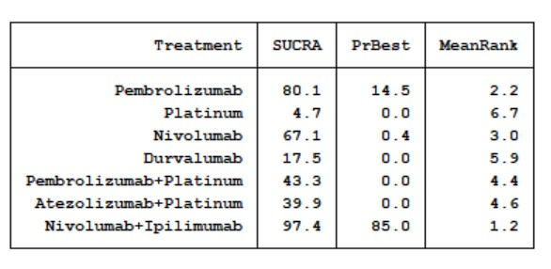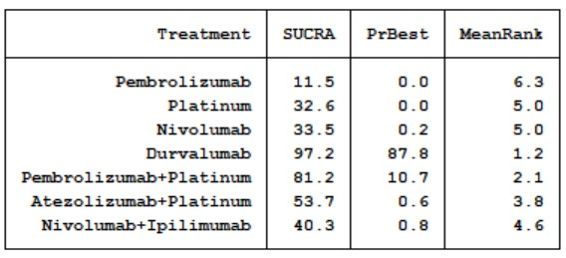
C D
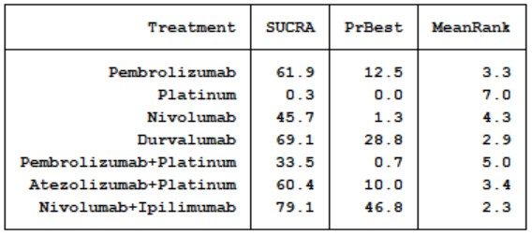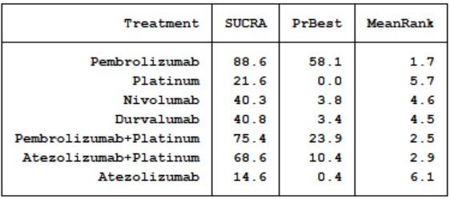

E
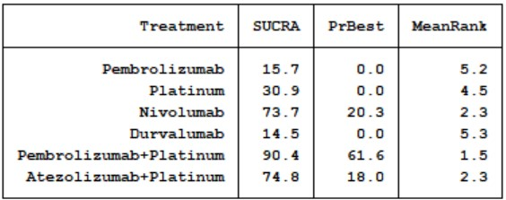

Figure s1:The SUCRA value of A(dermatologic irAEs),B(gastrointestinal irAEs),C(endocrine irAEs),D(pneumonitis),E(liver irAEs).

A

B

C

D

E
Figure S2:The trajectory density maps of A(dermatologic irAEs),B(gastrointestinal irAEs),C(endocrine irAEs),D(pneumonitis),E(liver irAEs). show that all the models have good convergence.
A B
C D
E
Figure S3: Heterogeneity test of A(dermatologic irAEs),B(gastrointestinal irAEs),C(endocrine irAEs),D(pneumonitis),E(liver irAEs).
A B
C D
E

Figure S4:Inconsistency assessment of A(dermatologic irAEs),B(gastrointestinal irAEs),C(endocrine irAEs),D(pneumonitis),E(liver irAEs).

