Graph 1. Correlation between projected new cases of cancer per state and number of CACONs/UNACONs per state

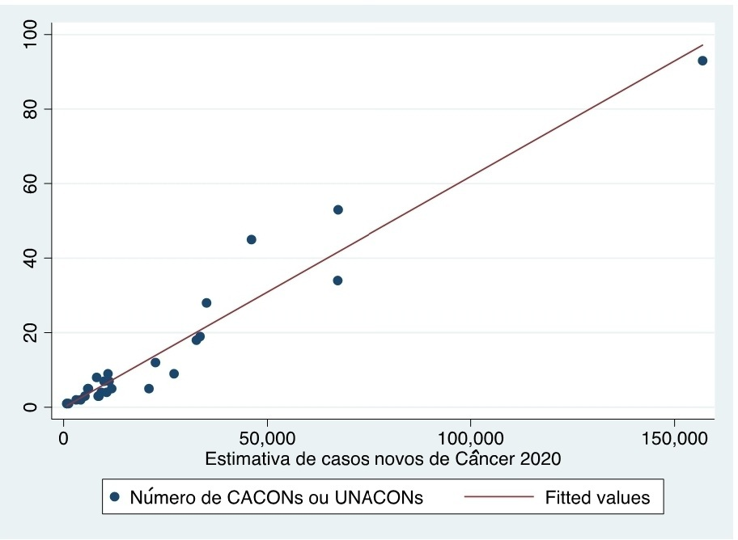

Graph 2. Correlation between projected new cases of cancer by state and number of radiotherapy centers per state.
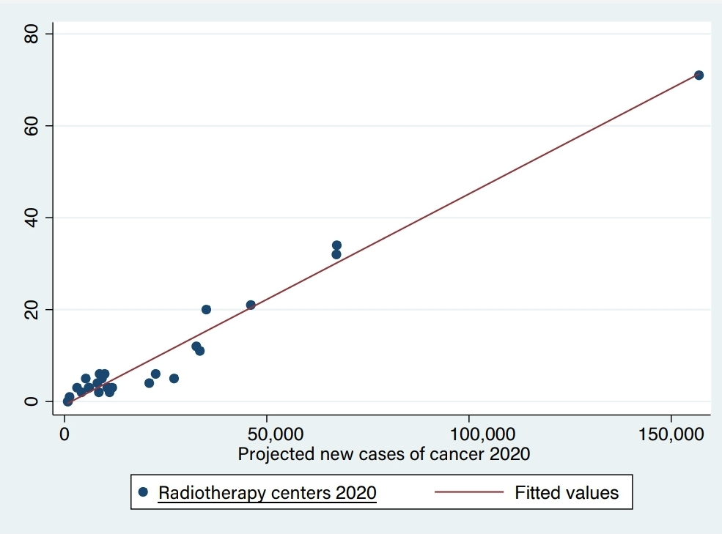

Graph 3. Correlation between GDP per state in millions and number of CACONS/UNACONs per state.
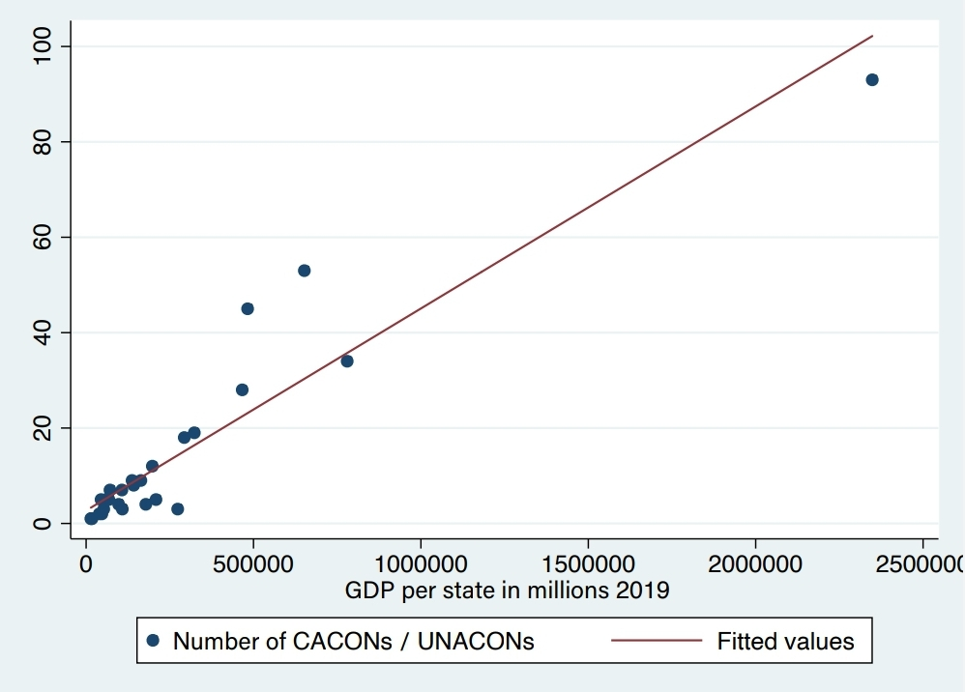

Graph 4. Correlation between GDP per state in millions and number of radiotherapy centers per state.

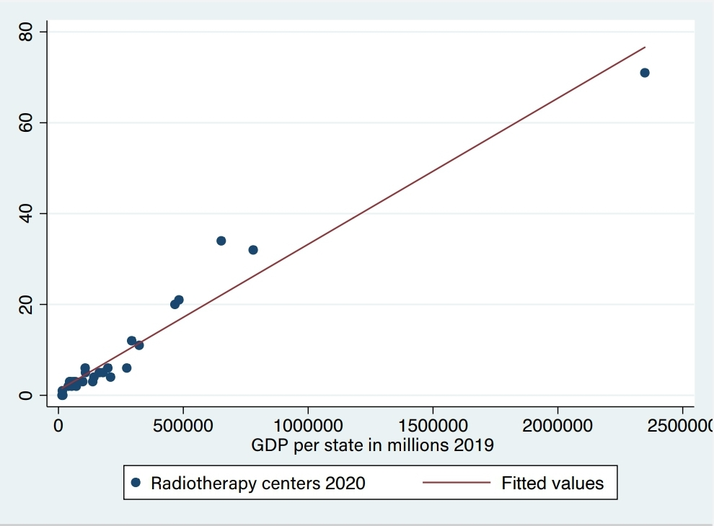

Graph 5. Correlation between GDP per state in millions and projected new cases per state.
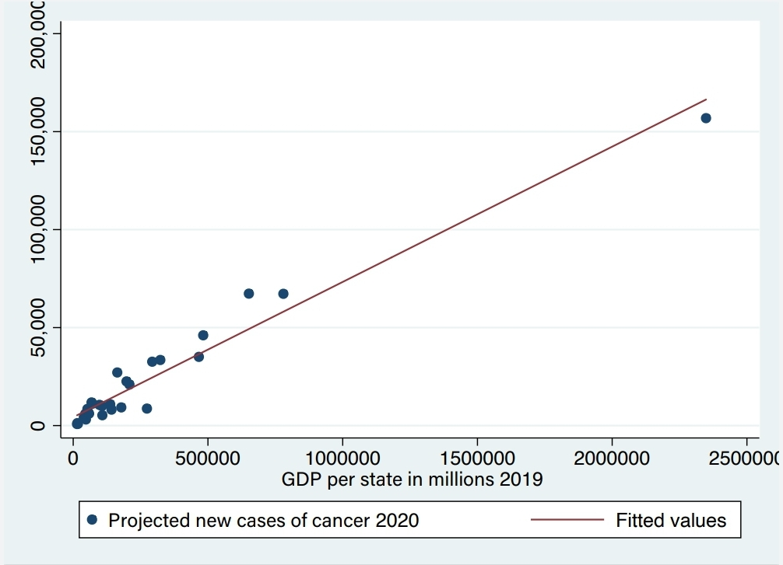

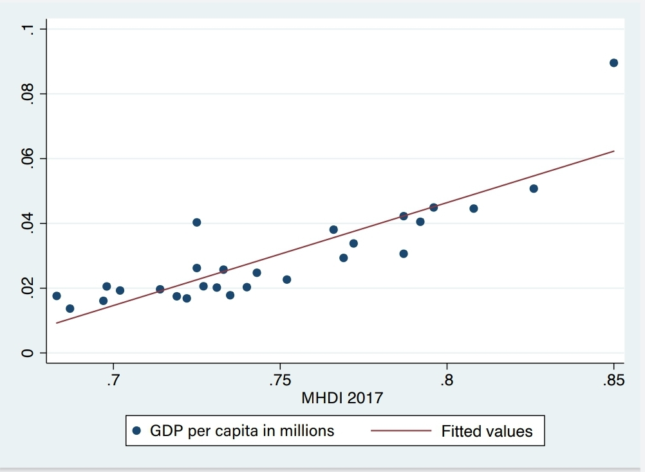
Graph 6. Correlation between average HDI based on education in 2017 and GDP per capita per state in millions.

Graph 7. Correlation between population per state and number of CACONs/UNACONs per state.
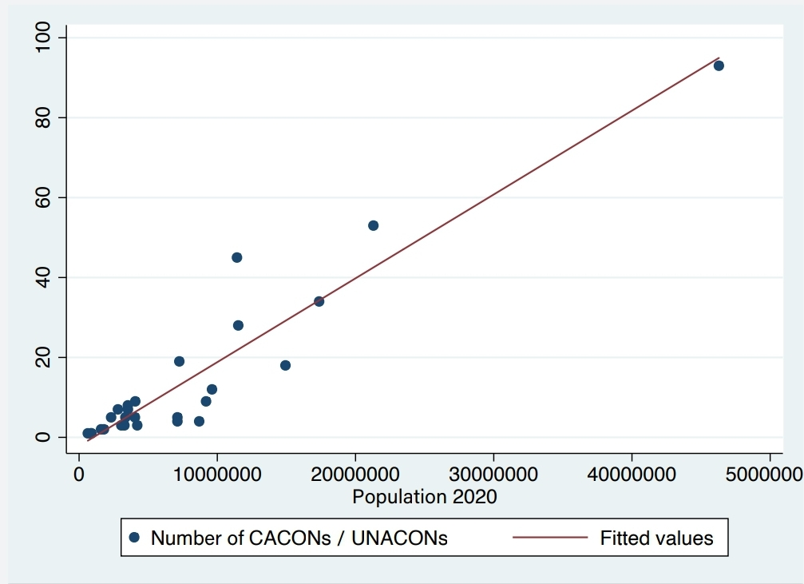

Graph 8. Correlation between population per state and number of radiotherapy centers per state.
