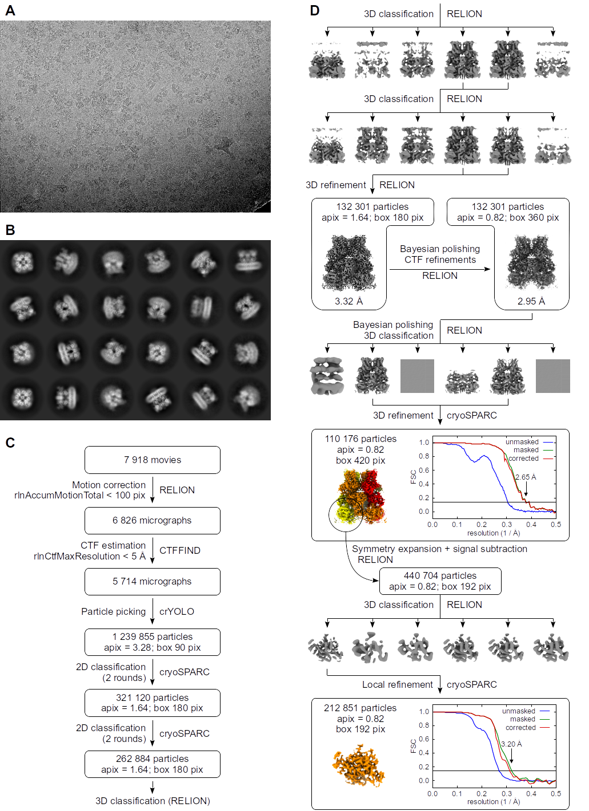
Figure S1. Cryo-electron microscopy data processing, related to Figure 1. (A) Representative cryo-EM micrograph. (B) Selected class averages after last round of two-dimensional classification. (C) Initial processing steps and particle curation. (D) Three-dimensional reconstruction pipeline. For the final reconstructions, gold-standard Fourier shell correlation (FSC) curves between two half maps are presented. The horizontal line represents a value of 0.143. Final maps are colored as in Figure 1.
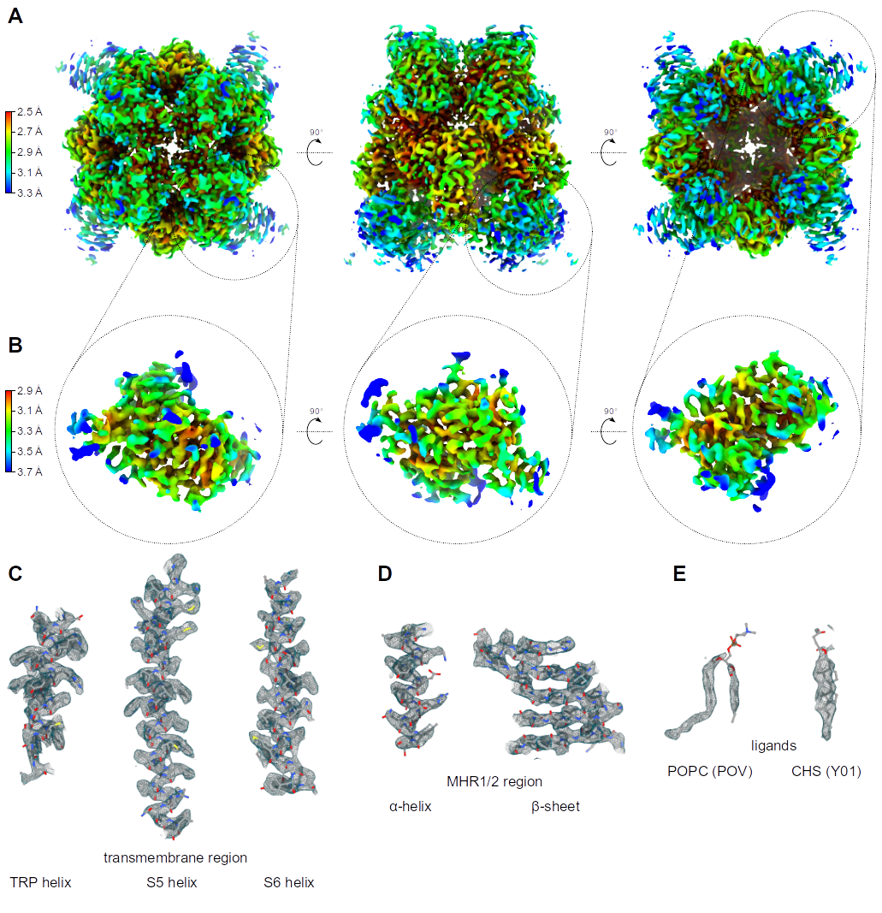
Figure S2. Quality of cryo-EM maps, related to Figure 1, Figure 3, and Figure 4. (A, B) Local resolution calculated from half maps in cryoSPARC for (A) consensus TRPM8 refinement and (B) focused MHR1/2 refinement. (C-E) Quality of the composite cryo-EM map, showing selected secondary structures from the pore region (C) and the MHR1/2 domain (D). (E) Electron microscopy potential density for the selected modeled ligands: phosphatidylcholine (POPC) and cholesterol hemisuccinate (CHS).

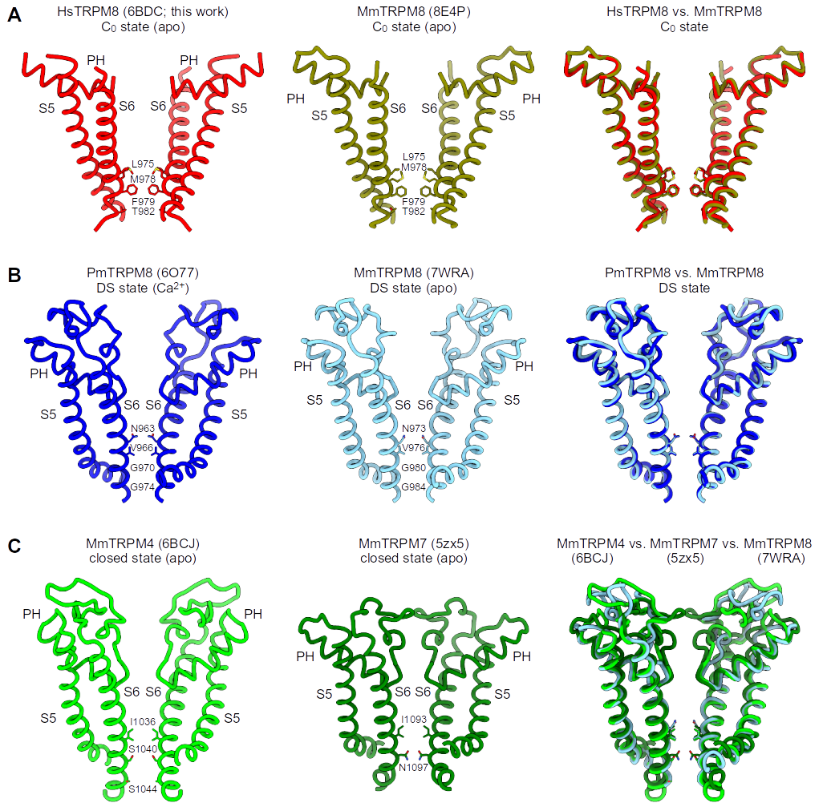
Figure S3. Comparison of the pore region of selected TRPM channels, related to Figure 2. (A) TRPM8 structures in closed state: HsTRPM8 (this work) and PmTRPM8 (PDB ID: 6O6A). (B) MmTRPM8 structure (PDB ID: 7WRA) aligned with desensitized PmTRPM8 structure (PDB ID: 7O77). (C) MmTRPM8 (PDB ID: 7WRA) aligned with MmTRPM4 (PDB ID: 6BCJ) and MmTRPM7 (PDB ID: 5ZX5). Front and rear subunits were removed for clarity.

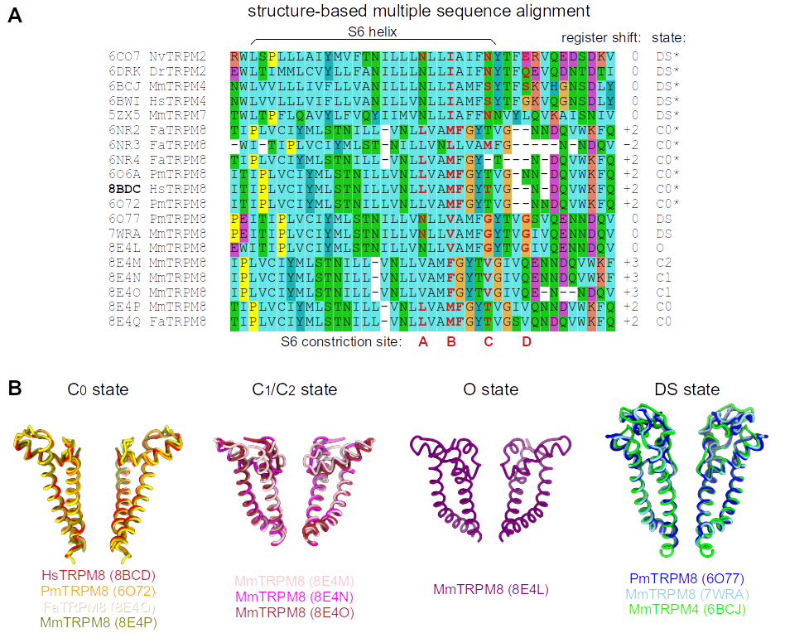

Figure S4. Differences in the pore configuration between C₀, C₁/C₂, O, and DS states of TRPM channels, related to Figure 2. (A) Structure-based sequence alignment of S6 helices from selected TRPM channels. Residues contributing to constriction site are marked red. Register shift (relative to the reference 6CO7 structure) and established or inferred (‘*’) state of the channel are indicated. See also Figure 4 in Huffer et al., 2020¹⁸. (B) Comparison of the pore region of selected TRPM channels in indicated states.
Movie S5. Morphing between different conformations of HsTRPM8 resolved by 3D Variability analysis.

Table S1. Data collection and processing
 | Consensus TRPM8 map | Focused MHR1/2 map
Microscope | Titan Krios G3i
Camera | Gatan K3
Energy filter | Gatan BioQuantum with 20 eV slit
Voltage (kV) | 300
Magnification | 105,000×
Electron exposure (e/Å²) | 41.42
Defocus range (μm) | -0.9 to -2.7
Pixel size (Å) | 0.82
Initial particle images (no.) | 1,239,855
Final particle images (no.) | 110,176 | 212,851
Symmetry imposed | C4 | C1
Resolution at 0.143 FSC (masked, Å) | 2.65 | 3.20
Resolution range at atom positions (Å)* | 2.38-5.43 | 2.90-4.64**
Map sharpening B factor (Å²) | -87 | -148
EMDB accession code | EMDB- 15982 | EMDB- 15983
*Range of the local resolution map values at atom positions. **Calculated for residues 1-446.
Table S2. Refinement and validation statistics
PDB accession code | 8BDC
Non-hydrogen atoms | 29,972
Protein residues | 3,868
Ligands | 24
Bonds (RMSD): Length (Å) | 0.003
Bonds (RMSD): Angles (°) | 0.459
Validation: Rotamer outliers (%) | 0.56
Ramachandran plot (%):  outliers  allowed  favored | 0.00  3.78  96.22
Table S3. Docking scores for modelling of icilin
 | Xscore | ChemPLP | Elec_DD | No. contacts | CHARM6-12
Original pose
A | -9.05 | -59.14 | -2.19 | 6 | -41.99
B | -9.05 | -58.92 | -2.20 | 6 | -41.99
C | -9.05 | -86.45 | -4.39 | 11 | -44.77
D | -9.23 | -72.53 | -3.72 | 11 | -40.49
Mean | -9.10 | -69.26 | -3.12 | 8.5 | -42.31
Rotated pose
A | -9.23 | -49.84 | -1.51 | 8 | -40.90
B | -9.42 | -81.32 | -3.82 | 7 | -40.41
C | -9.31 | -60.73 | -3.48 | 8 | -40.06
D | -9.17 | -80.75 | -1.93 | 7 | -38.94
Mean | -9.28 | -68.16 | -2.68 | 7.5 | -40.08
The XScore and ChemPLP scoring functions encode for overall stability of the generated poses. The Elec_DD score focuses on electrostatic interactions as computed by applying a distance dielectric function. The CHARM6-12 score corresponds to the non-bond Lennard Jones interaction energy using CHARMM parameters. “No. contacts” refers to residues within a 3 Å radius sphere around the ligand. Apart from “No. Contacts,” which is dimensionless, all other scores are expressed in kcal/mol.

