Supplementary Figure 1. KLF4 and TFCP2L1 in additional cell lines. a. Representative immunofluorescence image of KLF4 in TFAP2C/PRDM1 double positive hPGCLCs at D4 of aggregate differentiation using the UCLA1 and UCLA2 hESC lines (n= 6-12 independent aggregates analyzed). b. Representative immunofluorescence image for TFCP2L1 in TFAP2C/PRDM1 hPGCLCs at D4 of aggregate differentiation from the UCLA1 and UCLA2 hESC lines (n= 6-12 independent aggregates analyzed). c. Additional representative human gonadal sections, stained for KLF4 and TFCP2L1 with cKIT in fetal testes and ovaries, days post fertilization (dpf): Arrows highlight double positive hPGC, arrow head indicates single-positive somatic cell.

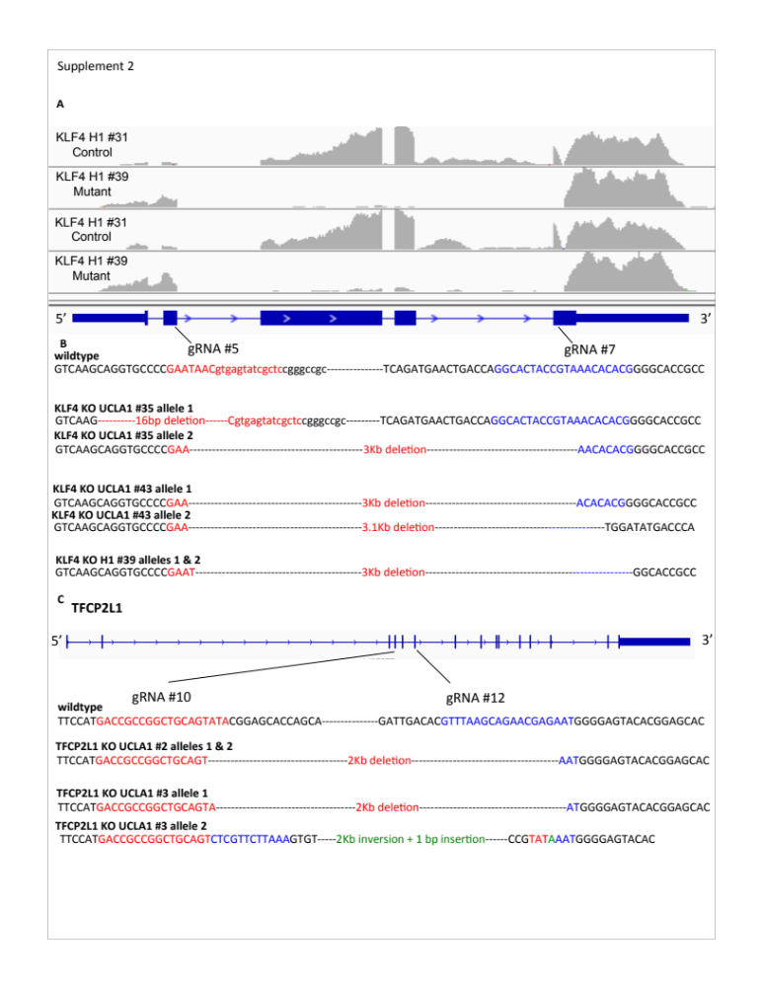
Supplementary Figure 2. KLF4 and TFCP2L1 knockout mutations by CRISPR/Cas9. a. genome browser of KLF4 deleted and out-of-frame transcripts in H1 mutant and control. b. Schematic of KLF4 mutation in each allele for the subclones #35, UCLA1 #43, H1-OCT4-GFP #39 c. schematic of TFCP2L1 mutation in each allele for UCLA1 #3 and UCLA1 #2.

Supplementary Figure 3. Immunofluorescence of hPGCLCs in 10 days of extended culture. a. Representative image of PRDM1/TFCP2L1 hPGCLCs at D4C10 showing TFCP2L1 protein expression (n= 39-75 colonies analyzed). b. Representative immunofluorescence image of PRDM1/TFAP2C positive hPGCLCs stained for TFCP2L1 from control and TFCP2L1 KO sublines at D4C10 shows TFCP2L1 is a null mutation (n=3 colonies analyzed) c. Representative image of TFAP2C/PRDM1 positive hPGCLCs at D4C10 in the TFCP2L1 control and KO sublines evaluated for Edu (4= colonies analyzed). Scale bars = 15 microns

Supplementary Figure 4. Immunofluorescence of KLF4 control and KO hPGCLCs in extended culture. a. Representative immunofluorescence image of PRDM1/TFAP2C positive hPGCLCs stained for KLF4 in control and KLF4 KO sublines at D4C10. b. Edu staining of PRDM1/TFAP2C positive hPGCLCs in control and KLF4 mutant hPGCLCs at D4C10 (n=3 colonies analyzed). c. Immunofluorescence of PRDM1/TFAP2C positive hPGCLCs in control and KLF4 KO hPGCLCs at D4C21. d. Representative image of PRDM1/TFAP2C positive hPGCLCs in control and KLF4 KO sublines at D4C21 stained for Edu (n=7-9 colonies analyzed). e. Quantification of %Edu positive PRDM1/TFAP2C hPGCLCs at D4C10 and D4C21. Error bars indicate biological replicates. Scale bars = 15 microns (a,b), 8 microns (c,), 7 microns (d).
Supplementary Table 1: Guide RNA and primer sequences for CRISPR mutations

 | forward | reverse
KLF4 gRNA5 | 5’ GAATAACgtgagtatcgctc | n/a
KLF4 gRNA7 | 5’ CGTGTGTTTACGGTAGTGCC | n/a
KLF4 external of cut genotyping | 5’ ATTAATGAGgtaggtgaggcg | 5’TTCCCTCATCGGGAAGACAGT
KLF4 internal 5’ cut genotyping | Same as external forward | 5’ caccacacccacgaaaacc
KLF4 internal 3’ cut | 5’ tgatggtcaaaattgctggga | Same as external reverse
TFCP2L1 gRNA10 | 5’ GACCGCCGGCTGCAGTATA | n/a
TFCP2L1 gRNA12 | 5’ GTTTAAGCAGAACGAGAAT | n/a
TFCP2L1 external of cut genotyping | 5’ gcactgagggtgttgagaaggct | 5’ gtctctgtgggcgaatgtgaccac
TFCP2L1 internal 5’ cut genotyping | Same as internal forward | 5’ ccaggagactcacCGATGTCC
TFCP2L1 internal 3’ cut genotyping | 5’ agtggtggggacttagctggt | Same as external reverse

Table 2: RNA sequencing samples and mapping
Sample name | adaptor | Adaptor sequence | Raw reads | # mapped reads | Mapped %
hPGCLC H1-O4-GFP KLF4 control rep 1 | BC9 | ACACGA | 34858644 | 29095098 | 83.47
hPGCLC H1-O4-GFP KLF4 KO rep 1 | BC10 | CACACA | 45144724 | 37308983 | 82.64
hPGCLC H1-O4-GFP KLF4 control rep 2 | BC13 | GTGGCC | 42998208 | 35615371 | 82.83
hPGCLC H1-O4-GFP KLF4 KO rep 2 | BC14 | TGTTGC | 48626147 | 39620501 | 81.48

