Supplementary Table 1. Primers for overlapping PCR used in this study.
Primer | Nucleotide sequence (5′ to 3′) | Position in AnBV
P1 | tccttgttactcgtggcatg | 1902-1921
P2 | cttctgatggtgacttcc | 5955-5938
P3 | tgcacggctctccaatacac | 1924-1943
P4 | ctattaataacagcttggat | 5901-5882
P5 | gctacatgattgatctgata | 1980-1961
P6 | ctctccagacgatacaagga | 6451-6470
P7 | ctgatatgcaaagccggtgt | 1966-1947
P8 | tacaaggaagacgagcactg | 6463-6482
P9 | gatatgtgcctacgcaagtg | 5824-5843
P10 | agccatgcctttatggccat | 6547-6528

Supplementary Table 2. Viruses and their sequence accession number used for sequence analysis in this study.
Full name | Abbreviation | Accession no.
This study
Andraeanum bacilliform virus | AnBV | OQ095368
Recognized by ICTV
Aglaonema bacilliform virus | ABV | NC055236
Badnavirus aucubae | BDV-auc | LC487411
Badnavirus castaneae | BDV-cas | MT269853
Banana streak GF virus | BSGFV | NC007002
Banana streak IM virus | BSIMV | NC015507
Banana streak MY virus | BSMYV | KR014107
Banana streak OL virus | BSOLV | JQ409540
Banana streak UA virus | BSUAV | NC015502
Banana streak UI virus | BSUIV | NC015503
Banana streak UL virus | BSULV | NC015504
Banana streak UM virus | BSUMV | NC015505
Banana streak VN virus | BSVNV | NC007003
Birch leaf roll-associated virus | BLRaV | NC040635
Blackberry virus F | BVF | NC029303
Bougainvillea chlorotic vein banding virus | BCVBV | MK816926
Cacao bacilliform Sri Lanka virus | CBSLV | MF642736
Cacao mild mosaic virus | CaMMV | NC033738
Cacao swollen shoot CD virus | CSSCDV | MN433936
Cacao swollen shoot CE virus | CSSCEV | NC040692
Cacao swollen shoot Ghana M virus | CSSGMV | NC043534
Cacao swollen shoot Ghana N virus | CSSGNV | NC040622
Cacao swollen shoot Ghana Q virus | CSSGQV | NC043535
Cacao swollen shoot Togo A virus | CSSTAV | AJ781003
Cacao swollen shoot Togo B virus | CSSTBV | MN179344
Cacao yellow vein banding virus | CYVBV | NC033739
Camellia lemon glow virus | CLGV | NC055598
Canna yellow mottle associated virus | CaYMaV | NC030462
Canna yellow mottle virus | CaYMV | MF074075
Citrus yellow mosaic virus | CYMV | NC003382
Codonopsis vein clearing virus | CoVCV | MK044821
Commelina yellow mottle virus | ComYMV | X52938
Cycad leaf necrosis virus | CyLNV | NC011097
Dioscorea bacilliform AL virus | DBALV | MH404174
Dioscorea bacilliform AL virus 2 | DBALV-2 | MH404164
Dioscorea bacilliform RT virus 1 | DBRTV-1 | NC038986
Dioscorea bacilliform RT virus 2 | DBRTV-2 | KY827393
Dioscorea bacilliform RT virus 3 | DBRTV-3 | MF476845
Dioscorea bacilliform SN virus | DBSNV | DQ822073
Dioscorea bacilliform TR virus | DBTRV | KX430257
Dracaena mottle virus | DrMV | NC008034
Epiphyllum mottle-associated virus | EpMoaV | MH396440
Fig badnavirus 1 | FBV-1 | KT809307
Gooseberry vein banding associated virus | GVBaV | MZ220960
Grapevine badnavirus 1 | GBV-1 | NC055481
Grapevine Roditis leaf discoloration-associated virus | GRLDaV | MT783680
Grapevine vein clearing virus | GVCV | MN716771
Green Sichuan pepper vein clearing-associated virus | GSPVCaV | MK371354
Ivy ringspot-associated virus | IRSaV | NC055604
Jujube mosaic-associated virus | JuMaV | KX852476
Kalanchoe top-spotting virus | KTSV | NC004540
Mulberry badnavirus 1 | MBV-1 | NC026020
Pagoda yellow mosaic associated virus | PYMAV | NC024301
Pineapple bacilliform CO virus | PBCOV | GQ398110
Piper yellow mottle virus | PYMoV | MW116777
Polyscias mosaic virus | PoMV | NC055562
Rubus yellow net virus | RYNV | OK666525
Spiraea yellow leafspot virus | SYLSV | MW080370
Sugarcane bacilliform Guadeloupe A virus | SCBGAV | NC038382
Sugarcane bacilliform Guadeloupe D virus | SCBGDV | NC013455
Sugarcane bacilliform IM virus | SCBIMV | NC003031
Sugarcane bacilliform MO virus | SCBMOV | NC008017
Sweet potato pakakuy virus | SPPV | FJ560943
Taro bacilliform CH virus | TaBCHV | MG833014
Taro bacilliform virus | TaBV | MG833013
Wisteria badnavirus 1 | WBV-1 | NC034252
Yacon necrotic mottle virus | YNMoV | NC026472
outgroup
Rice tungro bacilliform virus | RTBV | JX255736

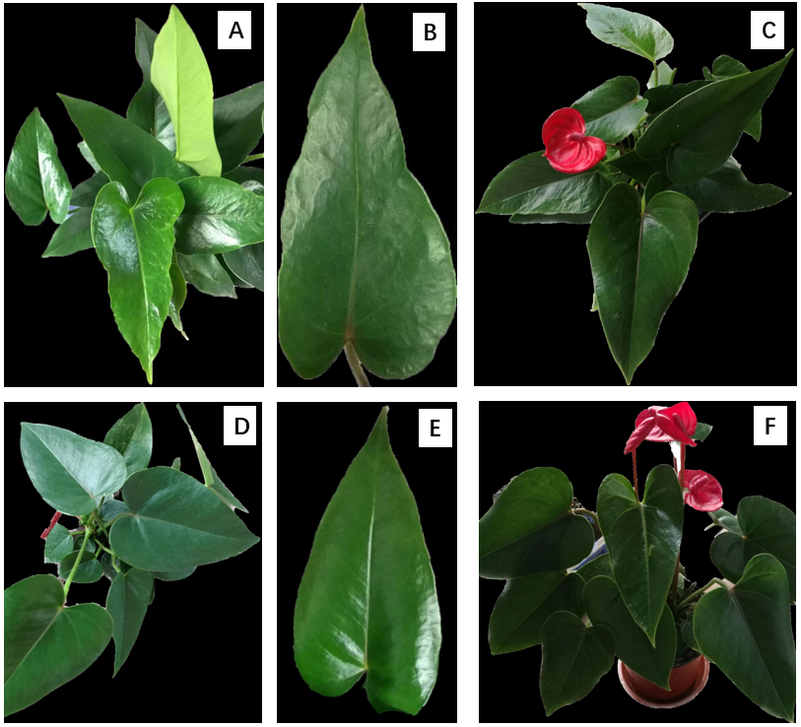
Supplementary Figure 1. Virus-like symptoms of A. andraeanum cv. Xiaojiao
A-C: Diseased plant, leaf and flower; D-F: Healthy plant, leaf and flower

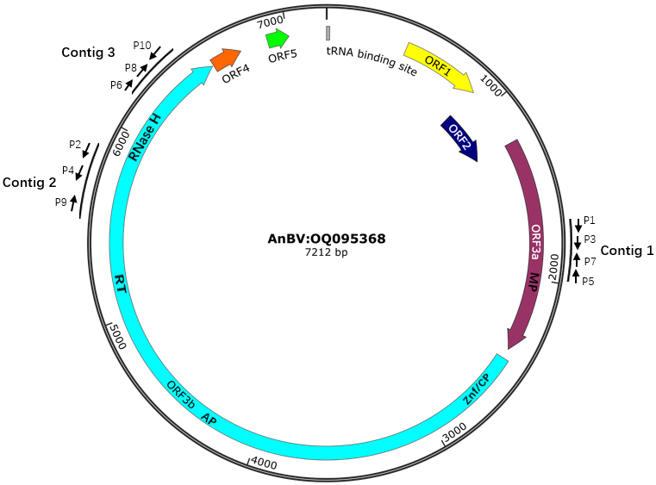
Supplementary Figure 2. Genome structure of andraeanum bacilliform virus (AnBV) generated using the software snapgene (https://www.snapgene.com). The outermost black arcs show the contigs obtained by small RNA sequencing and assembling. The black arrows near the arcs indicate primers used in overlapping (nested) PCR to obtain the sequences between gaps (primers combinations as: P1/P2 and P3/P4, P5/P6 and P7/P8 for the first and second round reaction in two set of nested PCR, respectively; P9/P10 for a convention PCR. The primer sequences are shown in supplementary Table 1). The black circle with nucleotide numbers indicated the genomic DNA framework. The colored arrows represent the ORFs encoded by the genome with conserved domains marked in them (MP, movement protein, Znf/CP, zinc finger domain/coat protein; Ap, aspartic protease; RT, reverse transcriptase; and RNaes H, ribonuclease H).

