Extended Data Figure 1. Associations between lung mucosa and systemic antibody levels against Spike post SARS-CoV-2 vaccination. (A to C) Levels of anti-N IgG in serum (A) and anti-N IgG (B) and IgA (C) in BAL fluid of control (n=11), naïve vaccinated (n=7) and infected vaccinated donors (n=15). Correlation of anti-S IgG (D) and anti-S IgA (E) levels measured in serum and BAL fluid of naïve, vaccinated (in turquoise) and infected, vaccinated donors (in purple). Total n=22 vaccinated individuals. R and p values are shown using Spearman rank correlation.

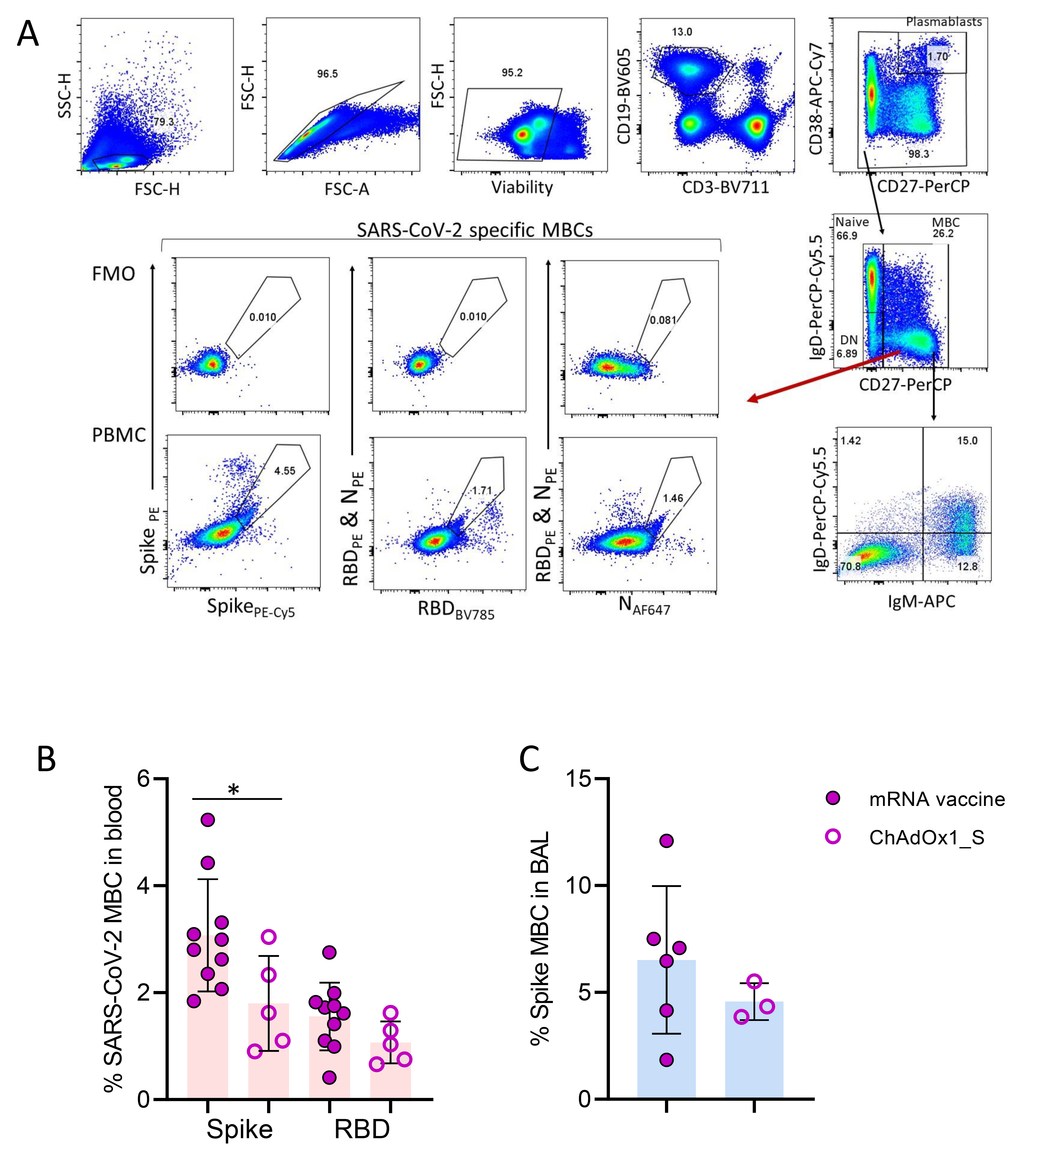

Extended Data Figure 2. Memory B cells and SARS-CoV-2 specific B cells responses in human blood and BAL. A) Gating strategy of B cells in human PBMC or BAL sample, with representative flow cytometry plots of SARS-CoV-2 specific B cells from controls and infected, vaccinated donors. B) Frequency of circulating SARS-CoV-2 MBCs in mRNA (n=10) or ChAdOxAd1_S vaccine (n=5) recipients with prior infection. C) Frequency of lower airway Spike MBCs in mRNA (close circles, n=6) or ChAdOxAd1_S vaccine (open circles, n=3) recipients with prior infection. Data shown are in median and interquartile range (IQR). Statistical differences were determined by Mann-Whitney U test. P values are indicated by *(p < 0.05), **(p < 0.01) and ****(p < 0.0001).

Extended Data Figure 3. A) Example gating of T cell staining after overnight stimulation with SARS-CoV-2 peptide pools. Lymphocytes (SSC-H vs. FSC-H), single cells (FSC-H vs. FSC-A), Live cells (fixable live/dead), CD3⁺, CD4⁺ or CD8⁺ or MAIT cells. Tissue resident memory (TRM) CD4⁺ and CD8⁺ T cells were defined as CD4⁺CD69⁺CD49a⁺ and CD8⁺CD69⁺CD103⁺, respectively. B) Representative plots of SARS-CoV-2 specific CD4⁺ and CD8⁺ T cells in PBMC and BAL of an infected, vaccinated donor after overnight stimulation with SARS-CoV-2 peptide pools. DMSO was used as a negative control. B-C) Frequency of circulating and lower-airway S-specific CD4⁺ and CD8⁺ T cells in mRNA (n=9) or ChAdOxAd1_S vaccine (n=5) recipients with prior infection. D-E) Paired analysis of proportions of CD4⁺ and CD8⁺ T cells which recognise SARS-CoV-2 antigens in BAL and paired blood. Statistical differences were determined by Mann-Whitney U test. *(p < 0.05).

