Supporting Information
Regenerated silk fibroin based on small aperture scaffolds and marginal sealing hydrogel for osteochondral defect repair

Yinyue Luo^{1,2}, Menglin Xiao³, Bushra sufyan Almaqrami⁴, Hong Kang⁵, Zhengzhong Shao³, Xin Chen³*, Ying Zhang^{1,2}*

1. Department of Preventive Dentistry, Shanghai Stomatological Hospital & School of Stomatology, Fudan University, Shanghai, 200001 China;
2. Shanghai Key Laboratory of Craniomaxillofacial Development and Diseases, Fudan University, Shanghai, 200002 China;
3. State Key Laboratory of Molecular Engineering of Polymers, Department of Macromolecular Science, Shanghai Stomatological Hospital & School of Stomatology, Laboratory of Advanced Materials, Fudan University, Shanghai, 200438 China;
4. Department of Orthodontics, Ningbo Dental Hospital, Ningbo, Zhejiang, 315032 China.
5. Department of Temporomandibular joint and Occlusion, School/Hospital of Stomatology, Lanzhou University, Lanzhou, Gansu, 730013 China.
*Corresponding author: Professor Chen Xin and Professor Zhang Ying are co-corresponding authors.
Electronic address: chenx@fudan.edu.cn, zhangyingcmu@vip.163.com/sophiazhang@163.com

- Experimental Section
1.1 Materials and reagents.
Regenerated silk fibroin (RSF) was prepared as a previously reported protocol.^{[1]}Type Ⅰ collagenase (COL Ⅰ, Sigma, USA), chondroitin sulfate (CS, Solarbio, Beijing, China), hyaluronic acid (HA, Solarbio, Beijing, China), Hydroxyproline (HYP) Content Assay Kit (Solarbio, Beijing, China), dsDNA HS Assay Kit for Qubit® (Yeasen, Shanghai, China) were used as received. The modified Safranine O-Fast Green FCF Cartilage Stain Kit was provided by Solarbio (Beijing, China). The anti-SOX9 (C-20) and anti-type Ⅱ collagen (collagenⅡ, COL2) antibodies were purchased at Santa Cruz Biotechnology (Shanghai, China), and the anti-aggrecan antibody at Affinity Biosciences (Jiangsu, China). Fluorescently labelled secondary antibodies (goat anti-mouse immunoglobulin G (IgG) (H ± L) Rhodamine for COL2 and SOX9; goat anti-rabbit IgG (H ± L) FITC for aggrecan were purchased at Abcam (Shanghai, China).
- Supporting Figures

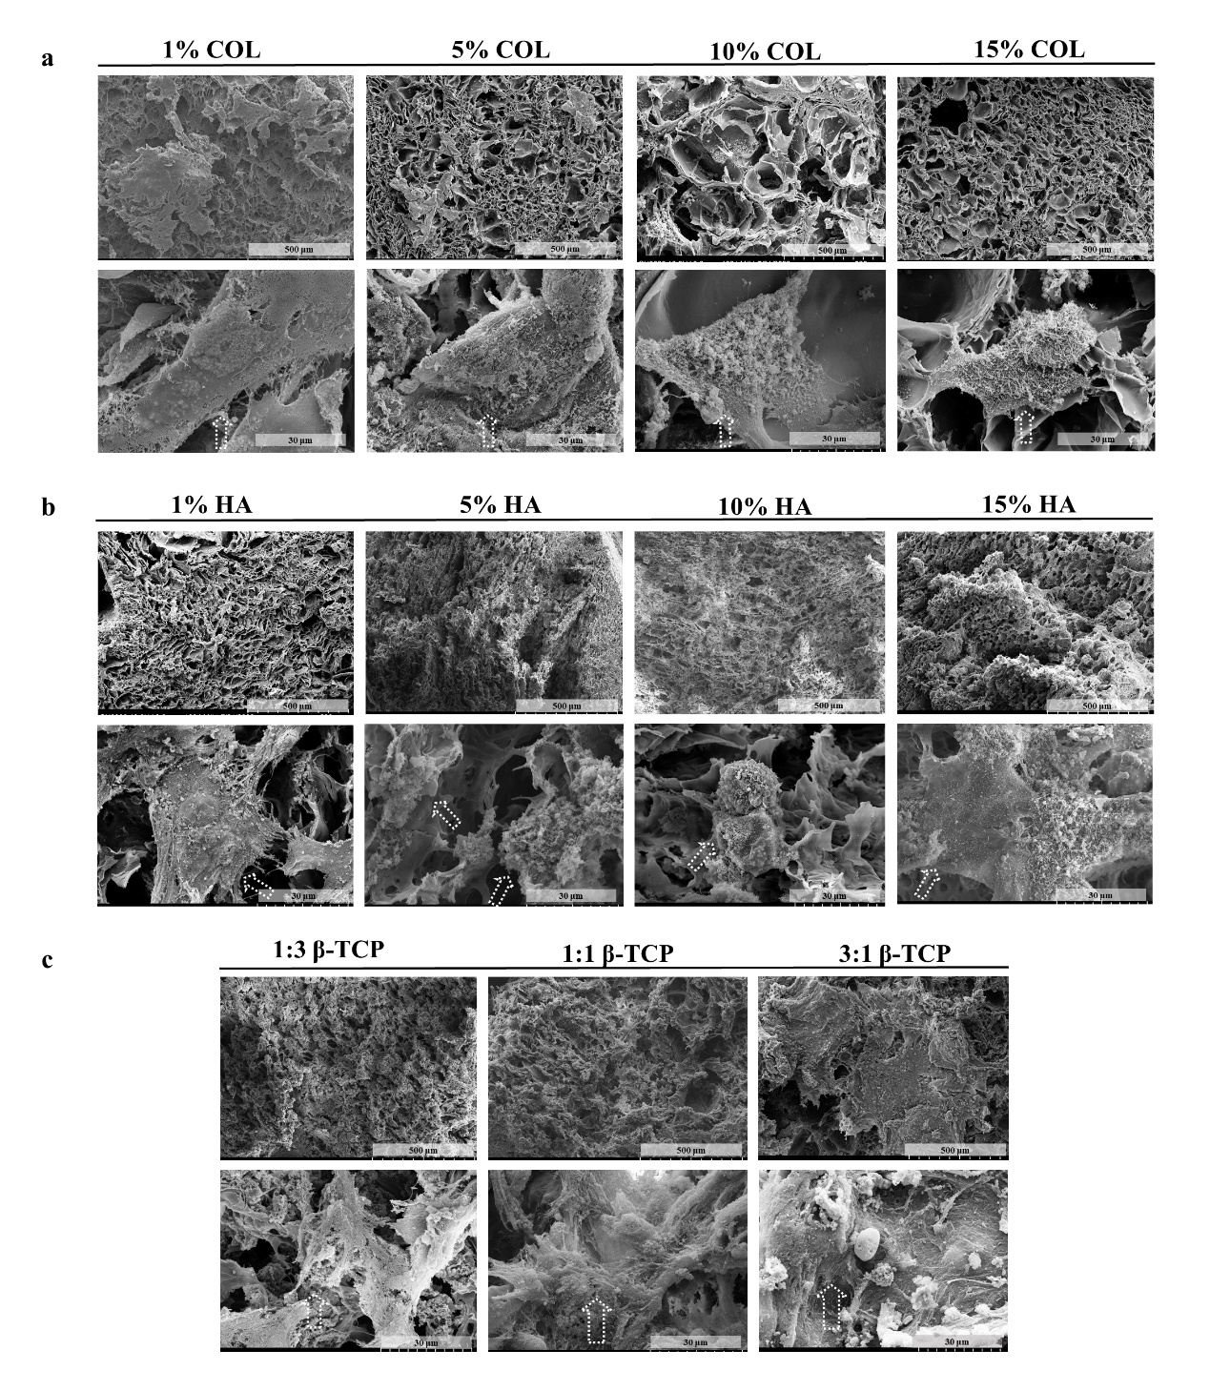
Fig. S1
Screening ingredients at different concentrations for ECM-inspired small aperture scaffolds in vitro. a-c) SEM of chondrocytes or BMSCs on different scaffolds cultured for 7 d.

Fig. S2
Screening ingredients at different concentrations for ECM-inspired small aperture scaffolds in vitro. a) Illustration of cell-scaffold complex preparation. b-j) dsDNA, total GAG, and total collagen content of different HA, COL Ⅰ, and TCP mass ratios of the small aperture scaffolds after co-culturing with chondrocytes or BMSCs for 7d. * represents p < 0.05, ** represents p < 0.01, *** represents p < 0.001 and **** represents p < 0.0001.

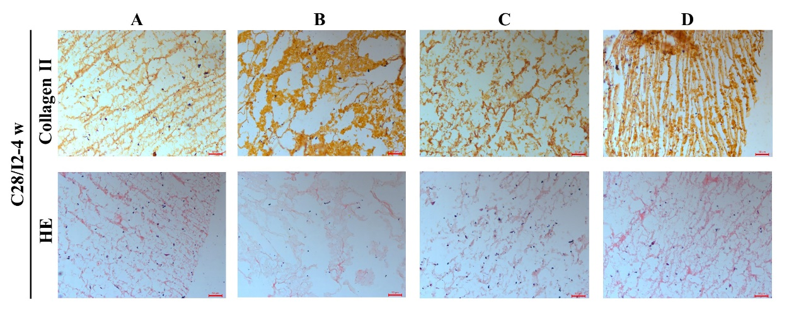
Fig. S3
Morphological staining of cell scaffold complexes in vitro.
a) Immunohistochemical staining of type II collagen at 4 weeks of cell scaffold complex. b) HE staining of cell scaffold complex at 4 weeks.
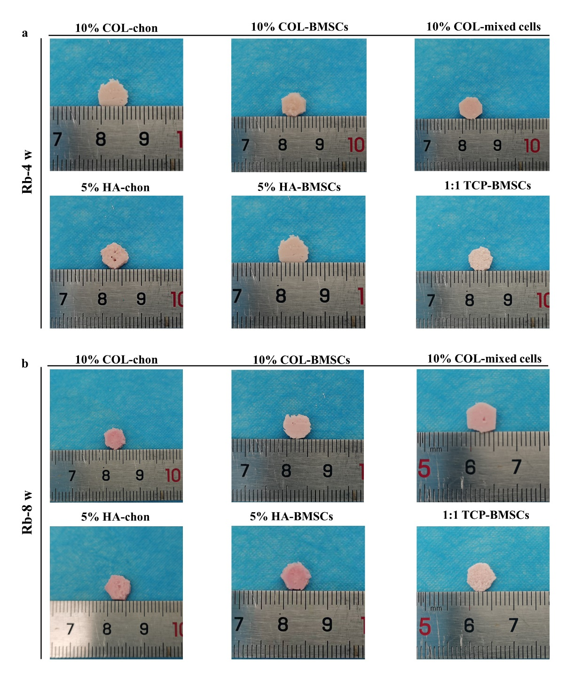
Fig. S4
Macroscopic view of cell scaffold complex in vitro.
a, b) Macroscopic view of rabbit chondrocytes and/or BMSCs co-cultured with RSF scaffolds for 4, 8 weeks in vitro. Scaffolds maintain the morphology well. Chon represents chondrocytes.

Fig. S5
Microscopic view of cell scaffold complex in vitro.
a, b) Microscopic view of cell scaffold complex for 4, 8 weeks of different groups in vitro. Flocculent substances similar to ECM were produced around the complex.

Fig. S6
Labelling rate detection of cell fluorescent probes by flow cytometry.
a) 99.84% labelling rate of chondrocytes with a red fluorescent probe (DIL). b) 84.32% labelling rate of BMSCs with a green fluorescent probe (DIO).
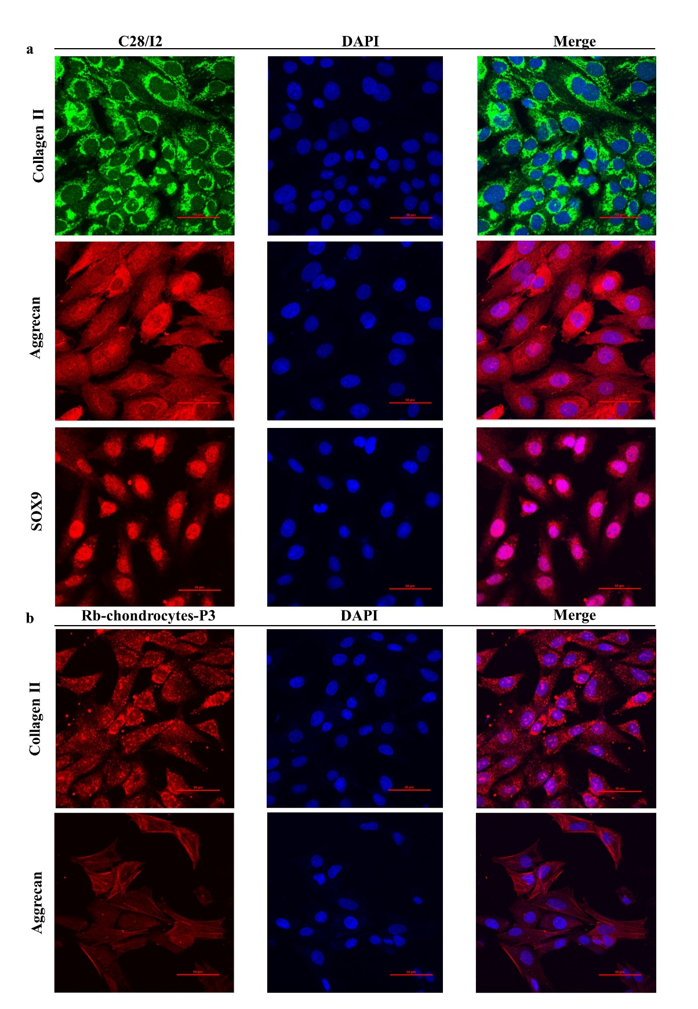
Fig. S7
Cell identification.
a) Immunofluorescence staining of collagen type II, aggrecan and SOX9 of human chondrocyte line C28/I2. b) Immunofluorescence staining of collagen type II and aggrecan of rabbit chondrocytes of the knee joint.

Reference
[1] M. Lu, M. Wu, Y. Huang, J. Yao, Z. Shao, X. Chen, J Mater Chem B 2022, 10, 3798.
[2] R. Rajkhowa, E. S. Gil, J. Kluge, K. Numata, L. Wang, X. Wang, D. L. Kaplan, Macromol Biosci 2010, 10, 599.

