Supplementary materials:

Supplementary Table 1.1: Demographic and clinical characteristics of breast cancer patients
Characteristics | Total sample  1058 | *P-value
Characteristics | Total sample  1058 | Overall survival
Age at diagnosis, mean ± SD | 57.48 ± 13.03 | < 0.0001
Race, N (%) |  | 0.398
American Indian or Alaska Resident or | 59 (5.58%)
Asian
Black or African American | 178 (16.82%)
White | 821 (77.60%)
Disease stage, N (%) |  | <0.0001
Stage I | 193 (18.24%)
Stage II | 608 (57.47%)
Stage III | 240 (22.68%)
Stage IV | 17 (1.61%)

*Analysis conducted by fitting CoxPH model using each of the variables respectively. P-values computed via likelihood ratio test. During model fitting, patients were categorized into “white” and “other races” based on their race status; they were categorized into “stage I”, “stage II”, and “stage III or higher” based on their clinical stage.

Supplementary Table 1.2: Demographic and clinical characteristics of ovarian cancer patients
Characteristics | Total sample  355 | *P-value
Characteristics | Total sample  355 | Overall survival
Age at diagnosis, mean ± SD | 59.61 ± 11.29 | 0.0003
Race, N (%) |  | 0.018
American Indian or Alaska native or | 15 (4.23%)
Asian or native Hawaiian or other
Pacific Islander
Black or African American | 24 (6.76%)
White | 316 (89.01%)
Disease stage, N (%) |  | 0.040
Stage I | 1 (0.28%)
Stage II | 22 (6.2%)
Stage III | 278 (78.31%)
Stage IV | 54 (15.21%)
Histological grade, N (%) |  | 0.429
G1 | 1 (0.28%)
G2 | 44 (12.39%)
GB | 2 (0.56%)
G3 | 307 (86.48%)
G4 | 1 (0.28%)

*Analysis conducted by fitting CoxPH model using each of the variables respectively. P-values computed via likelihood ratio test. During model fitting, patients were categorized into “white” and “other races”; “stage III or higher” and “lower stages”; “G3 or higher” and “lower grades”.

Detailed information about the GDC pipelines applied to generate the gene and miRNA expression data on UCSC Xena portal can be found on the following websites:
Gene expression RNAseq | https://docs.gdc.cancer.gov/Data/Bioinformatics_Pipelines/Expression_mRNA_Pipeline/
MiRNA expression quantification | https://docs.gdc.cancer.gov/Data/Bioinformatics_Pipelines/miRNA_Pipeline/

We obtained chromosome information for the genes using R package biomaRt. Xena portal provides Ensemble IDs for the genes. During preprocessing, a gene was removed if its ID cannot get a matched chromosome.
Supplementary Table 2: Summary of the gene/miRNA expression data
Dataset | Number of features before filtering process and adaptation for pathway-masking design: genes / miRNAs | Number of features after filtering process and adaptation for pathway-masking design: genes / miRNAs
TCGA-BRCA | 60,483 / 1,881 | 2,699 / 516
TCGA-OV | 60,483 / 1,881 | 5,147 / 865
For the filtering process, we first filtered out genes that are not on the autosomes or X chromosome, then the original expression data were min-max normalized across all patients in the tuning set and genes/miRNAs with variance of < 0.02 were excluded. Adaptation for pathway-masking design: Genes that do not belong to any of the Reactome pathways were excluded. TCGA-BRCA: GDC TCGA Breast Cancer cohort; TCGA-OV: GDC TCGA Ovarian Cancer cohort.

Supplementary Table 3.1 – Hyperparameters for KL-PMVAE
Hyperparameter | Values tuned
Number of latent features in bottleneck layer | 8, 16, 32, 64
Learning rate | 0.1, 0.05, 0.005, 0.001
Weight decay (i.e., regularization parameter $λ_{1}$) | 0.1, 0.05, 0.005, 0.0005
Number of epochs | 800, 1200, 1600, 2000, 2400
Number of cycles | 2, 4, 5, 10
Cutting ratio | 0.3, 0.5, 0.7, 0.9
The set of hyperparameters that yielded the lowest reconstruction loss were selected as the best set of hyperparameters.

Supplementary Table 3.2 – Hyperparameters for LFSurv
Hyperparameters | Values tuned
Number of nodes in the hidden layer | 4, 8, 16, 32
Learning rate | 0.3, 0.1, 0.05, 0.01, 0.0075
Weight decay (i.e., regularization parameter $λ_{2}$) | 0.001, 0.00075, 0.0005, 0.00025, 0.0001
Dropout rate for input layer | 0.1, 0.3, 0.5
Dropout rate for hidden layer | 0.1, 0.3, 0.5
The set of hyperparameters that yielded the highest C-index were selected as the best set of hyperparameters.

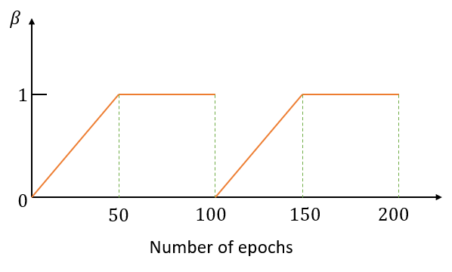
Supplementary Figure 1: Example of KL-annealing learning scheme. In this example the total number of epochs is 200, there are 2 cycles, each with 100 epochs, and the cutting ratio within each cycle is 50:50. In the first part of each cycle (i.e., 50 epochs), the value of $β$ gradually increases from 0 to 1, and in the second part of the cycle the value of $β$ is fixed at 1. $β$ value will change to 0 at the beginning of the next cycle and the process repeats.

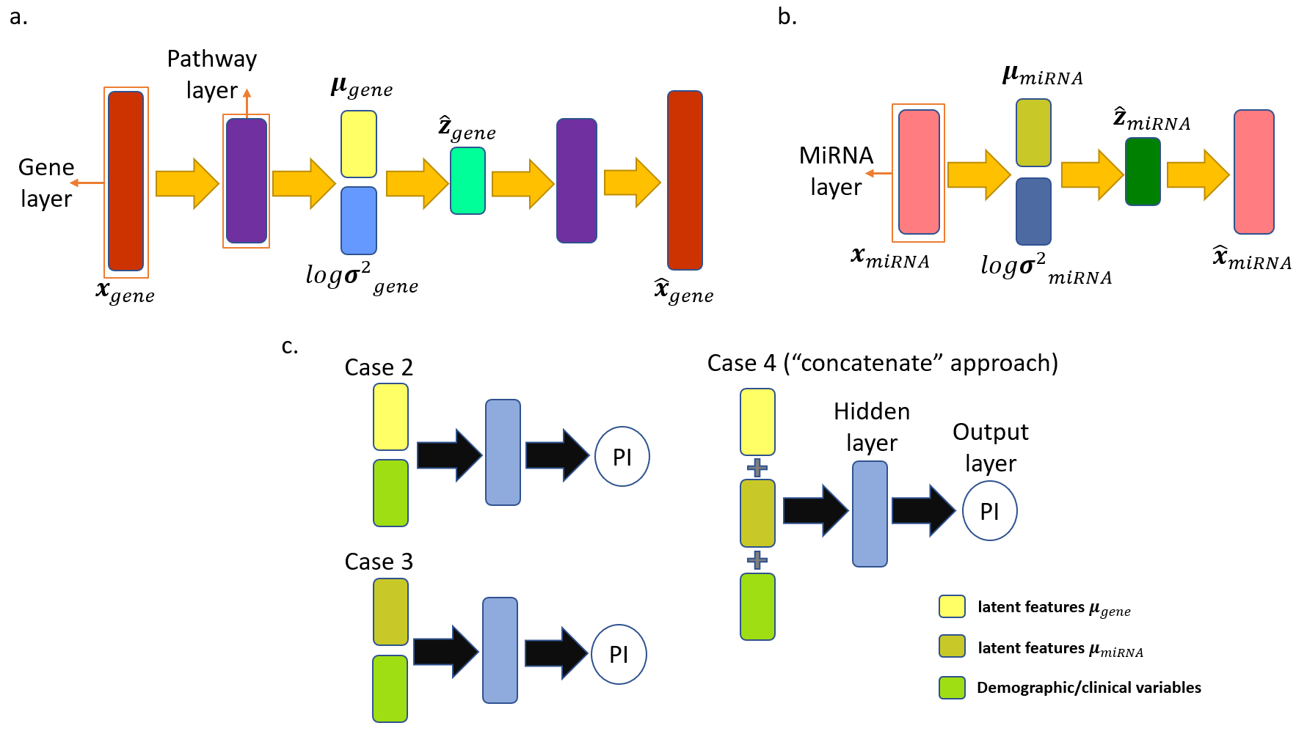
Supplementary Figure 2: AUTOSurv components in different cases. (a) Modified KL-PMVAE to extract latent features from gene expression data. (b) Modified KL-PMVAE to extract latent features from miRNA expression data. (c) LFSurv network taking different input data: in Case 2, latent features $μ_{gene}$ and demographic/clinical variables (e.g., age, disease stage, race) were taken as input; in Case 3, latent features $μ_{miRNA}$ and demographic/clinical variables were taken as input; in Case 4, latent features $μ_{gene}$ and $μ_{miRNA}$ were concatenated directly and the concatenated features together with demographic/clinical variables were fed into LFSurv as input.

