Supplemental Information

in situ Tracking Water Oxidation Generated Lattice Strain Effects in Layered Double Hydroxides Nanosheets
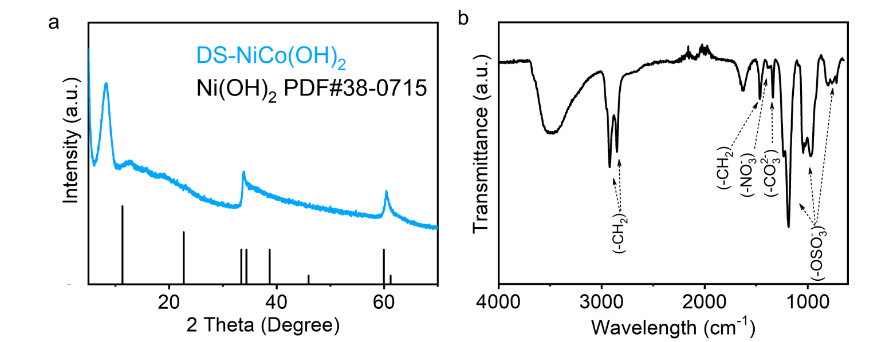
Supplementary Figure 1. (a) XRD pattern of bulk NiCo LDHs precursor. The diffraction peaks at about 14° and 33° correspond to the (003) and (101) planes of the α–Ni(OH)₂ (JCPDS 38-0715). The peak at 8° is attributed to the extended basal spacing induced by the intercalation of dodecyl sulfate (DS) ions.¹ (b) FTIR of NiCo LDHs. The stretching mode of sulfate (-OSO₃⁻) in DS ions contributes to the peaks in the range of 1300-900 cm⁻¹.
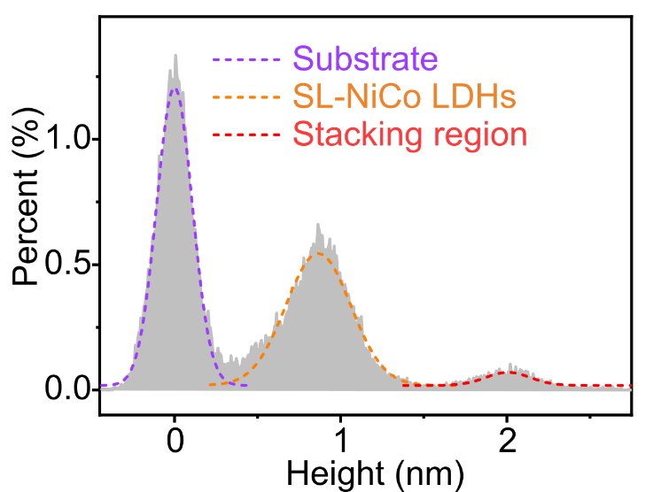
Supplementary Figure 2. Height distribution of SL-NiCo LDHs nanosheets electrode in Fig. 1b. The peaks at separations 0 nm, 0.9 ± 0.2 nm and 2.01 ± 0.16 nm refer to the apparent heights of HOPG substrate, individual SL-NiCo LDHs nanosheets and stacking region of two nanosheets, respectively. The value for the stacking region is slightly higher than that of two single layers, suggesting the existence of gap in between.
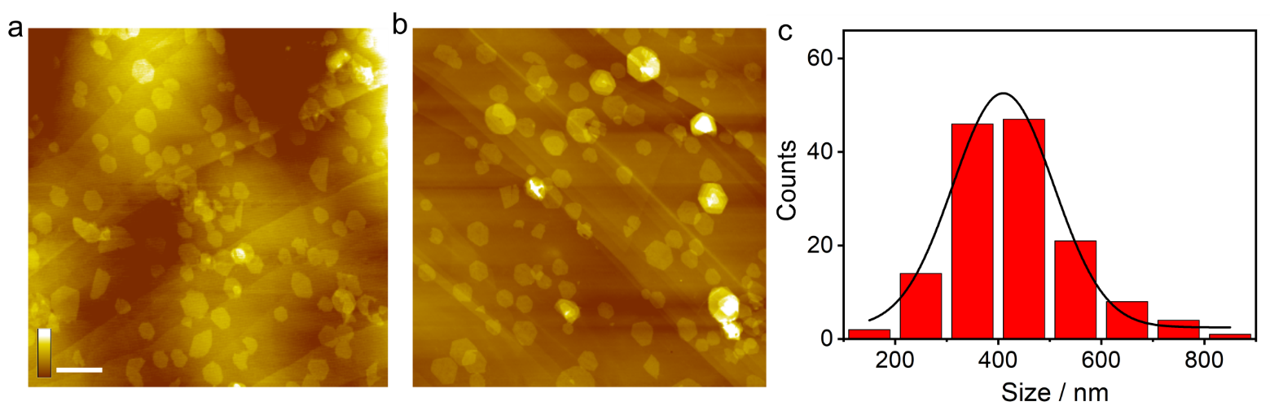
Supplementary Figure 3. (a, b) AFM topography images of SL-NiCo LDHs nanosheets. Scale bar, 1 um. Color scale, -2~8 nm. (c) Corresponding size statistics distribution.
Supplementary Figure 4. Spatial elemental distributions mapped by means of STEM-EDX.
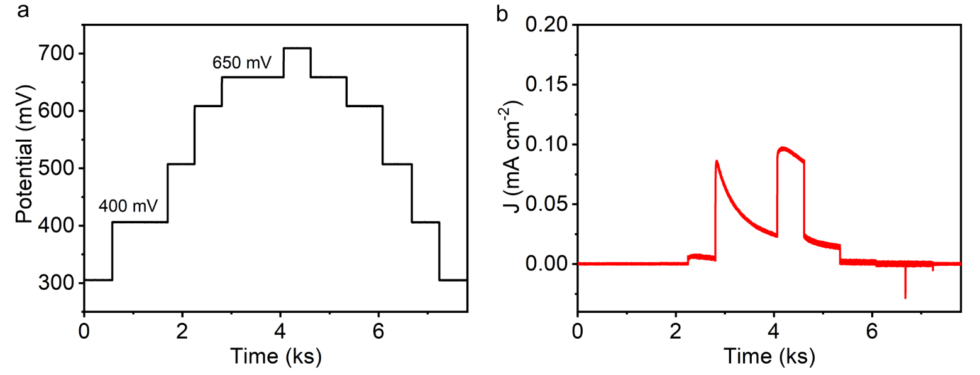
Supplementary Figure 5. (a) The detailed potential steps for in situ EC-AFM measurements, and (b) simultaneously recorded current density. The bias step begins at 300 mV, then progressively steps to 700 mV, and finally regresses to 300 mV.
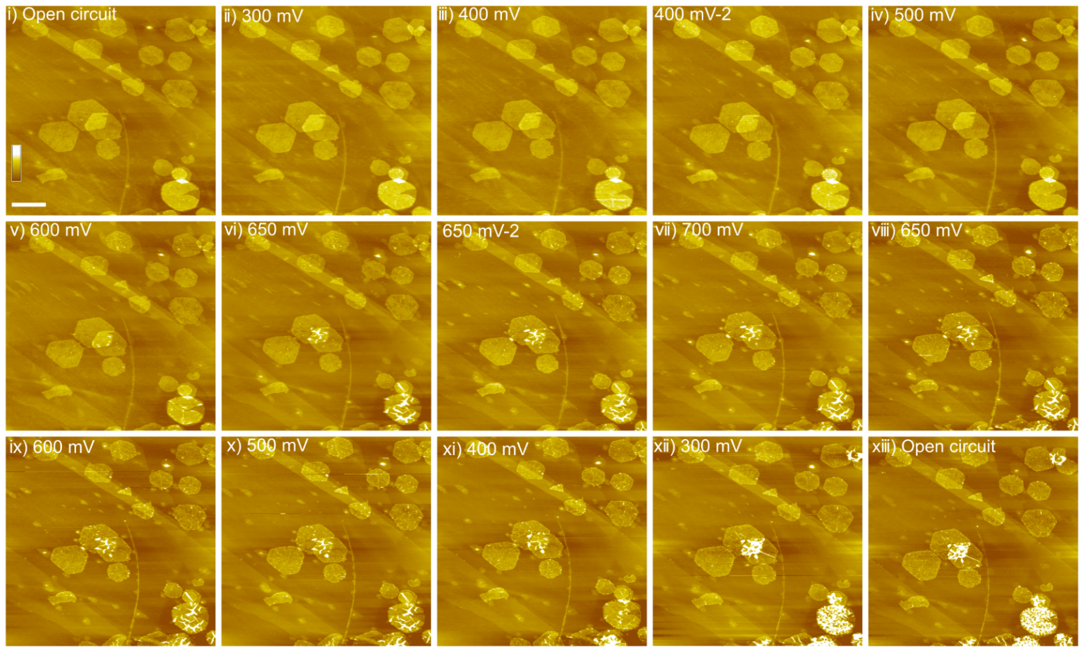
Supplementary Figure 6. Operando AFM images at above potential steps, with the applied potential displayed in the upper left corner of each image. Scale bar, 500 nm. Color scale, -1~4 nm. AFM images were captured at each potential step with an acquisition time of 567s. We capture two images at anodically 400 mV and 650 mV.
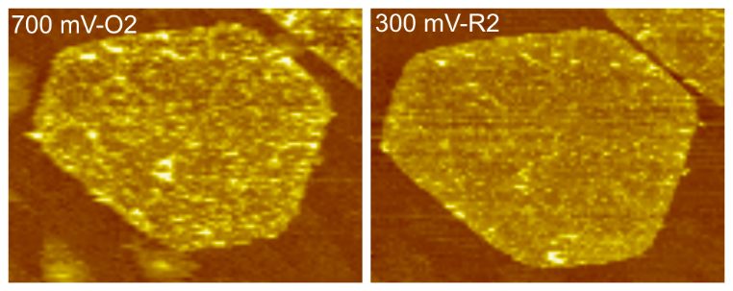
Supplementary Figure 7. AFM topography images of the single SL-NiCo LDHs nanosheet under successively switching the applied bias to (a) 700 mV (700 mV-O2) and (b) 300 mV (300 mV-R2).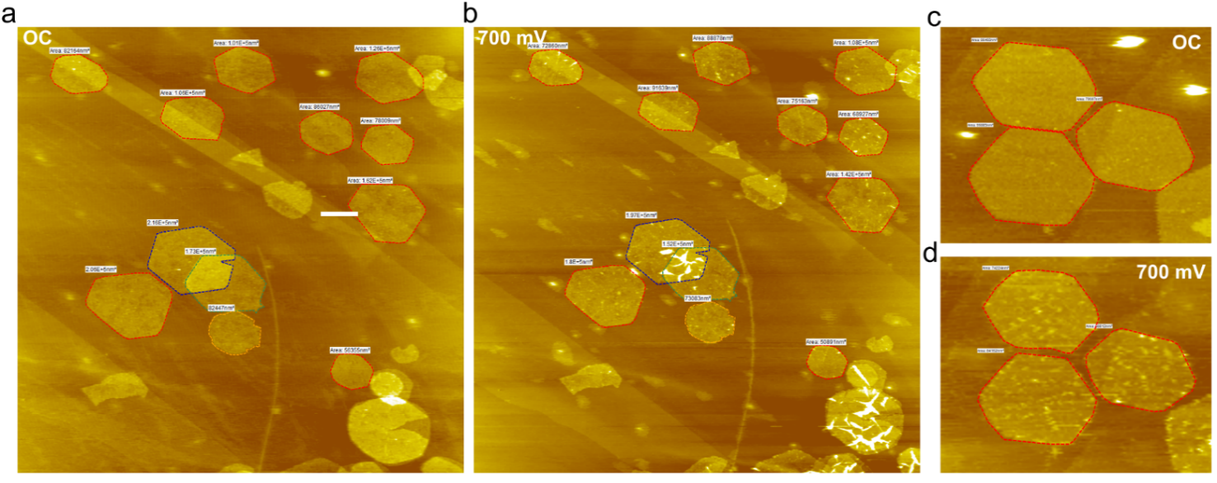Supplementary Figure 8. Operando AFM images at (a, c) OC and (b, d) 700 mV. The selected nanosheets for counting distribution of contraction ratio ((A₀ - A_{700 mV}) /A₀) are highlighted by dashed polygons.

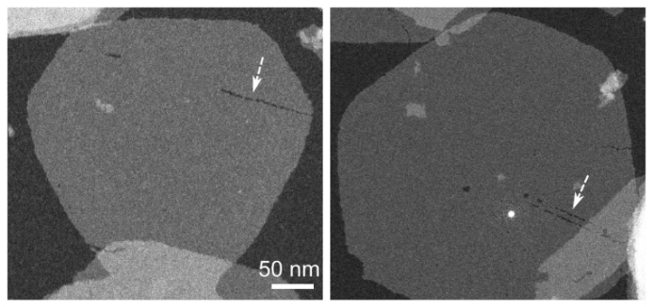
Supplementary Figure 9. STEM images of SL-NiCo LDHs nanosheets with intrinsic line defects, as indicated by the white arrows. In general, the nanosheet with large size is prone to generating defects during the exfoliation process.
Supplementary Figure 10. The optimized structure for all intermediates adsorbed on O site on the (110) surface of NiCo LDHs under a 16 Å vacuum, dash lines present partial vacuum.
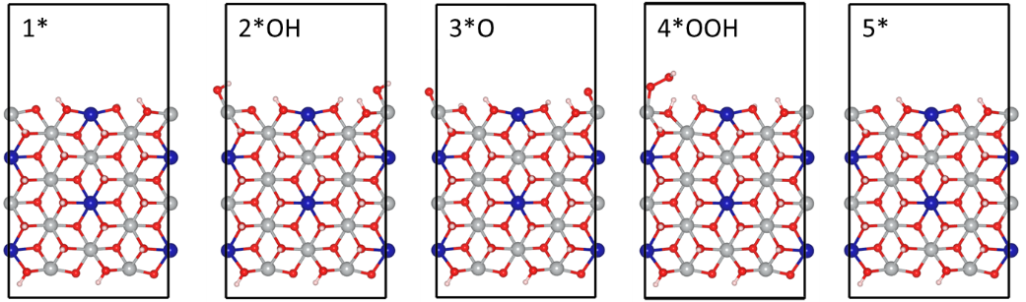
Supplementary Figure 11. The optimized structure for all intermediates adsorbed on Ni site on the (001) surface of NiCo LDHs under a 16 Å vacuum.
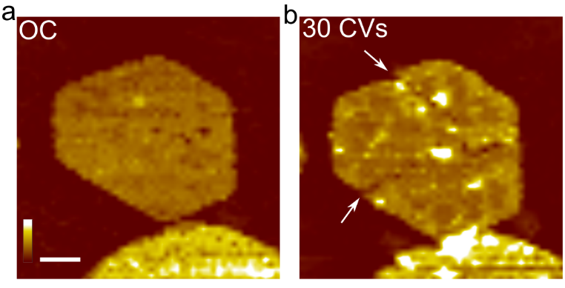
Supplementary Figure 12. AFM images obtained (a) before and (b) after performing 30 CVs in 0.1 M KOH. Scale bar, 100 nm. Color scale, 0~3 nm. The white arrows highlight the produced hairlines in the nanosheet.
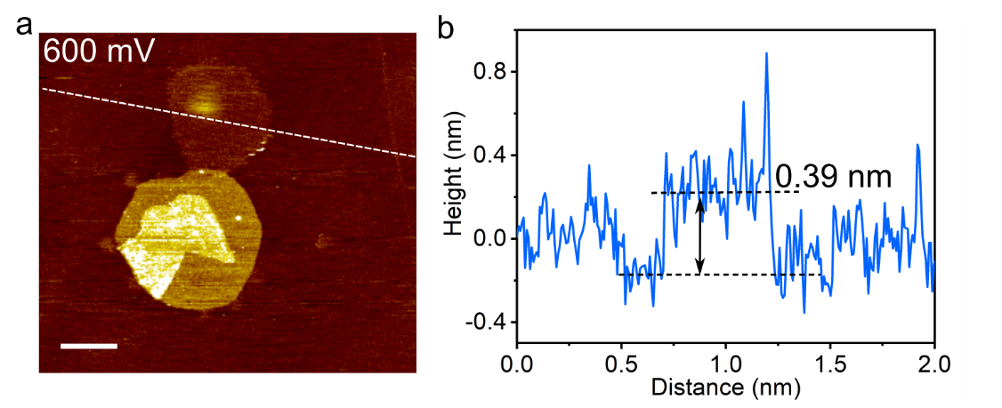
Supplementary Figure 13. (a) Operando AFM image of SL-NiCo LDHs nanosheets at 600 mV. Color bar, -4~4 nm. Scale bar, 300 nm. (b) Height profile of the micropancake along the white line in a.
Previous simulations indicate that flat micropancakes occur when the electrode-gas attraction is significantly stronger than the electrode−water attraction.² For hydrophobic HOPG, the O₂ gas should prone to nucleate in the regime of micropancake.
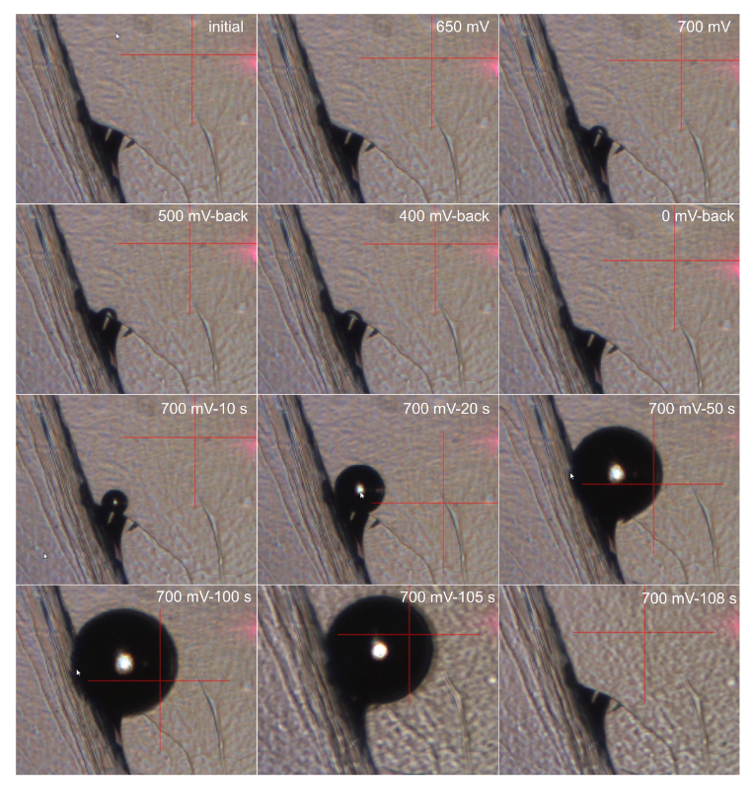
Supplementary Figure 14. Operando optical images of the SL-NiCo LDHs electrode.
The images were acquired by the optical microscope vertically suspended on the EC-AFM setup. The microbubble appears and grows as the potential increases, while scanning in reverse or abruptly pausing the bias makes the microbubble gradually become smaller and finally disappear. With a constant voltage of 700 mV, the size of the microbubble expanded with the reaction time and eventually detached from the surface when it reached a sufficient size. The evolving tendency coincided well with the observed behavior of nanobubbles during operation.
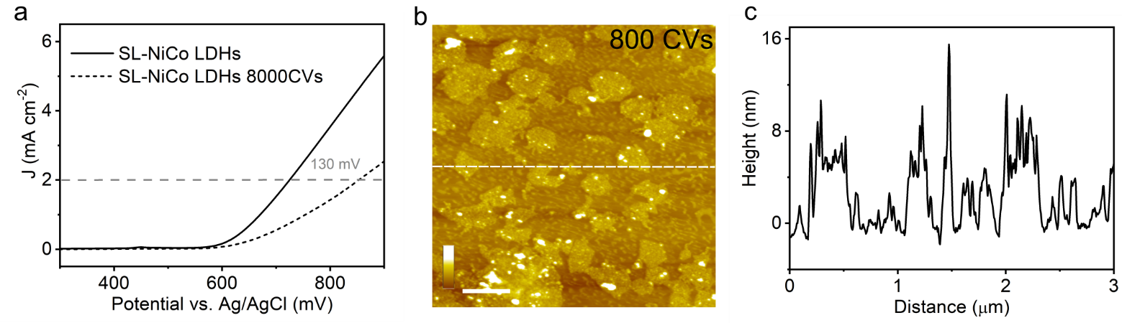
Supplementary Figure 15. (a) LSV curves of a SL-NiCo LDHs electrode before and after 8000 CVs (without IR correction) (b) AFM image of the electrode after 8000 CVs. Color bar, -10~30 nm. Scale bar, 500 nm. (c) Height profiles along the white line in b.
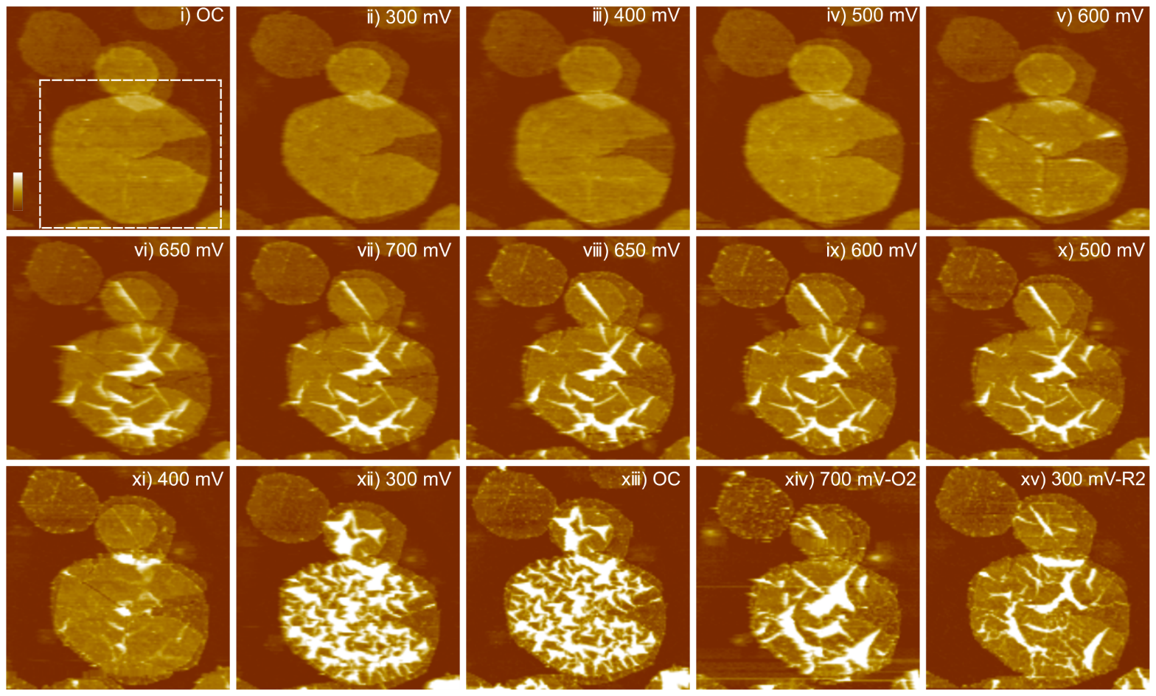
Supplementary Figure 16. Operando AFM images with fully stacking SL-NiCo LDHs nanosheets (extracted from Supplementary Figure 6). Color scale, -1~4 nm. The image size is 801 nm*801 nm.
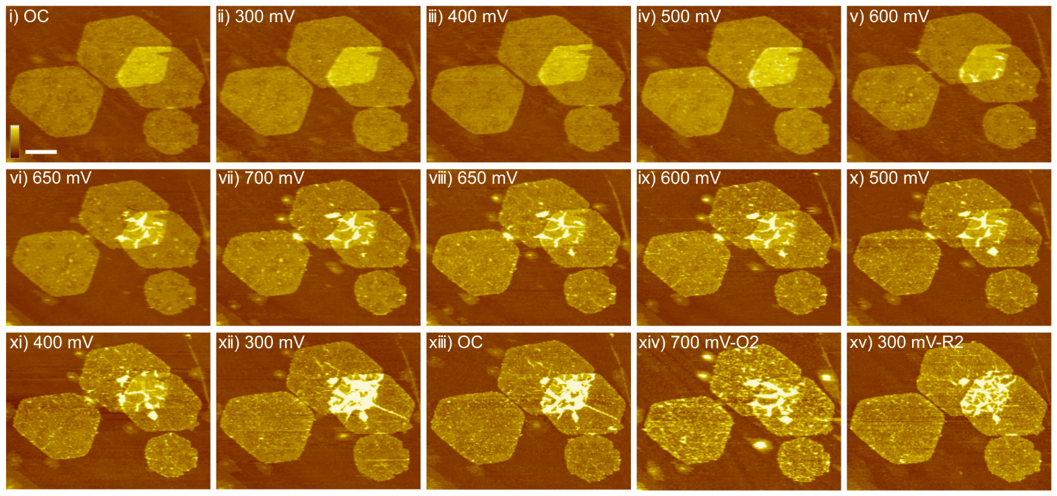
Supplementary Figure 17. Operando AFM images with partially stacking SL-NiCo LDHs nanosheets (extracted from Supplementary Figure 6). Color scale, -1~3 nm. Scale bar, 200 nm.
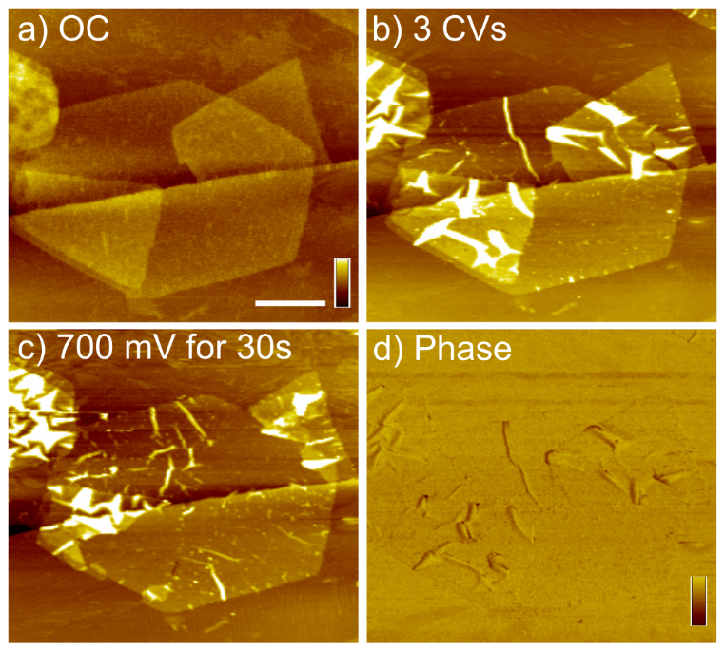
Supplementary Figure 18. AFM topography images of stacking SL-NiCo LDHs nanosheets (a) at OC, (b) after performing 3 CVs from 0 mV to 700 mV and (c) after the chronopotentiometry measurement at 700 mV for 30 s. Color bar, -4~4 nm. Scale bar, 200 nm. (d) Phase image after performing 3 CVs. Color bar, -6.3~1.7°.
Here the AFM images were obtained with AFM tapping mode, which allows for simultaneous acquisition of the topography and phase images. When the probe encounters different compositions with varying surface stiffness/softness and/or adhesion between the tip and surface, the phase signal changes, which allows for the identification of regions that possess different surface mechanical priorities.³ The network structure exhibits the same contrast as the flat region in the phase profile, indicating that the wrinkles are most likely composed of NiCo LDHs instead of other species.
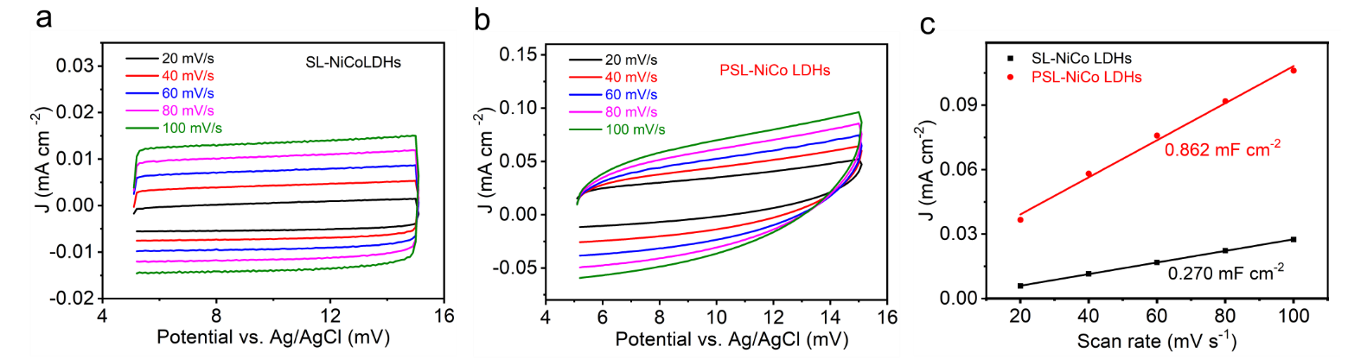
Supplementary Figure 19. CV curves of (a) SL-NiCo LDHs and (b) PSL-NiCo LDHs nanosheets with different scanning rates. (c) The capacitive current measured at 100 mV was plotted as a function of scan rate.
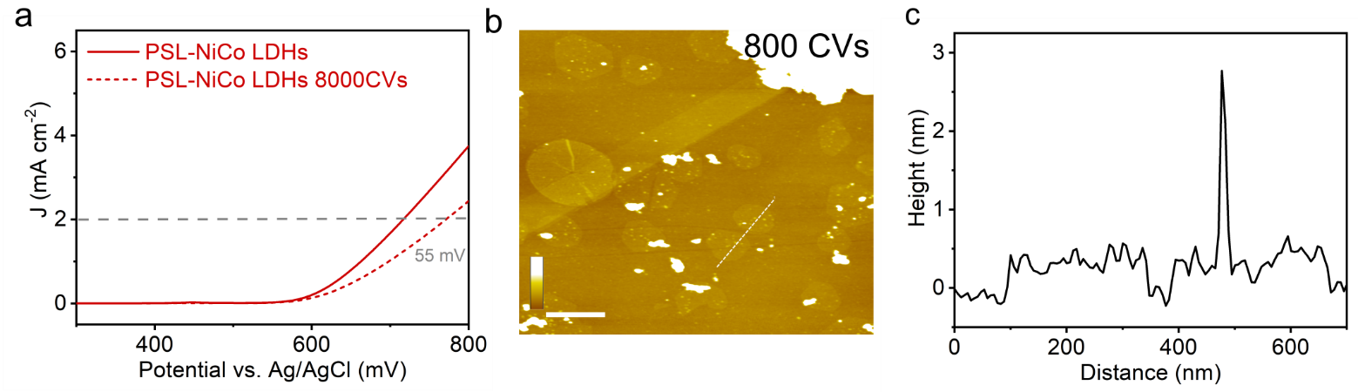
Supplementary Figure 20. (a) LSV curves of a PSL-NiCo LDHs electrode before and after 8000 CVs (without IR correction) (b) AFM image of the electrode after 8000 CVs. Color bar, -2~6 nm. Scale bar, 500 nm. (c) Height profiles along the white line in b.

Supplementary References

1. Ida, S., Shiga, D., Koinuma, M. & Matsumoto, Y. Synthesis of hexagonal nickel hydroxide nanosheets by exfoliation of layered nickel hydroxide intercalated with dodecyl sulfate ions. J. Am. Chem. Soc. 130, 14038-14039 (2008).
2. Perez Sirkin, Y. A., Gadea, E. D., Scherlis, D. A. & Molinero, V. Mechanisms of nucleation and stationary states of electrochemically generated nanobubbles. J. Am. Chem. Soc. 141, 10801-10811 (2019).
3. An, H. et al. Graphene nanobubbles produced by water splitting. Nano Lett. 17, 2833-2838 (2017).

