Supporting information

Conformational preferences of inosine and its methyl derivatives: Comparison of the AMBER derived force field parameters and reparameterization of the glycosidic torsion parameters

Nivedita Dutta, † Indrajit Deb, † Joanna Sarzynska, ‡ Ansuman Lahiri*, †

Author Affiliations

†Department of Biophysics, Molecular Biology and Bioinformatics, University of Calcutta, 92, Acharya Prafulla Chandra Road, Kolkata 700009, West Bengal, India

‡Institute of Bioorganic Chemistry, Polish Academy of Sciences, Noskowskiego 12/14, 61-704 Poznan, Poland

*Correspondence to

Ansuman Lahiri (Email albmbg@caluniv.ac.in )

ORCID of the authors: Nivedita Dutta (0000-0002-8371-9007), Indrajit Deb (0000-0002-2722-582X) Joanna Sarzynska (0000-0002-0500-2238), Ansuman Lahiri (0000-0002-7398-4114)

METHODS

MD simulations using charmm36m parameter sets

The CHARMM [1] software package was used for the system preparation, solvation, minimization and production run. The initial structure of inosine (NORTH/ANTI/g⁺) was solvated using a TIP3P water in a truncated octahedral box having the closest distance of 9 Å between the edge of the box and any solute atom. Short minimization consisting of steepest descent minimization followed by ABNR minimization was carried out at 298 K keeping the heavy atoms of the nucleoside residue fixed. This was followed by another short minimization consisting of steepest descent minimization followed by ABNR minimization carried at 298 K keeping without fixing the residue. Next, the minimized system was subjected to NVT equilibration at 298 K for 25 ps with a 1 fs time step using a harmonic position restraining force on the heavy atoms of the solute molecule. The system was then simulated at 298 K using NPT dynamics at 1 atm pressure and the frames were saved at 10 ps intervals. The leap-frog integrator (with a time step of 2 fs) was utilized for numerical integration. For handling the long-range electrostatic interactions, the particle mesh Ewald (PME) method was used. To include nonbonded interactions, a long-range cutoff of 12 Å was considered. To constrain the bonds that involved hydrogen atoms, the SHAKE algorithm was used. The simulations were carried out using the CPU version of the CHARMM software package. Two independent sets of normal MD simulations (each of 100 ns) were performed at 298 K generating a total simulation of 200 ns.

Analysis of trajectories

The population of pseudorotation angle, the 𝛘 and 𝛄 torsion angles and hydrogen bonding characteristics were analyzed using the cpptraj tool from Ambertools18. The calculations were performed in a similar way as is described in the main text. The population of the sugar pucker conformation, base orientation and the conformation of the 𝛄 torsion angle, frequencies of the hydrogen bonds and N9 pyramidalization were calculated for the concatenated trajectory of 200 ns. The time series plots of the pseudorotation angle and the 𝛘 and 𝛄 torsion angles were prepared for each (100ns) of the two independent simulation sets separately.

Topology and parameter files

- INO.prepin

0 0 2

Developed at B.M.B. University of Calcutta
INO.res
INO INT 0
CORRECT OMIT DU BEG
0.0000
1 DUMM DU M 0 -1 -2 0.000 .0 .0 .00000
2 DUMM DU M 1 0 -1 1.449 .0 .0 .00000
3 DUMM DU M 2 1 0 1.522 111.1 .0 .00000
4 H5T HO M 3 2 1 1.540 111.208 180.000 0.4295
7 O5' OH M 4 3 2 1.598 82.161 -137.047 -0.6223
8 C5' CI M 7 4 3 1.446 120.671 -148.171 0.0558
9 H5'1 H1 E 8 7 4 1.070 106.609 -71.448 0.0679
10 H5'2 H1 E 8 7 4 1.069 106.628 57.929 0.0679
11 C4' CT M 8 7 4 1.508 110.266 173.250 0.1065
12 O4' OS S 11 8 7 1.453 109.844 -59.180 -0.3548
13 C1' CT 3 12 11 8 1.426 109.114 148.326 0.0842
14 C2' CT B 13 12 11 1.534 106.436 2.267 0.0670
15 O2' OH S 14 13 12 1.417 107.585 89.750 -0.6139
16 HO'2 HO E 15 14 13 0.959 109.522 -113.598 0.4186
17 H2' H1 E 14 13 12 1.070 117.302 -150.811 0.0972
18 N9 N* S 13 12 11 1.470 109.366 -119.332 0.0240
19 C8 Q1 B 18 13 12 1.368 127.832 57.310 0.0988
20 N7 NB S 19 18 13 1.283 113.696 179.740 -0.5483
21 C5 CB S 20 19 18 1.371 104.400 -0.015 0.1716
22 C6 C B 21 20 19 1.443 130.521 179.954 0.5049
23 O6 O E 22 21 20 1.193 130.707 0.063 -0.5385
24 N1 NA B 22 21 20 1.411 109.195 180.000 -0.3706
25 C2 CA B 24 22 21 1.354 126.106 0.000 0.2155
26 N3 NC S 25 24 22 1.276 125.016 0.055 -0.5106
27 C4 CB E 26 25 24 1.362 112.344 -0.050 0.2396
28 H2 H5 E 25 24 22 1.074 115.499 179.941 0.1422
29 H1 H E 24 22 21 0.998 114.688 -179.937 0.3154
30 H8 H5 E 19 18 13 1.071 121.020 -0.255 0.1825
31 H1' H2 E 13 12 11 1.069 112.559 122.310 0.1053
32 H4' H1 E 11 8 7 1.070 103.540 176.972 0.1174
33 C3' CT M 11 8 7 1.518 115.185 56.643 0.2022
34 H3' H1 E 33 11 8 1.069 115.847 -39.072 0.0615
35 O3' OH M 33 11 8 1.425 110.049 79.043 -0.6541
37 H3T HO E 35 33 11 1.000 115.000 180.000 0.4376

LOOP
C3' C2'
C4 N9
C4 C5

IMPROPER
C4 C8 N9 C1'
H8 N9 C8 N7
C6 C4 C5 N7
C5 N1 C6 O6
H2 N1 C2 N3
C5 N9 C4 N3

DONE
STOP

- 1MI.prepin

0 0 2

Developed at B.M.B. University of Calcutta
1MI.res
1MI INT 0
CORRECT OMIT DU BEG
0.0000
1 DUMM DU M 0 -1 -2 0.000 .0 .0 .00000
2 DUMM DU M 1 0 -1 1.449 .0 .0 .00000
3 DUMM DU M 2 1 0 1.522 111.1 .0 .00000
4 H5T HO M 3 2 1 1.540 111.208 180.000 0.4295
7 O5' OH M 4 3 2 1.598 104.833 -41.929 -0.6223
8 C5' CI M 7 4 3 1.446 120.678 36.320 0.0558
9 H5'1 H1 E 8 7 4 1.070 106.577 -71.456 0.0679
10 H5'2 H1 E 8 7 4 1.070 106.583 57.821 0.0679
11 C4' CT M 8 7 4 1.508 110.284 173.240 0.1065
12 O4' OS S 11 8 7 1.453 109.823 -59.203 -0.3548
13 C1' CT 3 12 11 8 1.426 109.082 148.294 0.0693
14 C2' CT B 13 12 11 1.533 106.459 2.326 0.0670
15 O2' OH S 14 13 12 1.418 107.622 89.692 -0.6139
16 HO'2 HO E 15 14 13 0.960 109.457 -113.516 0.4186
17 H2' H1 E 14 13 12 1.070 117.372 -150.869 0.0972
18 N9 N* S 13 12 11 1.469 109.396 -119.359 0.0552
19 C8 Q1 B 18 13 12 1.369 127.926 54.963 0.1110
20 N7 NB S 19 18 13 1.283 113.802 179.690 -0.5360
21 C5 CB S 20 19 18 1.372 104.292 -0.015 0.1049
22 C6 C B 21 20 19 1.440 130.321 179.954 0.4948
23 O6 O E 22 21 20 1.196 129.502 0.062 -0.5337
24 N1 N* B 22 21 20 1.416 110.553 180.000 -0.0348
25 C2 CA B 24 22 21 1.356 123.676 0.051 0.1193
26 N3 NC S 25 24 22 1.279 126.429 -0.059 -0.4930
27 C4 CB E 26 25 24 1.358 112.460 0.053 0.2085
28 H2 H5 E 25 24 22 1.074 115.182 179.992 0.1554
29 C10 CT 3 24 22 21 1.460 115.907 -180.000 -0.1776
30 H20 H1 E 29 24 22 1.079 109.981 -59.628 0.0979
31 H21 H1 E 29 24 22 1.081 109.960 59.810 0.0979
32 H22 H1 E 29 24 22 1.080 109.091 -179.944 0.0979
33 H8 H5 E 19 18 13 1.071 120.943 -0.367 0.1720
34 H1' H2 E 13 12 11 1.070 112.475 122.333 0.1070
35 H4' H1 E 11 8 7 1.071 103.446 176.987 0.1174
36 C3' CT M 11 8 7 1.517 115.157 56.664 0.2022
37 H3' H1 E 36 11 8 1.070 115.903 -39.154 0.0615
38 O3' OH M 36 11 8 1.425 110.116 79.045 -0.6541
39 H3T HO E 38 36 11 1.000 115.000 180.000 0.4376

LOOP
C3' C2'
C4 N9
C4 C5

IMPROPER
C4 C8 N9 C1'
H8 N9 C8 N7
C6 C4 C5 N7
C5 N1 C6 O6
H2 N1 C2 N3
C5 N9 C4 N3

DONE
STOP

- MRI.prepin
0 0 2

Developed at B.M.B. University of Calcutta
MRI.res
MRI INT 0
CORRECT OMIT DU BEG
0.0000
1 DUMM DU M 0 -1 -2 0.000 .0 .0 .00000
2 DUMM DU M 1 0 -1 1.449 .0 .0 .00000
3 DUMM DU M 2 1 0 1.522 111.1 .0 .00000
4 H5T HO M 3 2 1 1.540 111.208 180.000 0.4295
7 O5' OH M 4 3 2 1.598 82.161 -137.047 -0.6223
8 C5' CI M 7 4 3 1.446 120.671 -148.171 0.0558
9 H5'1 H1 E 8 7 4 1.070 106.609 -71.448 0.0679
10 H5'2 H1 E 8 7 4 1.069 106.628 57.929 0.0679
11 C4' CT M 8 7 4 1.508 110.266 173.250 0.1065
12 O4' OS S 11 8 7 1.453 109.844 -59.180 -0.3548
13 C1' CT 3 12 11 8 1.426 109.114 148.326 0.1076
14 C2' CT B 13 12 11 1.534 106.436 2.267 0.0670
15 O2' OS S 14 13 12 1.417 107.585 89.750 -0.6139
16 CM2 CT 3 15 14 13 1.431 109.497 147.623 0.9463
17 H20 H1 E 16 15 14 1.069 109.471 173.829 -0.1757
18 H21 H1 E 16 15 14 1.070 109.467 -66.100 -0.1757
19 H22 H1 E 16 15 14 1.070 109.430 53.787 -0.1757
20 H2' H1 E 14 13 12 1.070 117.302 -150.811 0.0972
21 N9 N* S 13 12 11 1.470 109.366 -119.332 -0.0275
22 C8 Q1 B 21 13 12 1.368 127.832 57.310 0.1304
23 N7 NB S 22 21 13 1.283 113.696 179.740 -0.5607
24 C5 CB S 23 22 21 1.371 104.400 -0.015 0.2083
25 C6 C B 24 23 22 1.443 130.521 179.954 0.4804
26 O6 O E 25 24 23 1.193 130.707 0.063 -0.5347
27 N1 NA B 25 24 23 1.411 109.195 180.000 -0.3567
28 C2 CA B 27 25 24 1.354 126.106 0.000 0.2003
29 N3 NC S 28 27 25 1.276 125.016 0.055 -0.4937
30 C4 CB E 29 28 27 1.362 112.344 -0.050 0.2250
31 H2 H5 E 28 27 25 1.074 115.499 179.941 0.1447
32 H1 H E 27 25 24 0.998 114.688 -179.937 0.3138
33 H8 H5 E 22 21 13 1.071 121.020 -0.255 0.1719
34 H1' H2 E 13 12 11 1.069 112.559 122.310 0.1063
35 H4' H1 E 11 8 7 1.070 103.540 176.972 0.1174
36 C3' CT M 11 8 7 1.518 115.185 56.643 0.2022
37 H3' H1 E 36 11 8 1.069 115.847 -39.072 0.0615
38 O3' OH M 36 11 8 1.425 110.049 79.043 -0.6541
39 H3T HO E 38 36 11 1.000 115.000 180.000 0.4376

LOOP
C3' C2'
C4 N9
C4 C5

IMPROPER
C4 C8 N9 C1'
H8 N9 C8 N7
C6 C4 C5 N7
C5 N1 C6 O6
H2 N1 C2 N3
C5 N9 C4 N3

DONE
STOP

- MMI.prepin

0 0 2

Developed at B.M.B. University of Calcutta
MMI.res
MMI INT 0
CORRECT OMIT DU BEG
0.0000
1 DUMM DU M 0 -1 -2 0.000 .0 .0 .00000
2 DUMM DU M 1 0 -1 1.449 .0 .0 .00000
3 DUMM DU M 2 1 0 1.522 111.1 .0 .00000
4 H5T HO M 3 2 1 1.540 111.208 180.000 0.4295
7 O5' OH M 4 3 2 1.598 104.833 -41.929 -0.6223
8 C5' CI M 7 4 3 1.446 120.678 36.320 0.0558
9 H5'1 H1 E 8 7 4 1.070 106.577 -71.456 0.0679
10 H5'2 H1 E 8 7 4 1.070 106.583 57.821 0.0679
11 C4' CT M 8 7 4 1.508 110.284 173.240 0.1065
12 O4' OS S 11 8 7 1.453 109.823 -59.203 -0.3548
13 C1' CT 3 12 11 8 1.426 109.082 148.294 0.0916
14 C2' CT B 13 12 11 1.533 106.459 2.326 0.0670
15 O2' OS S 14 13 12 1.418 107.622 89.692 -0.6139
16 CM2 CT 3 15 14 13 1.430 109.478 147.617 0.9577
17 H23 H1 E 16 15 14 1.070 109.432 173.852 -0.1787
18 H24 H1 E 16 15 14 1.070 109.487 -66.122 -0.1787
19 H25 H1 E 16 15 14 1.071 109.440 53.888 -0.1787
20 H2' H1 E 14 13 12 1.070 117.372 -150.869 0.0972
21 N9 N* S 13 12 11 1.469 109.396 -119.359 0.0047
22 C8 Q1 B 21 13 12 1.369 127.926 54.963 0.1445
23 N7 NB S 22 21 13 1.283 113.802 179.690 -0.5486
24 C5 CB S 23 22 21 1.372 104.292 -0.015 0.1389
25 C6 C B 24 23 22 1.440 130.321 179.954 0.4749
26 O6 O E 25 24 23 1.196 129.502 0.062 -0.5313
27 N1 N* B 25 24 23 1.416 110.553 180.000 -0.0311
28 C2 CA B 27 25 24 1.356 123.676 0.051 0.1131
29 N3 NC S 28 27 25 1.279 126.429 -0.059 -0.4800
30 C4 CB E 29 28 27 1.358 112.460 0.053 0.1959
31 H2 H5 E 28 27 25 1.074 115.182 179.992 0.1561
32 C10 CT 3 27 25 24 1.460 115.907 -180.000 -0.2037
33 H20 H1 E 32 27 25 1.079 109.981 -59.628 0.1063
34 H21 H1 E 32 27 25 1.081 109.960 59.810 0.1063
35 H22 H1 E 32 27 25 1.080 109.091 -179.944 0.1063
36 H8 H5 E 22 21 13 1.071 120.943 -0.367 0.1606
37 H1' H2 E 13 12 11 1.070 112.475 122.333 0.1085
38 H4' H1 E 11 8 7 1.071 103.446 176.987 0.1174
39 C3' CT M 11 8 7 1.517 115.157 56.664 0.2022
40 H3' H1 E 39 11 8 1.070 115.903 -39.154 0.0615
41 O3' OH M 39 11 8 1.425 110.116 79.045 -0.6541
42 H3T HO E 41 39 11 1.000 115.000 180.000 0.4376

LOOP
C3' C2'
C4 N9
C4 C5

IMPROPER
C4 C8 N9 C1'
H8 N9 C8 N7
C6 C4 C5 N7
C5 N1 C6 O6
H2 N1 C2 N3
C5 N9 C4 N3

DONE
STOP

- INO_FF99_chi_KOL0_gamma_bsc0.frcmod

Developed at B.M.B. University of Calcutta

MASS
Q1 12.01 0.360 Q1 is the same as CP in parm10.dat

BOND
Q1-H5 367.0 1.080
Q1-N* 440.0 1.371
Q1-NB 529.0 1.304
C -O 570.0 1.229
CA-H5 367.0 1.080

ANGLE
H5-Q1-N* 50.0 123.05
H5-Q1-NB 50.0 123.05
N*-Q1-NB 70.0 113.90
CB-N*-Q1 70.0 105.40
CT-N*-Q1 70.0 128.80
CB-NB-Q1 70.0 103.80
CT-OH-HO 55.0 108.50
CI-OH-HO 55.0 108.50
NA-CA-H5 50.0 115.45
NC-CA-H5 50.0 115.45

DIHE

X -Q1-N*-X 4 6.80 180.0 2.
X -Q1-NB-X 2 20.00 180.0 2.
CT-CT-N*-Q1 1 0.560197 0.0 -4. chi KOL0
CT-CT-N*-Q1 1 0.00648998 180.0 -3. chi KOL0
CT-CT-N*-Q1 1 0.0343393 0.0 -2. chi KOL0
CT-CT-N*-Q1 1 1.1051 0.0 1. chi KOL0
OS-CT-N*-Q1 1 0.458791 0.0 -4. chi KOL0
OS-CT-N*-Q1 1 0.0132474 180.0 -3. chi KOL0
OS-CT-N*-Q1 1 1.21305 0.0 -2. chi KOL0
OS-CT-N*-Q1 1 0.0464629 0.0 1. chi KOL0

IMPROPER
CB-CT-N*-Q1 1.0 180. 2. Added from frcmod.parmCHI_YIL
X -X -Q1-H5 1.1 180. 2.

NONBON
Q1 1.9080 0.0860

- 1MI_FF99_chi_KOL0_gamma_bsc0.frcmod

Developed at B.M.B. University of Calcutta
MASS
Q1 12.01 0.360 Q1 is the same as CP in parm10.dat

BOND
Q1-H5 367.0 1.080
Q1-N* 440.0 1.371
Q1-NB 529.0 1.304
C -O 570.0 1.229 JCC,7,(1986),230; AA,CYT,GUA,THY,URA (parm10.dat)
CA-H5 344.3 1.073 same as c2-ha
N*-CA 411.1 1.377 same as c2-na

ANGLE
H5-Q1-N* 50.0 123.05
H5-Q1-NB 50.0 123.05
N*-Q1-NB 70.0 113.90
CB-N*-Q1 70.0 105.40
CT-N*-Q1 70.0 128.80
CB-NB-Q1 70.0 103.80
CT-OH-HO 55.0 108.50 manually added from parm99.dat
CI-OH-HO 55.0 108.50 manually modified from parm99.dat & frcmod.parmbsc0
NC-CA-H5 50.0 115.45
CA-N*-CT 64.2 119.96 same as c2-na-c3
N*-CA-NC 71.7 120.896 same as n2-c2-na
N*-CA-H5 51.2 115.182 same as ha-c2-na
N*-C -O 75.0 120.653 same as na-c -o
C -N*-CA 64.3 132.609 same as c -na-c2
C -N*-CT 64.7 116.471 same as c -na-c3
CB-C -N* 69.5 110.71 Calculated with empirical approach
N*-CT-H1 49.9 109.200 same as hc-c3-na

DIHE
X -Q1-N*-X 4 6.80 180.0 2.
X -Q1-NB-X 2 20.00 180.0 2.
H5-CA-N*-CT 1 0.625 180.000 2.000 same as X -c2-na-X
NC-CA-N*-CT 1 0.625 180.000 2.000 same as X -c2-na-X
C -N*-CA-NC 1 0.625 180.000 2.000 same as X -c2-na-X
C -N*-CA-H5 1 0.625 180.000 2.000 same as X -c2-na-X
O -C -N*-CT 1 0.350 180.000 4.000 same as X -c -na-X
CT-N*-C -O 1 2.000 180.000 2.000 same as X -c -na-X
O -C -N*-CA 1 0.350 180.000 4.000 same as X -c -na-X
CA-N*-C -O 1 2.000 180.000 2.000 same as X -c -na-X
CB-C -N*-CT 1 0.350 180.000 4.000 same as X -c -na-X
CB-C -N*-CA 1 2.000 180.000 2.000 same as X -c -na-X
CA-N*-CT-H1 1 0.000 0.000 2.000 same as X -c3-na-X
C -N*-CT-H1 1 0.000 0.000 2.000 same as X -c3-na-X
N*-CA-NC-CB 1 4.150 180.000 2.000 same as X -c2-n2-X
NB-CB-C -N* 1 2.175 180.000 2.000 same as X -c -c2-X
N*-C -CB-CB 1 2.175 180.000 2.000 same as X -c -c2-X
CT-CT-N*-Q1 1 0.749508 0.0 -4. chi KOL0
CT-CT-N*-Q1 1 0.15392 0.0 -3. chi KOL0
CT-CT-N*-Q1 1 0.197192 0.0 -2. chi KOL0
CT-CT-N*-Q1 1 1.30067 0.0 1. chi KOL0
OS-CT-N*-Q1 1 0.651255 0.0 -4. chi KOL0
OS-CT-N*-Q1 1 0.130711 0.0 -3. chi KOL0
OS-CT-N*-Q1 1 1.38382 0.0 -2. chi KOL0
OS-CT-N*-Q1 1 0.246844 0.0 1. chi KOL0

IMPROPER
X -X -Q1-H5 1.1 180. 2.
CB-CT-N*-Q1 1.0 180. 2.
H5-N*-CA-NC 1.1 180. 2. Using default value
CB-N*-C -O 1.1 180. 2. Using default value

NONBON
Q1 1.9080 0.0860

- MRI_FF99_MRI_chi_KOL0_gamma_bsc0.frcmod

Developed at B.M.B. University of Calcutta
MASS
Q1 12.01 0.360 Q1 is the same as CP in parm10.dat

BOND
Q1-H5 367.0 1.080
Q1-N* 440.0 1.371
Q1-NB 529.0 1.304
C -O 570.0 1.229
CA-H5 367.0 1.080

ANGLE
H5-Q1-N* 50.0 123.05
H5-Q1-NB 50.0 123.05
N*-Q1-NB 70.0 113.90
CB-N*-Q1 70.0 105.40
CT-N*-Q1 70.0 128.80
CB-NB-Q1 70.0 103.80
CT-OH-HO 55.0 108.50
CI-OH-HO 55.0 108.50
NA-CA-H5 50.0 115.45
NC-CA-H5 50.0 115.45

DIHE
X -Q1-N*-X 4 6.80 180.0 2.
X -Q1-NB-X 2 20.00 180.0 2.
CT-CT-N*-Q1 1 0.506944 0.0 -4. chi KOL0
CT-CT-N*-Q1 1 0.154972 180.0 -3. chi KOL0
CT-CT-N*-Q1 1 0.272234 180.0 -2. chi KOL0
CT-CT-N*-Q1 1 0.981303 0.0 1. chi KOL0
OS-CT-N*-Q1 1 0.281191 0.0 -4. chi KOL0
OS-CT-N*-Q1 1 0.108929 180.0 -3. chi KOL0
OS-CT-N*-Q1 1 1.01949 0.0 -2. chi KOL0
OS-CT-N*-Q1 1 0.131643 180.0 1. chi KOL0

IMPROPER
CB-CT-N*-Q1 1.0 180. 2. Added from frcmod.parmCHI_YIL
X -X -Q1-H5 1.1 180. 2.

NONBON
Q1 1.9080 0.0860

- MMI_FF99_chi_KOL0_gamma_bsc0.frcmod

Developed at B.M.B. University of Calcutta
MASS
Q1 12.01 0.360 Q1 is the same as CP in parm10.dat

BOND
Q1-H5 367.0 1.080
Q1-N* 440.0 1.371
Q1-NB 529.0 1.304
C -O 570.0 1.229 JCC,7,(1986),230; AA,CYT,GUA,THY,URA (parm10.dat)
CA-H5 344.3 1.073 same as c2-ha
N*-CA 411.1 1.377 same as c2-na

ANGLE
H5-Q1-N* 50.0 123.05
H5-Q1-NB 50.0 123.05
N*-Q1-NB 70.0 113.90
CB-N*-Q1 70.0 105.40
CT-N*-Q1 70.0 128.80
CB-NB-Q1 70.0 103.80
CT-OH-HO 55.0 108.50 manualy added from parm99.dat
CI-OH-HO 55.0 108.50 manualy modified from parm99.dat & frcmod.parmbsc0
NC-CA-H5 50.0 115.45
CA-N*-CT 64.2 119.96 same as c2-na-c3
N*-CA-NC 71.7 120.896 same as n2-c2-na
N*-CA-H5 51.2 115.182 same as ha-c2-na
N*-C -O 75.0 120.653 same as na-c -o
C -N*-CA 64.3 132.609 same as c -na-c2
C -N*-CT 64.7 116.471 same as c -na-c3
CB-C -N* 69.5 110.71 Calculated with empirical approach
N*-CT-H1 49.9 109.200 same as hc-c3-na

DIHE
X -Q1-N*-X 4 6.80 180.0 2.
X -Q1-NB-X 2 20.00 180.0 2.
H5-CA-N*-CT 1 0.625 180.000 2.000 same as X -c2-na-X
NC-CA-N*-CT 1 0.625 180.000 2.000 same as X -c2-na-X
C -N*-CA-NC 1 0.625 180.000 2.000 same as X -c2-na-X
C -N*-CA-H5 1 0.625 180.000 2.000 same as X -c2-na-X
O -C -N*-CT 1 0.350 180.000 4.000 same as X -c -na-X
CT-N*-C -O 1 2.000 180.000 2.000 same as X -c -na-X
O -C -N*-CA 1 0.350 180.000 4.000 same as X -c -na-X
CA-N*-C -O 1 2.000 180.000 2.000 same as X -c -na-X
CB-C -N*-CT 1 0.350 180.000 4.000 same as X -c -na-X
CB-C -N*-CA 1 2.000 180.000 2.000 same as X -c -na-X
CA-N*-CT-H1 1 0.000 0.000 2.000 same as X -c3-na-X
C -N*-CT-H1 1 0.000 0.000 2.000 same as X -c3-na-X
N*-CA-NC-CB 1 4.150 180.000 2.000 same as X -c2-n2-X
NB-CB-C -N* 1 2.175 180.000 2.000 same as X -c -c2-X
N*-C -CB-CB 1 2.175 180.000 2.000 same as X -c -c2-X
CT-CT-N*-Q1 1 0.515077 0.0 -4. chi KOL0
CT-CT-N*-Q1 1 0.195876 180.0 -3. chi KOL0
CT-CT-N*-Q1 1 0.26396 180.0 -2. chi KOL0
CT-CT-N*-Q1 1 1.0236 0.0 1. chi KOL0
OS-CT-N*-Q1 1 0.305859 0.0 -4. chi KOL0
OS-CT-N*-Q1 1 0.132695 180.0 -3. chi KOL0
OS-CT-N*-Q1 1 0.985703 0.0 -2. chi KOL0
OS-CT-N*-Q1 1 0.0897368 180.0 1. chi KOL0

IMPROPER
X -X -Q1-H5 1.1 180. 2.
CB-CT-N*-Q1 1.0 180. 2.
H5-N*-CA-NC 1.1 180. 2. Using default value
CB-N*-C -O 1.1 180. 2. Using default value

NONBON
Q1 1.9080 0.0860

Table S1. Frozen and restrained dihedral angles during the QM optimizations in PES scan and MM energy minimizations.ª

Frozen dihedral  angles | Quantum mechanical (QM) scan |  |  |  | Molecular  mechanical  (MM) scan
Frozen dihedral  angles | SC1 | SC2 | SC3 | SC4 | Molecular  mechanical  (MM) scan
O5'-C5'-C4'-C3 | 54° | 54° | 54° | 54° | X
C5'-C4'-C3'-O3' | 140° | 140° | 81° | 81° | X
O4'-C1'-C2'-C3' | 32° | 32° | -24° | -24° | X
H5T-O5'-C5'-C4’ | 60° | 60° | 174° | 174° | X
C4'-C3'-O3'-H3T | -148° | -148° | -148° | -148° | X
C1′-C2′-O2′-HO′2  Or  C1′-C2′-O2′-CM2  (for MMI and MRI) | -61° | 21° | -153° | 93° | X
C1'-C8-N9-C4 | 180° | 180° | 180° | 180° | X
N9-N3-C4-C5 | 180° | 180° | 180° | 180° | X
C4-C5-N7-C8 | 0° | 0° | 0° | 0° | X
C4-C5-C6-N1 | 0° | 0° | 0° | 0° | X
C6-N1-C2-N3 | 0° | 0° | 0° | 0° | X
O4'-C1'-N9-C8 | N.A. | N.A. | N.A. | N.A. | X
O4'-C1'-N9-C4 | N.A. | N.A. | N.A. | N.A. | X
ªHere, N.A. stands for “Not Applicable”. X indicates the restrained dihedrals during MM
energy minimization.

Table S2. Partial atomic charges for inosine and its methyl derivatives (INO, 1MI, MRI and MMI)

INO |  | 1MI |  | MRI |  | MMI
H5T | 0.4295 | H5T | 0.4295 | H5T | 0.4295 | H5T | 0.4295
O5' | -0.6223 | O5' | -0.6223 | O5' | -0.6223 | O5' | -0.6223
C5' | 0.0558 | C5' | 0.0558 | C5' | 0.0558 | C5' | 0.0558
H5'1 | 0.0679 | H5'1 | 0.0679 | H5'1 | 0.0679 | H5'1 | 0.0679
H5'2 | 0.0679 | H5'2 | 0.0679 | H5'2 | 0.0679 | H5'2 | 0.0679
C4' | 0.1065 | C4' | 0.1065 | C4' | 0.1065 | C4' | 0.1065
O4' | -0.3548 | O4' | -0.3548 | O4' | -0.3548 | O4' | -0.3548
C1' | -0.1541 | C1' | -0.1541 | C1' | -0.1541 | C1' | -0.1541
C2' | 0.0670 | C2' | 0.0670 | C2' | 0.0670 | C2' | 0.0670
O2' | -0.6139 | O2' | -0.6139 | O2' | -0.6139 | O2' | -0.6139
HO2' | 0.4186 | HO2' | 0.4186 | C10 | 0.9463 | C11 | 0.9577
H2' | 0.0972 | H2' | 0.0972 | H20 | -0.1757 | H30 | -0.1787
N9 | 0.0240 | N9 | 0.0552 | H21 | -0.1757 | H31 | -0.1787
C8 | 0.0988 | C8 | 0.1110 | H22 | -0.1757 | H32 | -0.1787
N7 | -0.5483 | N7 | -0.5360 | H2' | 0.0972 | H2' | 0.0972
C5 | 0.1716 | C5 | 0.1049 | N9 | -0.0275 | N9 | 0.0047
C6 | 0.5049 | C6 | 0.4948 | C8 | 0.1304 | C8 | 0.1445
O6 | -0.5385 | O6 | -0.5337 | N7 | -0.5607 | N7 | -0.5486
N1 | -0.3706 | N1 | -0.0348 | C5 | 0.2083 | C5 | 0.1389
C2 | 0.2155 | C2 | 0.1193 | C6 | 0.4804 | C6 | 0.4749
N3 | -0.5106 | N3 | -0.4930 | O6 | -0.5347 | O6 | -0.5313
C4 | 0.2396 | C4 | 0.2085 | N1 | -0.3567 | N1 | -0.0311
H2 | 0.1422 | H2 | 0.1554 | C2 | 0.2003 | C2 | 0.1131
H1 | 0.3154 | C10 | -0.1776 | N3 | -0.4937 | N3 | -0.4800
H8 | 0.1825 | H20 | 0.0979 | C4 | 0.2250 | C4 | 0.1959
H1' | 0.1053 | H21 | 0.0979 | H2 | 0.1447 | H2 | 0.1561
H4' | 0.1174 | H22 | 0.0979 | H1 | 0.3138 | C10 | -0.2037
C3' | 0.2022 | H8 | 0.1720 | H8 | 0.1719 | H20 | 0.1063
H3' | 0.0615 | H1' | 0.1070 | H1' | 0.1063 | H21 | 0.1063
O3' | -0.6541 | H4' | 0.1174 | H4' | 0.1174 | H22 | 0.1063
H3T | 0.4376 | C3' | 0.2022 | C3' | 0.2022 | H8 | 0.1606
 |  | H3' | 0.0615 | H3' | 0.0615 | H1' | 0.1085
 |  | O3' | -0.6541 | O3' | -0.6541 | H4' | 0.1174
 |  | H3T | 0.4376 | H3T | 0.4376 | C3' | 0.2022
 |  |  |  |  |  | H3' | 0.0615
 |  |  |  |  |  | O3' | -0.6541
 |  |  |  |  |  | H3T | 0.4376

Table S3. Distribution (in %) of conformational preferences of inosine, I (INO)

Force fields | Distribution (in %) of sugar puckering | Distribution (in %) of base orientation | Distribution (in %) of 𝛄 population
ff_A | NORTH 22.99±0.91  SOUTH 76.99±0.91 | ANTI 76.34±2.46  SYN 13±2.07  OTHERS 10.66±0.40 | g+ 35.68±3.65  g- 25.23±2.39  TRANS 37.28±4.52  OTHERS 1.80±0.19
ff_A_𝛄_{bsc0} | NORTH 32.47±1.60  SOUTH 67.53±1.60 | ANTI 75.52±1.57  SYN 14.14±1.84  OTHERS 10.34±0.40 | g+ 94.19±1.23  g- 3.89±1.89  TRANS 1.44±0.63  OTHERS 0.48±0.04
ff_A_𝛘_{OL3} | NORTH 29.07±1.55  SOUTH 70.93±1.55 | ANTI 24±3.1  SYN 50.30±2.22  OTHERS 25.69±0.88 | g+ 43.64±3.68  g- 21.27±2.07  TRANS 33.67±2.29  OTHERS 1.41±0.18
ff_A_𝛘_{OL3}_𝛄_{bsc0} | NORTH 32.98±0.90  SOUTH 67.41±0.90 | ANTI 19.06±4.93  SYN 53.63±4.24  OTHERS 27.31±0.76 | g+ 91.98±1.28  g- 6.31±1.48  TRANS 1.39±0.16  OTHERS 0.33±0.05
ff_A_𝛘_{YIL} | NORTH 24.74±0.32  SOUTH 75.25±0.32 | ANTI 6.63±1.17  SYN 61.88±2.62  OTHERS 31.48±1.45 | g+ 51.25±5.05  g- 20.41±5.84  TRANS 26.95±1.96  OTHERS 1.39±0.15
ff_A_𝛘_{YIL}_𝛄_{bsc0} | NORTH 27.39±1.32  SOUTH 72.59±1.32 | ANTI 6.2±0.33  SYN 61.19±1.83  OTHERS 31.82±0.68 | g+ 94.26±1.99  g- 4.37±1.17  TRANS 1.09±0.89  OTHERS 0.28±0.06
ff_A_𝛘_{SHAW} | NORTH 27.3±1.89  SOUTH 72.7±1.89 | ANTI 26.74±3.36  SYN 50.67±2.56  OTHERS 22.59±0.86 | g+ 43.57±2.82  g- 20.25±2.29  TRANS 34.7±3.90  OTHERS 1.14±0.53
ff_A_𝛘_{SHAW}_𝛄_{bsc0} | NORTH 30.42±0.96  SOUTH 69.58±0.96 | ANTI 22.98±7.19  SYN 53.36±5.20  OTHERS 23.65±1.98 | g+ 93.87±1.11  g- 4.94±1.76  TRANS 0.69±0.56  OTHERS 0.50±0.35
ff_A_𝛘_{SHAW}_𝛄_{SHAW} | NORTH 0.49±0.10  SOUTH 99.51±0.10 | ANTI 21.69±0.22  SYN 52.31±0.58  OTHERS 26±0.56 | g+ 78.61±6.77  g- 6.8±2.83  TRANS 11.81±3.39  OTHERS 2.77±0.57
ff_A_𝛘_{ROC} | NORTH 31.84±1.98  SOUTH 68.16±1.98 | ANTI 46.03±3.22  SYN 34.43±4.77  OTHERS 19.79±1.56 | g+ 33.88±3.87  g- 24.47±2.42  TRANS 39.82±2.53  OTHERS 1.83±0.22
ff_A_𝛘_{ROC}_𝛄_{bsc0} | NORTH 37.79±1.12  SOUTH 62.20±1.12 | ANTI 44.24±2.01  SYN 37.31±2.13  OTHERS 18.45±0.72 | g+ 93.3±1.86  g- 4.03±0.89  TRANS 2.24±1.16  OTHERS 75.49±0.98
ff_A_𝛘_{ROC}_𝛄_{ROC} | NORTH 1.78^{(a)}  SOUTH 98.22 | ANTI 44.4^{(a)}  SYN 33.72  OTHERS 21.88 | g+ 31.38^{(a)}  g- 31.78  TRANS 34.35  OTHERS 2.49
ff_A_RNA_ROC | NORTH 5.07±0.56  SOUTH 94.93±0.56 | ANTI 65.21±3.39  SYN 12.35±2.97  OTHERS 22.44±0.48 | g+ 75.49±0.99  g- 8.15±1.10  TRANS 14.56±1.37  OTHERS 1.79±0.16
FF99_𝛘_{KOL0}_𝛄_{bsc0} | NORTH 49.07±1.76  SOUTH 50.93±1.76 | ANTI 33.78±3.52  SYN 60.03 ±3.93  OTHERS 6.19 ±0.49 | g+ 94.42±0.58  g- 3.55±0.32  TRANS 1.62±0.51  OTHERS 0.41±0.03
CHARMM36m | NORTH 29.93^{(b)}  SOUTH 70.07 | ANTI 36.48^{(b)}  SYN 58.49  OTHERS 5.03 | g+ 93.2^{(b)}  g- 0.67  TRANS 0.07  OTHERS 6.06
NMR | NORTH 37.5^{c}  SOUTH 62.5  (ROSSI ET AL. 1990) | SYN^{d} | g+ 62.18e
ª The values reported here are obtained from 16 ns REMD simulations at 300K.

ªThe values reported here are obtained from 200 ns normal MD simulations at 298 K.

^{c} Calculated from coupling constants (J_{1′2′}/J_{3′4′}) by the formulas%N = 100[J_{3′4′} /(J_{1′2′} + J_{3′4′})] %S = 100[J_{1′2′} /(J_{1′2′} + J_{3′4′})] from experimental (NMR) data reported by Rossi et al. [2].

^{d} From the experimental (NMR) data reported by Rossi et al. [2].

^{e} Calculated from coupling constants (J4′5′/J4′5″) by the formula % γ = [((13.75 − J4′5′ − J4′5″)/10.05) × 100] from experimental (NMR) data reported by Rossi et al. [2].

The other values reported here are the averages and standard deviations obtained from three independent sets of 16 ns REMD simulations at 300K.

Table S4. Distribution (in %) of conformational preferences of 1MI, MRI and MMI.

Modified nucleosides | Force field | Distribution (in %) of sugar puckering | Distribution (in %) of base orientation | Distribution (in %) of 𝛄 population
1MI | ff_A_𝛘_{OL3}_𝛄_{bsc0} | NORTH 32.32  SOUTH 67.68 | ANTI 22.95  SYN 50.1  OTHERS 26.95 | g+ 94.85  g- 3.76  TRANS 0.82  OTHERS 0.57
1MI | ff_A_𝛘_{YIL}_𝛄_{bsc0} | NORTH 72.08  SOUTH 27.92 | ANTI 6.81  SYN 60.25  OTHERS 32.94 | g+ 92.2  g- 6.48  TRANS 1.12  OTHERS 0.2
1MI | FF99_𝛘_{KOL0}_𝛄_{bsc0} | NORTH 46.72  SOUTH 53.28 | ANTI 36.81  SYN 58.14  OTHERS 5.05 | g+ 90.88  g- 4.38  TRANS 4.22  OTHERS 0.52
1MI | NMR (298K)  [3] | NORTH 39.1ª  SOUTH 60.9 | NA | g+ 74.4^{b}
MRI | ff_A_𝛘_{OL3}_𝛄_{bsc0} | NORTH 29.35  SOUTH 70.65 | ANTI 14.65  SYN 61.32  OTHERS 24.03 | g+ 92.19  g- 6.25  TRANS 1.24  OTHERS 0.32
MRI | ff_A_𝛘_{YIL}_𝛄_{bsc0} | NORTH 23.3  SOUTH 76.7 | ANTI 3.19  SYN 65.94  OTHERS 30.87 | g+ 97.21  g- 2.2  TRANS 0.4  OTHERS 0.19
MRI | FF99_𝛘_{KOL0}_𝛄_{bsc0} | NORTH 42.9  SOUTH 57.1 | ANTI 33.91  SYN 59.18  OTHERS 6.91 | g+ 89.15  g- 5.15  TRANS 5.16  OTHERS 0.54
MMI | ff_A_𝛘_{OL3}_𝛄_{bsc0} | NORTH 76.15  SOUTH 23.85 | ANTI 21.5  SYN 58.32  OTHERS 20.18 | g+ 94.74  g- 2.45  TRANS 2.48  OTHERS 0.33
MMI | ff_A_𝛘_{YIL}_𝛄_{bsc0} | NORTH 73.81  SOUTH 26.19 | ANTI 6.66  SYN 68.29  OTHERS 25.11 | g+ 93.55  g- 3.16  TRANS 3.00  OTHERS 0.29
MMI | FF99_𝛘_{KOL0}_𝛄_{bsc0} | NORTH 37.28  SOUTH 62.72 | ANTI 26.91  SYN 66.88  OTHERS 6.21 | g+ 90.35  g- 6.1  TRANS 3.01  OTHERS 0.54
The values reported here are obtained from 16 ns REMD simulations at 300K.

ªCalculated from coupling constants (J_{1′2′}/J_{3′4′}) by the formulas%N = 100[J_{3′4′} /(J_{1′2′} + J_{3′4′})] %S = 100[J_{1′2′} /(J_{1′2′} + J_{3′4′})] from experimental (NMR) data obtained from [3] (https://hmdb.ca/spectra/nmr_one_d/1902).
^{b}Calculated from coupling constants (J4′5′/J4′5″) by the formula % γ = [((13.75 − J4′5′ − J4′5″)/10.05) × 100] from experimental (NMR) data obtained from [3] https://hmdb.ca/spectra/nmr_one_d/1902.

Table S5. Population (in %)ª of inosine conformers with O5’-H5T---N3 and O2’-HO2’---N3 hydrogen bonding interactions.

Force fields | Hydrogen bonding atoms
Force fields | O5’-H5T---N3 | O2’-HO2’---N3
ff_A | 2.30±0.32 | 8.41±1.41
ff_A_𝛄_{bsc0} | 3.87±0.41 | 7.16±0.41
ff_A_𝛘_{OL3} | 8.07±0.35 | 8.28±0.43
ff_A_𝛘_{OL3}_𝛄_{bsc0} | 15.85±0.95 | 7.01±1.61
ff_A_𝛘_{YIL} | 13.05±0.93 | 3.09±0.41
ff_A_𝛘_{YIL}_𝛄_{bsc0} | 20.01±0.27 | 2.83±0.40
ff_A_𝛘_{SHAW} | 9.21±1.66 | 2.45±0.35
ff_A_𝛘_{SHAW}_𝛄_{bsc0} | 16.52±1.68 | 1.96±0.19
ff_A_𝛘_{SHAW}_𝛄_{SHAW} | 28.01±2.48 | 2.38±0.39
ff_A_𝛘_{ROC} | 1.97±0.35 | 26.33±3.37
ff_A_𝛘_{ROC}_𝛄_{bsc0} | 5.55±0.25 | 22.32±1.58
ff_A_𝛘_{ROC}_𝛄_{ROC} | 6.16^{(b)} | 32.65^{(b)}
ff_A_RNA_ROC | 4.67±1.12 | 5.67±1.41
FF99_𝛘_{KOL0}_𝛄_{bsc0} | 16.21± 0.98 | 0.95±0.18
CHARMM36m | 12.87^{(c)} | 0.05^{(c)}
ªThe population of the inosine conformers were calculated by dividing the number of conformers with O5’-H5T---N3 or O2’-HO2’---N3 hydrogen bond by the total number of conformers corresponding to a set of 16 ns REMD simulation.
^{b}The values corresponding to a set of 16 ns REMD simulation.
^{c}The values corresponding to the concatenated trajectory of 200 ns MD simulation.
The other values reported here are the averages and standard deviations obtained from three independent sets of 16 ns REMD simulations (at 300 K).

Table S6. Population (in %)ª of conformers of 1MI, MRI and MMI with O5’-H5T---N3 and O2’-HO2’---N3 (not applicable for MRI and MMI) hydrogen bonding interactions.

Modified nucleosides | Force field | Hydrogen bonding atoms
Modified nucleosides | Force field | O5’-H5T---N3 | O2’-HO2’---N3
1MI | ff_A_𝛘_{YIL}_𝛄_{bsc0} | 19.89 | 2.29
1MI | ff_A_𝛘_{OL3}_𝛄_{bsc0} | 15.36 | 9.45
1MI | FF99_𝛘_{KOL0}_𝛄_{bsc0} | 15.94 | 1.66
MRI | ff_A_𝛘_{YIL}_𝛄_{bsc0} | 21.86 | N.A.
MRI | ff_A_𝛘_{OL3}_𝛄_{bsc0} | 17.95 | N.A.
MRI | FF99_𝛘_{KOL0}_𝛄_{bsc0} | 17.81 | N.A.
MMI | ff_A_𝛘_{YIL}_𝛄_{bsc0} | 7.62 | N.A.
MMI | ff_A_𝛘_{OL3}_𝛄_{bsc0} | 6.74 | N.A.
MMI | FF99_𝛘_{KOL0}_𝛄_{bsc0} | 17.44 | N.A.
ªThe population of the inosine conformers were calculated by dividing the number of conformers with O5’-H5T---N3 or O2’-HO2’---N3 hydrogen bond by the total number of conformers corresponding to a set of 16 ns REMD simulation. The values reported here are obtained from a set of 16 ns REMD simulations (at 300 K).

Table S7. Average values of the C3’-O3’ bond distance and C2’-C3’-O3’ and C4’-C3’-O3’ sugar valence angles of inosine

Force fields | C3’-O3’ bond distance (Å) | C2’-C3’-O3’ angle (Degrees) | C4’-C3’-O3’ angle (Degrees)
ff_A | 1.4496±0.000358 | 110.6351±0.030580 | 109.3286±0.040856
ff_A_𝛄_{bsc0} | 1.4492±0.000285 | 110.7749±0.063212 | 109.504±0.04530
ff_A_𝛘_{OL3} | 1.4490±0.000171 | 110.6738±0.084702 | 109.4176±0.042058
ff_A_𝛘_{OL3}_𝛄_{bsc0} | 1.4499±0.000092 | 110.7055±0.028328 | 109.4843±0.042532
ff_A_𝛘_{YIL} | 1.4494±0.000348 | 110.6077±0.016288 | 109.3924±0.039450
ff_A_𝛘_{YIL}_𝛄_{bsc0} | 1.4497±0.000698 | 110.6212±0.072052 | 109.3824±0.052788
ff_A_𝛘_{ROC} | 1.4492±0.000319 | 110.7529±0.059683 | 109.4438±0.045176
ff_A_𝛘_{ROC}_𝛄_{bsc0} | 1.4493±0.000149 | 110.8518±0.038712 | 109.5648±0.043978
ff_A_𝛘_{ROC}_𝛄_{ROC} | 1.4515^{(a)} | 109.0138^{(a)} | 107.4838^{(a)}
ff_A_RNA_ROC | 1.4498±0.000216 | 110.0288±0.031229 | 110.3887±0.026626
ff_A_𝛘_{SHAW} | 1.4493±0.000491 | 110.6681±0.050433 | 109.3646±0.064974
ff_A_𝛘_{SHAW}_𝛄_{bsc0} | 1.4493±0.000087 | 110.6990±0.050715 | 109.4425±0.069679
ff_A_𝛘_{SHAW}_𝛄_{SHAW} | 1.4506±0.000622 | 109.6527±0.044470 | 108.2252±0.024250
FF99_𝛘_{KOL0}_𝛄_{bsc0} | 1.4225±0.000404 | 111.4046 ± 0.000902 | 111.6169±0.078243
CHARMM36 | 1.4388^{(b)} | 114.1032^{(b)} | 112.2471^{(b)}
ªThe values corresponding to a set of 16 ns REMD simulation.
^{b}The values corresponding to the concatenated trajectory of 200 ns MD simulation.
The other values are the mean and the standard deviations of the average values of the bond distance and angles obtained for three independent sets of 16 ns REMD simulations are reported in this table.

Table S8. Values of 𝜿′ (C4−N9−C1′−C8 − 180°) torsion angle (degrees) for inosine.

Force fields | Set 1 | Set 2 | Set 3
FF99_𝛘_{KOL0}_𝛄_{bsc0} | -3.21 ± 10.04 | -2.54 ± 10.27 | -2.46 ± 10.16
CHARMM36m | 0.55 ± 6.49
The values for FF99_𝛘_{KOL0}_𝛄_{bsc0} reported here are obtained from three independent sets (set 1, set 2 and set 3) of 16 ns REMD simulations (at 300 K).
For CHARMM36m the value corresponds to the concatenated trajectory of 200 ns MD simulation.

Table S9. Values of 𝜿′ (C4−N9−C1′−C8 − 180°)ª torsion angle for the methyl derivatives of inosine under this study corresponding to FF99_𝛘_{KOL0}_𝛄_{bsc0}.

Force fields | 1MI | MRI | MMI
FF99_𝛘_{KOL0}_𝛄_{bsc0} | -2.88 ± 10.06 | -2.25 ± 10.72 | -2.59 ± 10.51
ªThe values corresponding to a set of 16 ns REMD simulation.

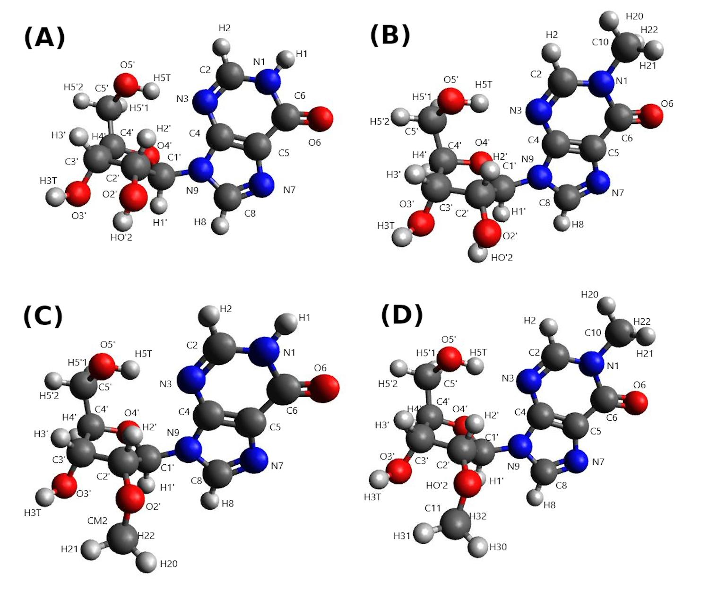
Figure S1. Quantum mechanically optimized structures of (A) inosine; (B) 1-methylinosine; (C) 2'-O-methylinosine and (D) 1,2’-O-dimethylinosine for SC1.

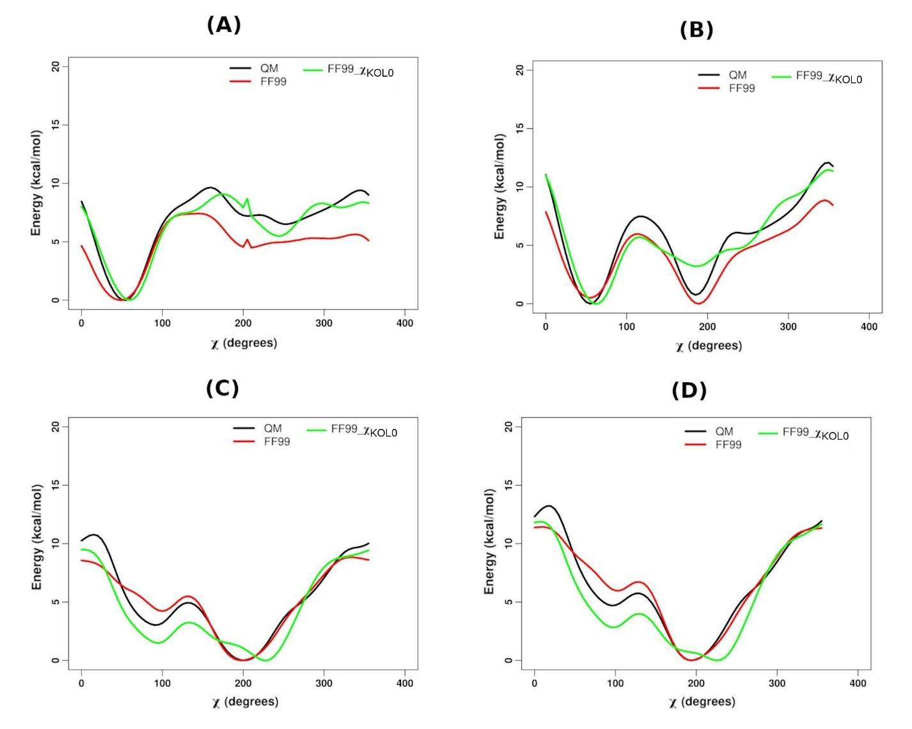
Figure S2. Energy profiles around 𝛘 torsion angle (O4'-C1'-N9-C4) for 1-methylinosine (1MI) corresponding to quantum mechanical (QM) calculations (black), molecular mechanical (MM) calculations with the AMBER FF99 parameter sets [4] keeping the glycosidic torsion parameters zero (red) and molecular mechanical (MM) calculations with the FF99 parameter sets in combination with the newly derived glycosidic torsion parameter sets (FF99_𝛘_{KOL0}) (green) and reoptimized sets of partial atomic charges, for (A) SC1, (B) SC2, (C) SC3 and (D) SC4 respectively.. For convenience the minimum energies were set to zero. SYN and ANTI base orientations correspond to the x-axis ranges of 30°-90° and 170°-300° respectively.

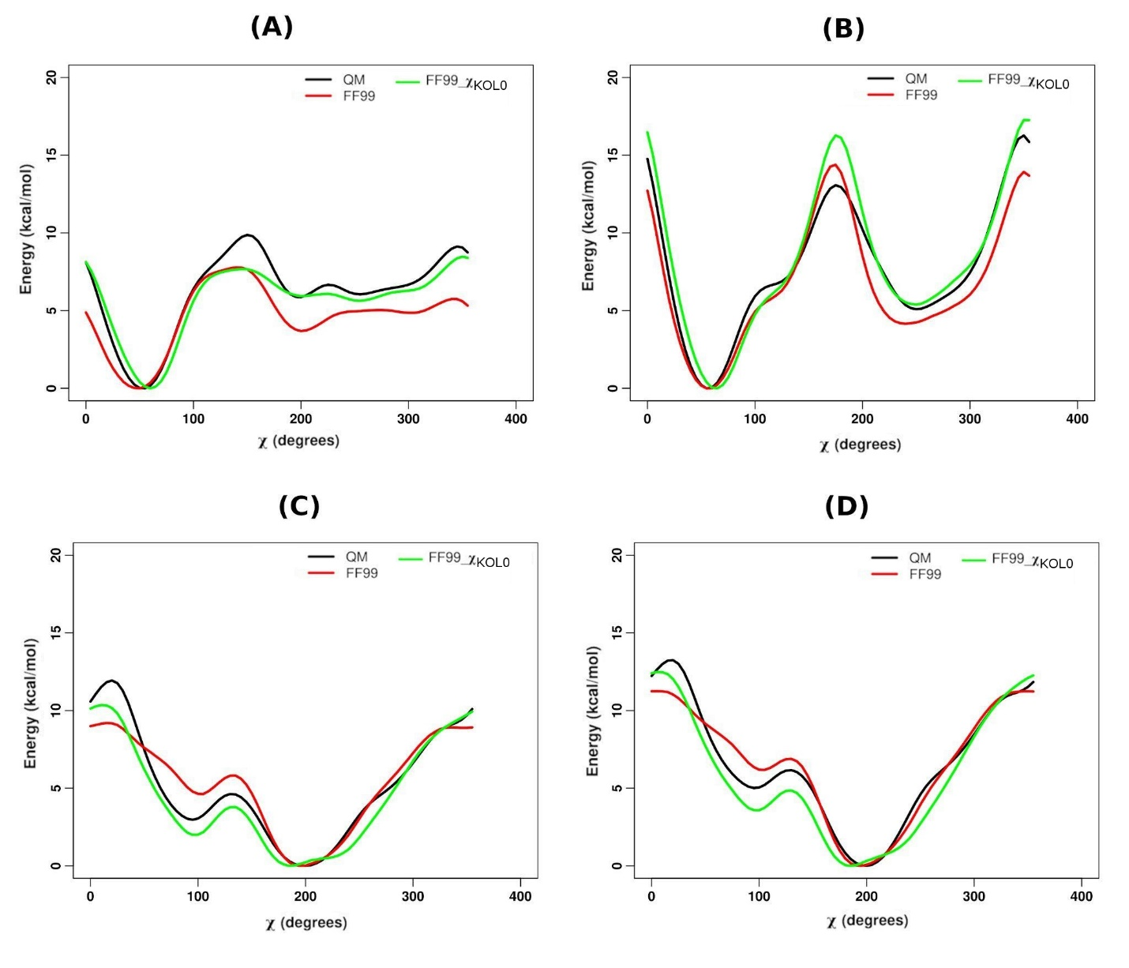
Figure S3. Energy profiles around 𝛘 torsion angle (O4'-C1'-N9-C4) for 2'-O-methylinosine (MRI) corresponding to quantum mechanical (QM) calculations (black), molecular mechanical (MM) calculations with the AMBER FF99 parameter sets [4] keeping the glycosidic torsion parameters zero (red) and molecular mechanical (MM) calculations with the FF99 parameter sets in combination with the newly derived glycosidic torsion parameter sets (FF99_𝛘_{KOL0}) (green) and reoptimized sets of partial atomic charges, for (A) SC1, (B) SC2, (C) SC3 and (D) SC4 respectively.. For convenience the minimum energies were set to zero. SYN and ANTI base orientations correspond to the x-axis ranges of 30°-90° and 170°-300° respectively.

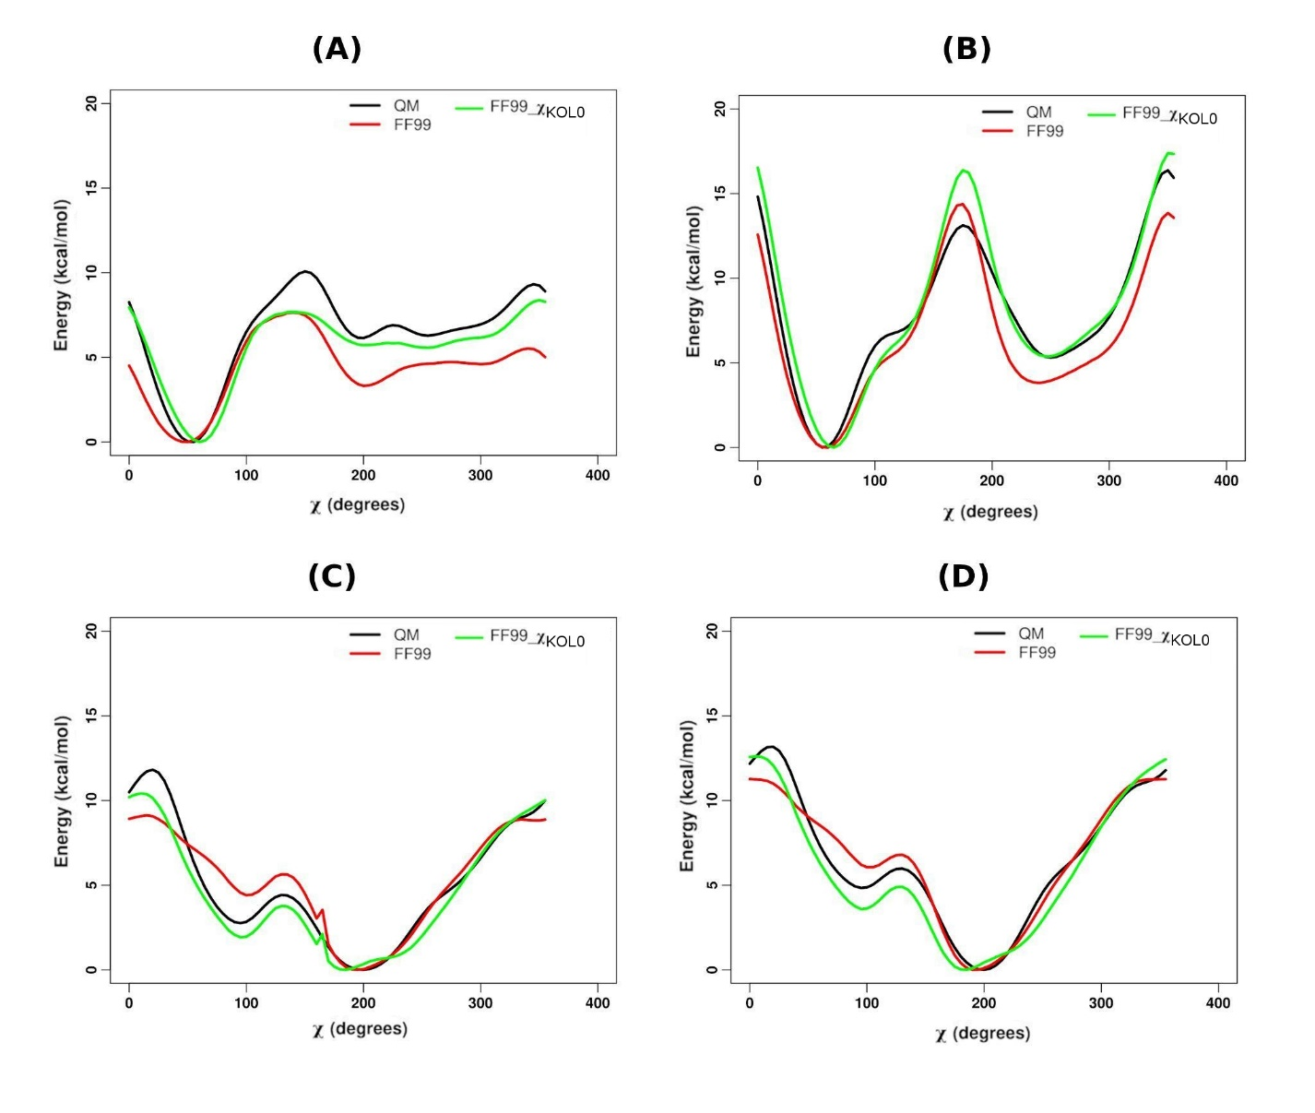

Figure S4. Energy profiles around 𝛘 torsion angle (O4'-C1'-N9-C4) for 1,2'-O-dimethylinosine (MMI) corresponding to quantum mechanical (QM) calculations (black), molecular mechanical (MM) calculations with the AMBER FF99 parameter sets [4] keeping the glycosidic torsion parameters zero (red) and molecular mechanical (MM) calculations with the FF99 parameter sets in combination with the newly derived glycosidic torsion parameter sets (FF99_𝛘_{KOL0}) (green) and reoptimized sets of partial atomic charges, for (A) SC1, (B) SC2, (C) SC3 and (D) SC4 respectively. For convenience the minimum energies were set to zero. SYN and ANTI base orientations correspond to the x-axis ranges of 30°-90° and 170°-300° respectively.

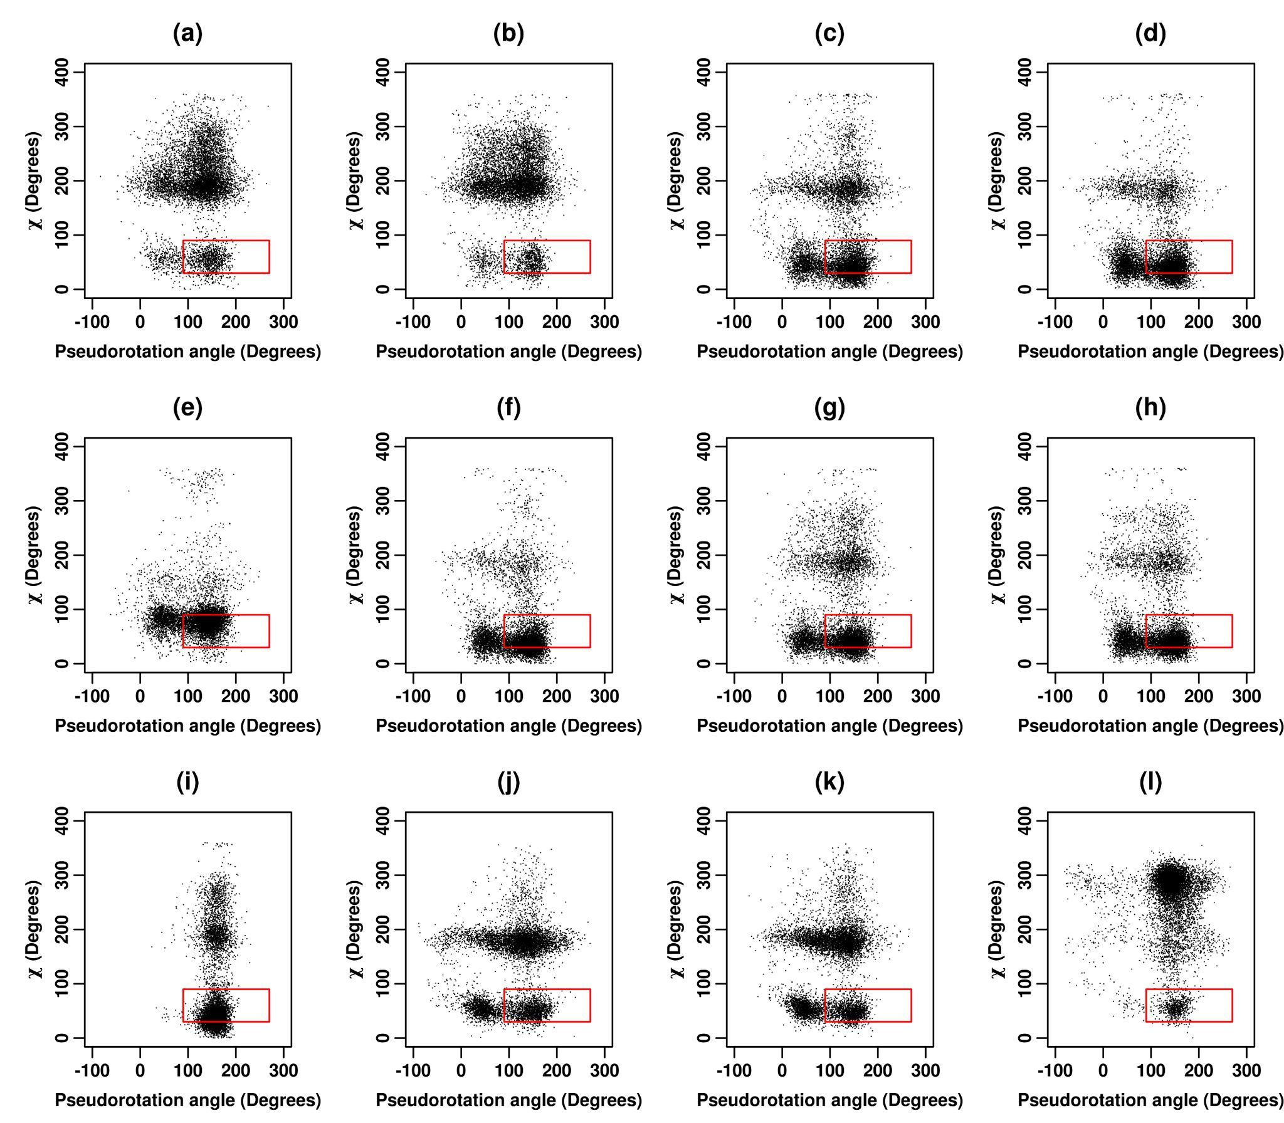

Figure S5. 2D scatter plot of pseudorotation angle (P) versus glycosidic torsion angle (χ) for inosine for (a) ff_A, (b) ff_A_𝛄_{bsc0}, (c) ff_A_𝛘_{OL3}, (d) ff_A_𝛘_{OL3}_𝛄_{bsc0}, (e) ff_A_𝛘_{YIL}, (f) ff_A_𝛘_{YIL}_𝛄_{bsc0}, (g) ff_A_𝛘_{SHAW}, (h) ff_A_𝛘_{SHAW}_𝛄_{bsc0}, (i) ff_A_𝛘_{SHAW}_𝛄_{SHAW}, (j) ff_A_𝛘_{ROC},(k) ff_A_𝛘_{ROC}_𝛄_{bsc0}, (l) ff_A_RNA_ROC force fields for the first set of 16 ns REMD simulations (at 300 K). The scale for pseudorotation angle (P) along the X-axis was converted to -90 ° to 270° to better delineate the NORTH (270°≤P<90°) and SOUTH (90°≤P<270°) regions. The red rectangles outline the regions which correspond to the experimentally observed preferences.

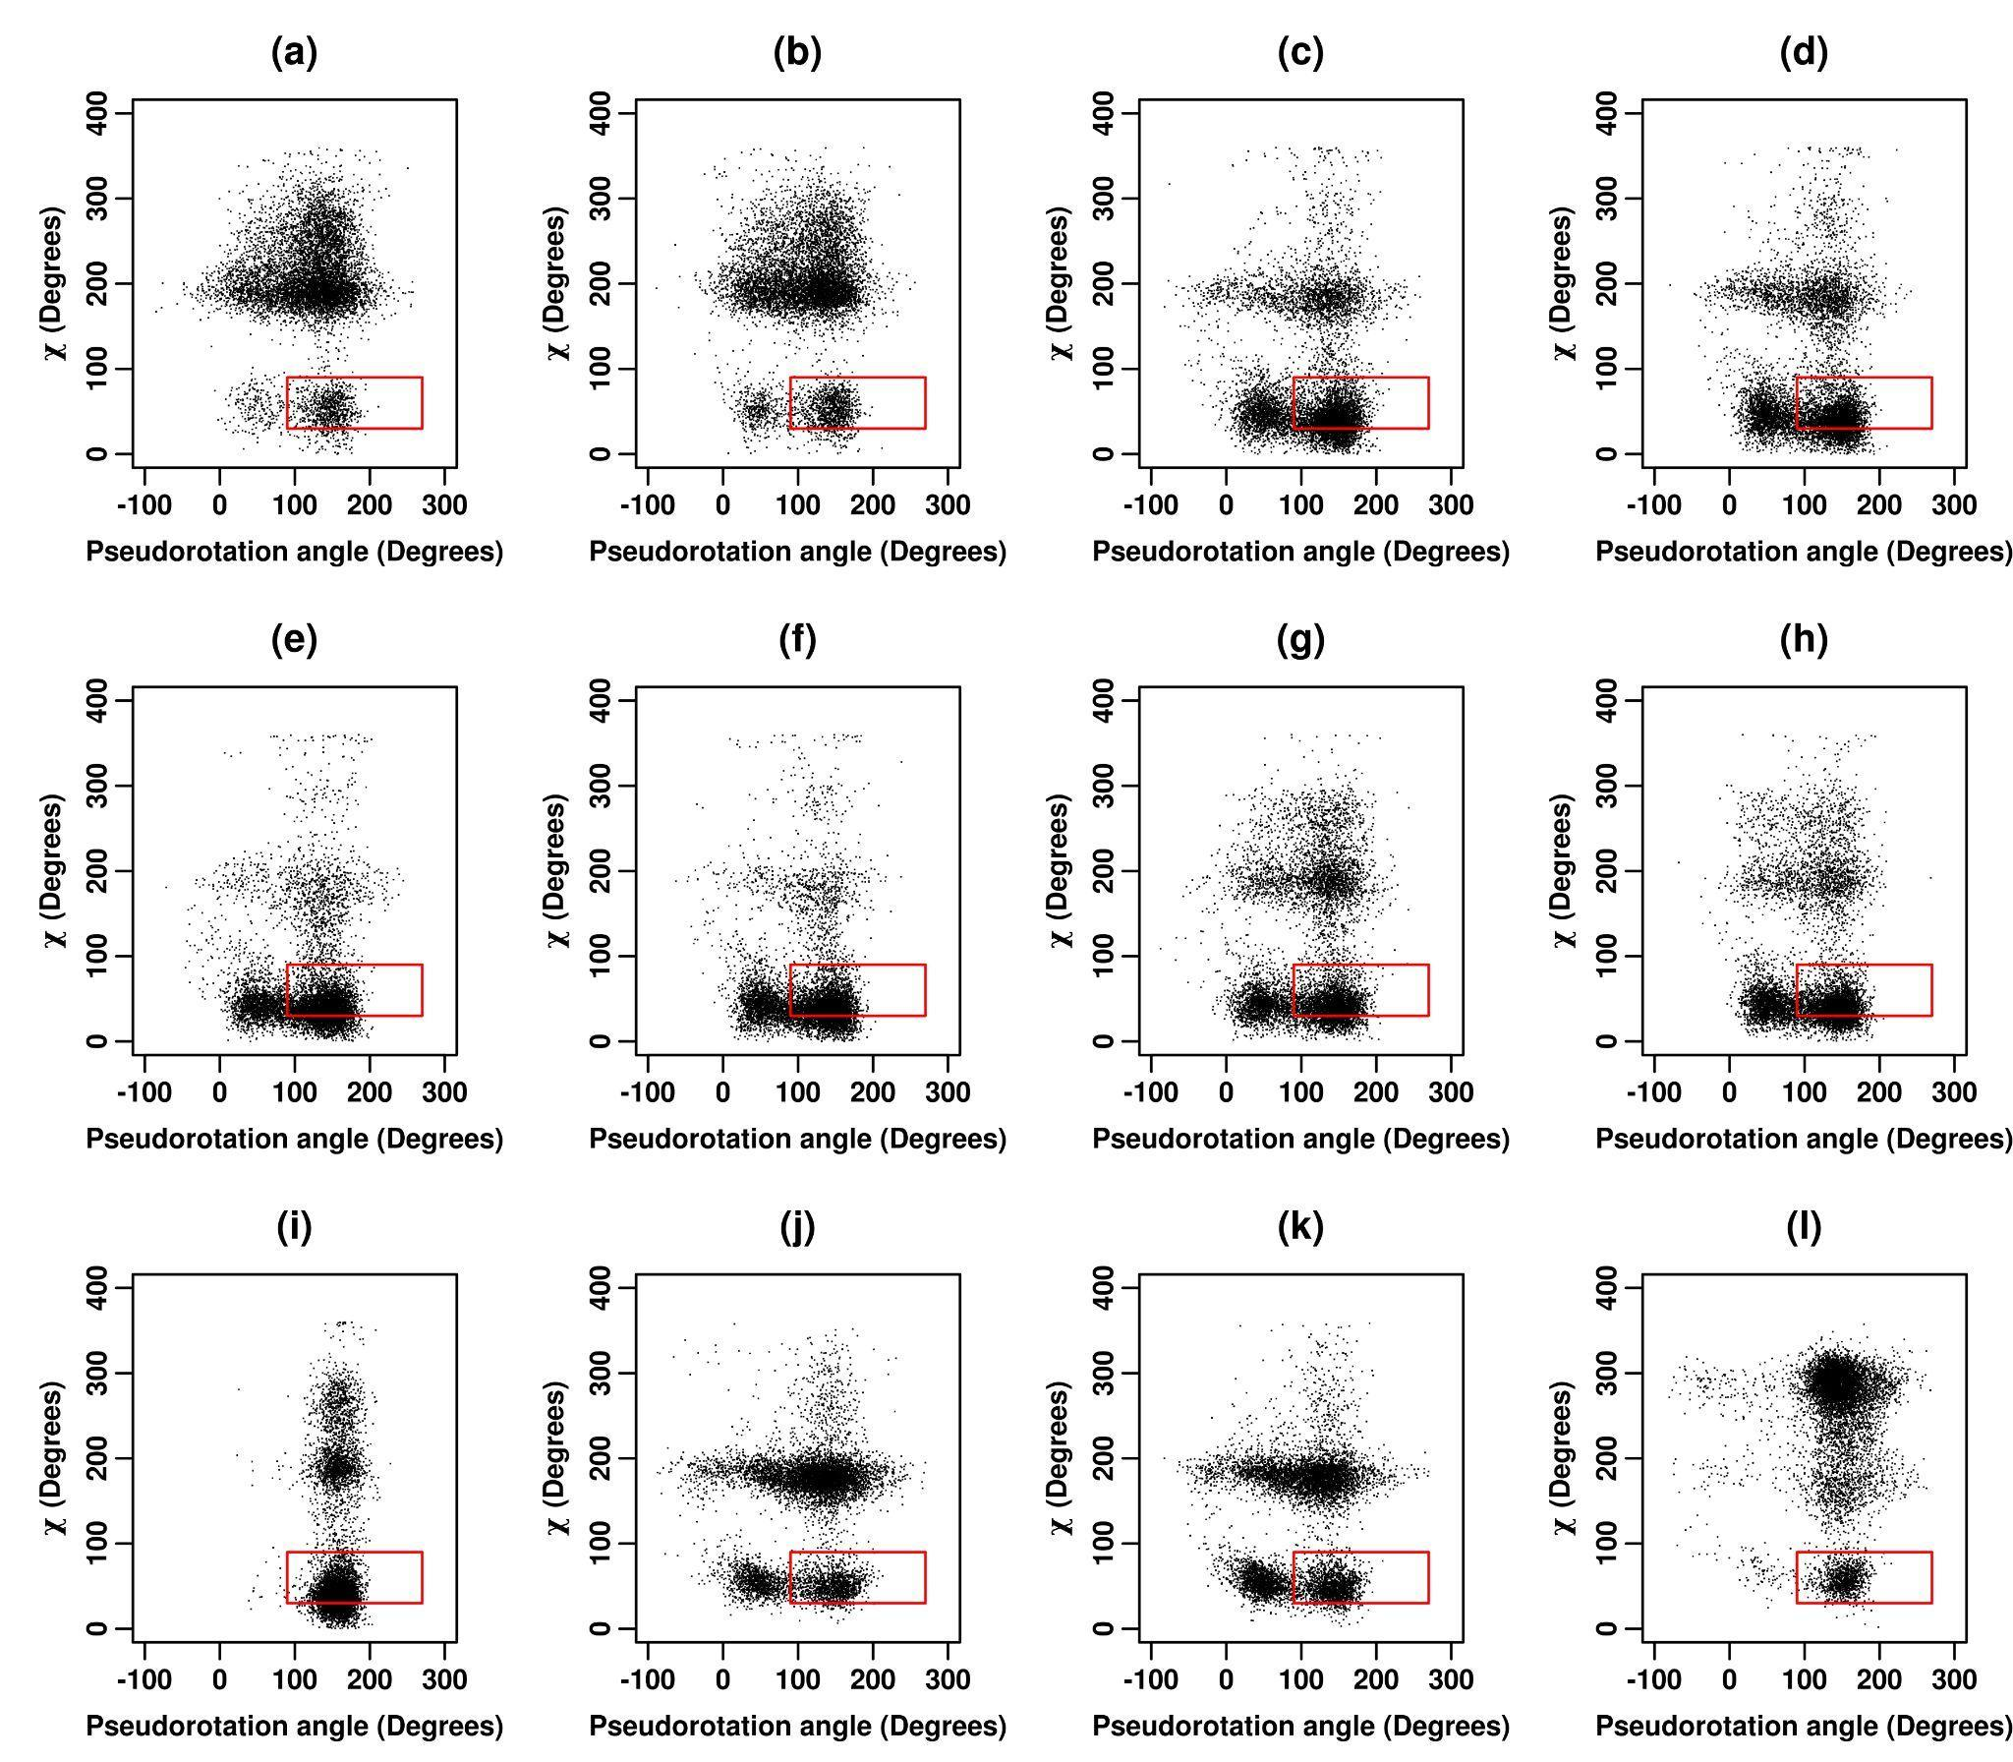

Figure S6. 2D scatter plot of pseudorotation angle (P) versus glycosidic torsion angle (χ) for inosine for (a) ff_A, (b) ff_A_𝛄_{bsc0}, (c) ff_A_𝛘_{OL3}, (d) ff_A_𝛘_{OL3}_𝛄_{bsc0}, (e) ff_A_𝛘_{YIL}, (f) ff_A_𝛘_{YIL}_𝛄_{bsc0}, (g) ff_A_𝛘_{SHAW}, (h) ff_A_𝛘_{SHAW}_𝛄_{bsc0}, (i) ff_A_𝛘_{SHAW}_𝛄_{SHAW}, (j) ff_A_𝛘_{ROC},(k) ff_A_𝛘_{ROC}_𝛄_{bsc0}, (l) ff_A_RNA_ROC force fields for the second set of 16 ns REMD simulations (at 300 K). The scale for pseudorotation angle (P) along the X-axis was converted to -90 ° to 270° to better delineate the NORTH (270°≤P<90°) and SOUTH (90°≤P<270°) regions. The red rectangles outline the regions which correspond to the experimentally observed preferences.

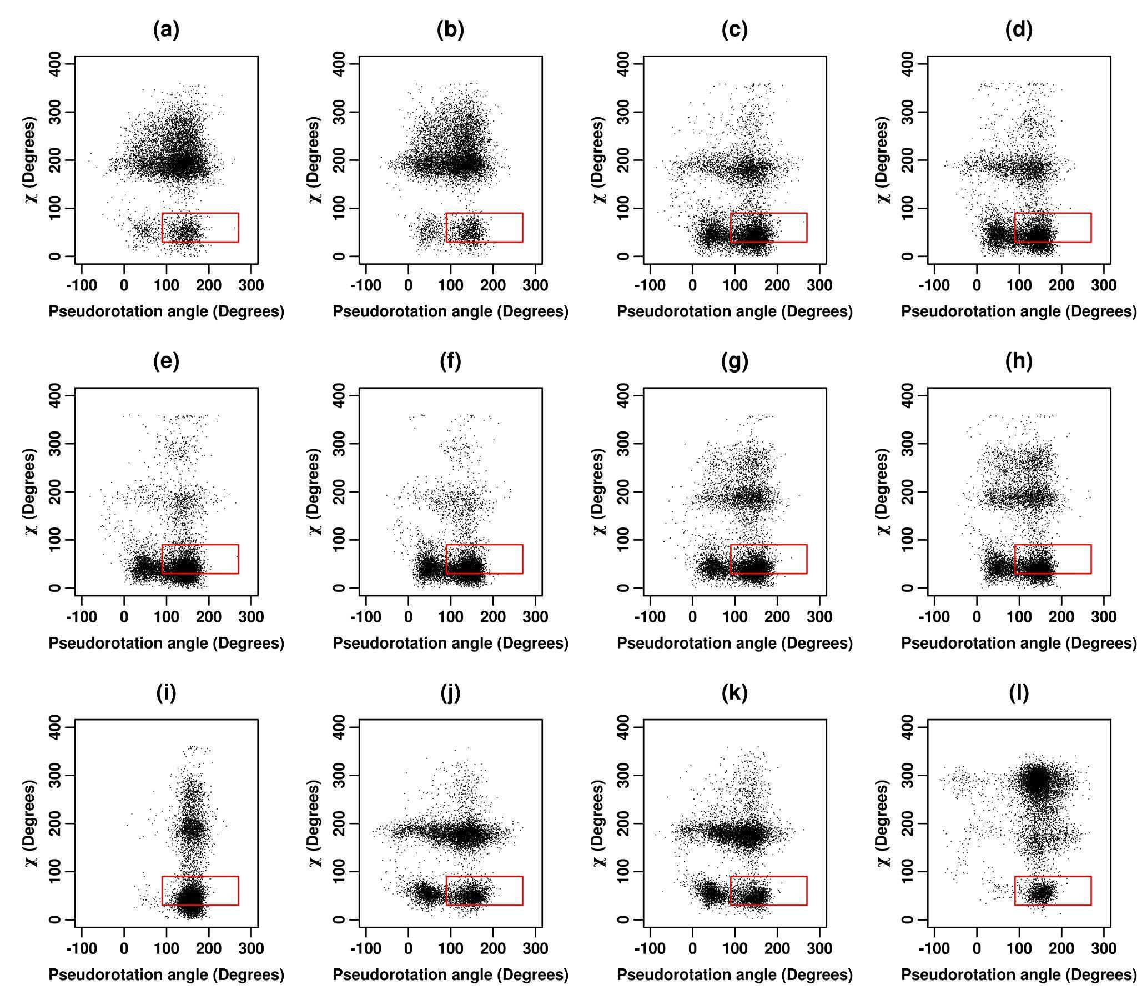
Figure S7. 2D scatter plot of pseudorotation angle (P) versus glycosidic torsion angle (χ) for inosine for (a) ff_A, (b) ff_A_𝛄_{bsc0}, (c) ff_A_𝛘_{OL3}, (d) ff_A_𝛘_{OL3}_𝛄_{bsc0}, (e) ff_A_𝛘_{YIL}, (f) ff_A_𝛘_{YIL}_𝛄_{bsc0}, (g) ff_A_𝛘_{SHAW}, (h) ff_A_𝛘_{SHAW}_𝛄_{bsc0}, (i) ff_A_𝛘_{SHAW}_𝛄_{SHAW}, (j) ff_A_𝛘_{ROC},(k) ff_A_𝛘_{ROC}_𝛄_{bsc0}, (l) ff_A_RNA_ROC force fields for the third set of 16 ns REMD simulations (at 300 K). The scale for pseudorotation angle (P) along the X-axis was converted to -90 ° to 270° to better delineate the NORTH (270°≤P<90°) and SOUTH (90°≤P<270°) regions. The red rectangles outline the regions which correspond to the experimentally observed preferences.

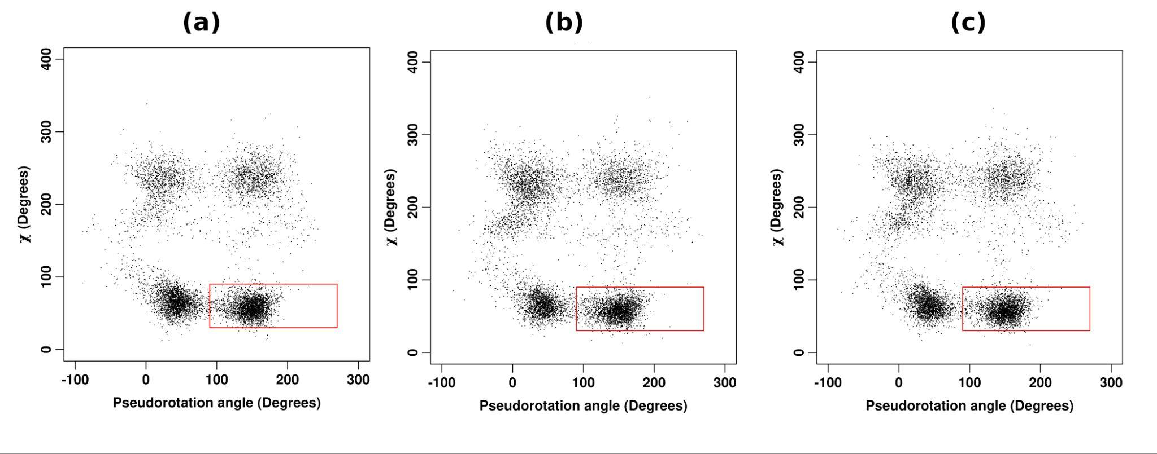
Figure S8. 2D scatter plot of pseudorotation angle (P) versus glycosidic torsion angle (χ) for inosine corresponding to FF99_𝛘_{KOL0}_𝛄_{bsc0} force field for the (a) first, (b) second and (c) third sets of 16 ns REMD simulations respectively (at 300 K). The scale for pseudorotation angle (P) along the X-axis was converted to -90 ° to 270° to better delineate the NORTH (270°≤P<90°) and SOUTH (90°≤P<270°) regions. The red rectangles outline the regions which correspond to the experimentally observed preferences.

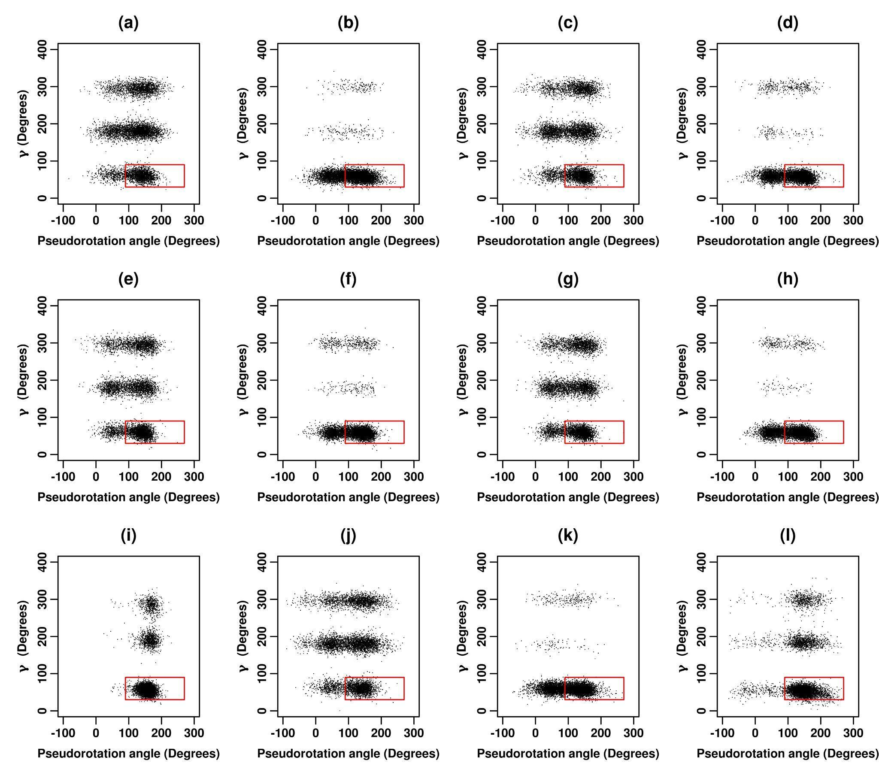
Figure S9. 2D scatter plot of pseudorotation angle (P) versus gamma torsion angle (𝛄) for inosine for (a) ff_A, (b) ff_A_𝛄_{bsc0}, (c) ff_A_𝛘_{OL3}, (d) ff_A_𝛘_{OL3}_𝛄_{bsc0}, (e) ff_A_𝛘_{YIL}, (f) ff_A_𝛘_{YIL}_𝛄_{bsc0}, (g) ff_A_𝛘_{SHAW}, (h) ff_A_𝛘_{SHAW}_𝛄_{bsc0}, (i) ff_A_𝛘_{SHAW}_𝛄_{SHAW}, (j) ff_A_𝛘_{ROC},(k) ff_A_𝛘_{ROC}_𝛄_{bsc0}, (l) ff_A_RNA_ROC force fields for the first set of 16 ns REMD simulations (at 300 K). The scale for pseudorotation angle (P) along the X-axis was converted to -90 ° to 270° to better delineate the NORTH (270°≤P<90°) and SOUTH (90°≤P<270°) regions. The red rectangles outline the regions which correspond to the experimentally observed preferences.

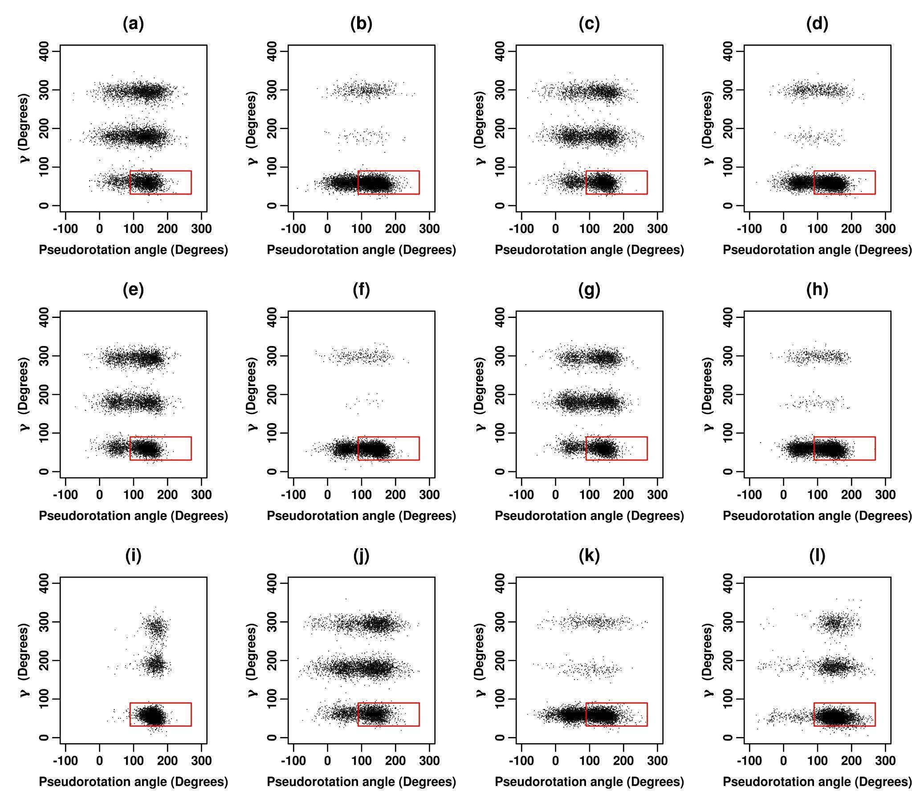
Figure S10. 2D scatter plot of pseudorotation angle (P) versus gamma torsion angle (𝛄) for inosine for (a) ff_A, (b) ff_A_𝛄_{bsc0}, (c) ff_A_𝛘_{OL3}, (d) ff_A_𝛘_{OL3}_𝛄_{bsc0}, (e) ff_A_𝛘_{YIL}, (f) ff_A_𝛘_{YIL}_𝛄_{bsc0}, (g) ff_A_𝛘_{SHAW}, (h) ff_A_𝛘_{SHAW}_𝛄_{bsc0}, (i) ff_A_𝛘_{SHAW}_𝛄_{SHAW}, (j) ff_A_𝛘_{ROC}, (k) ff_A_𝛘_{ROC}_𝛄_{bsc0}, (l) ff_A_RNA_ROC force fields for the second set of 16 ns REMD simulations (at 300 K). The scale for pseudorotation angle (P) along the X-axis was converted to -90 ° to 270° to better delineate the NORTH (270°≤P<90°) and SOUTH (90°≤P<270°) regions. The red rectangles outline the regions which correspond to the experimentally observed preferences.

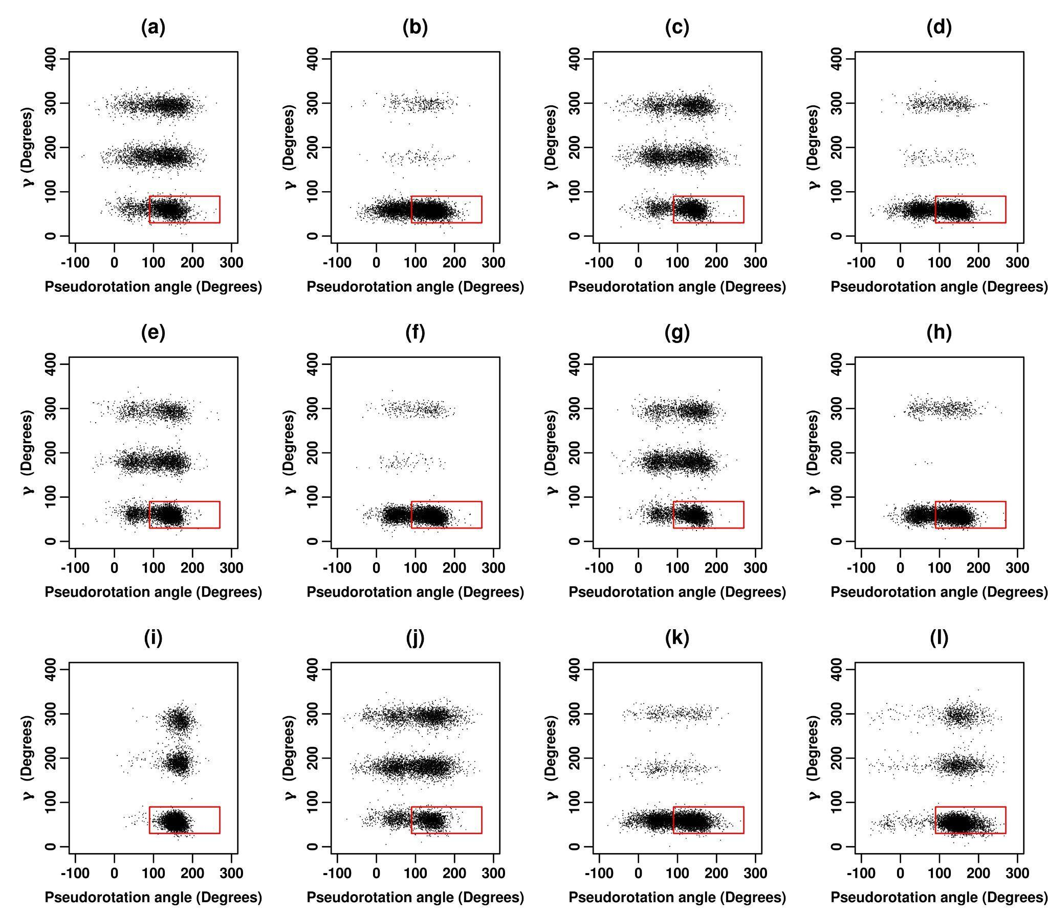
Figure S11. 2D scatter plot of pseudorotation angle (P) versus gamma torsion angle (𝛄) for inosine for (a) ff_A, (b) ff_A_𝛄_{bsc0}, (c) ff_A_𝛘_{OL3}, (d) ff_A_𝛘_{OL3}_𝛄_{bsc0}, (e) ff_A_𝛘_{YIL}, (f) ff_A_𝛘_{YIL}_𝛄_{bsc0}, (g) ff_A_𝛘_{SHAW}, (h) ff_A_𝛘_{SHAW}_𝛄_{bsc0}, (i) ff_A_𝛘_{SHAW}_𝛄_{SHAW}, (j) ff_A_𝛘_{ROC}, (k) ff_A_𝛘_{ROC}_𝛄_{bsc0}, (l) ff_A_RNA_ROC force fields for the third set of 16 ns REMD simulations (at 300 K). The scale for pseudorotation angle (P) along the X-axis was converted to -90 ° to 270° to better delineate the NORTH (270°≤P<90°) and SOUTH (90°≤P<270°) regions. The red rectangles outline the regions which correspond to the experimentally observed preferences.

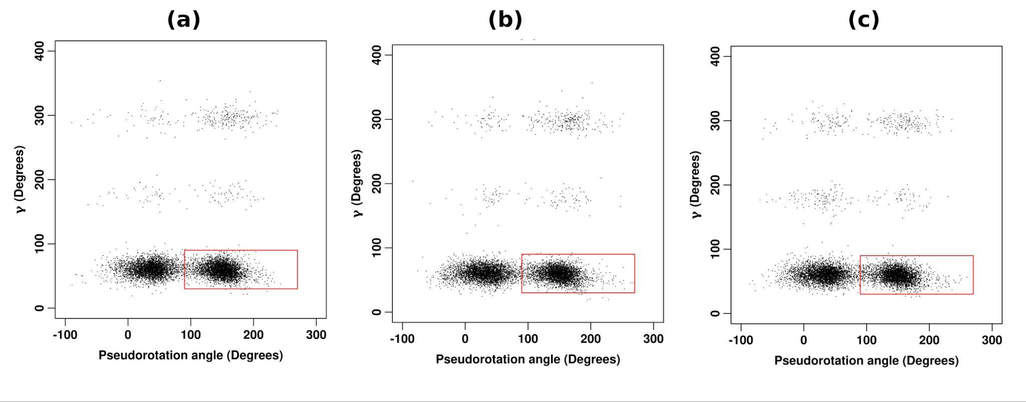
Figure S12. 2D scatter plot of pseudorotation angle (P) versus gamma torsion angle (𝛄) for inosine for FF99_𝛘_{KOL0}_𝛄_{bsc0} force fields for the (a) first, (b) second and (c) third sets of 16 ns REMD simulations (at 300 K). The scale for pseudorotation angle (P) along the X-axis was converted to -90 ° to 270° to better delineate the NORTH (270°≤P<90°) and SOUTH (90°≤P<270°) regions. The red rectangles outline the regions which correspond to the experimentally observed preferences.
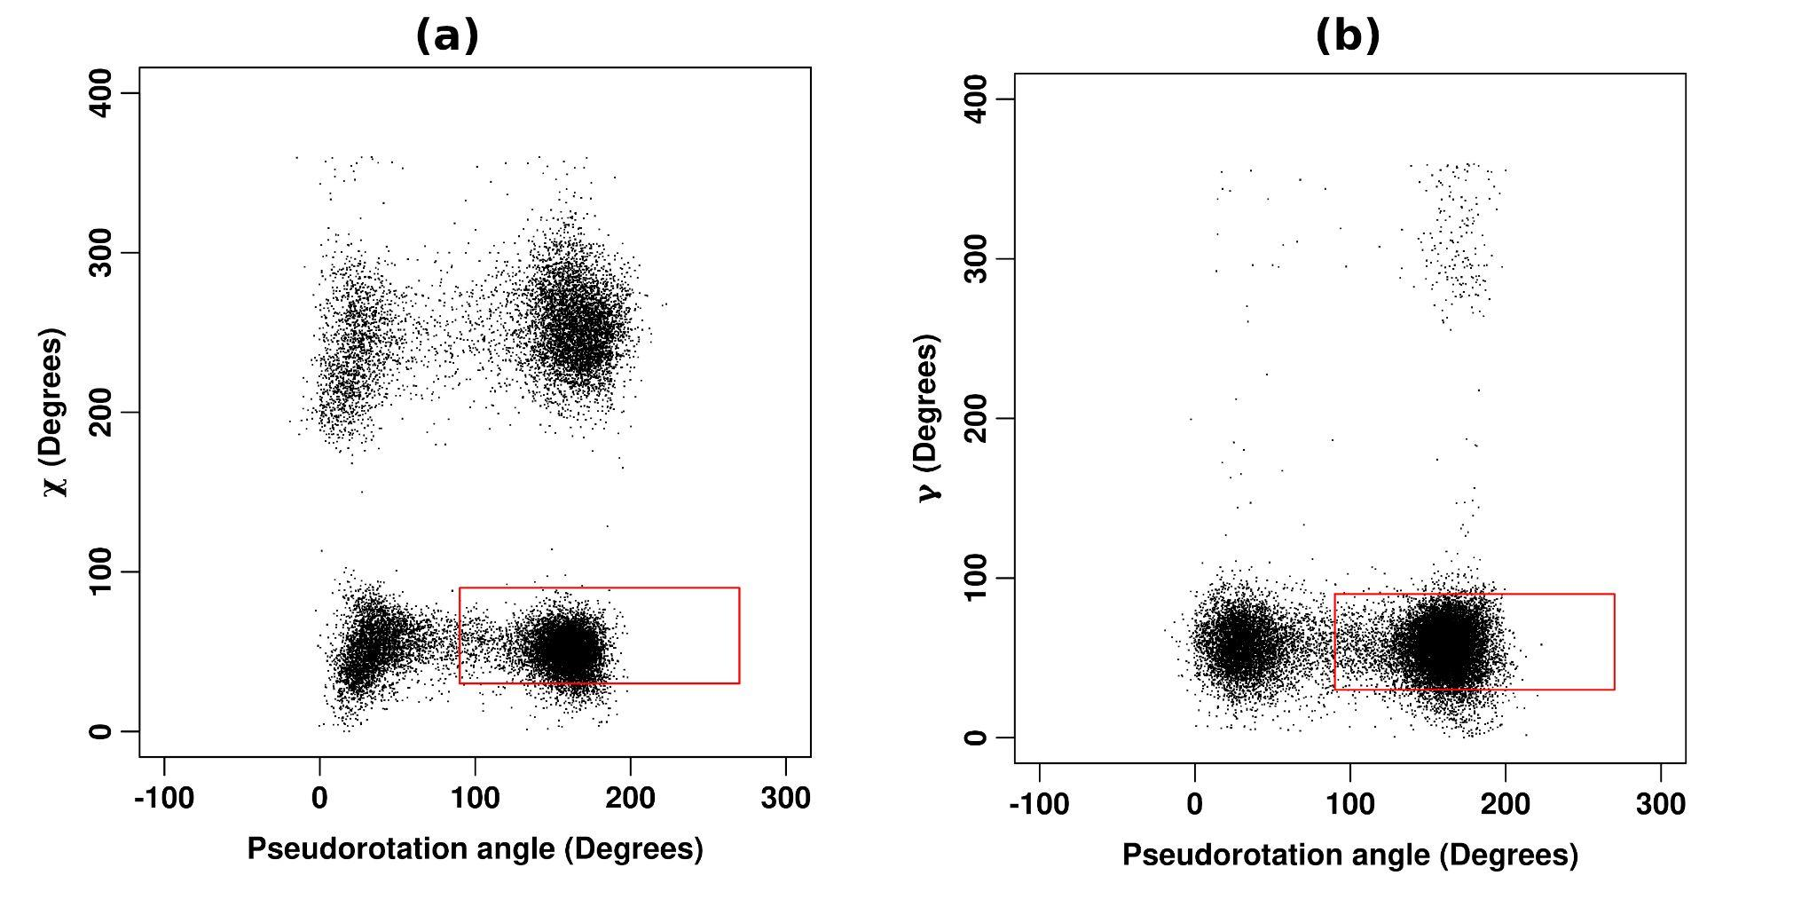
Figure S13. 2D scatter plot of (1) pseudorotation angle (P) versus glycosidic torsion angle (χ) and (2) pseudorotation angle (P) versus gamma torsion angle (𝛄) corresponding to the CHARMM36m parameter sets for 200 ns MD simulations (at 298 K) for inosine (INO). The scale for pseudorotation angle (P) along the X-axis was converted to -90 ° to 270° to better delineate the NORTH (270°≤P<90°) and SOUTH (90°≤P<270°) regions. The red rectangles outline the regions which correspond to the experimentally observed preferences.

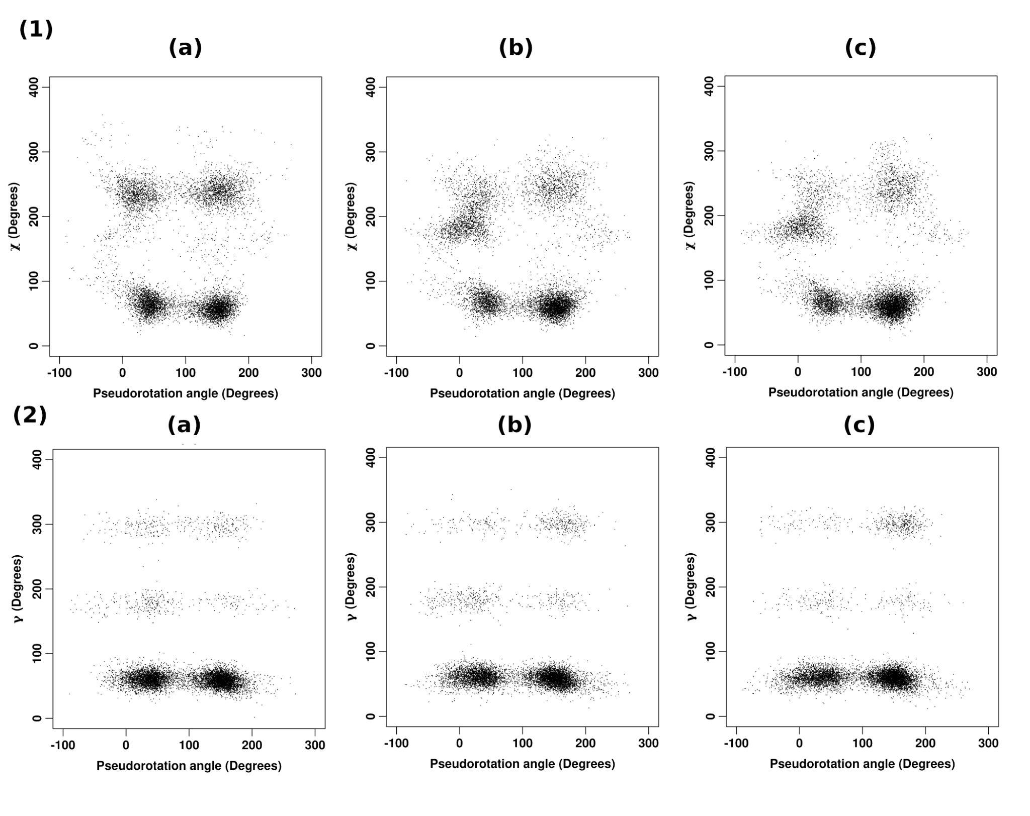
Figure S14. 2D scatter plot of (1) pseudorotation angle (P) versus glycosidic torsion angle (χ) and (2) pseudorotation angle (P) versus gamma torsion angle (𝛄) corresponding to the FF99_𝛘_{KOL0}_𝛄_{bsc0} parameter sets for a set of 16 ns REMD simulations (at 300 K) for (a) 1-methylinosine (1MI); (b) 2'-O-methylinosine (MRI) and (c) 1,2'-O-dimethylinosine (MMI) respectively. The scale for pseudorotation angle (P) along the X-axis was converted to -90 ° to 270° to better delineate the NORTH (270°≤P<90°) and SOUTH (90°≤P<270°) regions. The red rectangles outline the regions which correspond to the experimentally observed preferences.

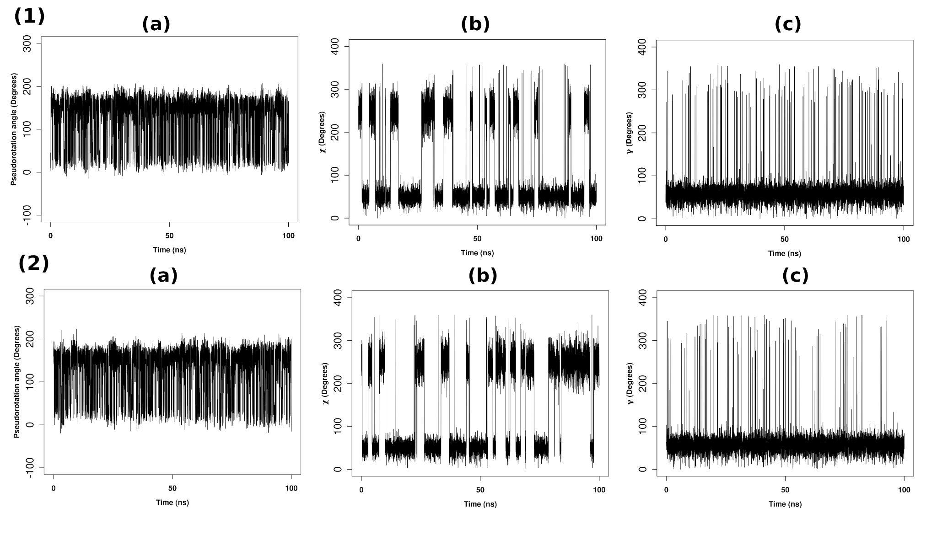
Figure S15. Time series of (a) pseudorotation angle (P); (b) glycosidic torsion angle (χ); and (c) gamma torsion angle (𝛄) for inosine for the (1) first and (2) second sets of 100ns (each) MD simulations (at 298 K) respectively, with the CHARMM36m parameter sets. The scale for pseudorotation angle (P) along the Y-axis was converted to -90 ° to 270° to better delineate the NORTH (270°≤P<90°) and SOUTH (90°≤P<270°) regions.

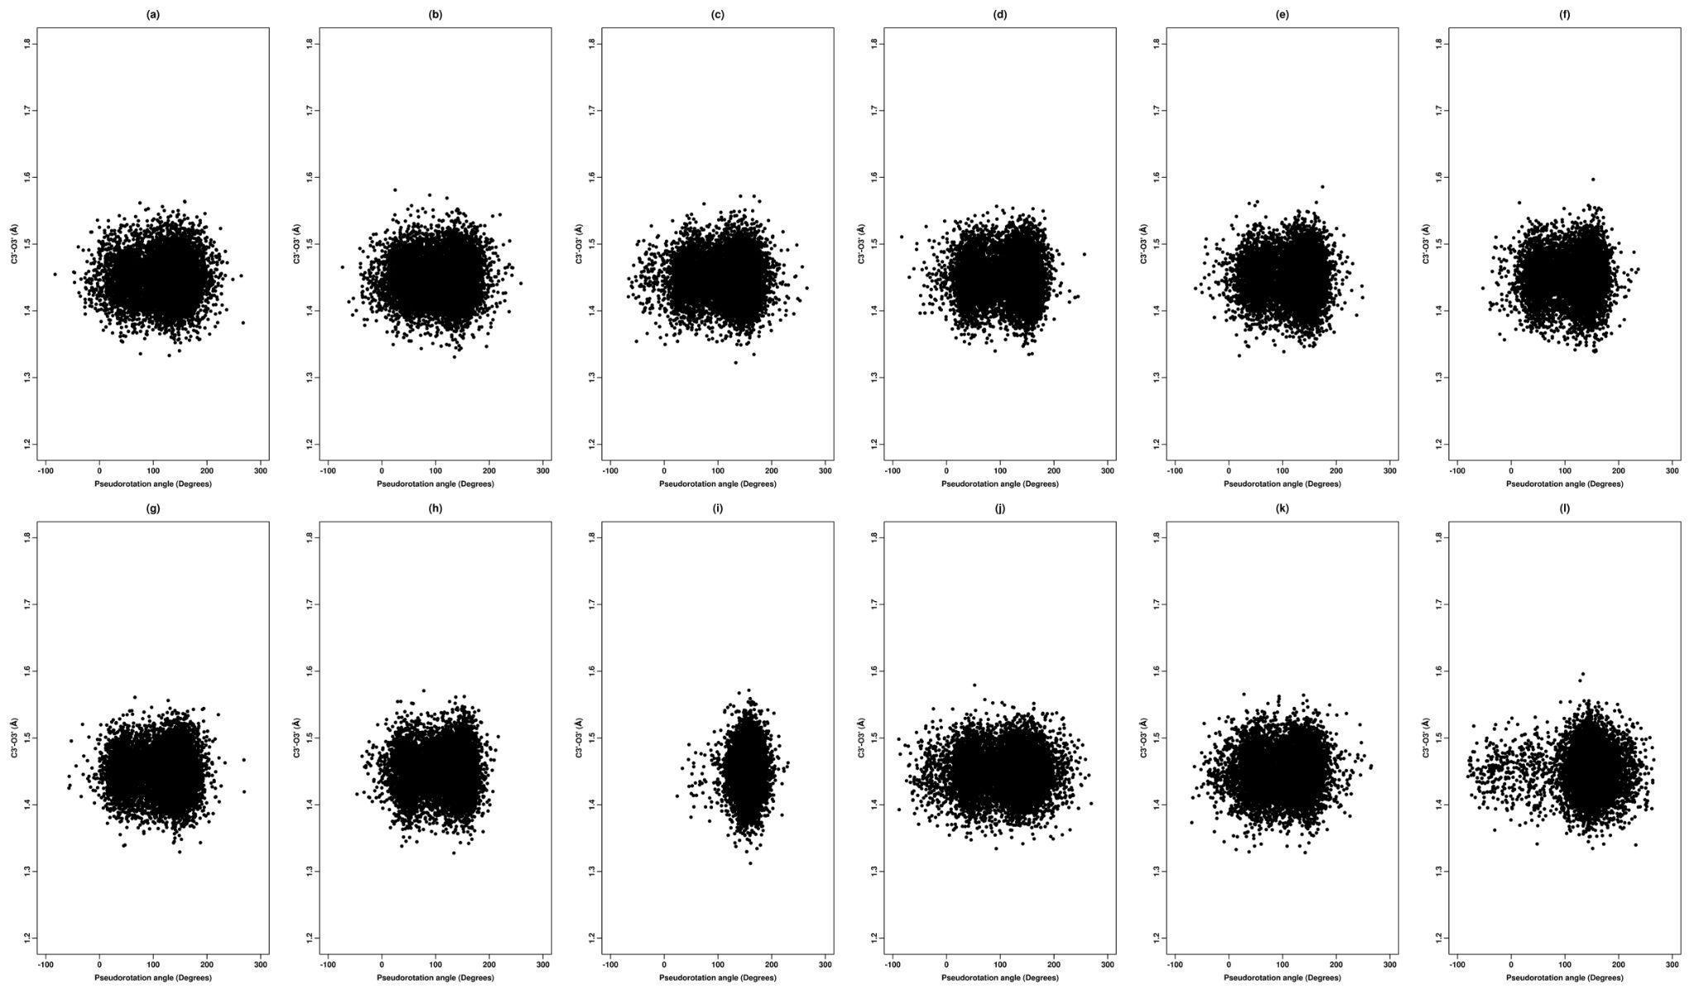

Figure S16. 2D scatter plot of pseudorotation angle (P) versus C3′-O3′ bond distance for inosine corresponding to (a) ff_A, (b) ff_A_𝛄_{bsc0}, (c) ff_A_𝛘_{OL3}, (d) ff_A_𝛘_{OL3}_𝛄_{bsc0}, (e) ff_A_𝛘_{YIL}, (f) ff_A_𝛘_{YIL}_𝛄_{bsc0}, (g) ff_A_𝛘_{SHAW}, (h) ff_A_𝛘_{SHAW}_𝛄_{bsc0}, (i) ff_A_𝛘_{SHAW}_𝛄_{SHAW}, (j) ff_A_𝛘_{ROC}, (k) ff_A_𝛘_{ROC}_𝛄_{bsc0}, (l) ff_A_RNA_ROC for the first set of 16 ns REMD simulations (at 300 K). The scale for pseudorotation angle (P) along the X-axis was converted to -90 ° to 270° to better delineate the NORTH (270°≤P<90°) and SOUTH (90°≤P<270°) regions.

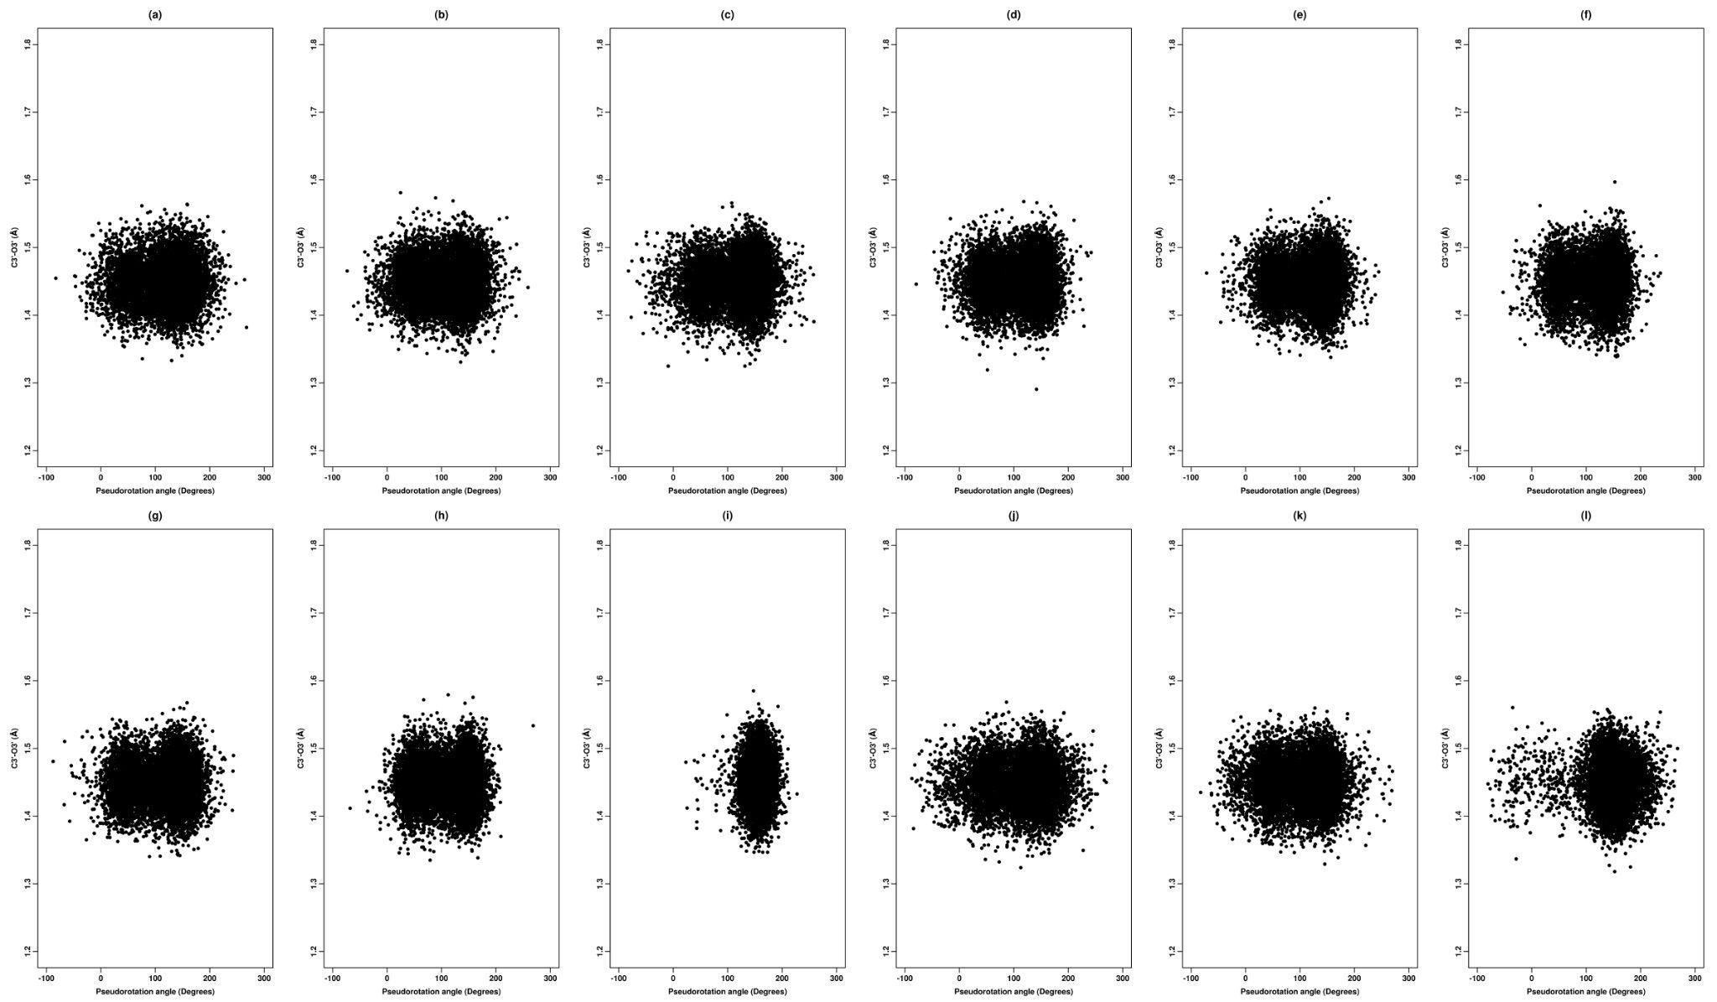

Figure S17. 2D scatter plot of pseudorotation angle (P) versus C3′-O3′ bond for inosine corresponding to (a) ff_A, (b) ff_A_𝛄_{bsc0}, (c) ff_A_𝛘_{OL3}, (d) ff_A_𝛘_{OL3}_𝛄_{bsc0}, (e) ff_A_𝛘_{YIL}, (f) ff_A_𝛘_{YIL}_𝛄_{bsc0}, (g) ff_A_𝛘_{SHAW}, (h) ff_A_𝛘_{SHAW}_𝛄_{bsc0}, (i) ff_A_𝛘_{SHAW}_𝛄_{SHAW}, (j) ff_A_𝛘_{ROC}, (k) ff_A_𝛘_{ROC}_𝛄_{bsc0}, (l) ff_A_RNA_ROC for the second set of 16 ns REMD simulations (at 300 K). The scale for pseudorotation angle (P) along the X-axis was converted to -90 ° to 270° to better delineate the NORTH (270°≤P<90°) and SOUTH (90°≤P<270°) regions.

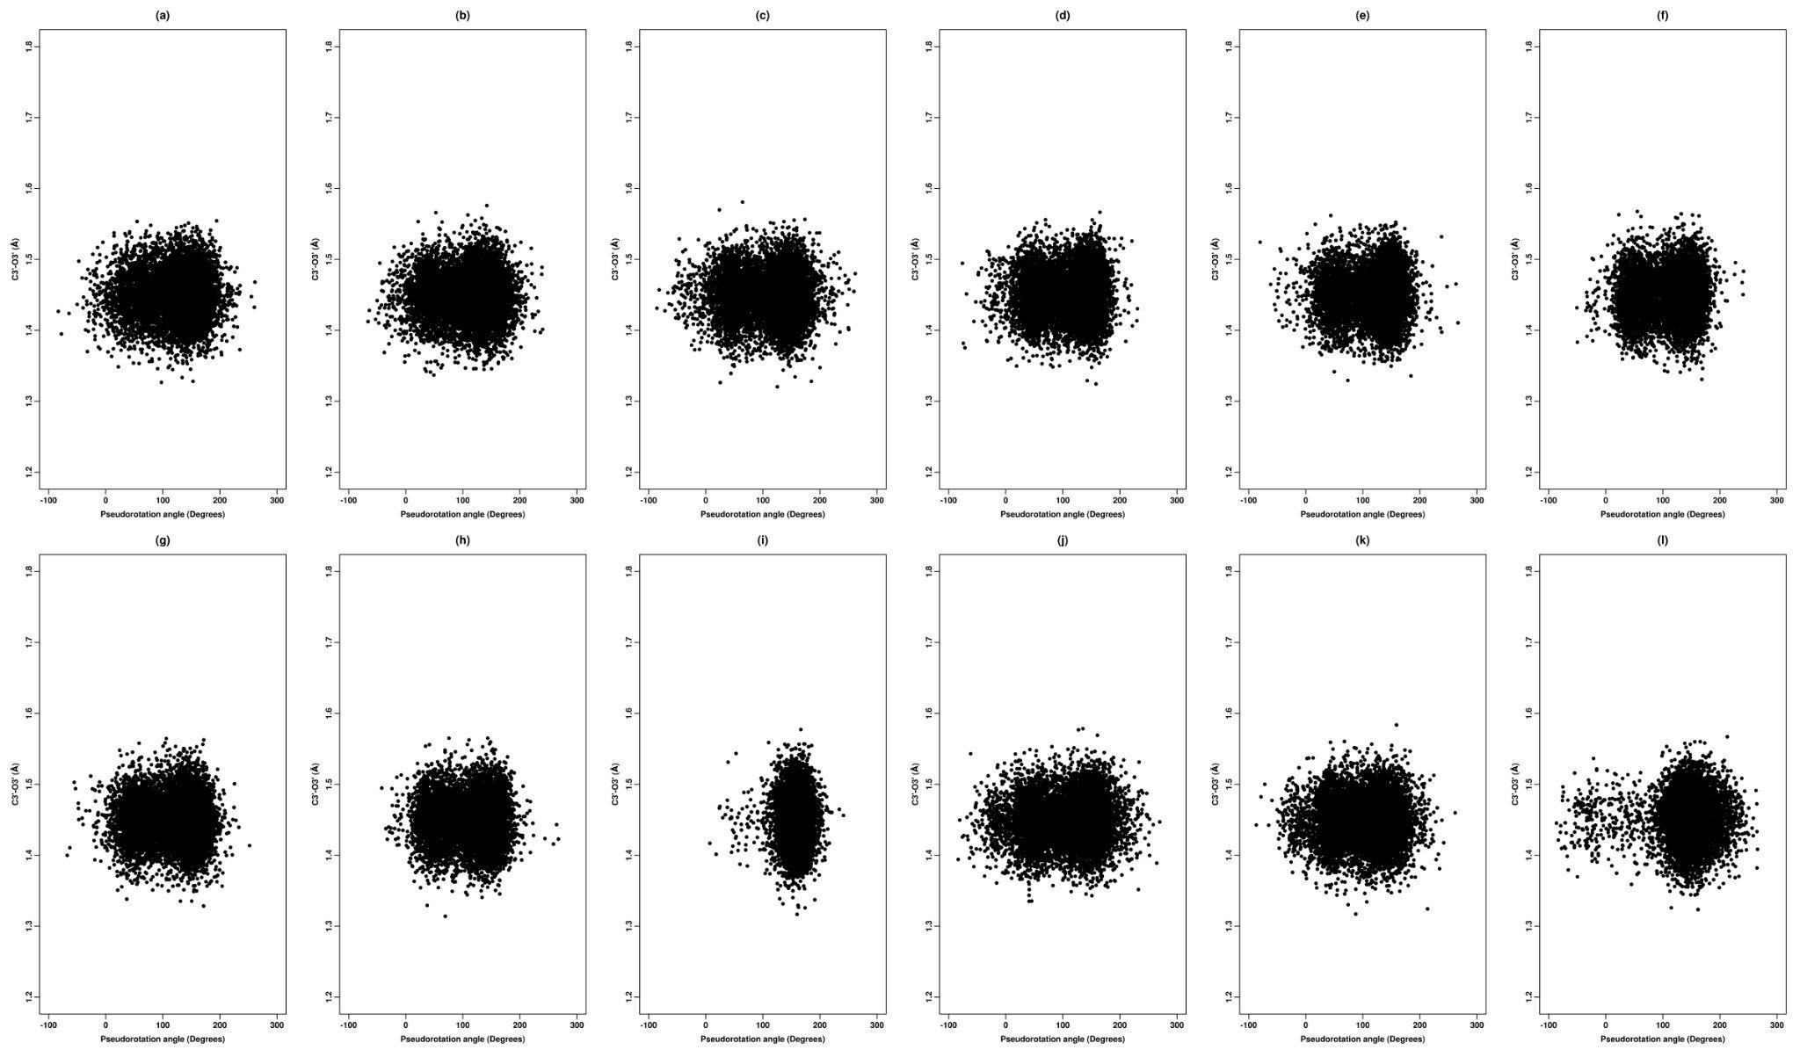

Figure S18. 2D scatter plot of pseudorotation angle (P) versus C3′-O3′ bond for inosine corresponding to (a) ff_A, (b) ff_A_𝛄_{bsc0}, (c) ff_A_𝛘_{OL3}, (d) ff_A_𝛘_{OL3}_𝛄_{bsc0}, (e) ff_A_𝛘_{YIL}, (f) ff_A_𝛘_{YIL}_𝛄_{bsc0}, (g) ff_A_𝛘_{SHAW}, (h) ff_A_𝛘_{SHAW}_𝛄_{bsc0}, (i) ff_A_𝛘_{SHAW}_𝛄_{SHAW}, (j) ff_A_𝛘_{ROC}, (k) ff_A_𝛘_{ROC}_𝛄_{bsc0}, (l) ff_A_RNA_ROC for the third set of 16 ns REMD simulations (at 300 K). The scale for pseudorotation angle (P) along the X-axis was converted to -90 ° to 270° to better delineate the NORTH (270°≤P<90°) and SOUTH (90°≤P<270°) regions.

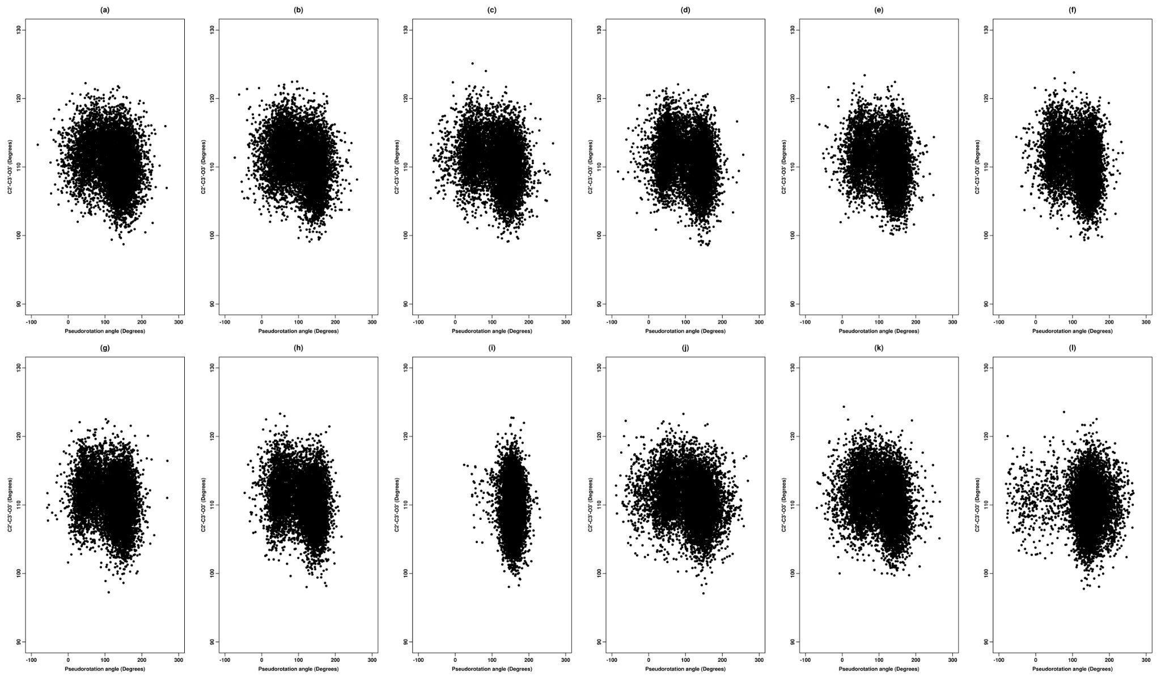

Figure S19. 2D scatter plot of pseudorotation angle (P) versus C2′-C3′-O3′ sugar valence angle for inosine corresponding to (a) ff_A, (b) ff_A_𝛄_{bsc0}, (c) ff_A_𝛘_{OL3}, (d) ff_A_𝛘_{OL3}_𝛄_{bsc0}, (e) ff_A_𝛘_{YIL}, (f) ff_A_𝛘_{YIL}_𝛄_{bsc0}, (g) ff_A_𝛘_{SHAW}, (h) ff_A_𝛘_{SHAW}_𝛄_{bsc0}, (i) ff_A_𝛘_{SHAW}_𝛄_{SHAW}, (j) ff_A_𝛘_{ROC}, (k) ff_A_𝛘_{ROC}_𝛄_{bsc0}, (l) ff_A_RNA_ROC for the first set of 16 ns REMD simulations (at 300 K). The scale for pseudorotation angle (P) along the X-axis was converted to -90 ° to 270° to better delineate the NORTH (270°≤P<90°) and SOUTH (90°≤P<270°) regions.

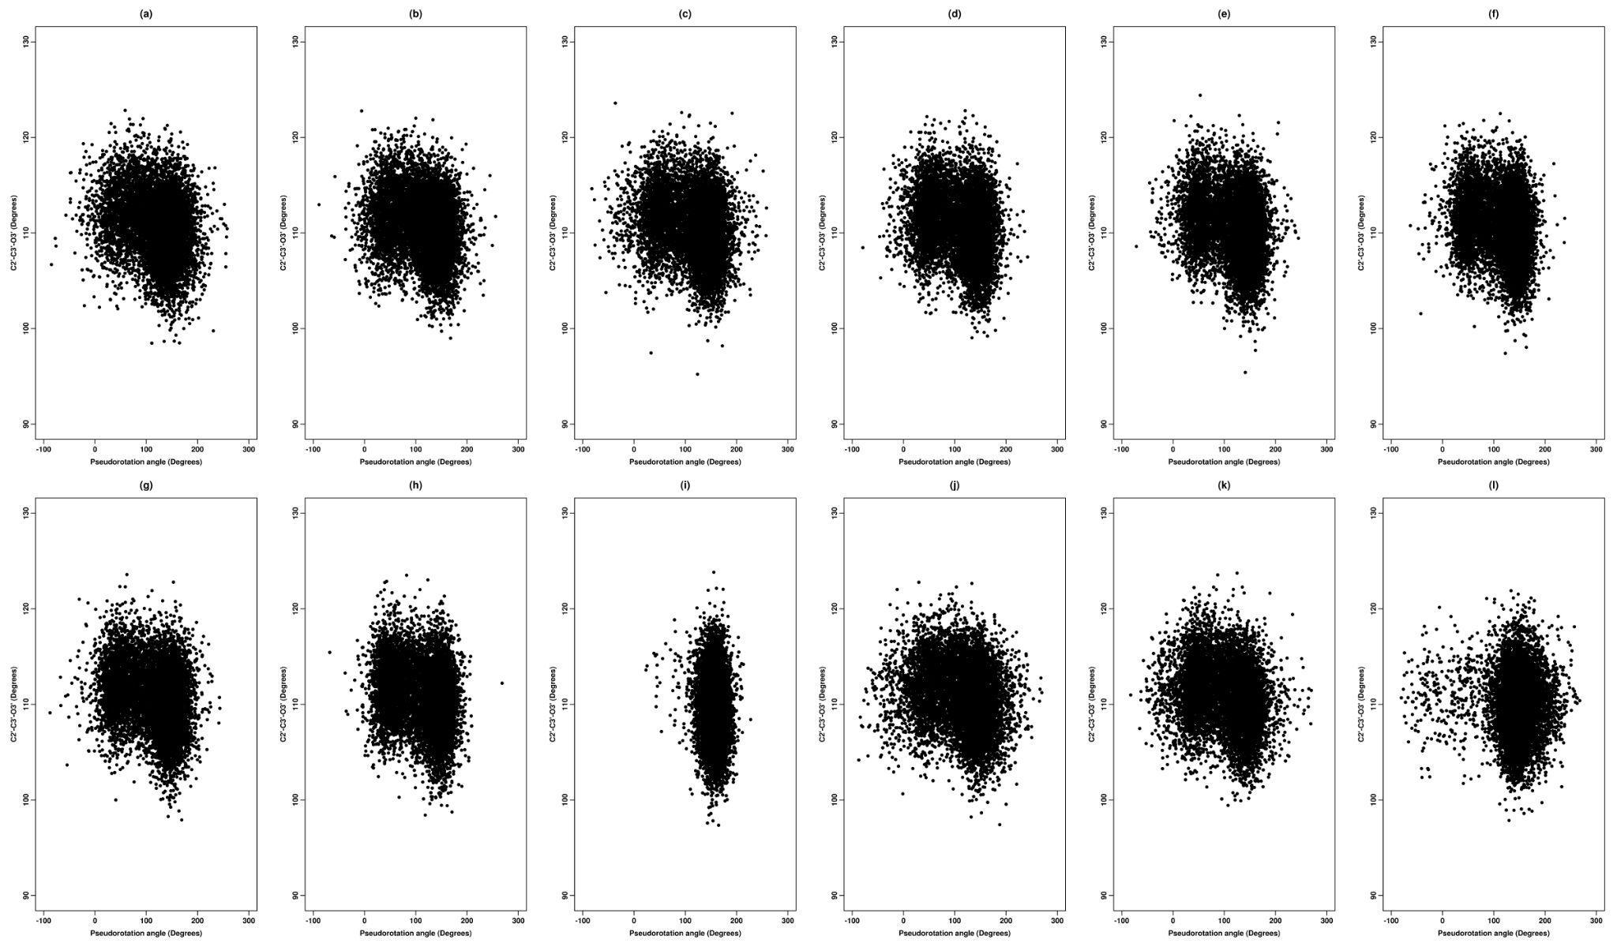

Figure S20. 2D scatter plot of pseudorotation angle (P) versus C2′-C3′-O3′ sugar valence angle for inosine corresponding to (a) ff_A, (b) ff_A_𝛄_{bsc0}, (c) ff_A_𝛘_{OL3}, (d) ff_A_𝛘_{OL3}_𝛄_{bsc0}, (e) ff_A_𝛘_{YIL}, (f) ff_A_𝛘_{YIL}_𝛄_{bsc0}, (g) ff_A_𝛘_{SHAW}, (h) ff_A_𝛘_{SHAW}_𝛄_{bsc0}, (i) ff_A_𝛘_{SHAW}_𝛄_{SHAW}, (j) ff_A_𝛘_{ROC}, (k) ff_A_𝛘_{ROC}_𝛄_{bsc0}, (l) ff_A_RNA_ROC for the second set of 16 ns REMD simulations (at 300 K). The scale for pseudorotation angle (P) along the X-axis was converted to -90 ° to 270° to better delineate the NORTH (270°≤P<90°) and SOUTH (90°≤P<270°) regions.

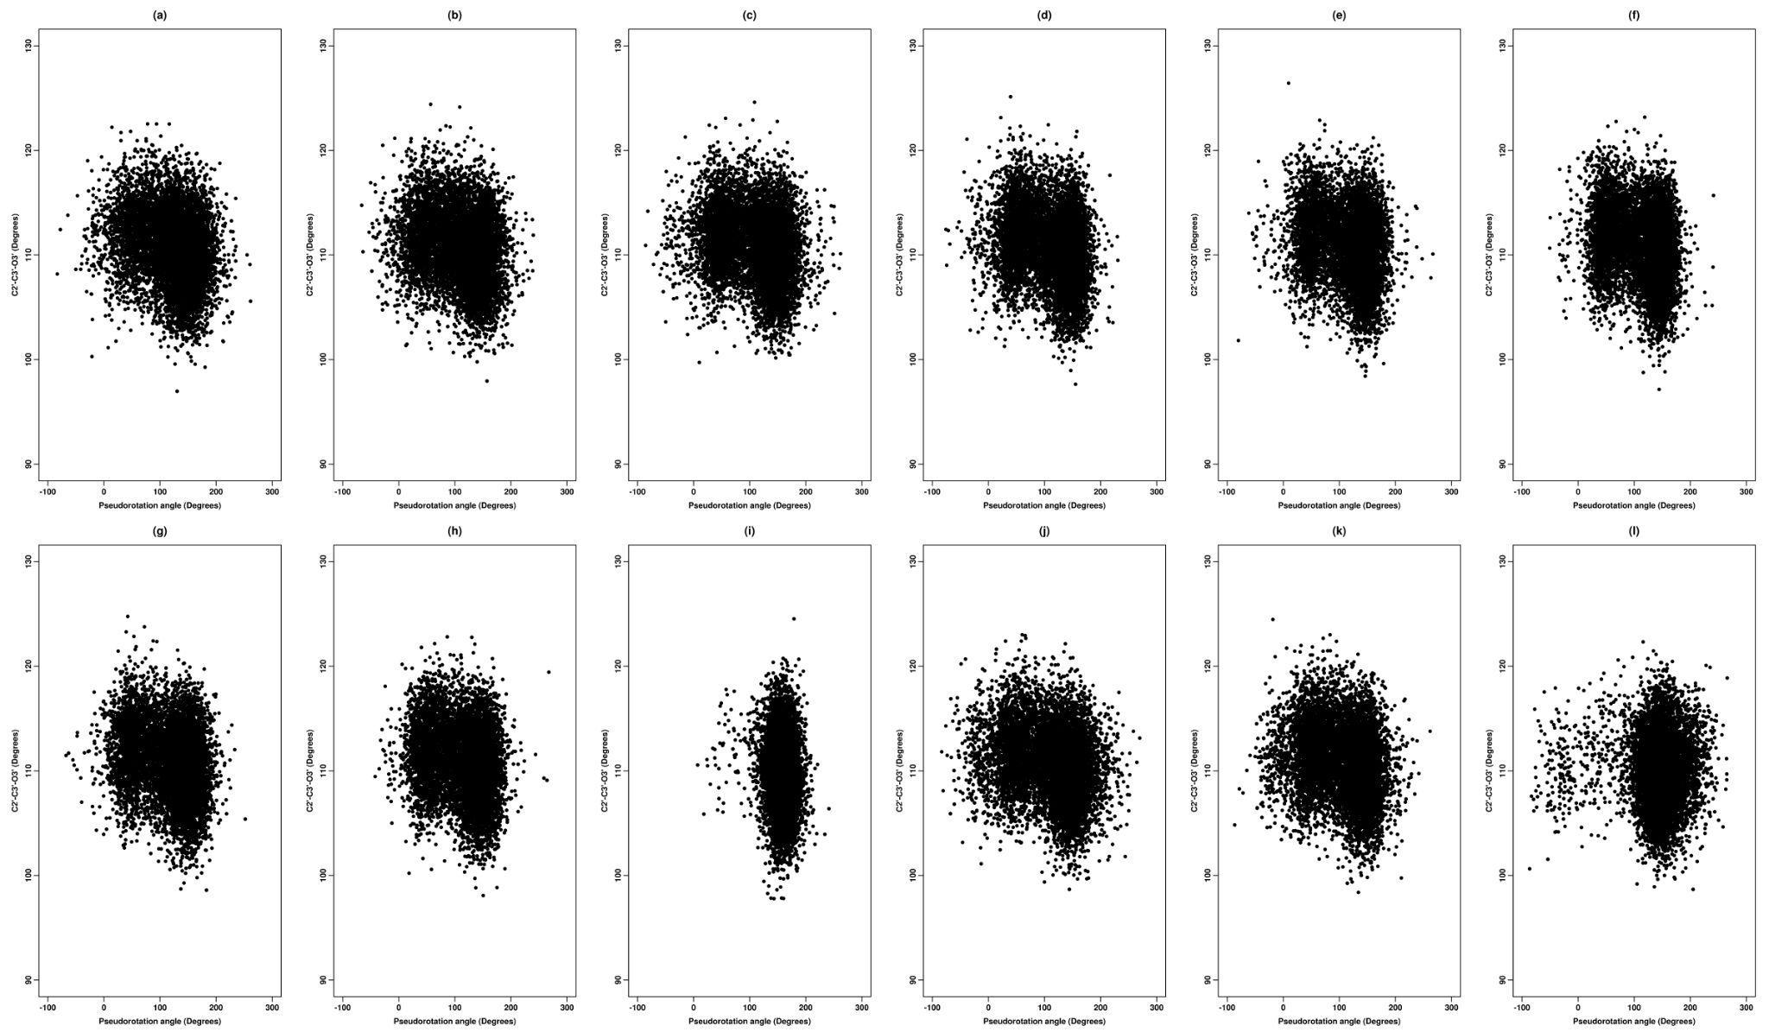
Figure S21. 2D scatter plot of pseudorotation angle (P) versus C2′-C3′-O3′ sugar valence angle for inosine corresponding to (a) ff_A, (b) ff_A_𝛄_{bsc0}, (c) ff_A_𝛘_{OL3}, (d) ff_A_𝛘_{OL3}_𝛄_{bsc0}, (e) ff_A_𝛘_{YIL}, (f) ff_A_𝛘_{YIL}_𝛄_{bsc0}, (g) ff_A_𝛘_{SHAW}, (h) ff_A_𝛘_{SHAW}_𝛄_{bsc0}, (i) ff_A_𝛘_{SHAW}_𝛄_{SHAW}, (j) ff_A_𝛘_{ROC}, (k) ff_A_𝛘_{ROC}_𝛄_{bsc0}, (l) ff_A_RNA_ROC for the third set of 16 ns REMD simulations (at 300 K). The scale for pseudorotation angle (P) along the X-axis was converted to -90 ° to 270° to better delineate the NORTH (270°≤P<90°) and SOUTH (90°≤P<270°) regions.

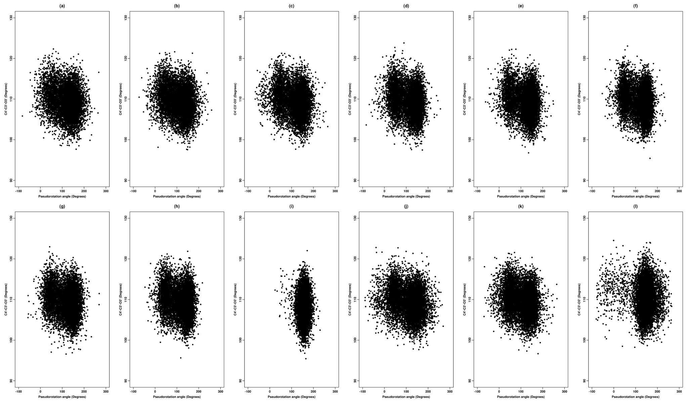

Figure S22. 2D scatter plot of pseudorotation angle (P) versus C4′-C3′-O3′ sugar valence angle for inosine corresponding to (a) ff_A, (b) ff_A_𝛄_{bsc0}, (c) ff_A_𝛘_{OL3}, (d) ff_A_𝛘_{OL3}_𝛄_{bsc0}, (e) ff_A_𝛘_{YIL}, (f) ff_A_𝛘_{YIL}_𝛄_{bsc0}, (g) ff_A_𝛘_{SHAW}, (h) ff_A_𝛘_{SHAW}_𝛄_{bsc0}, (i) ff_A_𝛘_{SHAW}_𝛄_{SHAW}, (j) ff_A_𝛘_{ROC}, (k) ff_A_𝛘_{ROC}_𝛄_{bsc0}, (l) ff_A_RNA_ROC for the first set of 16 ns REMD simulations (at 300 K). The scale for pseudorotation angle (P) along the X-axis was converted to -90 ° to 270° to better delineate the NORTH (270°≤P<90°) and SOUTH (90°≤P<270°) regions.

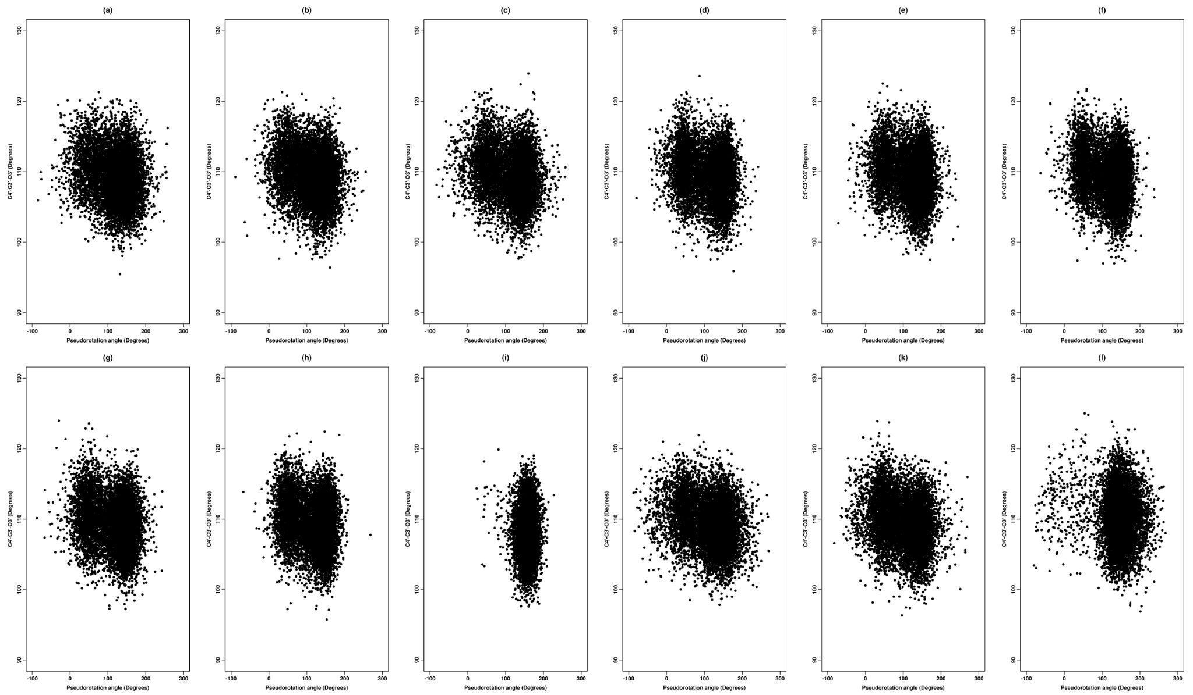

Figure S23. 2D scatter plot of pseudorotation angle (P) versus C4′-C3′-O3′ sugar valence angle for inosine corresponding to (a) ff_A, (b) ff_A_𝛄_{bsc0}, (c) ff_A_𝛘_{OL3}, (d) ff_A_𝛘_{OL3}_𝛄_{bsc0}, (e) ff_A_𝛘_{YIL}, (f) ff_A_𝛘_{YIL}_𝛄_{bsc0}, (g) ff_A_𝛘_{SHAW}, (h) ff_A_𝛘_{SHAW}_𝛄_{bsc0}, (i) ff_A_𝛘_{SHAW}_𝛄_{SHAW}, (j) ff_A_𝛘_{ROC}, (k) ff_A_𝛘_{ROC}_𝛄_{bsc0}, (l) ff_A_RNA_ROC for the second set of 16 ns REMD simulations (at 300 K). The scale for pseudorotation angle (P) along the X-axis was converted to -90 ° to 270° to better delineate the NORTH (270°≤P<90°) and SOUTH (90°≤P<270°) regions.

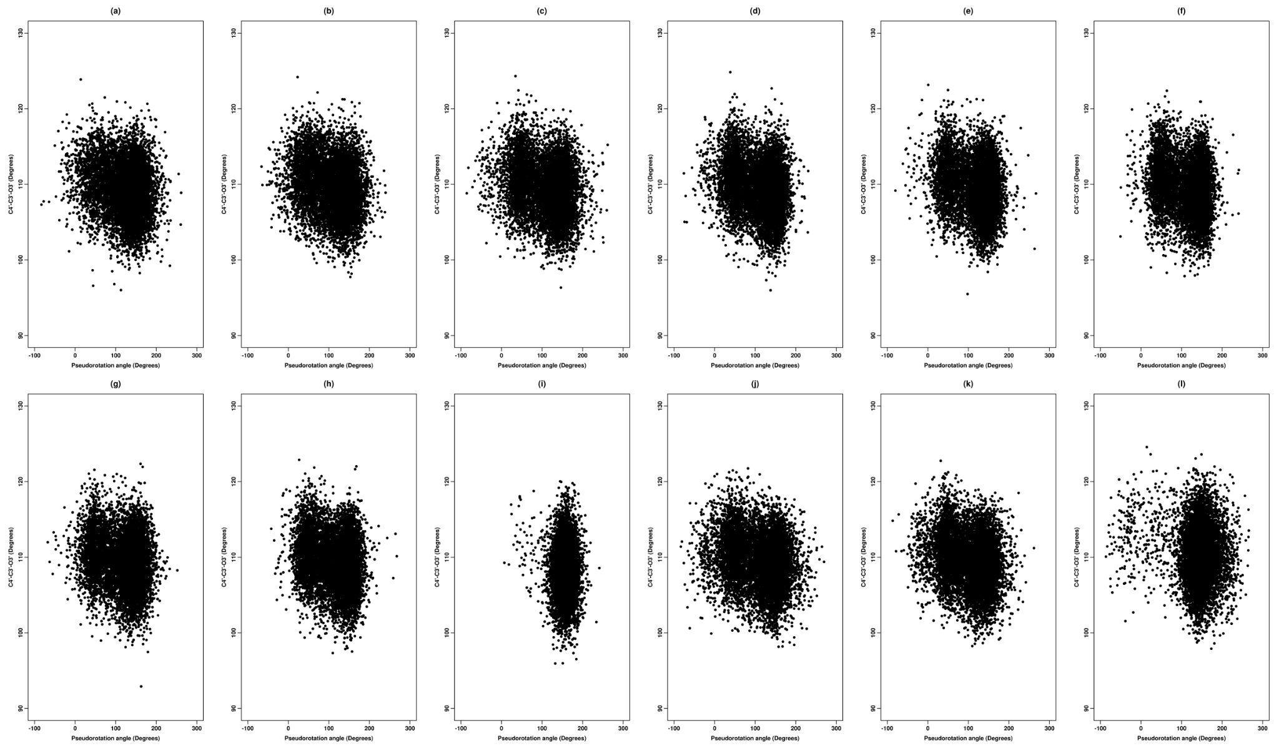

Figure S24. 2D scatter plot of pseudorotation angle (P) versus C4′-C3′-O3′ sugar valence angle for inosine corresponding to (a) ff_A, (b) ff_A_𝛄_{bsc0}, (c) ff_A_𝛘_{OL3}, (d) ff_A_𝛘_{OL3}_𝛄_{bsc0}, (e) ff_A_𝛘_{YIL}, (f) ff_A_𝛘_{YIL}_𝛄_{bsc0}, (g) ff_A_𝛘_{SHAW}, (h) ff_A_𝛘_{SHAW}_𝛄_{bsc0}, (i) ff_A_𝛘_{SHAW}_𝛄_{SHAW}, (j) ff_A_𝛘_{ROC}, (k) ff_A_𝛘_{ROC}_𝛄_{bsc0}, (l) ff_A_RNA_ROC for the third set of 16 ns REMD simulations (at 300 K). The scale for pseudorotation angle (P) along the X-axis was converted to -90 ° to 270° to better delineate the NORTH (270°≤P<90°) and SOUTH (90°≤P<270°) regions.

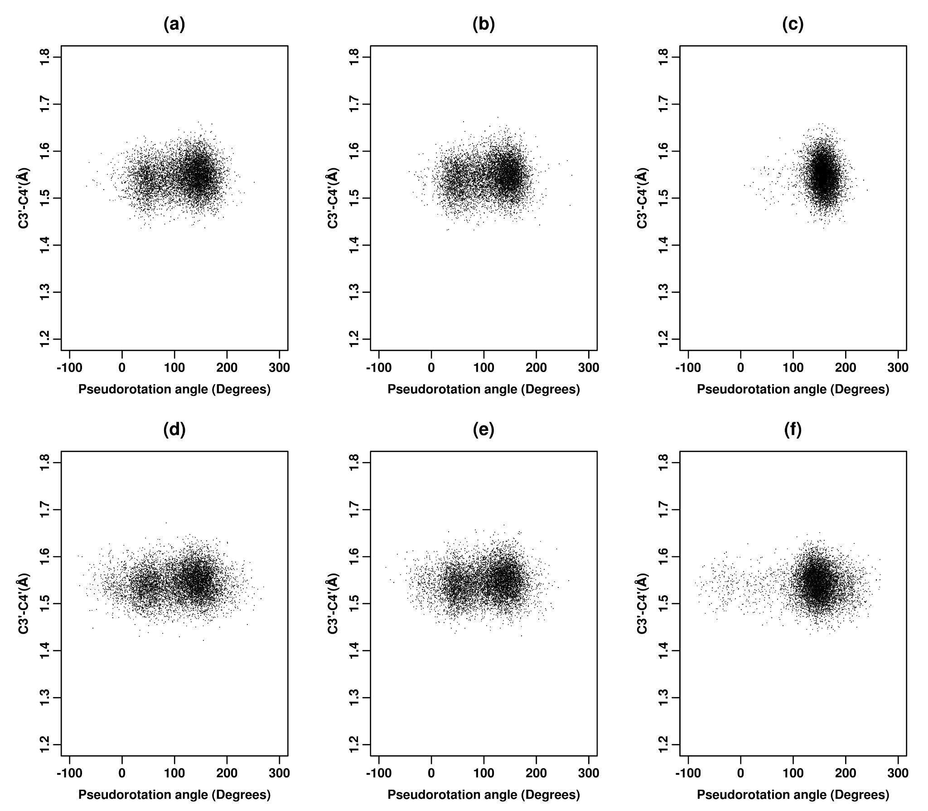
Figure S25. 2D scatter plot of pseudorotation angle (P) versus C3′-C4′ bond distance for inosine corresponding to (a) ff_A_𝛘_{SHAW}, (b) ff_A_𝛘_{SHAW}_𝛄_{bsc0}, (c) ff_A_𝛘_{SHAW}_𝛄_{SHAW}, (d) ff_A_𝛘_{ROC}, (e) ff_A_𝛘_{ROC}_𝛄_{bsc0}, (f) ff_A_RNA_ROC for the second set of 16 ns REMD simulations (at 300 K). The scale for pseudorotation angle (P) along the X-axis was converted to -90 ° to 270° to better delineate the NORTH (270°≤P<90°) and SOUTH (90°≤P<270°) regions.

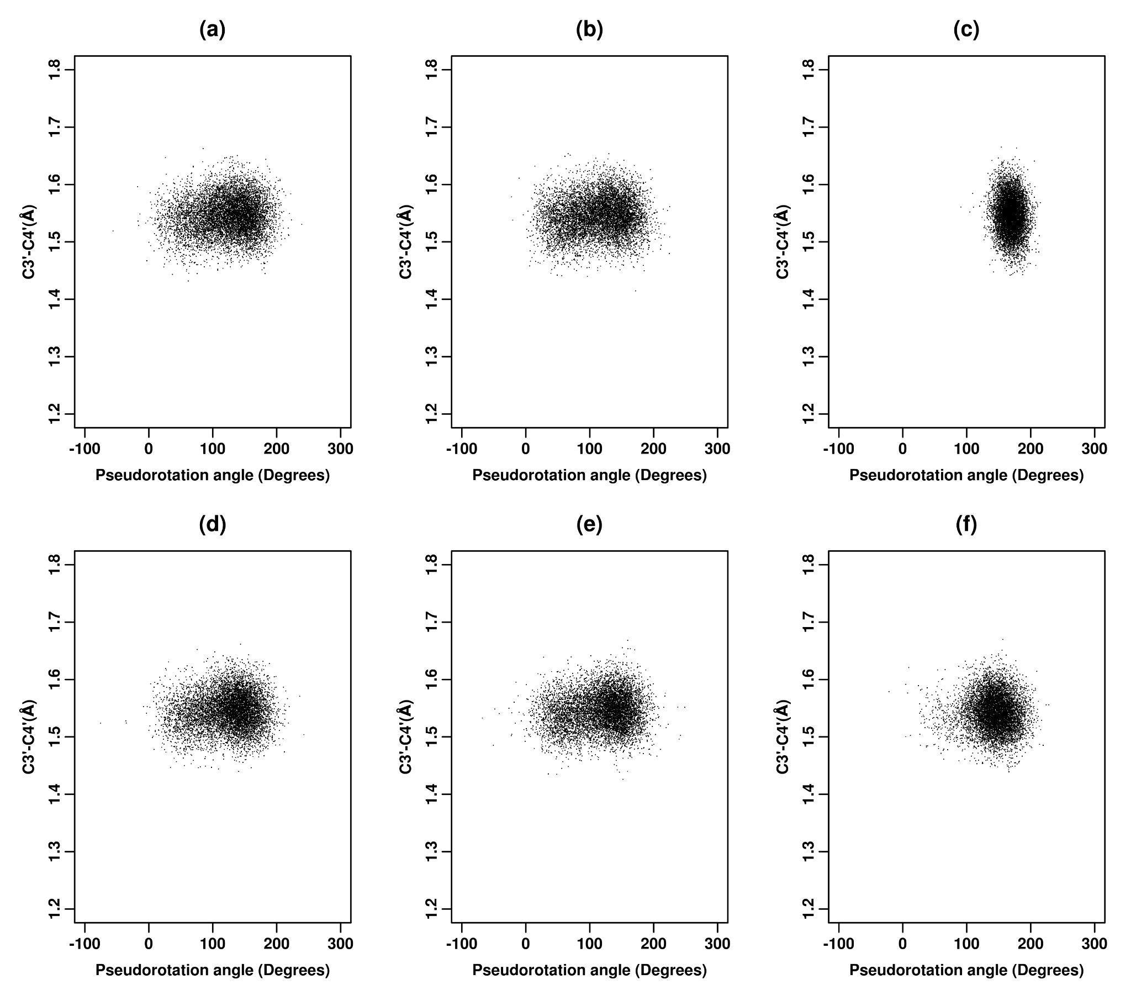
Figure S26. 2D scatter plot of pseudorotation angle (P) versus C3′-C4′ bond distance for inosine corresponding to (a) ff_A_𝛘_{SHAW}, (b) ff_A_𝛘_{SHAW}_𝛄_{bsc0}, (c) ff_A_𝛘_{SHAW}_𝛄_{SHAW}, (d) ff_A_𝛘_{ROC}, (e) ff_A_𝛘_{ROC}_𝛄_{bsc0}, (f) ff_A_RNA_ROC for the third set of 16 ns REMD simulations (at 300 K). The scale for pseudorotation angle (P) along the X-axis was converted to -90 ° to 270° to better delineate the NORTH (270°≤P<90°) and SOUTH (90°≤P<270°) regions.

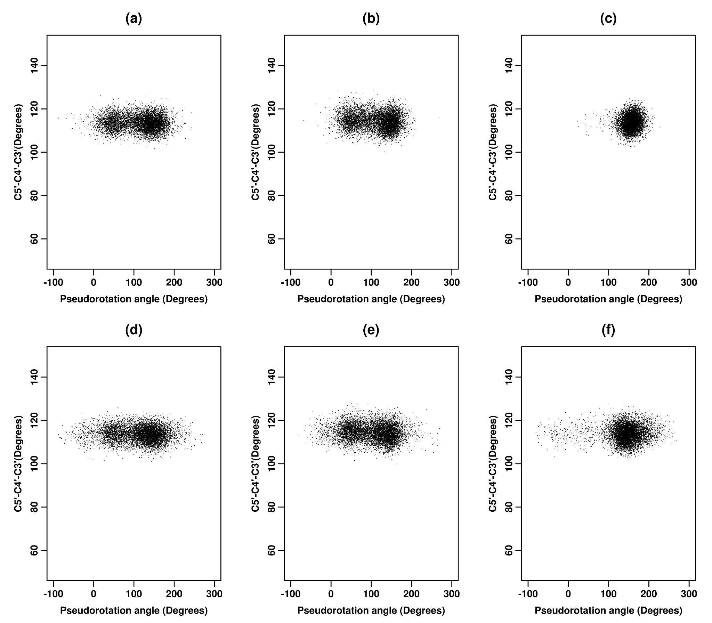
Figure S27. 2D scatter plot of pseudorotation angle (P) versus C5′-C4′-C3′ angle for inosine corresponding to (a) ff_A_𝛘_{SHAW}, (b) ff_A_𝛘_{SHAW}_𝛄_{bsc0}, (c) ff_A_𝛘_{SHAW}_𝛄_{SHAW}, (d) ff_A_𝛘_{ROC}, (e) ff_A_𝛘_{ROC}_𝛄_{bsc0}, (f) ff_A_RNA_ROC for the second set of 16 ns REMD simulations (at 300 K). The scale for pseudorotation angle (P) along the X-axis was converted to -90 ° to 270° to better delineate the NORTH (270°≤P<90°) and SOUTH (90°≤P<270°) regions.

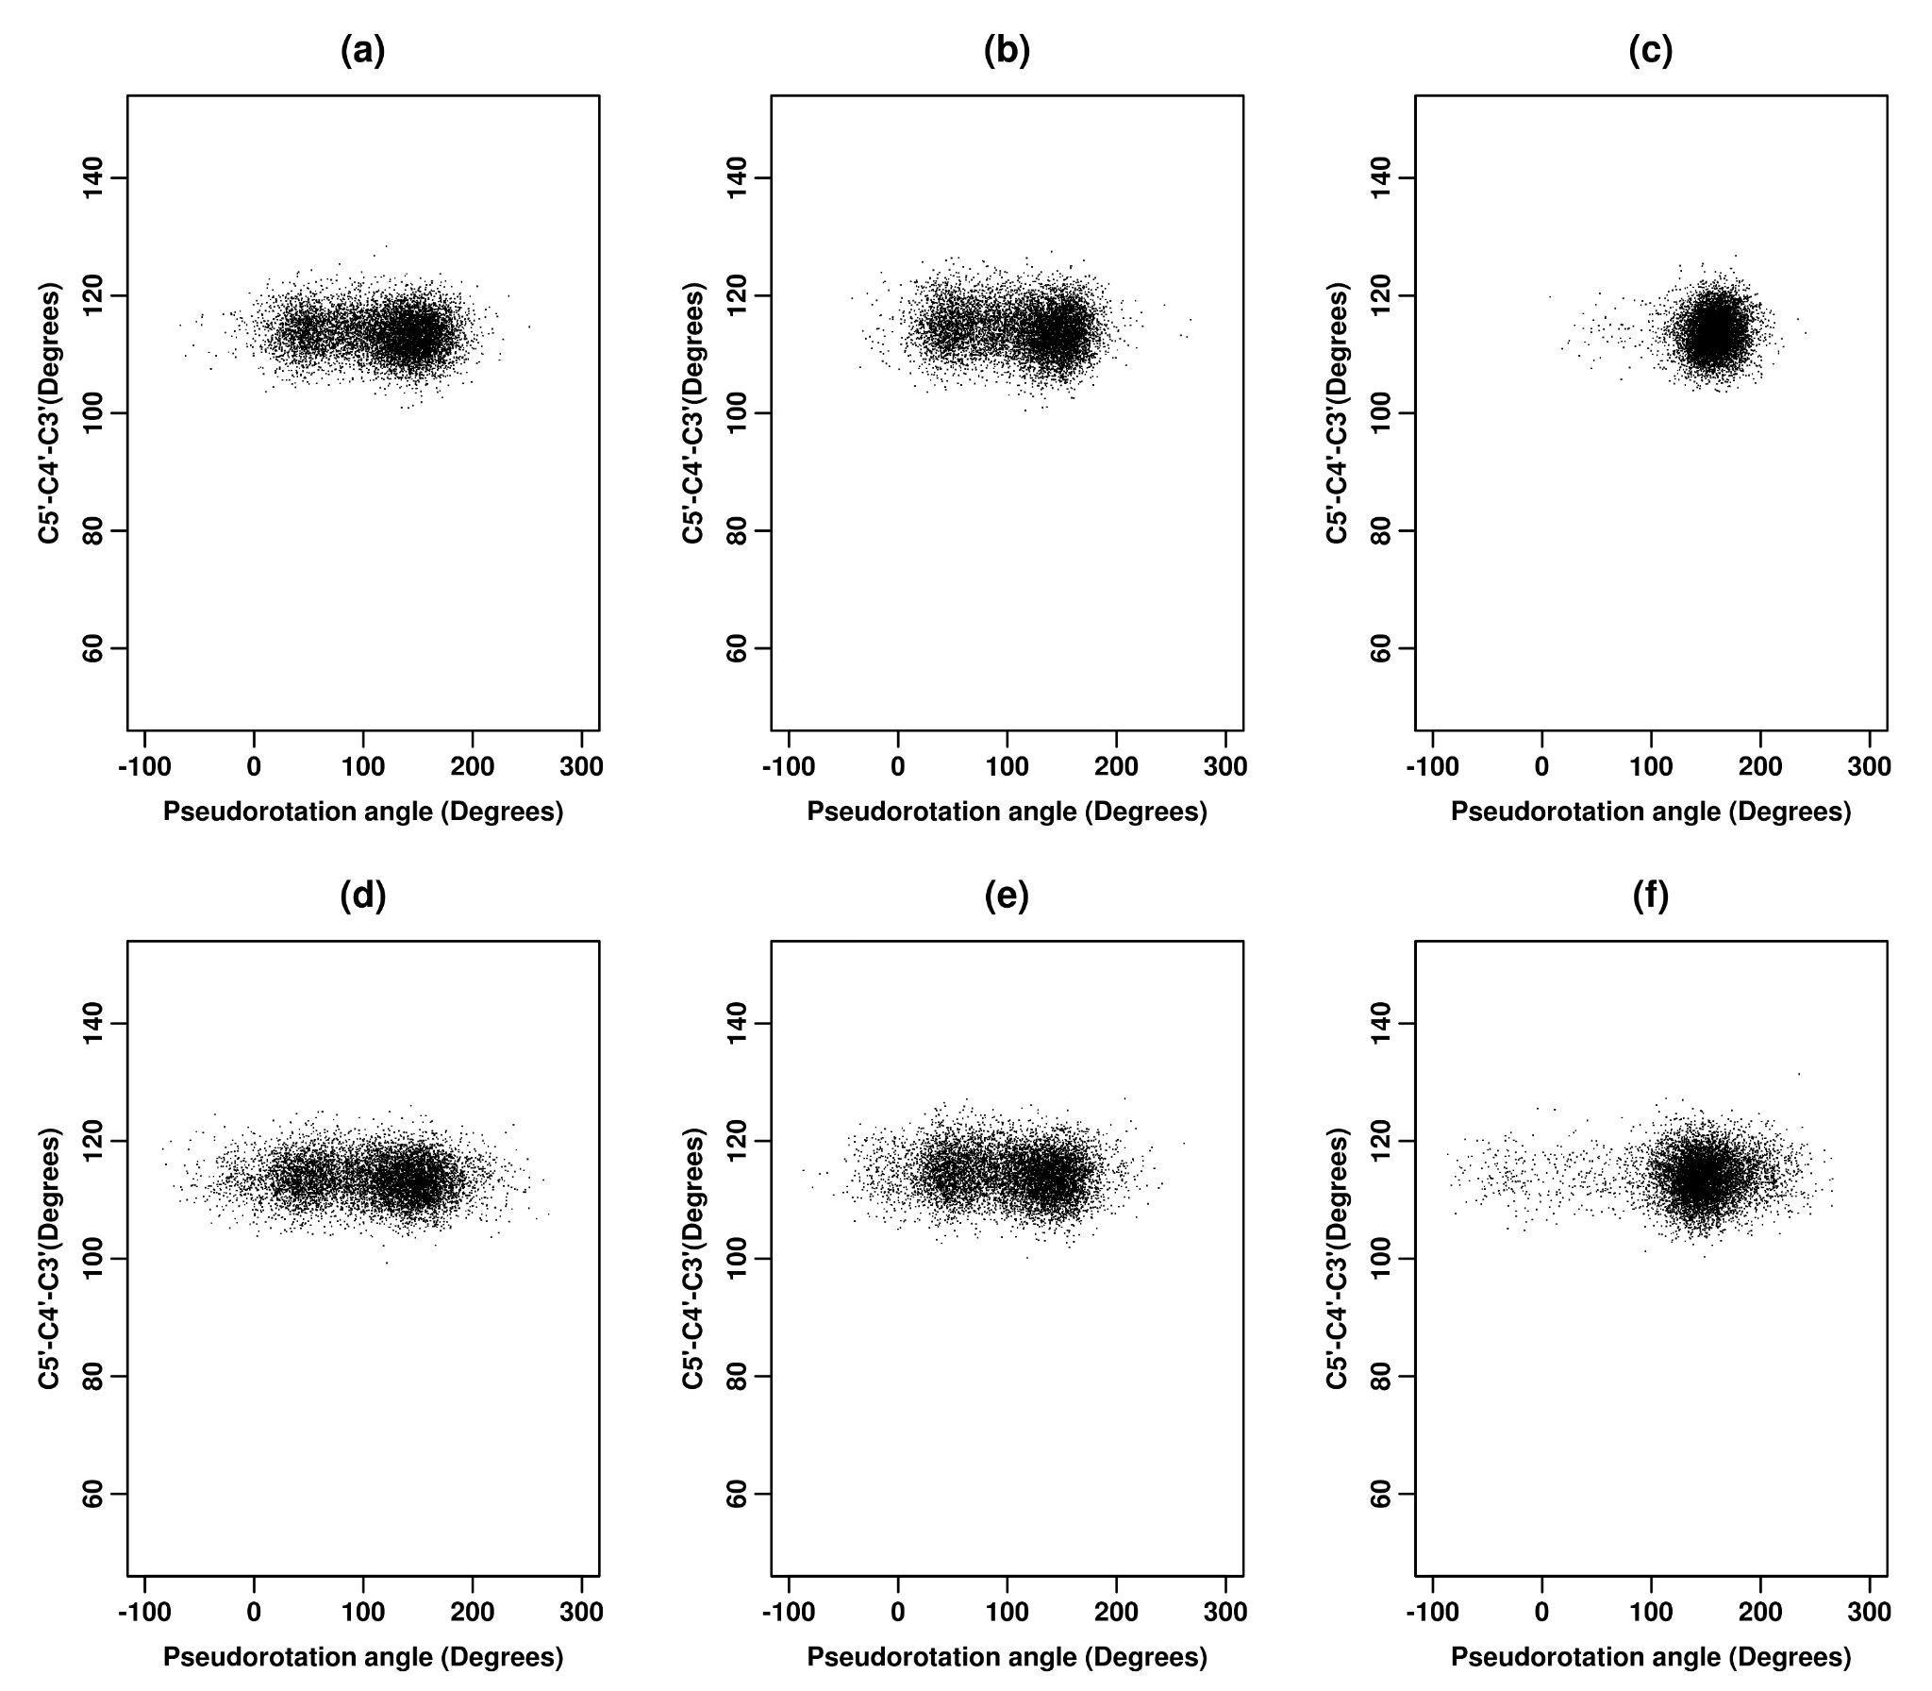
Figure S28. 2D scatter plot of pseudorotation angle (P) versus C5′-C4′-C3′ angle for inosine corresponding to (a) ff_A_𝛘_{SHAW}, (b) ff_A_𝛘_{SHAW}_𝛄_{bsc0}, (c) ff_A_𝛘_{SHAW}_𝛄_{SHAW}, (d) ff_A_𝛘_{ROC}, (e) ff_A_𝛘_{ROC}_𝛄_{bsc0}, (f) ff_A_RNA_ROC for the third set of 16 ns REMD simulations (at 300 K). The scale for pseudorotation angle (P) along the X-axis was converted to -90 ° to 270° to better delineate the NORTH (270°≤P<90°) and SOUTH (90°≤P<270°) regions.

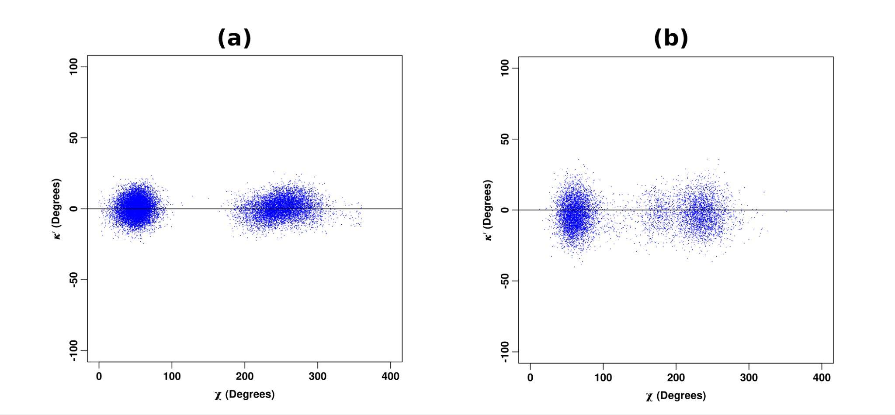

Figure S29. 2D scatter plot of 𝜿′ (C4−N9−C1′−C8 − 180°) torsion angle versus glycosidic torsion angle (χ) for inosine corresponding to the (a) CHARMM36m parameters (200ns MD simulations at 298 K, number of conformers = 20000) and (b) FF99_𝛘_{KOL0}_𝛄_{bsc0} (for the first set of 16 ns REMD simulations at 300 K, number of conformers = 8000) force fields respectively. 𝜿′ =0° (shown by the horizontal line in the plots) corresponds to the idealized planar configuration of the N9 atom.

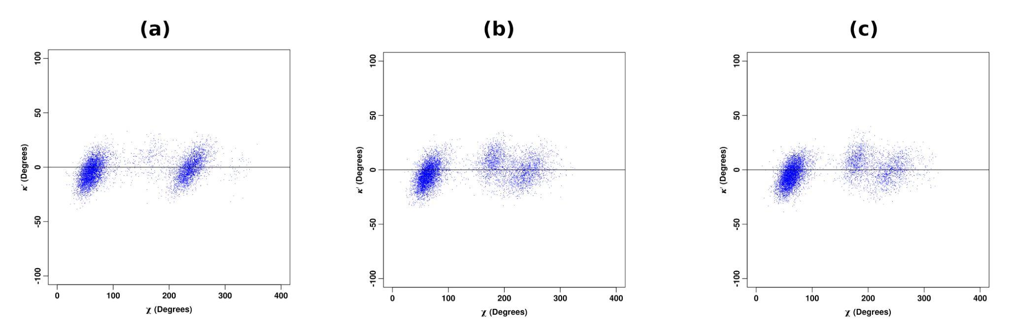
Figure S30. 2D scatter plot of 𝜿′ (C4−N9−C1′−C8 − 180°) torsion angle versus glycosidic torsion angle (χ) corresponding to the FF99_𝛘_{KOL0}_𝛄_{bsc0} parameter sets for a set of 16 ns REMD simulations (at 300 K) for (A) 1-methylinosine (1MI); (B) 2'-O-methylinosine (MRI) and (C) 1,2'-O-dimethylinosine (MMI) respectively. 𝜿′ =0° (shown by the horizontal line in the plots) corresponds to the idealized planar configuration of the N9 atom.

REFERENCES

1. Brooks BR, Brooks CL 3rd, Mackerell AD Jr, et al (2009) CHARMM: the biomolecular simulation program. J Comput Chem 30:1545–1614
2. Rossi C, Picchi M, Tiezzi E, et al (1990) Conformational and dynamic investigation in solution of inosine and its molecular complex, inosiplex, by proton and carbon NMR spectroscopy. Magn Reson Chem 28:348–354
3. Wishart DS, Knox C, Guo AC, et al (2009) HMDB: a knowledgebase for the human metabolome. Nucleic Acids Research 37:D603–D610
4. Cheatham TE 3rd, Cieplak P, Kollman PA (1999) A modified version of the Cornell et al. force field with improved sugar pucker phases and helical repeat. J Biomol Struct Dyn 16:845–862

