Supplementary Figure 1. Survival analysis based on the metastatic pattern of prior TKIs in patients who received third-generation TKIs as subsequent therapy.
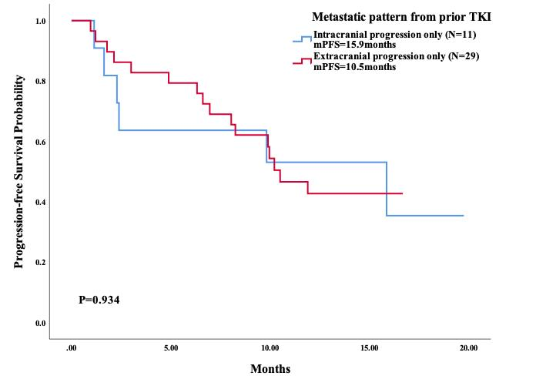

Supplementary Figure 2. Survival analysis based on the lines of previous systemic therapy in patients receiving subsequent third-generation TKIs.

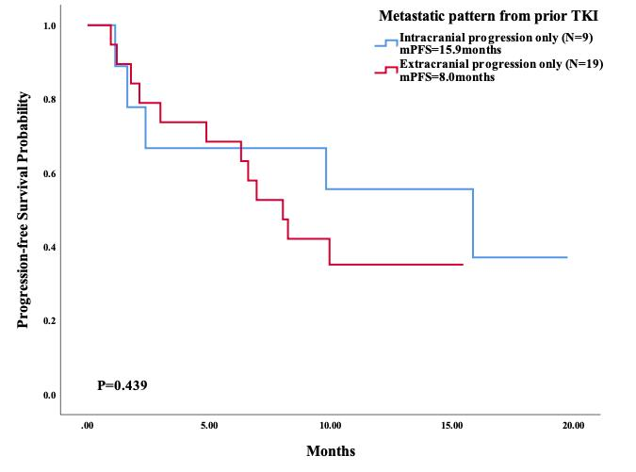

Supplementary Figure 3. Hazard ratio of PFS in all patients with different characteristics who received third-generation TKIs as subsequent therapy using univariate analysis. A hazard ratio less than 1 implies a lower risk of disease progression or death in group 1 than in group 2.
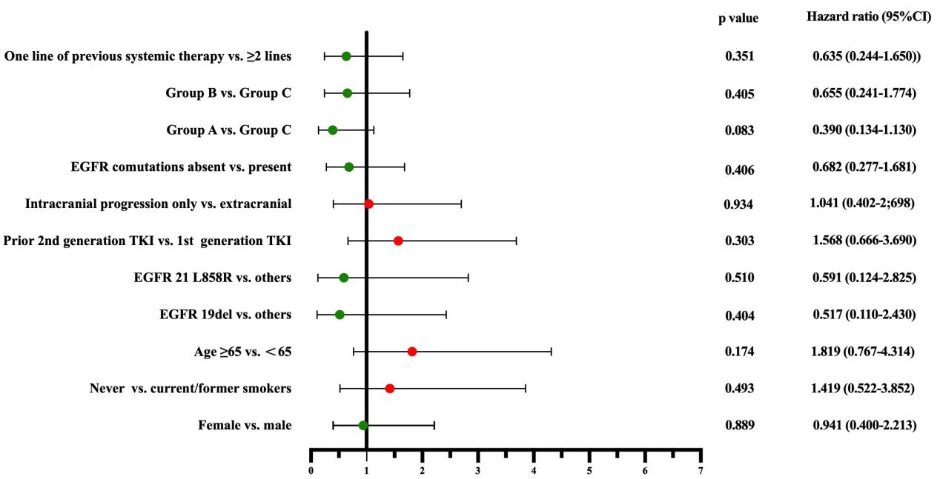

Supplementary Figure 4. Hazard ratio of PFS in T790M-negative patients with different characteristics who received third-generation TKIs as subsequent therapy using univariate analysis. A hazard ratio less than 1 implies a lower risk of disease progression or death in group 1 than in group 2.
