Annexure
The area is simply a count of the number of grid squares an object occupies. If desired, a true area (say, in km² ) can be obtained by adding up the true areas of all the grid squares inside an object. The centroid is a kind of geometric centre of an object and can be calculated from the first moments. It allows one to assign a single point location to what may be a large, extended object. For tracking the HW movement these single-point locations for observations and forecasts are plotted over the India map, which can give better guidance to the HW forecast. Axis Angle gives information on the orientation or “tilt” of an object. Curvature is another attribute that uses moments in its calculation, specifically, third-order moments. The Aspect Ratio is computed by fitting a rectangle around an object. The rectangle is aligned so that it has the same axis angle as the object, and the length and width are chosen so as to just enclose the object. We make no claim that the rectangle so obtained is the smallest possible rectangle enclosing the given object. However, this rectangle is much easier to calculate than a smaller enclosing rectangle and serves our purposes just as well. Once the rectangle is determined, the aspect ratio of the object is defined to be the width of the fitted rectangle divided by its length. Another object attribute defined by MODE is complexity. Complexity is defined by comparing the area of an object to the area of its convex hull. All the attributes discussed so far are defined for single objects. Once these are determined, they can be used to calculate attributes for pairs of objects. One example is the centroid difference. This measure is simply the (vector) difference between the centroids of the two objects. Another example is the angle difference. This is the difference between the axis angles.
Several area measures are also used for pair attributes. Union Area is the total area that is in either one (or both) of the two objects. The intersection area is the area that is inside both objects simultaneously. Symmetric Difference is the area inside at least one object, but not inside both.
MODE provides the capability to select a single model variable/level from which to derive objects to be analyzed. MODE was developed and tested using accumulated precipitation. However, the code has been generalized to allow the use of any gridded model and observation field. Based on the options specified in the configuration file, MODE will define a set of simple objects in the model and observation fields. It will then compute an interest value for each pair of objects across the fields using a fuzzy engine approach. Those interest values are thresholded, and any pairs of objects above the threshold will be matched/merged. Through the configuration file, MODE offers a wide range of flexibility in how the objects are defined, processed, matched, and merged.
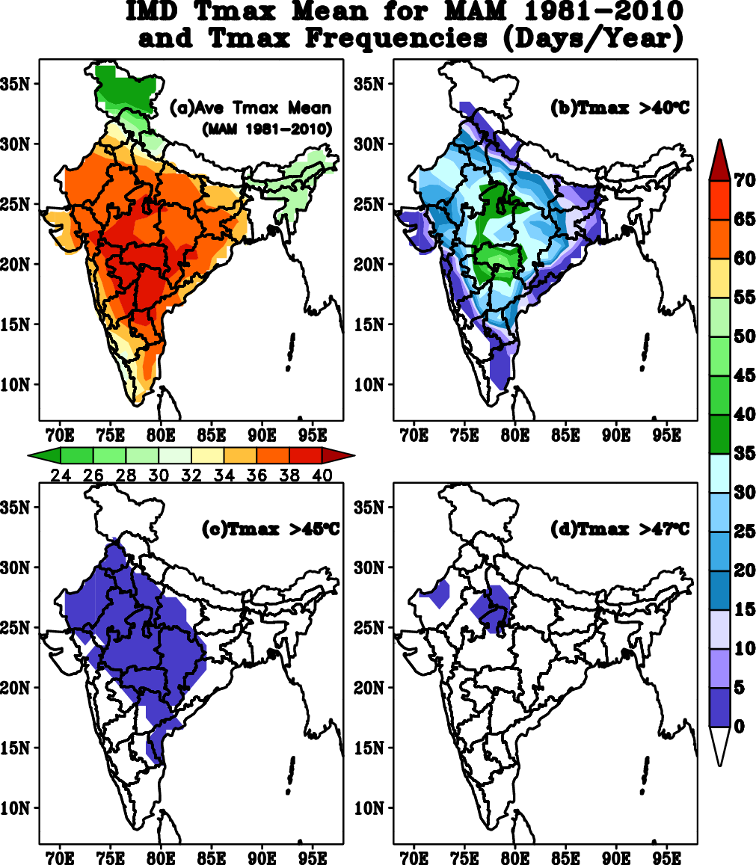
Fig.1. (a) Mean Maximum Temperature observed over India during 1981–2010 along with the average frequency of days with Tmax (b) > 40°C (d) > 45°C and (d) > 47°C.
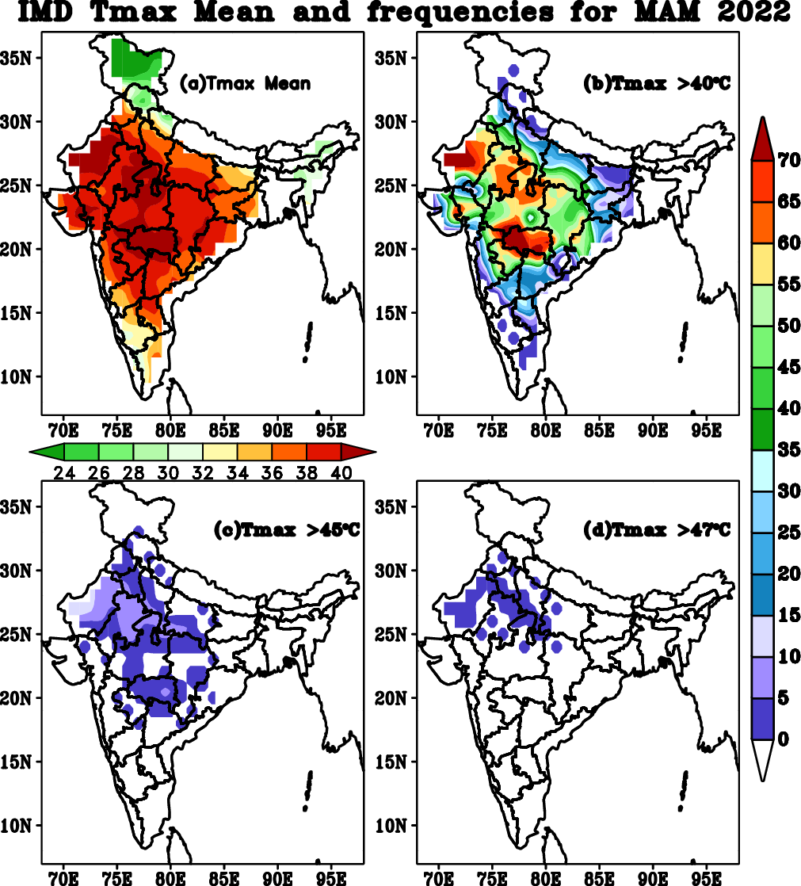
Fig.2. (a) Mean Maximum Temperature observed over India during 2022 along with the average frequency of days with Tmax (b) > 40°C (d) > 45°C and (d) > 47°C.

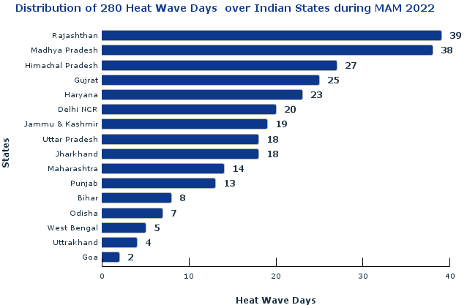
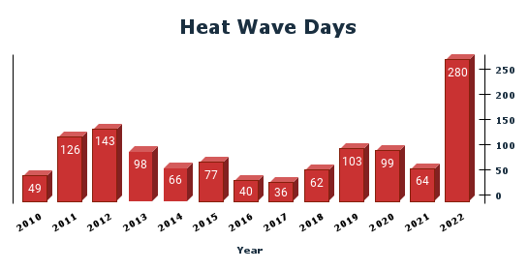

Fig.3. (a) Heat waves days from 2010 to 2022 (b) State-wise distribution of 280 heatwave days
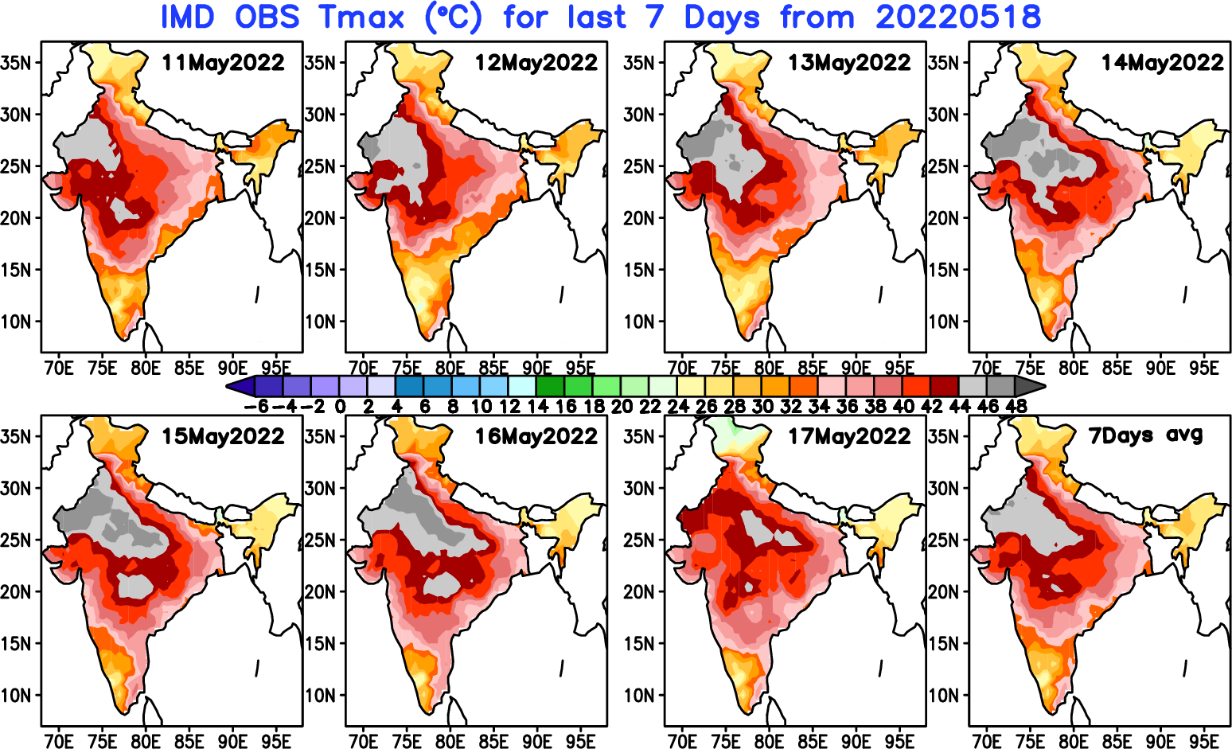
Fig.4. Spatial distribution of IMD Tmax heat wave episodes over India during 11th May 2022 to 17th May 2022.

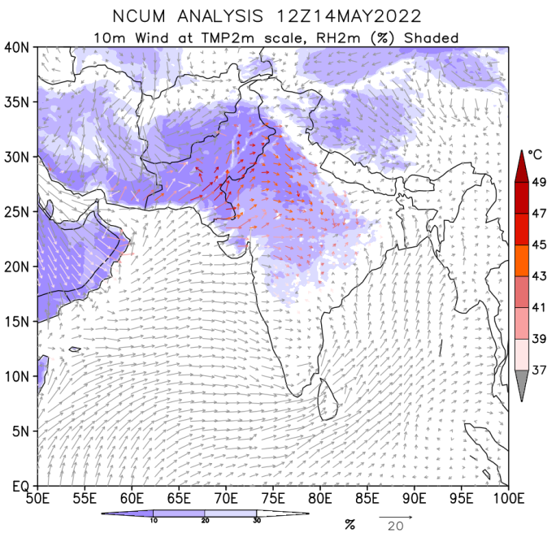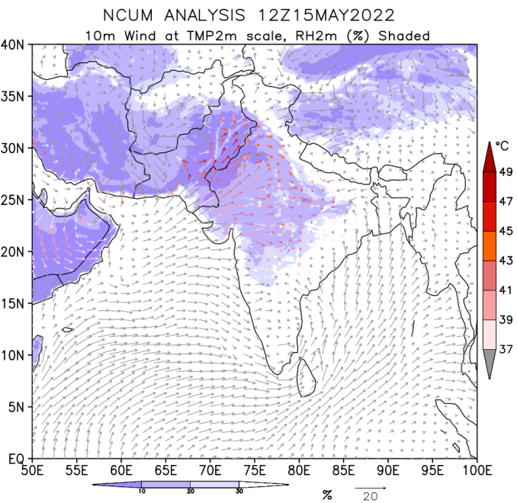
Fig.5. The synoptic features for heat wave, incursion of dry air from the northwest India, (a) NCUM analysis for 10m winds at Tmax (°C) scale and 2m Relative Humidity (in shades) for 12Z14May 2022 and (b) 12Z15May 2022.

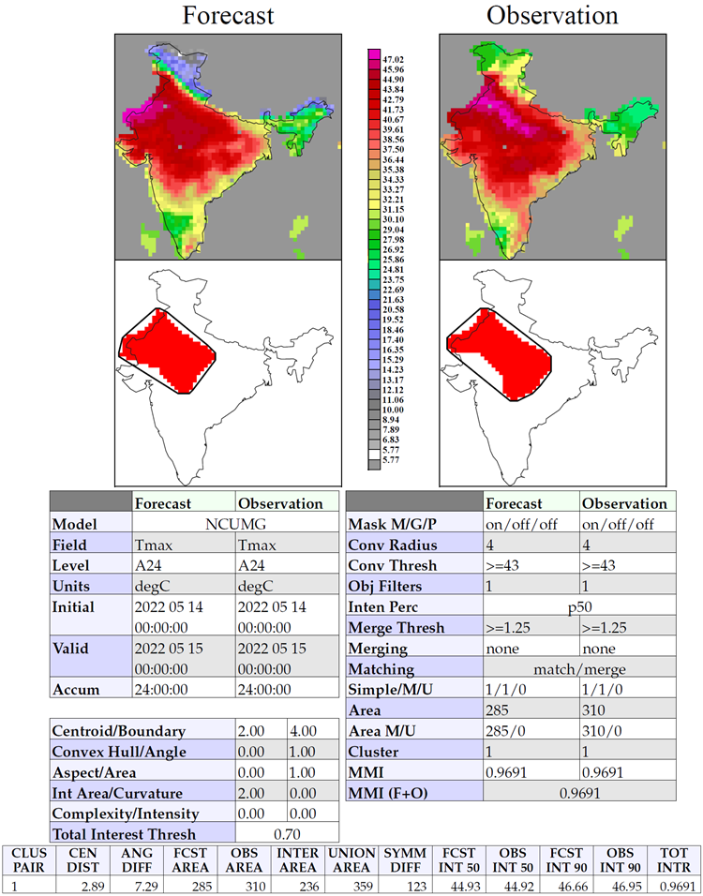
Fig. 6. Heat waves object-area identification with Convolution Radius=4 grid size and CT ≥ 43°C by spatial-verification of NCUM 24hr Tmax forecast with IMD observations valid for 15 May 2022

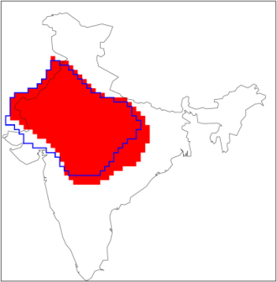
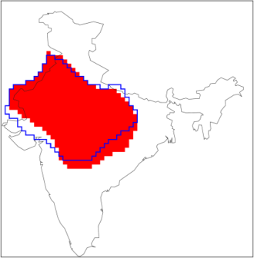
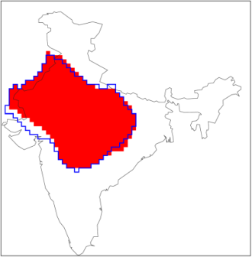
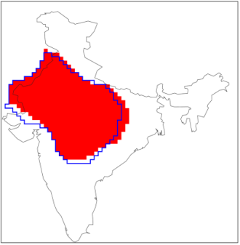
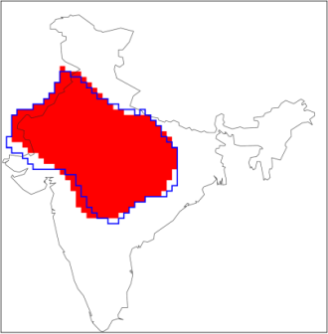
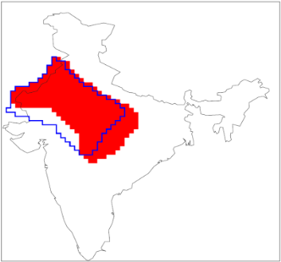
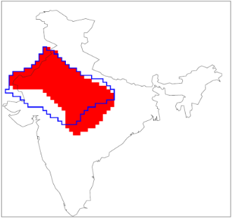
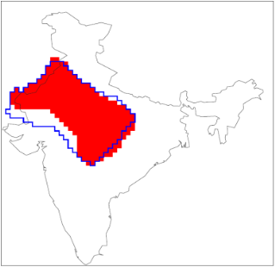
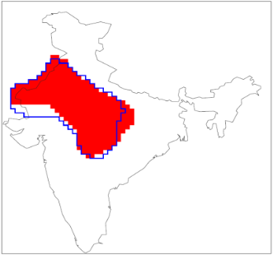
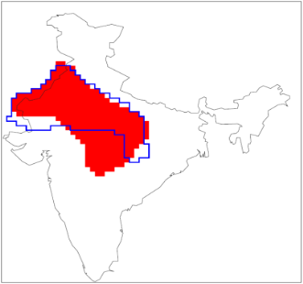
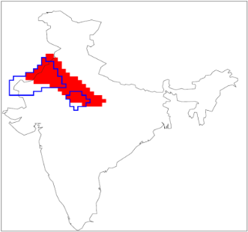
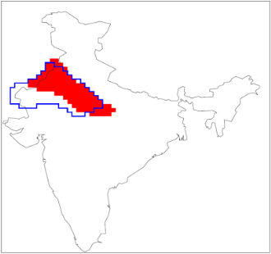
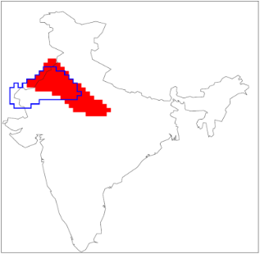
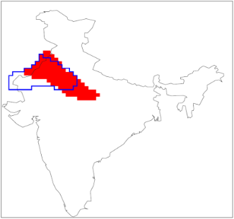
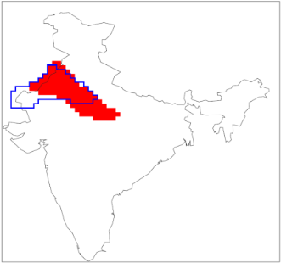

Day-1 Day-2 Day-3 Day-4 Day-5
CT ≥ 45°C CT ≥ 43°C CT ≥ 41°C
(a) (b) (c) (d) (e)

(f) (g) (h) (i) (j)

(k) (l) (m) (n) (o)

Fig. 7. Spatial verification of heat wave event as Observation Object with forecast outline for convolution threshold CT ≥ 41°C, CT ≥ 43°C, and CT ≥ 45°C, from day 1 to day 5 valid for 15 May 2022.

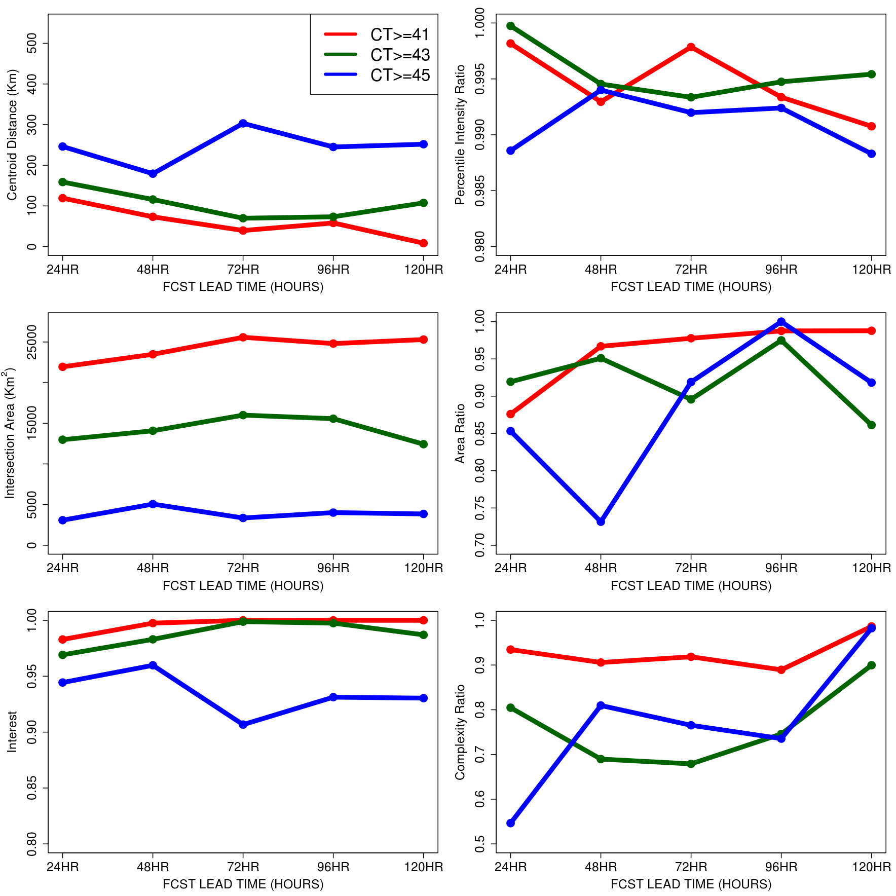
Fig.8. Verification scores obtained from MODE valid for 15th May 2022, for convolution threshold CT ≥ 41°C, CT ≥ 43°C,and CT ≥ 45°C, from 24 hr to 120 hr lead time (a) Centroid distance (km) in upper left panel (b) The 50th percentile intensity ratio (c) The Area Ratio (d) The intersection of area (e) the complexity ratio and (f) the total Interest or simple interest

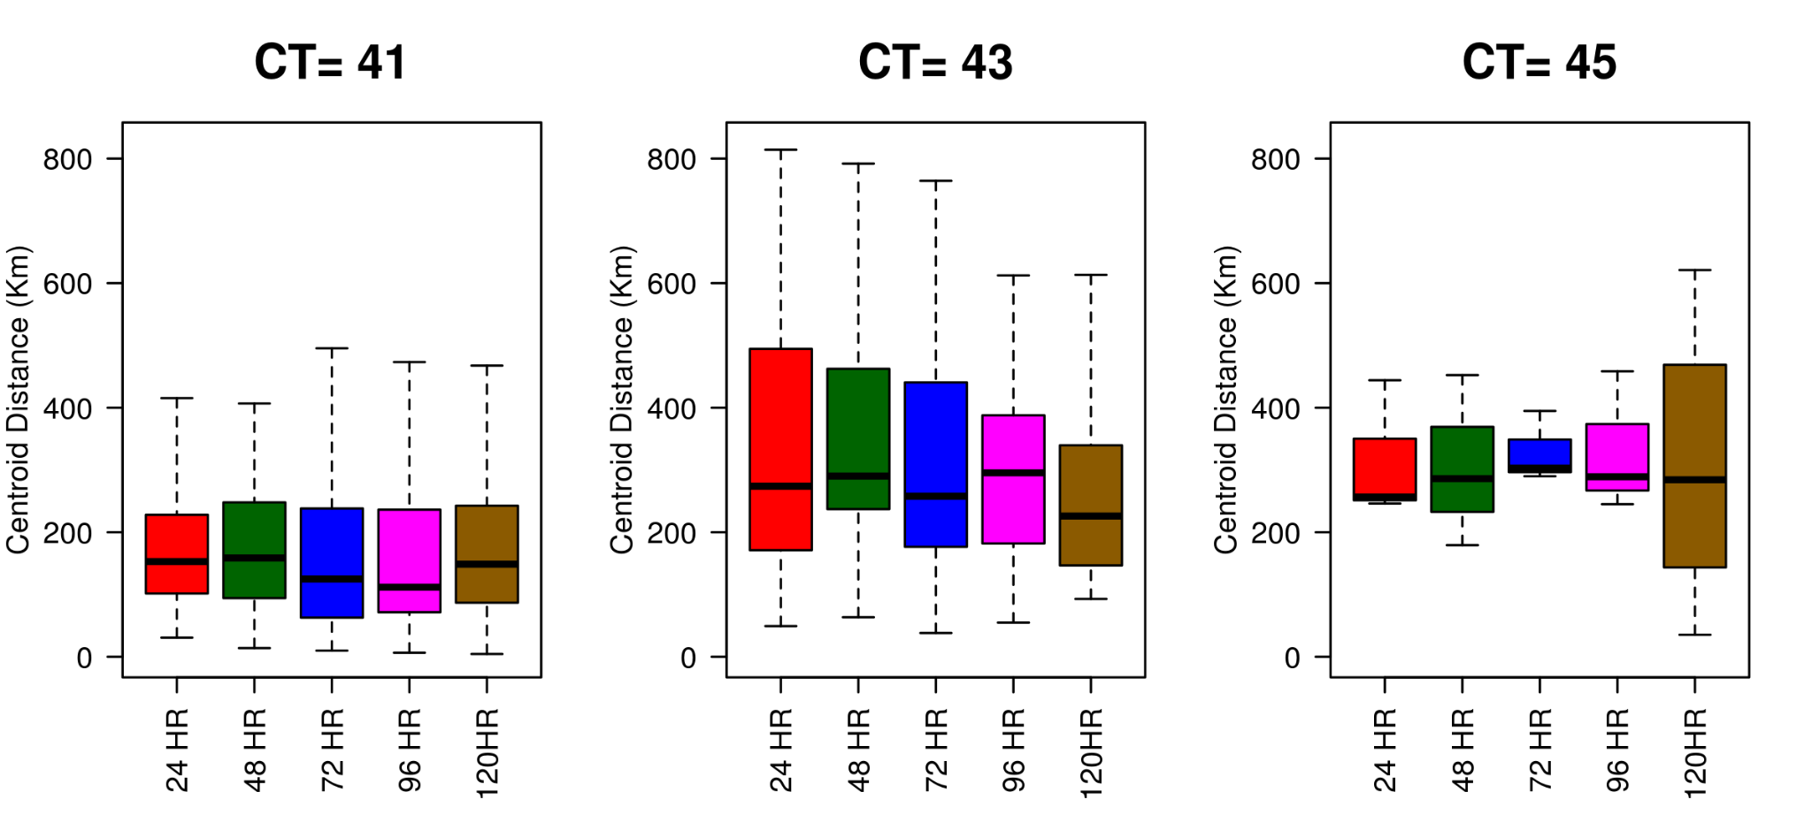
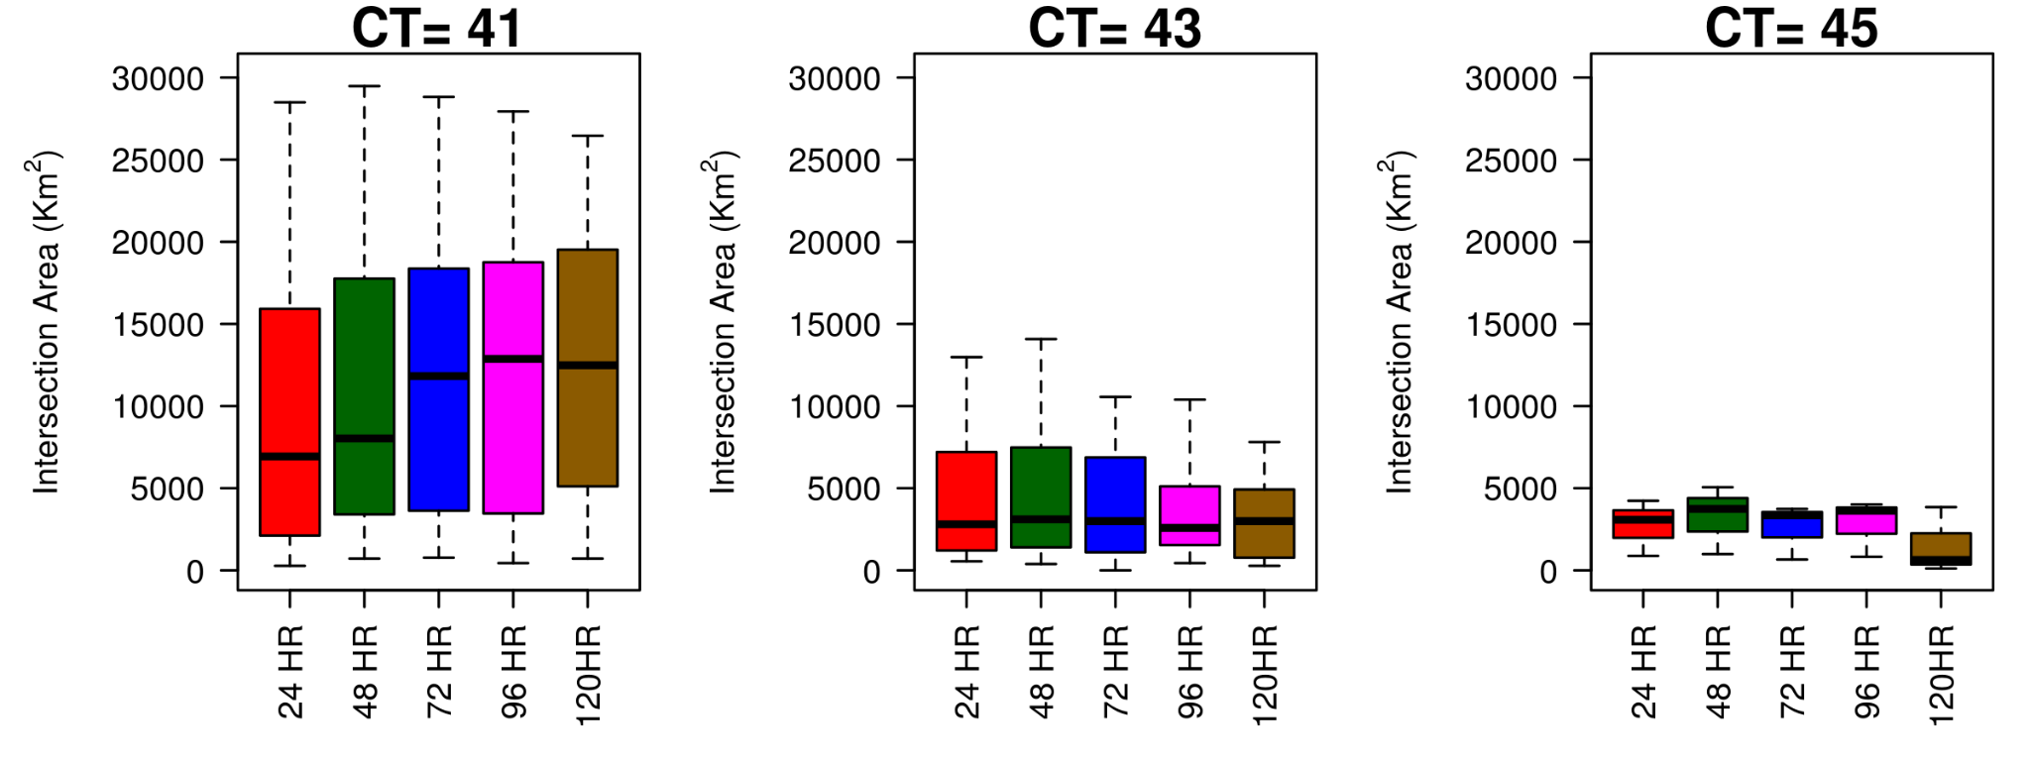

Fig.9. Verification scores obtained from MODE for the summer season ie. MAM 2022, for convolution threshold CT ≥ 41°C, CT ≥ 43°C,and CT ≥ 45°C, from 24 hr to 120 hr lead time (a) the centroid distance (in Km) and (b) Intersection area (in Km² )

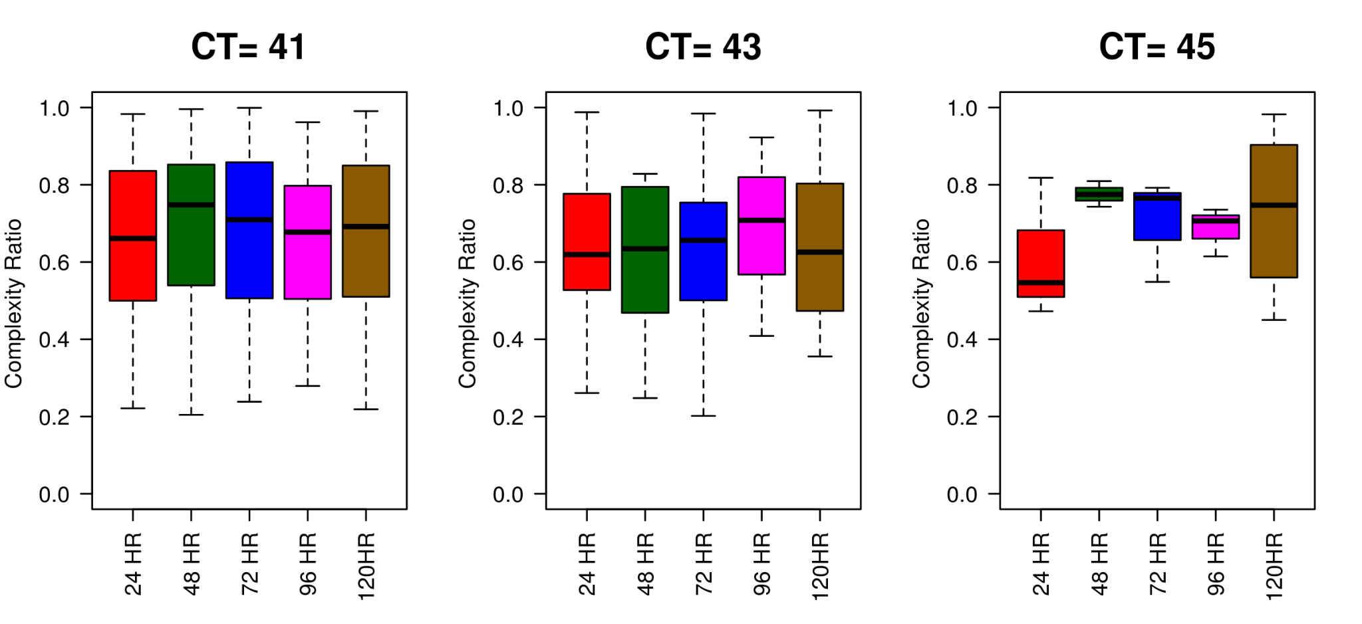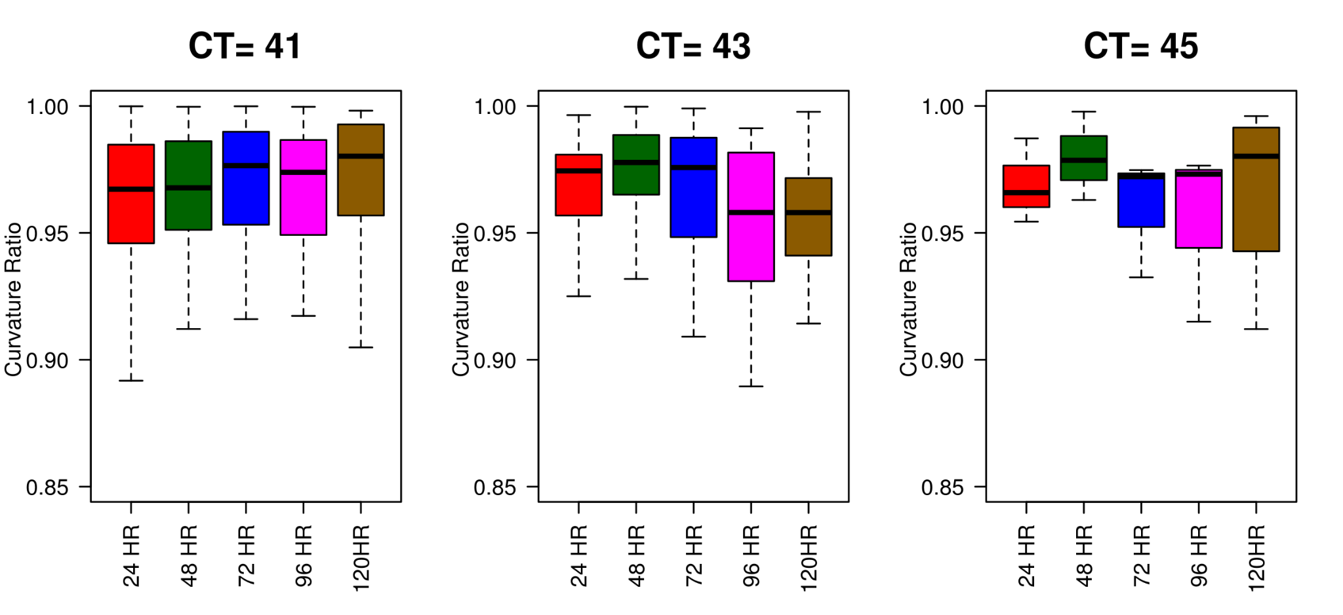
Fig.10. Verification scores obtained from MODE for the summer season ie. MAM 2022, for convolution threshold CT ≥ 41°C, CT ≥ 43°C,and CT ≥ 45°C, from 24 hr to 120 hr lead time (a) The complecity Ratio and (b) the curvature ratio

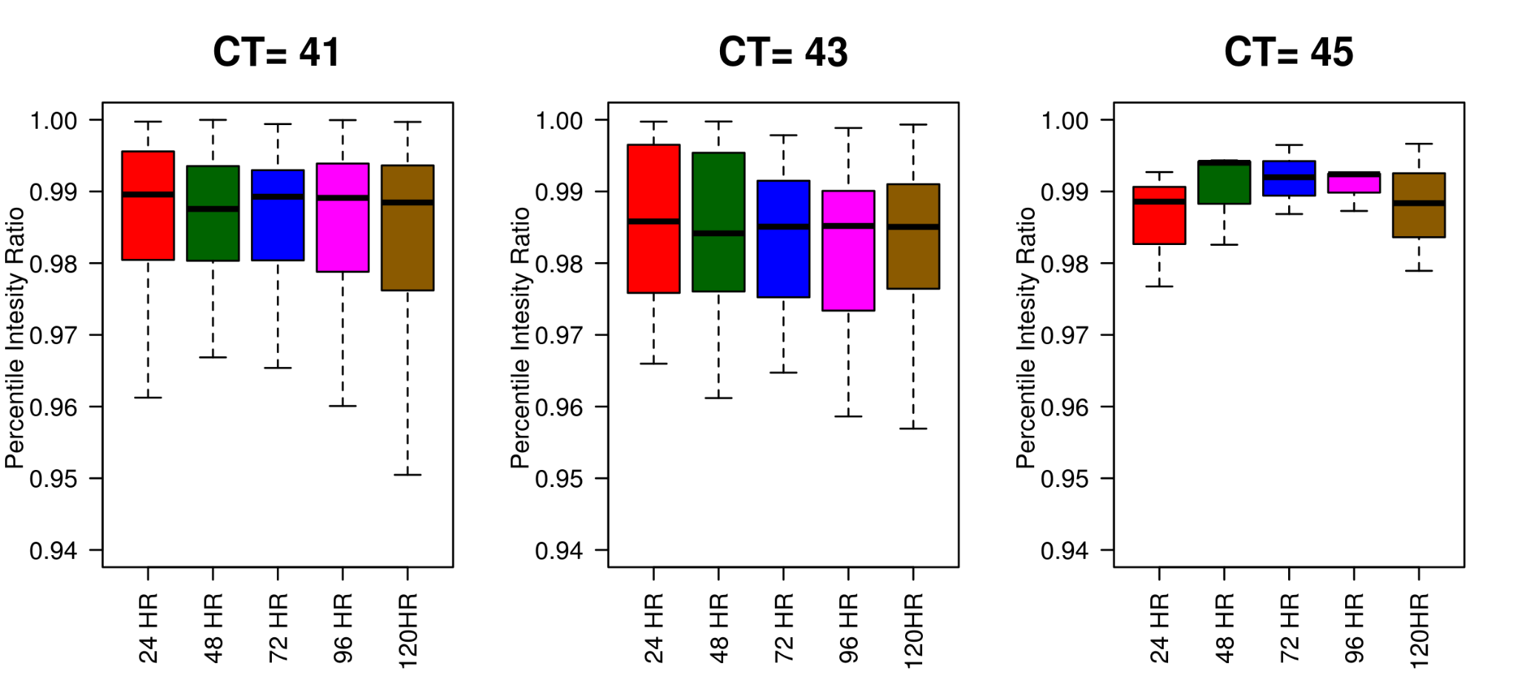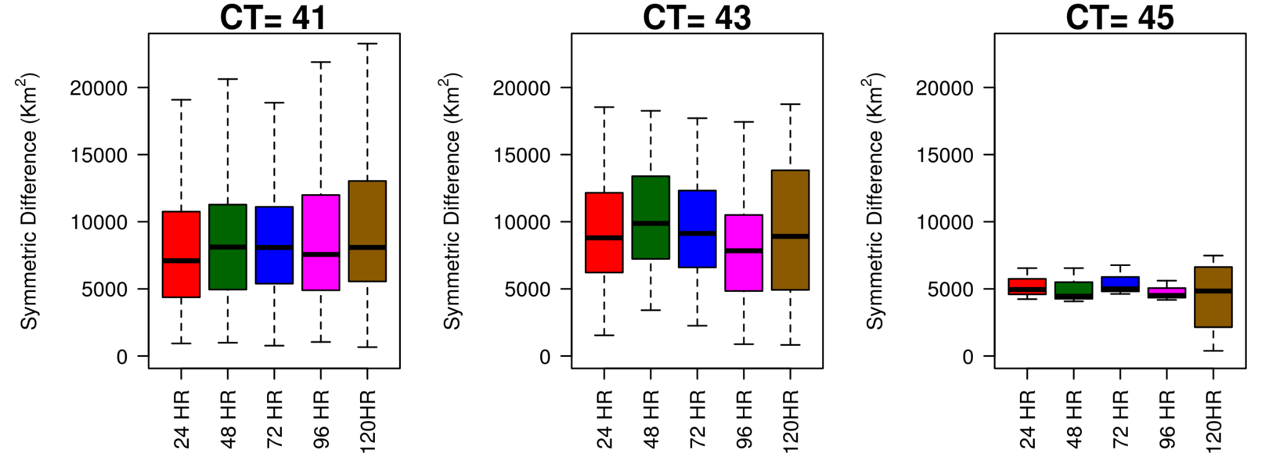
Fig.11. Verification scores obtained from MODE for the summer season ie. MAM 2022, for convolution threshold CT ≥ 41°C, CT ≥ 43°C,and CT ≥ 45°C, from 24 hr to 120 hr lead time (a) The 50th percentile intensity ratio and (b) The Symmetric difference

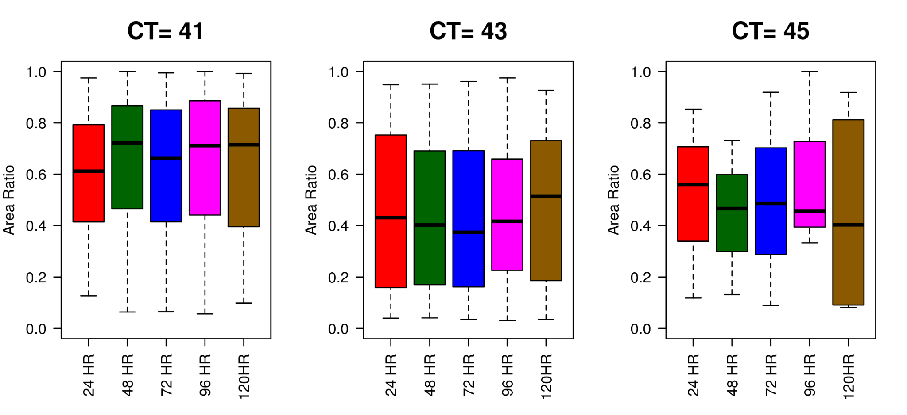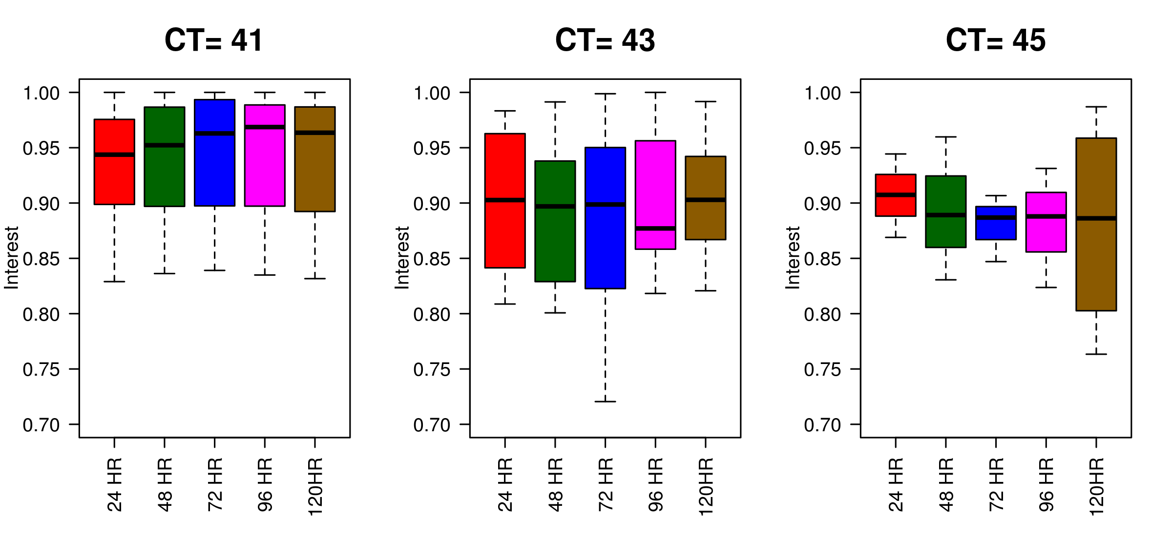
Fig.12. Verification seasonal scores obtained from MODE for the summer season ie. MAM 2022, for convolution threshold CT ≥ 41°C, CT ≥ 43°C,and CT ≥ 45°C, from 24 hr to 120 hr lead time (a) The Area Ratio and (b) Interest

