Supplementary information
Soret-effect induced phase-change in chromium nitride semiconductor film

Authors: Yi Shuang¹*, Shunsuke Mori², Takuya Yamamoto³, Shogo, Hatayama², Yun-Heub Song⁴, Jin-Pyo Hong⁵, Daisuke Ando², Yuji Sutou^{1,2}*

Affiliations:
¹WPI Advanced Institute for Materials Research, Tohoku University, 2-1-1 Katahira, Aoba, Sendai 980-8577, Japan
²Department of Materials Science, Graduate School of Engineering, Tohoku University, 6-6-11 Aoba-yama, Sendai 980-8579, Japan
³Department of Metallurgy, Graduate School of Engineering, Tohoku University, Miyagi 980-8579, Japan
⁴Department of Electronic Engineering, Hanyang University, 17 Haengdang-dong, Seongdong-gu, Seoul 133-791, Korea
⁵Department of Physics, Hanyang University, Seoul, 04763, Korea

*Corresponding authors: shuang.yi.e3@tohoku.ac.jp (Y. Shuang), ysutou@material.tohoku.ac.jp (Y. Sutou)

1. Fabrication of the CrN-based memory device.

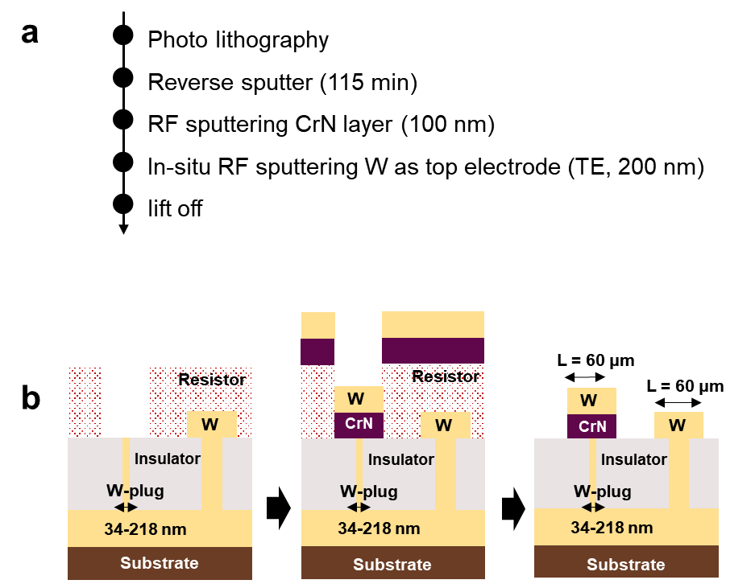

Fig. S1. (a) Fabrication sequence. (b) Process flow.

2. Crystal structure of the CrN thin film.
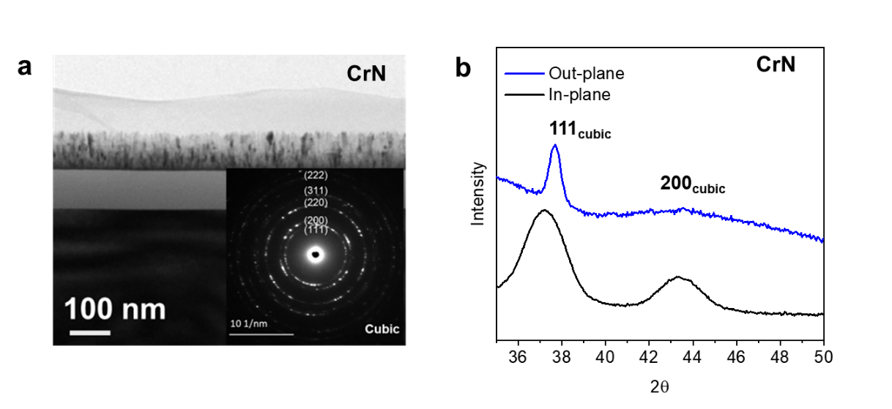
Fig. S2. (a) Bright-field cross-section TEM micrograph, revealing a columnar-like grain microstructure and a relatively smooth film surface; the inset displays a selected area electron diffraction (SAED) pattern of the film, showing a ring pattern of the polycrystalline phase that can be attributed to a single NaCl-like cubic CrN phase. (b) In- and out-of-plane XRD spectra at room temperature, indicating a cubic phase.

3. Temperature dependence of resistivity.

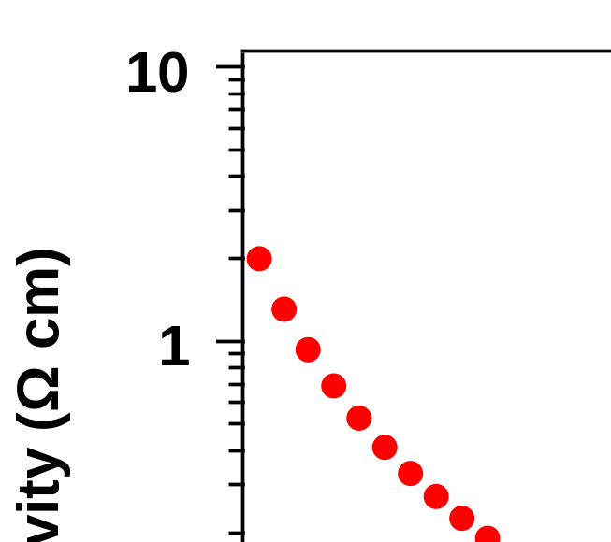

Fig. S3. The resistivity measured from the Hal measurement system at varies temperature from 80 to 400 K.

4. Setup for measuring the switching properties.

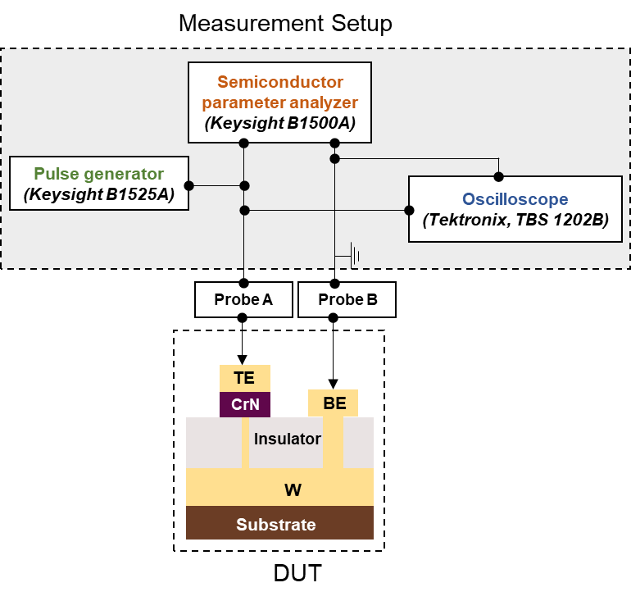
Fig. S4. The DC read resistance of the device were measured using a semiconductor parameter analyzer. To evaluate the resistive switching properties, a pulse generator was used to apply short voltage pulses to the device under test (DUT), and the pulse amplitude and pulse were confirmed by an oscilloscope.

5. Crystal structures of Cr-N compounds.

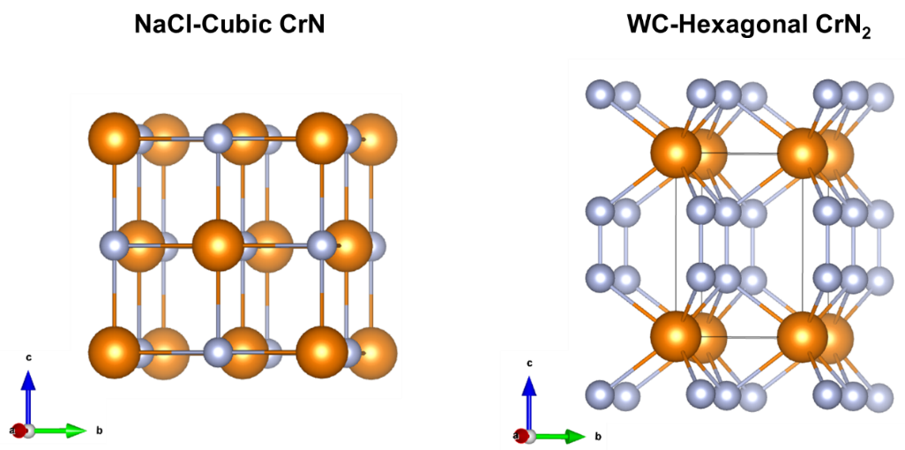
Fig. S5. Crystal structures of NaCl-like cubic CrN and WC-like hexagonal CrN₂.

6. N sites in hexagonal CrN₂.
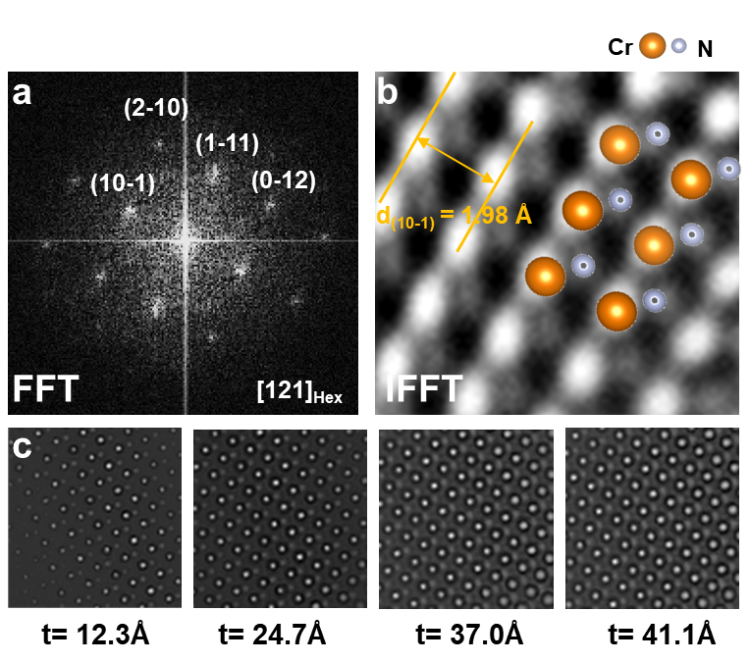
Fig. S6. (a) FFT and (b) IFFT image derived from the [121] zone axis, indicating the location of N atoms. (c) Simulated thickness/defocus map of (b) obtained by the multislice method from HRTEM images by using the QSTEM software (¹); for the simulation, the lattice parameters 𝑎 = 2.71931 Å and 𝑐 = 3.71155 Å were used for hexagonal CrN₂. The IFFT images were obtained using the Gatan DigitalMicrograph software.

7. Oxygen content as function of working pressure.

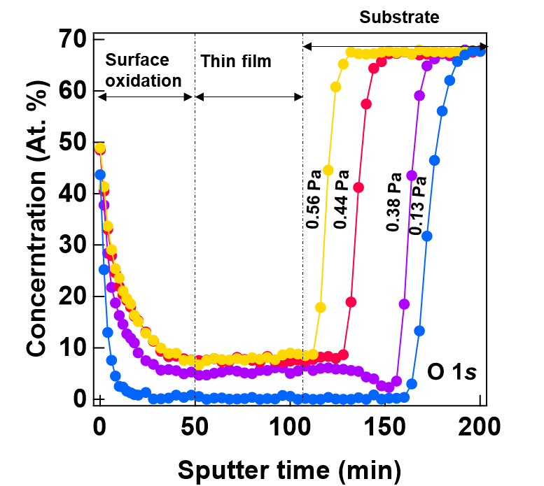

Fig. S7. The oxygen concentration profile of CrN films sputtered at various working pressure by X-ray Photoelectron Spectroscopy (XPS, Quantum 2000, ULVAC-PHI). It can be clearly seen that the O content in the flat region of the thin-film profile kept decrease with decreasing working pressure, and it reached almost 0 at the working pressure 0.13 Pa.

8. Crystal structure of the CrN’ thin film.

The CrN’ film was deposited using the same sputter chamber and conditions except for the working pressure, which was 1.3 × 10⁻¹ Pa. The TEM and XRD of CrN’ film were measured using same method with CrN thin film.
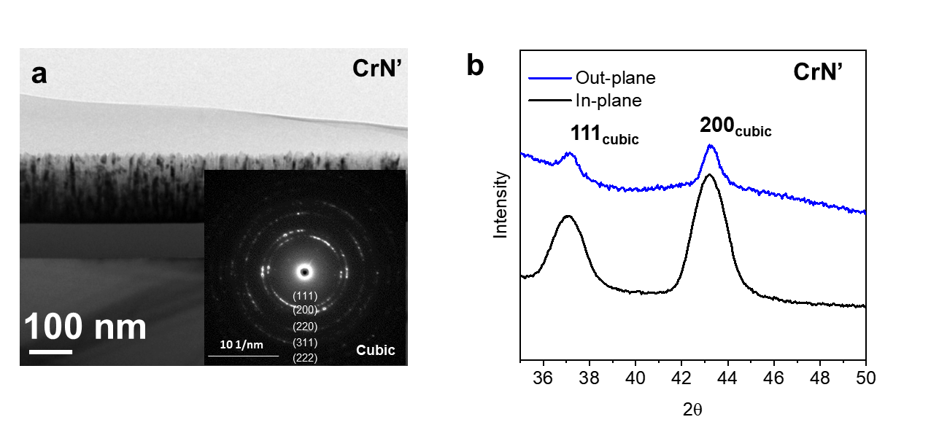
Fig. S8. (a) Bright-field cross-section TEM micrograph, exhibiting a microstructure similar to the CrN thin film shown in Fig. S2a, along with a SAED pattern (inset) showing a ring pattern of the polycrystalline phase, which can be indexed as a single NaCl-like cubic CrN phase. (b) In- and out-of-plane XRD spectra at room temperature, indicating a cubic phase.

9. The switching performance and phase change behavior of CrN’ memory.

We tested the switching performance of the CrN’-based memory device under electrical pulses. Fig. S9a displays the resulting RV characteristics. For the device with a plug size of 34 nm × 34 nm, when we applied a positive voltage pulse to the bottom electrode (BE), the device reached an HRS of ~10⁸ Ω at 1.2 V and, then, recovered its initial LRS reversibly at a higher voltage (1.5 V). The devices with a larger plug exhibited similar RV trends, indicating nonvolatile and reversible resistive switching, i.e., LRS-to-HRS (RESET process) and HRS-to-LRS (SET process). The highest HRS resistance observed was ~10⁹ Ω, and the HRS/LRS resistance ratio could be as high as 10⁶. When applying a positive-current pulse sweep (pulse width: 500 µS) in the HRS, a typical threshold switching phenomenon can be observed, same as CrN memory cell.
A TEM observation was conducted to investigate the resistive switching mechanism of the device with a plug size of 218 nm × 218 nm. Before the TEM analysis, the device sample was switched to an HRS of ~10⁶ Ω by applying a voltage pulse of 5 V for 50 ns. A distinct bright contrast was observed in the CrN’ layer between the W plug and TE electrode (Fig. S9c). Fig. S9d displays a high-resolution TEM (HRTEM) image taken at the boundary region between the matrix (upper part) and active region (lower part) indicated by a light-blue square in Fig. S9d. Fig. S9e illustrates an inverse fast Fourier transform (IFFT) image of the boundary region between matrix and active areas that is enclosed by a light-blue square in Fig. S9d; the bright and darker spots were supposed to be Cr and N atoms, respectively. On the matrix side, the IFFT image shows a clear cubic atomic column structure of CrN’, which is consistent with the lattice parameter a = 4.17 Å of a NaCl-like cubic structure. For the active region, the IFFT image reveals a new atomic column structure that can be indexed not as cubic but as hexagonal, indicating a phase change from cubic to a hexagonal structure.

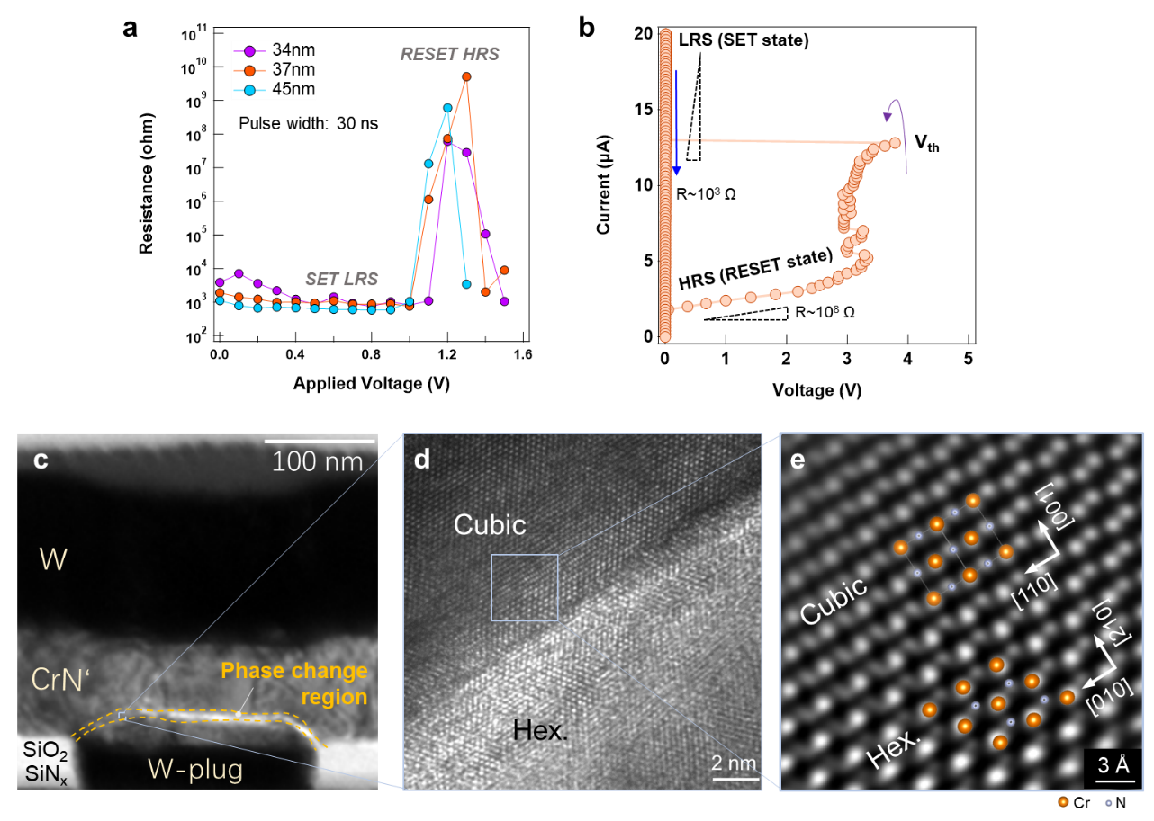
Fig. S9. (a) Resistance as a function of the pulse voltage for various plug sizes; the pulse width was fixed at 30 ns and the read voltage was 0.1 V. (b) Threshold switching behavior, showing a resistance change from ~10⁸ (high-resistance state: HRS) to ~10³ (low-resistance state: LRS). (c) Cross-sectional transmission electron microscopy (TEM) image of the device with a 218 nm × 218 nm plug, which was previously reset to a high-resistance state. (d) Cross-sectional high-resolution TEM image taken at the boundary of the phase-change region in (c). (e) Inverse fast Fourier transform image of local areas from the active and inactive region in (d).

10. The carrier types in CrN and CrN’ thin films.

Febvrier et al. recently obtained p-type CrN by controlling the stoichiometry without additional dopants in DC magnetron sputtering deposition; they demonstrated that the p-type conduction can be attributed to Cr vacancies, which pushes the Fermi level down toward the valence band.² In the present study, we first obtained a CrN film with a composition of Cr 47.5 at%, N 43.9 at%, and O 8.6 at%, where the composition was determined by RBS. The small amount of oxygen was introduced in the case of sputtering deposition at a high working pressure. In this case, the total concentration of N and O anions exceeded that of Cr, indicating a Cr-deficient composition and, thus, resulting in p-type conduction by Cr vacancies, as shown in Fig. S10 (upper figure). By lowering the working pressure during sputtering deposition, we obtained an O-free CrN film (designated as CrN’) with the N/Cr composition ratio of 0.98. This N-deficient composition film with a NaCl-type cubic structure shows an n-type semiconductor characteristic, as shown in Fig. S10 (bottom figure).

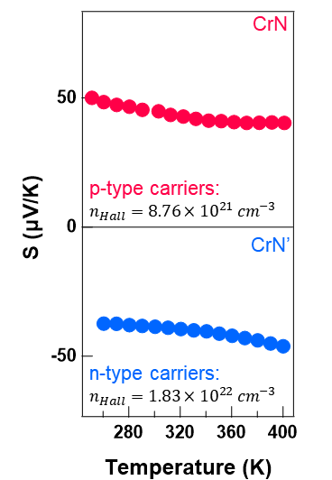

Fig. S10. Seebeck coefficient of CrN and CrN’ at various temperatures.

11 Thermal distribution simulation in CrN memory cell.

To understand the driving force of ion diffusion and phase change in CrN-based memory cells, the thermal and electrical physics of the memory devices were simply modeled without considering the thermoelectric effect (Thomson and Peltier effects), thermal boundary resistance, and electrical interface resistance. The CrN/metal electrode interfacial properties could also be ignored because the contact resistance has been confirmed to be a minor factor in the device operation and CrN behaves more like a metal than a semiconductor in conducting property terms. A constant voltage of 0.2 V was driven as a simulation input from the BE, and Joule heating was used to determine the heat generation throughout the structure. The simulations were based on the current conservation law and energy conservation law as follows:
$∇∙\left(σ∇∅\right)=0$, (S1)
$j=-σ∇∅$, (S2)
and
$ρC_{p}\frac{∂T}{∂t}=∇∙\left(k∇T\right)+ρ_{c}\left(j∙j\right)$ (S3)
where $σ$ is the electrical conductivity, $j$ is the current density, $∅$ is the electrostatic potential, $ρ$ is the density, $C_{p}$ is the specific heat, T is the temperature, t is the time, k is the thermal conductivity, and $ρ_{c}$ is the resistivity. The program that solves these equations is implemented in the open-source software, OpenFOAM. The corresponding values for CrN, TiN, W, and SiO₂ in the devices used for the calculation are listed in Table S2.

Table S2. Resistivity, thermal conductivity, density, and specific heat values used for the simulations.
 | Resistivity  (mΩ∙cm) | Thermal conductivity (W/mK) | Density (g/cm³) | Specific heat (J/mol∙K)
CrN | 0.93 | 2.3³ | 5.9 | 52.44⁴
TiN | 2.5E−2⁵ | 10⁶ | 5.4 | 37.22⁴
W | 5.6E−3⁷ | 50⁶ | 19.25 | 24.31⁴
SiO₂ | $$∞$$ | 1.38⁶ | 2.65 | 44.57⁴

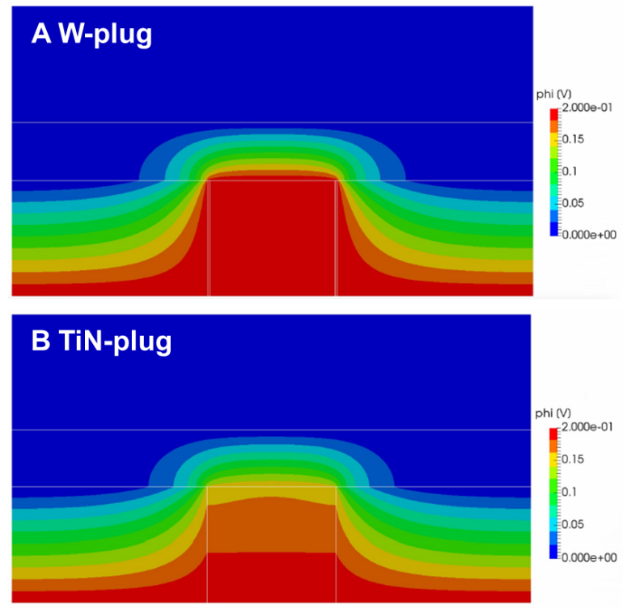

Fig. S11. Simulated electrical field distribution. In (a) W plug with a 4-nm TiN adhesion layer and (b) TiN plug devices.

12. Cyclic resistive switching of CrN memory.

We investigated the feasibility of cyclic resistive switching in both CrN-based memory devices (Fig. S12). Although our devices exhibited resistive switching under unipolar positive voltage pulses, the narrow window of the pulse voltage applied for switching to the HRS (as small as 0.2 V) made it difficult to switch repeatedly under a constant pulse width. For example, the HRS was sometimes hard to achieve accurately because a little bit higher voltage could induce an LRS beyond the voltage limit for the HRS. In T-shaped PCRAM operation, positive electrical pulses are generally applied to the TE for both the RESET and SET processes because of the higher thermal efficiency compared with the case of negative electrical pulses applied to the BE ⁸. Therefore, to investigate the endurance of the CrN-based memory devices, we adopted a negative electrical pulse direction to lower the thermal efficiency for the SET process, which enabled a large window of pulse voltage for the RESET/SET switch. The CrN-based memory device with a plug size of 45 nm × 45 nm showed bipolar switching. The device with an LSR of ~2 × 10⁴ Ω started to switch to an HRS of ~2 × 10⁸ Ω when applying a positive voltage pulse of 1.4 V, and it went back to the LRS after applying a negative voltage pulse of −1.4 V with a width of 50 ns (Fig. S13).
Note that the programming window in the bipolar cyclic measurements was about 10³–10⁴, smaller than that in the unipolar RV measurements, indicating a dependence of the programming window on the switching mode (unipolar or bipolar). Besides, the endurance of CrN-based memory devices probably also depends on their cell structure parameters, including thickness of the sidewall electrode, presence or absence of the heater electrode sidewall, and electrode contact size. Further studies are required to evaluate the cyclic durability of these devices, such as cell structure optimization, electrical pulse optimization for operation, and selection of suitable heater electrode materials.

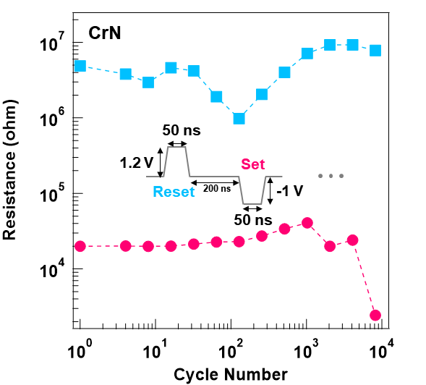

Fig. S12. Results on endurance tests on cells with a plug size of 45 nm × 45 nm.

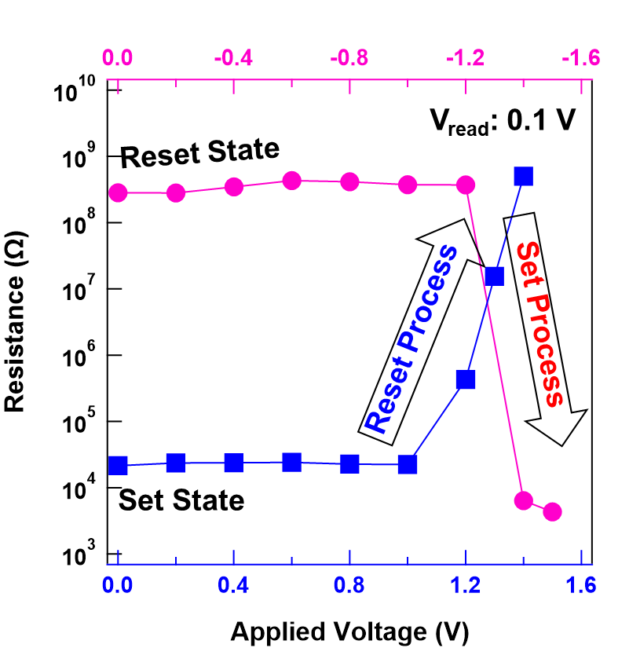
Fig. S13. Bipolar pulse switching behavior of a CrN-based memory cell. RV characteristics for a plug size of 45 nm × 45 nm.

1. Koch, C. DETERMINATION OF CORE STRUCTURE PERIODICITY AND POINT DEFECT DENSITY ALONG DISLOCATIONS by. (2002).
2. Le Febvrier, A. et al. P -type behavior of CrN thin films via control of point defects. Phys. Rev. B 105, 104108 (2022).
3. Quintela, C. X. et al. Epitaxial CrN Thin films with high thermoelectric figure of merit. Adv. Mater. 27, 3032–3037 (2015).
4. Webbook, N., Nist, T., Webbook, C., Reference, S. & Program, D. Welcome to the NIST Chemistry WebBook. Secretary 1–2 (2012).
5. Sosnin, D., Kudryashov, D. & Mozharov, A. Investigation of electrical and optical properties of low temperature titanium nitride grown by rf-magnetron sputtering. J. Phys. Conf. Ser. 917, 052025 (2017).
6. Ahn, C. et al. Energy-Efficient Phase-Change Memory with Graphene as a Thermal Barrier. Nano Lett. 15, 6809–6814 (2015).
7. Elert, G. Resistivity of Gold, The Physics Factbook. https://hypertextbook.com/facts/2004/DeannaStewart.shtml (2004).
8. Hatayama, S., Song, Y. H. & Sutou, Y. Low resistance-drift characteristics in Cr₂Ge₂Te₆-based phase change memory devices with a high-resistance crystalline phase. Mater. Sci. Semicond. Process. 133, 105961 (2021).

