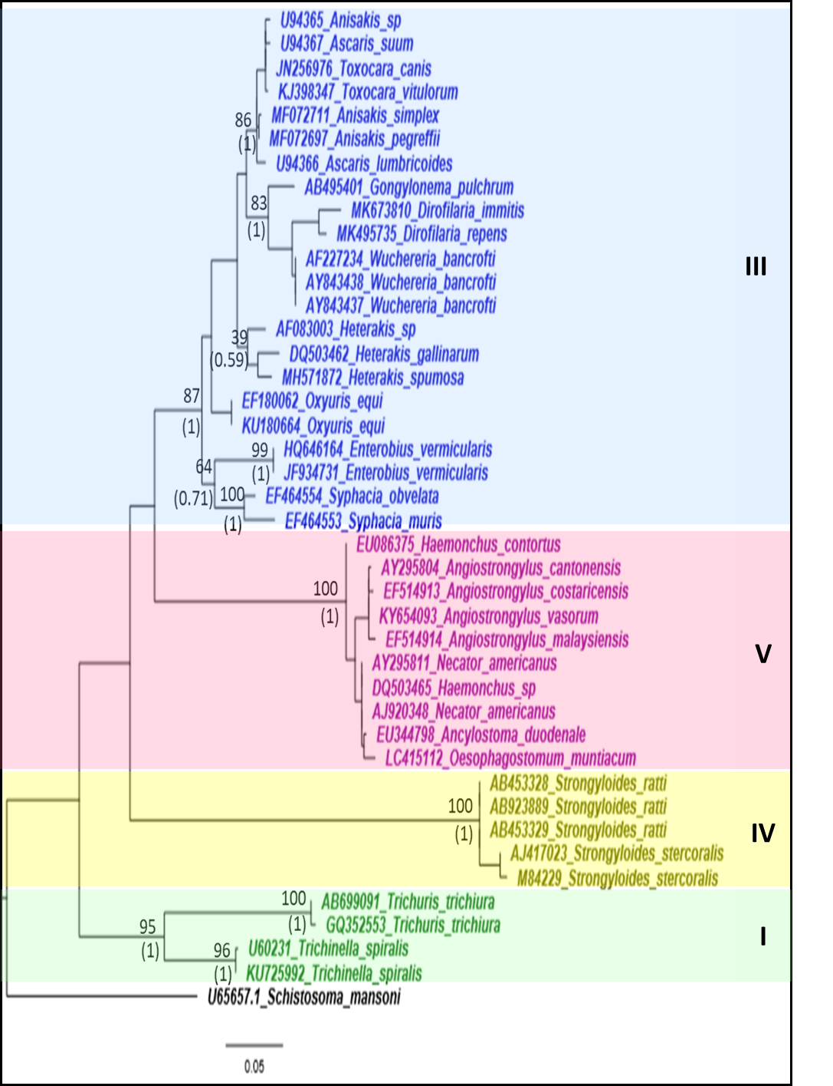
Additional file 3: Figure S1. Phylogeny using 18S rRNA gene sequences as a genetic marker
Phylogenetic analyzes using maximum likelihood (TN93 + G) and Bayesian inference. Numbers without parentheses at nodes indicate bootstrap values from ML analysis, whereas numbers with parentheses indicate posterior probability values from BI analysis. Different colors correspond to each nematode clade: outgroup (black), clade I (green), clade III (blue), clade IV (yellow), clade V (purple). Monophyletic clades are highlighted in their respective color.

