Supplementary Table 5. Relative abundance of bacterial taxa in vaginal samples obtained from “Prevention” group
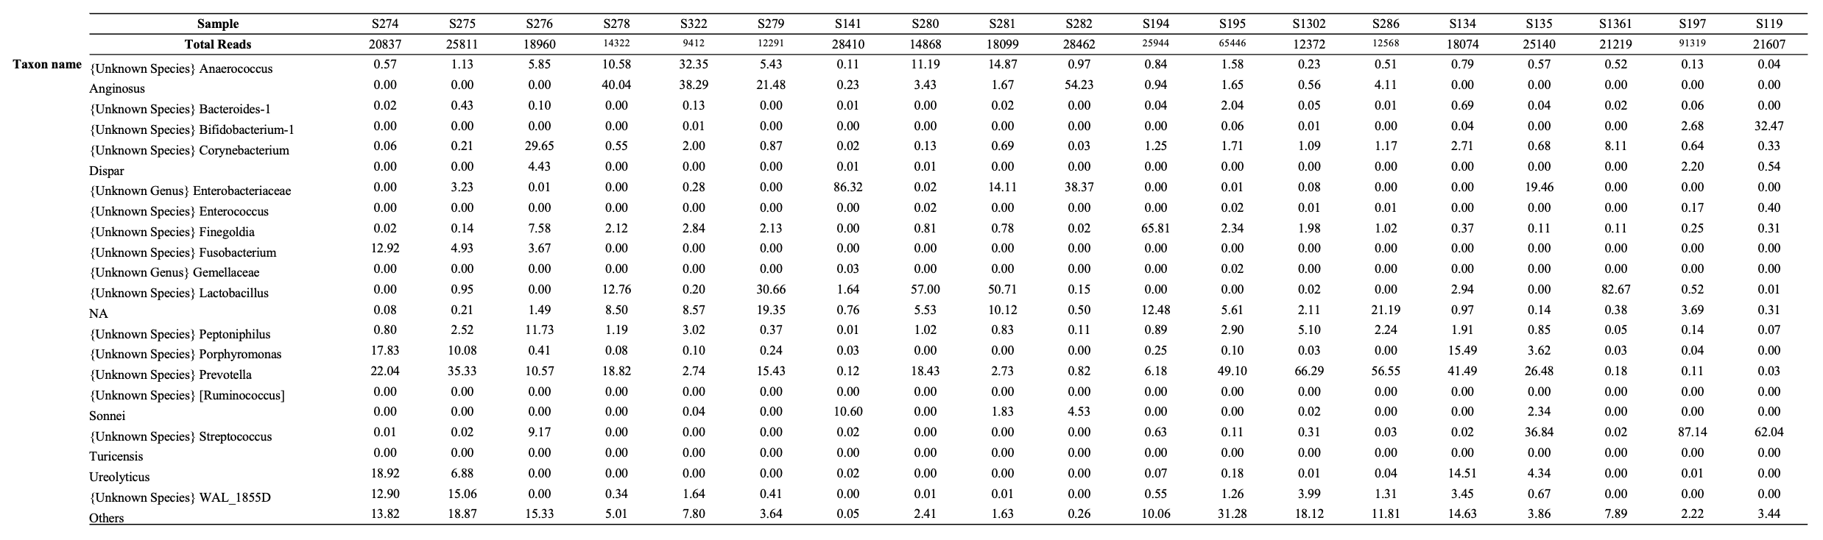
Supplementary Table 5-1.
Taxa with >10% abundance in at least one sample are included. Taxa in the samples with < 10% abundance in all samples are aggregated into category: "Others.” NA: not applicable

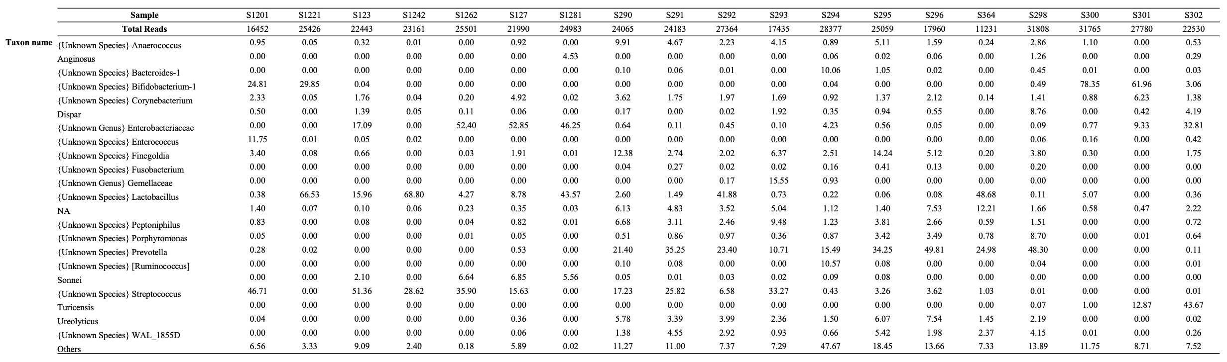
Supplementary Table 5-2.
Taxa with >10% abundance in at least one sample are included. Taxa in the samples with < 10% abundance in all samples are aggregated into category: "Others.” NA: not applicable

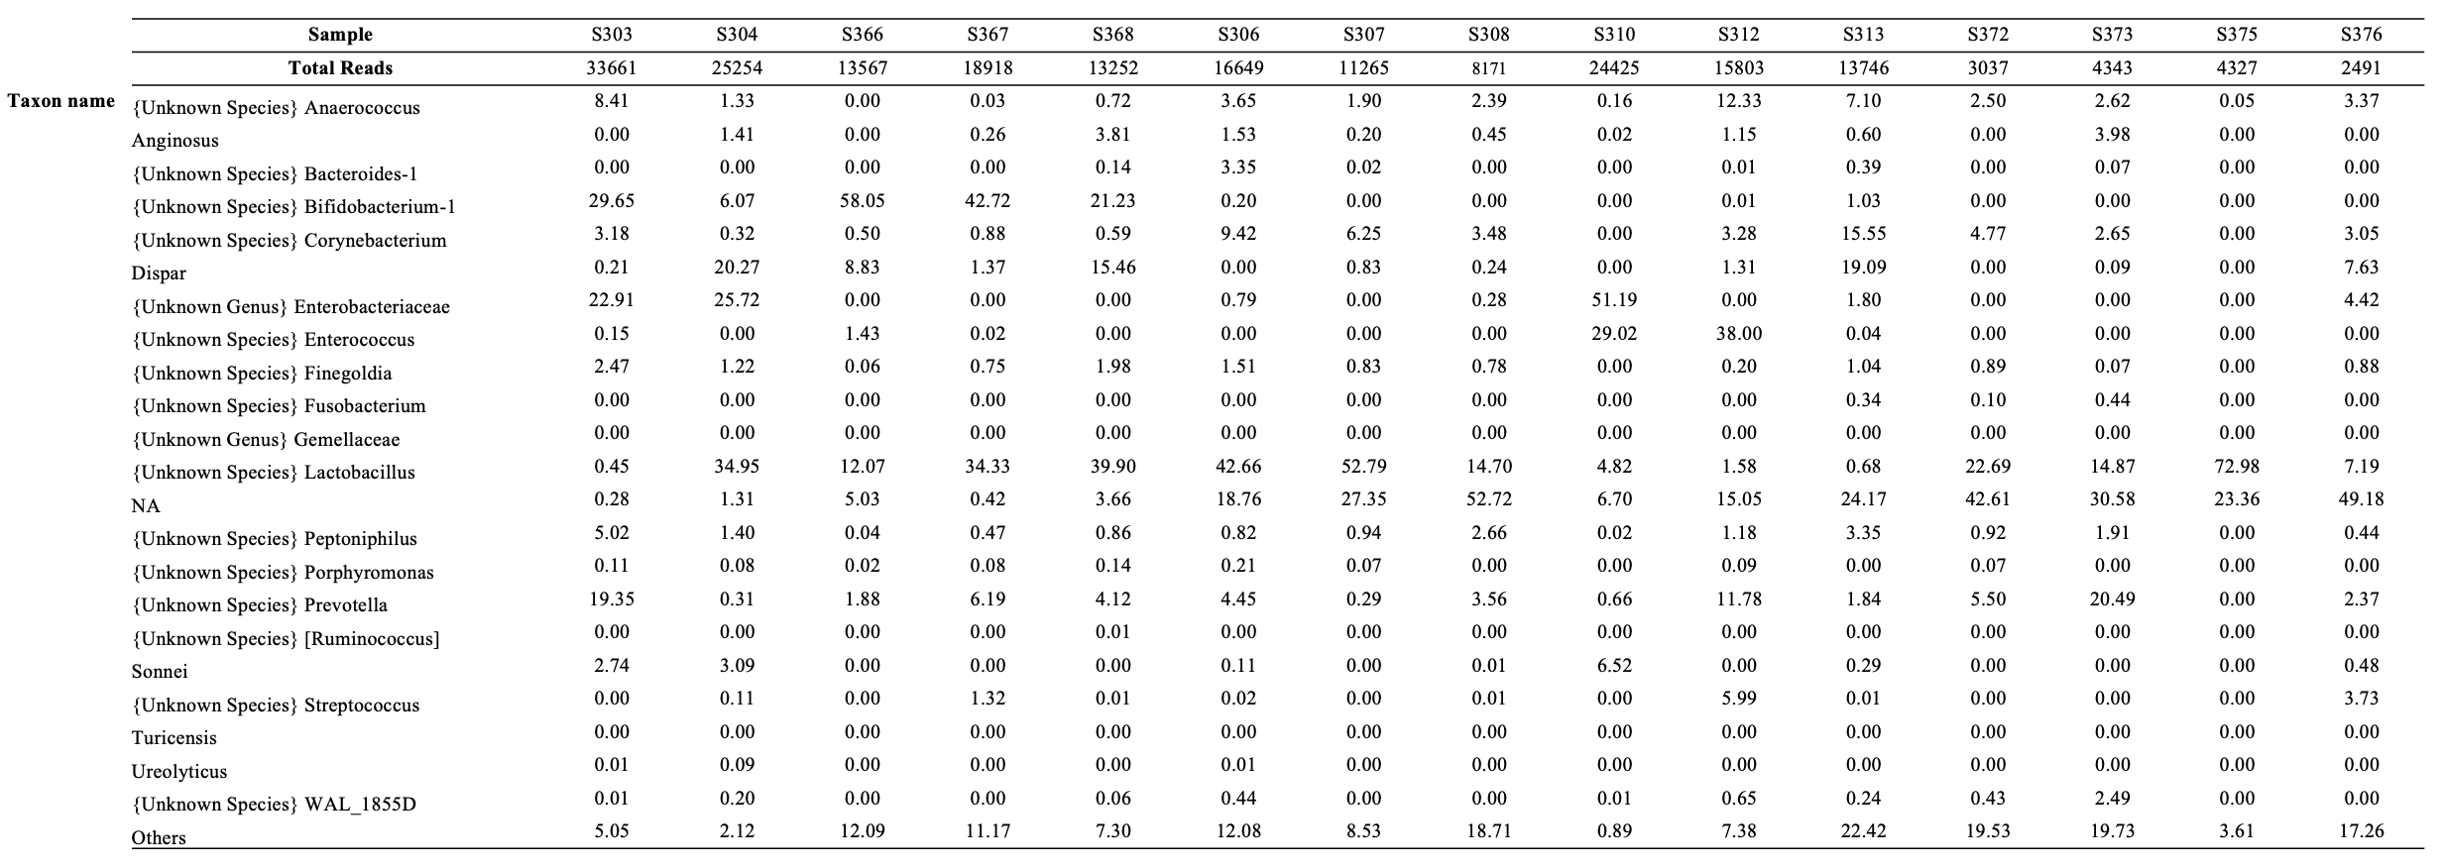
Supplementary Table 5-3.
Taxa with >10% abundance in at least one sample are included. Taxa in the samples with < 10% abundance in all samples are aggregated into category: "Others.” NA: not applicable

