Supplementary Table 2. Relative abundance of bacterial taxa in vaginal samples obtained from the “Healthy” group.
No.4
No.8
No.4
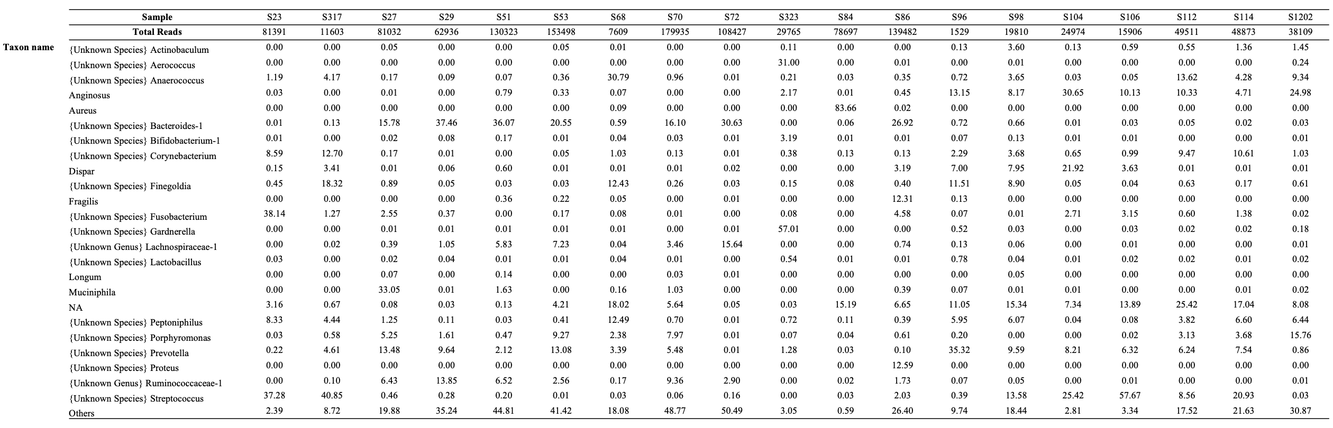
Supplementary Table 2-1.
Taxa with >10% abundance in at least one sample are included. Taxa in the samples with < 10% abundance in all samples are aggregated into category: "Others.” NA: not applicable

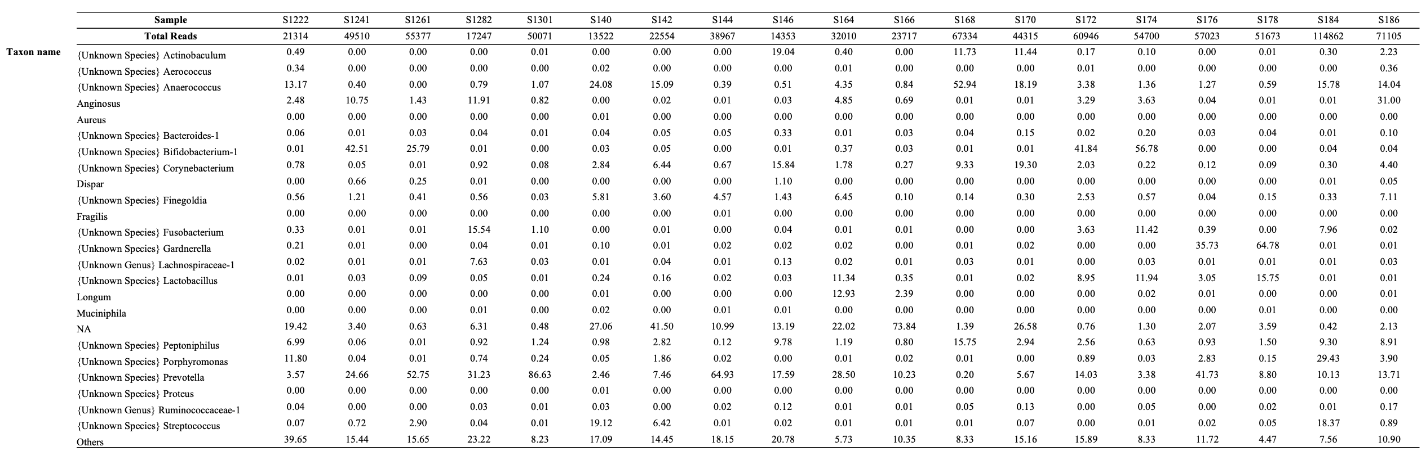
Supplementary Table 2-2.
Taxa with >10% abundance in at least one sample are included. Taxa in the samples with < 10% abundance in all samples are aggregated into category: "Others.” NA: not applicable

