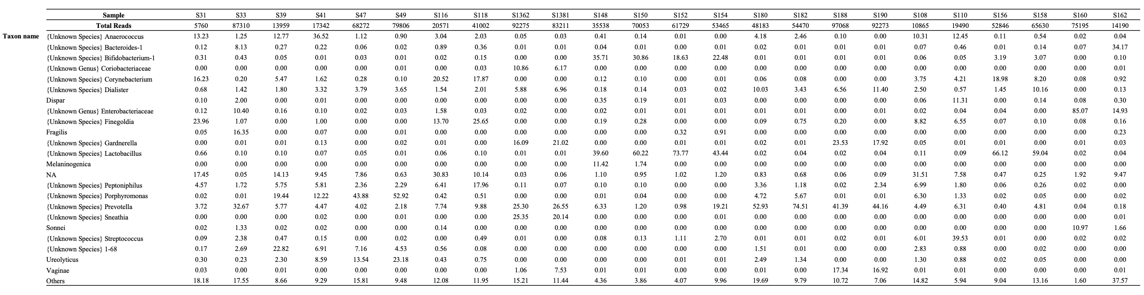
Supplementary Table 3. Relative abundance of bacterial taxa in vaginal samples obtained from “Uncomplicated cystitis” group.
Taxa with >10% abundance in at least one sample are included. Taxa in the samples with < 10% abundance in all samples are aggregated into category: "Others.” NA: not applicable

