Supplementary Figures
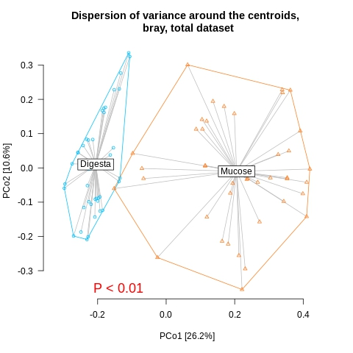
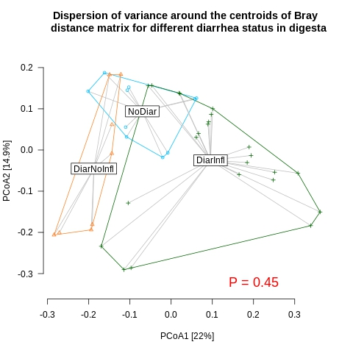
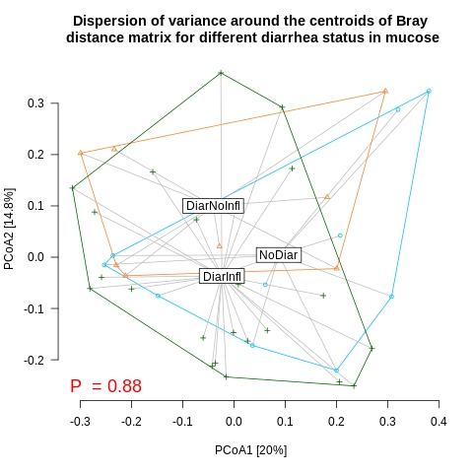
Fig. S1
A
B
C

PCo plot of variance dispersion around the centroids for Bray-Curtis dissimilarity in the whole dataset for digesta vs. mucosal samples (A), in digesta (B), and in mucosal samples (C). P-value below 0.05 indicates lack of homogeneity of variance around centroids.

Fig. S2
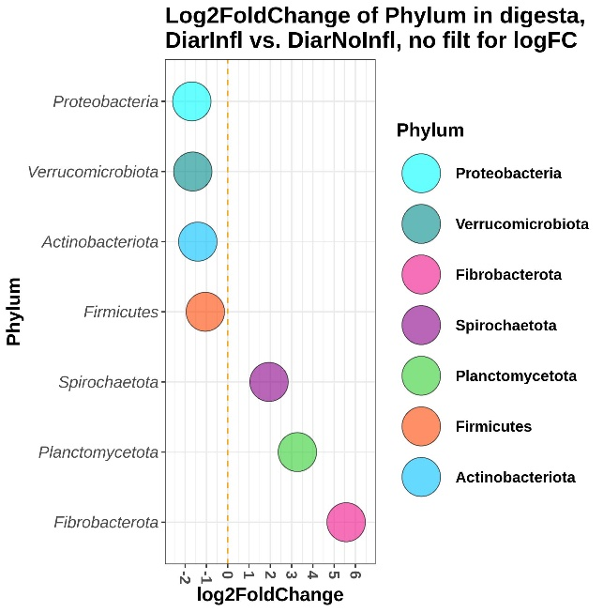
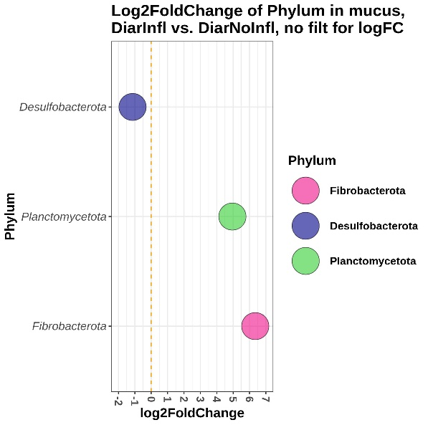
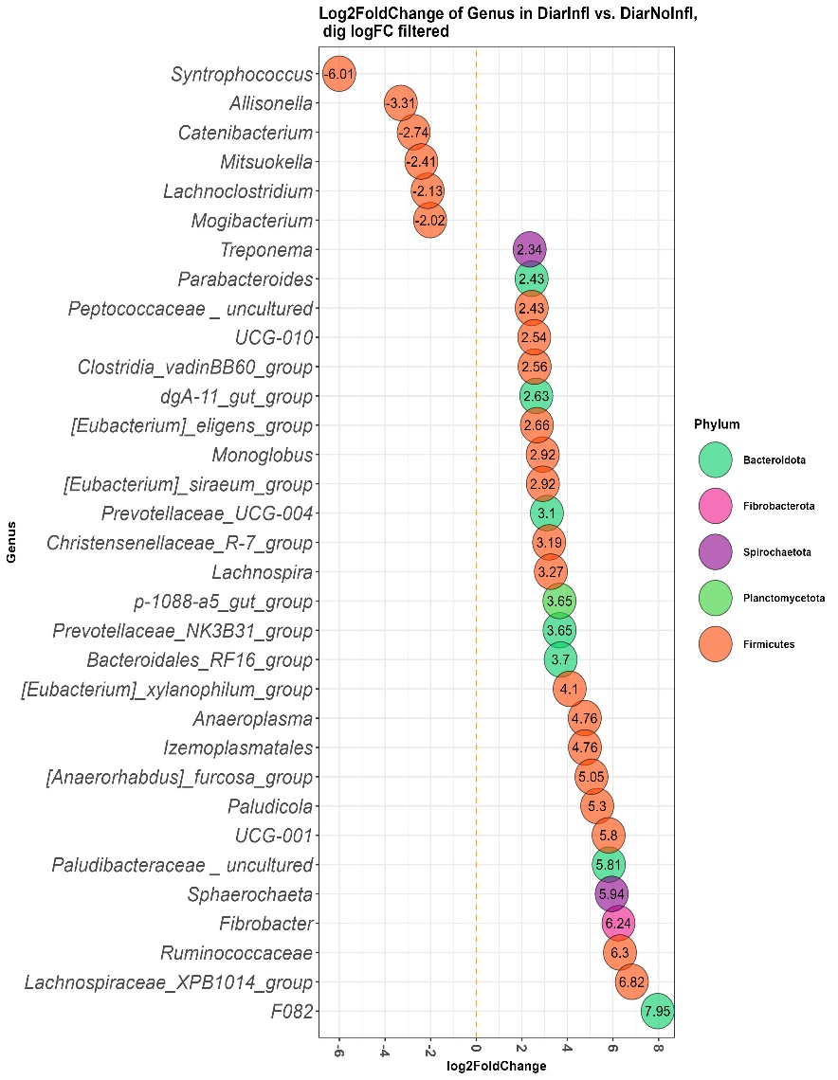
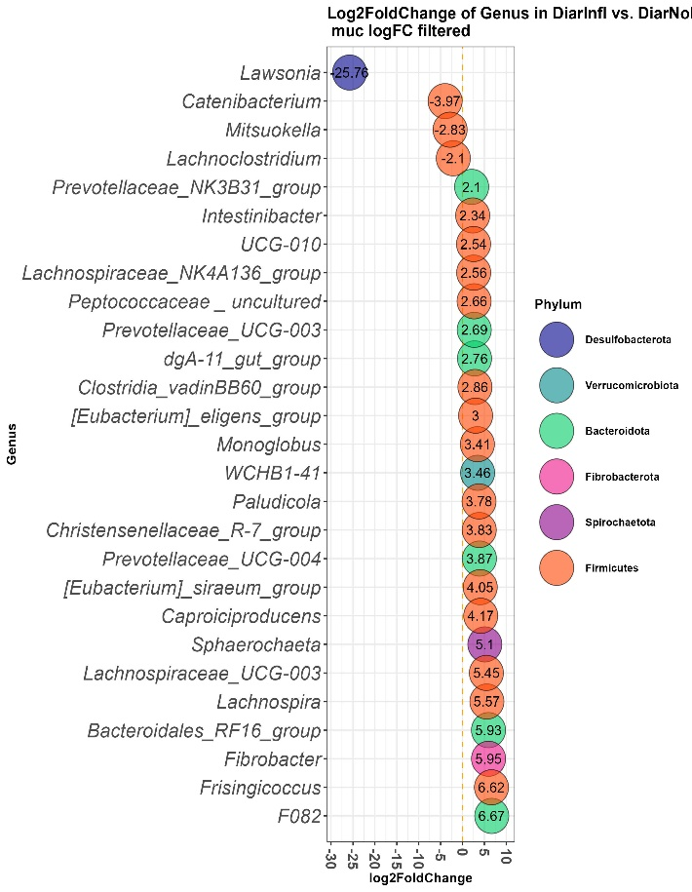
A
B
C

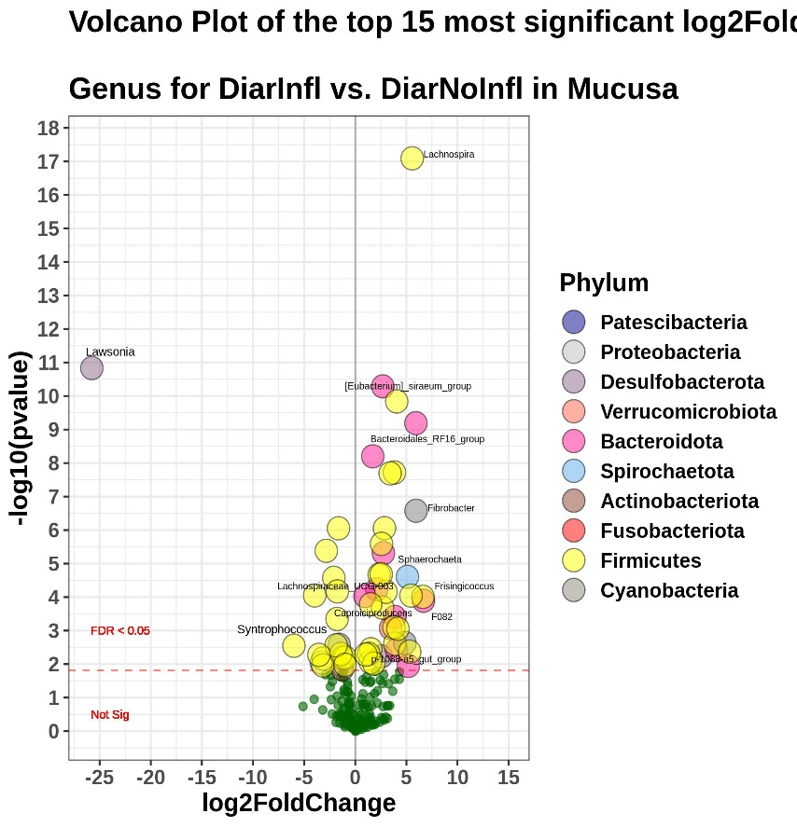
D

Differential abundance of phyla (FDR < 0.05) for DiarInfl vs. DiarNoInfl in digesta (A) and in mucus (B). Differentially abundant genera for DiarInfl vs. DiarNoInfl in digesta (C) and in mucus (D). Only genera with FDR ≤ 0.05 and with absolute value of log2FoldChange > 2 are presented. Each genus is colored to its representative phylum and labeled with their correspondent log2FoldChange values.

