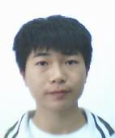 Yu-hang Wu is pursuing undergraduate in Jimei university. His research interest includes complex system.

Lin Xie is pursuing M.S. candidate in Jimei univeristy. Her research interests include complex system and stochastic process.

Wen-qing Ni received the B.S. and M.S from Fujian normal university respectively in 2000 and 2003, then received Ph.D from Zhejiang Gongshang University in 2018. His research interest includes complex system and stochastic process.

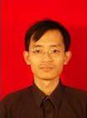 Guo-wei LEI received the B.S., M.S. and Ph.D degree from Gannan Normal University, Xiamen University, Beijing University of Posts and Telecommunications in 1999, 2004 and 2019 respectively. His research interests include modulation and codes, MIMO and space time codes.

 Guang-song Yang received the B.S. and Ph.D degree from Guilin university of electronic technology and Xiamen university in 1990 and 2004 respectively. His research interests include broadband mobile communication technology, RF and microwave devices, mobile terminals and internet-of-things.

