Supplemental Materials
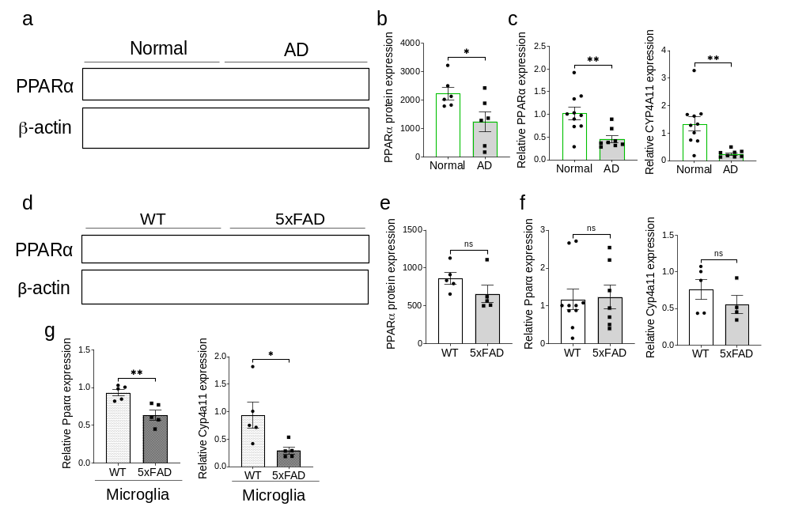
Supplementary Figures and Legends
Figure S1: PPARα levels suppressed in human AD and 5xFAD isolated microglia.
a. Representative Western blot analysis of the expression of PPARα in postmortem brain tissue from AD patients and cognitively normal aged-matched controls (n=6/group). Loading control was beta actin. b. Quantification of PPARα protein expression normalized to beta actin from panel A. c. qPCR analysis of expression of PPARA and downstream target CYP4A11 in the cortex of human AD patients and aged matched controls (n=6/group). d. Representative Western blot analysis of the expression of PPARα in 9-month-old 5xFAD and WT littermates (n=5/group). Loading control was beta actin. e. Quantification of PPARα protein expression normalized to beta actin from panel A. f. qPCR analysis of expression of Ppara and downstream target Cyp4a11 in the cortex of 9-month-old 5xFAD and WT littermates (n=5/group). g. qPCR analysis of Ppara and downstream target Cyp4a11 in sorted microglia isolated from 9-month-old 5xFAD and WT littermates’ brains (n=5/group). For all panels, data are presented as mean ± SEM. ns: non-significant, *p < 0.05, **p < 0.01, by 2-sided t tests.
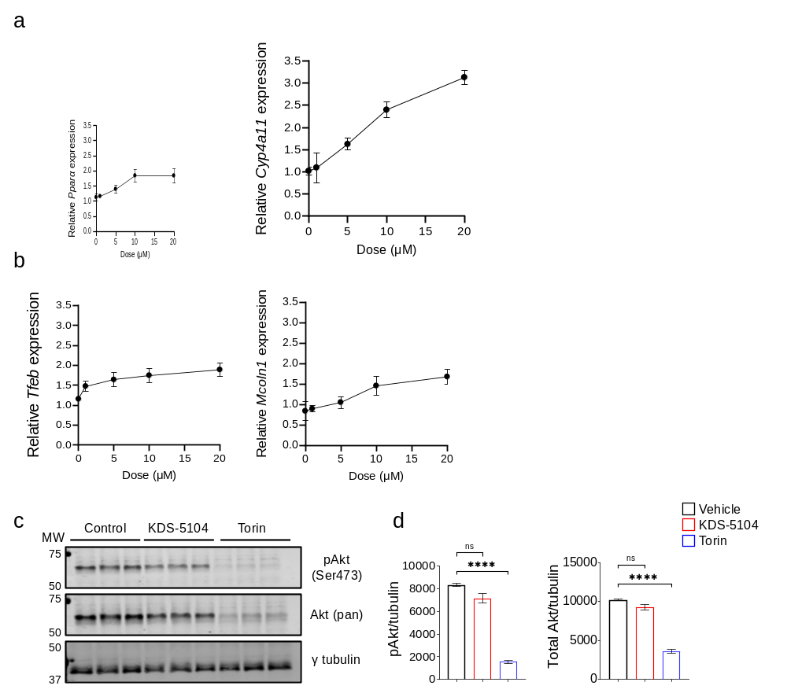
Figure S2: Dose optimization of KDS-5104 induced TFEB induction.
a. qPCR analysis of Ppara and Cyp4a11 in primary microglia treated with various concentrations of KDS-5104 (0 µM, 1 µM, 5 µM, 10 µM, and 20 µM). b. qPCR analysis of Tfeb and Mcoln1 in microglia treated with various concentrations of KDS-5104 (0 µM, 1 µM, 5 µM, 10 µM, and 20 µM). c. Representative Western blot analysis of pAkt (Ser473 phosphorylation site), total Akt in KDS-5104 treated microglia. The mTOR inhibitor mTOR was used as a positive control. Gamma tubulin was used as a loading control. d. Quantification of protein expression, ration of pAkt to total Akt and pAkt normalized to tubulin. For all panels, data are presented as mean ± SEM. ns: non-significant, ****p < 0.0001. One way ANOVA with Tukey's multiple comparisons tests as the post hoc analysis.

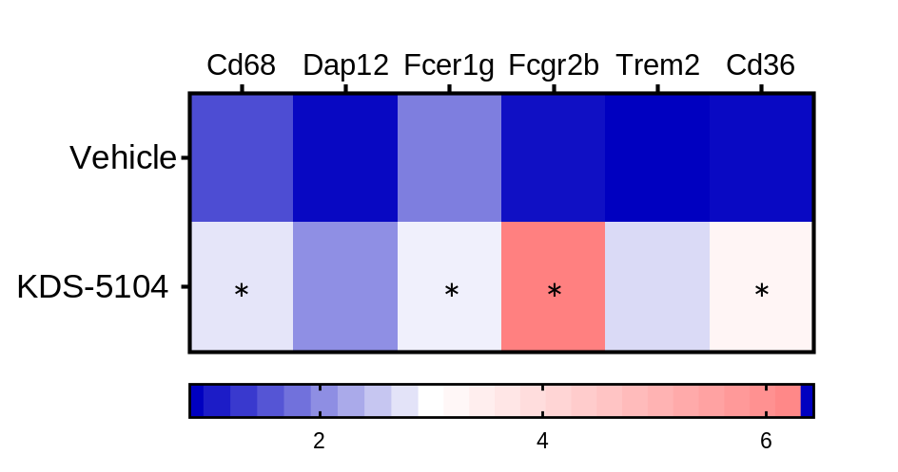
Figure S3: Phagocytosis genes were upregulated by KDS-5104 treatment.
Heat map of qPCR analysis of phagocytosis genes Cd68, Dap12, Fcerg1g, Fcgr2b, Trem2 and Cd36 are upregulated in WT primary microglia treated with KDS-5104 (10 µM; 8-hour treatment) compared to vehicle treated control. *p< 0.05 by two-sided t-tests.

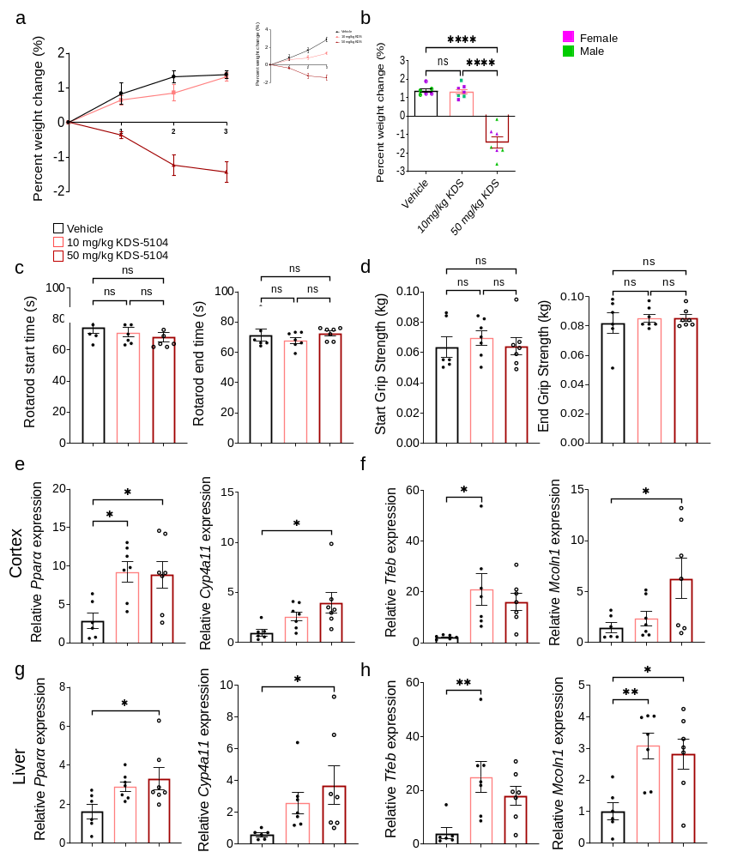

Figure S4: Behavioral and molecular assessment of subchronic KDS-5104 administration in WT mice.
WT mice received a dose of KDS-5104 (10 mg/kg or 50 mg/kg, i.p.) every other day for 3 weeks. a. Percent body weight change measured weekly. b. Total percent body weight change by sex. c. Time latency on rotarod prior to the start of KDS-5104 treatment and at the conclusion of the KDS-5104 treatment. d. The measured force (kg) of forelimb grip strength prior to the start of KDS-5104 treatment and at the conclusion of KDS-5104 treatment. e. qPCR analysis of cortex tissues of PPARa and downstream target Cyp4a11. f. qPCR of cortex tissue of Tfeb and Mcoln1 expression in the three groups. g. qPCR analysis of liver tissue measuring PPARa and Cyp4a11 and h. Tfeb and Mcoln1 (n=6 mice/group). For all panels, data are presented as mean ± SEM. ns: non-significant, *p < 0.05, **p < 0.01, ****p < 0.0001. One way ANOVA with Tukey's multiple comparisons tests as the post hoc analysis.

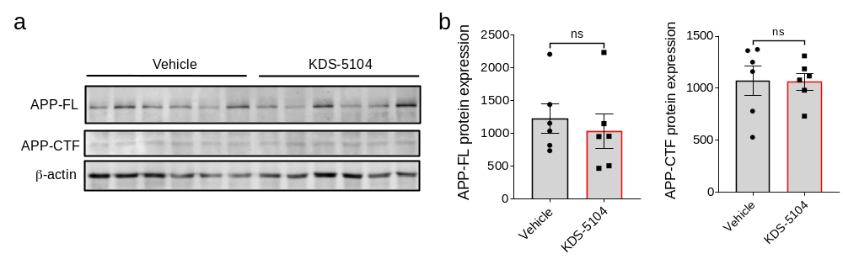 Figure S5: KDS-5104 treatment does not alter APP processing.
a. Western blot analysis of APP full length (APP-FL) and C-terminal fragment (APP-CTF) of the cortical protein extract from vehicle or KDS-5104 treated 5xFAD mice. β-actin was used as a loading control. b. Quantification of APP-FL and APP-CTF normalized to β-actin (n=5 mice/group). Data are presented as mean ± SEM. ns: non-significant by 2-sided t tests.

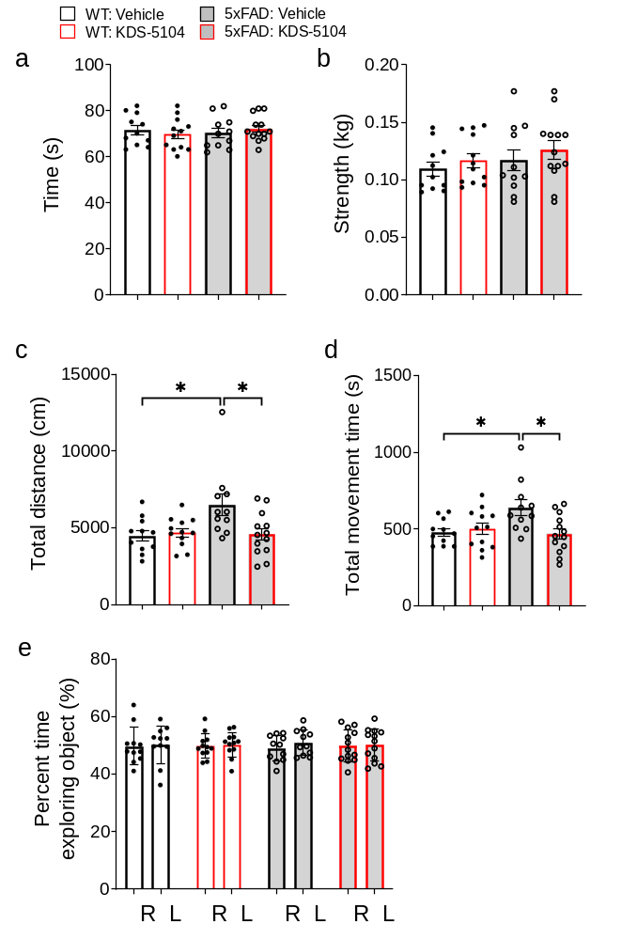
Figure S6: General neurological assessment of KDS-5104 treatment.
a. Bar graph depicting the time spent on rotarod in WT and 5xFAD mice treated with vehicle or KDS-5104. b. Bar graph showing the fore limb force (kg) of each animal measured by grip strength apparatus. c. The open field test to assess total distance travelled and d. Total movement time. e. Bar graph depicting the percentage of time spent with each identical object in the training phase of NOR for each group (n=8-10 mice/group). For all panels, data are presented as mean ± SEM. *p < 0.05. One way ANOVA with Tukey's multiple comparisons tests as the post hoc analysis.

Table S1. Significantly upregulated lipid species by KDS-5104 treatment in 5xFAD mice.
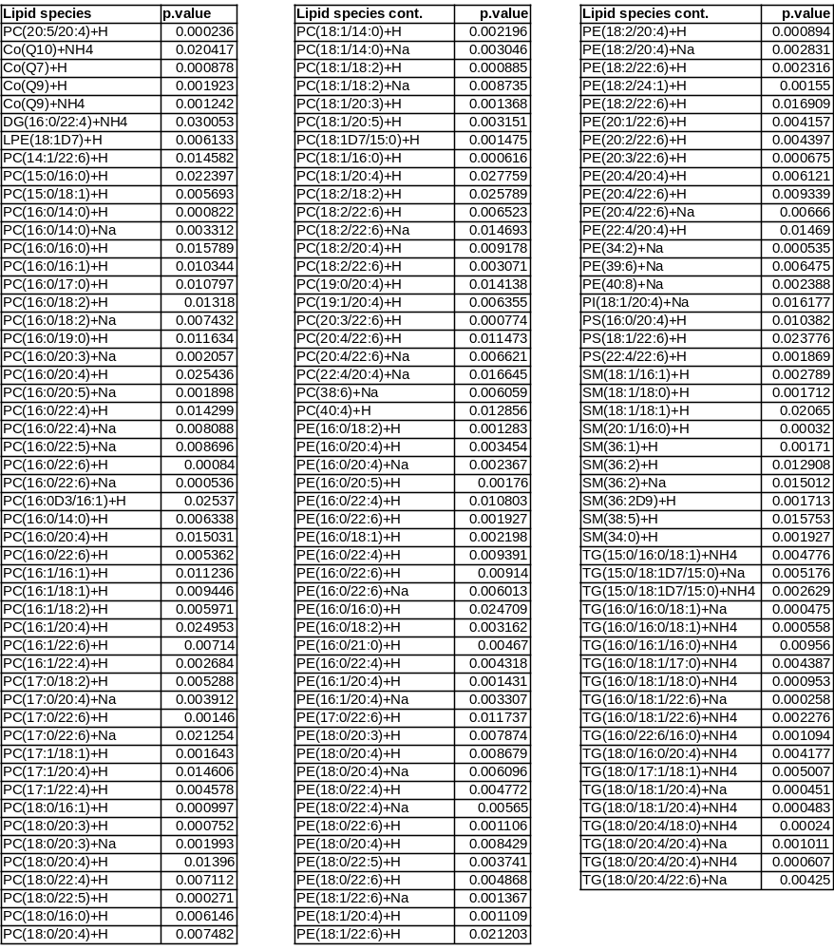

Table S2. Demographic data for postmortem brain tissue from AD patients and aged matched cognitively normal controls.
