A Appendix
A.1. Financial Inclusion Score
Adding respective points together and rescaling by multiplying by ¹⁰⁰⁄₅ produces a financial inclusion measure that yields a value between 0 and 100.
Table 3 Contributions Toward the Financial Inclusion Score.
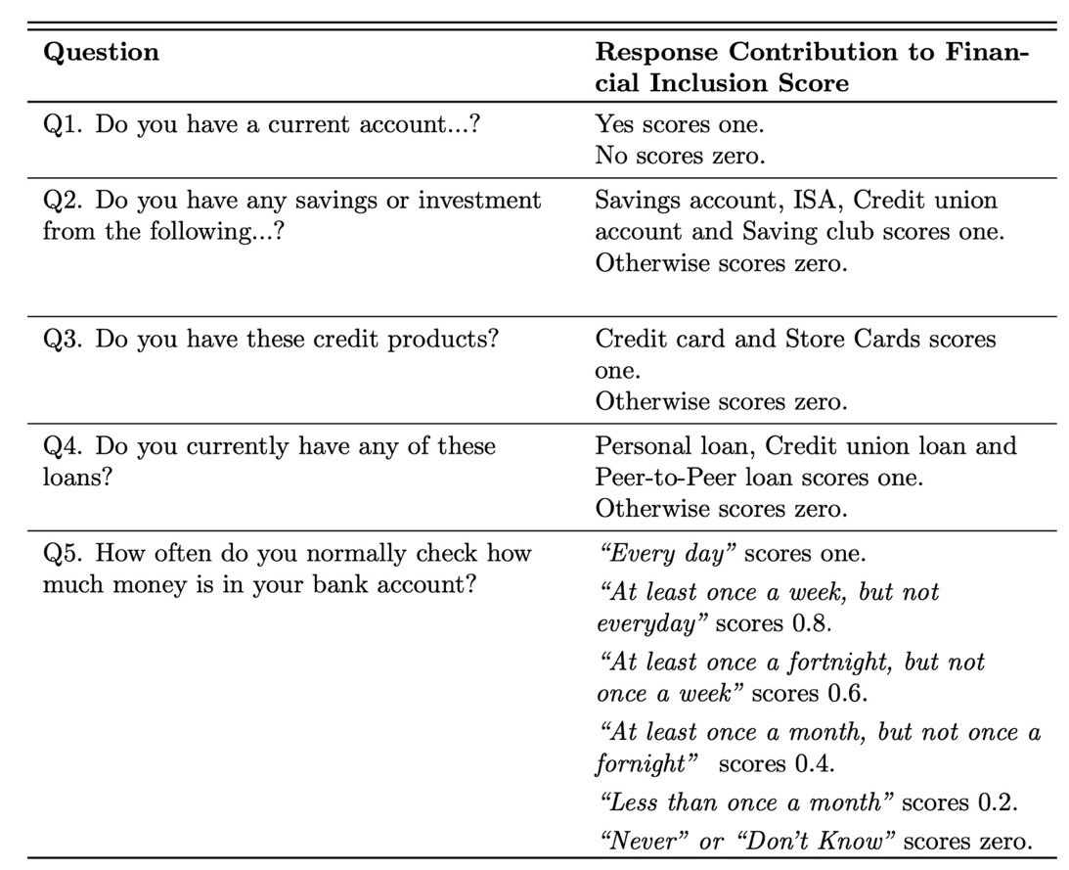

A.2. Financial Knowledge Score
Each question in Box 1 addresses an essential component of personal finance. Question (1) assesses respondents’ capability to read simple financial statements. Question (2) evaluates respondents’ basic financial numeracy, and Question (3) examines respondents’ familiarity with compound interest, exponentially expanding interest payments. Finally, Question (4) probes whether respondents understand inflation’s impact on purchasing power. Every correct answer contributes one point to the overall financial knowledge score. For reporting purposes, the score undergoes normalisation to 100, which entails multiplying the number of correct responses by ¹⁰⁰⁄₄.

Box 1: Financial Capability Survey Financial Knowledge Questions
Questions (1) and (2) direct respondents to enter an amount or “Don’t know”. Conversely, Questions (3) and (4) present multiple options to the respondents. Bold text indicates the question’s correct answer.

(1) Looking at this example of a bank statement, can you tell me how much money was in the account at the end of February? Please write your answer to the nearest pound. [£61]
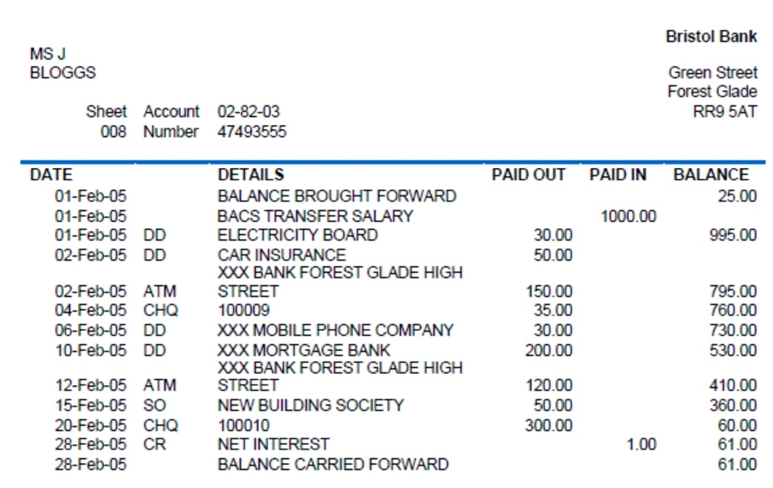

(2) Suppose you put £100 into a savings account with a guaranteed interest rate of 2% per year. You do not make any further payments into this account, and you do not withdraw any money. How much would be in the account at the end of the first year, once the interest payment is made? Enter amount. [£102]

(3) And how much would be in the account at the end of five years (remembering there are no fees or tax deductions). Would it be…?
¨ More than £110 ¨ Exactly £110 ¨ Less than £110 ¨ Impossible to tell ¨ Don’t know

(4) If the inflation rate is 5% and the interest rate you get on your savings is 3%, will your savings have more, less or the same amount of buying power in a year’s time?
¨ More ¨ The Same ¨ Less ¨ Don’t know
A.3. Financial Behaviour Score
The financial behaviour estimates a score based on “financially savvy” behaviours (Table 4). The score ranges from 1 to 7 once normalised by dividing by 24.
Table 4 Contributions Toward the Financial Behaviour Score.
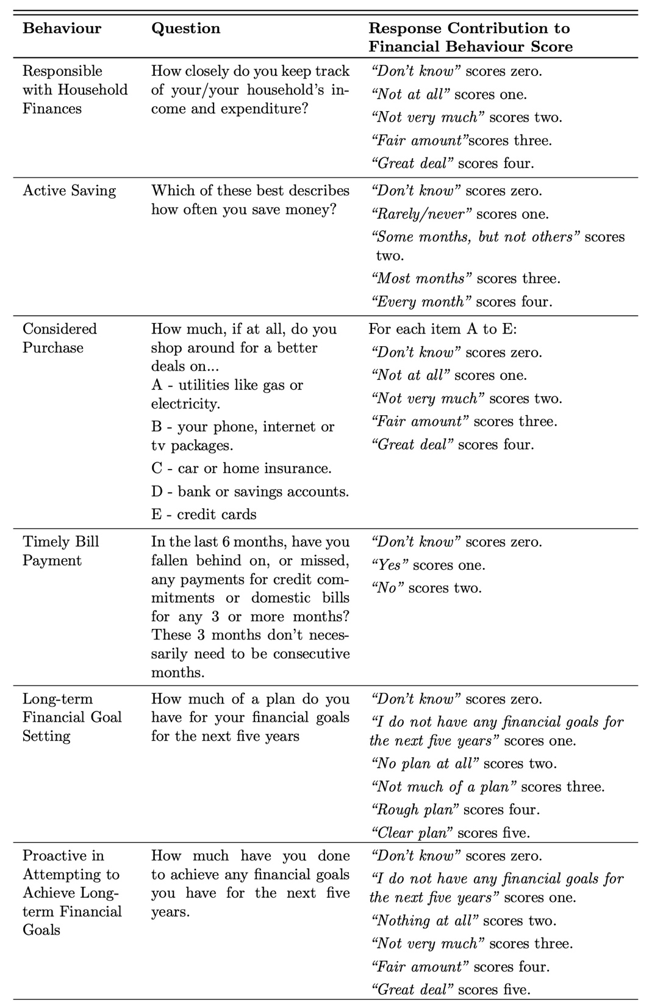

Table 4 (Cont.) Contributions Toward the Financial Behaviour Score.
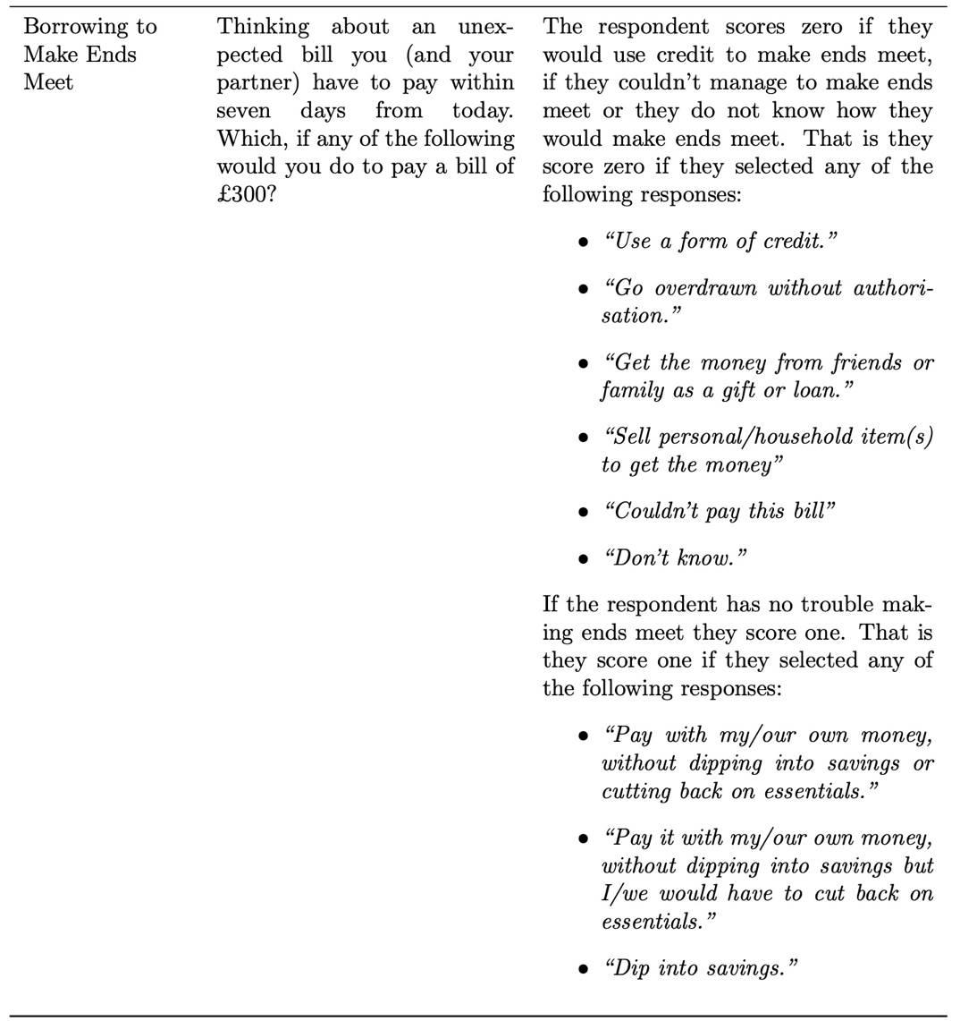
A.4. Financial Attitude Score
The attitudes score is based on the sum of the values for the six statements (Table 5) and then divided by six. Thus, the attitudes score ranges from 1 to 5.

Table 5 Contributions Toward the Financial Attitude Score.
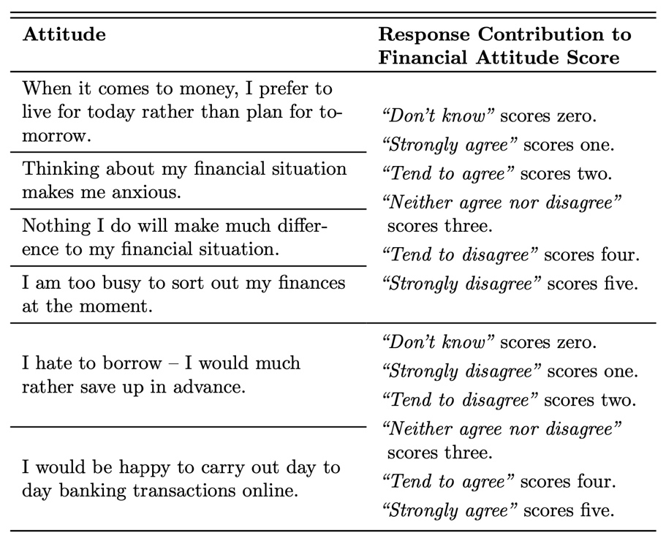

A.5. Financial Literacy Score
The financial knowledge score contributes four points, the financial behaviour score seven and the financial attitude score six. By summing all three scores together and multiplying by ¹⁰⁰⁄_{17,} the financial literacy score yields a value between 0 and 100. Note that the three scores treat “Don’t Know” responses as representing low levels of financial literacy in line with the literature.

A.5. Variable Key
Table 6 List and Description of Variables.
Main Variables | Description
Literacy | A percentage score measuring the respondent’s financial literacy
Knowledge | A percentage score measuring the respondent’s financial knowledge
Inclusion | A percentage score measuring the respondent’s financial inclusion
Location | Dummies for UK region of residence. 12 regions consistent with the NUTS Level 1 boundaries set by the ONS. The reference category is respondent’s residing in the East of England. The regions are London, East of England, East Midlands, West Midlands, Northeast, Northwest, Southeast, Southwest, Yorkshire and the Humber, Scotland, Wales, and Northern Ireland.
Gender | Dummy for respondent’s gender. 1= Female, 0=Male
Age | Measures the respondent’s age
Education | Dummies for the highest education attained. The reference category is no qualifications, with the remaining categories being secondary, vocational, and Tertiary
Social Grade | Dummies for the respondent’s social grade. Reference category DE represents unemployed respondents in semi-skilled, unskilled, and lowest grade of occupation. Three other categories (AB, C1 and C2) denote respondents in upper managerial and administrative positions, supervisory and junior managerial roles and finally, skilled in manual occupations.
Income | Dummies for the respondent’s household income. The reference categories are respondents with income less than £11500. The other income bands are £11500-£24999, £25000-£34999, £35000-49999 and £50000.

