Appendix B₁
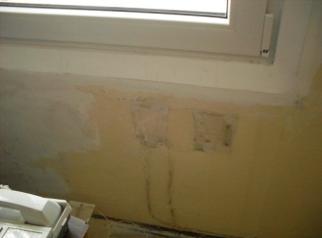 a) 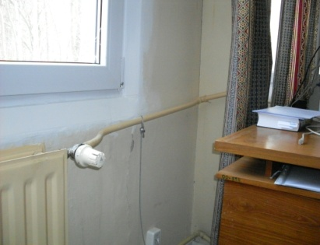 b) 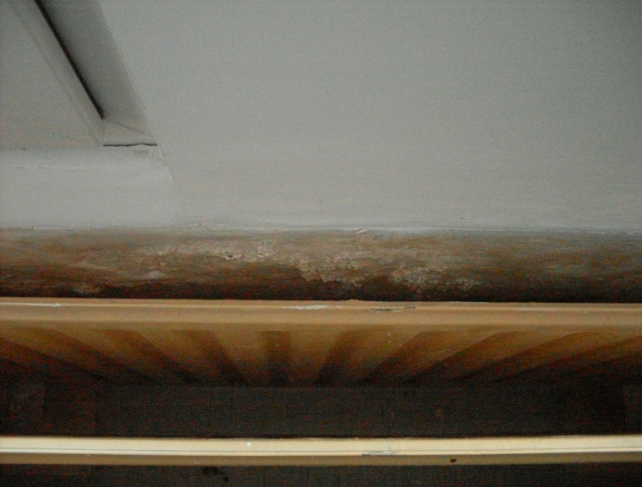 c₁)
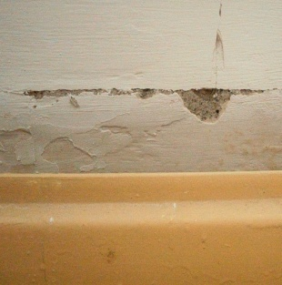 c₂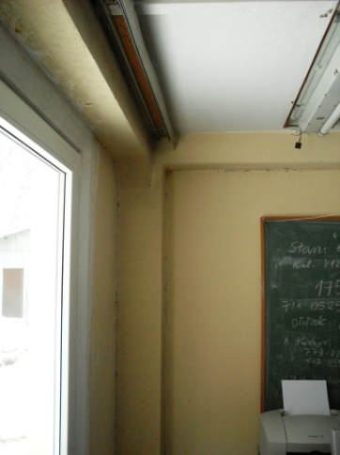 d₁) 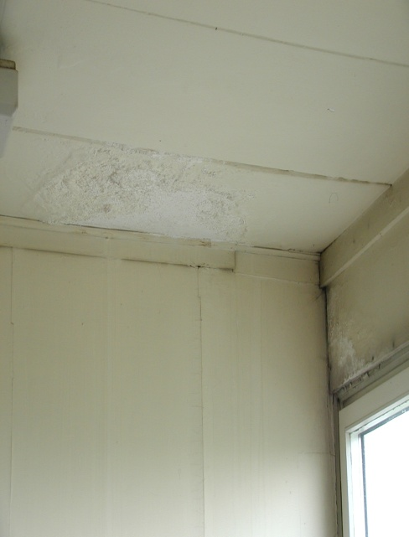 d₂) 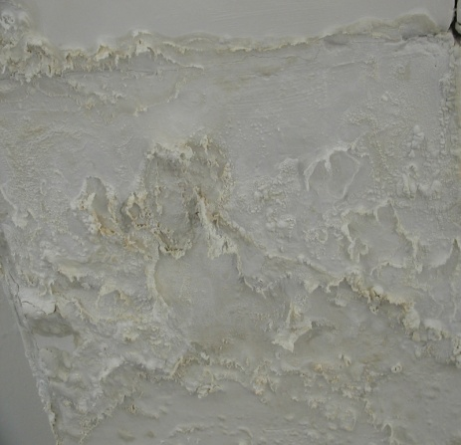 d₃) 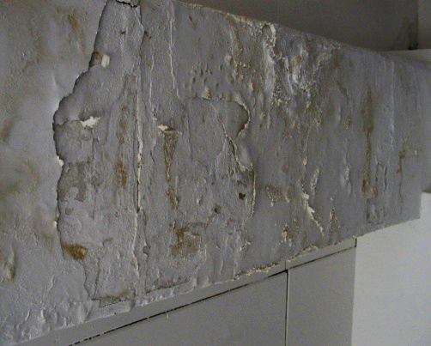 d₄) 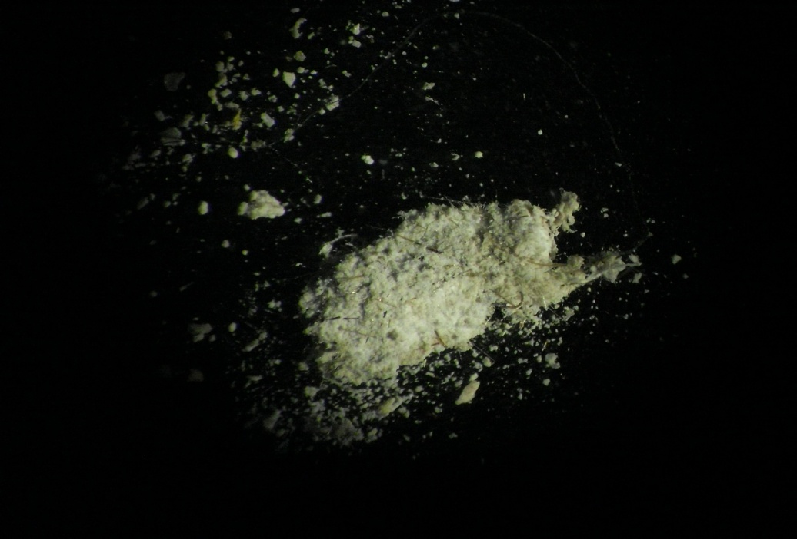 e ₁) e₂)
Damage of ACM in Building type “BERLIN”. Type of ACM destruction: caused by freezing of walls and condensation humidity and water vapour on their internal surfaces. Typical damage was visible in rooms in building no.1. Cases visible in photos c2 and d1 were caused by natural mechanical damage and vibration of the structure.
a) b) Mechanical damage before painting, after replacing windows.
c₁) Destruction of the friable ACM, "SOKALIT" panels behind the radiators (caused by changes in humidity).Enlarged fragment of damage to the "SOKALIT" panels around the frames above the radiators at the panel joints.
c₂) Gaps on the SOKALIT panel joints behind the radiator. Damage caused vibration of a non-rigid building structure and, cracks in wall elements of different stiffness.
d₁) Damage to the walls caused by ageing and structure vibrations: Destruction of the "SOKALIT" boards in the vicinity of the lintels above the windows; Damage to the "SOKALIT" panels at the point of contact between the partition wall and the building structure.
d₂), d₃) and d₄) Fragments of ceiling surfaces and wall corners made of "SOKALIT" degraded by water penetration (steam condensation, wall freezing, sewage pipe leakage)
e) Product of corrosion and destructive water damage to the "SOKALIT" board. e₁) Crushing fragments of "SOKALIT" boards collected from the floor under radiators. e₂) The dust that collects on the floor at the site of damage and its image seen in SEM, magnification 1000 x.

