Appendix B2

Comparison of similar damages of ACM-s products in twin "BERLIN" type buildings no. 1 and no. 3a and 4a
Building „BERLIN” no. 1
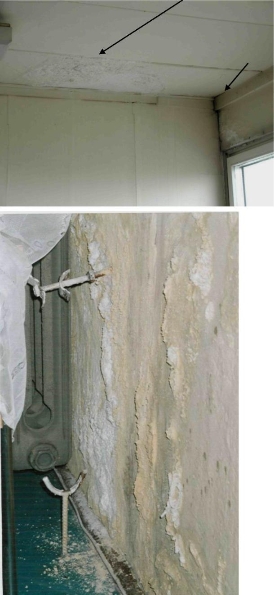b)
a)
b)

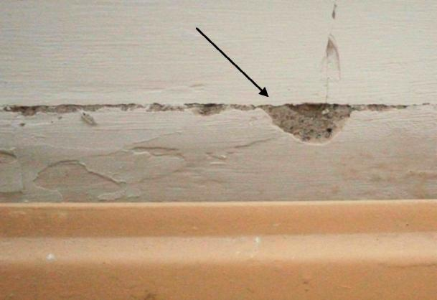 c)

e)
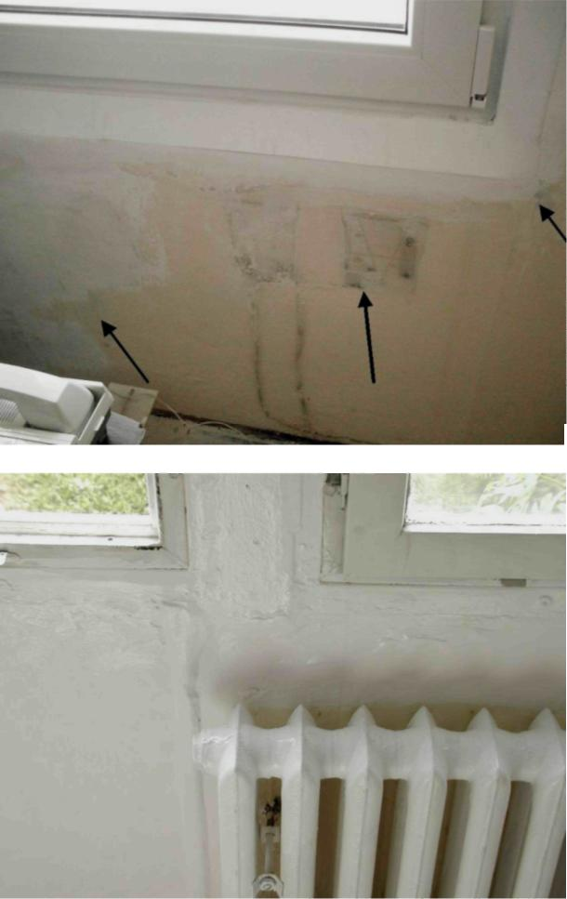
d)

Photos a) – e) present the condition of asbestos-containing products ("SOKALIT") in building No 1 at the time when the renovation was stopped and the tests began. Airborne concentration in that room was about 3200 – 7000 f/m³
a) A leaky roof damaged the suspended ceiling with “SOKALIT” (big arrow). Biological destruction (fungal infestation) of the corner of the window strip and the gable wall by freezing the walls (Photo 1a, small arrow and 1b, photo below ).
b) Damage caused in an unused room on the inside of the outer wall of the building (the effect of freezing and condensation)
c) Paint cracks on the joints of “SOKALIT” boards (arrow) visible behind the edge of the radiator (caused by vibrations of the building structure and local temperature changes).
d) Damage and defects of the “SOKALIT” surface covered with plaster mortar.
e) Destruction of the plate “SOKALIT” surface, which develops under the paints under ad hoc repairs. Inappropriate paints were used that do not match the surface of the plate

Buildings “BERLIN” nos. 3a and 4a

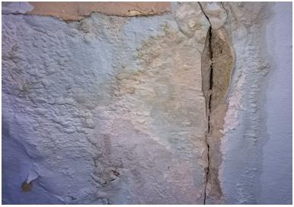 f)

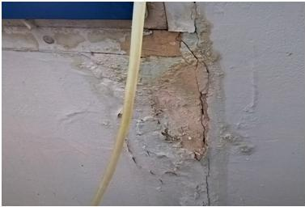 g)
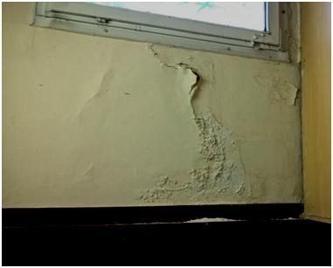 h)

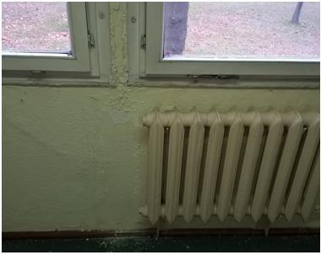i)

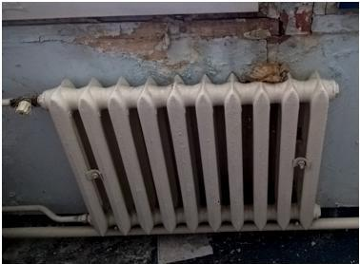 j)

Photos: f) – j) present the condition of asbestos-containing products ("SOKALIT") in buildings nos. 3a and 4a during normal use as classrooms in the school. The average value of 60 measurements of the concentration of asbestos fibres in the air in both buildings was < 300 f/m³. The maximum value was 560 +/- 60 f/m^{3.}

