Appendix C₁

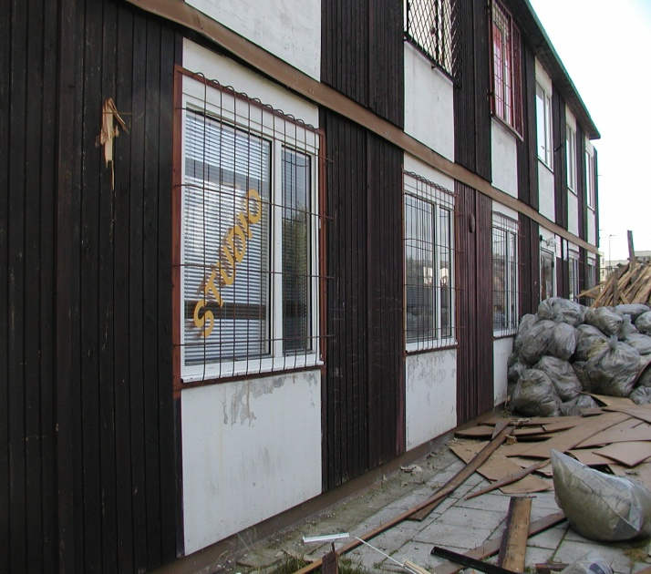 a 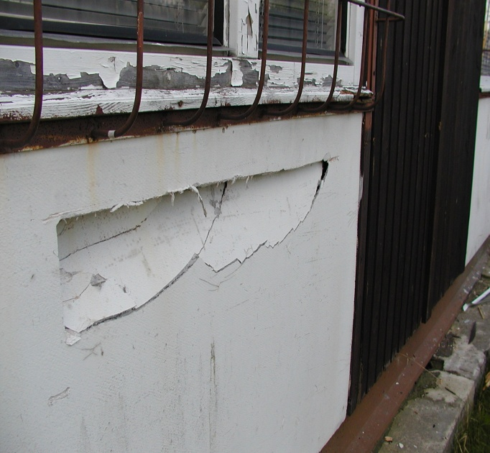 b
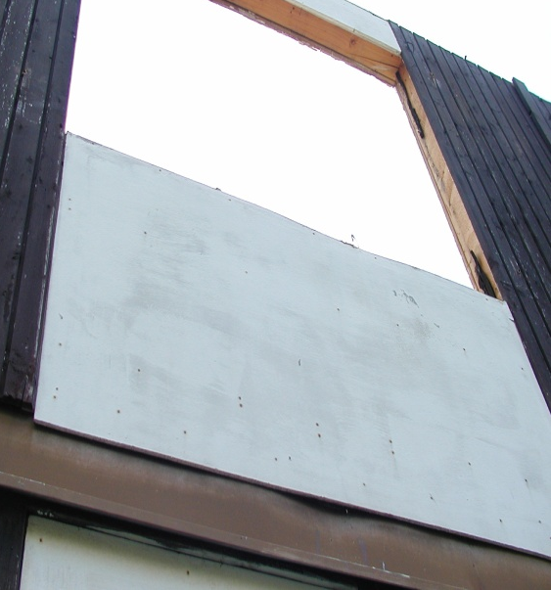 c 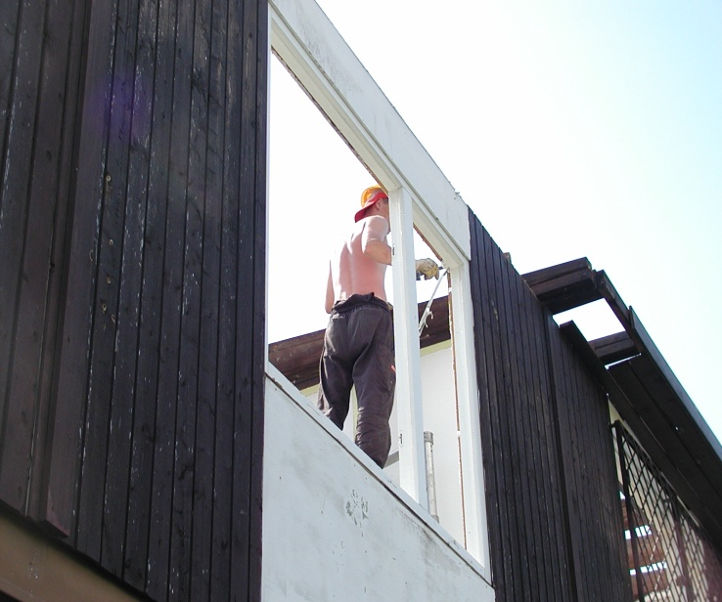 d
Demolition of the MOA building. The general appearance of the work carried out.
a) No separation of waste, mixing asbestos with other waste, without its tight closure.
b) Breakage of the ACM boards constituting the internal and external sheathing of the building's external and partition sandwich walls.
c) A fragment of an external wall on the 1st floor.
d) View after removing the roof. 14th day of work.

