Appendix C₂
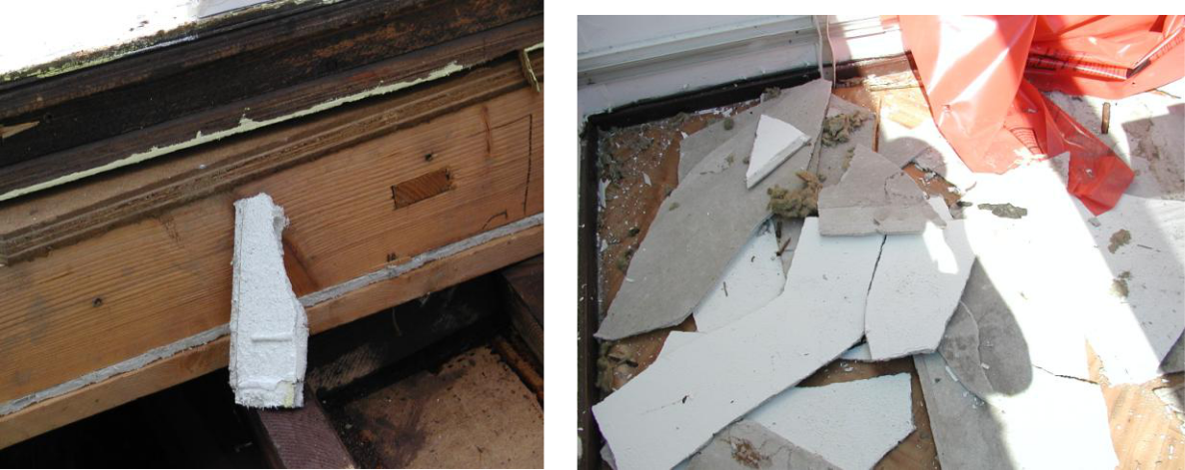

a

b

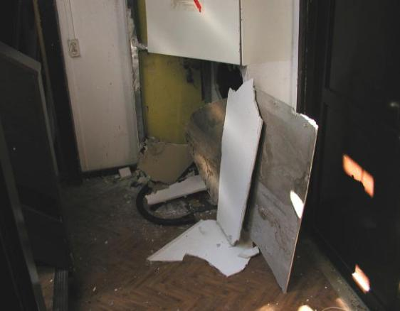 c 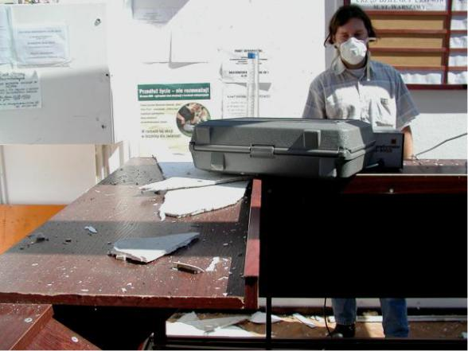

d

The photographs show the scale of irregularities that result in the environmental pollution described in the text. MOA building during demolition, after removing the roof. The air samples were taken on the ground floor. The solar beams visible in photos (b, c, d) prove the removal of the roof and the ceiling with the floor of the first floor. At that time the interior of the building became open to the outside air.

- Sandwich wall with crushed friable ACM (white-boards) in the curtain wall of the demolished building

- and c) The fragments of ACM boards (similar to "SOKALIT") scattered around the interior of the rooms, immediately after the roof was demolished

d) Air sampling by the ITB research team inside the building that is being disassembled.

