Supplementary Information
A. Measurement of particle diameter from SEM images
Protocol
- Open scanning electron microscopy image with software ImageJ
- Set up the scale in the image
  - Enlarge the image where the reference bar is
  - Draw a line with Stairght button on the scale bar
  - Go to Analyze / Set Scale and indicate that the length of the drawn line (pixels) corresponds to the reference bar (µm)
- Measure the projected area of ​​spheres
  - Define the contrast between background and spherical particle with the IsoData algorithm
  - Go to Analyze / Analyze Particles to define the estimated area of ​​the particle so that the software only detects the particles of our interest
  - Go to Show and select
    - Overlay for the software to highlight the delimited particles in the image after analysis
    - Exclude on edge to exclude particles that are in contact with the edges of the image
    - Display results to obtain the value of the areas (μm²) of each of the delimited particles
- Calculate the diameter of the spheres assuming that the projected area of ​​each particle is a circle
Results
Figure 6. Scanning electron microscopy image of SiO₂ particles before formation of the shell processed with software ImageJ. Light areas with yellow border are projected areas of spherical particles that were detected and measured by ImageJ software. Areas with red stripes are outliers detected by the Grubbs test (see Table 1).

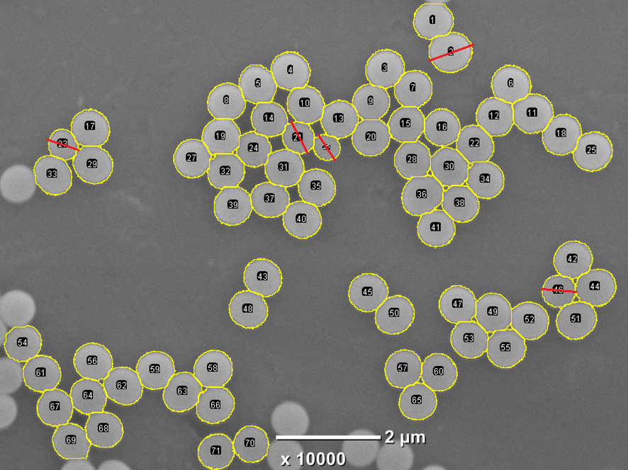
Figure 7. Scanning electron microscopy image of SiO₂@Fe_{x}O_{y} particles processed with software ImageJ. Light areas with yellow border are projected areas of spherical particles that were detected and measured by ImageJ software. Areas with red stripes are outliers detected by the Grubbs test (see Table 2).

Figure 8. Q-Q plot for the diameters of the SiO₂ spheres before formation of the shell. The data aligned to 45° indicate qualitatively that they belong to a normal distribution. Diameters expressed in micrometers.

Figure 9. Q-Q plot for the diameters of the SiO₂@Fe_{x}O_{y} spheres after the shell formation. The data aligned to 45° indicate qualitatively that they belong to a normal distribution. Diameters expressed in micrometers.

Table 1. Outliers y p-values obtained by the Grubbs test for Figure 6
Outliers | p-value | Number in the figure
0.176 | 1.37E-07 | 32
0.246 | 1.38E-04 | 30
0.274 | 0.00105 | 28
0.287 | 0.00115 | 54
0.484 | 0.00432 | 6

Table 2. Outliers y p-values obtained by the Grubbs test for Figure 7.
Outliers | p-value | Number in the figure
0.197 | 1.5E-05 | 26
0.25 | 2.8E-04 | 23
0.289 | 0.005 | 21
0.306 | 0.010 | 46
0.494 | 0.006 | 2

Table 3. Results of the t-Student test for the comparison of diameters (microns) before and after the formation of the oxide layer. We reject H0 in favor of H1 with 95% confidence. The variances between the groups are statistically equal with 95% confidence. LCL: lower confidence limit; UCL: upper confidence limit; T is the statistic used in the student's test of the difference of means with unknown but equal variances; pHomVar is the p-value of the F test of hypothesis of equal variances.
 | SiO₂@Fe_{x}O_{y} | SiO₂
n | 66 | 91
Average | 0.7160 | 0.7073
Variance | 0.0004 | 0.0004
Average(1)-Average(2) | 0.009
LCL(95) | 0.003
UCL(95) | 0.015
pHomVar | 0.8897
T | 2.8212
Degree of freedom | 155
p-value | 0.0054

B. Supplementary information on characterization
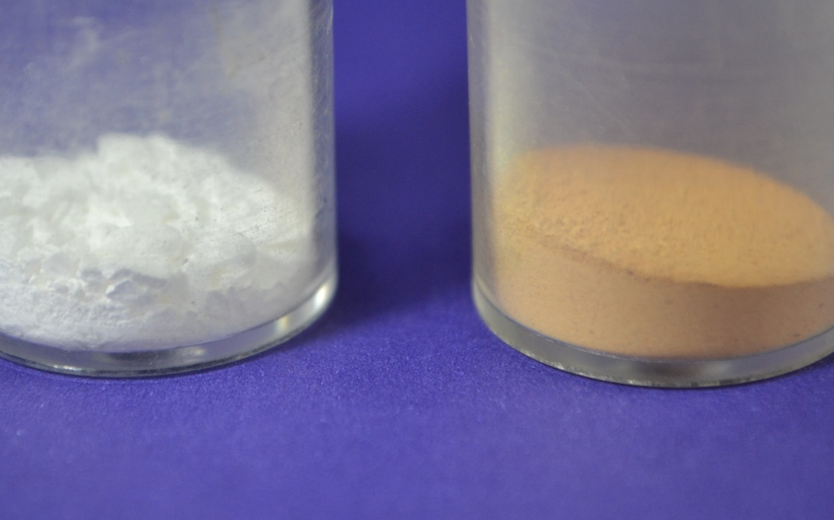
Figure 10. Powder formed by monodisperse silica spheres (left) and powder formed by SiO₂@Fe_{x}O_{y} (right).

Figure 11. X-ray diffractogram of the sample after the synthesis of the iron oxide shell.

Figure 12. The mapping of the elements Si and Fe shows a homogeneous distribution of both elements in the spherical particles. (Top left) Scanning electron microscopy image. (Top right) X-ray fluorescence emission spectrum of the sample. (Bottom left) Fe mapping in the sample. (Bottom right) mapping of Si in the sample.

C. Supplementary information on fluoride removal

Table 4. Contrast table of factorial design 2².
Factor |  | Treatment combination | F⁻ Concentration
(A) S/L ratio [g.L⁻¹] | (B) Time [min] | Treatment combination | I  [ppm] | II [ppm] | III [ppm] | Total
1 (-) | 30 (-) | 1 | 40,9 | 40,6 | 38,6 | 120,1
10 (+) | 30 (-) | a | 18,4 | 16,9 | 16,4 | 51,7
1 (-) | 120 (+) | b | 39,6 | 39,3 | 34,1 | 113
10 (+) | 120 (+) | ab | 15,2 | 18,1 | 15,5 | 48,8

Scheme 2. Scheme of the factorial design 2².

Table 5. Analysis of variance of the factorial design 2² with α = 0.05. The S/L ratio is a significant factor in fluoride removal. Time is not a significant factor in fluoride removal. The interaction between the above factors is not significant in the removal of fluoride

Source | Sume of Squares | Degrees of freedom | Mean Square | F | p-value
Model | 1475,03 | 3 | 491,68 | 133,31 | <0,0001
S/L ratio | 1465,23 | 1 | 1465,23 | 397,26 | 0,0001
Contact time | 8,33 | 1 | 8,33 | 2,26 | 0,1712
S/L ratio*Contact time | 1,47 | 1 | 1,47 | 0,4 | 0,5454
Error | 29,51 | 8 | 3,69
Total | 1504,54 | 11

Table 6. Minimum significant difference according to the LSD test with α = 0.05 and DMS = 2.55690. Fluoride removal with S/L = 1 and 10 significantly differ being the removal with S/L = 10 higher than with S/L = 1.

S/L ratio | Average | n | Estimated Error.
10 | 16,75 | 6 | 0,78 | A
1 | 38,85 | 6 | 0,78 | B

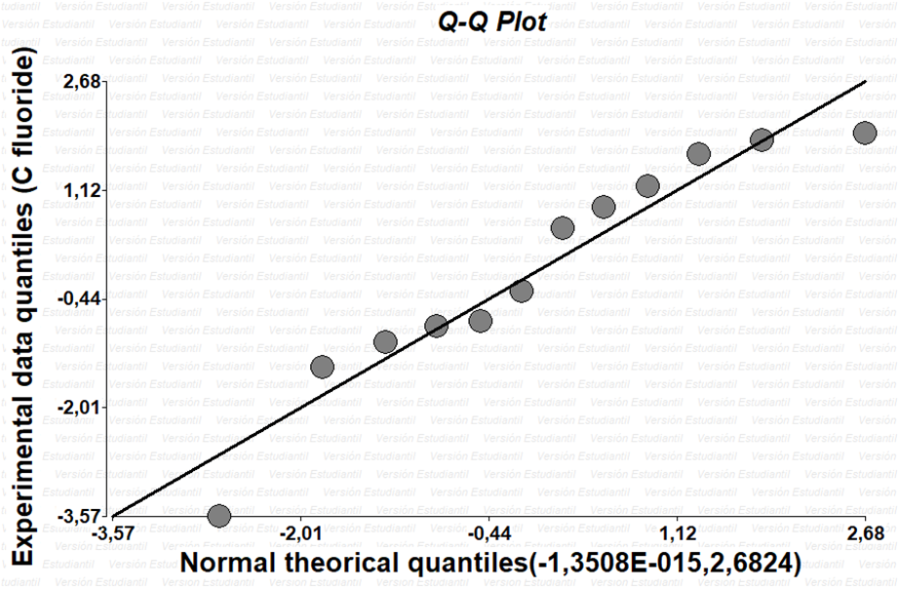
Figure 13. Q-Q plot for fluoride concentration. The data aligned to 45° indicate qualitatively that they belong to a normal distribution. C fluoride expressed in ppm

Table 7. Minimum significant difference according to the LSD test with α = 0.05 and DMS = 2.55690. The blank (S/L = 0), the batch system with the least amount of solid (S/L = 1), and the batch system with the highest amount of solid (S/L = 10) all differ significantly from each other.

S/L ratio | Average | n | Estimated Error
10 | 16,75 | 6 | 0,74 | A
1 | 38,85 | 6 | 0,74 | B
0 | 41,77 | 3 | 1,05 | C

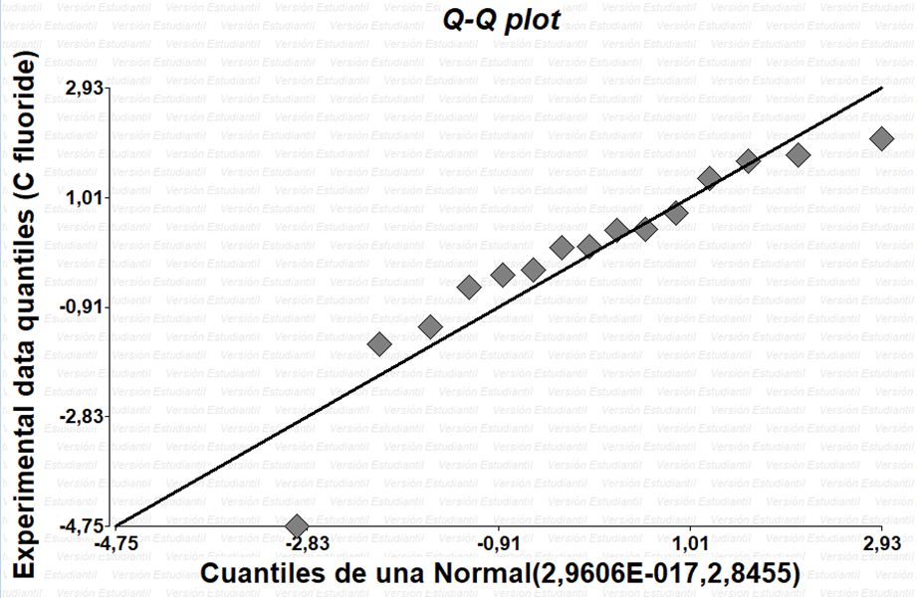
Figure 14. Q-Q plot for fluoride concentration. The data aligned to 45° indicate qualitatively that they belong to a normal distribution. C fluoride expressed in ppm.

